Multi Node Cluster Installation

1. Virtual Machine Setup
- Change Root Password
sudo passwd
- Reboot Server
reboot

Java

1.1.1 Download java
apt update
reboot
apt install openjdk-8-jdk

SSH

1.2.1 Download SSH
apt-get install ssh
apt install openssh-server
reboot
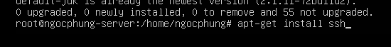

1.2.1 Configuration SSH
nano /etc/ssh/sshd_config
- Find # PubkeyAuthentication yes and # PasswordAuthentication yes.
- Uncomment # to PubkeyAuthentication yes andPasswordAuthentication yes ...
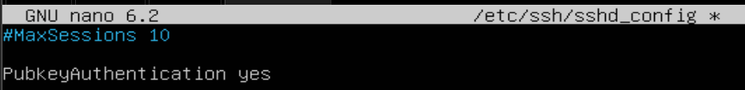

- Restart SSH
service sshd restart

2. Hadoop

2.1 Create user hadoopngocphung
adduser hadoopngocphung
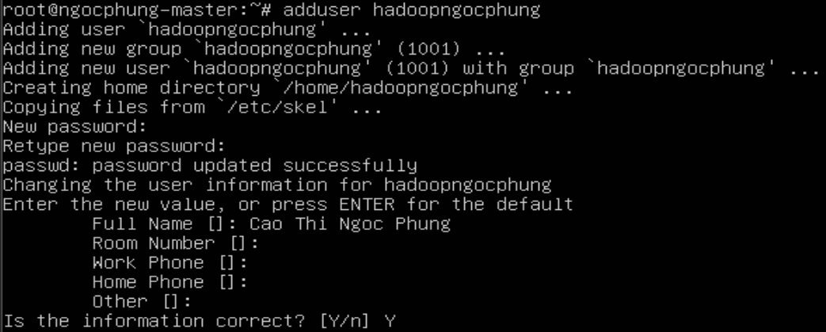

2.2 Install Hadoop 3.3.6
su hadoopngocphung
wget https://dlcdn.apache.org/hadoop/common/hadoop-3.3.6/hadoop-3.3.6.tar.gz
tar -xzf hadoop-3.3.6.tar.gz
mv hadoop-3.3.6 hadoop
mv hadoop-3.3.6.tar.gz tools/hadoop/
mv hadoop-3.3.6/ tools/hadoop/
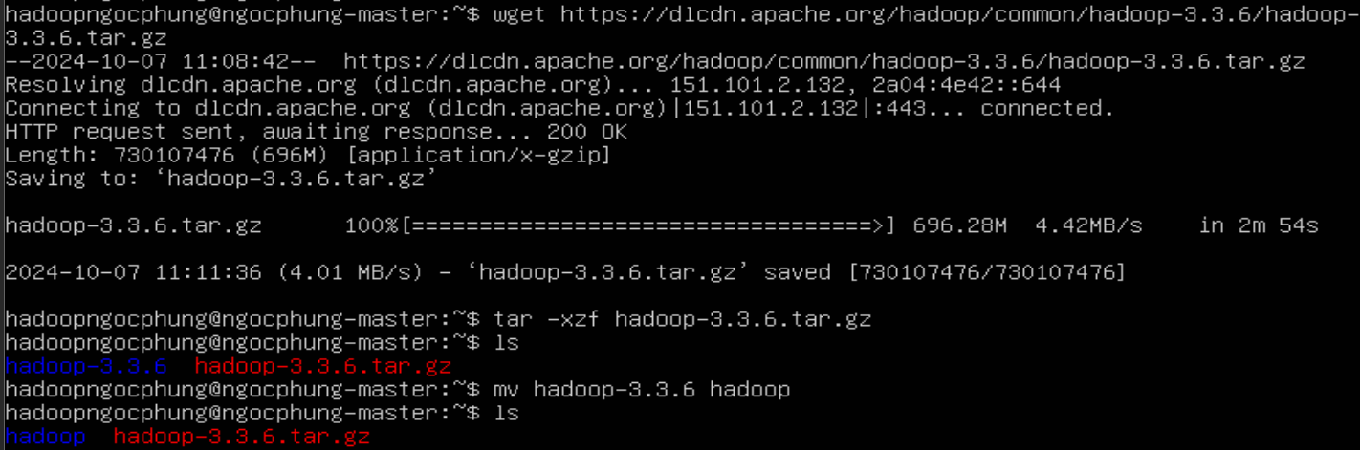

- Add the following content to the end of the .bashrc file:
nano ~/.bashrc

# JAVA
export JAVA_HOME=/usr/lib/jvm/java-1.8.0-openjdk-amd64
export PATH=$PATH:$JAVA_HOME/bin
source ~/.bashrc

2.3 Standalone Operation
- By default, Hadoop is configured to run in non-distributed mode as a single Java process. The following example copies all .xml files in the /etc/hadoop directory to the input directory, then finds and displays all results that match the given regular expression.
mkdir input
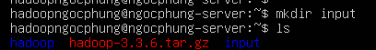
- Copy all the files ending in ".xml" from the "hadoop/etc/hadoop/" directory and place them in the "input" directory.
cp hadoop/etc/hadoop/*.xml input
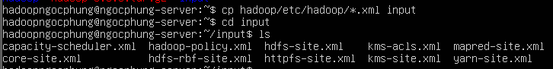
tools/hadoop/hadoop/bin/hadoop jar tools/hadoop/hadoop/share/hadoop/mapreduce/hadoop-mapreduce-examples-3.3.6.jar grep tools/hadoop/input tools/hadoop/output 'dfs[a-z.]+'
- Used to run a MapReduce application in Apache Hadoop
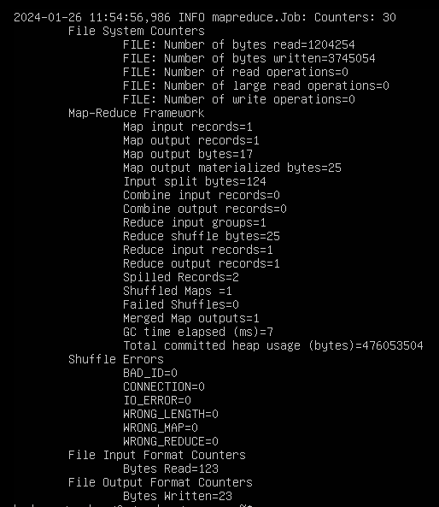

- display the contents of all files in the "output" directory
cat output/*

2.4 Create ssh key
- Creatae ssh key
ssh-keygen -t rsa -P ""
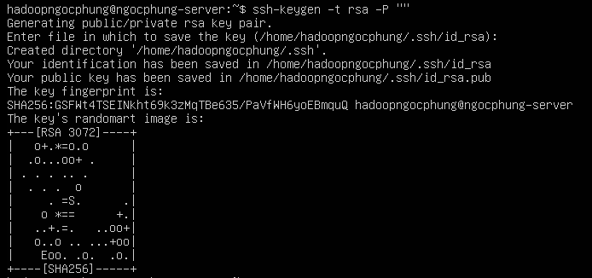
cat /home/hadoopngocphung/.ssh/id_rsa.pub >> /home/hadoopngocphung/.ssh/authorized_keys
- Add the contents of the "id_rsa.pub" file to the end of the "authorized_keys" file
chmod 600 /home/hadoopngocphung/.ssh/authorized_keys
- Change the permissions of the "authorized_keys" file in the .ssh directory of the user "hadoopngocphung"

3. Configuring files for Hadoop

3.1 File .bashrc
nano ~/.bashrc
- Add the following content to the end of the .bashrc file:
# JAVA
export JAVA_HOME=/usr/lib/jvm/java-1.8.0-openjdk-amd64
export PATH=$PATH:$JAVA_HOME/bin
# HADOOP
export HADOOP_HOME=/home/hadoopngocphung/tools//hadoop/hadoop
export PATH=$PATH:$HADOOP_HOME/bin
export PATH=$PATH:$HADOOP_HOME/sbin
export HADOOP_MAPRED_HOME=$HADOOP_HOME
export HADOOP_COMMON_HOME=$HADOOP_HOME
export HADOOP_HDFS_HOME=$HADOOP_HOME
export HADOOP_CONF_DIR=$HADOOP_HOME/etc/hadoop
export HADOOP_YARN_HOME=$HADOOP_HOME
export HADOOP_COMMON_LIB_NATIVE_DIR=$HADOOP_HOME/lib/native
export HADOOP_OPTS="-Djava.library.path=$HADOOP_HOME/lib/native"
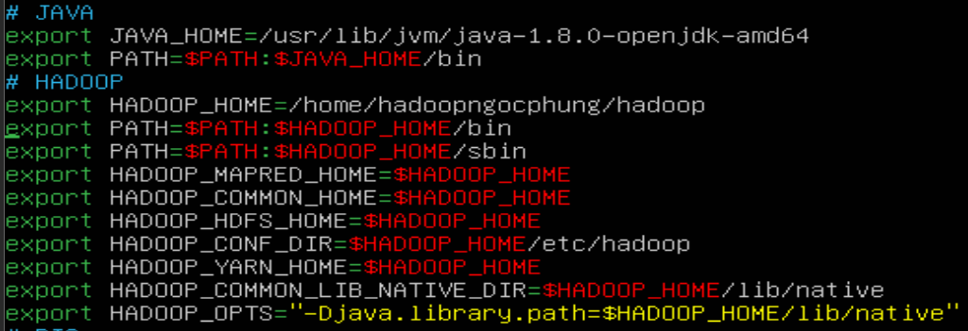
source ~/.bashrc

3.2 File hadoop-env.sh
nano ~/tools/hadoop/hadoop/etc/hadoop/hadoop-env.sh
- find export JAVA_HOME=... change to java location:
export JAVA_HOME=/usr/lib/jvm/java-1.8.0-openjdk-amd64

3.3 File core-site.xml
nano ~/tools/hadoop/hadoop/etc/hadoop/core-site.xml
- configure data in file
<configuration>
<property>
<name>hadoop.tmp.dir </name>
<value>/home/hadoopngocphung/tools/hadoop/tmp</value>
</property>
<property>
<name>fs.defaultFS</name>
<value>hdfs://ngocphung-master:9000</value>
</property>
</configuration>
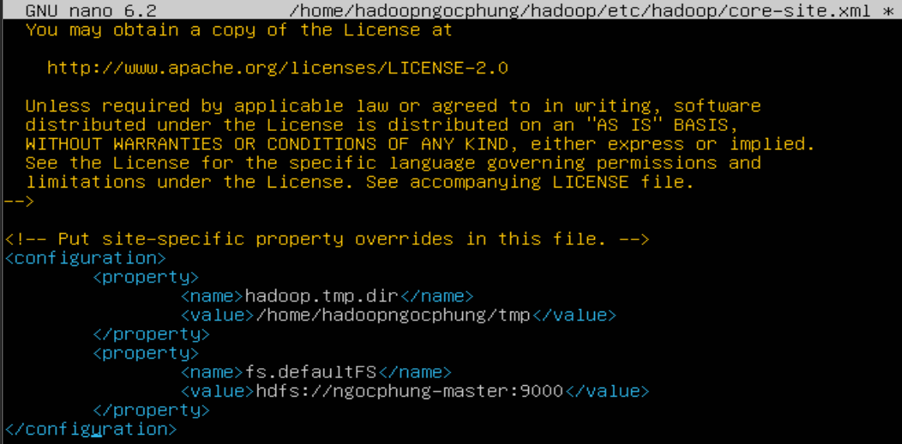

3.4 File mapred-site (chỉ cấu hình ở master)
nano ~/tools/hadoop/hadoop/etc/hadoop/mapred-site.xml
<property>
<name>mapreduce.application.classpath</name> <value>$HADOOP_MAPRED_HOME/share/hadoop/mapreduce/*:$HADOOP_MAPRED_HOME/share/hadoop/mapreduce/lib/*</value>
</property>
<property>
<name>mapreduce.jobtracker.address</name>
<value>ngocphung-master:9001</value>
</property>
<property>
<name>mapreduce.framework.name</name>
<value>yarn</value>
</property>
<property>
<name>yarn.app.mapreduce.am.env</name>
<value>HADOOP_MAPRED_HOME=/home/hadoopngocphung/tools/hadoop/hadoop</value>
</property>
<property>
<name>mapreduce.map.env</name>
<value>HADOOP_MAPRED_HOME=/home/hadoopngocphung/tools/hadoop/hadoop</value>
</property>
<property>
<name>mapreduce.reduce.env</name>
<value>HADOOP_MAPRED_HOME=/home/hadoopngocphung/tools/hadoop/hadoop</value>
</property>
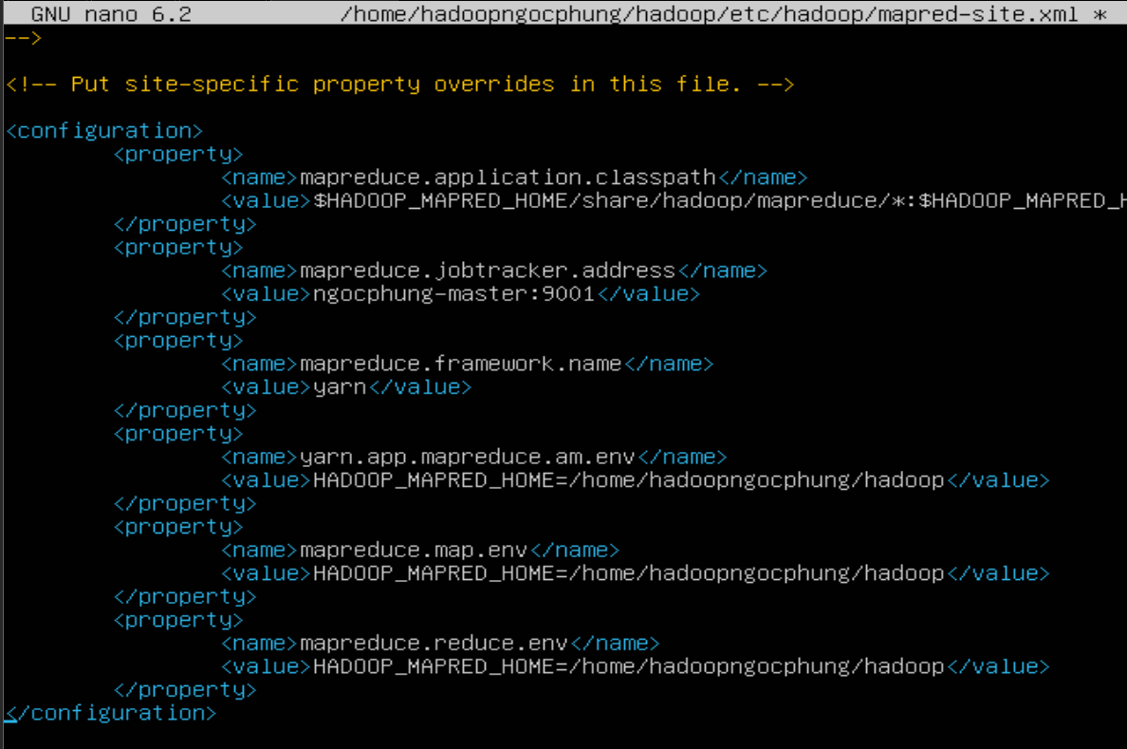

3.5 File hdfs-site.xml
nano ~/tools/hadoop/hadoop/etc/hadoop/hdfs-site.xml
- configure data in file
<property>
<name>dfs.replication</name>
<value>2</value>
</property>
<property>
<name>dfs.namenode.name.dir</name> <value>/home/hadoopngocphung/tools/hadoop/hadoop/hadoop_data/hdfs/namenode</value>
</property>
<property>
<name>dfs.datanode.data.dir</name> <value>/home/hadoopngocphung/tools/hadoop/hadoop/hadoop_data/hdfs/datanode</value>
</property>
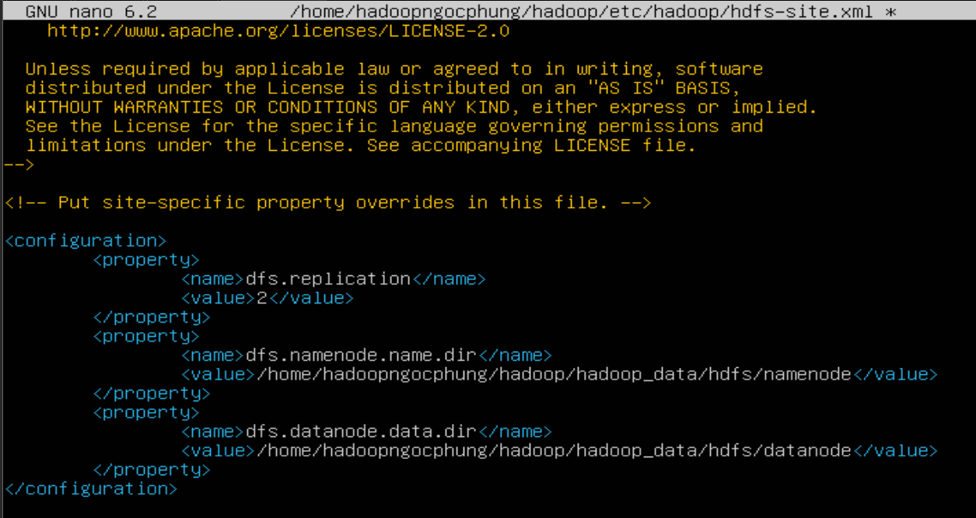

3.6 File yarn-site.xml
nano ~/tools/hadoop/hadoop/etc/hadoop/yarn-site.xml
- configure data in file
<property>
<name>yarn.nodemanager.aux-services</name>
<value>mapreduce_shuffle</value>
</property>
<property>
<name>yarn.nodemanager.env-whitelist</name>
<value>JAVA_HOME,HADOOP_COMMON_HOME,HADOOP_HDFS_HOME,HADOOP_CONF_DIR,CLASSPATH_PREPEND_DISTCACHE,HADOOP_YARN_HOME,HADOOP_MAPRED_HOME </value>
</property>
<property>
<name>yarn.resourcemanager.scheduler.address</name>
<value>ngocphung-master:9002</value>
</property>
<property>
<name>yarn.resourcemanager.address</name>
<value>ngocphung-master:9003</value>
</property>
<property>
<name>yarn.resourcemanager.webapp.address</name>
<value>ngocphung-master:9004</value>
</property>
<property>
<name>yarn.resourcemanager.resource-tracker.address</name>
<value>ngocphung-master:9005</value>
</property>
<property>
<name>yarn.resourcemanager.admin.address</name>
<value>ngocphung-master:9006</value>
</property>
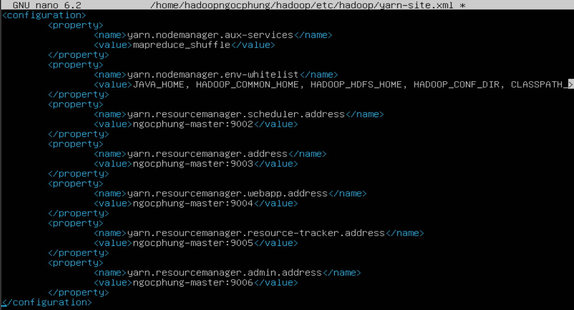

4. Configuring network

4.1 Configuring for MASTER
- Install Open vSwitch software on the system
apt-get install openvswitch-switch

4.1.1 Configuring hostname for master
nano /etc/hostname
- In this file will appear the default hostname of the machine, delete it and change it to ngocphung-master

4.1.2 Set up static host IP for MASTER
networkctl
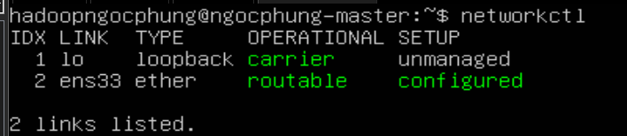
networkctl status
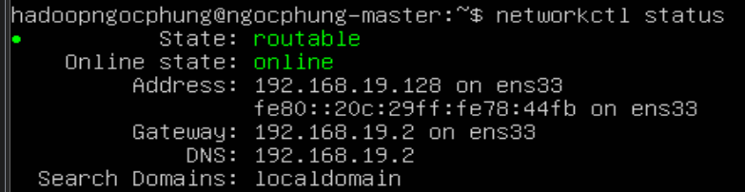
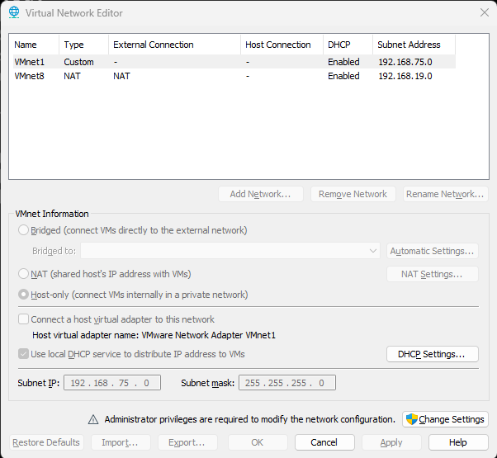

nano /etc/netplan/00-installer-config.yaml
sudo chmod 600 /etc/netplan/00-installer-config.yaml
network:
ethernets:
ens33:
dhcp4: false
dhcp6: false
addresses: [192.168.19.1/24]
routes:
- to: default
via: 192.168.19.2
nameservers:
addresses: [192.168.19.1, 8.8.8.8, 8.8.4.4]
version: 2
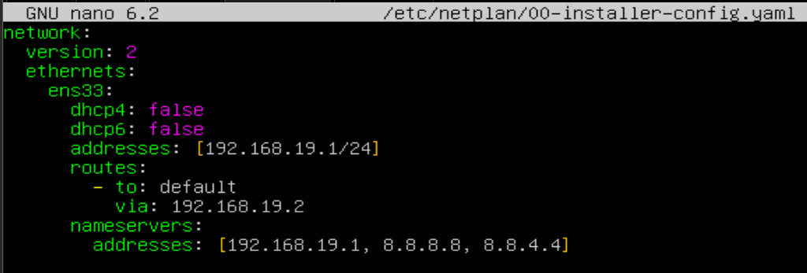
netplan apply
- Hệ thống đã được cấu hình theo IP mới, để kiểm tra chạy 1 trong 2 lệnh sau
networkctl status
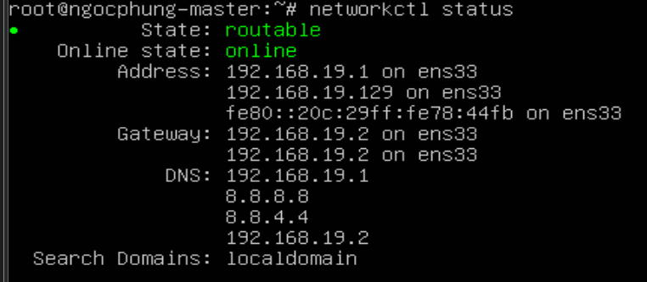

4.1.3 Configuring host
nano /etc/hosts
- Fill in the content, each slave machine is a line
192.168.19.1 ngocphung-master
192.168.19.3 ngocphung-slave1
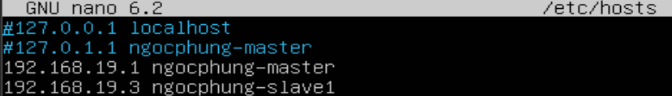

4.1.4 List slave machines (only done on master machine)
su hadoopngocphung
nano ~/tools//hadoop/hadoop/etc/hadoop/workers
- Fill in the names of slave1 machines

4.2 Configuring for SLAVE1

4.2.1 Create ngocphung-slave1
- Turn off Master.
- Copy Master, rename to Slave1
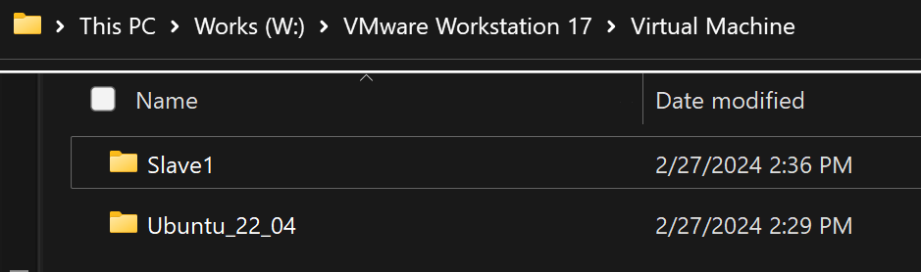
- Turn on the slave machine, adjust the static IP and parameters accordingly: hosts, hostname...

4.2.2 Set up hostname for slave
nano /etc/hostname
- In this file will appear the default hostname of the machine, delete it and change it to ngocphung-master

4.2.3 Set up static host IP for SLAVE1
nano /etc/netplan/00-installer-config.yaml
network:
ethernets:
ens33:
dhcp4: false
dhcp6: false
addresses: [192.168.19.3/24]
routes:
- to: default
via: 192.168.19.2
nameservers:
addresses: [192.168.19.1, 8.8.8.8, 8.8.4.4]
version: 2
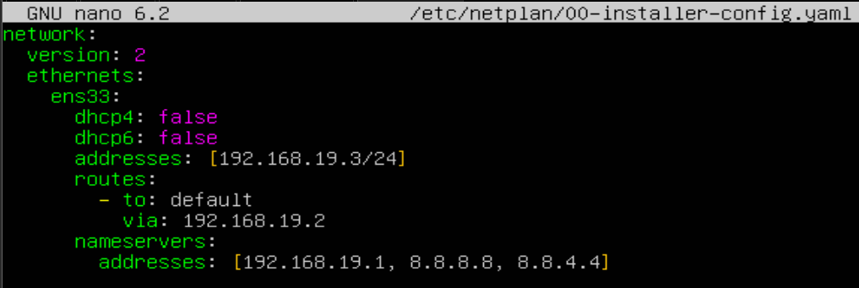
netplan apply
- The system has been configured with the new IP, to check run 1 of the following 2 commands
networkctl status
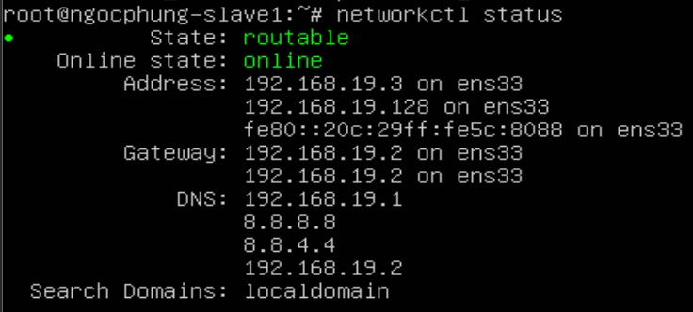

5. Set up ssh key between nodes

5.1 Share key
This operation is only performed on master
- Login with hadoopngocphung
- Create ssh key
ssh-keygen -t rsa -P ""
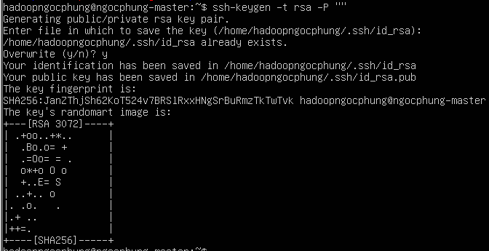
cat /home/hadoopngocphung/.ssh/id_rsa.pub >> /home/hadoopngocphung/.ssh/authorized_keys
chmod 600 /home/hadoopngocphung/.ssh/authorized_keys
- Share ssh key master - master
ssh-copy-id -i ~/.ssh/ id_rsa.pub ngocphung-master
- Share ssh key master – slave
ssh-copy-id -i ~/.ssh/id_rsa.pub ngocphung-slave1
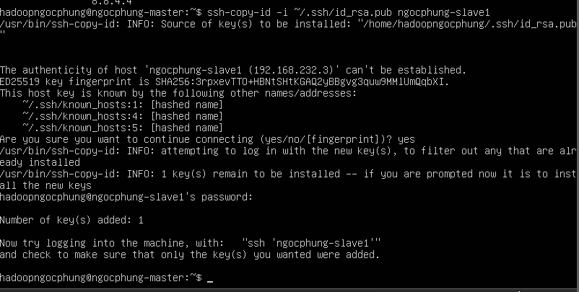

5.2 Test connection ssh
- Test connection to master
ssh hadoopngocphung@ngocphung-master
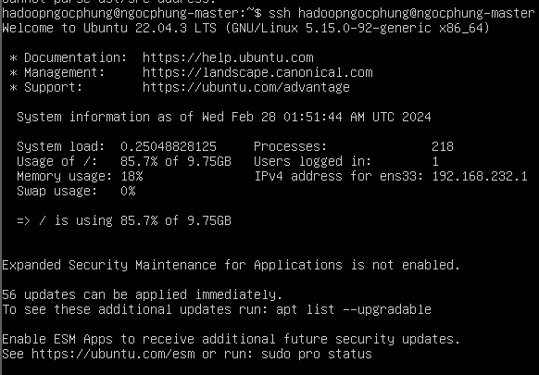
logout
- Test connection to slave
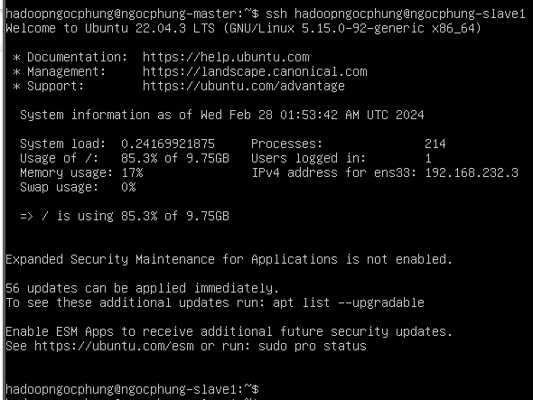
ssh hadoopngocphung@ngocphung-slave1

6. Format namenode
This operation is only performed on the master and only done once.
Update the master configuration information
hadoop/bin/hdfs namenode -format

7. Create file test
- Go to root directory, create test file
nano test.sh
- Contains the following contents
#!/bin/bash
# test the hadoop cluster by running wordcount
# create input files
mkdir input
echo "Hello World" >input/file1.txt
echo "Hello Hadoop" >input/file2.txt
# create input directory on HDFS
hadoop fs -mkdir -p input1
# put input files to HDFS
hdfs dfs -put ./input/* input1
# run wordcount
hadoop jar $HADOOP_HOME/share/hadoop/mapreduce/sources/hadoop-mapreduce-examples-3.3.6-sources.jar org.apache.hadoop.examples.WordCount input1 output1
# print the input files
echo -e "\ninput file1.txt:"
hdfs dfs -cat input1/file1.txt
echo -e "\ninput file2.txt:"
hdfs dfs -cat input1/file2.txt
# print the output of wordcount
echo -e "\nwordcount output:"
hdfs dfs -cat output1/part-r-00000
- Authorize and test run
chmod +x test.sh
./test.sh
- if wanna run again
rm -rf input
hadoop fs -rm -r input1
hadoop fs -rm -r output1
