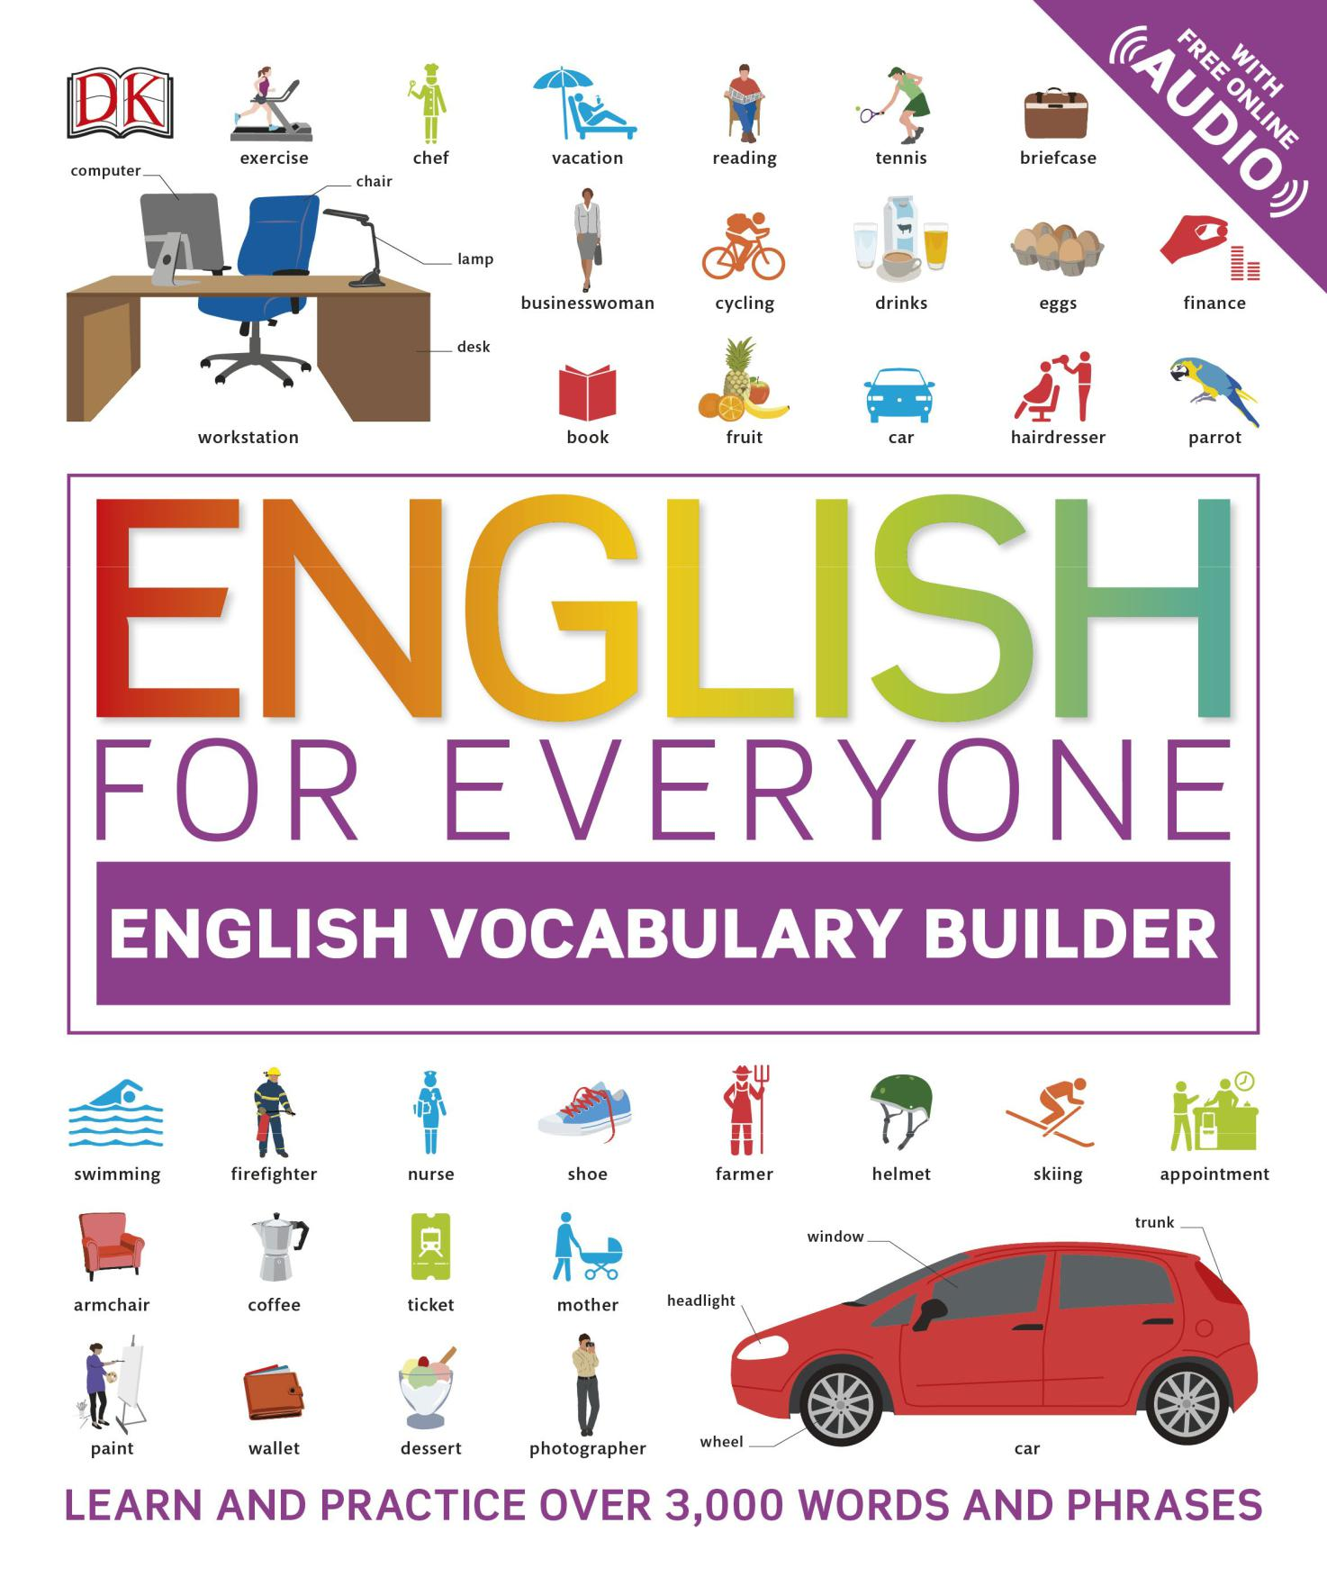

ENGLISH

FOR EVERYONE

**ENGLISH VOCABULARY BUILDER**

**FREE AUDIO**

website and app

**www.dkefe.com**

Author

Thomas Booth worked for 10 years as an English-language teacher in Poland and Russia. He now lives in England, where he works as an editor and English-language materials writer, notably of course books and vocabulary textbooks.

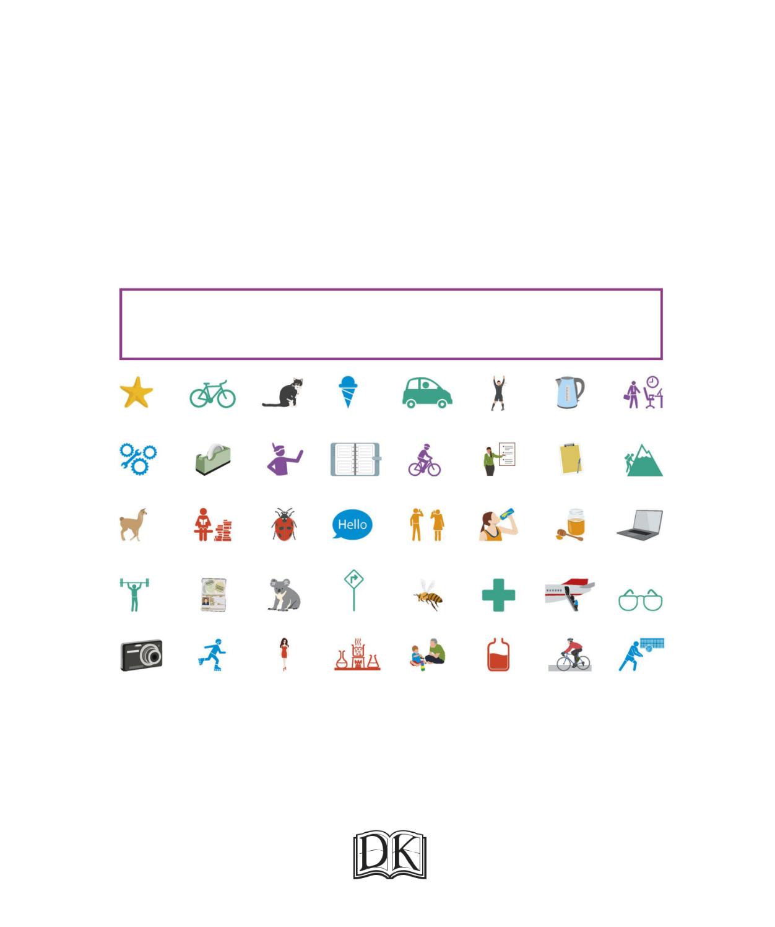ENGLISH

FOR EVERYONE

**ENGLISH VOCABULARY BUILDER**

US Editors Kayla Dugger, Jenny Siklos

Senior Editor Laura Sandford

Project Editor Thomas Booth

Senior Art Editors Amy Child, Anna Hall

Art Editors Raymond Bryant, Michelle Staples,

Jemma Westing

Illustrators Edward Byrne, Michael Parkin, Gus Scott

Project Manager Christine Stroyan

Jacket Designer Surabhi Wadhwa

Jacket Editor Claire Gell

Jacket Design Development Manager Sophia MTT

Producer, Pre-production Gillian Reid

Producers Alex Bell, Anna Vallarino

Publisher Andrew Macintyre

Art Director Karen Self

Publishing Director Jonathan Metcalf

DK India

Project Art Editor Sanjay Chauhan

Art Editor Meenal Goel

Assistant Art Editor Devika Khosla

Project Editor Nisha Shaw

Illustrator Arun Pottirayil

Jacket Designer Juhi Sheth

Managing Jackets Editor Saloni Singh

Pre-production Manager Balwant Singh

Senior DTP Designer Vishal Bhatia

Managing Art Editor Sudakshina Basu

Managing Editor Rohan Sinha

First American Edition, 2018

Published in the United States by DK Publishing,

345 Hudson Street, New York, New York 10014

1819202122 10987654321

001—305538—Jan/2018

Copyright © 2018 Dorling Kindersley Limited DK, a Division of Penguin Random House LLC All rights reserved.

Without limiting the rights under copyright reserved above, no part of this publication may be reproduced, stored in or introduced into a retrieval system, or transmitted in any form or by any means (electronic, mechanical, photocopying, recording, or otherwise) without the prior written permission of the copyright owner. Published in Great Britain by Dorling Kindersley Limited.

A catalog record for this book is available from the

Library of Congress.

ISBN 978-1-4654-6483-5

DK books are available at special discounts when purchased in bulk for sales promotions, premiums, fund-raising, or educational use. For details, contact DK Publishing Special Markets, 345 Hudson Street, NewYork, New York 10014 or SpecialSales@dk.com.

Printed in China

A WORLD OF IDEAS:

SEE ALL THERE IS TO KNOW

**www.dk.com**

Contents

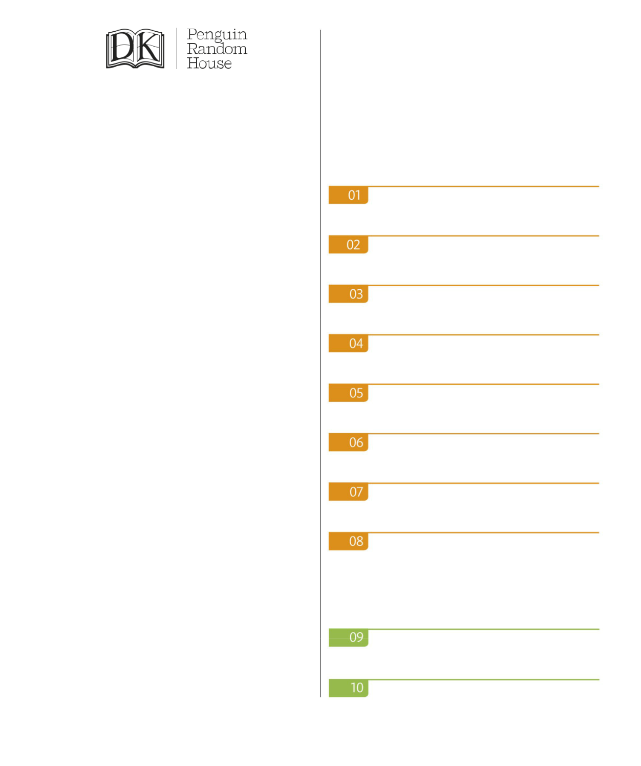

|  |  |
| --- | --- |
| How to use this book | 8 |

GETTING STARTED

|  |  |
| --- | --- |
| Countries and nationalities | 10 |
| Numbers | 14 |
| Time expressions | 18 |
| Daily routines | 22 |
| Describing things: facts | 26 |
| Describing things: opinions | 30 |
| Sharing information | 34 |
| Common English idioms | 38 |

HOME

|  |  |
| --- | --- |
| Around the house | 42 |
| Kitchen implements and toiletries | 46 |

4

Chores and cleaning

Tools and gardening

Moving and renting

PEOPLE

The body

Clothes

Accessories and beauty products

Appearance

Personality traits

Feelings and moods

Family tree

Family and relationships

Baby equipment and toys

Education

50

54

58

62

66

70

74

78

82

86

90

94

98

Studying

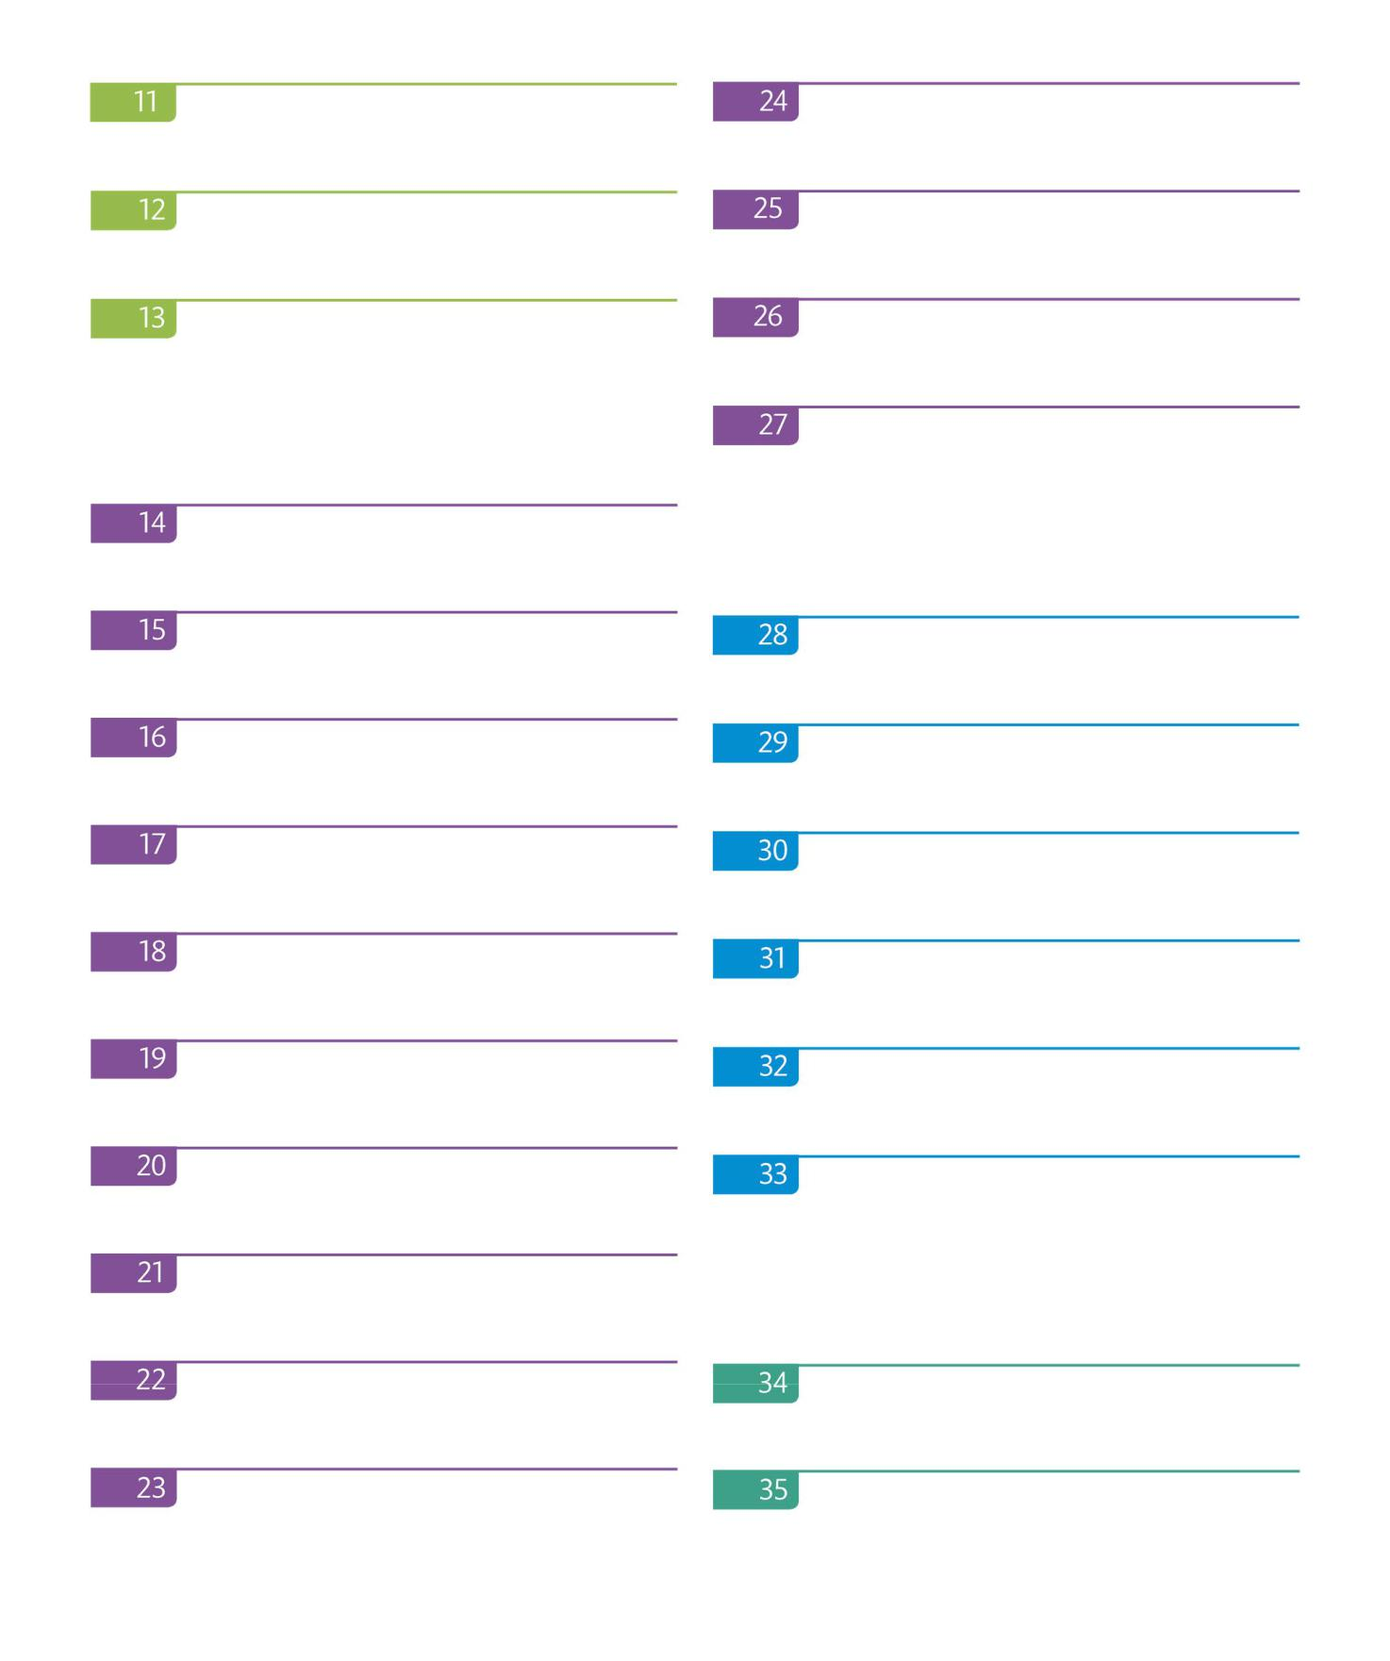

Speaking a foreign language

Communication and beliefs

Crime and the law

FOOD AND DRINK

Meat, fish, dairy, and snacks

Fruit and nuts

Vegetables

Bread, desserts, and condiments

Drinking and eating

Eating in and eating out

WORK

Jobs

Working conditions

102

106

110

114

118

122

126

130

134

138

142

146

5

Industries and departments

Office equipment

Money and finance

Working

Meeting and presenting

Work and business idioms

Applying for a job

Workplace skills and abilities

TRAVEL

Transportation and travel

Driving a car

Maps and directions

Travel and accommodation

Travel and tourism

1. Camping and cycling

1. Beach

158

THE ENVIRONMENT

1. Weather and climate
2. Geographical features
3. Environmental concerns

174

ANIMALS

1. Pets and farm animals

Wild animals

1. Birds and bugs
2. Fish, whales, and sea creatures

190

ACTIVITIES

1. Free time activities
2. Abilities and actions

202

206

210

214

218

222

226

230

234

238

242

6

Sports 246 AROUND TOWN

Soccer

Sports equipment and venues

ARTS AND THE MEDIA

Books and reading

Music

Movies and plays

TV

Media and celebrity

HEALTH

Sickness

Medicine and treatment

Healthy eating

Fitness and well-being

250

254

258

262

266

270

274

278

282

286

290

Around town

Shopping

At the supermarket

Urban life

SCIENCE AND TECHNOLOGY

Technology and gadgets

Technology and the future

Science

Answers

Word list

Acknowledgments

294

298

302

306

310

314

318

322

340

360

7

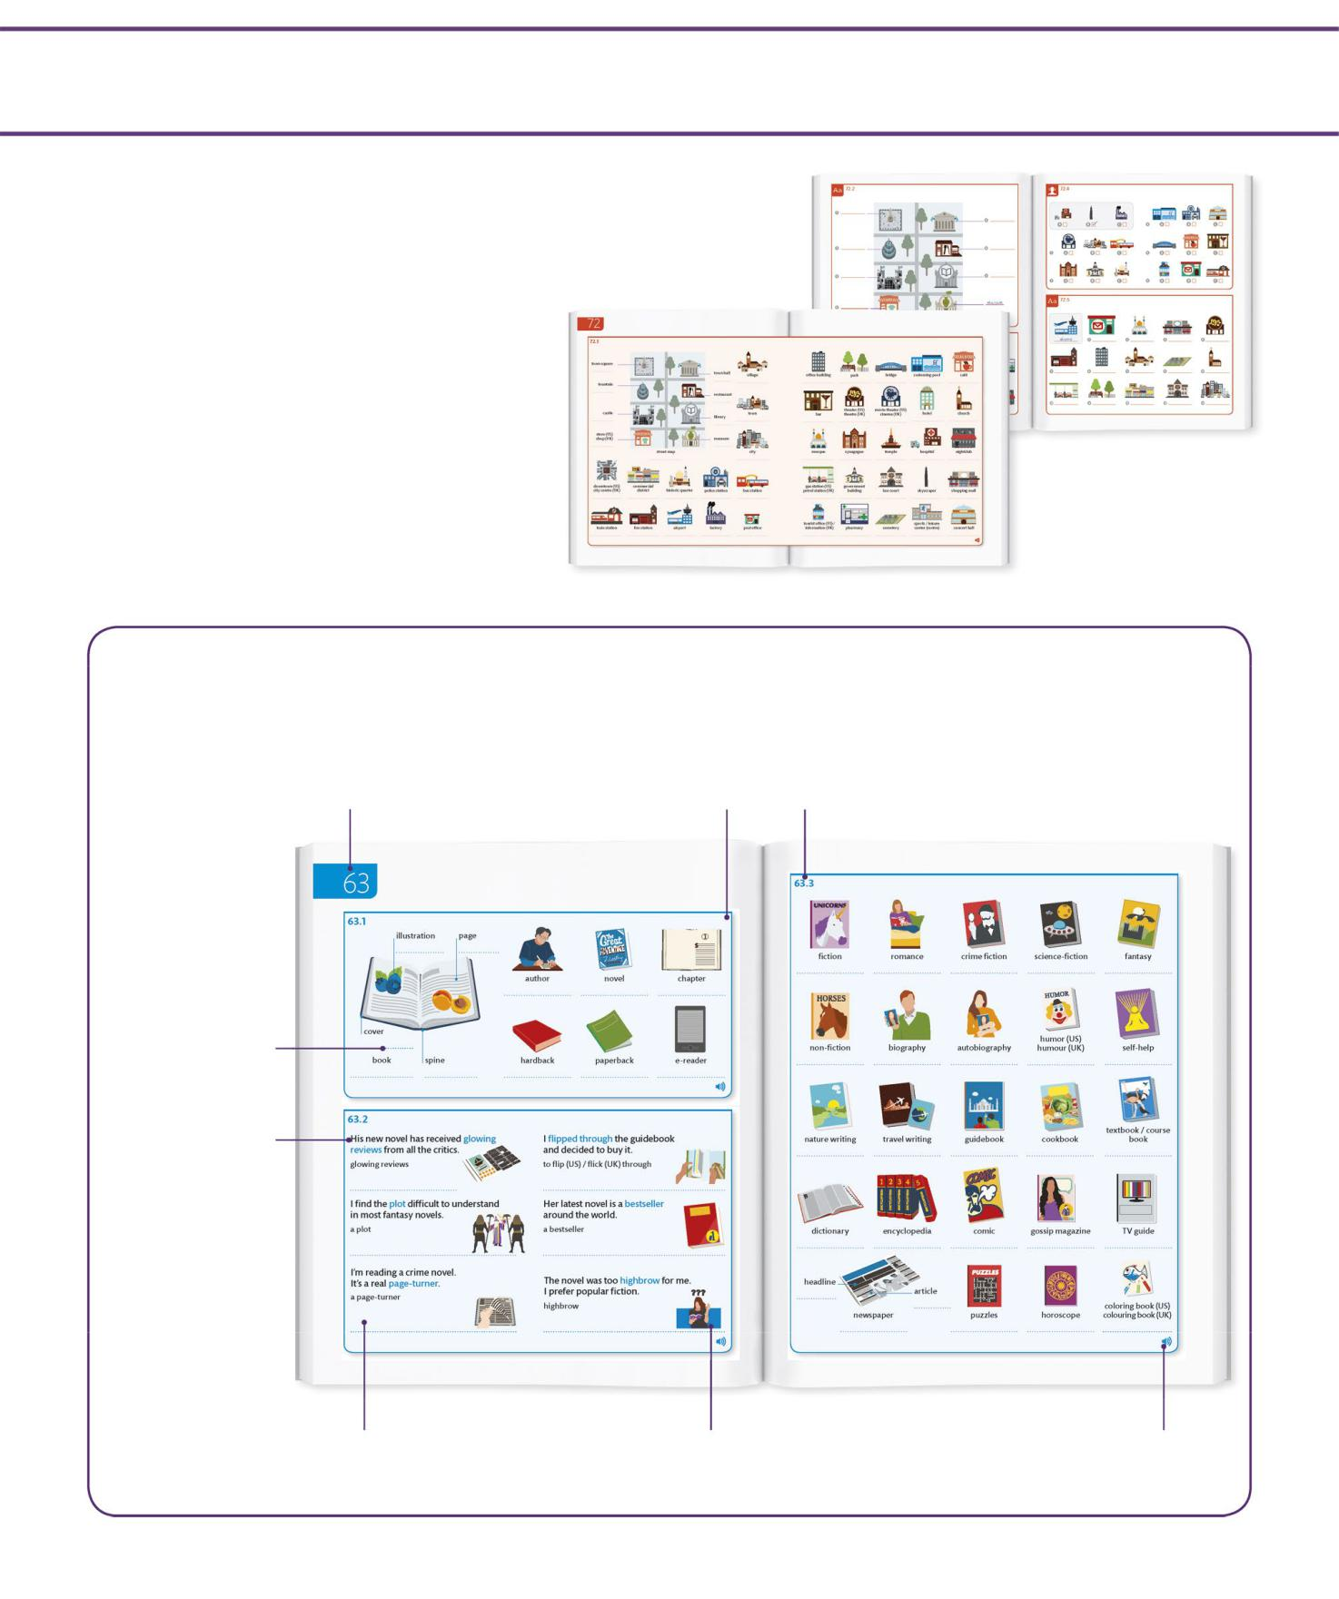AROUND TOWN

Around town

How to use this book

Each unit of *English for Everyone: English Vocabulary Builder* consists of a teaching spread and a practice spread. Teaching spreads give you an illustrated vocabulary list on a particular topic. Practice spreads include a variety of exercises to reinforce

what you have learned. Supporting audio for each teaching spread is available on the website and app. The best way to learn spoken vocabulary is to listen to the audio and repeat each word and phrase on the spread. If you have difficulty understanding a word or phrase, look it up in your dictionary or the word list at the back of this book.

LOOK AT THE PICTURE AND WRITE THE CORRECT WORD LISTEN TO THE AUDIO AND MARK THE CORRECT PICTURE FOR EACH

FOR EACH LABEL WORD YOU HEAR

WRITE THE CORRECT WORD UNDER EACH PICTURE

FIND FIVE MORE WORDS IN THE GRID THAT MATCH THE PICTURES

296 297

PRACTICE SPREAD

TEACHING SPREAD

Teaching spreads

|  |  |
| --- | --- |
| **Unit number** The book is | **Modules** Most teaching spreads are |
| divided into units. The unit |
| number helps you keep | broken down into modules covering |
| track of your progress. | different aspects of a topic. |

Books and reading

BOOKS

**Write-on lines** You

are encouraged to

write your own

translations of English

words to create your

own reference pages.

USEFUL EXPRESSIONS

|  |  |  |  |
| --- | --- | --- | --- |
| **Sample sentences** |  |  |  |
| Some modules show |  |  |  |
| useful English phrases | [highly positive reviews] |  | [to take a quick look inside a book] |
| in the context of a |  |  |  |
| sample sentence. |  |  |  |
|  | [a series of events that make up a story] | | [a book that sells a large number of copies] |
|  | [a novel that makes you want |  |  |
|  | to read more] |  | [containing difficult or intellectual ideas] |
|  | 258 |  |  |
| **Definitions** Idiomatic English | | **Supporting graphics** Visual cues | |
| phrases are accompanied | |  | help you understand and |
| by definitions. | |  | remember new vocabulary. |

**Module number** Every module is identified with a unique number, so you can easily locate the related audio.

READING AND GENRES

259

**Audio support** All teaching modules are supported by audio recordings to help you recognize and pronounce spoken vocabulary.

8

Practice exercises

Each teaching spread is followed by exercises that help to fix new words and phrases in your memory. Working through the exercises will help you to remember what you have learned and to use and recognize new English vocabulary. Answers are provided for every exercise.

**Listening exercise** This symbol indicates that you should listen to an audio track in order to answer the questions in the exercise.

LISTEN TO THE AUDIO AND MARK THE CORRECT PICTURE FOR EACH SPORT YOU HEAR

**Exercise number** Each exercise is **Exercise instruction** Each exercise

identified with a unique number, so is introduced with a brief instruction,

you can easily locate answers. telling you what you need to do.

LOOK AT THE PICTURE CLUES AND WRITE THE ANSWERS IN THE

CORRECT PLACES ON THE GRID

**Space for writing** You are encouraged to write your answers in the book for future reference.

**Sample answer**

The first question

of each exercise

is answered for

you, to help make

the task easy to

understand.

**Supporting graphics** Visual

cues are given to help you

understand the exercises.

Audio

*English for Everyone: English Vocabulary Builder* features extensive supporting audio resources. Every word and phrase in the teaching spreads is recorded, and you are encouraged to listen to the audio and repeat the words and phrases out loud, until you are confident you understand and can pronounce what has been said.

**SUPPORTING AUDIO**

This symbol indicates that audio recordings of the words and phrases in a module are available for you to listen to.

**LISTENING EXERCISES**

This symbol indicates that you should

listen to an audio track in order to

answer the questions in the exercise.

**FREE AUDIO**

website and app

**www.dkefe.com**

Answers

This book is designed to make

it easy to monitor your progress.

Answers are provided for every

exercise, so you can see how well

you have understood and

remembered the vocabulary you

have learned.

**Answers** Find the answers

to every exercise printed

at the back of the book.

**Exercise numbers**

Match these numbers

to the unique identifier

at the top-left corner

of each exercise.

9

Countries and nationalities

COUNTRIES

10

NATIONALITIES

11

MARK THE CORRECT COUNTRY FOR EACH FLAG

FIND EIGHT MORE COUNTRIES IN THE GRID THAT MATCH THE FLAGS

12

LISTEN TO THE AUDIO AND WRITE THE CORRECT

CIRCLE THE WORDS YOU HEAR COUNTRY UNDER EACH FLAG

WRITE THE WORDS FROM THE

PANEL IN THE CORRECT GROUPS

COUNTRIES NATIONALITIES

13