

**SOFTWARE REQUIREMENT SPECIFICATION**

**Project Name (Code)**

– Hanoi, Jan 2024 –

**Table of Contents**

I. Record of Changes 3

II. Software Requirement Specification 4

1. Overall Requirements 4

1.1 Context Diagram 4

1.2 Main Business Processes 5

1.3 User Requirements 5

1.4 System Functionalities 7

1.5 Entity Relationship Diagram 7

2. Use Case Specifications 8

2.1 <<Feature Name1>> 8

2.2 Xyz Feature 10

3. Functional Requirements 11

3.1 Feature Name1 11

3.2 User Authentication 11

3.3 System Administration 12

4. Non-Functional Requirements 13

3.1 External Interfaces 13

3.2 Quality Attributes 13

5. Requirement Appendix 14

5.1 Business Rules 14

5.2 System Messages 14

5.3 Other Requirements… 15

# I. Record of Changes

| **Date** | **A* M, D** | **In charge** | **Change Description** |
| --- | --- | --- | --- |
|  |  |  |  |
|  |  |  |  |
|  |  |  |  |
|  |  |  |  |
|  |  |  |  |
|  |  |  |  |
|  |  |  |  |
|  |  |  |  |
|  |  |  |  |
|  |  |  |  |
|  |  |  |  |
|  |  |  |  |
|  |  |  |  |

*A - Added M - Modified D - Deleted

# II. Software Requirement Specification

## 1. Overall Requirements

### 1.1 Context Diagram

The **Cinema Booking System** is an integrated software platform that streamlines ticket booking and theater operations. It connects different user roles—Guests, Registered Users, Staff, and Admins—with supporting services such as Payment and Notification Systems. The system ensures smooth interaction between customers and theaters, covering the entire process from browsing movies to booking, payment, and confirmation.

**External Entities & Main Interfaces (as shown in the diagram):**

* **Guest:** can browse movie information, view theater showtimes, and access basic movie details without logging in.
* **User (Registered Customer):** can log in or recover accounts, manage personal profiles, select movies and showtimes, manage bookings, and receive e-ticket confirmations.
* **Staff:** manages movie schedules, showtimes, and theater-related operations within the system.
* **Admin:** oversees the platform by managing user accounts, monitoring data, and generating movie analysis and performance reports. Admins also handle troubleshooting and system-level controls
* **Payment System:** processes financial transactions by receiving payment requests from the Cinema Booking System and returning results (success/failure) with transaction details.
* **Notification System:** distributes email confirmations and booking notifications (e.g., ticket details, reminders) to users.

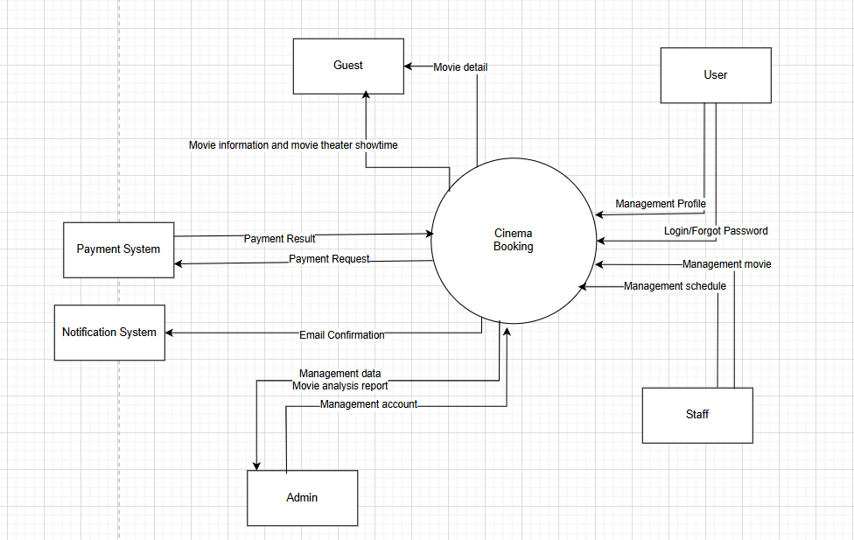

>>

### 1.2 Main Business Processes

*[Provide main workflows (business processes) using the swim-lane diagram(s) like sample below]*

#### 1.2.1 Order Processing

#### 1.2.2 Customer Support

…

### 1.3 User Requirements

#### 1.3.1 Actors

| **#** | **Actor** | **Description** |
| --- | --- | --- |
| 1 | Guest | Unregistered visitor who can explore movie-related content but cannot book tickets. |
| 2 | Admin | Maintains global system operations, user management, contracts, and platform analytics. |
| 3 | User | Registered customer who can book tickets, manage bookings, and interact with personalized features. |
| 4 | Staff | Manages theater operations including showtimes, rooms, pricing, and performance reports. |
| 5 | Payment System | The module responsible for generating QR codes linked to each booking or service order. It facilitates user payments by providing secure QR codes but does not directly process or hold funds. Once a user completes payment via external banking apps (e.g., MB Bank,TP Bank, Viettel Money, ...), the Payment System verifies the transaction status, updates the associated order in the system, and triggers confirmation notifications. |
| 6 | Notification System | The module responsible for sending real-time notifications to users, guests, staff, managers, and owners. Notifications are triggered by key events such as booking confirmations, payment completions, cancellations, maintenance updates, and promotional messages. Notifications are delivered via in-app alerts, emails, depending on the user’s configured preferences. |

#### 1.3.2 Use Cases (UC)

| **ID** | **Use Case** | **Feature** | **Use Case Description** |
| --- | --- | --- | --- |
| UC01 | View home page | Navigation | Guest opens the landing page to see banners, featured movies, and navigation. |
| UC02 | View movie list | Movie browsing | Guest views a paginated list of movies that are now showing or coming soon with posters and brief info. |
| UC03 | Filter movies | Movie browsing | Guest filters the movie list by genre, rating, language, or duration to narrow results. |
| UC04 | View movie details | Movie details | Guest opens a movie detail page showing synopsis, cast, trailer link, duration, rating, release date. |
| UC05 | Watch trailer | Trailer | Guest plays the official trailer in an embedded player with basic controls. |
| UC06 | View showtimes | Showtimes filtering | Guest sees available showtimes filtered by selected movie, theater, and date. |
| UC07 | Search movies/theaters | Search | Guest searches by keywords to find movies or theaters; results link to details and showtimes. |
| UC08 | Register account | Registration | Guest signs up by providing profile credentials; the system creates a user account and logs them in. |
| UC09 | Login / Forgot password | Authentication | Guest logs in with email/password or requests a password reset via email/phone verification. |
| UC10 | Select theater | Movie selection | Customer chooses a preferred theater (by location or favorites) to start a booking flow. |
| UC11 | Select showtime | Showtime selection | Customer selects a date and time slot for the chosen movie at the selected theater. |
| UC12 | Select seats | Seat selection | Customer views the seat map and selects one or more available seats; prices shown per seat type. |
| UC13 | View seat availability | Seat selection | Customer sees live seat states (available/held/booked) with a legend; map updates on conflicts. |
| UC14 | Apply discount code | Promotions | Customer enters a voucher/promo code; system validates and applies discount to the cart total. |
| UC15 | Make payment | Payment | Customer chooses payment method (card/QR/wallet) and completes payment to confirm booking. |
| UC16 | View booking history | Booking history | Customer views a list of all past and active bookings with status, amounts, and quick actions. |
| UC17 | View booking detail & QR | Ticket management | Customer opens a booking to see full ticket info and the QR code to present at theater entry. |
| UC18 | Cancel booking | Booking management | Customer submits a cancellation request (subject to policy); system updates status accordingly. |
| UC19 | Update profile | Profile management | Customer edits profile (name, contact, gender, avatar) and saves updates to the account. |
| UC20 | Manage favourites | Movie preferences | Customer marks/unmarks movies as favorites; list is saved and accessible from profile. |
| UC21 | Rate/review movie | User feedback | Customer rates a watched movie and optionally leaves a short review visible to other users. |
| UC22 | View staff dashboard | Dashboard | Staff sees today’s showtimes, ticket sales summary, alerts, and quick links to operations. |
| UC23 | Manage theater profile | Theater management | Staff maintains local theater information (name, address, contact) for customer-facing pages. |
| UC24 | Manage rooms | Screen management | Staff adds/edits rooms (screens), capacity, and metadata used by showtime scheduling. |
| UC25 | Manage seat layout | Screen management | Staff designs the seat map for a room (rows, numbers, seat types) and publishes changes. |
| UC26 | Manage movies (local) | Movie management | Staff manages the set of movies available in the local theater (add/edit/remove, poster/trailer). |
| UC27 | Manage showtimes (local) | Showtime management | Staff schedules showtimes for selected movies/rooms/dates, including base price. |
| UC28 | Publish/unpublish showtime | Showtime control | Staff toggles a showtime’s visibility; unpublished showtimes are hidden from customers. |
| UC29 | Search bookings | Booking management | Staff searches bookings by code, user, date, or showtime and opens results for actions. |
| UC30 | Cancel/modify bookings | Booking management | Staff cancels or amends bookings (change seats/time) per policy; system adjusts inventory. |
| UC31 | Scan/verify ticket | Check-in | Staff scans a customer’s QR code; system validates authenticity and marks as checked-in. |
| UC32 | View admin dashboard | Dashboard | Admin views global KPIs: total users, theaters, revenue, failure rates, and system health. |
| UC33 | Manage user accounts | User management | Admin creates, updates, deactivates, or reactivates customer accounts and roles. |
| UC34 | Reset user password | User recovery | Admin resets a customer’s password when requested or mandated by policy. |
| UC35 | Manage staff accounts | Staff management | Admin provisions staff accounts, assigns roles, and maps staff to theaters; manages statuses. |
| UC36 | Manage theaters (global) | Theater management | Admin administers the global directory of theaters (create/edit/disable) and ownership. |
| UC37 | Manage transactions | Payment management | Admin monitors transactions, views details, and triggers/approves refunds when applicable. |
| UC38 | View analytics | Analytics | Admin opens analytics with dashboards for users, cinema performance, and ticket pricing trends. |
| UC39 | Export analytics report | Analytics/reporting | Admin exports selected reports (users/cinema/pricing) to CSV/PDF for sharing and auditing. |
| UC40 | Handle violation reports | Moderation | Admin reviews flagged incidents (fraud/abuse), takes action, and records outcomes. |
| UC41 | Manage notifications | Notification system | Admin composes and sends announcements to audiences (all, staff, segment); view delivery logs. |
| UC42 | Manage banners | Banner management | Admin manages homepage banners, scheduling visibility windows and activation state. |

#### 1.3.2 Use Case Diagrams

*In this section, you need to provide the UC diagram(s) to show the actor-UCs and UC-UC relationships like the sample below. You can have multiple UC diagrams for the system, each diagram is for one actor or one workflow]*

##### 1.3.2.1 UCs for Guest

##### 1.3.2.2 UCs for Student

##### 1.3.2.3 UCs for Staff

##### 1.3.2.3 UCs for Admin

### 1.4 System Functionalities

*[Provide functionality overview of software system: screen flow, screen descriptions, system user roles, screen authorization, non-screen functions, ERD]*

#### 1.4.1 Screens Flow

*[This part shows the system screens and the relationship among screens. You can draw the Screens Flow for the system in the form of diagram as below.]*

#### 

| **#** | **Feature** | **Screen** | **Description** |
| --- | --- | --- | --- |
| 1 | Home Page | Home Page | Main landing page showing movie listings, trailers, user options. |
| 2 | Browse Movies | Movie List | Displays all available movies. |
| 3 | Browse Movies | Movie Detail | Shows detailed info about a selected movie. |
| 4 | Browse Movies | Seat Layout | Lets users select their seats for a specific showtime. |
| 5 | Booking | Payment | Allows users to complete their ticket purchase. |
| 6 | View | Movie Trailer | Displays promotional trailers of movies. |
| 7 | My Activity | My Booking | Shows user's booked tickets with the option to view QR code. |
| 8 | User Profile | Profile | Allows users to update personal details. |
| 9 | Favorites | Favourites | Displays list of movies favorited by the user. |
| 10 | Authentication | Login | Enables existing users to log in. |
| 11 | Authentication | Register | Allows new users to create an account. |
| 12 | Authentication | Forgot Password | Password recovery screen. |
| 13 | Admin Panel | Admin Dashboard | Entry point for admin to manage system functions. |
| 14 | Admin Management | User Management | Manage customer user accounts. |
| 15 | Admin Management | Staff Management | Manage staff accounts and promote users to staff. |
| 16 | Admin Management | Payment Management | Oversee payment data and manage transactions. |
| 17 | Staff | Movie | Admin-level movie listing management (Add/Edit/Detail). |
| 18 | Staff | Booking | View/manage booking records. |
| 19 | Staff | Theater | Manage theater info. |
| 20 | Staff | Showtime | Manage showtime configurations. |
| 21 | Staff | Partner Dashboard | Entry point for partners to manage their theater data. |
| 22 | Staff | Theater | Add/Edit/View theaters associated with the partner. |
| 23 | Staff | Screen | Configure theater screens and rooms. |
| 24 | Staff | Movie | Manage movies shown by a partner (Add/Edit/Detail). |
| 25 | Staff | Showtime | Set up and edit showtimes. |

#### 

#### 1.4.2 Screen Authorization

*[Provide the system roles authorization to the system features (down to screens, and event to the screen activities if applicable) in the table form as below – replace Role-Name1, Role-Name2,… with your specific system user role names]*

| **Screen** | **Role-Name1** | **Role-Name2** | **Role-Name3** | **…** |
| --- | --- | --- | --- | --- |
| <<Screen Name1>> | X |  | X | X |
| <<Screen Name2>> |  | X |  |  |
| … |  |  |  |  |

#### 1.4.3 Non-UI Functions

*[Provide the descriptions for the non-screen system functions, i.e batch/cron job, service, API, etc.]*

| **#** | **Feature** | **System Function** | **Description** |
| --- | --- | --- | --- |
| 1 | <<Feature Name>> | <<Function Name1>> | <<Function Name1 Description>> |
| 2 | … |  |  |

### 1.5 Entity Relationship Diagram

*[Provide the* ***ERD*** *using the Crow-Foot notation and the entity descriptions as below]*

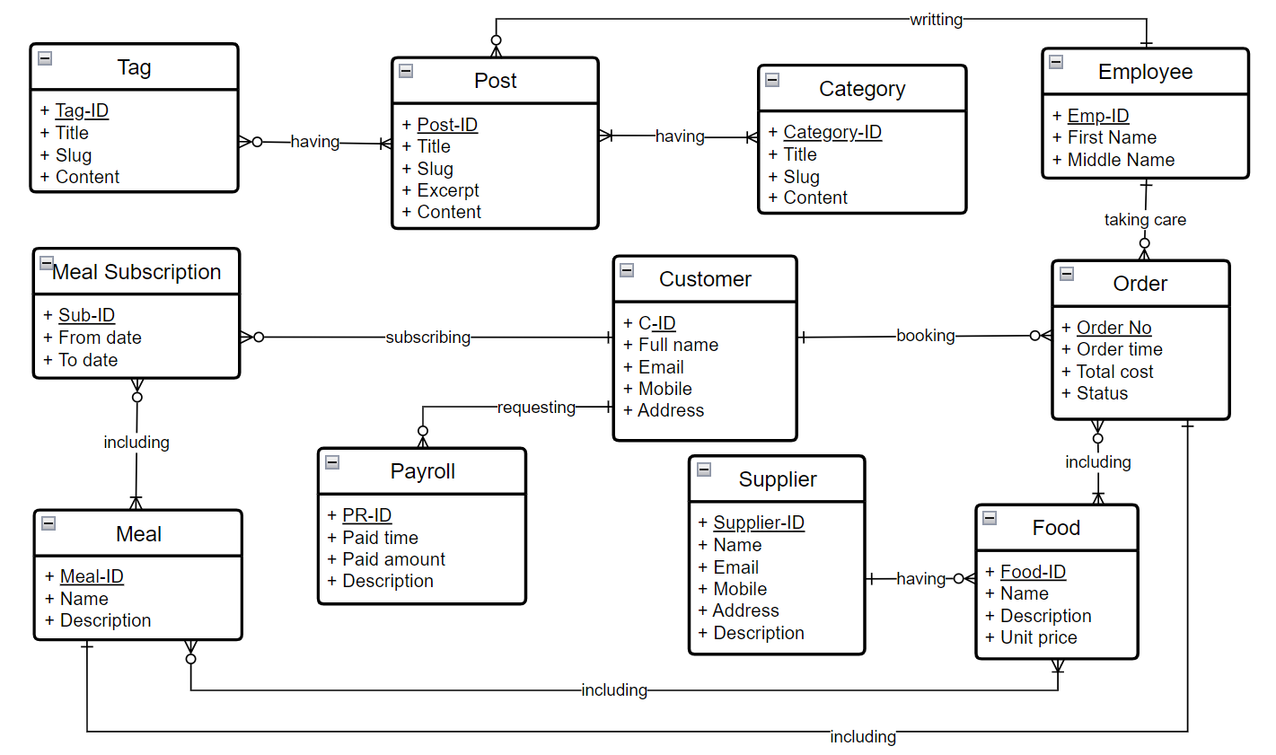

**Entities Description**

| **#** | **Entity** | **Description** |
| --- | --- | --- |
| 1 | Patrol | Cafeteria’s customer information |
| 2 | Meal | … |
| 3 | … |  |

## 2. Use Case Specifications

*[Provide specifications for the use cases (UCs) those are covered in the system. The UCs are grouped by the system features and even sub features.* ***You just need to provide UC specifications for complex UCs involving in the main workflows (business processes)****. Other UCs (i.e CRUD or data-viewing UCs) are simple, and you just need to refer the descriptions in the Functional Requirement (part 3) below)]*

### 2.1 <<Feature Name1>>

#### 2.1.1 UC Name1

| Primary Actors |  | Secondary Actors |  |
| --- | --- | --- | --- |
| Description |  | | |
| Preconditions |  | | |
| Postconditions |  | | |
| Normal Sequence/Flow |  | | |
| Alternative Sequences/Flows |  | | |

***Primary and Secondary Actors***

An actor is a person or other entity external to the software system being specified who interacts with the system and performs use cases to accomplish tasks. Name the primary actor that will be initiating this UC and any other secondary actors who will participate in completing execution of the UC.

***Description***

Provide a brief description of the reason for and outcome of this use case, or a high-level description of the sequence of actions and the outcome of executing the use case. The description can be in the form of a user story (As a **<type of user>**, I want **<some goal>** so that **<some reasons>**)

***Preconditions***

List any activities that must take place, or any conditions that must be true, before the use case can be started.

***Postconditions***

Describe the state of the system at the successful conclusion of the use case execution.

***Normal Flow***

Provide a description of the user actions and corresponding system responses that will take place during execution of the use case under normal, expected conditions.

***Alternative Flows***

Describe below two information if any:

* Other successful usage scenarios that can take place within this use case. State the alternative flow, and describe any differences in the sequence of steps that take place.
* Any anticipated error conditions that could occur during execution of the use case and how the system is to respond to those conditions.

#### 2.1.2 Login System

| Primary Actors | Customer | Secondary Actors | None |
| --- | --- | --- | --- |
| Description | As a user, I want to be able to log into the system so that I can use the system’s authenticated features and access my personalized account. | | |
| Preconditions | User account has been created & authorized | | |
| Postconditions | * User logs in the system successfully * The system tracked successful login into the Activity Log | | |
| Normal Sequence/Flow | ***Login System***   1. User clicks Login button from the page header or accesses an authenticated feature (from a link or type the page URL directly into the address bar) 2. System show the User Login screen 3. User types in the login details (email, password) 4. User clicks the Login button 5. System validates the login details (BR-01, BR-02) 6. System allows user to access 7. System tracks user’s success login to the Activity Log 8. System directs user to the Home Page (or the previous calling page if any) | | |
| Alternative Sequences/Flows | ***Step 2.1_Google Login***   1. User clicks Google Login button to login system using Google account 2. System redirects the user to the Google’s Login screen 3. User types in the Google account details and chooses to login 4. Google validates user’s login information successfully and redirect him/her back to the system 5. Return to step 5 of normal flow.   ***Step 4_System can’t authenticate the user***  User can’t be authenticated & get relevant error message in one of below cases   1. He/she leaves the Email and/or Password field blank (MSG10) 2. Input Email or Password are incorrect (MSG09) 3. Input Email/Password are correct but email has not been verified (MSG11) 4. The user account is blocked / inactive (MSG12)   If user inputs wrong logging-in details 5 times continuously, system will lock his/her account in 30 minutes (with relevant warning message - MSG13) | | |

#### 2.1.3 UC Name2

…

### 2.2 Xyz Feature

…

## 3. Functional Requirements

*[Provide descriptions about the system’s functions/screens. The functions/screens are grouped by the system features, and even sub-features if needed. For the screens, you need to provide the screen layouts (mock-up screens) and relevant specifications if needed]*

### 3.1 Feature Name1

#### 3.1.1 SubFeature Name1.1

##### 3.1.1.1 Screen/Function Name1

*[Content #1: UI layout (Mockup screen prototype)]*

*[Content #2: brief descriptions of the screen/function, mapped to the relevant use cases]*

*[Content #3: provide further descriptions for the screen’s components/fields using table format below]*

| **Field Name** | **Description** |
| --- | --- |
| Field Name1 | Field description: data type min/max length or value, initial data, etc. |
| Field Name2 | … |
| ***Field Group-Name1*** | |
| Field Name3 | … |
| Field Name4 | … |
| ***Field Group-Name2*** | |
| … | … |

##### 3.1.1.2 Screen/Function Name2

…

#### 3.1.2 SubFeature Name1.2

…

### 3.2 User Authentication

#### 3.2.1 User Register

…

#### 3.2.2 User Login

…

#### 3.2.3 Password Reset

…

### 3.3 System Administration

#### 3.3.1 Master Data

##### 3.3.1.1 Setting List

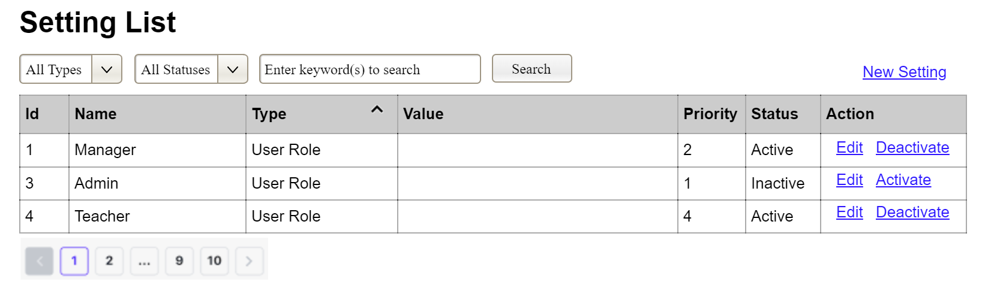

This screen allows the Administrator to:

* View Setting List: view list of current master data.
* Filter Setting List: filter master data by data types, statuses
* Search Settings: enter keyword(s) to search master data by their names or values
* Sort Setting List: sort master data list (ascending, descending) by clicking column headers

On the screen, s/he can also

* Activate/Deactivate Setting: change status of a specific inactive/active master data
* Choose to go to the Setting Details screens for adding new or updating an existing master data by clicking the New Setting or Edit link.

**Field Description**

| **Field Name** | **Description** |
| --- | --- |
| (1) | Initial values: all the active setting names with null or blank type  Hover the mouse to show the field name: “Setting Type” |
| (2) | Initial values: All Statuses, Active, Inactive (default value “All Status”)  Hover the mouse to show the field name: “Setting Status” |
| (3) | The change-status action is Activate or Deactivate depending on the current status of the relevant setting (Inactive or Active, respectively). |

##### 3.3.1.2 Setting Details

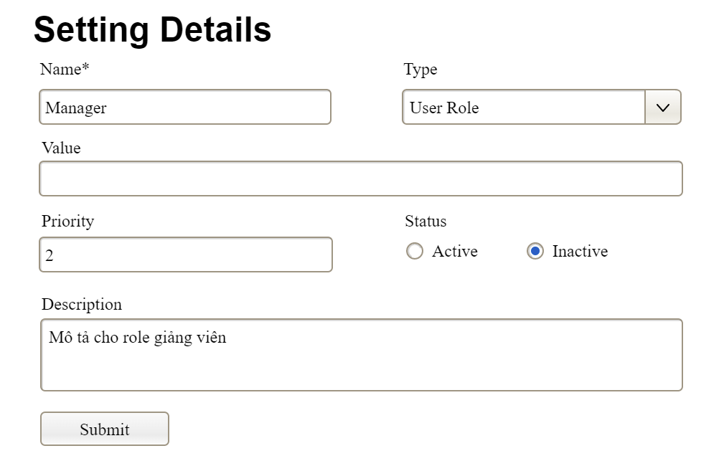

This screen allows the Administrator to:

* Add New Setting: add new master data.
* Update Setting Details: update details of a specific master data

**Field Description**

| **Field Name** | **Description** |
| --- | --- |
| Name | Data type: non-digit string, max length of 20 characters |
| Type | Initial data values: all active setting names (with null or blank type) |
| Value | Data type: any string, max length of 100 characters |
| Priority | Data type: a positive integer |
| Description | Data type: any string, max length of 200 characters |

#### 3.3.2 User Management

##### 3.3.2.1 User List

…

##### 3.3.2.2 User Details

…

## 4. Non-Functional Requirements

### 3.1 External Interfaces

*[This section provides information to ensure that the system will communicate properly with users and with external hardware or software/system elements.]*

### 3.2 Quality Attributes

*[List all the required system characteristics (quality attributes) specification. Some of the possible attributes are provided with the guide/descriptions are mentioned here]*

#### 3.2.1 Usability

*[This section includes all those requirements that affect usability. For example, specify the required training time for a normal user and a power user to become productive at particular operations specify measurable task times for typical tasks or base the new system’s usability requirements on other systems that the users know and like specify requirement to conform to common usability standards, such as IBM’s CUA standards Microsoft’s GUI standards]*

#### 3.2.2 Performance

*[The system’s performance characteristics are outlined in this section. Include specific response times. Where applicable, reference related Use Cases by name.*

*Response time for a transaction (average, maximum)*

*Throughput, for example, transactions per second*

*Capacity, for example, the number of customers or transactions the system can accommodate*

*Resource utilization, such as memory, disk, communications, and so forth.]*

#### 3.2.3 …

## 5. Requirement Appendix

*[Provide business rules, common requirements, or other extra requirements information here]*

### 5.1 Business Rules

*[Provide common business rules that you must follow. The information can be provided in the table format as the sample below]*

| **ID** | **Rule Definition** |
| --- | --- |
| BR-01 | Delivery time windows are 15 minutes, beginning on each quarter hour. |
| BR-02 | Deliveries must be completed between 10:00 A.M. and 2:00 P.M. local time, inclusive. |
| BR-03 | All meals in a single order must be delivered to the same location. |
| BR-04 | All meals in a single order must be paid for by using the same payment method. |
| BR-11 | If an order is to be delivered, the patron must pay by payroll deduction. |
| BR-12 | Order price is calculated as the sum of each food item price times the quantity of that food item ordered, plus applicable sales tax, plus a delivery charge if a meal is delivered outside the free delivery zone. |
| BR-24 | Only cafeteria employees who are designated as Menu Managers by the Cafeteria Manager can create, modify, or delete cafeteria menus. |
| BR-33 | Network transmissions that involve financial information or personally identifiable information require 256-bit encryption. |
| BR-86 | Only regular employees can register for payroll deduction for any company purchase. |
| BR-88 | An employee can register for payroll deduction payment of cafeteria meals if no more than 40 percent of his gross pay is currently being deducted for other reasons. |

### 5.2 System Messages

| **#** | **Message code** | **Message Type** | **Context** | **Content** |
| --- | --- | --- | --- | --- |
| 1 | MSG01 | In line | There is not any search result | *No search results.* |
| 2 | MSG02 | In red, under the text box | Input-required fields are empty | *The * field is required.* |
| 3 | MSG03 | Toast message | Updating asset(s) information successfully | *Update asset(s) successfully.* |
| 4 | MSG04 | Toast message | Adding new asset successfully | *Add asset successfully.* |
| 5 | MSG05 | Toast message | Confirming email of asset hand-over is sent successfully | *A confirmation email has been sent to {email_address}.* |
| 6 | MSG06 | Toast message | Resetting asset information successfully | *Return asset(s) successfully.* |
| 7 | MSG07 | Toast message | Deleting asset information successfully | *Delete asset(s) successfully.* |
| 8 | MSG08 | In red, under the text box | Input value length > max length | *Exceed max length of {max_length}.* |
| 9 | MSG09 | In line | Username or password is not correct when clicking sign-in | *Incorrrect user name or password. Please check again.* |
| 10 | .. |  |  |  |

### 5.3 Other Requirements…