Weekly Report
19/10/2026 – 25/10/2026
Group ID: 3
Project Name: InterviewBuddy
Prepared by: Dao Ngoc Chung Nguyen

Team members:
- 24127466 – Dao Ngoc Chung Nguyen (Group Leader / DevOps & QA)
- 24127119 – Tran Phuoc Tai (Team Member / Frontend)
- 24127410 – Nguyen Dang Hoang Khang (Team Member / Frontend & Vision)
- 24127476 – Nguyen Tran Trung Nhan (Team Member / Architecture & Backend)
- 24127389 – Lam Gia Hung (Team Member / AI & Plan)

Achievements since last week:

Summary of work tasks
STT | Description | Due Date | Responsibility | %Complete
1 | Manage progress on Jira, set up automatic live preview links for testing, and write the weekly report. | 25/10/2026 | Dao Ngoc Chung Nguyen | 100%
2 | Set up the initial Next.js project skeleton, create database tables on Supabase, and manage code reviews and merging. | 23/10/2026 | Nguyen Tran Trung Nhan | 100%
3 | Build the common navigation shell, dashboard overview screen, and the User Login/Signup page. | 23/10/2026 | Tran Phuoc Tai | 100%
4 | Program the integration logic with Google Gemini so the AI can read and evaluate the match rate between a CV and a JD. | 23/10/2026 | Lam Gia Hung | 100%
5 | Develop the user interface components for Job Description input, CV upload, and interactive analysis results display. | 23/10/2026 | Nguyen Dang Hoang Khang | 100%

Detailed task assignment table
STT | Done Tasks | Due Date | Responsibility | %Complete
1 | Create this week's tasks on Jira so everyone can pick up their assignments. | 25/10/2026 | Dao Ngoc Chung Nguyen | 100%
2 | Connect GitHub to Vercel so that whenever members push code, a preview web link (staging URL) is automatically generated. |  | Dao Ngoc Chung Nguyen | 100%
3 | Write the draft Use Case specifications for the application features and save them in the /docs/requirements folder. |  | Dao Ngoc Chung Nguyen | 100%
4 | Gather progress updates from members at the end of the week to compile and submit the Weekly Report W3. |  | Dao Ngoc Chung Nguyen | 100%
5 | Initialize the Next.js project (TypeScript, Tailwind) and connect Supabase. |  | Nguyen Tran Trung Nhan | 100%
6 | Create database tables for storing data (users, interview sessions, questions, etc.). |  | Nguyen Tran Trung Nhan | 100%
7 | Securely send connection details (API keys) to Tài so he can build the login page. |  | Nguyen Tran Trung Nhan | 100%
8 | Review incoming Pull Requests from team members, check the code, and merge them into the main branch. |  | Nguyen Tran Trung Nhan | 100%
9 | Build the core layout skeleton (Sidebar, Topbar) for the main application pages. |  | Tran Phuoc Tai | 100%
10 | Build the login page (/login) enabling users to sign in quickly using Google or Email via Supabase. |  | Tran Phuoc Tai | 100%
11 | Create reusable UI components (Buttons, Cards, Inputs) for other members to use. |  | Tran Phuoc Tai | 100%
12 | Verify that the layout is fully responsive across mobile devices and desktops. |  | Tran Phuoc Tai | 100%
13 | Write the backend code calling Gemini AI to process CV and JD text contents. |  | Lam Gia Hung | 100%
14 | Implement the logic to calculate the Fit Score (%) along with matched and missing skills lists. |  | Lam Gia Hung | 100%
15 | Publish the data format contract (API contract) to Khang by Tuesday so he can build the UI accordingly. |  | Lam Gia Hung | 100%
16 | Test and verify the analysis results on at least 5 different JD/CV pairs. |  | Lam Gia Hung | 100%
17 | Build the JD input text box with a character limit counter. |  | Nguyen Dang Hoang Khang | 100%
18 | Build the drag-and-drop PDF upload component and use a text-parsing library to extract text from the PDF file. |  | Nguyen Dang Hoang Khang | 100%
19 | Connect this frontend form to Hưng's API so that clicking "Analyze" calls the AI and renders the score and skills on the screen. |  | Nguyen Dang Hoang Khang | 100%
20 | Extract CV text with pdf-parse (/api/extract-cv) and show the analysis result (Screen 2) |  | Nguyen Dang Hoang Khang | 100%

Issues:
- When a repository is set to private, the Vercel Hobby (free) plan restricts the automatic creation of preview deployments for commits or pull requests (PRs) submitted by users other than the repository owner.
- Hưng is responsible for the AI-related routes (e.g., `/api/analyze-fit`), while Khang and Tài are working on the user interface. If the returned JSON format does not strictly adhere to the agreed-upon documentation, the interface is likely to encounter errors when rendering either sample data or actual API responses.
- There is a risk of accidentally committing sensitive security keys (such as a Supabase service role key or a Gemini API key) to GitHub.

Next week's goals:

Summary of work tasks
STT | Description | Due Date | Responsibility | %Complete
1 | Assemble, check and submit the PA2 package (requirements and initial design), run the cross-review of all PA2 documents, and write the Weekly Report W4. | 01/11/2026 | Dao Ngoc Chung Nguyen | None
2 | Finish the SAD and ERD, write the seed script, and build the interview session API (create/read sessions, link the analysis result, cross-user access test). | 30/10/2026 | Nguyen Tran Trung Nhan | None
3 | Finish the remaining Figma screens and the screen flow, then build the interview setup page (/interview/new) and the profile page. | 30/10/2026 | Tran Phuoc Tai | None
4 | Update Project Plan v1.2 (estimates, reporting, configuration management, schedule, risks) and test the interviewer AI design before coding starts in Week 5. | 30/10/2026 | Lam Gia Hung | None
5 | Make the non-functional requirements measurable, update the Vision to v1.2, and improve the fit analysis (scanned-PDF warning, 3000-character limit, privacy notice, save result with the session). | 30/10/2026 | Nguyen Dang Hoang Khang | None

Detailed task assignment table
STT | Done Tasks | Due Date | Responsibility | %Complete
1 | Finish all use case specifications (main and alternative flows) and make the traceability table: feature → use case → screen. | 01/11/2026 | Dao Ngoc Chung Nguyen | None
2 | Put every PA2 file in the right /docs folder and, check file names, versions, English and consistency between Vision, Plan and UI. |  | Dao Ngoc Chung Nguyen | None
3 | Organise the cross-review of all PA2 documents. |  | Dao Ngoc Chung Nguyen | None
4 | Zip PA2, copy it to /pa/PA2 and upload it to Moodle by Sun 01/11. |  | Dao Ngoc Chung Nguyen | None
5 | Gather progress updates from members at the end of the week to compile and submit the Weekly Report W4 to /docs/management. |  | Dao Ngoc Chung Nguyen | None
6 | Write the SAD (logical, data and deployment views, technology choices with reasons) and update the ERD to match the real database. | 30/10/2026 | Nguyen Tran Trung Nhan | None
7 | Write a seed script that creates test users and sample sessions. |  | Nguyen Tran Trung Nhan | None
9 | Build the interview session API: POST /api/interview (type, difficulty, language, position, duration, input mode) returns a session id; GET returns the settings and the linked JD/CV analysis. |  | Nguyen Tran Trung Nhan | None
10 | Link the saved analysis result to the session and test that user B cannot read user A's session. |  | Nguyen Tran Trung Nhan | None
11 | Design the remaining screens in Figma: login, history, practice plan, settings and the shared report view. | 30/10/2026 | Tran Phuoc Tai | None
12 | Draw a flow diagram showing how the screens link, plus the empty and error states of key screens. |  | Tran Phuoc Tai | None
13 | Build the interview setup page /interview/new (Screen 3) with the form and the session preview, ready to be connected to the API next week. |  | Tran Phuoc Tai | None
14 | Build the profile page: field of study, target position, experience level and preferred language. |  | Tran Phuoc Tai | None
15 | Fill Project Plan 4.1 Project Estimates (story points per feature, sprint capacity) and replace 4.2 with the new schedule plus the Jira roadmap screenshot. | 30/10/2026 | Lam Gia Hung | None
16 | Fill 4.3.2 Reporting and Measurement and 4.3.4 Configuration Management, and update the risk table. |  | Lam Gia Hung | None
17 | Draft the interviewer AI prompt (inputs: JD, CV, round, difficulty, language) and define the output: follow-up, new topic or end, with a one-line reason. |  | Lam Gia Hung | None
18 | Test the prompt on 3 sample JDs in Vietnamese and English and write half a page of findings in /docs/analysis and design. |  | Lam Gia Hung | None
19 | Rewrite the performance, security, usability and AI-quality requirements as testable statements in the Supplementary Specification. | 30/10/2026 | Nguyen Dang Hoang Khang | None
20 | Update the Vision to v1.2 using the TA feedback and Jira issues, and check the version history against the Plan and the UI. |  | Nguyen Dang Hoang Khang | None
21 | Handle scanned or empty PDFs with a warning and the paste-CV-text fallback; enforce the 3000-character JD limit. |  | Nguyen Dang Hoang Khang | None
22 | Show a notice that the CV file is not stored permanently, and save the analysis result with the session so the interview can use it. |  | Nguyen Dang Hoang Khang | None

Evidence of work for week 3 (Jira and Git Activity)

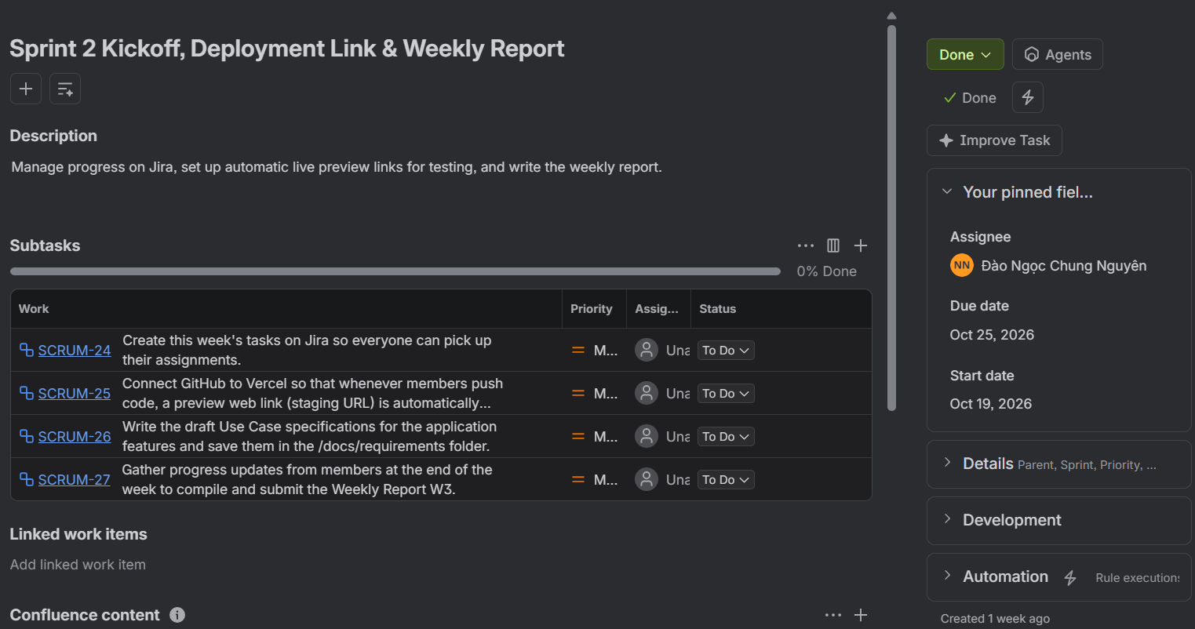
Figure 1: Dao Ngoc Chung Nguyen
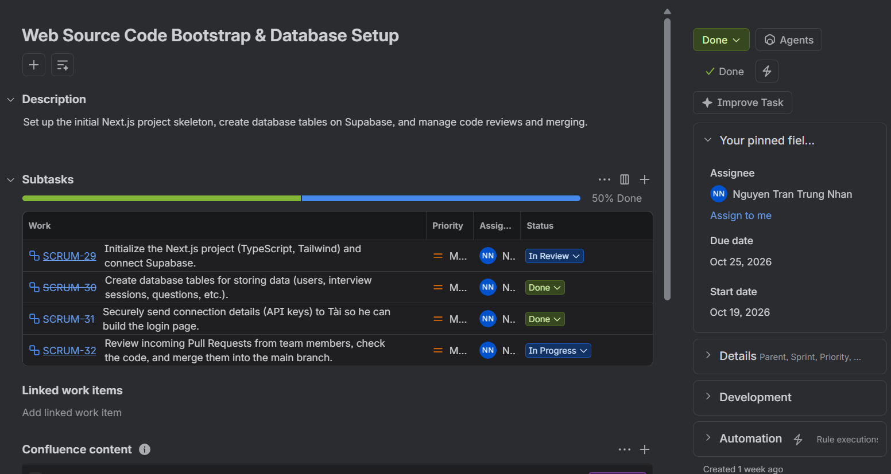
Figure 2: Nguyen Tran Trung Nhan
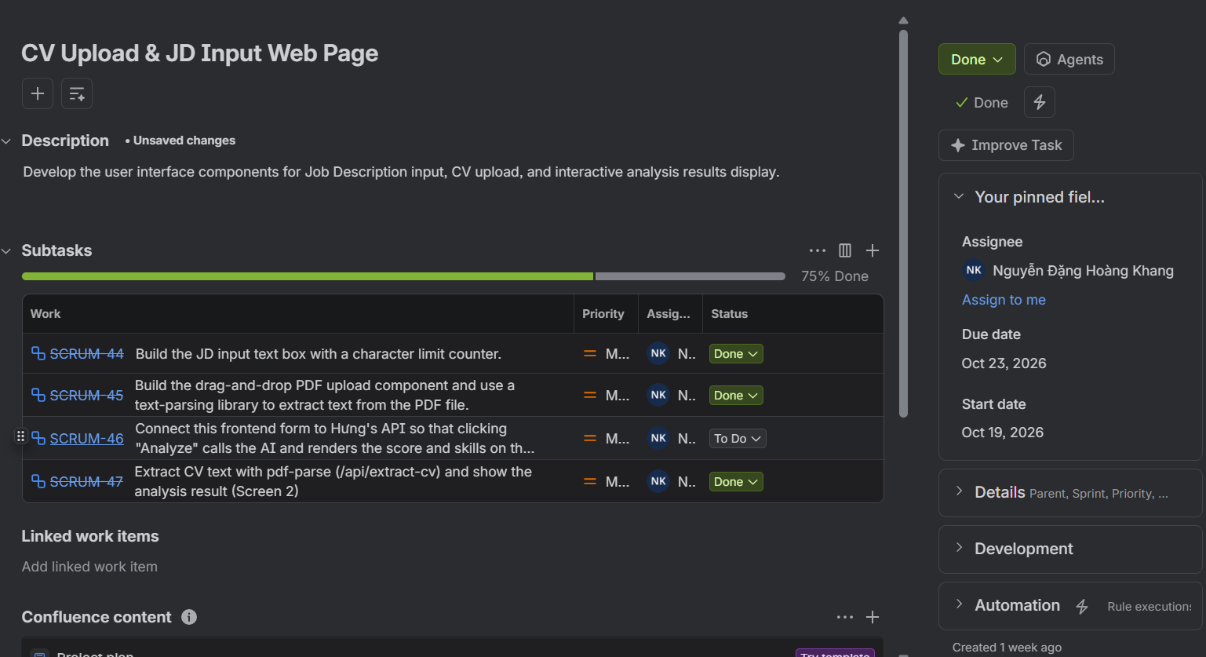
Figure 3: Nguyen Dang Hoang Khang
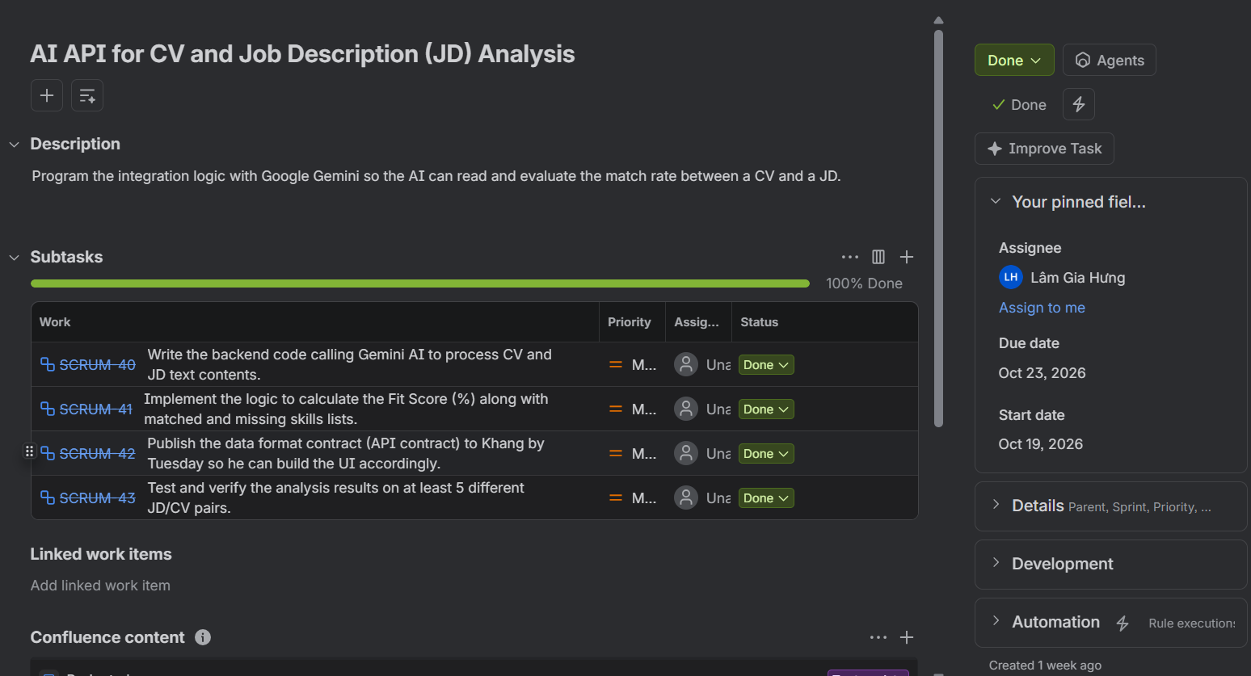
Figure 4: Lam Gia Hung
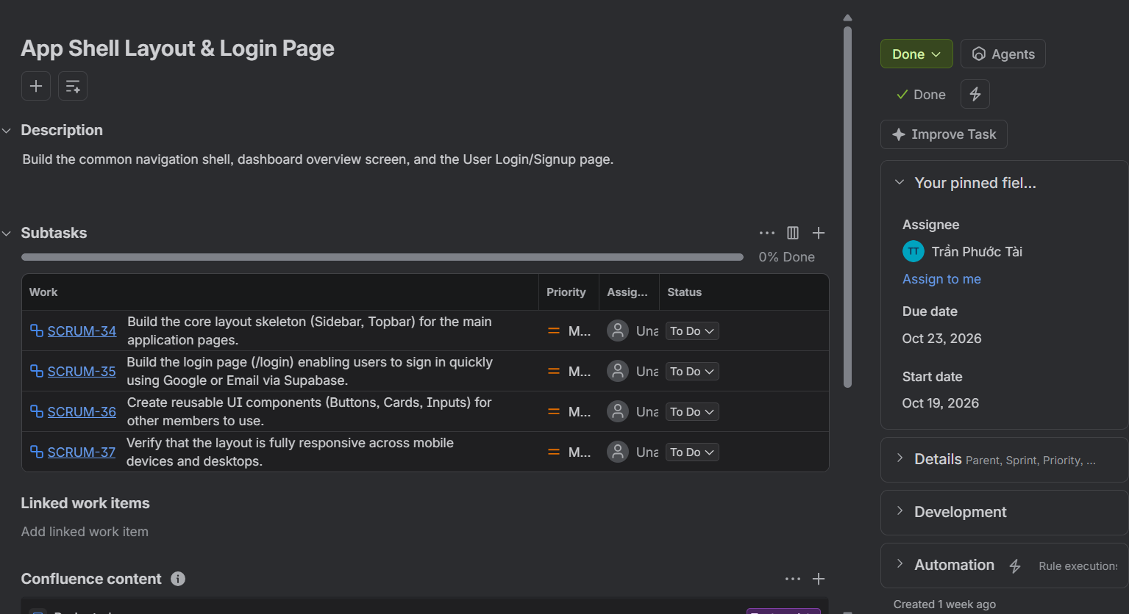
Figure 5: Tran Phuoc Tai

