Weekly Report
26/10/2026 – 1/11/2026
Group ID: 3
Project Name: InterviewBuddy
Prepared by: Dao Ngoc Chung Nguyen

Team members:
- 24127466 – Dao Ngoc Chung Nguyen (Group Leader / DevOps & QA)
- 24127119 – Tran Phuoc Tai (Team Member / Frontend)
- 24127410 – Nguyen Dang Hoang Khang (Team Member / Frontend & Vision)
- 24127476 – Nguyen Tran Trung Nhan (Team Member / Architecture & Backend)
- 24127389 – Lam Gia Hung (Team Member / AI & Plan)

Achievements since last week:

Summary of work tasks
STT | Description | Due Date | Responsibility | %Complete
1 | Assemble, check and submit the PA2 package (requirements and initial design), run the cross-review of all PA2 documents, and write the Weekly Report W4. | 01/11/2026 | Dao Ngoc Chung Nguyen | 100%
2 | Finish the SAD and ERD, write the seed script, and build the interview session API (create/read sessions, link the analysis result, cross-user access test). | 30/10/2026 | Nguyen Tran Trung Nhan | 100%
3 | Finish the remaining Figma screens and the screen flow, then build the interview setup page (/interview/new) and the profile page. | 30/10/2026 | Tran Phuoc Tai | 100%
4 | Update Project Plan v1.2 (estimates, reporting, configuration management, schedule, risks) and test the interviewer AI design before coding starts in Week 5. | 30/10/2026 | Lam Gia Hung | 100%
5 | Make the non-functional requirements measurable, update the Vision to v1.2, and improve the fit analysis (scanned-PDF warning, 3000-character limit, privacy notice, save result with the session). | 30/10/2026 | Nguyen Dang Hoang Khang | 100%

Detailed task assignment table
STT | Done Tasks | Due Date | Responsibility | %Complete
1 | Finish all use case specifications (main and alternative flows) and make the traceability table: feature → use case → screen. | 01/11/2026 | Dao Ngoc Chung Nguyen | 100%
2 | Put every PA2 file in the right /docs folder and, check file names, versions, English and consistency between Vision, Plan and UI. | 01/11/2026 | Dao Ngoc Chung Nguyen | 100%
3 | Organise the cross-review of all PA2 documents. | 01/11/2026 | Dao Ngoc Chung Nguyen | 100%
4 | Zip PA2, copy it to /pa/PA2 and upload it to Moodle by Sun 01/11. | 01/11/2026 | Dao Ngoc Chung Nguyen | 100%
5 | Gather progress updates from members at the end of the week to compile and submit the Weekly Report W4 to /docs/management. | 01/11/2026 | Dao Ngoc Chung Nguyen | 100%
6 | Write the SAD (logical, data and deployment views, technology choices with reasons) and update the ERD to match the real database. | 30/10/2026 | Nguyen Tran Trung Nhan | 100%
7 | Write a seed script that creates test users and sample sessions. | 30/10/2026 | Nguyen Tran Trung Nhan | 100%
9 | Build the interview session API: POST /api/interview (type, difficulty, language, position, duration, input mode) returns a session id; GET returns the settings and the linked JD/CV analysis. | 30/10/2026 | Nguyen Tran Trung Nhan | 100%
10 | Link the saved analysis result to the session and test that user B cannot read user A's session. | 30/10/2026 | Nguyen Tran Trung Nhan | 100%
11 | Design the remaining screens in Figma: login, history, practice plan, settings and the shared report view. | 30/10/2026 | Tran Phuoc Tai | 100%
12 | Draw a flow diagram showing how the screens link, plus the empty and error states of key screens. | 30/10/2026 | Tran Phuoc Tai | 100%
13 | Build the interview setup page /interview/new (Screen 3) with the form and the session preview, ready to be connected to the API next week. | 30/10/2026 | Tran Phuoc Tai | 100%
14 | Build the profile page: field of study, target position, experience level and preferred language. | 30/10/2026 | Tran Phuoc Tai | 100%
15 | Fill Project Plan 4.1 Project Estimates (story points per feature, sprint capacity) and replace 4.2 with the new schedule plus the Jira roadmap screenshot. | 30/10/2026 | Lam Gia Hung | 100%
16 | Fill 4.3.2 Reporting and Measurement and 4.3.4 Configuration Management, and update the risk table. | 30/10/2026 | Lam Gia Hung | 100%
17 | Draft the interviewer AI prompt (inputs: JD, CV, round, difficulty, language) and define the output: follow-up, new topic or end, with a one-line reason. | 30/10/2026 | Lam Gia Hung | 100%
18 | Test the prompt on 3 sample JDs in Vietnamese and English and write half a page of findings in /docs/analysis and design. | 30/10/2026 | Lam Gia Hung | 100%
19 | Rewrite the performance, security, usability and AI-quality requirements as testable statements in the Supplementary Specification. | 30/10/2026 | Nguyen Dang Hoang Khang | 100%
20 | Update the Vision to v1.2 using the TA feedback and Jira issues, and check the version history against the Plan and the UI. | 30/10/2026 | Nguyen Dang Hoang Khang | 100%
21 | Handle scanned or empty PDFs with a warning and the paste-CV-text fallback; enforce the 3000-character JD limit. | 30/10/2026 | Nguyen Dang Hoang Khang | 100%
22 | Show a notice that the CV file is not stored permanently, and save the analysis result with the session so the interview can use it. | 30/10/2026 | Nguyen Dang Hoang Khang | 100%

Issues:
- Serverless Environment PDF Parsing Error (/api/extract-cv): The PDF extraction module encountered a ReferenceError: DOMMatrix is not defined and missing native canvas dependencies (@napi-rs/canvas) when executing on Vercel's serverless environment. This occurred because standard PDF parsing libraries attempted to access browser-specific graphic contexts and DOM elements that are unavailable in a serverless backend container.
- Gemini AI Integration and API Availability (/api/analyze-fit): The application experienced 502 AI_UNAVAILABLE and HTTP 503 service disruption errors from the Gemini model endpoint. This caused intermittent failures during the automated fit analysis between CVs and job descriptions, temporarily halting the evaluation workflow.
- Google OAuth Authentication Configuration: The Google login feature failed with a site url is improperly formatted error due to misconfigured Site and Redirect URLs in the Supabase authentication dashboard. Trailing slashes and formatting discrepancies between the Vercel staging deployment URL and Supabase settings prevented proper OAuth callback redirection.

Next week's goals:

Summary of work tasks
STT | Description | Due Date | Responsibility | %Complete
1 | Write the Test Plan for Build 1 (PA3), run the mid-sprint check on Wed 04/11, and write the Weekly Report W5. | 08/11/2026 | Dao Ngoc Chung Nguyen | None
2 | Make interview sessions safe to save and resume, add a daily AI call limit per user, and write the detailed design documents (sequence diagrams, component diagram, API table, ERD) for PA3. | 06/11/2026 | Nguyen Tran Trung Nhan | None
3 | Connect the interview setup page to the real session API, show real data on the dashboard, and build the Settings page. | 06/11/2026 | Tran Phuoc Tai | None
4 | Build the interview engine API (/api/interview/next) that asks the next question and decides whether to follow up, change topic or finish. | 06/11/2026 | Lam Gia Hung | None
5 | Build the chat interview page (/interview/[id]) where the user answers the questions one at a time by typing. | 06/11/2026 | Nguyen Dang Hoang Khang | None

Detailed task assignment table
STT | Done Tasks | Due Date | Responsibility | %Complete
1 | Write the Test Plan strategy: scope, test levels (manual functional tests and API checks), environments and tools. | 01/11/2026 | Dao Ngoc Chung Nguyen | None
2 | Define the entry/exit criteria for Build 1, the defect severity levels, the Jira workflow and who retests. | 01/11/2026 | Dao Ngoc Chung Nguyen | None
3 | Draft the test cases for F1–F4 and ask each feature owner to review them; prepare at least 5 CV/JD test pairs in Vietnamese and English. | 01/11/2026 | Dao Ngoc Chung Nguyen | None
4 | On Wed 04/11, review the Jira board for blocked or late tasks, give each blocker an owner, and move or cut tasks if needed. | 01/11/2026 | Dao Ngoc Chung Nguyen | None
5 | Gather progress updates from members at the end of the week to compile and submit the Weekly Report W5 to /docs/management. | 01/11/2026 | Dao Ngoc Chung Nguyen | None
6 | Save every question and answer as soon as it is finished, and let the user reopen an unfinished session where it stopped. | 30/10/2026 | Nguyen Tran Trung Nhan | None
7 | Add a daily AI call limit per user (for example 100) with a friendly message, and turn AI and database errors into short messages a user can understand. | 30/10/2026 | Nguyen Tran Trung Nhan | None
9 | Repeat the cross-user access test (RLS) on the new tables. | 30/10/2026 | Nguyen Tran Trung Nhan | None
10 | Draw the sequence diagrams (analyze fit, one interview turn, session resume) and the component/class diagram of the main modules. | 30/10/2026 | Nguyen Tran Trung Nhan | None
11 | Make the API table (endpoint, input, output, errors), collect the endpoints of each owner by Thu 05/11, and update the ERD after any table change. | 30/10/2026 | Tran Phuoc Tai | None
12 | Connect /interview/new to POST /api/interview on submit, then open the chat page with the returned session id. | 30/10/2026 | Tran Phuoc Tai | None
13 | Show the total sessions and the recent sessions from the database on the Dashboard (score cards stay placeholders until Week 8). | 30/10/2026 | Tran Phuoc Tai | None
14 | Build the Settings page: preferred language and a button that deletes the user's CV and history. | 30/10/2026 | Tran Phuoc Tai | None
15 | Show a short notice on the setup and chat pages that AI feedback is practice guidance and may be wrong. | 30/10/2026 | Lam Gia Hung | None
16 | Post an example request and response of /api/interview/next in Slack for Khang by Tue 03/11. | 30/10/2026 | Lam Gia Hung | None
17 | Build /api/interview/next: each question is made from the JD skills, the CV, the round, the difficulty and the language. | 30/10/2026 | Lam Gia Hung | None
18 | Decide the next step (follow up on a vague or interesting answer, change topic otherwise, finish when the question count or time is reached), and send the last 4 turns plus a short summary to the AI so questions do not repeat. | 30/10/2026 | Lam Gia Hung | None
19 | Stream the text to the browser so the first words appear within 2 seconds, and validate the structured part of every response. | 30/10/2026 | Lam Gia Hung | None
20 | Test with 10 sample answers in each language and save the results in /docs/test. | 30/10/2026 | Nguyen Dang Hoang Khang | None
21 | Build the chat page header (interview type, progress bar "Question 3 of 10", timer) and the message list with AI questions, follow-up notes and the user's answers. | 30/10/2026 | Nguyen Dang Hoang Khang | None
22 | Build the answer box with Send and End Interview (with a confirmation), and show streamed text plus loading, error and retry states. | 30/10/2026 | Nguyen Dang Hoang Khang | None
23 | Build the side panel with the role, the skills from the analysis and tips. | 30/10/2026 | Nguyen Dang Hoang Khang | None

Evidence of work for week 4 (Jira and Git Activity)

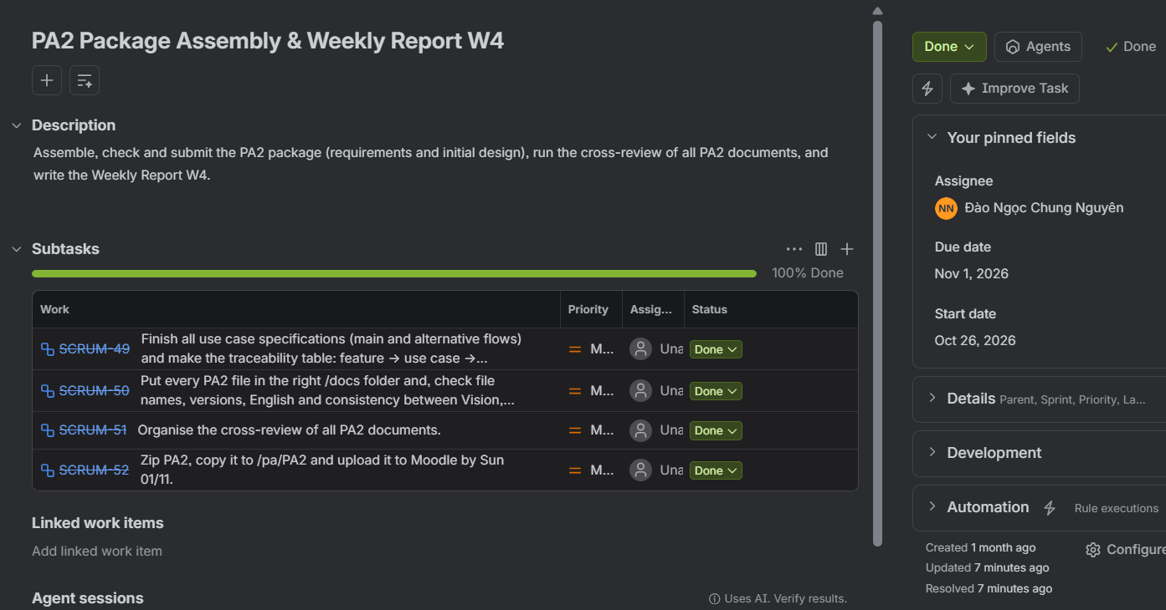

Figure 1: Dao Ngoc Chung Nguyen

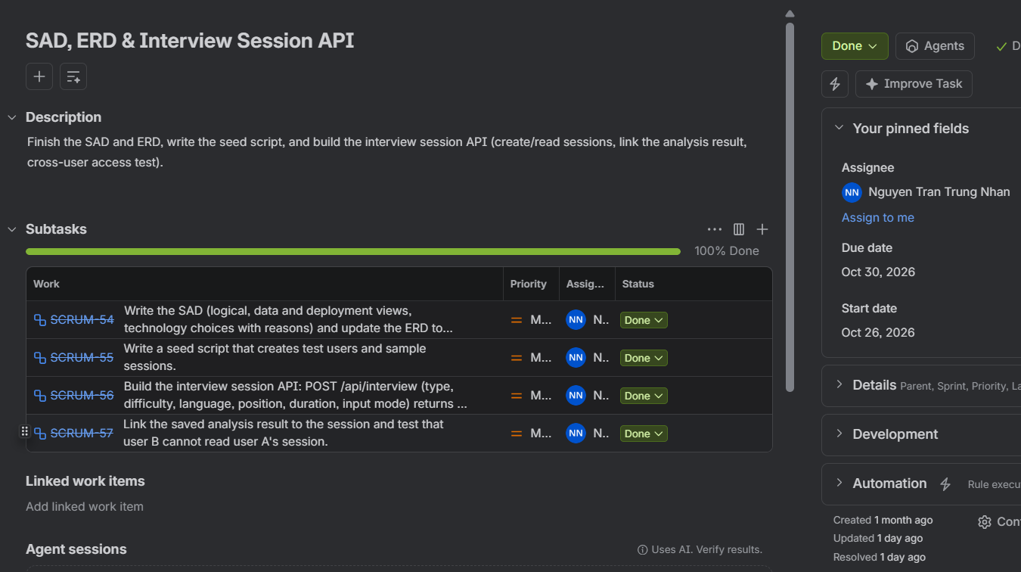

Figure 2: Nguyen Tran Trung Nhan

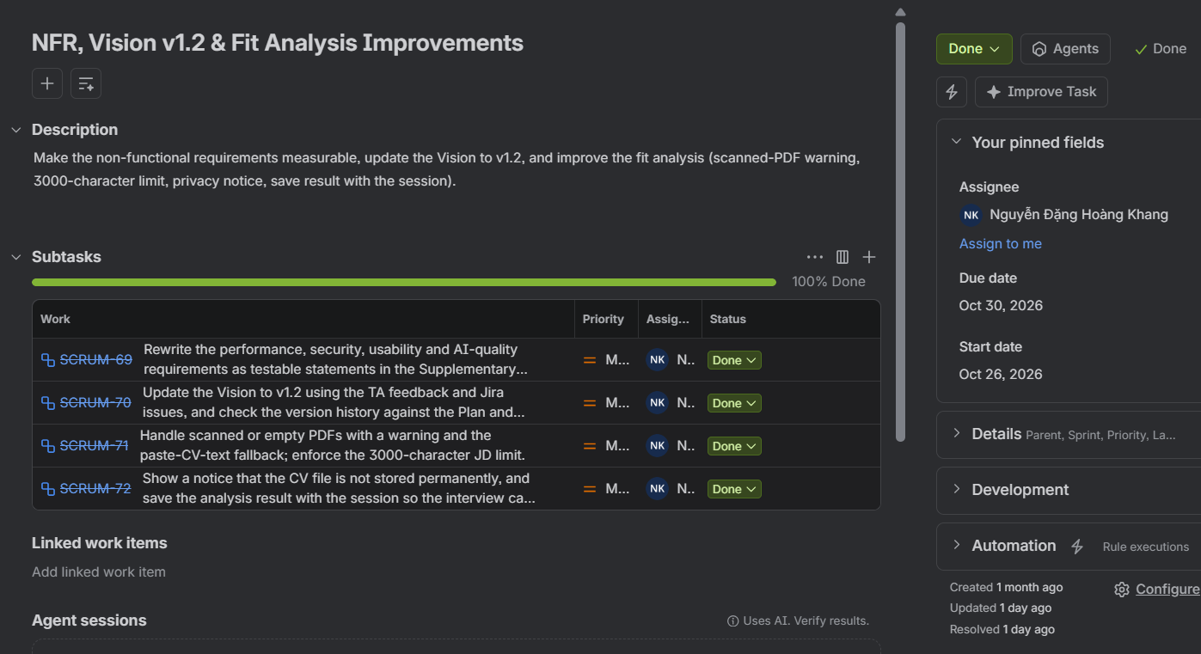

Figure 3: Nguyen Dang Hoang Khang

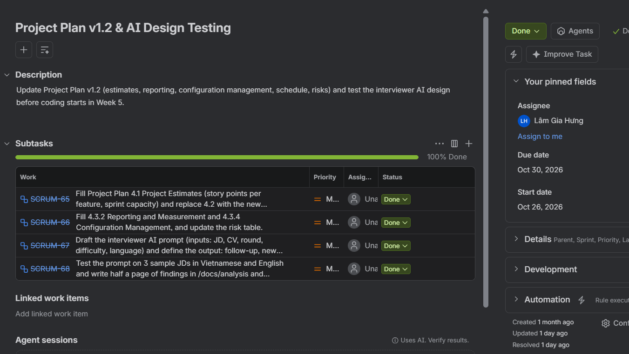

Figure 4: Lam Gia Hung

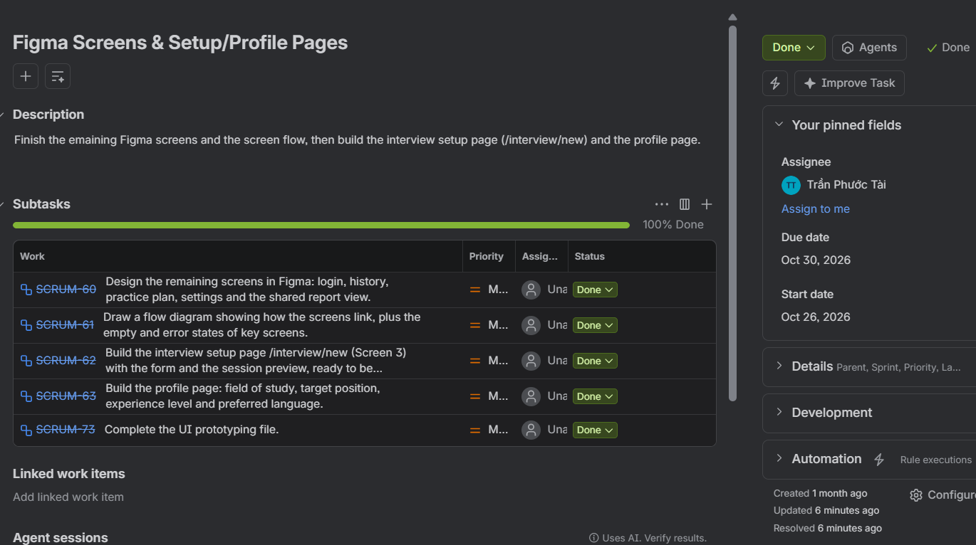

Figure 5: Tran Phuoc Tai

