InterviewBuddy

Use-Case Model

Version 1.2

Revision History
Date | Version | Description | Author
22/Oct/26 | 1.0 | Initial draft (Sprint 2, Week 3): actors, use-case diagram for features F1–F11, use-case list with descriptions, and full specifications of UC-02 Log in, UC-04 Analyze CV–JD fit and UC-05 Set up mock interview. | Dao Ngoc Chung Nguyen
29/Oct/26 | 1.1 | Part 2 (Sprint 2, Week 4): full specifications of the remaining 14 use cases (UC-01, UC-03, UC-06 to UC-17). Continues Section 2 of Part 1. | Dao Ngoc Chung Nguyen
31/Oct/26 | 1.2 | Actor definitions have been refined, the complete list of 17 use cases has been finalized, and the first section has been moved into a separate file `InterviewBuddy_Use_Case_Model` rather than remaining within the `InterviewBuddy_Use_Case_Specification` file. | Dao Ngoc Chung Nguyen

Table of Contents
1. Use-case Model 4
1.1 1.1 Actors 4
1.2 1.2 Use-case Diagram 5
1.3 1.3 Use-case List and Descriptions 6
2. Use-case Specifications 8
2.1 Use-case: Sign up (UC-01) 8
2.2 Use-case: Log in (UC-02) 10
2.3 Use-case: Manage profile (UC-03) 12
2.4 Use-case: Analyze CV–JD fit (UC-04) 13
2.5 Use-case: Set up mock interview (UC-05) 15
2.6 Use-case: Conduct mock interview (UC-06) 17
2.7 Use-case: Answer by voice (UC-07) 20
2.8 Use-case: View answer feedback (UC-08) 22
2.9 Use-case: View interview report (UC-09) 24
2.10 Use-case: Practice targeted questions (UC-10) 26
2.11 Use-case: View history and progress (UC-11) 28
2.12 Use-case: Bookmark a question (UC-12) 30
2.13 Use-case: Generate practice plan (UC-13) 31
2.14 Use-case: Export report as PDF (UC-14) 33
2.15 Use-case: Share report by link (UC-15) 34
2.16 Use-case: View shared report (UC-16) 35
2.17 Use-case: Delete personal data (UC-17) 36

Use-case Model
This document describes how users interact with InterviewBuddy, an AI-powered mock-interview website. Section 1 presents the actors, the use-case diagram for the eleven features (F1–F11) of the Vision Document and a short description of every use case. Section 2 gives the full specification of all core use cases.

1.1 Actors
Actor | Type | Description
Candidate | Primary | A third- or fourth-year student or recent graduate preparing for an internship or first job. Creates a profile, analyzes a CV against a job description, runs mock interviews, reviews feedback and reports, practises weak areas and tracks progress.
Career Changer | Primary | A person with work experience who wants to change jobs or fields. A specialization of Candidate: uses the same use cases (usually with a higher difficulty level).
Mentor / Reviewer | Primary | A lecturer, senior, friend or career advisor who receives a read-only report link from a Candidate. Does not need an account.
AI service (Google Gemini API) | Secondary (external system) | Extracts and compares skills, generates questions and follow-ups, scores answers, writes feedback and builds practice plans.
Authentication service (Supabase Auth, Google sign-in) | Secondary (external system) | Registers users and verifies email/password and Google sign-in.

1.2 Use-case Diagram
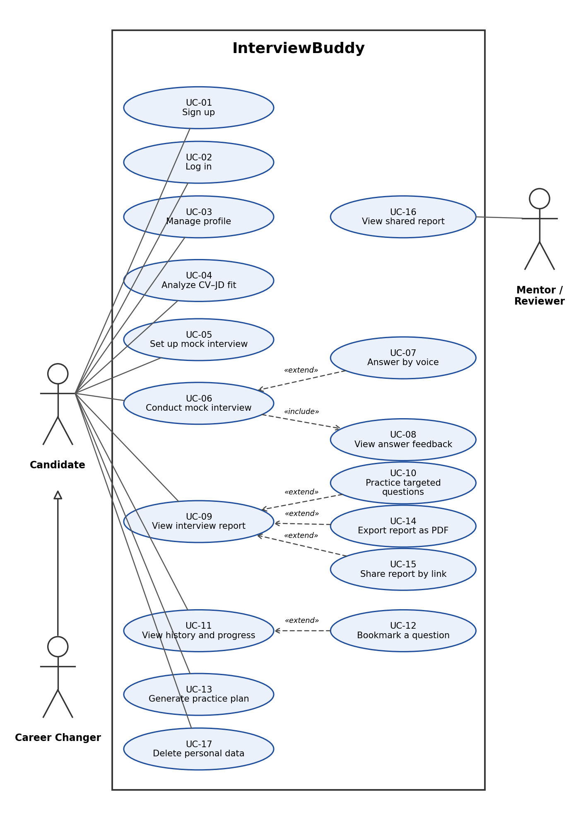
Figure 1. Use-case diagram of InterviewBuddy (F1–F11)

1.3 Use-case List and Descriptions
F1–F11 refer to the product features in Section 5 of the Vision Document.

ID | Use case | Actors | Feature | Description
UC-01 | Sign up | Candidate; Auth service | F1 | A new user creates an InterviewBuddy account with an email address and password or with a Google account, so that practice data can be saved and kept private.
UC-02 | Log in | Candidate; Auth service | F1 | A registered user signs in with email and password or with a Google account to reach the Dashboard. Pages other than the login page are available only after signing in, and each user can see only their own data.
UC-03 | Manage profile | Candidate | F1 | The Candidate views and updates the profile: field of study, target position, experience level and preferred language. The profile is used to personalise interviews and as default values in the interview setup.
UC-04 | Analyze CV–JD fit | Candidate; AI service | F2 | The Candidate pastes a job description and uploads a CV (PDF) or pastes the CV text. The system extracts the required skills, compares them with the CV and shows a fit score, matched and missing skills, evidence for each requirement and recommendations.
UC-05 | Set up mock interview | Candidate | F3 | The Candidate chooses the interview type (HR, technical or behavioural), difficulty, language, target position, interview date, duration and answer mode, checks the session preview and starts the interview.
UC-06 | Conduct mock interview | Candidate; AI service | F4 | The Candidate answers the AI interviewer's questions one at a time in a chat interface. After each answer the AI decides whether to ask a deeper follow-up question, move to a new topic or end the interview. The session is saved after every turn so it can be resumed.
UC-07 | Answer by voice | Candidate | F5 | Instead of typing, the Candidate presses the microphone button and speaks. The speech is transcribed, the Candidate edits the transcript, and the edited text is submitted as the answer. Typing is always available.
UC-08 | View answer feedback | Candidate; AI service | F6 | Each answer is scored on the rubric (content, STAR structure, clarity, confidence). The Candidate sees the strengths, areas to improve, an explanation that quotes the answer and a suggested answer outline. Feedback is practice guidance, not a hiring assessment.
UC-09 | View interview report | Candidate | F7 | When a session ends, the Candidate opens the report: overall score, scores by criterion, strengths, areas to improve, speaking indicators for voice answers and the question timeline.
UC-10 | Practice targeted questions | Candidate; AI service | F8 | From the report, the Candidate receives new practice questions aimed at the weakest criteria and starts a practice session from one of them.
UC-11 | View history and progress | Candidate | F9 | The Candidate browses past sessions, filters them by interview type and date, opens an earlier report and views the score trend over time.
UC-12 | Bookmark a question | Candidate | F9 | The Candidate marks a useful question so that it can be found again later, and removes the mark when it is no longer needed.
UC-13 | Generate practice plan | Candidate; AI service | F10 | The Candidate enters the date of the real interview. The system builds a daily practice schedule based on current weaknesses and updates it when sessions are missed or scores change. The Candidate marks tasks as done.
UC-14 | Export report as PDF | Candidate | F11 | The Candidate downloads a finished interview report as a PDF file.
UC-15 | Share report by link | Candidate | F11 | The Candidate creates a read-only link to a report so that a mentor can review it, and can revoke the link at any time. A report stays private until the Candidate chooses to share it.
UC-16 | View shared report | Mentor / Reviewer | F11 | A Mentor or Reviewer opens the link received from a Candidate and reads the report without an account. The page is read-only and stops working when the link is revoked.
UC-17 | Delete personal data | Candidate | F1 | The Candidate deletes the uploaded CV, recordings and practice history from the Settings page, as promised in the privacy notice.

