InterviewBuddy

Weekly Report - Week 1

Version 1.0

Revision History
Date | Version | Description | Author
16/Oct/26 | 1.0 | Initial version for Week 1 Report | Dao Ngoc Chung Nguyen
18/Oct/26 | 1.1 | Updated Jira task screenshots with full details | Dao Ngoc Chung Nguyen

Table of Contents
1. Project Status Summary 4
2. Team Member Reports 4
2.1 Dao Ngoc Chung Nguyen 4
2.2 Nguyen Tran Trung Nhan 4
2.3 Tran Phuoc Tai 4
2.4 Lam Gia Hung 4
2.5 Nguyen Dang Hoang Khang 5

Weekly Report - Week 1

Project Status Summary
During Week 1 (Project Proposal – Sprint 1), the team successfully defined the core project concept for "InterviewBuddy"—an AI-powered web application designed to simulate job interviews for individuals seeking employment or internship opportunities. The team established the necessary collaborative infrastructure, including a task management board on Jira and a GitHub repository. Additionally, an online survey was conducted with 15 individuals from the target audience to gather feedback and refine key features. The Project Proposal (PA0) document was also completed and submitted on time. Overall, the project is progressing according to schedule.

Team Member Reports

Dao Ngoc Chung Nguyen
- Done Tasks (Current Week - Week 1)
  - Set up Jira.
  - Submit Project Proposal (PA0).
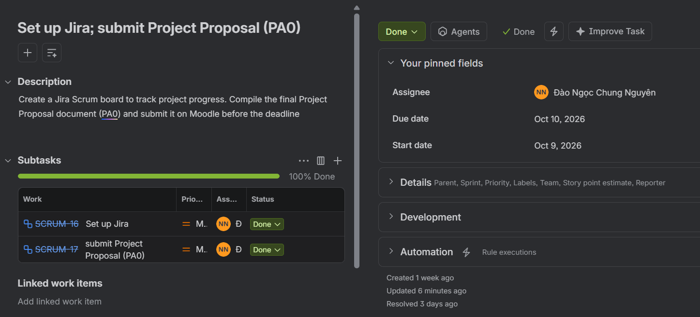
- Todo Tasks (Next Week - Week 2)
  - Compile Weekly Reports.
  - Compile Project Execution and Tracking Reports.
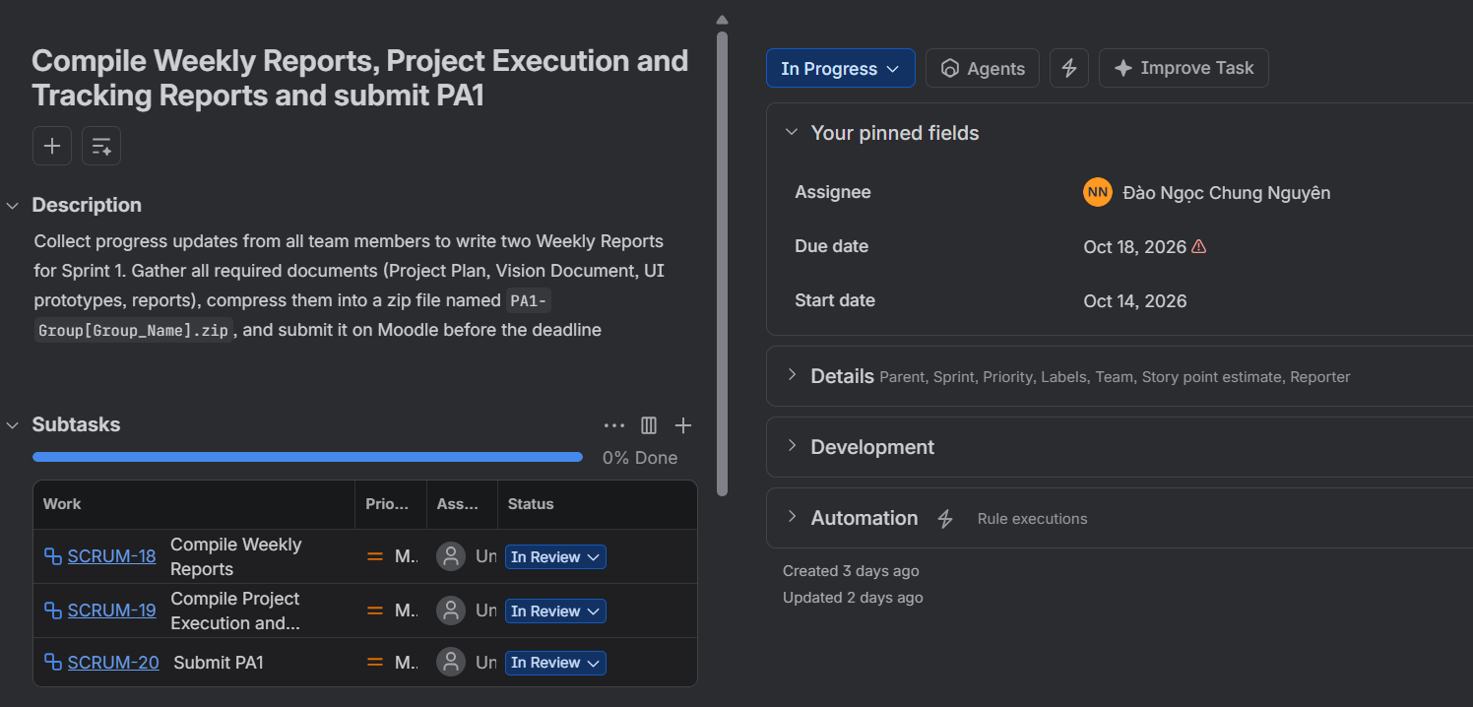
- Issues
  - Remind members to complete the assigned documents by October 17th so that the review process can be carried out.

Nguyen Tran Trung Nhan
- Done Tasks (Current Week - Week 1)
  - Set up GitHub Repository and directory structure.
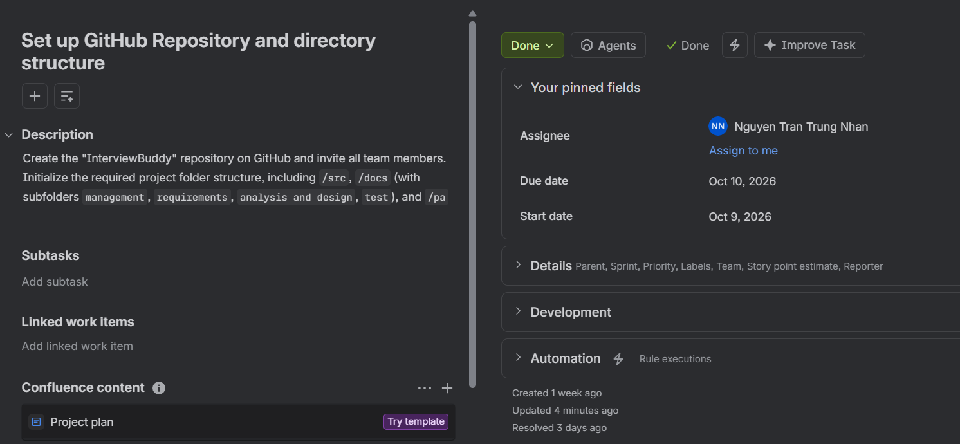
- Todo Tasks (Next Week - Week 2)
  - Draft Vision Document.
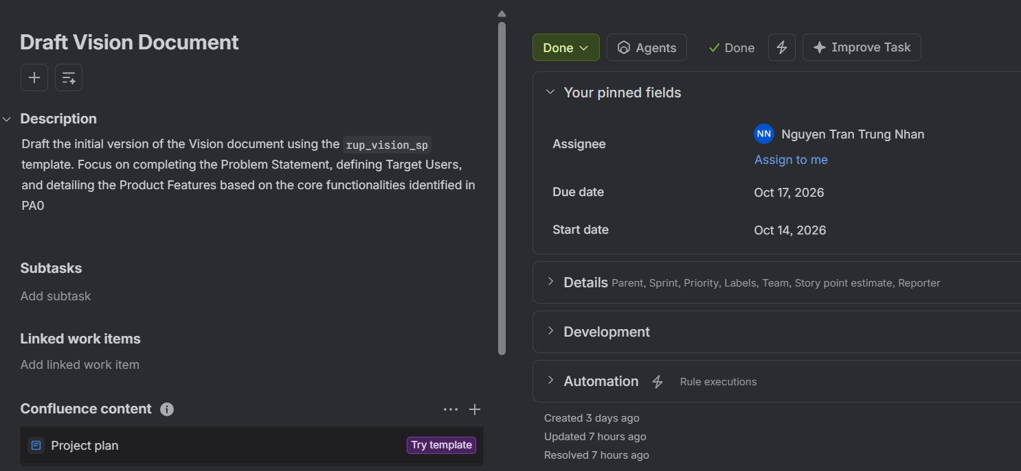
- Issues
  - Need to align with Tran Phuoc Tai on core features to ensure consistency between the Vision Document and UI prototypes.

Tran Phuoc Tai
- Done Tasks (Current Week - Week 1)
  - Define and describe 11 Key Features.
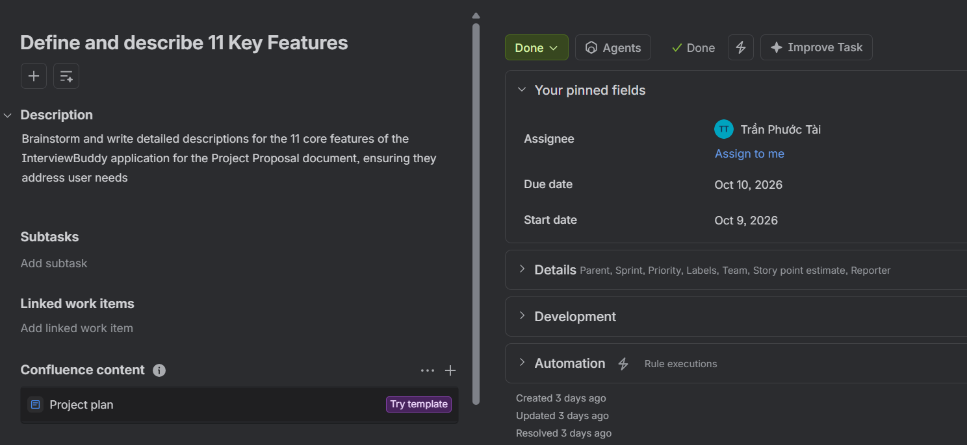
- Todo Tasks (Next Week - Week 2)
  - Design UI Prototyping.
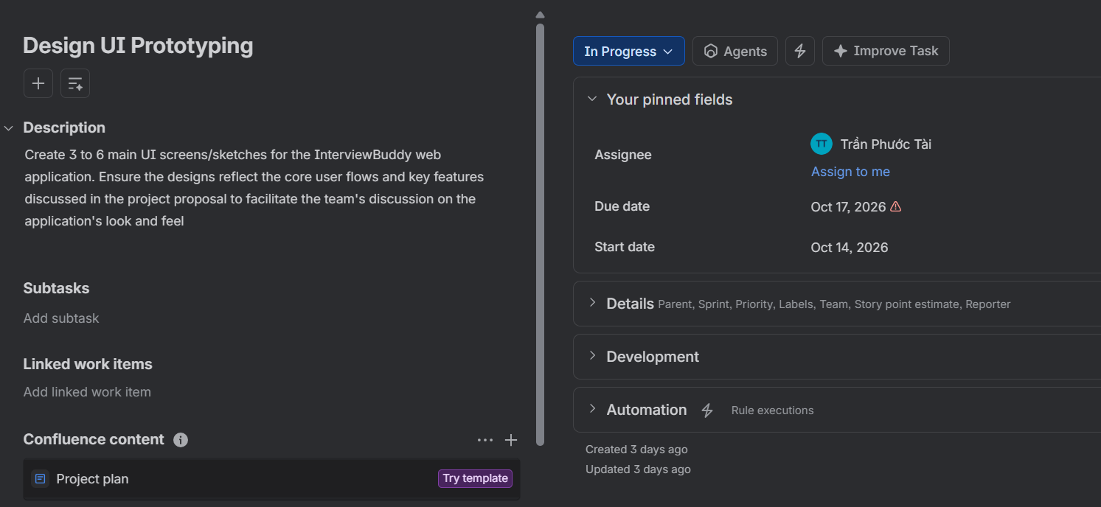
- Issues
  - Require team confirmation on primary user flow and color scheme before completing detailed high-fidelity designs.

Lam Gia Hung
- Done Tasks (Current Week - Week 1)
  - Conduct user survey.
  - Write User Interviews report.
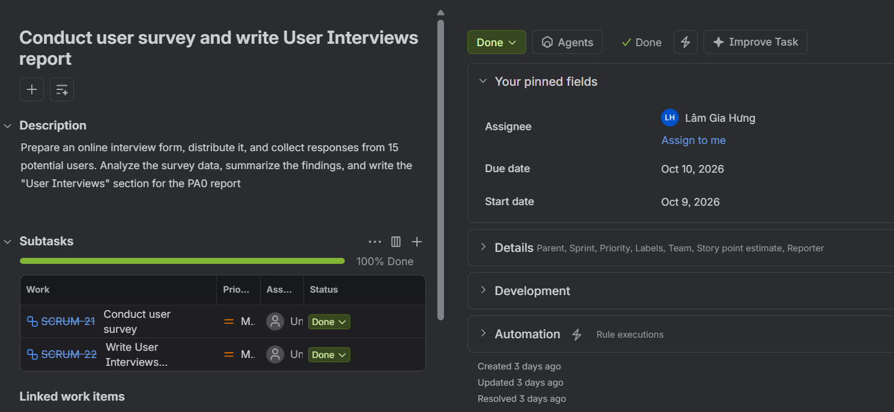
- Todo Tasks (Next Week - Week 2)
  - Draft Project Plan (Parts 1, 2, and 3).
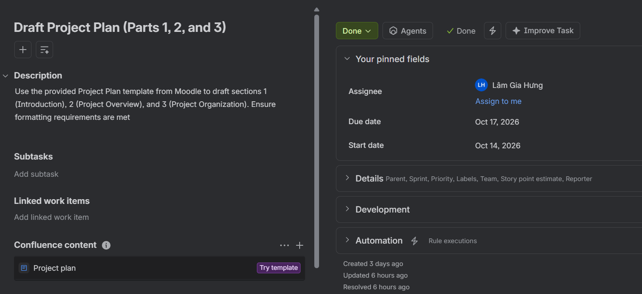
- Issues
  - None.

Nguyen Dang Hoang Khang
- Done Tasks (Current Week - Week 1)
  - Define Target Users and Environments.
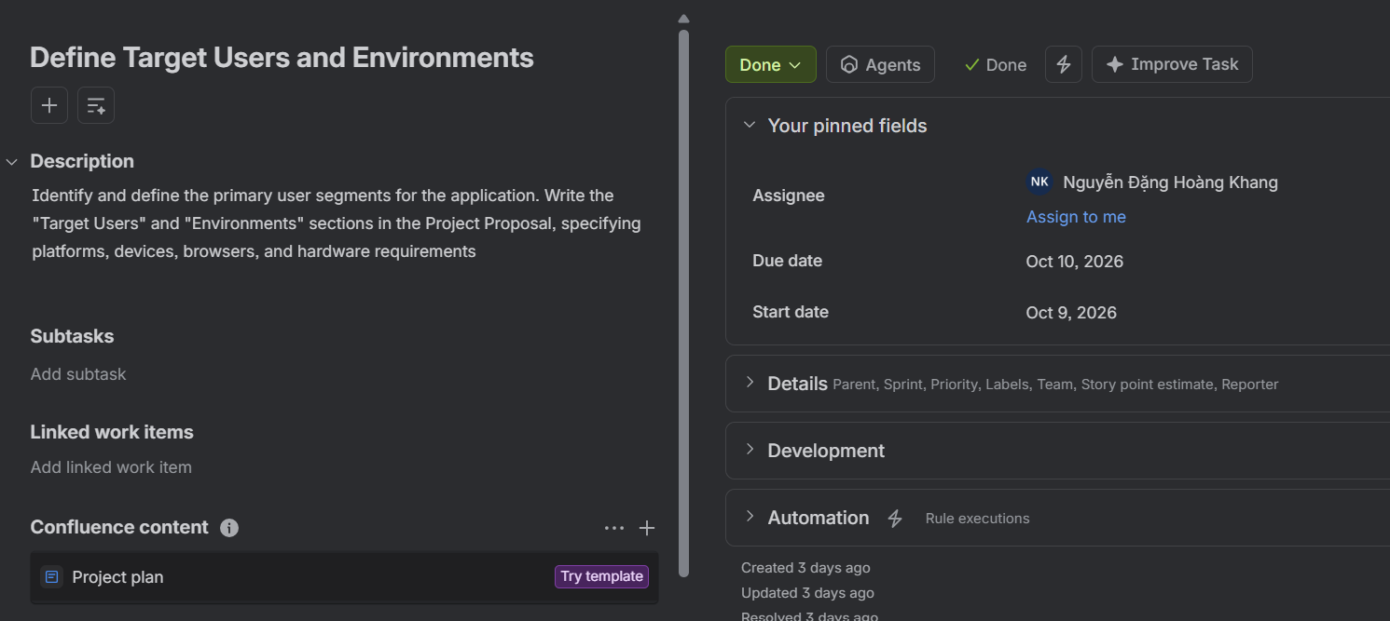
- Todo Tasks (Next Week - Week 2)
  - Draft Project Plan (Part 4 - Schedule & Management).
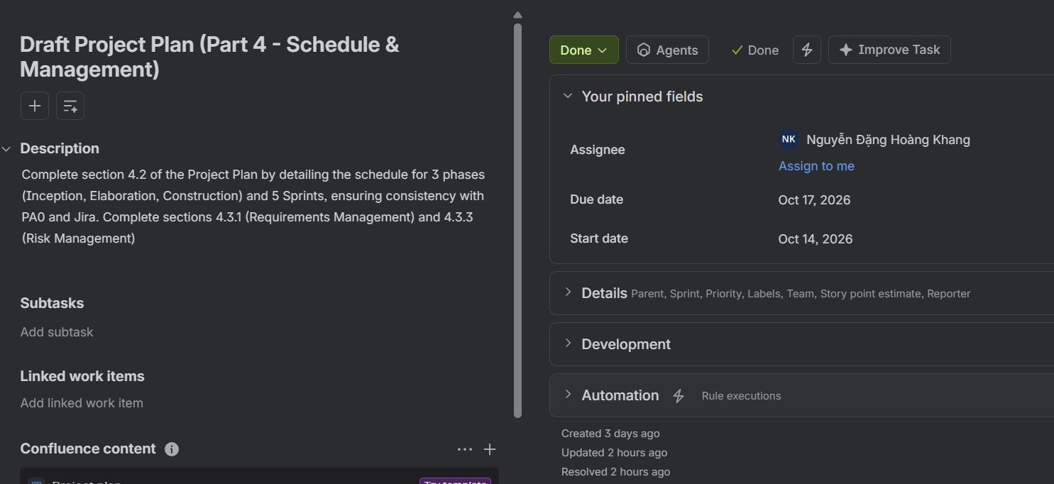
- Issues
  - Need an updated screenshot/overview of the overall Jira roadmap from leader to insert into Section 4.2.3.

