InterviewBuddy

Weekly Report - Week 2

Version 1.0

Revision History
Date | Version | Description | Author
18/Oct/26 | 1.0 | Initial version for Week 2 Report | Dao Ngoc Chung Nguyen

Table of Contents
1. Project Status Summary 4
2. Team Member Reports 4
2.1 Dao Ngoc Chung Nguyen 4
2.2 Nguyen Tran Trung Nhan 5
2.3 Tran Phuoc Tai 6
2.4 Lam Gia Hung 7
2.5 Nguyen Dang Hoang Khang 8

Weekly Report - Week 2

Project Status Summary
During Week 2 (Project Proposal – Sprint 1), th the team focused on finalizing the documentation for core requirements and design deliverables for Project Assignment 1 (PA1). Key achievements include: drafting the Vision Document—covering the problem statement, target users, and product features; developing 3–6 core user interface (UI) prototypes in Figma; and preparing a Software Development Plan (outlining an overall roadmap consisting of 3 phases and 5 sprints, along with a risk management strategy). Task allocation, progress tracking, and the management of source code and documentation were handled consistently via Jira and GitHub. The deliverable package for PA1 has been compiled and formatted in accordance with the provided guidelines. Overall, the project remains on schedule.

Team Member Reports

Dao Ngoc Chung Nguyen
- Done Tasks (Current Week - Week 2)
  - Compile Weekly Reports.
  - Compile Project Execution and Tracking Reports.
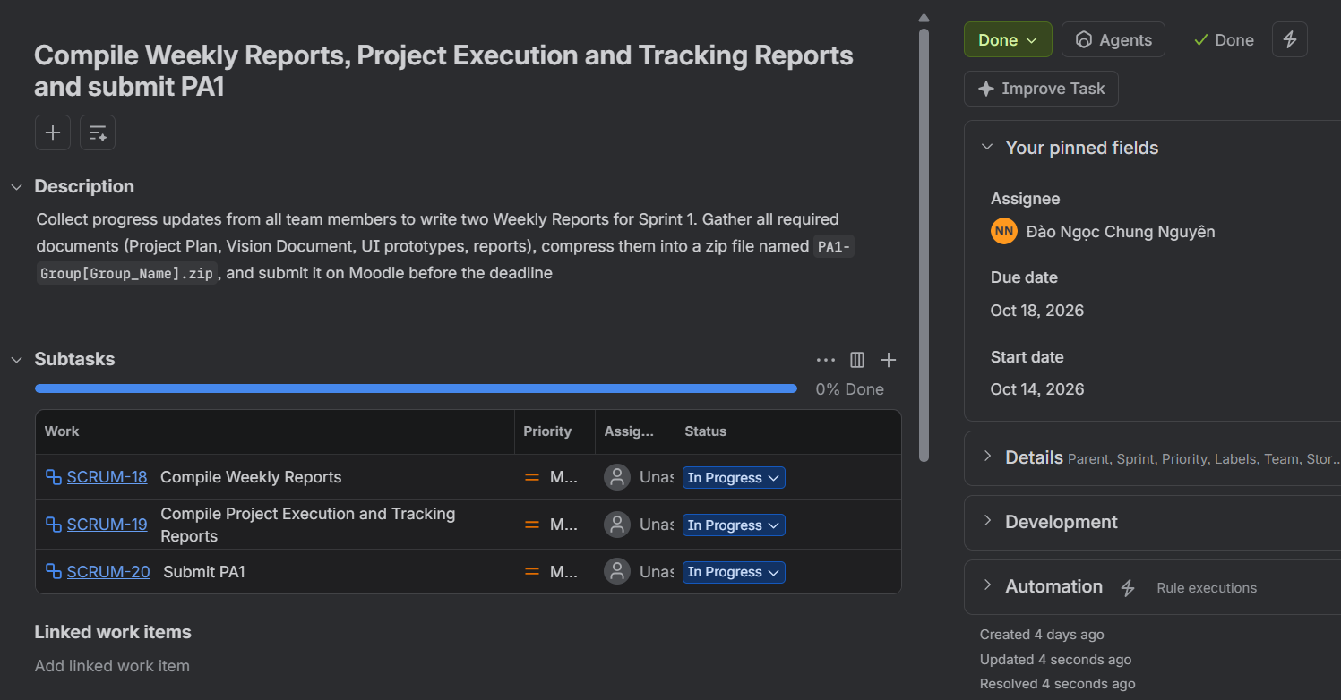
  - Push to Git:
- Todo Task (Next Week – Week 3)
  - Consolidate feedback on PA1 deliverables (Project Plan, Vision Document, UI, Weekly Reports).
  - Update Jira roadmap and assign Sprint 2 tasks to team members.
  - Align team on System Architecture and Data Flow across Next.js, Supabase, and Gemini API.
  - Host Sprint 2 kickoff meeting and compile Weekly Report Week 3.
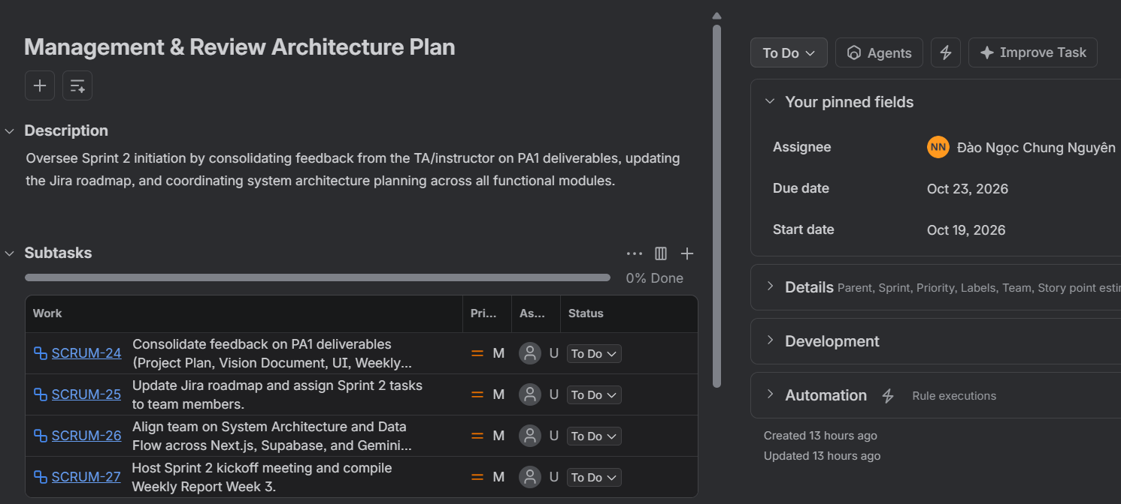
- Issues
  - Need to gather initial TA/instructor feedback on PA1 artifacts promptly to refine the Sprint 2 backlog and ensure smooth task handoffs across frontend, backend, and AI integration.

Nguyen Tran Trung Nhan
- Done Tasks (Current Week - Week 2)
  - Draft Vision Document.
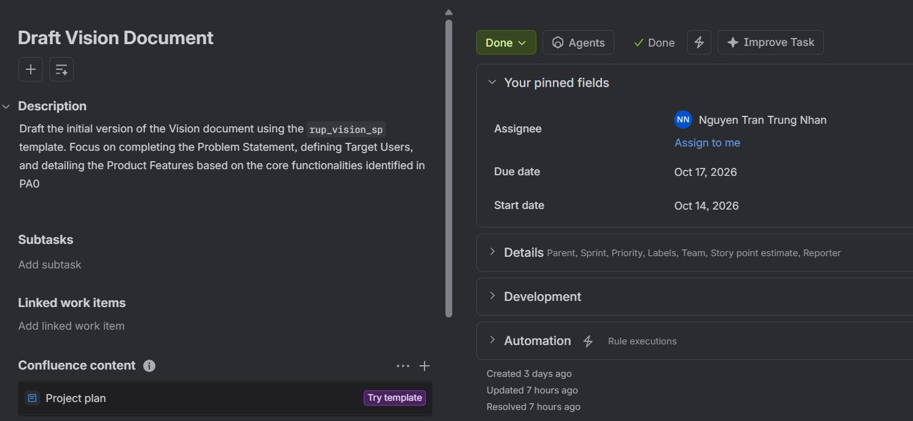
  - Push to Git:
- Todo Task (Next Week – Week 3)
  - Design System Architecture Diagram and data flow models.
  - Create Supabase Database Schema (Users, Profiles, InterviewSessions, Questions, Feedbacks).
  - Initialize Next.js repository with TypeScript, Tailwind CSS, ESLint, and Supabase client integration.
  - Draft initial Software Architecture Document (SAD).
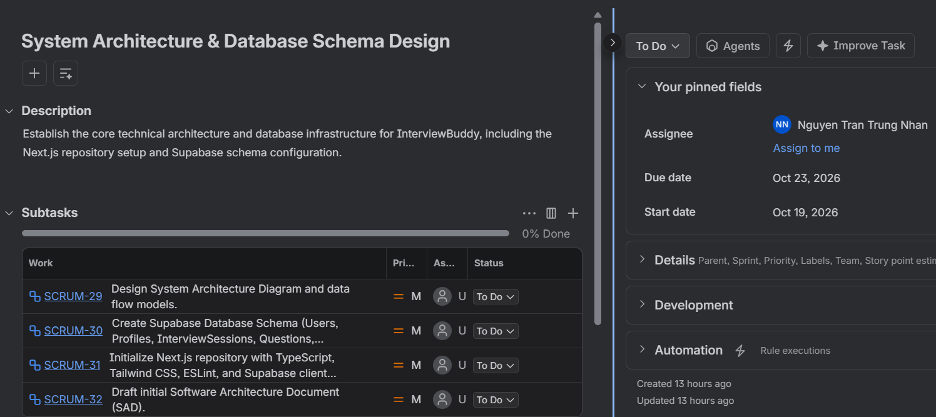
- Issues
  - Need team agreement on Supabase table relationships and Row Level Security (RLS) policies before initializing the Next.js codebase and executing database migrations.

Tran Phuoc Tai
- Done Tasks (Current Week - Week 2)
  - Design UI Prototyping.
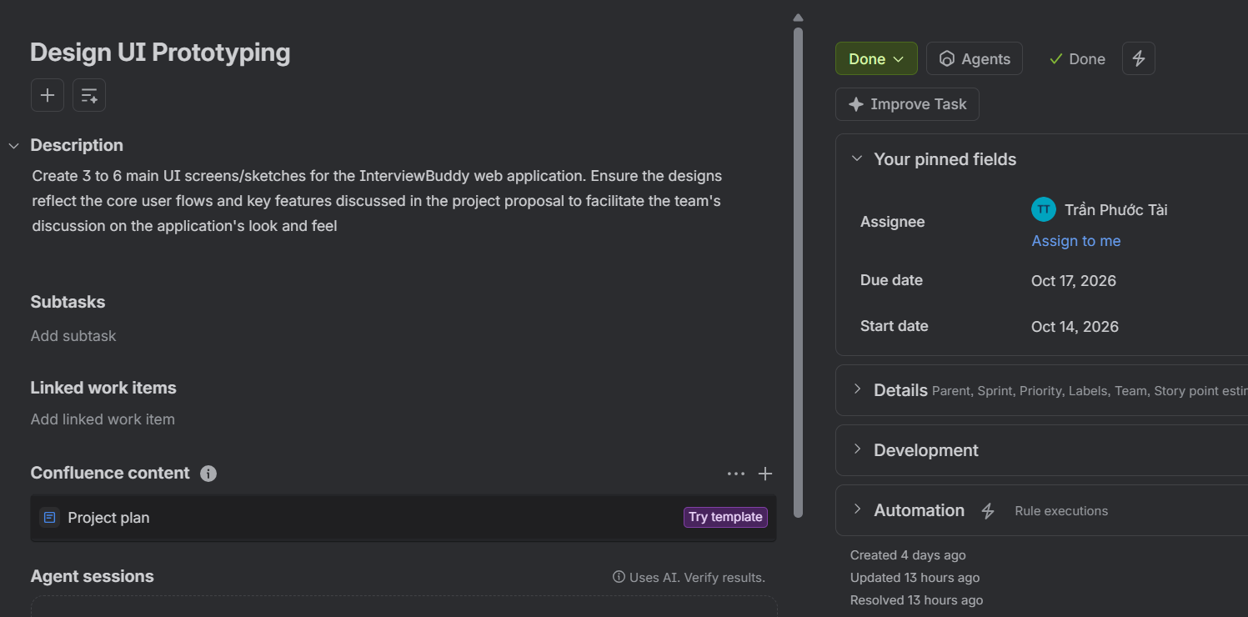
  - Push to Git:
- Todo Task (Next Week – Week 3)
  - Build responsive Navigation Sidebar, Topbar, and Dashboard layout (/dashboard).
  - Implement Login and Sign-up pages (/login) with Google OAuth and Email Auth via Supabase.
  - Convert Screen 1 UI prototype into reusable React/Next.js components.
  - Ensure mobile and desktop responsive design compliance.
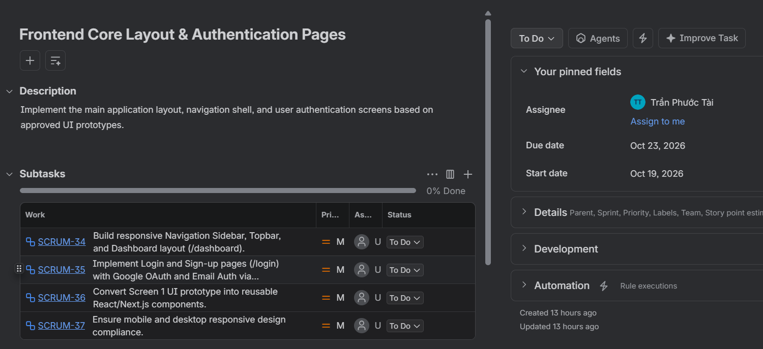
- Issues
  - Require configured Supabase project keys and Google OAuth client credentials from backend setup to complete the authentication flow integration on Next.js.

Lam Gia Hung
- Done Tasks (Current Week - Week 2)
  - Draft Project Plan (Parts 1, 2, and 3).
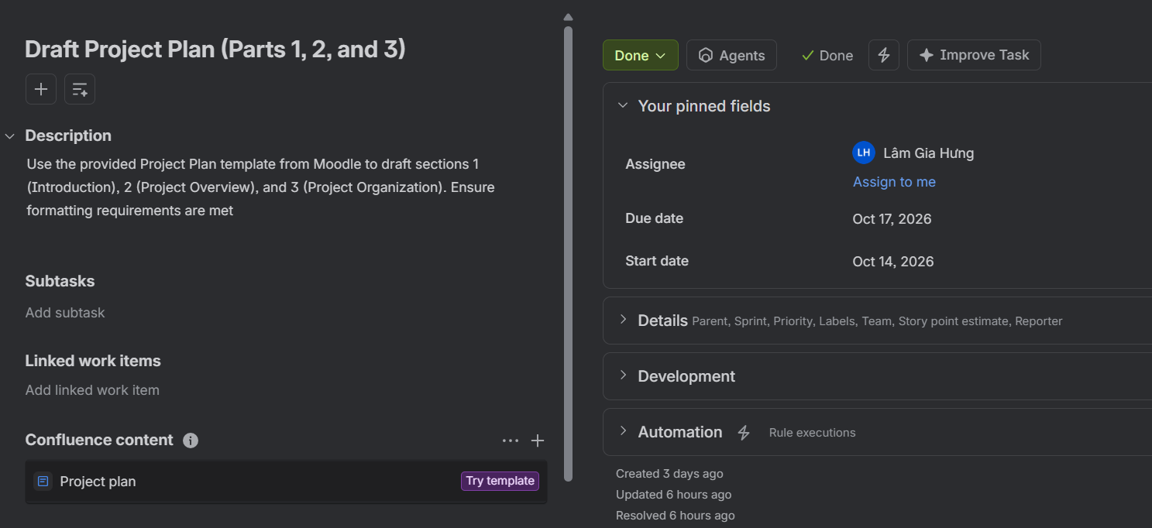
  - Push to Git:
- Todo Task (Next Week – Week 3)
  - Develop API route (/api/analyze-fit) integrated with Google Gemini 1.5 Flash.
  - Craft prompt templates to extract and compare skills from CVs and Job Descriptions.
  - Implement Fit Score (%) algorithm and identify matched vs. missing skills.
  - Enforce Structured JSON Outputs for seamless frontend consumption.
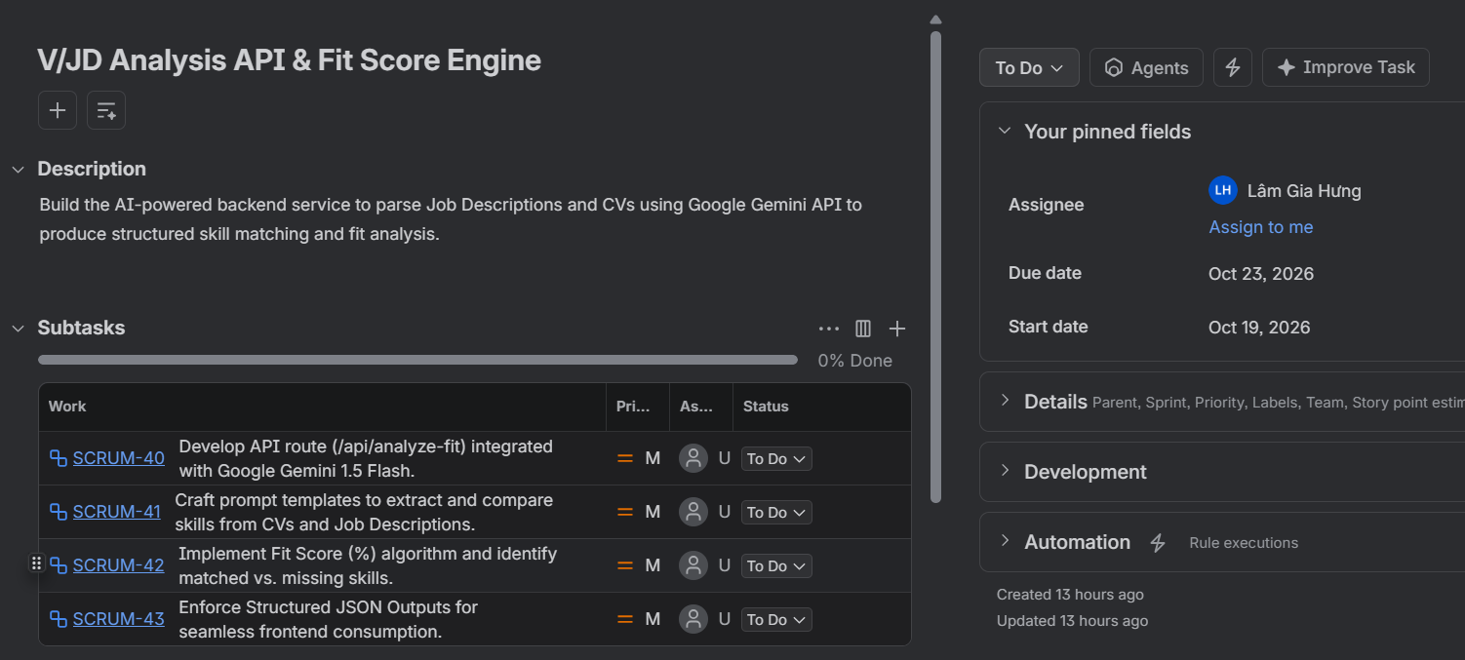
- Issues
  - Need to rigorously test Gemini 1.5 Flash prompt templates and output schemas to ensure consistent structured JSON responses and handle potential API rate limits smoothly.

Nguyen Dang Hoang Khang
- Done Tasks (Current Week - Week 2)
  - Draft Project Plan (Part 4 - Schedule & Management).
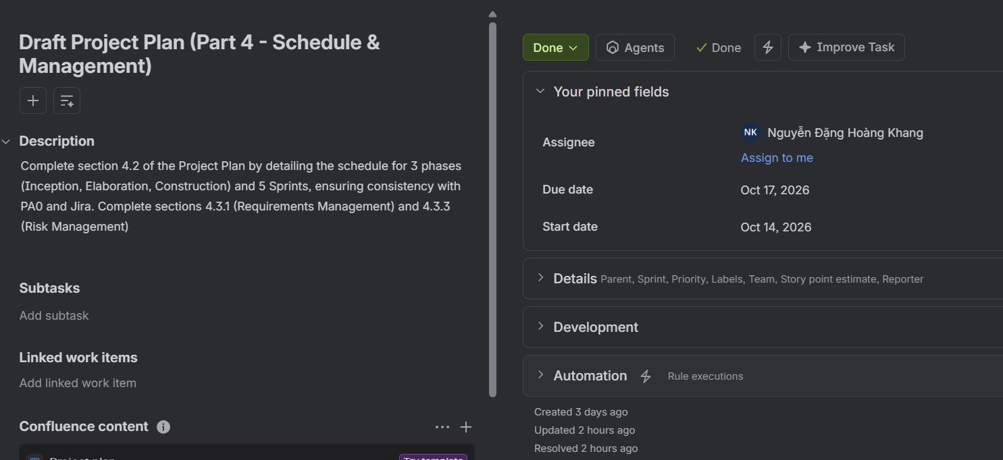
  - Push to Git:
- Todo Task (Next Week – Week 3)
  - Build UI components for JD text input and drag-and-drop CV PDF upload (/analysis).
  - Integrate client/server PDF parsing library (pdf-parse) to extract raw CV text.
  - Connect frontend form submission to /api/analyze-fit with loading indicators.
  - Render analysis results (Match Score bar, Matched/Missing skills) based on Screen 2 UI prototype.
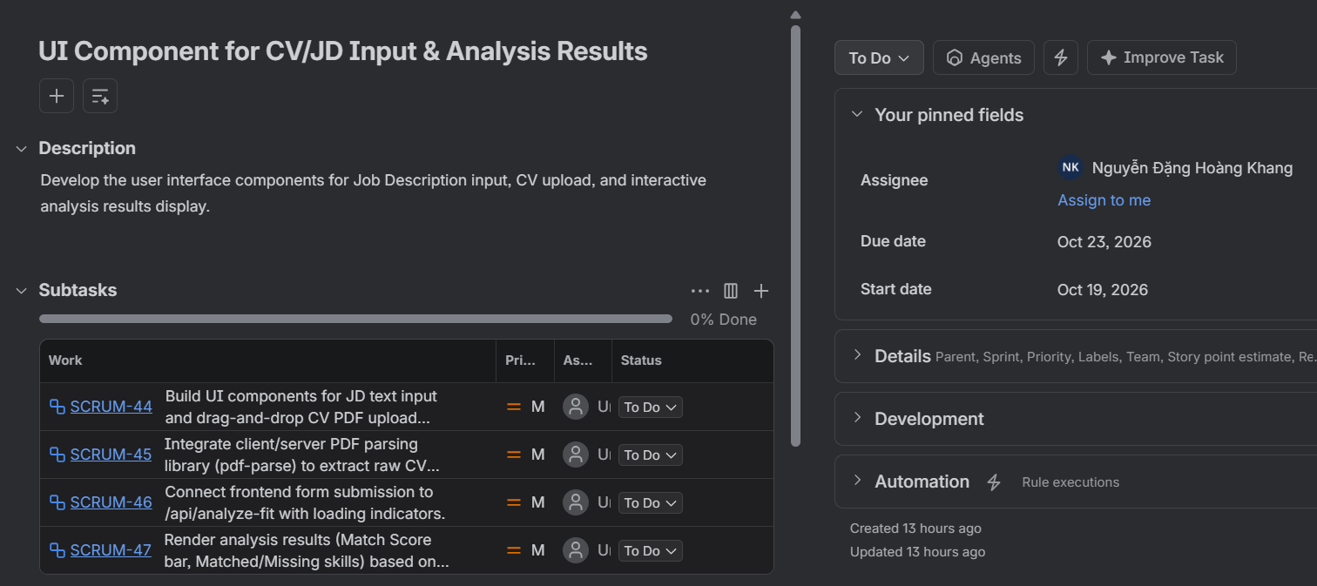
- Issues
  - Need to coordinate with Lam Gia Hung to finalize the API request/response contract for /api/analyze-fit to ensure seamless client-side PDF parsing and fit score rendering.

