InterviewBuddy

Use-Case Specification

Version 1.0

Revision History
Date | Version | Description | Author
22/Oct/26 | 1.0 | Initial draft (Sprint 2, Week 3): actors, use-case diagram for features F1–F11, use-case list with descriptions, and full specifications of UC-02 Log in, UC-04 Analyze CV–JD fit and UC-05 Set up mock interview. | Dao Ngoc Chung Nguyen

Table of Contents
1. Use-case Model 4
1.1 1.1 Actors 4
1.2 1.2 Use-case Diagram 5
1.3 1.3 Use-case List and Descriptions 6
2. Use-case Specifications 8
2.1 2.1 Use-case: Log in 8
2.2 2.2 Use-case: Analyze CV–JD fit 10
2.3 2.3 Use-case: Set up mock interview 12

Use-case Model
This document describes how users interact with InterviewBuddy, an AI-powered mock-interview website. Section 1 presents the actors, the use-case diagram for the eleven features (F1–F11) of the Vision Document and a short description of every use case. Section 2 gives the full specification of the three core use cases of this first draft: Log in, Analyze CV–JD fit and Set up mock interview. The other specifications will be added in the next version.

1.1 Actors
Actor | Type | Description
Candidate | Primary | A third- or fourth-year student or recent graduate preparing for an internship or first job. Creates a profile, analyzes a CV against a job description, runs mock interviews, reviews feedback and reports, practises weak areas and tracks progress.
Career Changer | Primary | A person with work experience who wants to change jobs or fields. A specialization of Candidate: uses the same use cases (usually with a higher difficulty level).
Mentor / Reviewer | Primary | A lecturer, senior, friend or career advisor who receives a read-only report link from a Candidate. Does not need an account.
AI service (Google Gemini API) | Secondary (external system) | Extracts and compares skills, generates questions and follow-ups, scores answers, writes feedback and builds practice plans.
Authentication service (Supabase Auth, Google sign-in) | Secondary (external system) | Registers users and verifies email/password and Google sign-in.

1.2 Use-case Diagram
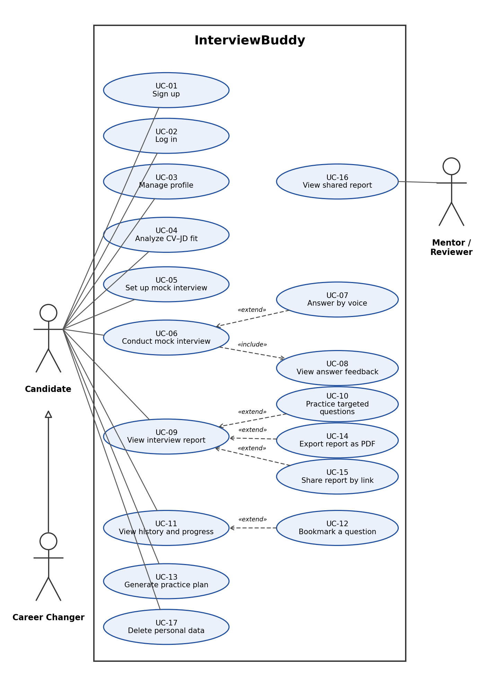
Figure 1. Use-case diagram of InterviewBuddy (F1–F11)

1.3 Use-case List and Descriptions
F1–F11 refer to the product features in Section 5 of the Vision Document.

ID | Use case | Actors | Feature | Description
UC-01 | Sign up | Candidate; Auth service | F1 | A new user creates an InterviewBuddy account with an email address and password or with a Google account, so that practice data can be saved and kept private.
UC-02 | Log in | Candidate; Auth service | F1 | A registered user signs in with email and password or with a Google account to reach the Dashboard. Pages other than the login page are available only after signing in, and each user can see only their own data.
UC-03 | Manage profile | Candidate | F1 | The Candidate views and updates the profile: field of study, target position, experience level and preferred language. The profile is used to personalise interviews and as default values in the interview setup.
UC-04 | Analyze CV–JD fit | Candidate; AI service | F2 | The Candidate pastes a job description and uploads a CV (PDF) or pastes the CV text. The system extracts the required skills, compares them with the CV and shows a fit score, matched and missing skills, evidence for each requirement and recommendations.
UC-05 | Set up mock interview | Candidate | F3 | The Candidate chooses the interview type (HR, technical or behavioural), difficulty, language, target position, interview date, duration and answer mode, checks the session preview and starts the interview.
UC-06 | Conduct mock interview | Candidate; AI service | F4 | The Candidate answers the AI interviewer's questions one at a time in a chat interface. After each answer the AI decides whether to ask a deeper follow-up question, move to a new topic or end the interview. The session is saved after every turn so it can be resumed.
UC-07 | Answer by voice | Candidate | F5 | Instead of typing, the Candidate presses the microphone button and speaks. The speech is transcribed, the Candidate edits the transcript, and the edited text is submitted as the answer. Typing is always available.
UC-08 | View answer feedback | Candidate; AI service | F6 | Each answer is scored on the rubric (content, STAR structure, clarity, confidence). The Candidate sees the strengths, areas to improve, an explanation that quotes the answer and a suggested answer outline. Feedback is practice guidance, not a hiring assessment.
UC-09 | View interview report | Candidate | F7 | When a session ends, the Candidate opens the report: overall score, scores by criterion, strengths, areas to improve, speaking indicators for voice answers and the question timeline.
UC-10 | Practice targeted questions | Candidate; AI service | F8 | From the report, the Candidate receives new practice questions aimed at the weakest criteria and starts a practice session from one of them.
UC-11 | View history and progress | Candidate | F9 | The Candidate browses past sessions, filters them by interview type and date, opens an earlier report and views the score trend over time.
UC-12 | Bookmark a question | Candidate | F9 | The Candidate marks a useful question so that it can be found again later, and removes the mark when it is no longer needed.
UC-13 | Generate practice plan | Candidate; AI service | F10 | The Candidate enters the date of the real interview. The system builds a daily practice schedule based on current weaknesses and updates it when sessions are missed or scores change. The Candidate marks tasks as done.
UC-14 | Export report as PDF | Candidate | F11 | The Candidate downloads a finished interview report as a PDF file.
UC-15 | Share report by link | Candidate | F11 | The Candidate creates a read-only link to a report so that a mentor can review it, and can revoke the link at any time. A report stays private until the Candidate chooses to share it.
UC-16 | View shared report | Mentor / Reviewer | F11 | A Mentor or Reviewer opens the link received from a Candidate and reads the report without an account. The page is read-only and stops working when the link is revoked.
UC-17 | Delete personal data | Candidate | F1 | The Candidate deletes the uploaded CV, recordings and practice history from the Settings page, as promised in the privacy notice.

Use-case Specifications

2.1 Use-case: Log in

Use case Name | UC-02 Log in.
Brief description | This use case describes how a registered user signs in to InterviewBuddy with an email address and password or with a Google account.
Actors | Candidate (primary; includes Career Changer)  Authentication service (secondary)
Basic Flow | - The user opens the login page (or is redirected to it when opening a protected page while signed out).  - The system displays the login form with the Email and Password fields, the “Log in” button, the “Continue with Google” button and a link to sign up.  - The user enters the email address and password.  - The user clicks the “Log in” button.  - The system checks that both fields are filled and that the email format is valid.  - The system sends the credentials to the authentication service.  - The authentication service confirms that the credentials are correct.  - The system creates a session that stays active after the page is refreshed.  - The system opens the Dashboard, or the page the user originally requested.
Alternative Flows | Alternative flow 1: User logs in with a Google account  - From step 3 of the basic flow, the user clicks the “Continue with Google” button.  - The system redirects the user to the Google sign-in page.  - The user selects a Google account and allows access.  - Google returns the user to InterviewBuddy.  - If no InterviewBuddy account exists for this Google account, the system creates one with an empty profile.  - Continue step 8 in the basic flow.  Alternative flow 2: Invalid input  - From step 5 of the basic flow, the system shows a message next to the invalid field (empty field or wrong email format).  - Continue step 3 in the basic flow.  Alternative flow 3: Wrong email or password  - From step 7 of the basic flow, the authentication service rejects the credentials.  - The system shows the message “Email or password is incorrect” without saying which one is wrong.  - Continue step 3 in the basic flow.  Alternative flow 4: Google sign-in is cancelled or refused  - From step 3 of alternative flow 1, the user cancels or denies access.  - The system returns to the login page and shows a message that the sign-in was not completed.  - The user clicks “Continue with Google” again, or continues step 3 in the basic flow.  Alternative flow 5: User is already signed in  - From step 1 of the basic flow, a valid session already exists.  - Continue step 9 in the basic flow.  Alternative flow 6: Authentication service is not available  - From step 6 of the basic flow (or step 2 of alternative flow 1), the system cannot reach the authentication service.  - The system shows a message that sign-in is not possible now and asks the user to try again later.  - No session is created and the user stays on the login page.
Pre-conditions | The user has an account (see UC-01 Sign up) or a Google account. The browser has JavaScript enabled, an internet connection is available and the authentication service is running.
Post-conditions | Success: the user is signed in, the session stays active after a page refresh, and the user sees the Dashboard. All pages and data requests are limited to the data of this user.  Failure: no session is created; protected pages keep redirecting the user to the login page.

2.2 Use-case: Analyze CV–JD fit

Use case Name | UC-04 Analyze CV–JD fit.
Brief description | This use case describes how the Candidate compares a CV with a job description to see how well they match, which skills are missing and what to improve before an interview.
Actors | Candidate (primary; includes Career Changer)  AI service – Google Gemini API (secondary)
Basic Flow | - The Candidate selects “Analysis” in the sidebar.  - The system displays the Analysis page with the Job Description box (with a character counter, maximum 3000 characters) and the CV / Resume area (upload or paste).  - The Candidate pastes the job description.  - The Candidate uploads a CV file in PDF format.  - The system shows the file name and size, and extracts the text from the PDF.  - The Candidate clicks the “Analyze Match” button.  - The system checks that the job description and the CV text are present and that the job description is not longer than 3000 characters.  - The system sends the job description and the CV text to the AI service to extract the required skills and compare them with the CV.  - The AI service returns the result in a structured format and the system checks the format.  - The system displays the Match Score, the overall assessment, the matched skills, the missing or weak skills, the “Requirements vs Your CV” table (each requirement marked as matched, partial match or not found, with evidence from the CV), a recommendation and tips for the interview.  - The system saves the analysis result so that it can be used when the Candidate sets up a mock interview (UC-05).
Alternative Flows | Alternative flow 1: Candidate pastes the CV text instead of uploading a file  - From step 4 of the basic flow, the Candidate pastes the CV content into the text box.  - Continue step 6 in the basic flow.  Alternative flow 2: The PDF has no readable text or is not a PDF  - From step 5 of the basic flow, the system detects that the file is not a PDF or contains no text (for example a scanned image).  - The system shows a warning that the CV cannot be read and asks the Candidate to upload a text-based PDF or to paste the CV text.  - Continue step 4 in the basic flow or alternative flow 1.  Alternative flow 3: Candidate removes the uploaded CV  - From step 5 of the basic flow, the Candidate clicks the delete icon next to the file.  - The system removes the file and its extracted text from the page.  - Continue step 4 in the basic flow.  Alternative flow 4: Job description or CV is missing, or the job description is too long  - From step 7 of the basic flow, the system shows a message that tells which input is missing or that the job description exceeds 3000 characters.  - The Candidate corrects the input. Continue step 3 (job description) or step 4 (CV) in the basic flow.  Alternative flow 5: The AI service fails or returns an unusable result  - From step 8 or step 9 of the basic flow, the AI service is not available, the quota is exceeded, or the result does not have the expected format.  - The system shows a clear message and a “Try again” option. The text entered by the Candidate is kept and no result is saved.  - The Candidate retries; continue step 6 in the basic flow.
Pre-conditions | The Candidate is signed in (see UC-02 Log in). The Candidate has the text of a job description and a CV (text-based PDF or pasted text). The AI service is available.
Post-conditions | Success: the fit result is displayed and saved for the Candidate and can be used for a mock interview. The uploaded CV file is not stored permanently; the Candidate is told how the CV data is used.  Failure: no result is saved and the entered job description and CV text remain on the page.

2.3 Use-case: Set up mock interview

Use case Name | UC-05 Set up mock interview.
Brief description | This use case describes how the Candidate configures a personalised mock interview and starts it.
Actors | Candidate (primary; includes Career Changer)
Basic Flow | - The Candidate selects “New Interview” in the sidebar.  - The system displays the Interview Setup page with default values and the Session Preview.  - The Candidate selects the interview type: Technical, Behavioral or HR.  - The Candidate selects the difficulty level: Easy, Medium or Hard.  - The Candidate selects the interview language: English or Vietnamese.  - The Candidate selects the target position.  - The Candidate selects the date of the real interview.  - The Candidate selects the duration: 15, 30 or 45 minutes.  - The Candidate selects the input mode: type the answer or voice answer.  - The system updates the Session Preview after every change.  - The Candidate checks the Session Preview and clicks the “Start Interview” button.  - The system checks that all required settings are filled.  - The system creates an interview session with these settings and links the latest saved fit analysis (UC-04) to it.  - The system opens the AI Mock Interview page (UC-06).
Alternative Flows | Alternative flow 1: No saved fit analysis  - From step 13 of the basic flow, the Candidate has no saved fit analysis.  - The system tells the Candidate that the questions will be based only on the chosen settings and profile, and offers a link to the Analysis page (UC-04).  - The Candidate follows the link, or starts the interview anyway; continue step 13 in the basic flow.  Alternative flow 2: A required setting is missing  - From step 12 of the basic flow, the system highlights the missing settings and shows a message.  - Continue step 3 in the basic flow.  Alternative flow 3: Voice input is not supported by the browser  - From step 9 of the basic flow, the browser does not support speech recognition (for example Safari or Firefox).  - The system disables the voice option and keeps “Type answer” selected.  - Continue step 10 in the basic flow.  Alternative flow 4: Interview date is in the past  - From step 7 of the basic flow, the Candidate selects a date earlier than today.  - The system shows a message and asks for today or a later date.  - Continue step 7 in the basic flow.  Alternative flow 5: The session cannot be created  - From step 13 of the basic flow, the session cannot be saved (network or database error).  - The system shows an understandable error message and keeps the chosen settings on the page.  - The Candidate clicks “Start Interview” again; continue step 12 in the basic flow.
Pre-conditions | The Candidate is signed in (see UC-02 Log in). Optionally, a fit analysis has been saved (see UC-04).
Post-conditions | Success: a new interview session with the chosen settings is saved, is accessible only by the Candidate, and the AI Mock Interview page is open.  Failure: no session is created and the Candidate stays on the setup page with the settings still filled in.

