

Faculty oF information AND COMMUNICATION technology
PROG 103 – INTRO TO STRUCTURED PROGRAMMING

Title : Group Project
Due Date : Week 12
Semester/Year : 2/1
Lecturer : Mr. Amadu Kamara
Class : BSEM 1202
NO. | Name | Surname | ID | SIGN
1 | George N’Golomusa | Kargbo | 905006239
2 | Elizabeth Rose | Collier | 905006415
3 | Franklyna Fatmata | Nylander | 905006245
Academic Honesty Policy Statement
We, hereby attest that contents of this attachment are my own work. Referenced works, articles, art, programs, papers or parts thereof are acknowledged at the end of this paper. This includes data excerpted from CD-ROMs, the Internet, other private networks, and other people’s disk of the computer system.

Submitting Person’s Signature : Date: 29/04/2026
(If submission is for a group work, all students’ names MUST appear above and put down their signatures here)

LECTURER’S COMMMENTS/GRADE: | for office use only upon receive  Remark  DATE:  TIME:  RECEIVER’S NAME:

1. Introduction & Contextual Landscape
In developing economies like Sierra Leone, Small and Medium Enterprises (SMEs) function as the bedrock of macroeconomic stability, wealth creation, and community employment. Despite their critical importance, the vast majority of micro-retailers, local market traders, and small-scale business operators across the country navigate their daily transactions without formal digital accounting frameworks. Instead, operational financial tracking is predominantly performed using traditional, physical ledger books.
While accessible, paper-based tracking introduces a cascade of systemic vulnerabilities, including:
- Catastrophic data loss from physical environmental damage.
- Manual calculation errors in fast-paced retail settings.
- Inability to reconcile compound variables such as localized overhead costs and customer discounts.
Without structured mathematical visibility, local operators frequently fall victim to the "Margin Illusion"—a phenomenon where high transaction volumes are falsely conflated with sustainable profitability, masking underlying deficits and miscalculated unit margins.
2. Problem Description & Target Vulnerabilities
The specific challenges targeted by the Sierra Leonean Leone (Le) tracking system include:
The Margin Illusion Framework: Mistaking high raw transaction volumes for healthy business performance while neglecting underlying operating expenses and compounding discounts.
- Manual Math Faults: Inaccuracies in multi-variable equations containing combinations of gross quantities, product discounts, and localized overhead parameters.
- Lack of Real-time History: Inability to view chronological multi-product performance over a single daily shift or tracking session.
The Sierra Leone SME Tracker bridges this digital divide by offering a low-footprint, intuitive desktop workstation engineered for local hardware constraints while computing financial outcomes with programmatic precision.

3. System Explanation & Workflow Architecture
The system is architected as a lightweight standalone graphical desktop application using Python's native Tkinter ecosystem. The programmatic pipeline operates through clear input capturing, data validation, localized arithmetic execution, state preservation, and output compilation.
3.1 The Data Processing Lifecycle
The processing logic models standard managerial accounting frameworks tailored to micro-enterprises. It collects structural fields, applies conditional checking, and uses the following systemic mathematical definitions:
Total Cost Outlay (TC)=Q×CP
Gross Revenue (GR)=Q×SP
Net Revenue (NR)=GR−D
Total Net Profit (Pnet​)=NR−(TC+E)
Where: Q=Quantity, CP=Cost Price, SP=Selling Price, D=Discount, E=Expenses
3.2 Core Operational Methods
- calculate_report(): Extracts user text strings from input fields, forces parsing via int() and float() within safe try-except boundaries, computes profit margins, appends metrics to an active runtime list state, and flushes formatted results to a terminal emulation view.
- clear_fields(): Purges existing variable states within UI fields, resets default values back to 0 for discounts/operating expenses, and resets the window to a baseline greeting.
- view_records(): Loops over the state storage array to construct an audit ledger summarizing performance metrics over an active execution session.
4. Modular Decomposition & Defensive Design
Instead of relying on a monolithic layout, the system isolates user interactions, functional operations, and presentation states. Each operation is packaged inside clear, single-responsibility functions.
A primary rule of structured programming is maintaining execution stability when given corrupted data. The system enforces defensive bounds checks using try-except control logic blocks. This design shields the application from runtime memory crashes or calculation halts due to bad user input (such as alphabetic strings passed into monetary fields or blank descriptions), safely alerting users via dialog boxes while keeping the program alive.
5. Alignment with UN Sustainable Development Goals (SDG 8)
- UN SDG Target 8.3: Promote Development-Oriented Policies that support productive activities, decent job creation, entrepreneurship, creativity and innovation, and encourage the formalization and growth of micro-, small- and medium-sized enterprises.
By providing localized tools that handle currency scaling flawlessly using Sierra Leonean Leones (Le), business owners move from intuitive guesswork to data-backed financial choices. They can see exactly how discounts impact net margins, allowing them to optimize pricing strategies safely.

6.SCREENSHOTS
- import tkinter as tk
- from tkinter import messagebox

- # ==========================================
- # MODERN COLOR PALETTE & STYLES
- # ==========================================
- BG_APP = "#000000" # Soft light grayish-blue background
- BG_CARD = "#FFFFFF" # Crisp white for input areas
- TEXT_DARK = "#FF0000" # High-contrast dark slate for text
- TEXT_LIGHT = "#7F8C8D" # Muted gray for secondary text
- THEME_BLUE = "#2980B9" # Corporate Header Blue
- TERM_BG = "#1E272E" # Dark Terminal Background
- TERM_FG = "#00D2D3" # Bright Cyan Terminal Text

- # Button Colors (Normal / Hover)
- BTN_CALC = ("#27AE60", "#2ECC71") # Emerald Green
- BTN_CLEAR = ("#F39C12", "#F1C40F") # Amber Orange
- BTN_VIEW = ("#2980B9", "#3498DB") # Modern Blue
- BTN_EXIT = ("#C0392B", "#E74C3C") # Crimson Red

- # ==========================================
- # SYSTEM LOGIC & FUNCTIONS
- # ==========================================
- sales_records = []

- def calculate_report():
- try:
- product_name = entry_name.get().strip()
- if not product_name:
- messagebox.showerror("Input Error", "Product name cannot be empty.")
- return

- quantity = int(entry_qty.get())
- cost_price = float(entry_cost.get())
- selling_price = float(entry_sell.get())
- discount = float(entry_discount.get())
- expenses = float(entry_expenses.get())

- if quantity < 0 or cost_price < 0 or selling_price < 0 or discount < 0 or expenses < 0:
- messagebox.showerror("Input Error", "Numeric values must be positive.")
- return

- # Processing Logic
- total_cost = quantity * cost_price
- total_revenue = quantity * selling_price
- net_revenue = total_revenue - discount
- final_profit = net_revenue - (total_cost + expenses)

- # Store record in history
- sales_records.append(f"[{product_name.upper()}] - Net Profit: Le {final_profit:,.2f}")

- # Formatting Output Display
- output_text.delete("1.0", tk.END)
- report = (
- f"==================================================\n"
- f" SMALL BUSINESS SALES REPORT (SDG 8) \n"
- f"==================================================\n"
- f" Product Name : {product_name.upper()}\n"
- f" Quantity Sold : {quantity} Units\n"
- f"--------------------------------------------------\n"
- f" Total Cost Outlay : Le {total_cost:,.2f}\n"
- f" Gross Revenue : Le {total_revenue:,.2f}\n"
- f" Discount Applied : Le {discount:,.2f}\n"
- f" Operating Expenses : Le {expenses:,.2f}\n"
- f"==================================================\n"
- f" TOTAL NET PROFIT : Le {final_profit:,.2f}\n"
- f"=================================================="
- )
- output_text.insert(tk.END, report)

- except ValueError:
- messagebox.showerror("Format Error", "Please ensure Quantity is a whole number and prices are numeric.")

- def clear_fields():
- """Resets all input fields to their default state."""
- entry_name.delete(0, tk.END)

- entry_qty.delete(0, tk.END)
- entry_cost.delete(0, tk.END)
- entry_sell.delete(0, tk.END)

- entry_discount.delete(0, tk.END)
- entry_discount.insert(0, "0")

7.System Screenshot

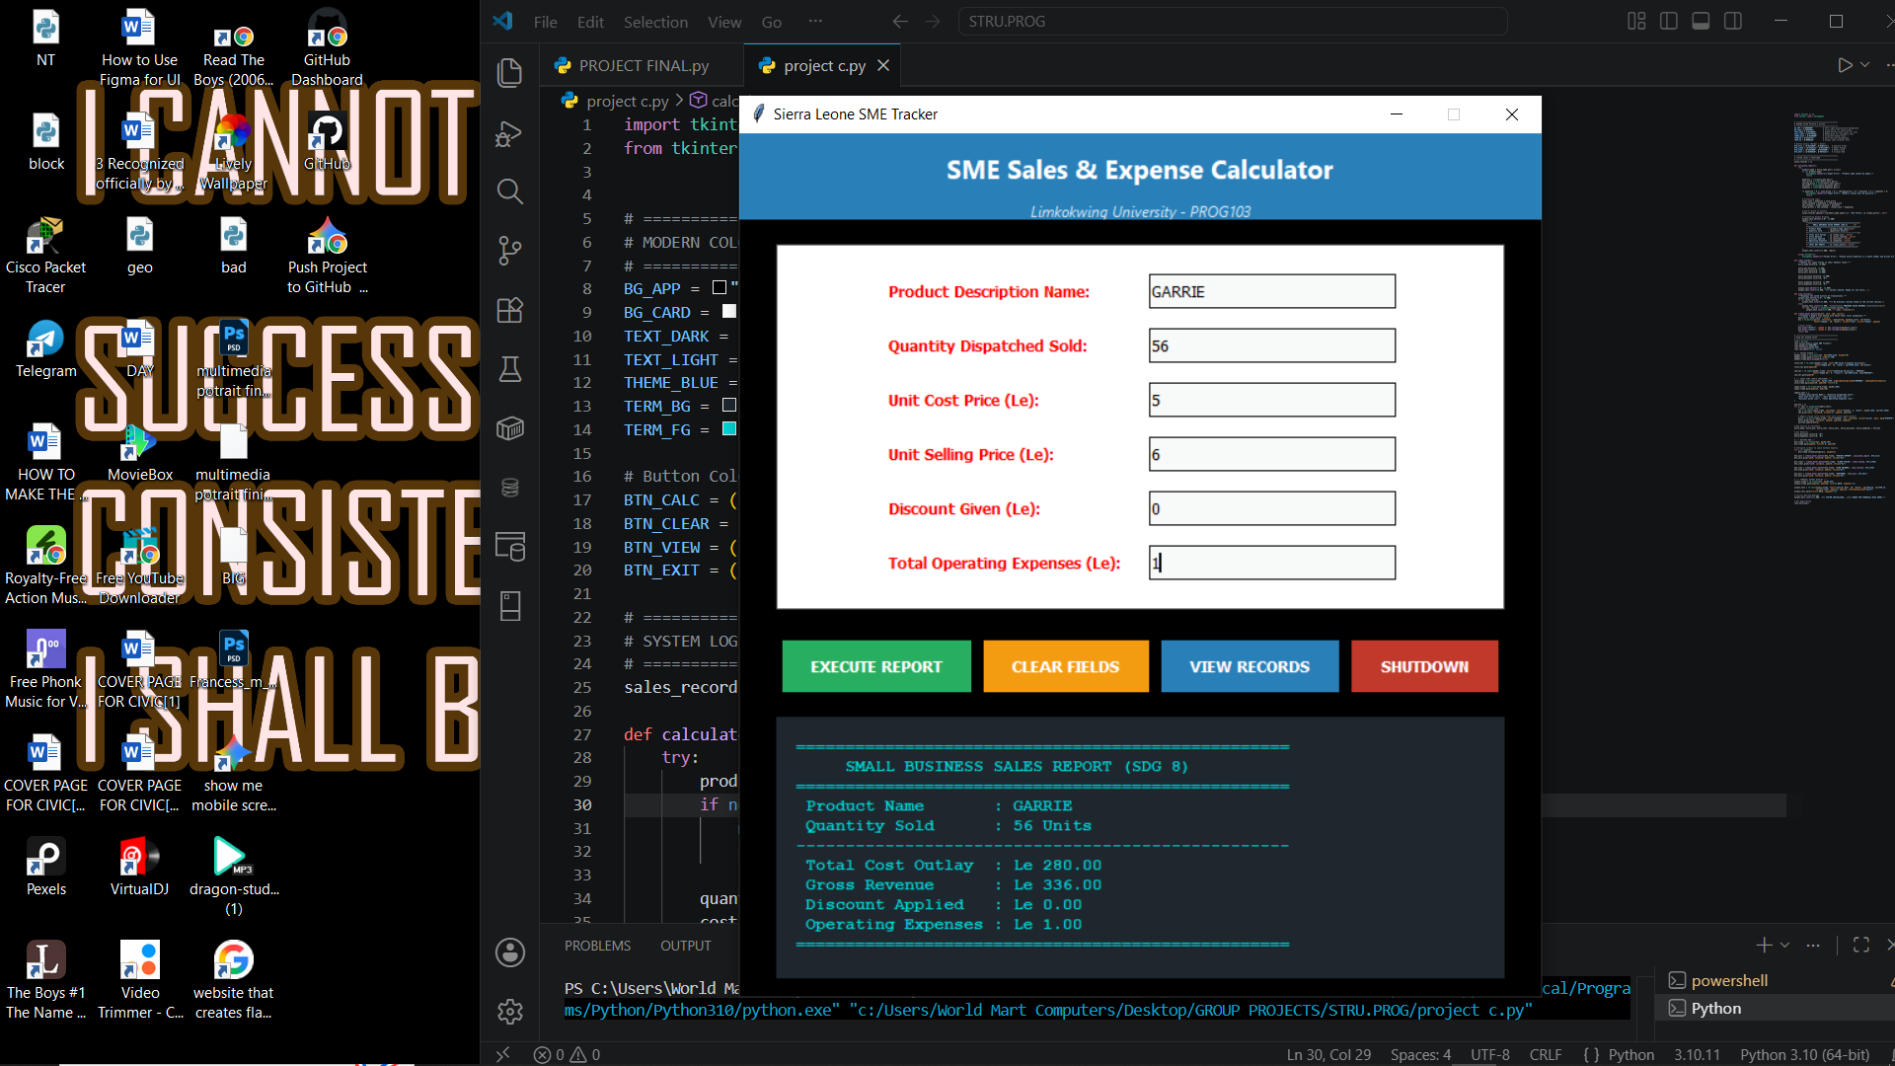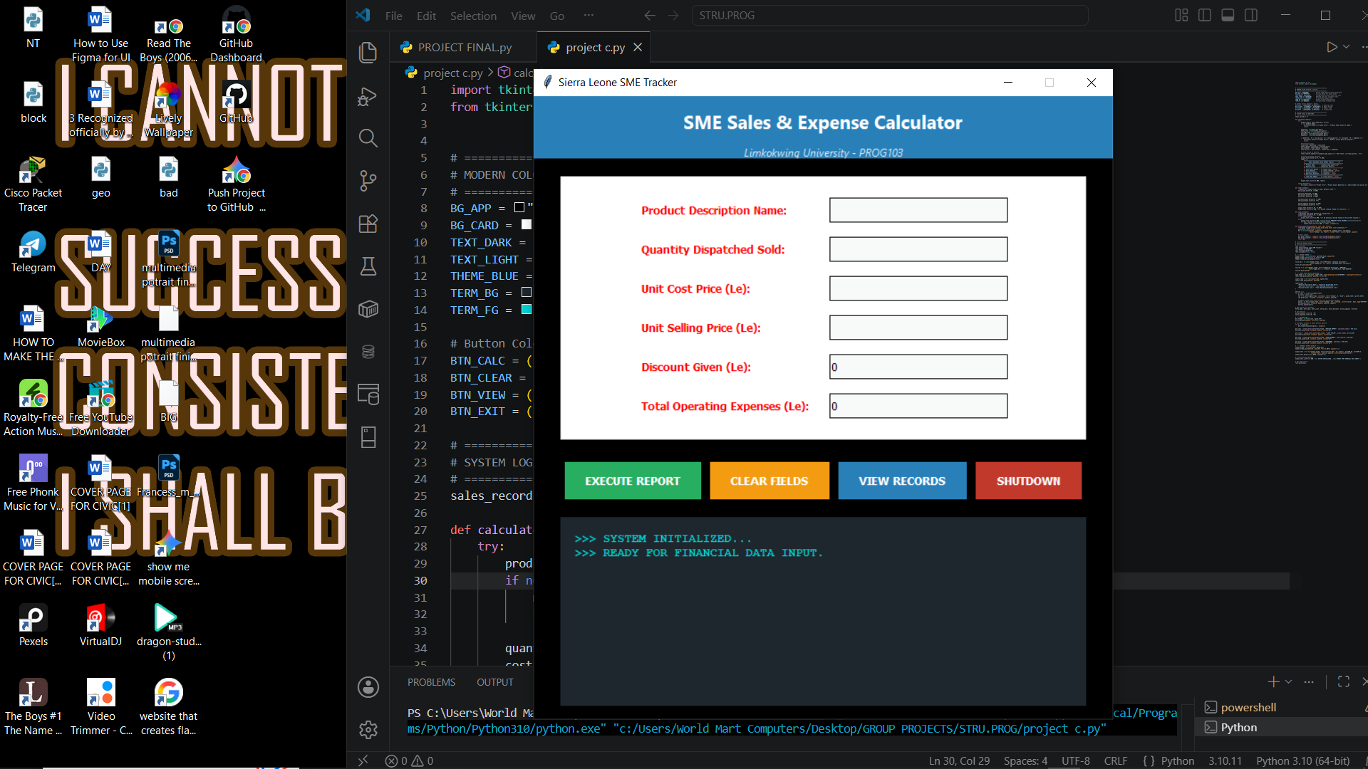

9. Conclusion
The development of the Sierra Leone SME Tracker demonstrates how targeted, lightweight software engineering can solve foundational operational challenges for micro-enterprises in emerging markets. By replacing error-prone manual ledgers with an automated, rule-based computational desktop application, the system effectively mitigates the mathematical faults, margin illusions, and data vulnerabilities that historically stifle the survival rate of local businesses.
Ultimately, this software establishes a scalable baseline for localized financial technology tools, providing operators with the analytical clarity required to optimize pricing, control expenses, and actively contribute to sustainable economic growth under the UN SDG 8 framework.

