**Nepal’s Agriculture and How it’s Affected by Global Warming/Climate Change and Migration**

**Nicholas Gomes**

### **Professor Simon Levin**

### **Lab Mentor Nicolas Choquette-Levy**

### **Near Peer Dameon Stackhouse**

**NSF REU Computational Biology 2021 Program**

**Abstract:**

Nepal is a country that is heavily reliant on agricultural cultivation and subsistence farming and is being impacted by global warming in various ways. This paper aims to correlate in which ways that agriculture is being affected and, correlate multiple studied variables that have been documented by various organizations and sources. These variables range from rising temperatures, rate of migration within locations in Nepal to outward migration from the country, and even crop yields, remittances and policies. Studies conducted by the NOAA that monitor weather pattern, FOA which record agricultural practices and yields, and many more organizations were utilized in the making of this paper. With statistical analysis of these various data points one can attempt to determine what is to be expected with Nepal and which polices may be best to implement in light of the data that is food.

**Table of Contents:**

Section 1: Intro

Section 2: Global Warming and Its Effects on Nepal

Section 3: The Effects of Migration

Section 4: Correlations

Section 5: Conclusion

Appendix

**Acronyms:**

FOA..............................Food and Agriculture Organization

GDP..............................Gross Domestic Product

GLOF............................Glacial Lake Outburst Floods

NOAA............................National Oceanic and Atmospheric Administrations

**Section 1: Intro**

Nepal, a country of 29,626,628 located in South Asia, is a country heavily reliant on its agriculture.1 In fact, 30% of Nepal’s total land is used for agricultural purposes as well as agriculture accounting for more than 36% of the nation’s GDP.2 As over 66% of the population are working in some agricultural capacity.3 These statistics go to show why agriculture is so important to the country of Nepal. Despite these facts and Nepal’s natural endowments for high land productivity, there are still food shortages for certain regions.4 These regions are broken down into 3 different topographical locations; the mountains, the hillsides, and the lower wet plains called the terai. Within these territories locals use differing methods of both production and policies that are relevant to the area at hand. For example, Nepal is glacially dependent and utilize the glacial flow as a source for water within the mountainous regions and even within hillside valleys. With an increase in temperature there has been more glacial melt causing excess floods and thus agricultural disruption that inevitably contributes to food shortages. This is only one example of the problems Nepal will be facing and, these food shortages will only continue to grow as global warming exacerbates the issue of extreme climate change. Rising flood rates in the wet season, extreme drought in the dry season, as well as, natural disasters occurring with more frequency will impact agricultural production. Furthermore, these environmental changes and food shortages may contribute to a perpetual outward migration. With increased outward migration Nepal’s agricultural production will decline. This issue has dire implication for local subsistence farmers as well as policy makers in Nepal.

By researching previous environmental changes and migration patterns alongside agricultural productions the research may answer the question of exactly how much global warming/climate change is affecting Nepal’s agricultural systems. Furthermore, the research may discover which policies and assistances are needed in order to better aide and support already existing productions. This study is important not only to the country of Nepal but surrounding countries as well. As food shortages arise the rate of outward migration will increase possibly causing displacement and stress in neighboring countries. For this reason, it is imperative to not only examine the correlation of global warming/climate change, outward migration and agricultural decline, but to come up with possible solutions as well.

**Section 2: Global Warming and Its Effects on Nepal**

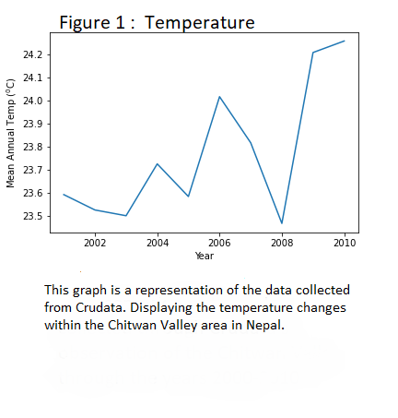While most are aware that global warming is affecting the climate in various ways, the small country of Nepal has been affected more than most. It has seen temperature rises and changes in precipitation at a faster rate than the global average.[1] In fact, according to NOAA the average rate of increased global temperature per decade is about .13 degrees Fahrenheit or .08 degrees Celsius.[2] While Nepal’s average rate of change is roughly .216 degrees Fahrenheit or .12 Celsius per decade.[3] These relatively huge upswings in temperature come with both obvious and ambiguous consequences. For example, most can determine that an increase in temperature consistently for decades can ultimately lead to drought/arid conditions. There are, however, less obvious consequences of these rising temperatures.

These overall rising temperatures has reportedly led to an increase in pests.[4] These pests not only cause agricultural destruction but are also causes of increased rates of diseases and with more people sick it further strains the capabilities of agricultural cultivation. Furthermore, droughts have increased chances of causing forest fires as well as depletions within the wetland areas (also known as the Terai in Nepal). In fact, in 2016 the multitude of forest fires impacted over 50 districts and damaged over 12,000 community forests.[5] The depletion of wetlands have caused destruction to both aquatic plants and other aquatic dependent animals, ranging from fish to the amphibians that assist with pest control. However, these are effects that have been only documented in the Nepal’s dry season. Global warming has also affected Nepal’s wet season in various ways.

For example, studies have shown that the mean rainfall has decreased an average of 3.7mm per month per decade.[6] This approximately adds up to a staggering 17.5 inches every decade is being lost.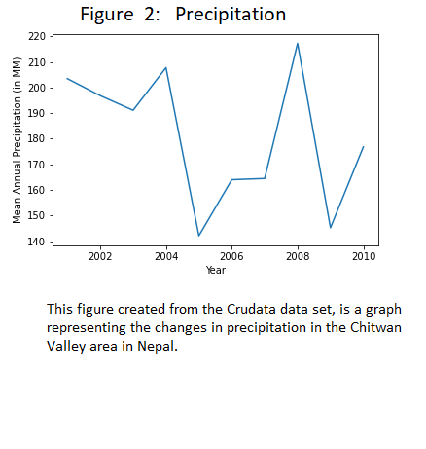 Also, Nepal’s yearly rainfall is only approximately 1900mm, or 74.8 inches a year.[7] That’s 748 inches of rainfall in a decade (not accounting for the yearly loss), this means a loss of more than 2% of the average rainfall (more when one considers that number of loss rain remains constant while the average of rainfall is perpetually decreasing every decade). While this may indicate a potential increase in drought the data is unclear in exact repercussions of these losses. However, loss of rainfall isn’t the only issue that Nepal is facing.

Nepal is technically a glacial dependent country, meaning in some locations the citizens are reliant on the glacial melts that cause fresh water lakes that can be utilized for various purposes. There are over 2,323 glacial lakes in Nepal accounting for 75 square kilometers.[8] However, in the second half of the 20th century glaciers have been retreating more rapidly that ultimately leads to glacial lake outburst floods, also called GLOF.[9] These types of sudden floods cause extreme disruptions, by damaging assets and infrastructure and even causing deaths. Also worth considering is the long-term repercussions of the glacial retreat. With rising temperatures, it is likely that glaciers will continuously melt at faster and faster rates. The being stated more GLOFs will also occur. Possibly causing settlements to consider relocation as a coping method from a location that was previously an agriculturally viable environment.

Global warming has and will continue to cause temperature rises and climate change within Nepal at documented faster rates than the global average. These changes will leave many settlements vulnerable in terms of keeping their livelihoods secured. This is because the erratic changes in climate and environments will lead to significant declines in certain staple crops. Not only this but with the rise in global temperature and increase in natural disasters as well as less predictable weather patterns have been reported. Ultimately meaning that those within Nepal will need a viable coping method, and when one’s currently environment is no longer favorable only one choice usually remains. Outward migration. This inevitable outward migration within Nepal will, and might already be, affecting Nepal’s possible agricultural productivity.

**Section 3: The Effects of Migration**

To elaborate, consider the previously mentioned fact that within the second half of the second century glaciers in Nepal began to melt at a faster rate than previously recorded. This is due to the fact that an increase in temperature was causing environmental change. These significant changes and their affect were recorded in a manuscript titled, “Environmental Change and Out-Migration: Evidence from Nepal”, by authors Douglas S. Massey, William G. Axinn, and Dr. Dirgha J. Ghimire. In this manuscript the authors studied the Chitwan Valley, a valley that was utilized by the Nepalese government in the hopes to alleviate the issues caused by more frequently occurring natural disasters as well as population growth around the mid 1950s. This land at first attracted environmental refugees of nearby area’s that suffered from land degradation, landslides, and floods around 1960-70s.[10]

This study observed various factors with environmental change that motivated migration, primarily dwindling resources. The dwindling resources was the result of both rapid population growth and a slew of environmental issues, ranging from deforestation, flooding, drought, to even desertification to name a few. However, to continue producing goods more money was needed to purchase the required materials for production. These materials such as seed and fodder for animal husbandry increased in price due to the increase in demand stemming from the lack of natural resources.[11] These increases in costs caused individuals to consider migration from rural settings into a more urban environment or even other countries in order to obtain higher wages for their families.[12]

Furthermore, it is interesting to note that the Nepalese government around the mid 1990’s started implementing foreign employment as a means of mitigating high unemployment and poverty issues.[13] The number of labor approvals remained relatively stagnate at less than four thousand for the first three years, but by the twenty first century was well over 100,000 while peaking at 500,000 by 2013/14.[14] Uncoincidentally, around the same time frame of the peak in out-ward migration the government of Nepal started receiving a substantial increase in remittances. Going from around 2.5 billion in USD in 2010/11 to approximately 5 billion in USD by 2013/14 and reaching just under 9 billion USD as of 2018/19.￼ This means that out-ward migration was bringing in roughly ¼ of the country's GDP by 2018/19. These remittances likely kept many farmers and other agricultural culturists able to continue producing crops/animals despite the increase in unfavorable agricultural producing circumstances. Such as the ability to purchase fodder for animals amongst the growing prices for it, or the ability to purchase high quality fertilizer/seeds that will help cultivation despite the worsening soil/environmental conditions. Implying that the effects of global warming on agriculture in Nepal is being offset by outward migration, more specifically the remittances that the outward migrants are providing for their families back home. 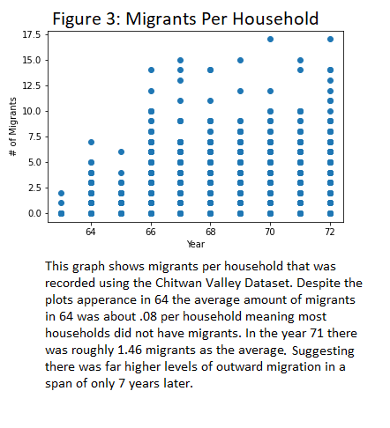 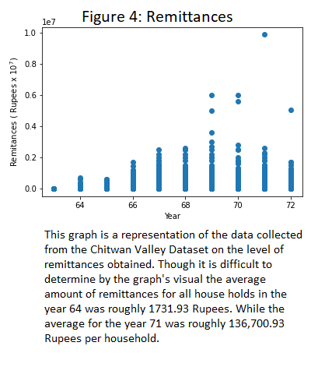

**Section 4: Correlations**

By running Ordinary Least Square regressions on annual remittances and various crops produced during any given year one would be able to determine exactly how much one Rupee (Nepal’s currency) effected the crops production. It is important to note that this can only be determined as statistically viable if something commonly referred to as the T-statistic and P- values are equal to or less than .05 or 5%. These values represented in figure 5 as “P > | t |” , determine the percentage at which the correlations are due to random distribution/chance. Also note that there are multiple variables in the upcoming regression analytical graphs and summary, meaning there is a higher change that the P-values will be affected. Notice however, that remittances to crop ratio in the figures show P-values of less than 1% meaning that the following graphs report a significant correlation. Furthermore, the following graphs have excluded the Nepali years 63 and 71 from the analytical graphing process. This was due to possible errors in data collection. In other words, it is uncertain whether the individuals collecting the data in the beginning of the research had enough time to settle in and build relations among the population in Chitwan Valley before the harvest season begun. This would have possibly led to variations in crop yield and misconstrued the data. Similarly, there was no way to determine that the same individual(s) did not have to leave before the harvest was recorded in the year 72 at the end of their research period. Also, in the year 72 (2015 in western time) there was a massive earthquake that devastated Nepal which would lead to variation in crop productions. It is for these reasons that these years were omitted from the regression analysis process.

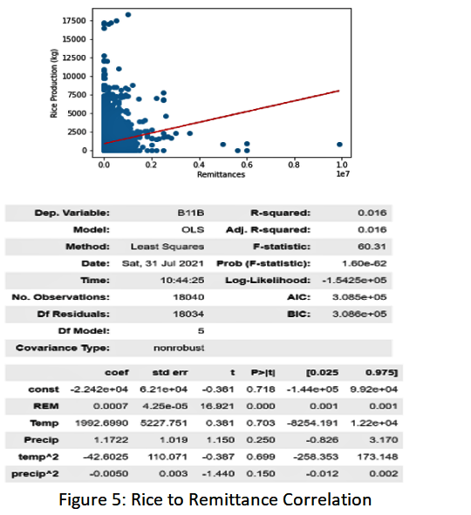Within each figure the results show that there are various positive relations between remittances and crop production. Consider figure 5, where you can see that the dependent variable rice (marked as B11B) is directly influenced by the independent variable of remittances (marked as REM) by a ratio of .0007 kg per ever 1 Rupee provided. While this may seem an insignificant finding the implications indicate a remarkable correlation between crop production and remittances. This is demonstrated by first collecting the average remittances received in any two given years such as, 64 and 71 (or 2006 and 2014 respectively). In the year 64 the average remittance received per household was 1731.93 Rupees while in 71 it was roughly 136700.93 Rupees per household. By multiplying .0007 by the average remittance received for both the specified years the study indicates that in 64 12.12 kg of rice can be attributed to remittances received whereas in the year 71, 95.69 kg of rice can be attributed to remittances. Furthermore, the average rice produced in 64 was approximately 920.44 kg. By dividing the rice attributed to remittances by the total rice produced for the years 64 one can concluded that the rice attributed by remittances accounted for 1.3% of the rice grown for that year. Conversely, in the year 71 the average rice produced was approximately 1027.75kg meaning the 95.69 kg attributed to remittances accounted for 9.3% of the rice grown that year.

However, by subtracting the amount of rice attributed from the remittances from both the respective years and then subtracting the total of rice produced in 71 by the total of rice produced in the year 64, one can see that there would still be a marginal growth in the crop production by approximately 2.6% over the course of 7 years. Whether or not the growth would have kept up with demands of a growing population is unclear but it may suggest that the effects of global warming may not yet have an effect of rice yields within Nepal. On the other hand, that is not the case with all crops recorded within the data set. In the year 64 the Chitwan Valley had produced a total average of 288.53 kg of maize per household while in 71 the average household produced 255.54 kg. As shown in figure 6 remittances have a relation of .0002 kg of maize per Rupee. For 64 and 71 the remittance numbers stay the same, at 1731.93 Rupees in 64 to 136,700.93 Rupees in 71. Meaning in 64 remittances accounted for .35 kg or .12% of the total wheat produced while in 71 it attributed 27.34 kg or 10.69% of the total maize grown. These results may indicate two things, first that perhaps the farmers utilize remittances for irrigation purposes or perhaps better tool and equipment that would explain how the same remittances can account for the boosting of all crops’ production. The second indication is that the statistics show that remittances play a vital role in mitigating agricultural decline. 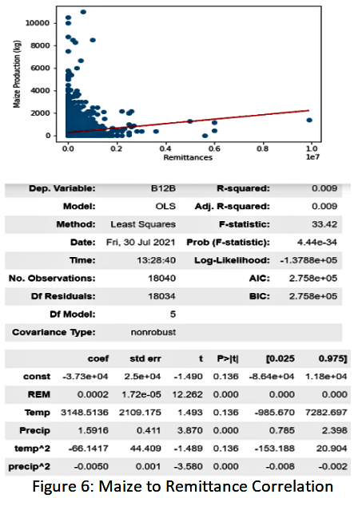

**Section 5: Conclusion**

What the current data demonstrates is that there seems to be an agricultural decline in some crops and a marginal growth in others. These results along with the limitations of the data sets make it unclear on whether or not global warming/climate change can be correlated with agricultural decline. None the less, there are a few important concepts to consider. One is that some crops may actually see a temporary boon of the increased temperatures and carbon dioxide until those variables pass a certain threshold. Secondly, the data collected for temperature and precipitation was not collected by the same study group. As a result, there is no telling if the temperature and precipitation was documented using the western calendar, which would mean they recorded starting in January as opposed to the Nepali calendar which beings in what would be considered mid-April in the western calendar. This would lead to errors in correlations between crop production, temperature and precipitation. Furthermore, it is important to note many natural disasters were never documented in the sample data set. Natural disasters such as drought, earthquakes, forest fires, and soil erosions were never documented. Making it difficult to see climate change and its effect on crop production. However, the sample data set did include the number of floods experienced. The data recorded had an observation of where the combined total of the last 3 years in the study had a total number of floods exceeding that of the combined total of the first 7 years in the study.

While the results are unclear or definitive in their implications of climate change and its relationship to crop production one thing is certain. Remittances for all crops observed has shown an increasing positive influence in farmers’ ability to produce crops. With this in mind it would be a logical to suggest that policy makes within Nepal, whose topographical location are similar to that of the Chitwan Valley to lower or even nullify taxation of remittances received by farmers. This would make sense for both the farms and local governments. For farmers it would makes sense because it would allow for more uses of remittances in an agricultural capacity. At the same time the local governments will be able to make some of the money forgone by the tax break in the increased ability of exporting the produced crops. Stimulating a growth and emphasis on agricultural production.

Lastly, it would be wise to continue doing a more specified and narrow research study on the relationship between climate changes, remittances, and crop productivity in order to receive a more nuanced understanding between the three variables. This future study could include changes in Carbon Dioxide in the air, frequency of earthquakes, level of soil erosions, drought, among many other naturally occurring disasters that effect agricultural growth and solutions (if any) that the farmers utilize to combat these issues. As well as, a record in percentages of how the farmers/ agriculturists utilize their remittances into two categories. One category depicting in detail the uses of remittances in agricultural purposes, as well as the use in remittances for other purposes such as housing payments, cloths, etc. By looking at the forementioned factors and comparing them to crop productivity future studies will show a more comprehensive understanding of the changes at hand. By then conducting the same study in all 3 of Nepal’s topographical locations then more detailed policies can be implemented to help both the farmers in crop productivity and government with monetary management. Furthermore, the practices used within this topographically diverse location may lead for many of the same studies and principles to be used in other locations around the globe allowing for the ability to preemptively combat the effects of global warming/climate change.

**Appendix**

This section includes the various graphs and charts that were documented from the Chitwan Valley dataset. Within this section the tools to see the difference in remittance attributed growth in crop production are given using the same formula and methods demonstrated within the correlation section of the report. As well as the correlation between what migrants and remittances are, in other words what on average a migrant is able to provide in terms of remittances.

Crops:

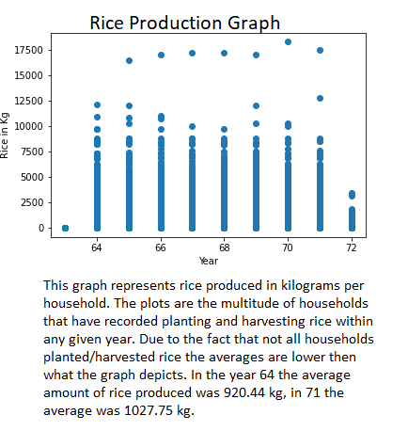 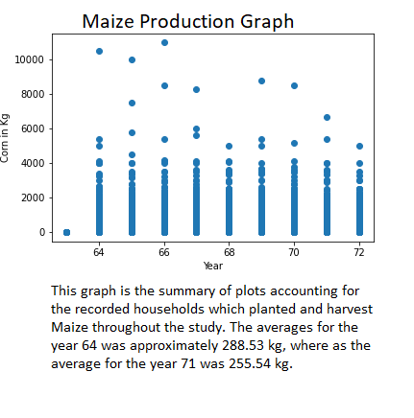 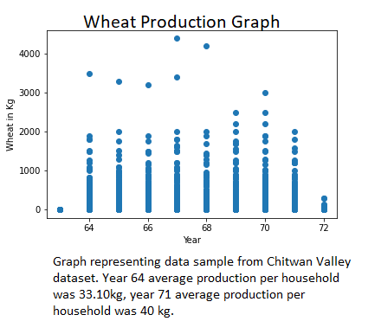 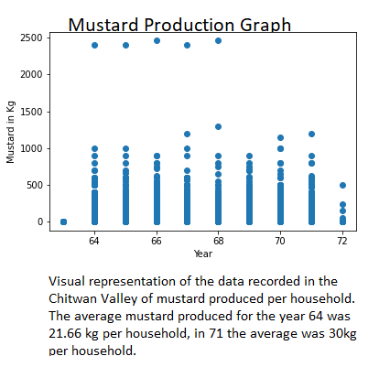 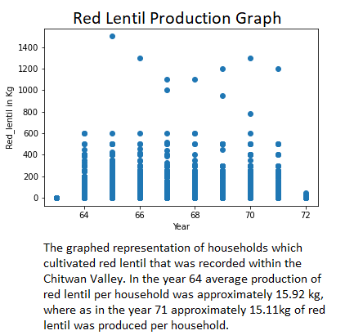

Crop to Remittance Correlation:

This section shows the relationship between the crop and remittances received. Where REM is the variable name indicating 1 Rupee is equivalent to the coefficient number to its right. To avoid redundancy rice and maize correlations (figures 5 and 6) are not included.

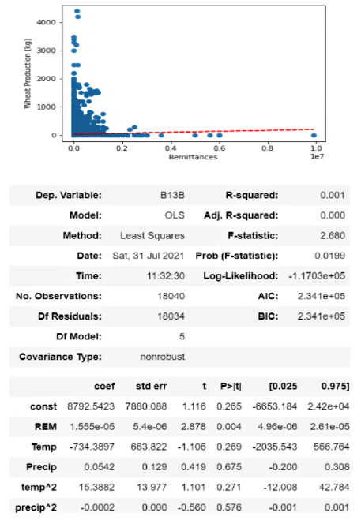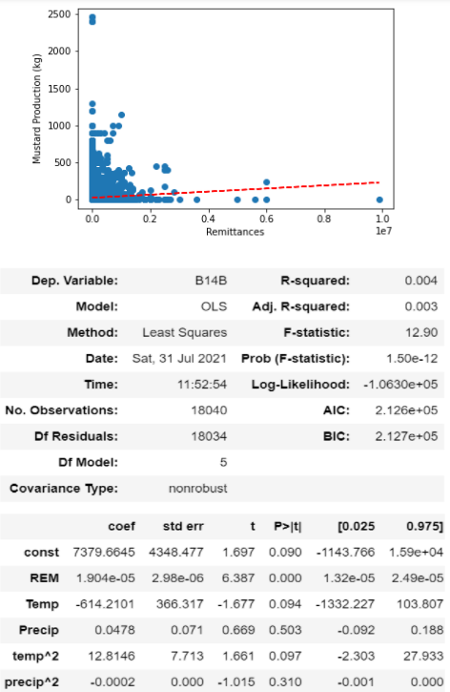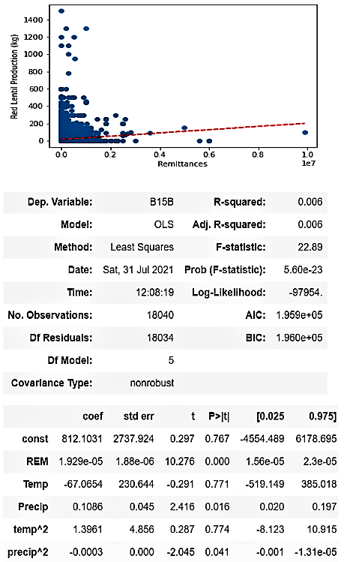 Wheat to Remittances Mustard to Remittances Red Lentil to Remittances

Migrant to Remittances Correlation:

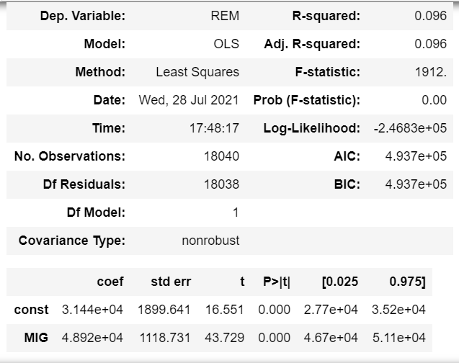

**References**

*Climate Change: Global Temperature | NOAA Climate.gov*. (2021, March 15). Www.Climate.Gov. <https://www.climate.gov/news-features/understanding-climate/climate-change-global-temperature>

*Climate Change in Nepal: Impacts and Adaptive Strategies*. (2013, September 23). World Resources Institute. <https://www.wri.org/our-work/project/world-resources-report/climate-change-nepal-impacts-and-adaptive-strategies>

*Climate Risk Profile: Nepal*. (2017, July 19). Global Climate Change. <https://www.climatelinks.org/resources/climate-risk-profile-nepal>

D. Massey, W. Axinn, D. Ghimire. (2010). *Enviornmental Change and Out-Migration: Evidence from Nepal*. NCBI. <https://www.ncbi.nlm.nih.gov/pmc/articles/PMC3042700/>

F. (n.d.). *Agriculture - Federation of Nepalese Chambers of Commerce and Industry [FNCCI]*. <Https://Www.Fncci.Org>. Retrieved June 10, 2021, from <https://www.fncci.org/agriculture-148.html#:%7E:text=About%2030%25%20of%20Nepal%27s%20total,wheat%2C%20barley%2C%20and%20buckwheat>.

Government of Nepal Ministry of Labour, Employment and Social Security. (2020). *Nepal Migration Report 2020*. Www.Moless.Gov.Np. <https://moless.gov.np/wp-content/uploads/2020/03/Migration-Report-2020-English.pdf>

*Nepal at a glance | FAO in Nepal | Food and Agriculture Organization of the United Nations*. (n.d.). <Http://Www.Fao.Org/>. Retrieved June 10, 2021, from <http://www.fao.org/nepal/fao-in-nepal/nepal-at-a-glance/en/>

*Nepal Population (2021) - Worldometer*. (2021). Worldometer. <https://www.worldometers.info/world-population/nepal-population/>

S. Massey, G. Axinn, J. Ghimire, D. W. D. (2011, February 11). *Environmental Change and Out-Migration: Evidence from Nepal*. National Center for Biotechnology Information. <https://www.ncbi.nlm.nih.gov/pmc/articles/PMC3042700/>

*World Bank Climate Change Knowledge Portal*. (2020–2021). For Global Climate Data and Information! <https://climateknowledgeportal.worldbank.org/country/nepal/climate-data-historical>

1. *Climate Risk Profile: Nepal*. (2017, July 19). Global Climate Change. <https://www.climatelinks.org/resources/climate-risk-profile-nepal>
2. *Climate Change: Global Temperature | NOAA Climate.gov*. (2021, March 15). Www.Climate.Gov. <https://www.climate.gov/news-features/understanding-climate/climate-change-global-temperature>
3. *Climate Risk Profile: Nepal*. (2017, July 19). Global Climate Change. <https://www.climatelinks.org/resources/climate-risk-profile-nepal>
4. *Climate Risk Profile: Nepal*. (2017, July 19). Global Climate Change. <https://www.climatelinks.org/resources/climate-risk-profile-nepal>
5. *Climate Risk Profile: Nepal*. (2017, July 19). Global Climate Change. <https://www.climatelinks.org/resources/climate-risk-profile-nepal>
6. *World Bank Climate Change Knowledge Portal*. (2020–2021). For Global Climate Data and Information! <https://climateknowledgeportal.worldbank.org/country/nepal/climate-data-historical>
7. *World Bank Climate Change Knowledge Portal*. (2020–2021). For Global Climate Data and Information! <https://climateknowledgeportal.worldbank.org/country/nepal/climate-data-historical>
8. *Climate Change in Nepal: Impacts and Adaptive Strategies*. (2013, September 23). World Resources Institute. <https://www.wri.org/our-work/project/world-resources-report/climate-change-nepal-impacts-and-adaptive-strategies>
9. *Climate Change in Nepal: Impacts and Adaptive Strategies*. (2013, September 23). World Resources Institute. <https://www.wri.org/our-work/project/world-resources-report/climate-change-nepal-impacts-and-adaptive-strategies>
10. S. Massey, G. Axinn, J. Ghimire, D. W. D. (2011, February 11). *Environmental Change and Out-Migration: Evidence from Nepal*. National Center for Biotechnology Information. <https://www.ncbi.nlm.nih.gov/pmc/articles/PMC3042700/>
11. S. Massey, G. Axinn, J. Ghimire, D. W. D. (2011, February 11). *Environmental Change and Out-Migration: Evidence from Nepal*. National Center for Biotechnology Information. <https://www.ncbi.nlm.nih.gov/pmc/articles/PMC3042700/>
12. S. Massey, G. Axinn, J. Ghimire, D. W. D. (2011, February 11). *Environmental Change and Out-Migration: Evidence from Nepal*. National Center for Biotechnology Information. <https://www.ncbi.nlm.nih.gov/pmc/articles/PMC3042700/>
13. Government of Nepal Ministry of Labour, Employment and Social Security. (2020). *Nepal Migration Report 2020*. Www.Moless.Gov.Np. <https://moless.gov.np/wp-content/uploads/2020/03/Migration-Report-2020-English.pdf>
14. Government of Nepal Ministry of Labour, Employment and Social Security. (2020). *Nepal Migration Report 2020*. Www.Moless.Gov.Np. <https://moless.gov.np/wp-content/uploads/2020/03/Migration-Report-2020-English.pdf>