#### 

UNIVERSITY OF BUEA REPUBLIC OF CAMEROON

Buea, South West Region PEACE-WORK-FATHERLAND

Cameroon

FACULTY OF ENGINEERING AND TECHNOLOGY

DEPARTMENT OF COMPUTER ENGINEERING

**Task 5: UI Design and Implementation**

Course Master: Dr Valery Nkemeni

CEF440:Internet Programming and Mobile Programming

GROUP 22

|  |  |
| --- | --- |
| NAMES | MATRICULE |
| NGOUH KAMBI MARCBRYAN | FE22A264 |
| AMBASSA LISE-ASTRID | FE22A146 |
| EPIE-NGOLE MCCAULEY | FE22A445 |
| EPANDA RICHARD JUNIOR | FE22A206 |
| NKIANGWA NKEGOA KAREL | FE22A277 |

**Table of Contents**

**Introduction**…………………………………………………………………………3

1**. App Identity** 3

Branding Strategy 3

Color Palette 4

Typography 4

**2.Visual Design** 4

Wireframes 4

UI Components 12

Layouts 13

Accessibility Considerations 13

**3. Frontend Implementation** 13

Development Process 13

Navigation Structure 13

Collaboration and Organization 13

**4. Discussion**  14

**5. Conclusion** 14

**1. Introduction**

This report details the UI design and implementation phase of the Road Sign and Road State Notifications Mobile App. The main goal of this phase is to develop an intuitive, aesthetically pleasing, and functional interface that facilitates real-time updates on road signs and real time road conditions, ultimately enhancing driver safety. This report contains information about, app identity, visual design, and frontend implementation.

**2. App Identity**

* **Branding Strategy**
* App Name: MotoSure
* Tagline: "The road talks, MotoSure listens"
* Logo Design:



* **Symbolism:** The helmet represents safety and protection, which aligns well with the app’s goal of enhancing driver safety through realtime road condition alerts. This passes a strong message to the user about safety while using the roads.
* **Professional Appearance**: The sleek and modern design of the logo gives a professional impression. This can help to establish trust with users, which is crucial for the Road Sign and Road State Notifications Mobile App’s aim to provide reliable road safety information.
* **Target Audience:** The logo appeals to road users, who are our primary stakeholders, effectively communicating the app’s focus on road saefty and road user awareness.
* **Color Palette**
* Primary Colors:

- Dark Ash(#2E3133): Used to give a more professional, and trust worthy impression.

- White(#FFFFFF): Background color for a clean, modern look.

* Secondary Colors:

- Red: Used for on the notifications icon, to create a sense of urgency.

- White(#FFFFFF): Used as text color over Dark Ash buttons, for a clean, consistent and modern look.

* **Typography**
* Headings: Montserrat (Bold, 24pt) for a modern and professional appearance.
* Body Text: Roboto (Regular, 14pt) for clear readability, ensuring accessibility across user demographics.
* Button Text: Roboto (Medium, 16pt) for clear call-to-action prompts.

**3. Visual Design**

* **Wireframes**

Paper-based sketches of the application were drawn, inorder to clearly visualise the system. Then, the User Interface Design was developed using Figma software, focusing on the following key pages:

**Link to the Figma File:** <https://www.figma.com/design/0Zgvpq8JvnQYcquFHWLmuL/MotoSure?node-id=0-1&p=f&t=Ab1Xzn4Gg2BQmfce-0>

* **Get started page:** It’s the first page the user encounters when the app is first launched on their device, prompting the user to either Sign In or Sign Up.

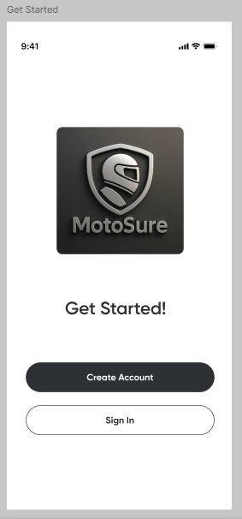

* **Sign In page:** From the Get Started page, the user gets redirected to this page if they choose to sign In with an account that’s registered in the system.

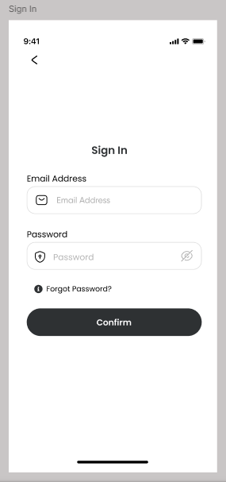

* **Sign Up page:** The user can get redirected to this page on two conditions;
* They choose to Sign Up directly from the Get Started page
* They move from the Get Started page, to the Sign In page, without using an account that was already registered (trying to Sign In without having Signed Up).

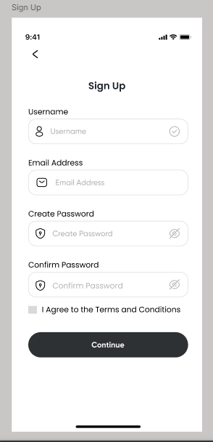

* **Home page:** Displays Weather information, road sign information, and quick action buttons. The user gets redirected here when they successfully login.

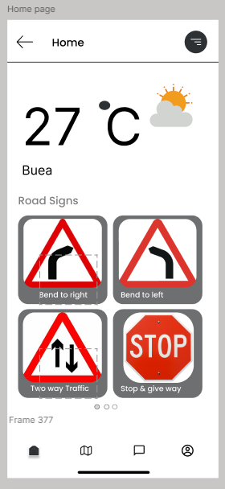

* **Map View page:** Displays interactive map with user location, road sign overlays, and alerts.

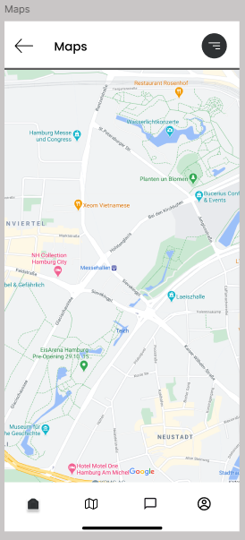

* **Report Submission page:** Displays an intuitive form allowing users to submit reports with options for text, images, or voice.

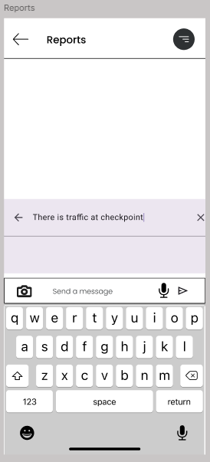

* **Alerts and Notifications page:** Displays all Alerts received by the user while using the application.

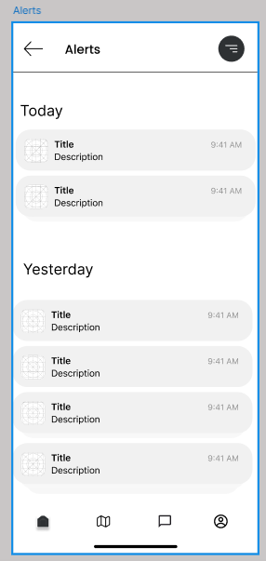

* **Profile page:** Displays users’ unique information such as; phone number, email address, Notification preferences, Language Preferences and the option to Sign Out of the application.

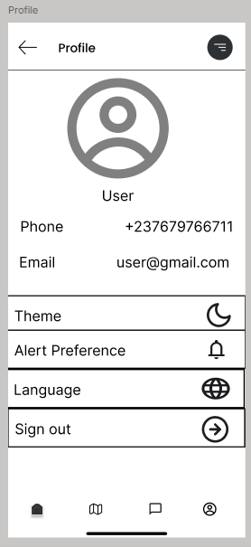

* **UI Components**
* **Buttons and icons:**
* Intuitive icons for major actions (e.g., "Report an Issue", "View Alerts").
* Color-coding on icons to indicate urgency (e.g., red for immediate alerts).

* **Images and Icons:**
* Custom-designed icons representing various road signs and alerts, ensuring clarity and recognition.
* Intuitive icons for navigation and reporting functionalities.
* **Layouts**
* Responsive Design: A flexible grid layout was implemented, that adapts to various screen sizes (smartphones and tablets) using Flutter’s layout widgets.
* Intuitive Navigation:
* Bottom navigation bar for seamless switching between Home, Map, Reports and Profile.
* **Accessibility Considerations**
* We ensured high contrast between text and background colors for readability.
* We intend to add text-to-speech functionality for visually impaired users.
* Implemented larger touch targets for buttons to accommodate users with mobility challenges.

1. **Frontend Implementation**

* **Development Process**
* Framework: We utilized Flutter for cross-platform development, allowing for a single codebase for both Android and iOS.
* Widgets: We leveraged Flutter’s widget library to create custom UI components, ensuring a consistent user experience.
* **Navigation Structure**
* We implemented a Bottom Navigation Bar for quick access to primary features.
* We used Named Routes to facilitate navigation between different screens.
* We also designed a Back Navigation system to enhance user flow, allowing users to easily return to previous screens.
* **Collaboration and Organization**
* We are making use of Github as a team, inorder to easily track and organize our code.
* Link to Github Repo: [NgouhKambiMarcB/MotoSure: Road Sign and Road State Notification Mobile Application. Motosure is going to help users learn about common road signs and also provide users with real time notifications about the current condition of the road.](https://github.com/NgouhKambiMarcB/MotoSure)

1. **Discussion**

The UI design and implementation phase for the Road Sign and Road State Notifications Mobile App is effectively producing a user-friendly and visually appealing interface. The app identity is cohesive and reflective of its purpose, while the visual design prioritizes usability and accessibility. The frontend implementation is robust, ensuring a seamless experience for users. Future iterations will focus on integrating additional user feedback and enhancing existing features.

1. **Conclusion**

This detailed report provides a comprehensive overview of the UI design and implementation phase, highlighting the steps taken, design choices made, and the rationale behind them.