#### 

**UNIVERSITY OF BUEA REPUBLIC OF CAMEROON**

Buea, South West Region PEACE-WORK-FATHERLAND

Cameroon

**FACULTY OF ENGINEERING AND TECHNOLOGY**

**DEPARTMENT OF COMPUTER ENGINEERING**

**Report on Task 2**

**Course Master: Dr Valery Nkemeni**

**CEF440:Internet Programming and Mobile Programming**

**GROUP 22**

|  |  |
| --- | --- |
| NAMES | MATRICULE |
| NGOUH KAMBI MARCBRYAN | FE22A264 |
| AMBASSA LISE-ASTRID | FE22A146 |
| EPIE-NGOLE MCCAULEY | FE22A445 |
| EPANDA RICHARD JUNIOR | FE22A206 |
| NKIANGWA NKEGOA KAREL | FE22A277 |

#### 

Table of Contents

Stakeholder Identification 3

Requirement Gathering Techniques 4

Data Gathering 12

Data Cleaning 13

User Reluctance Assessment 14

Limitations 15

#### ****Introduction****

**Requirement Gathering**, is a foundational step in the development of the mobile application for road sign and road state notifications. For this phase of the project, the goal was to collect the requirements necessary to design a user-friendly app that provides drivers with real-time road sign information and road condition updates. This task ensures that the app meets the needs of drivers, addresses the existing gaps in navigation tools, and adheres to the project goals.

This report provides a detailed breakdown of the **stakeholder identification**, **requirement gathering techniques**, **data gathering**, **data cleaning**, and **user reluctance assessment** specific to the **Road Sign and Road State Mobile Notification Application**.

### ****1. Stakeholder Identification****

Stakeholders for this project are the individuals or entities directly or indirectly affected by the application or involved in its development and deployment. Identifying stakeholders ensures their needs and perspectives are understood early on in the project.

#### ****Key Stakeholders for the Road Sign and Road State App****

1. **Drivers and Vehicle Owners**:

* Primary users of the app.
* Need real-time road condition updates and clear road sign information for safe and efficient travel.
* May require customizable notification preferences.

1. **Government Transportation Authorities**:

* Responsible for maintaining road safety and traffic regulations.
* Provide verified road sign data and official traffic updates.

**c. Mobile App Developers and Designers**:

* The team responsible for building, testing, and deploying the application.
* Require clear technical and functional requirements.

### ****2. Requirement Gathering Techniques****

To ensure the app meets stakeholder needs, various techniques were used to collect relevant data and gather requirements:

#### ****a. Surveys****

* The main bojective of this activity was to collect opinions from drivers about their challenges with road signs, real-time updates, and navigation tools.
* We distributed digital surveys using platforms like Google Forms and social media groups targeting drivers in Cameroon.
* **Some Questions we asked Iclude**:
  + How often do you face issues with unclear road signs or poor road conditions?
  + What type of notifications would you prefer (e.g., road closures, traffic jams, weather conditions)?
  + Would you be willing to contribute real-time updates (e.g., reporting potholes)?

Below are some charts drawn from analysis of 57 responses.

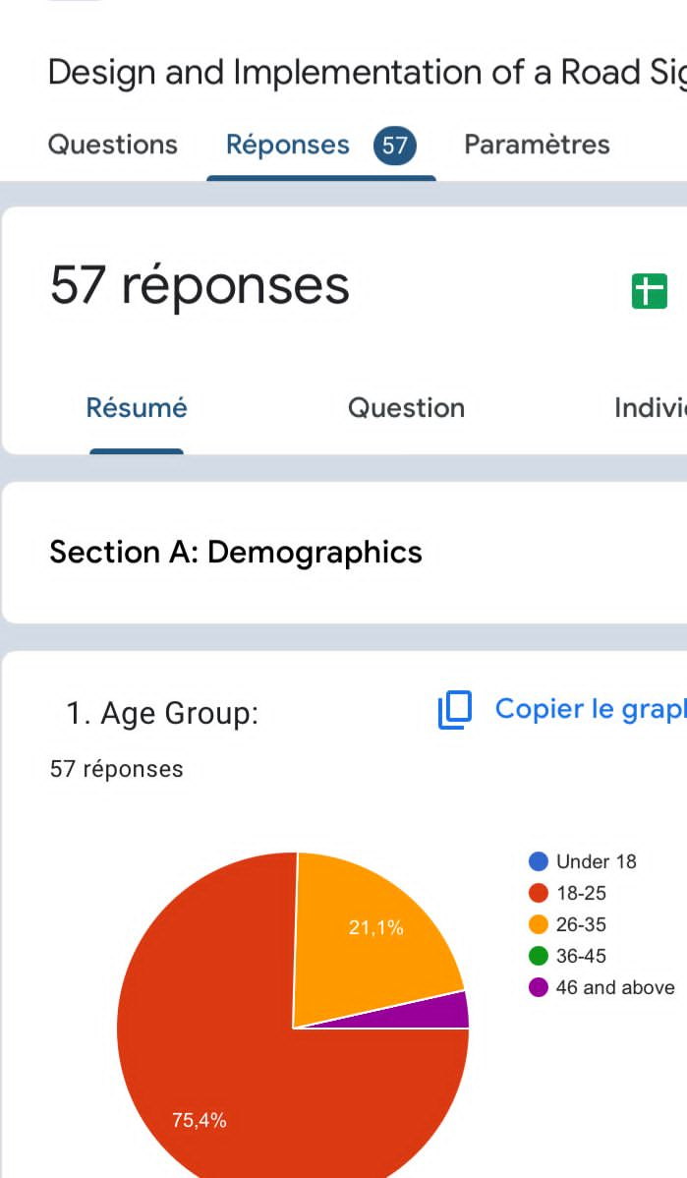

Figure 1

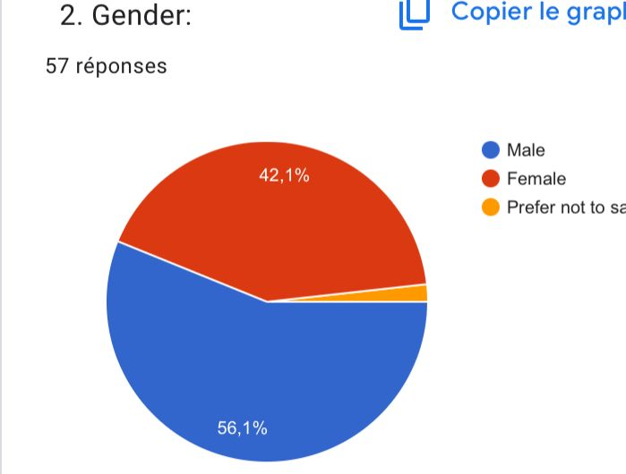

Figure 2

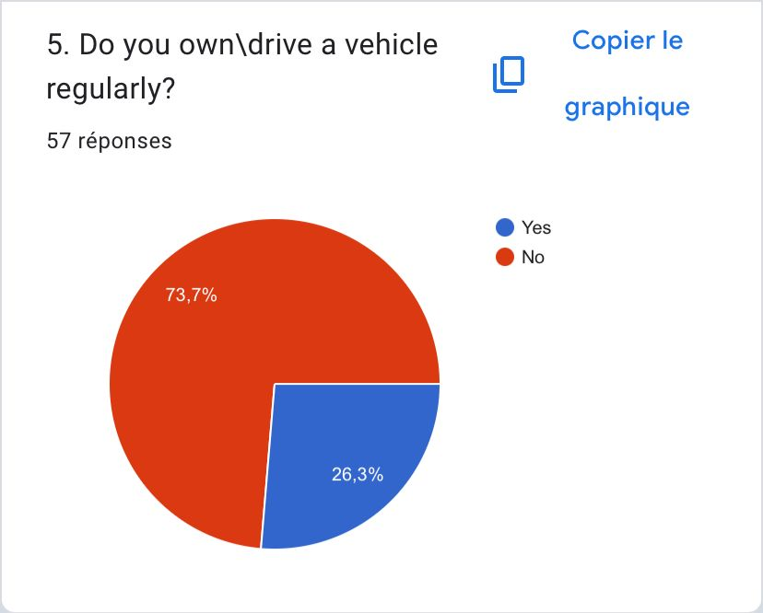

Figure 3

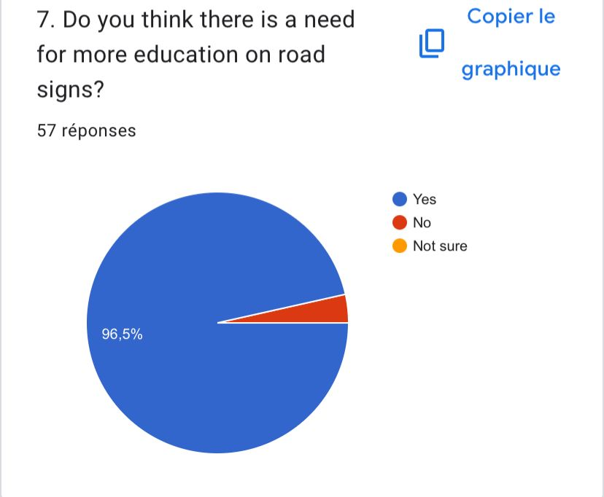

Figure 4

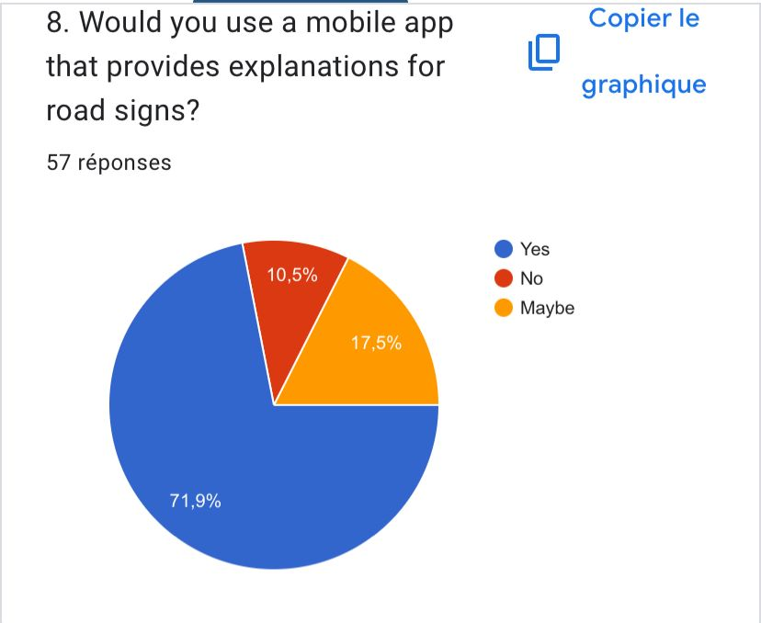

Figure 5

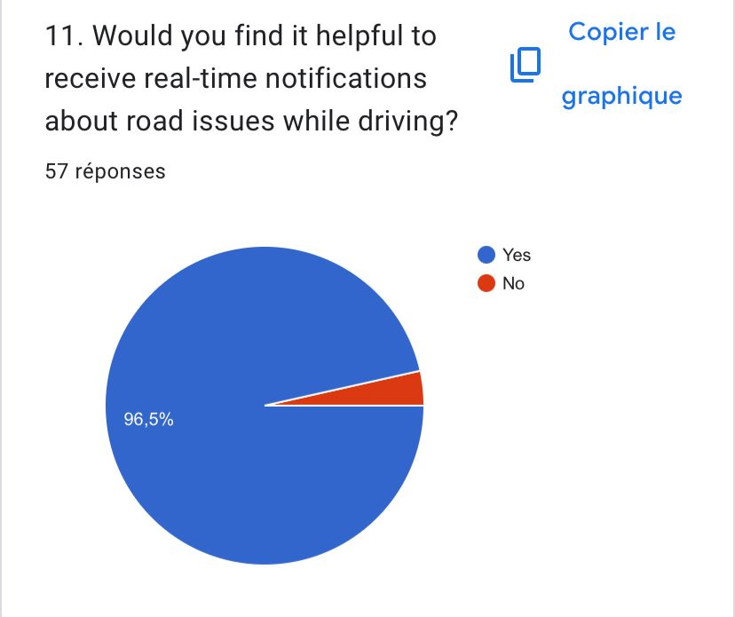

Figure 6

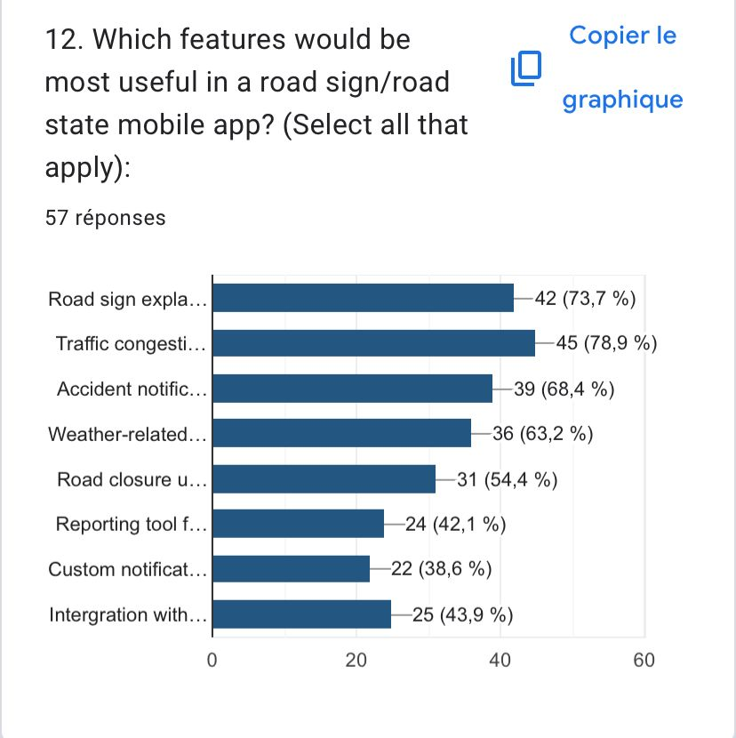

Figure 7

#### ****b. Interviews****

* The main bojective of this activity was to gain in-depth insights from key stakeholders such as transportation authorities and frequent drivers.
* We also Conducted one-on-one interviews with a government officials (The Traditional Ruler of Bonduma Village), and long-distance drivers in the Cities of Buea and Douala .
* The Interviews were made up of 5 questions:

1. What are the main challenges you face when using the roads?
2. What specific needs do you have, and want the app to fulfill?
3. How would you like to receive alerts?
4. What type of alerts would you like to receive?
5. Which extra features would you like the app to have?

We got the following insights, from the responses:

* Most common age group interviewed, was from ages 30 years to 45 years.
* The percentage of male was 88% and 12% for females.
* The percentage of Smart phone ownership was around 90%.
* The stakeholders use the roads very frequently.

#### ****c. Brainstorming****

* As a team, we carried out this activity, to generate innovative ideas for the app’s features and functionality.
* brainstorming sessions focused on app design, and user interface.

### ****3. Data Gathering****

#### ****Types of Data Collected****

1. **Road Sign Data**:
   * Comprehensive information about road signs (e.g., meanings, images, associated hazards).
   * Source: road safety manuals.

**b. User Preferences**:

* + Notification preferences (e.g. types of alerts).
  + Collected through surveys and interviews.

This activity helped use to:

* Ensure the app has accurate, localized, and reliable road sign and road condition information.
* Understand user behavior, preferences, and pain points to improve app usability.

### ****4. Data Cleaning****

#### ****Definition****

Data cleaning involves refining and organizing raw data to ensure accuracy, consistency, and relevance. For this project, the gathered data must be validated and structured to avoid errors in the app’s functionality.

#### ****We carried out the following Steps for Data Cleaning****

**a. Removed Redundant Data**:

* + Eliminated duplicate road sign entries or irrelevant traffic updates.

1. **Validated Data Accuracy**:
   * Cross-checked road sign information with official government sources.
   * Ensured real-time updates (e.g., traffic congestion, weather alerts) are accurate by integrating trusted APIs.
2. **Standardized Data Formats**:
   * Ensured consistent formats for road sign images, traffic data, and user reports.

### ****5. User Reluctance Assessment****

This was to identify potential reasons why users might hesitate to adopt or use the app. Addressing these concerns early can improve user adoption and satisfaction.

#### ****Potential Issues and Solutions****

1. **Privacy Concerns**:
   * Users expressed worry about sharing their location data.
   * To tackle this, we can implement clear privacy policies and allow users to control data sharing preferences.
2. **Notification Fatigue**:
   * Excessive or irrelevant notifications might frustrate users.
   * To tackle this, we can enable users to customize notification types and frequency.
3. **Usability Challenges**:
   * Users may find the app difficult to navigate or interact with while driving.
   * To tackle this, we will ensure to design a simple, intuitive interface with voice-enabled notifications.
4. **Lack of Trust in Crowdsourced Data**:
   * Users may doubt the accuracy of updates provided by other users.
   * To tackle this, we can include a verification system for user-submitted reports (e.g., upvoting/downvoting reports).

**Limitations**

Some of the Limitations we faced while at this face of the project include:

* Some individuals did not want to take part in the survey
* It was difficult to get in touch with more vehicle owners
* Some people are not well educated on road signs, issues and related tech solutions

### ****Conclusion****

Requirement gathering phase for the Road Sign and Road State Mobile Notification Application is a critical phase that ensures the app meets the needs of its users and stakeholders. Through stakeholder identification, effective techniques like surveys and interviews, data gathering and cleaning, and addressing user reluctance, the project will establish a good foundation for the subsequent phases of the project.