1.

import json  
import time  
from bs4 import BeautifulSoup  
import requests  
import urllib.parse  
from selenium import webdriver  
import networkx as nx  
import matplotlib.pyplot as plt  
  
  
  
  
  
def search_person_by_name(name):  
 url = 'https://search.douban.com/movie/subject_search?search_text=' + urllib.parse.quote(name)  
 # user_agent='Mozilla/5.0 (Windows NT 10.0; Win64; x64) AppleWebKit/537.36 (KHTML, like Gecko) Chrome/105.0.0.0 Safari/537.36'  
 browser = webdriver.Chrome()  
 browser.get(url)  
 soup = BeautifulSoup(browser.page_source, 'html.parser')  
 results = soup.select('#wrapper .detail .title a')[0]  
 name = results.text  
 id = results['href'].strip().split('/')[-2]  
 web = results['href']  
 person = (name, id, web)  
 print(person)  
 time.sleep(2)  
 return person  
  
  
def search_movies_by_person(person):  
 list = []  
 url = f'https://movie.douban.com/celebrity/{person[1]}/movies'  
 while True:  
 print(url)  
 browser = webdriver.Chrome()  
 browser.get(url)  
 soup = BeautifulSoup(browser.page_source, 'html.parser')  
 movies = soup.select('#wrapper .article dd h6 a')  
 for item in movies:  
 name = item.text.strip()  
 id = item['href'].strip().split('/')[-2]  
 web = item['href']  
 moive = (name, id, web)  
 list.append(moive)  
 print(moive)  
 time.sleep(1)  
 if len(soup.select('.next a')) == 0:  
 break  
 url = f'https://movie.douban.com/celebrity/{person[1]}/movies' + soup.select('.next a')[0]['href']  
 print(url)  
 return list  
  
  
def search_persons_by_moive(moive):  
 list = []  
 url = f'https://movie.douban.com/subject/{moive[1]}/celebrities'  
 print(url)  
 browser = webdriver.Chrome()  
 browser.get(url)  
 soup = BeautifulSoup(browser.page_source, 'html.parser')  
 results = soup.select('.list-wrapper')  
 for item in results:  
 if (item.select('h2')[0].text.strip() == '演员 Cast'):  
 members = item.select('li .name a')  
 for member in members:  
 name = member.text.strip().split(' ')[0]  
 id = member['href'].strip().split('/')[-2]  
 web = member['href']  
 number = (name, id, web)  
 list.append(number)  
 print(number)  
 time.sleep(0.5)  
 return list  
  
  
# 获取演员合作次数字典  
def draw(name):  
 dic = {}  
 person = search_person_by_name(name)  
 movies = search_movies_by_person(person)  
 for item in movies:  
 numbers = search_persons_by_moive(item)  
 for number in numbers:  
 if number[0] in dic:  
 dic[number[0]] += 1  
 else:  
 dic[number[0]] = 1  
 print(dic)  
 return dic  
  
  
def draw_graph(person_name, num_dict, tp='spring', max_node=50):  
 *"""  
 rela_dict: 节点关系列表，比如：[('张国立', '王刚', 30), ('张国立', '张铁林', 5), ('张国立', '黄晓明', 2)]  
 num_dict: 每个演员参与合作的电影数量比如：{'张国立':33,'王刚':30,'张铁林':5,'黄晓明':2}  
 person_name: 演员名称  
 tp: 图形分布类型（circular/spring/shell/spectral）  
 max_node：待显示的节点数量，默认是50个  
 """* rela_list = [(person_name, person, num_dict[person]) for person in num_dict if person != person_name]  
  
 plt.figure(figsize=(50, 50))  
  
 if len(rela_list) > max_node:  
 rela_list = sorted(rela_list, key=lambda x: x[2], reverse=True)  
 rela_list = rela_list[0:max_node]  
 for node in rela_list:  
 print(node)  
  
 G = nx.Graph()  
 for u, v, w in rela_list:  
 G.add_edge(u, v, weight=w)  
  
 layout = tp + "_layout"  
  
 attr = getattr(nx, layout)  
 if not attr:  
 print("can not find layout", tp)  
 attr = nx.circular_layout  
 pos = attr(G)  
 if tp == 'circular':  
 pos = nx.circular_layout(G) # 节点圆环分布  
 elif tp == 'spring':  
 pos = nx.spring_layout(G) # 节点放射分布  
 elif tp == 'shell':  
 pos = nx.shell_layout(G) # 节点同心圆分布，当节点较少时等同于圆环分布  
 elif tp == 'spectral':  
 pos = (nx.  
  
 spectral_layout(G)) # 拉普拉斯特征向量分布  
 else:  
 pos = nx.circular_layout(G) # 节点圆环分布  
  
 # 画边  
 nx.draw_networkx_edges(G, pos, width=[d['weight'] for (u, v, d) in G.edges(data=True)], edge_color='green')  
 # 画点  
 if num_dict:  
 nx.draw_networkx_nodes(G, pos, node_size=[(num_dict[node]) * 800 for node in G.nodes()], node_color='red')  
 nx.draw_networkx_nodes(G, pos, node_size= [(num_dict[node]) * 200 for node in G.nodes()], with_label=True, node_color='red')  
 # 标记  
 nx.draw_networkx_labels(G, pos, font_size=40, font_color='black', font_family='simhei')  
 # 画图  
 plt.rcParams['figure.figsize'] = (80.0, 40.0)  
 plt.savefig(person_name + ".png")  
  
  
def info(name):  
 num_dict = draw(name)  
 draw_graph(name, num_dict, 'spring')  
  
  
name = input('请输入演员名字：')  
info(name)

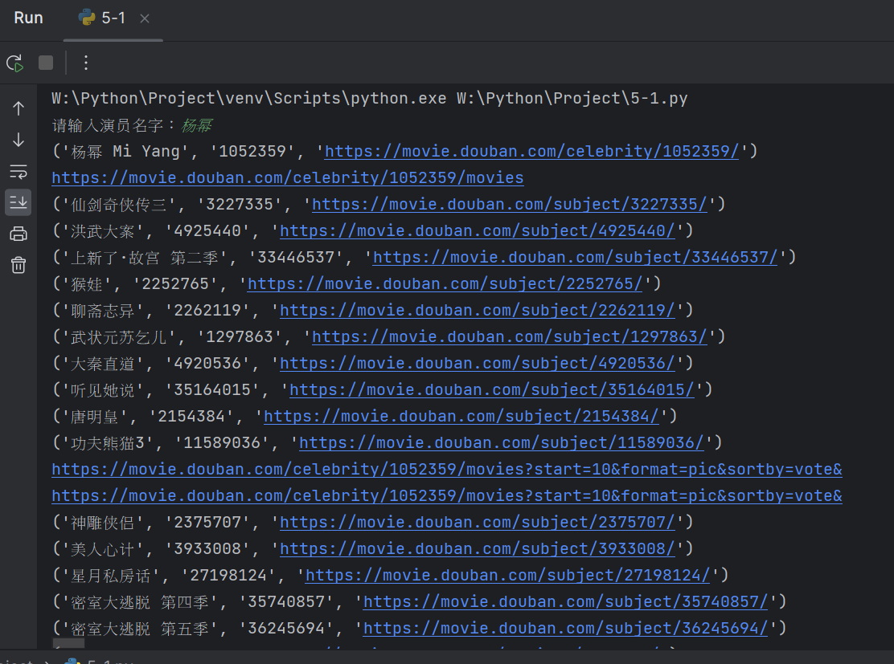

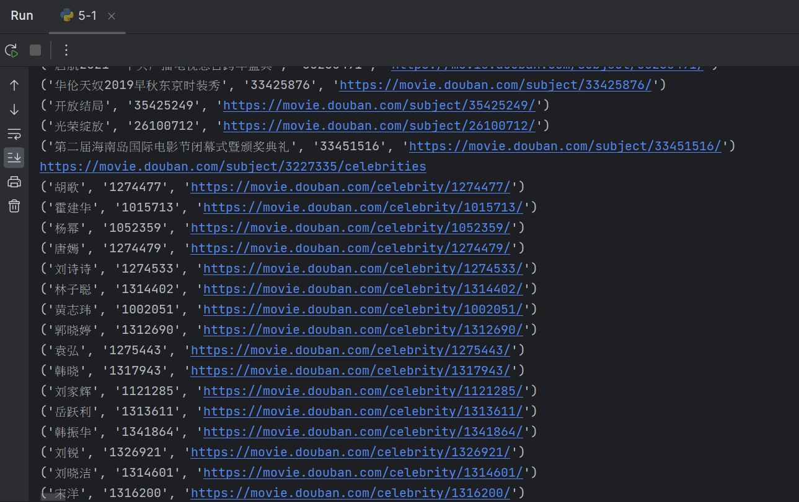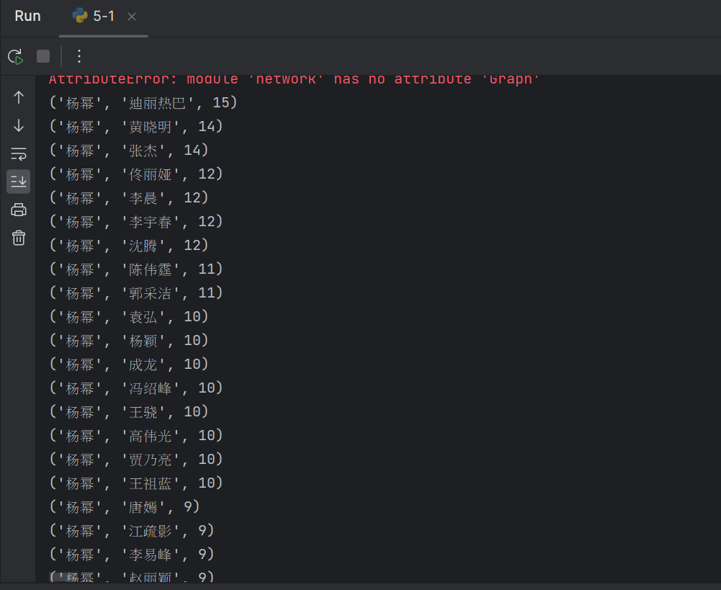

2.

import json  
import time  
from bs4 import BeautifulSoup  
import requests  
import jieba.analyse  
import jieba  
import wordcloud  
  
def get_dm_list_by_url(dm_url_list):  
 time.sleep(1.0)  
 dm_list = []  
 for cid in dm_url_list:  
 url = f"https://api.bilibili.com/x/v1/dm/list.so?oid={cid}"  
 response = requests.get(url)  
 response.encoding = "utf8"  
 soup = BeautifulSoup(response.text, "xml")  
 for dm in soup.select("d"):  
 dm_list.append(dm.text.strip())  
 time.sleep(1.0)  
 print(dm_list)  
  
  
def get_dm_list_by_movie_id(movie_id):  
 user_agent = ('Mozilla/5.0 (Windows NT 10.0; Win64; x64) '  
 'AppleWebKit/537.36 (KHTML, like Gecko) '  
 'Chrome/116.0.0.0 Safari/537.36 Edg/116.0.1938.69')  
 url = f"https://api.bilibili.com/x/web-interface/view/detail?byid={movie_id}"  
 headers = {  
 'User-Agent': user_agent  
 }  
 response = requests.get(url=url, headers=headers)  
 data = json.loads(response.text)  
  
 if "data" in data and "View" in data["data"] and "pages" in data["data"]["View"]:  
 dm_url_list = [page['cid'] for page in data["data"]["View"]["pages"]]  
 print(dm_url_list)  
 return get_dm_list_by_url(dm_url_list)  
 else:  
 print("無效的JSON結構")  
  
if __name__ == "__main__":  
 get_dm_list_by_movie_id("BV1Z8411q7gy")  
  
def get_keyword_by_dm(dm_list):  
 txt = ''.join(dm_list)  
 jieba.setLogLevel(20)  
 jieba.initialize()  
 kw_list = jieba.analyse.extract_tags(txt, topK=100)  
 print(kw_list)  
 return kw_list  
  
def gen_wordcloud(kw_list, png_name):  
 string = ' '.join(kw_list)  
 print(string)  
 wc = wordcloud.WordCloud(  
 width=1000,  
 height=700,  
 background_color='white',  
 font_path='msyh.ttc',  
 scale=15,  
 contour_width=5,  
 contour_color='red',  
 )  
 wc.generate(string)  
 wc.to_file(png_name)

3.

import requests  
import time  
from bs4 import BeautifulSoup  
from selenium import webdriver  
  
browser = webdriver.Chrome()  
url = "https://bj.lianjia.com/ershoufang/rs回龙观/"  
  
while True:  
 time.sleep(1.0)  
 browser.get(url)  
 soup = BeautifulSoup(browser.page_source, "html.parser")  
  
 sell_list = soup.select("ul.sellListContent li div.info")  
 for sell in sell_list:  
 print(sell)  
  
 page_list = soup.select("div.house-st-page-box a")  
 for page in page_list:  
 print(page.text, page['href'])  
 if page.text.strip() == "下一页":  
 url = "https://bj.lianjia.com" + page['href']  
 break  
 else:  
 break

