**Power Electronics-Assignment-2**

A DC load requires a mean voltage of 160V and takes a level current of 80A. Design rectifier circuits to the following configurations, specifying the required AC supply voltage and the required voltage and current ratings of the diodes (double the peak voltage and r.m.s current), draw waveforms of the load voltage, the AC supply current, and the diode voltage and current.

1. **Single-phase bridge**

Required AC supply voltage:

$$V_{d}=\frac{2\sqrt{2}}{π}V_{s}$$

$$V_{s}=\frac{πV_{d}}{2\sqrt{2}}=\frac{π×160}{2\sqrt{2}}=177.7 V$$

Required voltage ratings of the diodes:

$$2\sqrt{2}V_{s}=160π=502.7 V$$

Required current ratings of the diodes:

$$2I_{d1}=2×\frac{80}{\sqrt{2}}=113.1 A$$

Rectifier circuits:

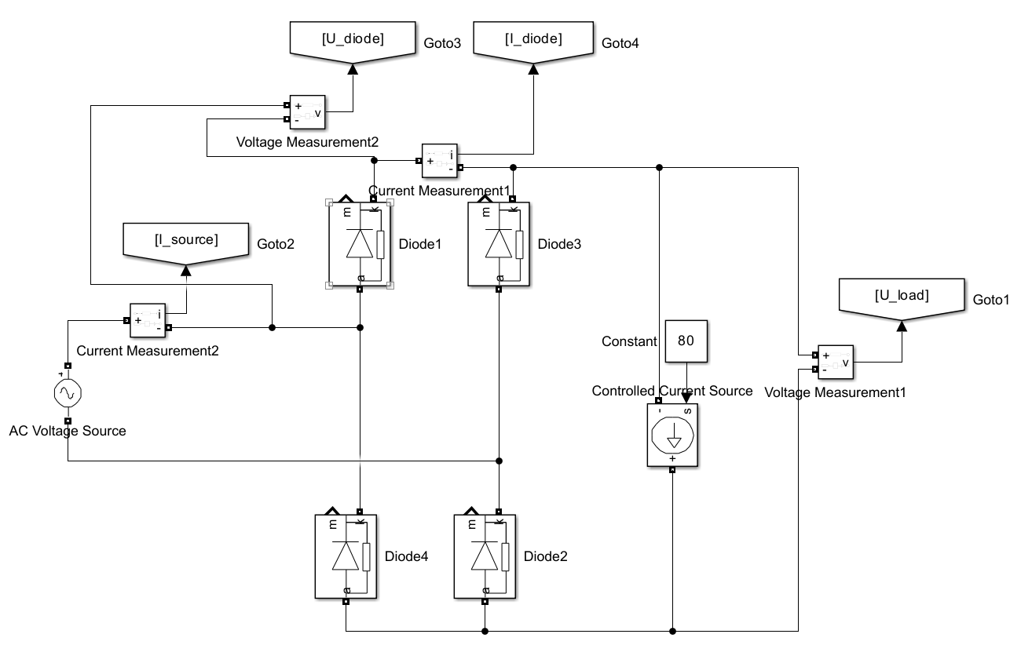

Waveforms:

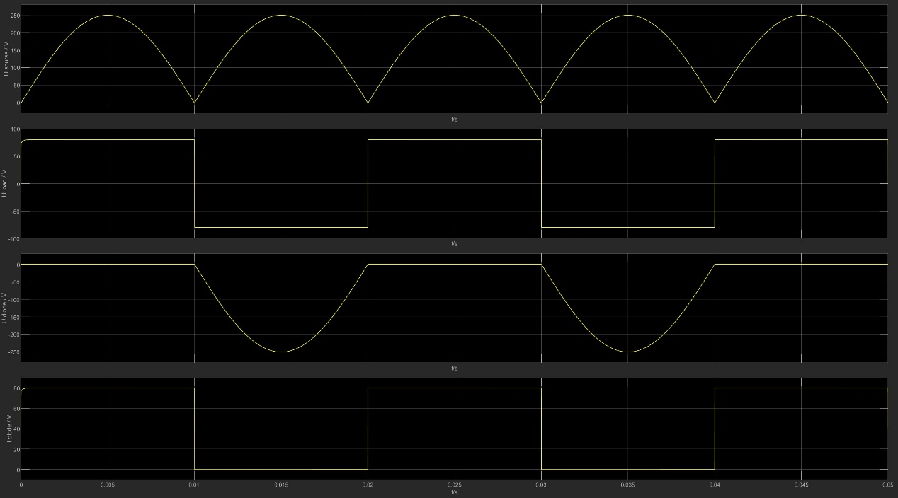

1. **Three-phase bridge**

Required AC supply voltage:

$$V_{d}=\frac{3\sqrt{6}}{π}V_{s}$$

$$V_{s}=\frac{πV_{d}}{3\sqrt{6}}=\frac{π×160}{3\sqrt{6}}=68.4 V$$

Required voltage ratings of the diodes:

$$2\sqrt{6}V_{s}=\frac{2×160π}{3}=335.1 V$$

Required current ratings of the diodes:

Rectifier circuits:

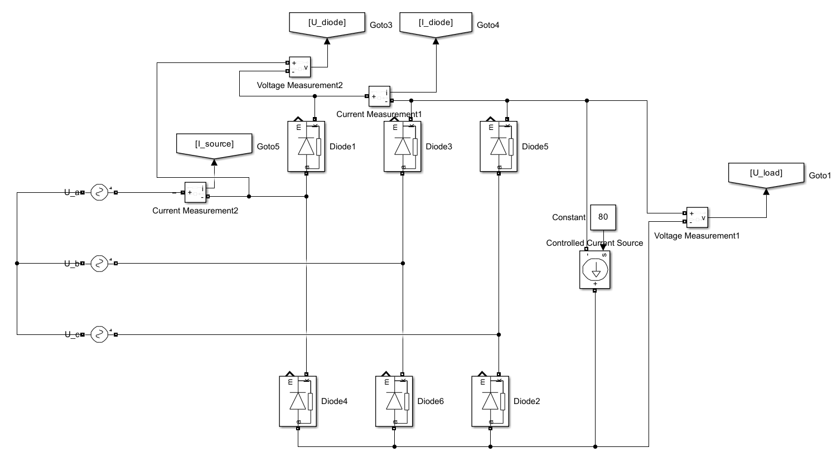

Waveforms:

