**Power Electronics-Assignment-3**

1. Complete the circuit analysis with ac-side inductance of the single-phase thyristor bridge referring to that of the single-phase diode bridge. Derive the expressions of the input current $i_{s}$, the overlap angle and the average voltage.

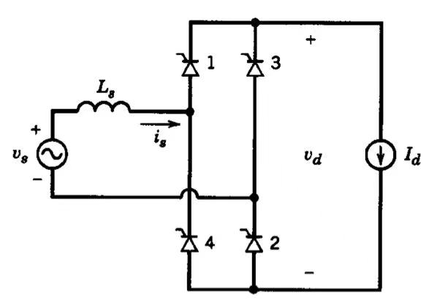

2. A DC load takes a level current of 100A from a single-phase thyristor AC-DC bridge. If the AC phase voltage is 220V and the conditions of the firing delay angle are listed as follows, calculate: 1) the mean load voltage, 2) the power factor on the AC side; draw the waveforms of output voltage, input currents and thyristor voltage with the reference of input voltages. Neglect device volt-drop. Assume the commutation overlap negligible.

${30}^{∘}$

The mean load voltage:

$$V_{d,avg}=\frac{2}{π}V_{smax}\cos{α}=\frac{2}{π}×220×\cos{{30}^{∘}=171.5V}$$

The power factor on the AC side;

$$PF=0.9\cos{α}=0.9\cos{{30}^{∘}=0.7794}$$

Circuits:

Waveforms:

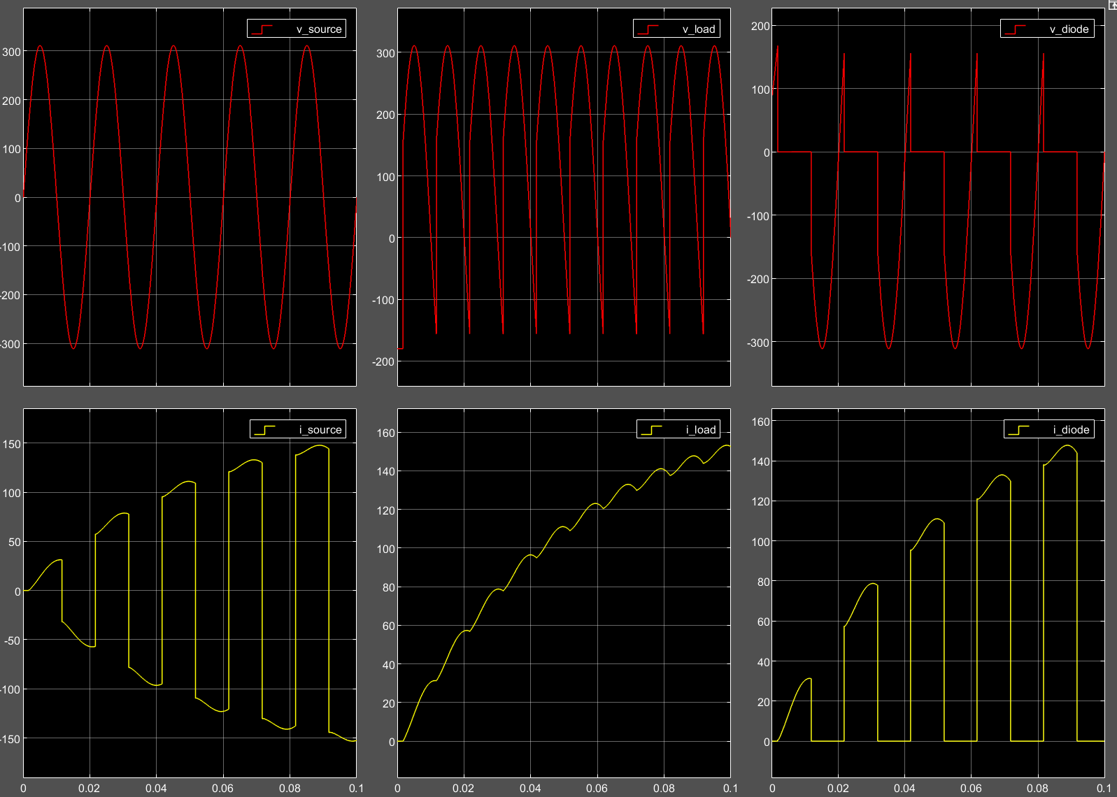

${150}^{∘}$

The mean load voltage:

$$V_{d,avg}=\frac{2}{π}V_{smax}\cos{α}=\frac{2}{π}×220×\cos{{150}^{∘}=-171.5V}$$

The power factor on the AC side;

$$PF=0.9\cos{α}=0.9\cos{{150}^{∘}=-0.7794}$$

Waveforms:

