**Bài 1**

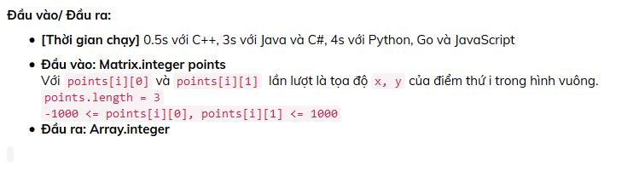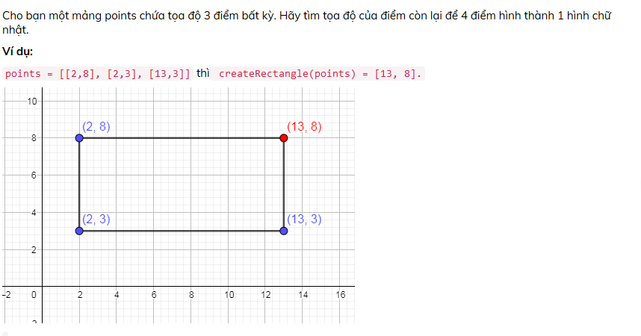Test case

1. [[2, 5], [2, 2], [5, 5]] 🡪 [5, 2]
2. [[2, 8], [2, 3], [13, 3]] 🡪 [13, 8]
3. [[-22, 16], [-14, 6], [-4, 14]] 🡪 [-12, 24]
4. [[40, 5], [25, 5], [40, -10]] 🡪 [25, -10]
5. [[-30, -10], [-35, 15], [-60, 10]] 🡪 [-55, -15]

**Bài 2**

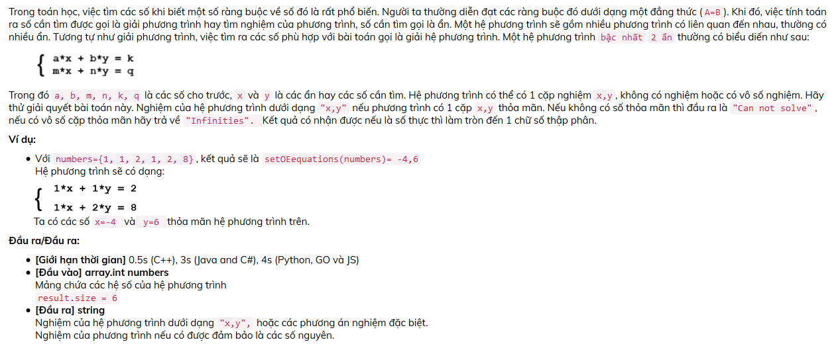

Test case

1. [1,5,2,3,15,6] 🡪 Infinities
2. [1, 1, 2, 1, 2, 8] 🡪 [-4, 6]
3. [1,2,3,4,5,6] 🡪 [-1,2]
4. [1,2,3,1,2,4] 🡪 Cannot solved
5. [1,2,3,7,7,7] 🡪 [-1, 2]
6. [120,187,2911,71,78,1298]🡪 [4, 13]

**Bài 3**

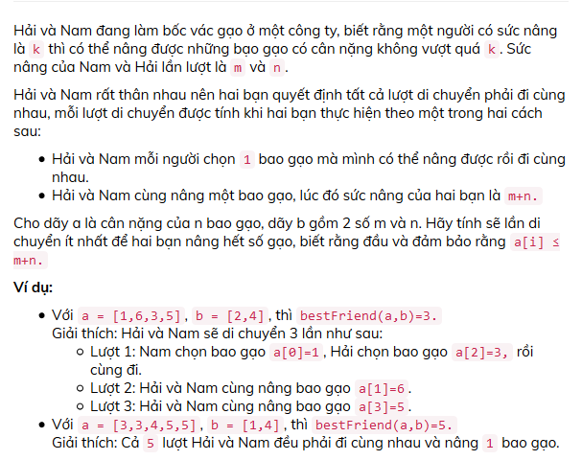

Test case

1. [3,3,4,5,5], [1,4]🡪 5
2. [4,4,1,4,4,4], [2,2]🡪 6
3. [3,6,9,8,7,7,4,11,10,11,2,10,2,10,3,9,8,6,3,1], [3,8]🡪 14
4. [10,1,1,5,9,2,7,8,9,9,5,6,5,2,7], [1,9] 🡪 13
5. [88,52,99,60,18,25,72,15,7,101,46,64,50,6,58,36,72,18,76,24,58,41,86,102,13,66,108,99,29,41], [41, 68]) 🡪 20.

**Bài 4**

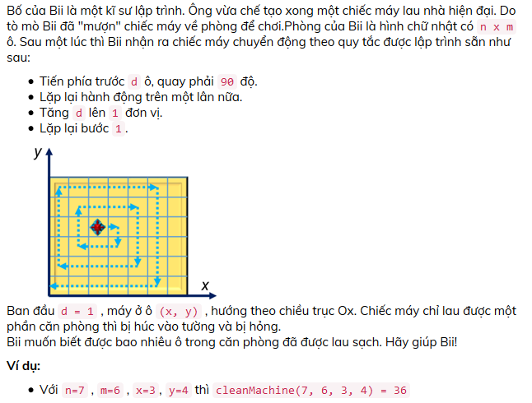

Test case

1. (7, 6, 3, 4) 🡪 36
2. (3, 3, 2, 2) 🡪 9
3. (5, 10, 2, 9) 🡪 16
4. (100, 45, 15, 32)🡪 812
5. (15, 16, 15 , 16) 🡪 1