HANOI UNIVERSITY OF SCIENCE AND TECHNOLOGY

SCHOOL OF ELECTRICAL AND ELECTRONIC ENGINEERING



Design a RISC Stored-Program Machine

A report on Digital Design Using VHDL Project

January 30, 2023

hust

Group 2

Students : Ngô Văn Cảnh 20193204

Phùng Mạnh Dũng 20193210

Nguyễn Danh Khuê 20193224

Advisor : Prof. Võ Lê Cường

Table of Contents

I. Introduction and Overview 3

II. Work distribution 4

III. Design Objective 4

IV. Design Hierarchy 4

V. Hardware composition 4

1. Processing Unit 6

a. Arithmetic Logic Unit 6

b. Register Unit 6

c. Multiplexer 6

2. Control Unit 7

a. Function of the control unit 7

b. Control Signals 7

c. Instruction Set 7

d. Controller States 9

e. State transition diagram 10

f. ASM chart 10

3. Memory Unit 12

VI. Verilog implementation 12

VII. Design Verification 12

1. Register Unit testbench 13

2. Program Counter testbench 14

3. Arithmetic Logic Unit testbench 15

4. Multiplexer testbench 16

5. Full Module Testbench 17

VIII. Conclusion 19

IX. Reference 19

Table of Figure

Figure 1 Execution time of a CPU 3

Figure 2 Hierarchy Table 4

[Figure 3 Architecture 5](https://husteduvn-my.sharepoint.com/personal/canh_nv193204_sis_hust_edu_vn/Documents/Report%20&%20Presentation/Group-2-RISC-SPM-report.docx#_Toc126767983)

[Figure 4 State transition diagram 10](https://husteduvn-my.sharepoint.com/personal/canh_nv193204_sis_hust_edu_vn/Documents/Report%20&%20Presentation/Group-2-RISC-SPM-report.docx#_Toc126767984)

[Figure 5 ASM diagram 11](https://husteduvn-my.sharepoint.com/personal/canh_nv193204_sis_hust_edu_vn/Documents/Report%20&%20Presentation/Group-2-RISC-SPM-report.docx#_Toc126767985)

Figure 6 Register testbench waveform 13

Figure 7 Program Counter testbench waveform 14

Figure 8 ALU testbench waveform 15

Figure 9 Mux_3_1_tb waveform 16

Figure 10 Full Module waveform 1 18

Figure 11 Full Module waveform 2 18

# Introduction and Overview

R

educed instruction-set computers (RISC) are designed to have a **small set of instructions**, which mean a **large number of instructions** per programthat execute in **short clock cycles** per instruction. RISC machines are optimized to achieve efficient pipelining of their instruction streams. The machine also serves as a starting point for developing architectural variants and a more robust instruction set.

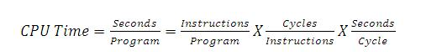

Figure 1 Execution time of a CPU

As opposite to RISC is the CISC ( Complex Instruction Set Computer ) architecture which have a **large set of instructions**, which will **minimize number of instructions** per program but at the cost of an **increase in the number of cycles** per instruction. The designers have to make the tradeoffs to selecting an architecture that serves an application. Table 1 below is all the differences of two architecture. Once an architecture has been selected, a circuit that has sufficient performance (speed) must be synthesized. Hardware description languages (HDLs) play a key role in this process by modeling the system and serving as a descriptive medium that can be used by a synthesis tool.

|  |  |
| --- | --- |
| RISC | CISC |
| Focus on software | Focus on hardware |
| Uses only Hardwired control unit | Uses both hardwired and microprogrammed control unit |
| Transistors are used for more registers | Transistors are used for storing complex  Instructions |
| Fixed sized instructions | Variable sized instructions |
| Can perform only Register to Register Arithmetic operations | Can perform REG to REG or REG to MEM or MEM to MEM |
| Requires more number of registers | Requires less number of registers |
| Code size is large | Code size is small |
| An instruction executed in a single clock cycle | Instruction takes more than one clock cycle |
| An instruction fit in one word | Instructions are larger than the size of one word |

Table 1 RISC vs. CISC

Our design is a modified version from the reference book that can be found at the end of this text. Though the book explained pretty clear about this topic, I’m still going to discuss as manything as posible in my word. The book even contains a full verilog implementation code already, but as we “copy” and try to run it, a few bugs still found. So we have spent quite a lot of time to fix and optimize the code.

Check out my github link for the source code : <https://github.com/canh25xp/RISC-SPM>

# Work distribution

|  |  |  |  |
| --- | --- | --- | --- |
|  | Cảnh | Khuê | Dũng |
| Leader | X |  |  |
| Researching | X | X | X |
| Code Writer and simulation | X |  |  |
| Testing and Fixing |  | X | X |
| Report |  |  | X |
| Presentation | X | X | X |

# Design Objective

The goal of this project is to design a RISC-SPM or Reduced Instruction Set Computer Store Program Machine using verilog HDL. As the name already suggest, the final design should be able to :

* Read and write data from the memory
* Performing arithmetic and logic operations base on the instruction.
* Execute the program store inside the memory ( A program is just a sequence of instructions )

# Design Hierarchy

We using the Top-Down methodology to design the system. Which mean the top-level block ( module ) is define first, all the sub-blocks ( instances ) necessary to build the top-level is define later. The hierarchy tree is shown in the *figure 2*

Figure 2 Hierarchy Table

As you can see in the diagram. The top-block is the module RISC-SPM, it called out three sub-block instances, which is the Control Unit, Processing Unit and Memory_Unit. The Processing Unit is then call out 7 Register Unit, a D-FlipFlop, a Program Counter, 2 Multiplexer and a Arithmetic Logic Unit.

# Hardware composition

RISC-SPM consists of three functional units :

* Processing Unit ( Processor )
* Controll Unit ( Controller )
* Memory Unit ( RAM )

The Overall Architecture of the RISC-SPM is shown in *figure 3*.

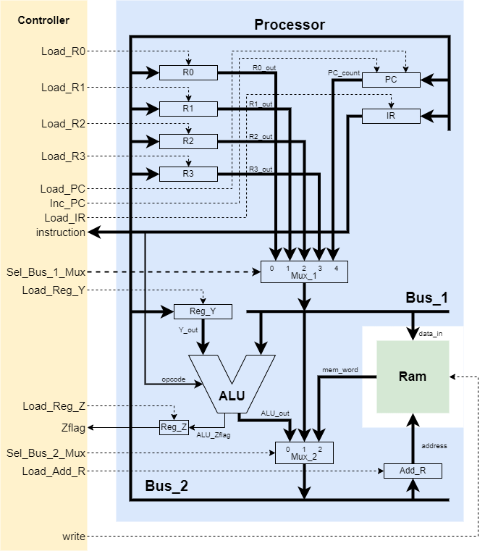Program instructions and data are stored in memory

Figure 3 Architecture

The Program Counter (PC) contains the address of the next instruction to be executed

The address register (Add_R) contains the address of the memory location that will be addressed next by a read or write operation.

The Instruction Register (IR) contains the instruction that currently being executed

## Processing Unit

The processor includes registers, buses, control lines, and an ALU capable of performing arithmetic and logic operations on its operands depends on the opcode held in the instruction register. Its take control from the Control_Unit, manipulate the Registers and read/write data to Memory_Unit.

### Arithmetic Logic Unit

For the purposes of this example, the ALU has two operand datapaths, data_1 and data_2, and its instruction set is limited to only 4 instructions, that is :

|  |  |
| --- | --- |
| Opcode | Action |
| ADD | Adds the datapaths to form data_1 + data_2 |
| SUB | Subtracts the datapaths to form data_1 - data_2 |
| AND | Takes the bitwise and of the datapaths data_1 & data_2 |
| NOT | Takes the bitwise Boolean complement of data_1 |

The ALU take the output of Reg_y is input for data_in and Bus_1 as input for data_2.

The Output result of the ALU is go to the Mux_2 and the zero flag bit is go to input of the Reg_Z. Note that the zero flag bit is set ( bit 1 ) when the ALU result is equals to 0.

### Register Unit

There are 9 registers in our design :

* 5 general-purpose registers R0, R1, R2, R3, Reg_y ( 8-bit )
* 3 special purpose register PC, IR, Add_R ( 8-bit )
* 1 flag register Reg_Z ( 1-bit )

All registers have a load signal to store data, a clock signal (clk) to synchronize and a reset signal (rst) to erase data (all bits are set to 0). Note that the **reset signal is active low**, which mean it’ll reset when signal is low (0)

The zero flag register Reg_Z is a 1-bit register, so basically it is a D flip flop.

The Program Counter Register (PC) has an additional signal Inc_PC to increase PC by 1 unit.

### Multiplexer

There are 2 multiplexers in the Processing Unit :

* Mux_1 : it's a 5-1 multiplexer
  + Output : Bus_1
  + Input : R0, R1, R2, R3, PC
  + Control input : Sel_Bus_Mux_1 ( 3 bits )
* Mux_2 : it's a 3-1 multiplexer
  + Output : Bus_2
  + Input : ALU's output, Bus_1
  + Control input : Sel_Bus_Mux_1 ( 2 bits )

An instruction can be fetched from memory, placed on Bus_2, and loaded into the instruction register. A word of data can be fetched from memory, and steered to a general-purpose register or to the operand register (Reg_Y) prior to an operation of the ALU. The result of an ALU operation can be placed on Bus_2, loaded into a register, and subsequently transferred to memory. A dedicated register (Reg_Z) holds a flag indicating that the result of an ALU operation is 0.

## Control Unit

The Control Unit is a FSM ( Finite State Machine ), or more specifically, a Mealy Machine. Because the output (The control signals) of it depends on both the state and external input (instruction, Zflag)

### Function of the control unit

* Determine when and which registers to be load
* Select the path of data through the multiplexers
* Determine when data should be written to memory
* Control the tri-state buffers in the architecture.

### Control Signals

There are 13 output signals of the controller, 1 instruction input, 1 zero flag input and a reset signal input. The Action of each control signal is describe as below.

|  |  |
| --- | --- |
| Control Signal | Action |
| Load_Add_R | Loads the Address Register |
| Load_PC | Loads Bus_2 to the Program Counter |
| Load_IR | Loads Bus_2 to the Instruction Register |
| Inc_PC | Increments the Program Counter |
| Sel_Bus_1_Mux | Selects among the Program Counter, R0, R1, R2, and R3 to drive Bus_1 |
| Sel_Bus_2_Mux | Selects among ALU_out, Bus_1, and memory to drive Bus_2 |
| Load_R0 | Loads general purpose register R0 |
| Load_R1 | Loads general purpose register R1 |
| Load_R2 | Loads general purpose register R2 |
| Load_R3 | Loads general purpose register R3 |
| Load_Reg_Y | Loads Bus_2 to the register Reg_Y |
| Load_Reg_Z | Stores the zero Flag of ALU in register Reg_Z |
| write | Loads Bus_1 into the memory |

### Instruction Set

A machine language program consists of a stored sequence of **8-bit words** (bytes). The format of an instruction of RISC_SPM can be long or short, depending on the operation :

* Short instructions : requires 1 byte of memory to specifies 4-bit opcode, 2-bit source register address, a 2-bit destination register address.
* Long instruction : requires 2 bytes of memory. The first word of a long instruction contains a 4-bit opcode. The remaining 4 bits of the word can be used to specify addresses of a pair of source and destination registers, depending on the instruction. The second word contains the address of the memory word that holds an operand required by the instruction.

|  |  |  |  |  |  |  |  |
| --- | --- | --- | --- | --- | --- | --- | --- |
| Opcode | | | | Dst | | Src | |
| 0 | 0 | 1 | 0 | 0 | 1 | 1 | 0 |

Table 2 Short instruction format

|  |  |  |  |  |  |  |  |  |  |  |  |  |  |  |  |
| --- | --- | --- | --- | --- | --- | --- | --- | --- | --- | --- | --- | --- | --- | --- | --- |
| Opcode | | | | Dst | | Src | | Address | | | | | | | |
| 0 | 1 | 1 | 0 | x | x | 1 | 0 | 0 | 0 | 0 | 1 | 1 | 1 | 0 | 1 |

Table 3 Long instruction format

The instruction mnemonics ( opcode ) and their actions are listed below.

|  |  |
| --- | --- |
| Short instruction | |
| NOP | No operation is performed; all registers retain their values. The addresses of the source and destination register are don't-cares, they have no effect. |
| ADD | Adds the contents of the source and destination registers and stores the result into the destination register. |
| SUB | Subtracts the content of the source register from the destination register and stores the result into the destination register. |
| AND | Forms the bitwise and of the contents of the source and destination registers and stores the result into the destination register. |
| NOT | Forms the bitwise complement of the content of the source register and stores the result into the destination register. |
| HALT | Halts execution until reset |
| Long instruction | |
| RD | Reads a word from the location specified by the second byte and loads the result into the destination register. The source register bits are don't-cares. |
| WR | Writes the contents of the source register to the word in memory specified by the address held in the second byte. The destination register bits are don't-cares. |
| BR | Branches the activity flow by loading the program counter with the word at the address specified by the second byte of the instruction. The source and destination bits are don't-cares. |
| BRZ | Branches if the zero flag register is asserted. |

|  |  |  |  |  |
| --- | --- | --- | --- | --- |
| Ins | Opcode | Dst | Src | Action |
| NOP | 0000 | xx | xx | none |
| ADD | 0001 | dst | src | dst <= src + dst |
| SUB | 0010 | dst | src | dst <= dst - src |
| AND | 0011 | dst | src | dst <= src && dst |
| NOT | 0100 | dst | src | dst <= ~ src |
| RD | 0101 | dst | xx | dst <= memory [Add_R] |
| WR | 0110 | xx | src | memory[Add_R] < = src |
| BR | 0111 | xx | xx | PC <= memory[Add_R] |
| BRZ | 1000 | xx | xx | PC <= memory[Add_R] |
| HALT | 1111 | xx | xx | Halts execution until reset (Finish programm) |

The RISC_SPM instruction set is summarized below.

### Controller States

Each instruction has three phases : fetch, decode, and execute.

* Fetching : Retrieves an instruction from memory . Its takes **2 clock cycles**, one to load  
  the address register and one to retrieve the addressed word from memory.
* Decoding : Decodes the instruction, manipulates datapaths ,and loads registers. Its takes **1 clock cycle**
* Execution : Generates the results of the instruction. Its might take **0, 1 or 2 clock cycles**, depends on the instruction :
  + NOP : 0 clock
  + ADD, SUB, AND, NOT : 1 clock
  + RD, WR, BR, BRZ : 2 clocks ( the BRZ instruction might take 0 instruction if the zero flag not set )

So overall, each instruction take around **3-5 clock cycles**.

Below is the table of 11 states and the description of each state

|  |  |
| --- | --- |
| State | Action |
| idle | State entered after reset is asserted. No action. |
| fet1 | Load the Add_R with the contents of the PC. (Note: PC is initialized to the starting address 00H by the reset action.) The state is entered at the first active clock after reset is de-asserted, and is revisited after a NOP instruction is decoded. |
| fet2 | Load the IR with the word addressed by the Add_R, and increment the PC to point to the next location in memory, in anticipation of the next instruction or data fetch. |
| dec | Decode the IR and assert signals to control datapaths and register transfers. |
| exe | Execute the ALU operation for a single-byte instruction, conditionally assert the zero flag, and load the destination register. |
| rd1 | Load the Add_R with the second byte of a RD instruction, and increment the PC. |
| rd2 | Load the destination register with the memory word addressed by the byte loaded in rd1. |
| wr1 | Load the Add_R with the second byte of a WR instruction, and increment the PC. |
| wr2 | Load the source register with the memory word addressed by the byte loaded in wr1. |
| br1 | Load the Add_R with the second byte of a BR instruction, and increment the PC. |
| br2 | Load the PC with the memory word addressed by the byte loaded in br1. |
| halt | Default state to trap failure to decode a valid instruction. |

### Diagram, shape Description automatically generatedState transition diagram

Figure 4 State transition diagram

*Figure 4* is a “State transition diagram”, do not misunderstanding it with “State diagram”, though it might looks like it, it is not. It mearly show how many states are there in the fsm and the transition between them. The ASM chart will give us a full detail about the fsm.

### ASM chart

A full ASM chart is shown in *figure 5*. Some thing to note here, is that because the controller has too many output signals to put on the diagram, so I will only mention about the set (1) signal, other signals is remain as reset (0).

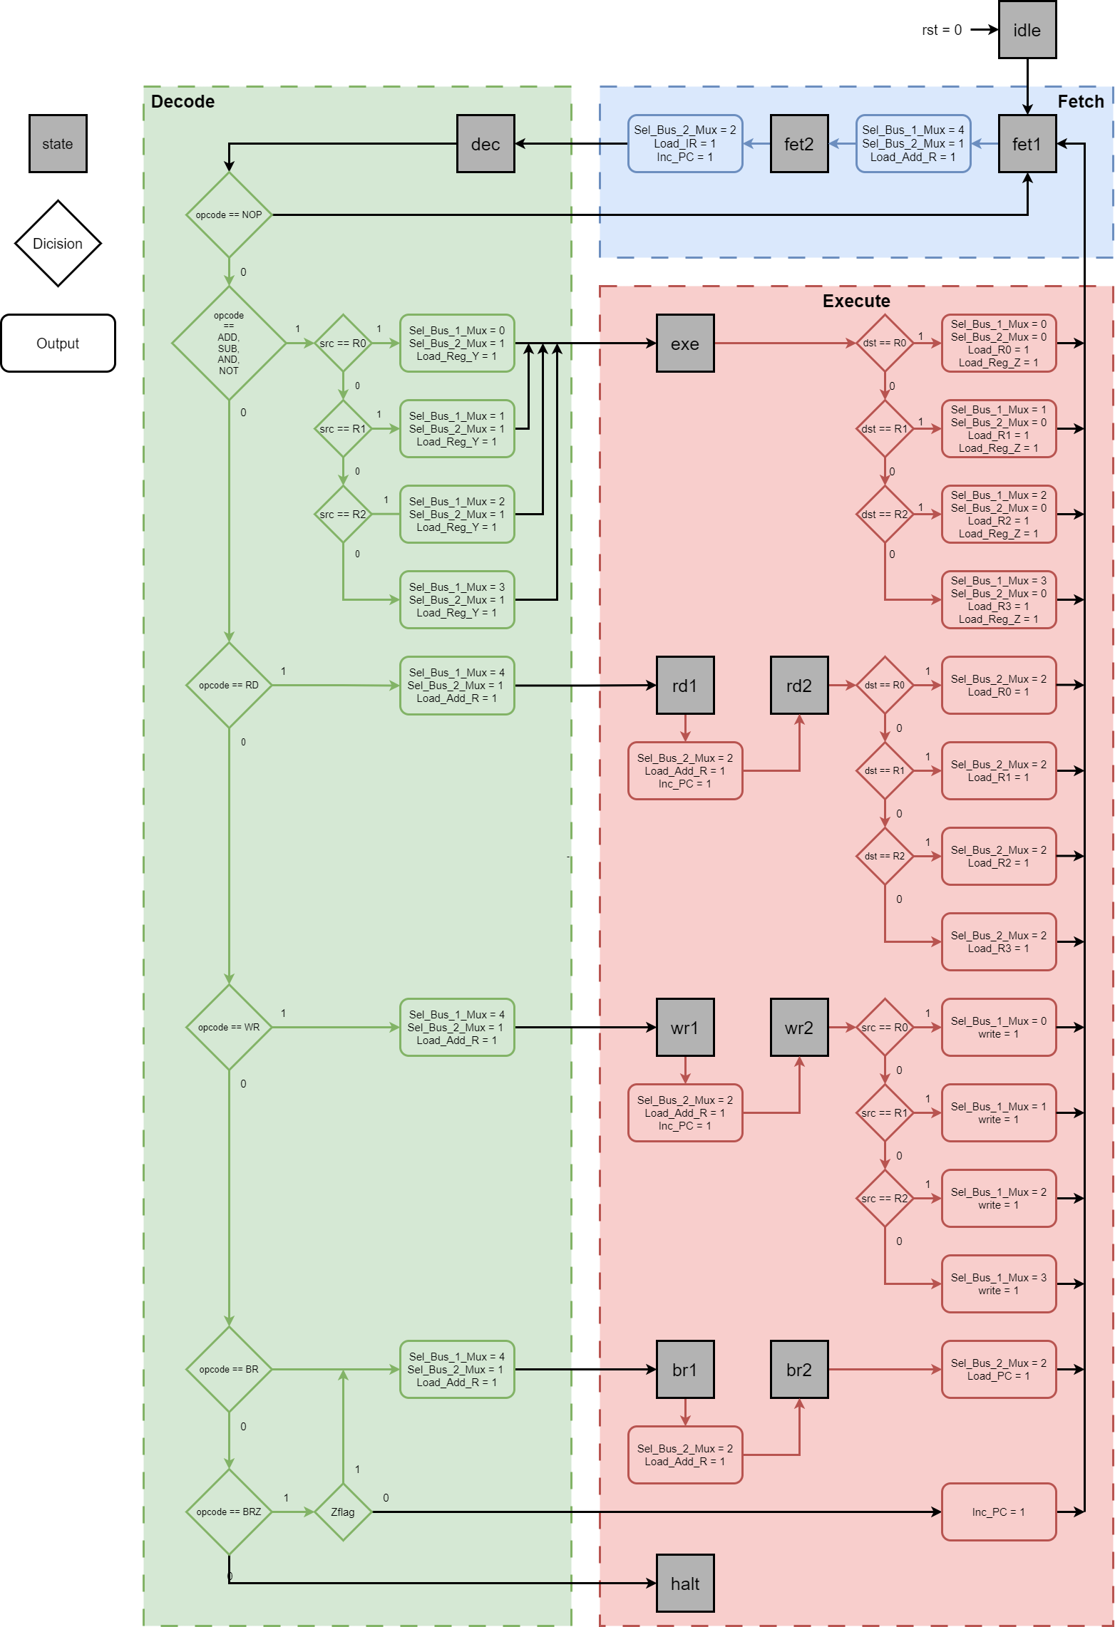

Figure 5 ASM diagram

## Memory Unit

For simplicity, the memory unit of the machine is modeled as **an array** of D flip-flops that form a **256 bytes** RAM.

This RAM ( Random Access Memory ) receiving an 8-bit address and output the data stored in the corresponding address. It also have an 8-bit input data. When the rising edge of the write signal is triggered, the input data is written to the corresponding position of the address.

There are no ROM ( Read-Only Memory ) in this design.

# Verilog implementation

All the verilog source codes is located in my github website or at the end of this report. <https://github.com/canh25xp/RISC-SPM>

# Design Verification

To ensure the working of the machine, each module has it own testbench : Memory Unit, Control Unit, Register Unit, Arithmetic Logic Unit.

## Register Unit testbench

module Register_Unit_tb;

    reg clk,rst, load;

    reg [7:0] data_in = 8'b00110011;

    wire [7:0] data_out;

    Register_Unit Test_Register(data_out, data_in, load, clk, rst);

    initial clk=1'b0;

    always #5 clk=~clk;

    initial begin

            rst=1'b1; load=0'b0;

        #17 load=1'b1;

        #21 load=0'b0;

        #15 data_in = 8'b11001100;

        #3  load=1'b1;

        #5  load=0'b0;

        #10 rst=0'b0;

        #10 $stop;

    end

endmodule

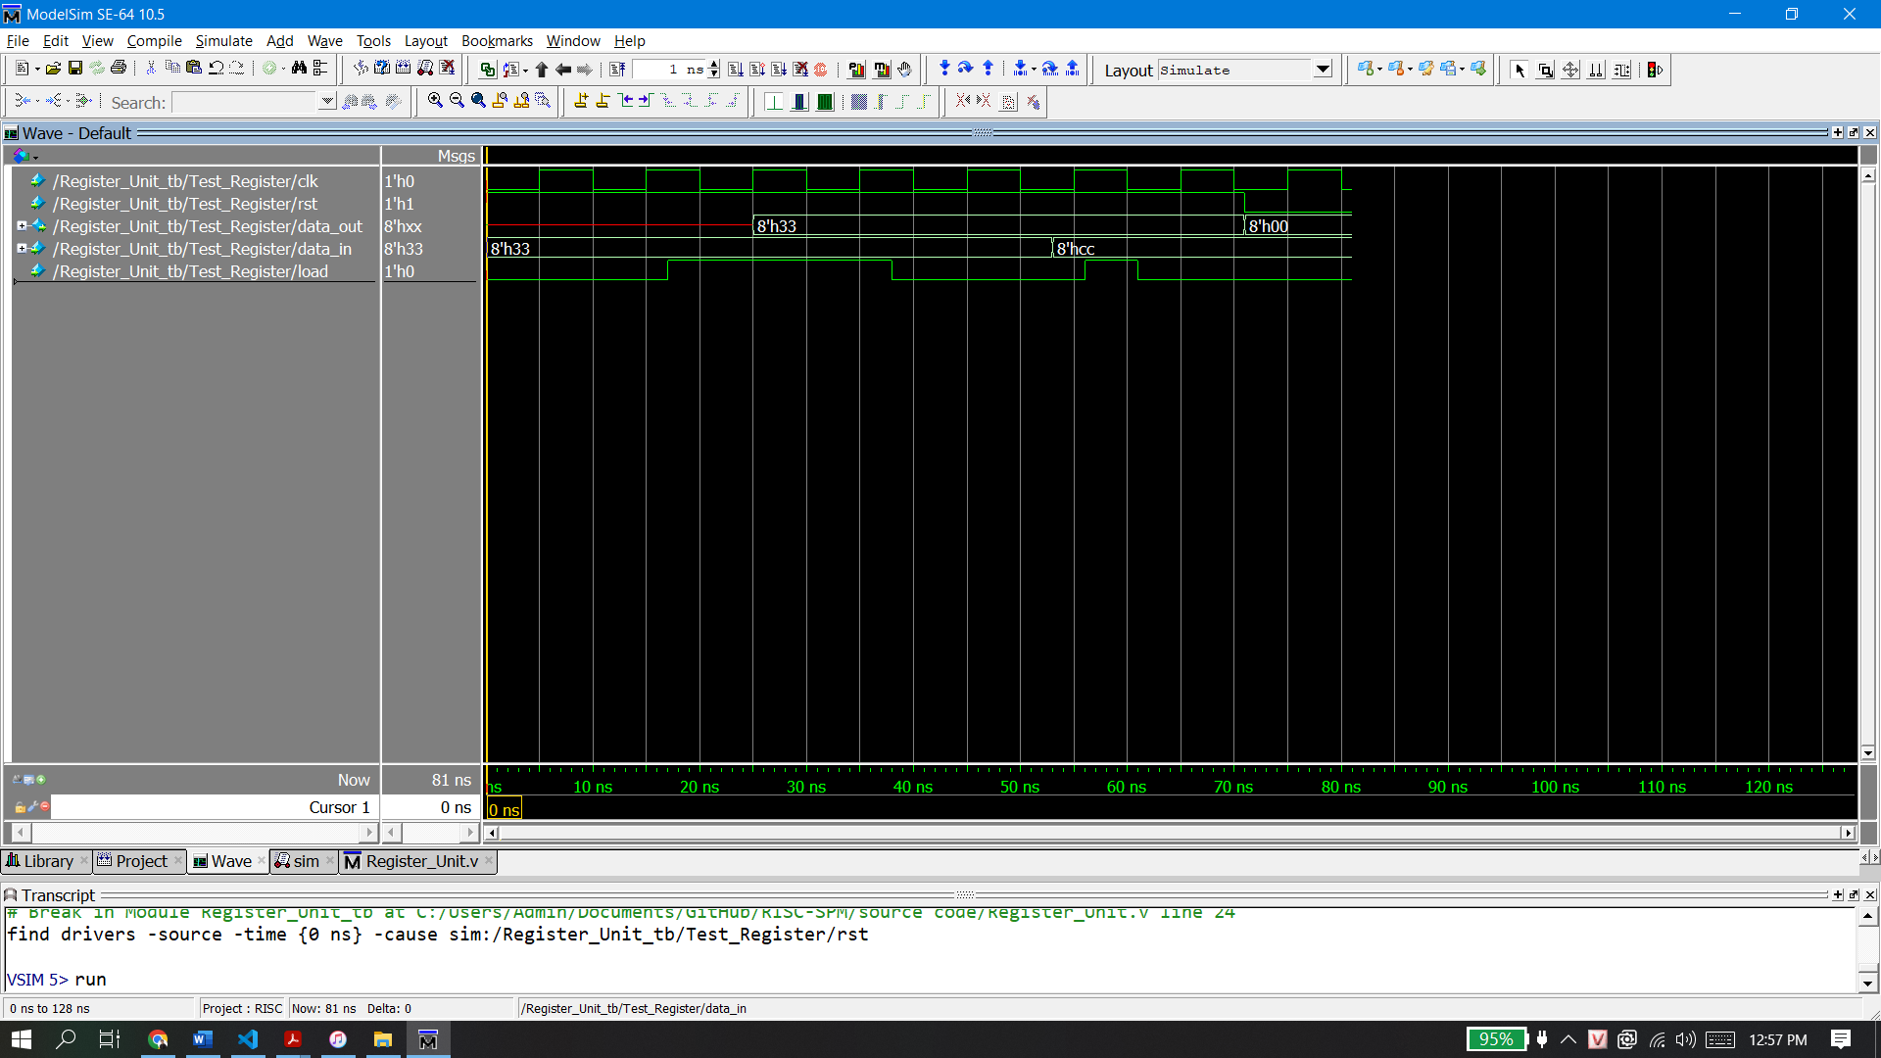

Figure 6 Register testbench waveform

## Program Counter testbench

module Program_Counter_tb;

    reg clk,rst, Load_PC, Inc_PC;

    reg [7:0] data_in;

    wire[7:0] count;

    Program_Counter Test_Counter(count, data_in, Load_PC, Inc_PC, clk, rst);

    initial clk=1'b0;

    always #5 clk=~clk;

    initial begin

                rst=1;Load_PC=0;

        #5      data_in=8'b00000001;

        #5      Load_PC=1;

        #10     Load_PC=0;

        #20     Inc_PC=1;

        #100    Inc_PC=0;

        #5      rst=0;

        #5      rst=1;

        #5      data_in=8'b10000000;

        #5      Load_PC=1;

        #10     Load_PC=0;

    end

endmodule

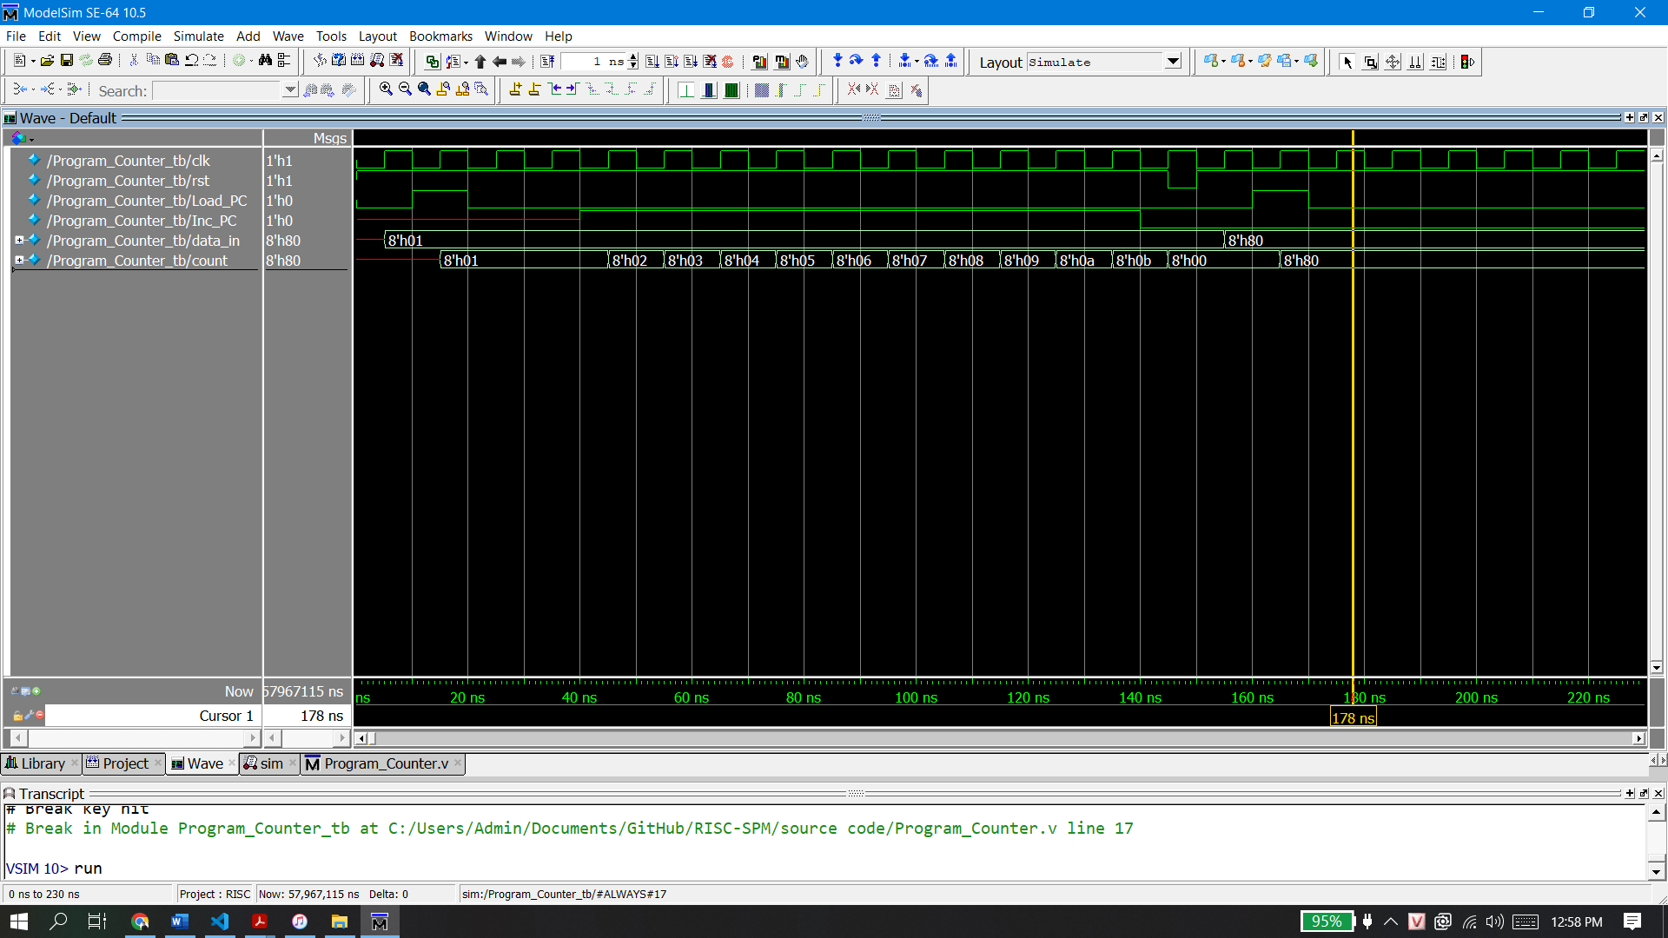

Figure 7 Program Counter testbench waveform

## Arithmetic Logic Unit testbench

module Arithmetic_Logic_Unit_tb;

    reg [7:0] data_1, data_2;

    reg [3:0] opcode;

    wire[7:0] out;

    wire      Zflag;

    Arithmetic_Logic_Unit ALU(out, Zflag, data_1, data_2, opcode);

    initial begin

        #0 data_1 = 64; data_2 = 128; opcode = `NOP;

        // 64 =  01000000

        // 128 = 10000000

        #5 opcode = `ADD; //result should be 192

        #5 opcode = `SUB; //result should be 64

        #5 opcode = `AND; //result should be 0

        #5 opcode = `NOT; //result should be 127

    end

endmodule

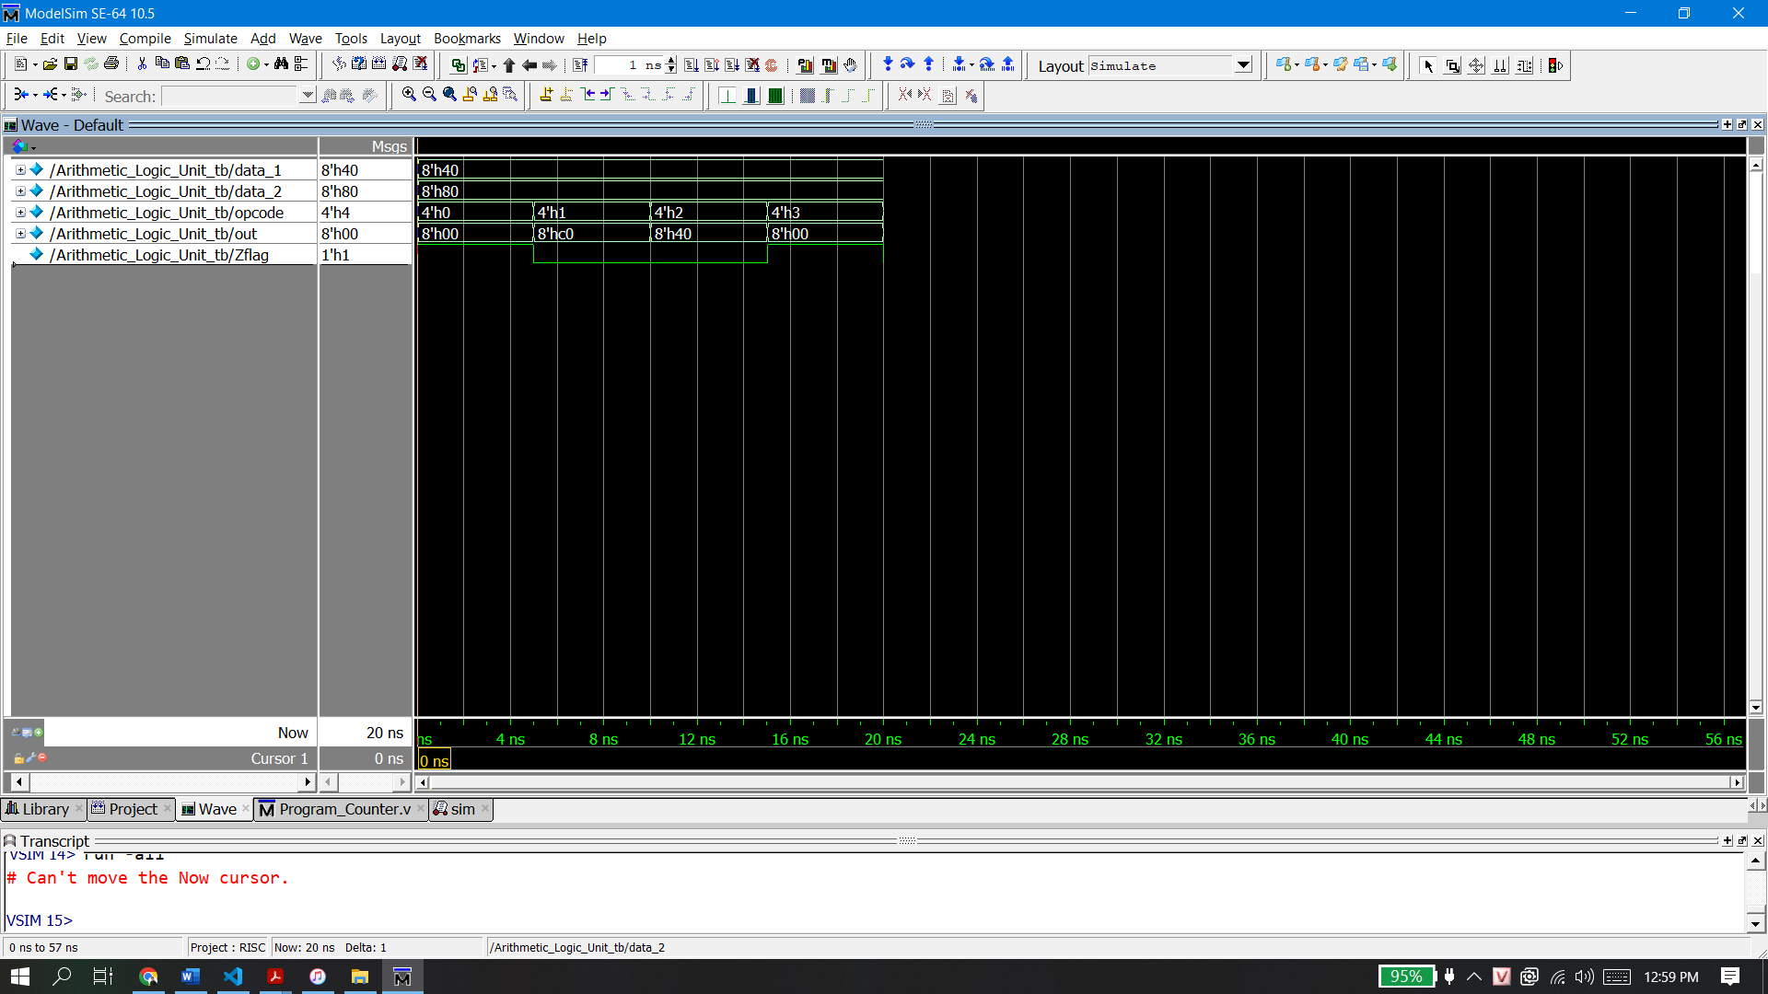

Figure 8 ALU testbench waveform

## Multiplexer testbench

module Mux_3_1_tb;

    reg [7:0] in0, in1, in2;

    reg [1:0] sel;

    wire [7:0] out;

    Mux_3_1 Test_Mux (out, in0, in1, in2, sel);

    initial begin

        in0 = 0; in1 = 128; in2 = 255;

        #5 sel = 2'b00;

        #5 sel = 2'b01;

        #5 sel = 2'b10;

        #5 sel = 2'b11;

    end

endmodule

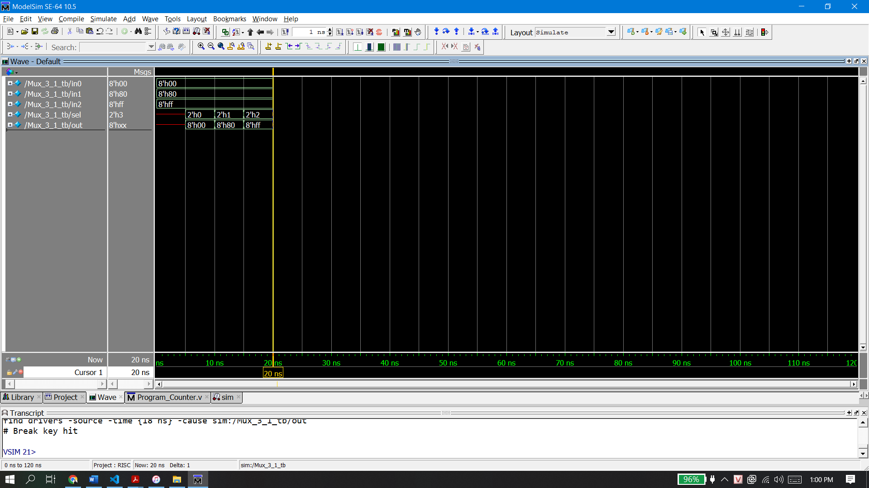

Figure 9 Mux_3_1_tb waveform

## Full Module Testbench

module RISC_SPM_tb;

    reg rst, clk;

    reg[8:0]i;

    RISC_SPM MCU (clk,rst);

    initial begin

        clk = 0;

        forever #5 clk = ~clk;

    end

    initial begin

        #0 rst=0;

            for(i=0;i<=255;i=i+1)

                MCU.Ram.memory[i]=0;

        #10 rst=1;

    end

    initial begin

        #5

        MCU.Ram.memory[0]= 8'b0000_00_00;  //NOP

        MCU.Ram.memory[1]= 8'b0101_01_00;  //R1 = memory[128] = 6

        MCU.Ram.memory[2]= 128;

        MCU.Ram.memory[3]= 8'b0101_00_00;  //R0 = memory[129] = 1

        MCU.Ram.memory[4]= 129;

        MCU.Ram.memory[5]= 8'b0010_01_00;   //R1 = R1 - R0

        MCU.Ram.memory[6]=8'b1000_00_00;   //BRZ to memory[130] = 10 ( HALT )

        MCU.Ram.memory[7]=130;

        MCU.Ram.memory[8]= 8'b0111_00_11;  //BR to memory[131] = 5

        MCU.Ram.memory[9]= 131;

        MCU.Ram.memory[10]=8'b1111_00_00;  //HALT

        //Load data

        MCU.Ram.memory[128]=6;

        MCU.Ram.memory[129]=1;

        MCU.Ram.memory[130]=10;

        MCU.Ram.memory[131]=5;

    end

    initial #2800 $stop;

endmodule

What do we expect the module should behave with this testbench ?

R1 = memory[128] = 6

R0 = memory[129] = 1

R1 = R1 – R0

if ( Zflag == 1 )

PC = memory[130] = 10

HALT

PC = memory[131] = 5

|  |  |
| --- | --- |
| **Address** | Data |
| **0000 0000** | **0000 0000** |
| **0000 0001** | **0101 0100** |
| **0000 0010** | **1000 0000** |
| **0000 0011** | **0101 0000** |
| **0000 0100** | **1000 0001** |
| **0000 0101** | **0010 0100** |
| **0000 0110** | **1000 0000** |
| **0000 0111** | **1000 0010** |
| **0000 1000** | **0111 0011** |
| **0000 1001** | **1000 0011** |
| **0000 1010** | **1111 0000** |
| **…** | **…** |
| **1000 0000** | **0000 0110** |
| **1000 0001** | **0000 0001** |
| **1000 0010** | **0000 1010** |
| **1000 0011** | **0000 0101** |
| **…** | **…** |
| **1111 1111** | **0000 0000** |

|  |  |
| --- | --- |
| **Address** | Data |
| **0** | **NOP** |
| **1** | **RD R1** |
| **2** | **128** |
| **3** | **RD R0** |
| **4** | **129** |
| **5** | **SUB R1 R0** |
| **6** | **BRZ** |
| **7** | **130** |
| **8** | **BR** |
| **9** | **131** |
| **10** | **HALT** |
| **…** | **…** |
| **128** | **6** |
| **129** | **1** |
| **130** | **10** |
| **131** | **5** |
| **…** | **…** |
| **255** | **0000 0000** |

raw data

instruction

First, it will fill the memory with data like the table above.

Using the instruction set table, we can then decode each data line. We can also convert the numeral system to decimal to make the debug process esier. But how can the machine tell if it is instruction or just raw data ? Well, it cannot, it is the programmer’s job to determine and foreseen the bahaviour of the machine. Oneway to do, it’s that we can split the memory space into 2 half. Like here, I use the first 128 bytes ( 0 to 127 ) to store instructions and the last 128 bytes (128 to 255 ) to store data, so the program don’t misunderstand any data with instruction.

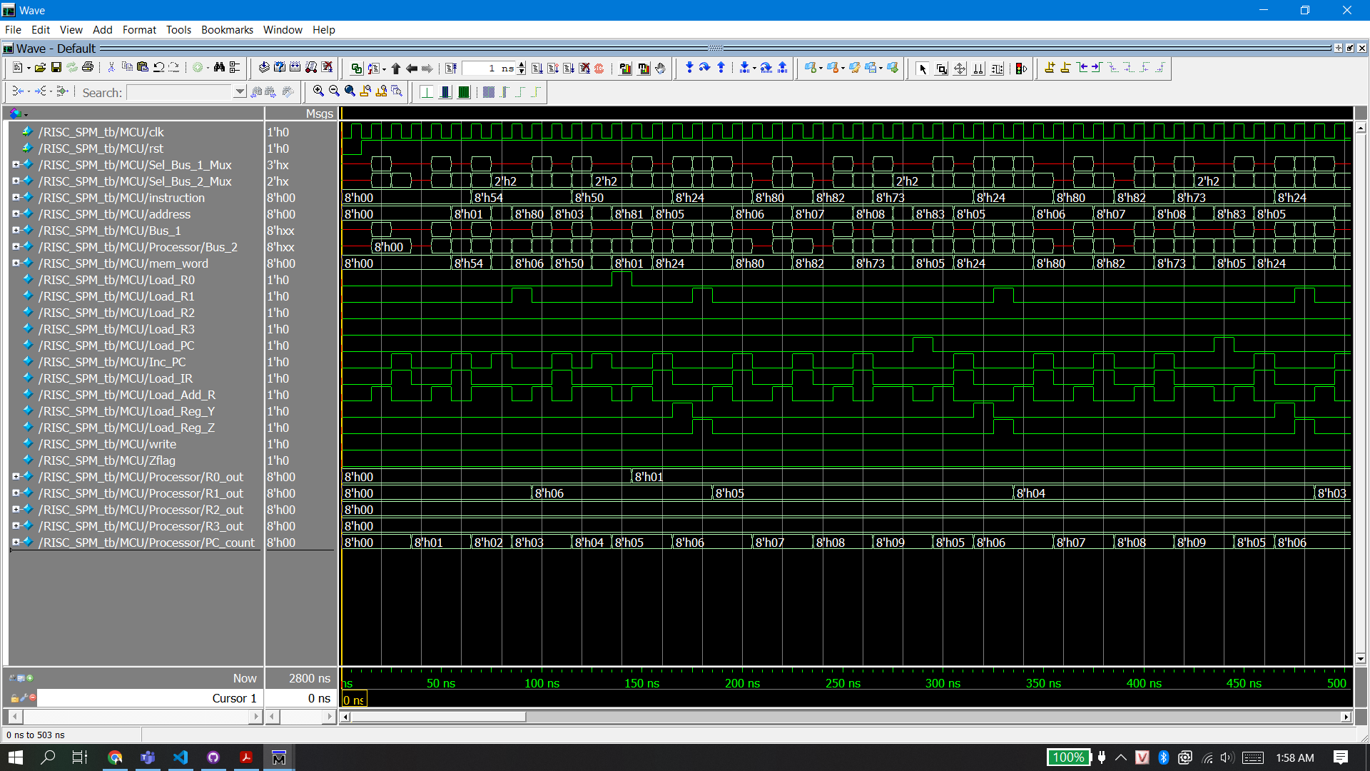

Figure 10 Full Module waveform 1

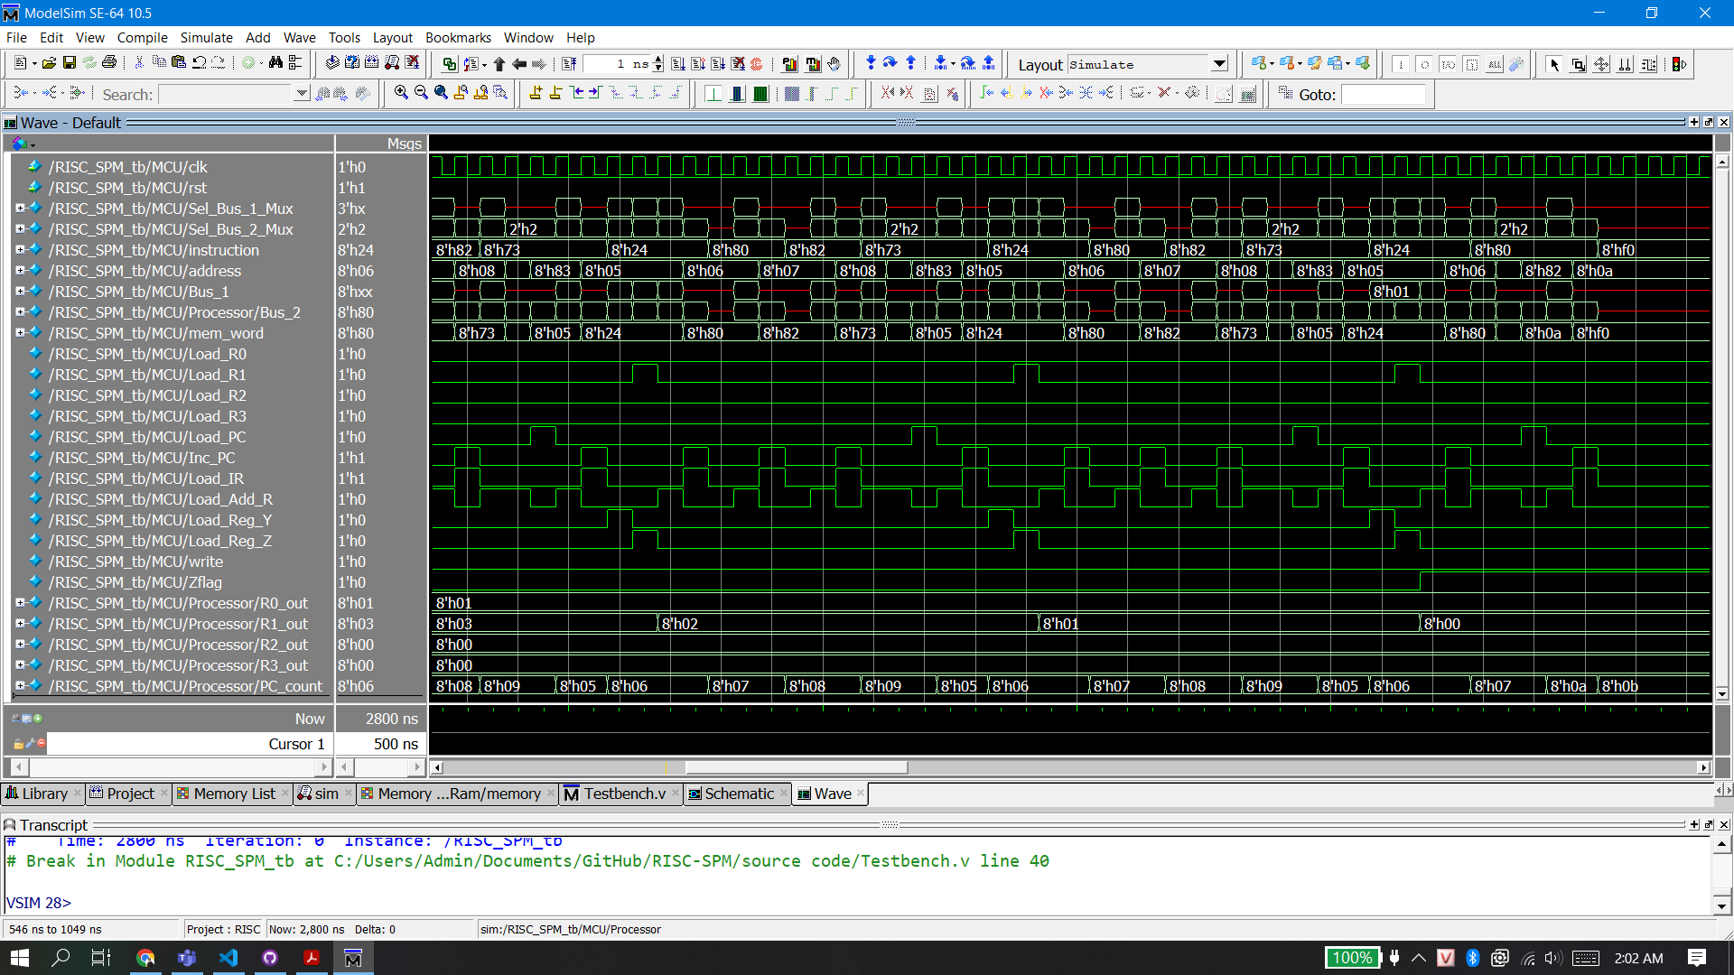

Figure 11 Full Module waveform 2

# Conclusion

This article builds an 8-bit RISC CPU, introduces the design process and experimental test in detail, including: hardware composition, instruction set system, etc. The focus is on the design of the controller. Based on the finite state machine, the correspondence and transfer between instructions and states has been realized, and a detailed simulation experiment has been carried out. The results prove that the CPU functions normally and meets expectations.

# Reference

[1] Michael D. Ciletti’s Advanced Digital Design with the Verilog HDL, 2005

[2] Samir Palnitkar’s Verilog HDL: A Guide to Digital Design and Synthesis, Second Edition, 2003

`define idle    0

`define fet1    1

`define fet2    2

`define dec     3

`define exe     4

`define rd1     5

`define rd2     6

`define wr1     7

`define wr2     8

`define br1     9

`define br2     10

`define halt    11

`define NOP     4'b0000

`define ADD     4'b0001

`define SUB     4'b0010

`define AND     4'b0011

`define NOT     4'b0100

`define RD      4'b0101

`define WR      4'b0110

`define BR      4'b0111

`define BRZ     4'b1000

module RISC_SPM(input clk,rst);

    wire [2:0] Sel_Bus_1_Mux; //5 to 1 multiplexer

    wire [1:0] Sel_Bus_2_Mux; //3 to 1 multiplexer

    wire [7:0] instruction, address, Bus_1, mem_word;

    wire Load_R0, Load_R1, Load_R2, Load_R3, Load_PC, Inc_PC, Load_IR, Load_Add_R, Load_Reg_Y, Load_Reg_Z, write, Zflag;

    Control_Unit Controller(

        Load_R0, Load_R1, Load_R2, Load_R3, Load_PC, Inc_PC, Load_IR, Load_Add_R, Load_Reg_Y, Load_Reg_Z, write,

        Sel_Bus_1_Mux,

        Sel_Bus_2_Mux,

        instruction,

        Zflag, clk, rst

    );

    Processing_Unit Processor(

        instruction, address, Bus_1,

        Zflag,

        mem_word,

        Sel_Bus_1_Mux,

        Sel_Bus_2_Mux,

        Load_R0, Load_R1, Load_R2, Load_R3, Load_PC, Inc_PC, Load_IR, Load_Add_R, Load_Reg_Y, Load_Reg_Z, clk, rst

    );

    Memory_Unit Ram(

        mem_word,

        Bus_1, address,

        write, clk

    );

endmodule

module Control_Unit(

    output reg Load_R0, Load_R1, Load_R2, Load_R3, Load_PC, Inc_PC, Load_IR, Load_Add_R, Load_Reg_Y, Load_Reg_Z, write,

    output reg [2:0] Sel_Bus_1_Mux,

    output reg [1:0] Sel_Bus_2_Mux,

    input [7:0] instruction,

    input Zflag, clk, rst

);

    reg [3:0] state, next_state;

    reg err_flag; // error flag to debug

    wire [3:0] opcode = instruction[7:4];

    wire [1:0] dst = instruction [3:2]; //destination

    wire [1:0] src = instruction [1:0]; //source

    //state register

    always @ (posedge clk or negedge rst) begin

        if(!rst)

            state <= `idle; // reset active low

        else

            state <= next_state;

    end

    //next state logic

    always @ (state or opcode or src or dst or Zflag) begin

        Sel_Bus_1_Mux = 3'bx ; Sel_Bus_2_Mux = 2'bx;

        Load_R0 = 0; Load_R1 = 0; Load_R2 = 0; Load_R3 = 0; Load_Reg_Y = 0; Load_Reg_Z = 0;

        Load_PC = 0; Inc_PC = 0; Load_IR = 0; Load_Add_R = 0;

        write = 0;

        err_flag = 0;

        next_state = state;

        case (state)

            `idle : next_state = `fet1;

            `fet1 :begin

                next_state = `fet2;

                Sel_Bus_1_Mux = 4; // Bus_1 = PC

                Sel_Bus_2_Mux = 1; // Bus_2 = Bus_1

                Load_Add_R = 1;

            end

            `fet2 :begin

                next_state = `dec;

                Sel_Bus_2_Mux = 2; // Bus_2 = memory

                Load_IR = 1;

                Inc_PC = 1;

            end

            `dec :begin

                case(opcode)

                    `NOP : next_state = `fet1;

                    `ADD, `SUB, `AND, `NOT : begin

                        next_state = `exe;

                        case (src)

                            0 : Sel_Bus_1_Mux = 0; //Bus 1 = R0

                            1 : Sel_Bus_1_Mux = 1; //Bus 1 = R1

                            2 : Sel_Bus_1_Mux = 2; //Bus 1 = R2

                            3 : Sel_Bus_1_Mux = 3; //Bus 1 = R3

                            default : err_flag = 1;

                        endcase

                        Sel_Bus_2_Mux = 1; // Bus_2 = Bus_1

                        Load_Reg_Y = 1; // Reg_Y = Bus_2 = Bus_1 = src

                    end

                    `RD : begin

                        next_state = `rd1;

                        Sel_Bus_1_Mux = 4; // Bus_1 = PC

                        Sel_Bus_2_Mux = 1; // Bus_2 = Bus_1

                        Load_Add_R = 1;

                    end

                    `WR : begin

                        next_state = `wr1;

                        Sel_Bus_1_Mux = 4; // Bus_1 = PC

                        Sel_Bus_2_Mux = 1; // Bus_2 = Bus_1

                        Load_Add_R = 1;

                    end

                    `BR : begin

                        next_state = `br1;

                        Sel_Bus_1_Mux = 4; // Bus_1 = PC

                        Sel_Bus_2_Mux = 1; // Bus_2 = Bus_1

                        Load_Add_R = 1;

                    end

                    `BRZ : begin

                        next_state = `br1;

                        if (Zflag == 1) begin

                            Sel_Bus_1_Mux = 4; // Bus_1 = PC

                            Sel_Bus_2_Mux = 1; // Bus_2 = Bus_1

                            Load_Add_R = 1;

                        end

                        else begin

                            next_state = `fet1;

                        end

                    end

                    default : next_state = `halt;

                endcase

            end

            `exe :begin

                next_state = `fet1;

                case (dst)

                    0: begin Sel_Bus_1_Mux = 0; Load_R0 = 1; end //R0 = ALU_out

                    1: begin Sel_Bus_1_Mux = 1; Load_R1 = 1; end //R1 = ALU_out

                    2: begin Sel_Bus_1_Mux = 2; Load_R2 = 1; end //R2 = ALU_out

                    3: begin Sel_Bus_1_Mux = 3; Load_R3 = 1; end //R3 = ALU_out

                    default : err_flag = 1;

                endcase

                Sel_Bus_2_Mux = 0; //Bus_2 = ALU_out

                Load_Reg_Z = 1;

            end

            `rd1 :begin

                next_state = `rd2;

                Sel_Bus_2_Mux = 2; // Bus_2 = mem_word

                Load_Add_R = 1;

                Inc_PC = 1;

            end

            `rd2 :begin

                next_state = `fet1;

                Sel_Bus_2_Mux = 2;

                case (dst)

                    0 : Load_R0 = 1;

                    1 : Load_R1 = 1;

                    2 : Load_R2 = 1;

                    3 : Load_R3 = 1;

                    default : err_flag = 1;

                endcase

            end

            `wr1 :begin

                next_state = `wr2;

                Sel_Bus_2_Mux = 2; // Bus_2 = mem_word

                Load_Add_R = 1;

                Inc_PC = 1;

            end

            `wr2 :begin

                next_state = `fet1;

                case (src)

                    0 : Sel_Bus_1_Mux = 0; // Bus_1 = R0

                    1 : Sel_Bus_1_Mux = 1; // Bus_1 = R1

                    2 : Sel_Bus_1_Mux = 2; // Bus_1 = R2

                    3 : Sel_Bus_1_Mux = 3; // Bus_1 = R3

                    default : err_flag = 1;

                endcase

                write = 1;

            end

            `br1 :begin

                next_state = `br2;

                Sel_Bus_2_Mux = 2; // Bus_2 = mem_word

                Load_Add_R = 1;

            end

            `br2 :begin

                next_state = `fet1;

                Sel_Bus_2_Mux = 2; // Bus_2 = mem_word

                Load_PC = 1;

            end

            `halt :begin

                next_state = `halt;

            end

            default : next_state = `idle;

        endcase

    end

endmodule

module Processing_Unit(

    output [7:0] instruction, address, Bus_1,

    output Zflag,

    input [7:0] mem_word,

    input [2:0] Sel_Bus_1_Mux,

    input [1:0] Sel_Bus_2_Mux,

    input Load_R0, Load_R1, Load_R2, Load_R3, Load_PC, Inc_PC, Load_IR, Load_Add_R, Load_Reg_Y, Load_Reg_Z, clk, rst

);

    wire [7:0] Bus_2, R0_out, R1_out, R2_out, R3_out, PC_count, Y_out, ALU_out;

    wire ALU_Zflag;

    wire [3:0] opcode = instruction [7:4];

    Register_Unit R0(R0_out, Bus_2,Load_R0, clk,rst);

    Register_Unit R1(R1_out, Bus_2,Load_R1, clk,rst);

    Register_Unit R2(R2_out, Bus_2,Load_R2, clk,rst);

    Register_Unit R3(R3_out, Bus_2,Load_R3, clk,rst);

    Register_Unit Reg_Y(Y_out, Bus_2, Load_Reg_Y, clk, rst);

    Register_Unit Add_R(address, Bus_2, Load_Add_R, clk, rst);

    Register_Unit IR(instruction, Bus_2, Load_IR, clk, rst);

    D_ff Reg_Z(Zflag, ALU_Zflag, Load_Reg_Z, clk,rst);

    Program_Counter PC(PC_count, Bus_2, Load_PC, Inc_PC, clk, rst);

    Mux_5_1 Mux_1(Bus_1, R0_out, R1_out, R2_out,  R3_out, PC_count, Sel_Bus_1_Mux);

    Mux_3_1 Mux_2(Bus_2, ALU_out, Bus_1, mem_word, Sel_Bus_2_Mux);

    Arithmetic_Logic_Unit ALU(ALU_out, ALU_Zflag, Y_out, Bus_1, opcode);

endmodule

module Memory_Unit(

    output [7:0] data_out,

    input [7:0] data_in, address,

    input write, clk

);

    reg [7:0] memory [255:0]; //256 bytes ram

    always @(posedge clk) begin

        if(write)

            memory[address] <= data_in;

    end

    assign data_out = memory[address];

endmodule

module Arithmetic_Logic_Unit(

    output reg [7:0] ALU_out,

    output ALU_Zflag,

    input [7:0] data_1, data_2,

    input [3:0] opcode

);

    assign ALU_Zflag = ~|ALU_out; //reduction nor

    always @(opcode or data_1 or data_2) begin

        case(opcode)

            `ADD :      ALU_out = data_2 + data_1;

            `SUB :      ALU_out = data_2 - data_1;

            `AND :      ALU_out = data_1 & data_2;

            `NOT :      ALU_out = ~ data_1;

            default :   ALU_out = 0;

        endcase

    end

endmodule

module Register_Unit(output reg [7:0] data_out, input [7:0] data_in, input load, clk, rst);

    always @(posedge clk or negedge rst)

    if (!rst)

        data_out <= 0;

    else if (load)

        data_out <= data_in;

endmodule

module Program_Counter(output reg [7:0] count, input [7:0] data_in, input Load_PC, Inc_PC, clk, rst);

    always @(posedge clk or negedge rst)

    if (!rst)

        count <= 0;

    else if (Load_PC)

        count <= data_in;

    else if (Inc_PC)

        count <= count+1;

endmodule

module D_ff(output reg data_out, input data_in, load, clk, rst);

    always @(posedge clk or negedge rst)

    if (!rst)

        data_out <= 0;

    else if (load)

        data_out <= data_in;

endmodule

module Mux_3_1 (output reg [7:0] out, input [7:0] in0, in1, in2, input [1:0] sel);

    always @(in0 or in1 or in2 or sel)

    case(sel)

        2'b00 : out = in0;

        2'b01 : out = in1;

        2'b10 : out = in2;

        default : out = 'bx;

    endcase

endmodule

module Mux_5_1 (output reg [7:0] out, input [7:0] in0, in1, in2, in3, in4, input [2:0] sel);

    always @(in0 or in1 or in2 or in3 or in4 or sel)

    case(sel)

        3'b000 : out = in0;

        3'b001 : out = in1;

        3'b010 : out = in2;

        3'b011 : out = in3;

        3'b100 : out = in4;

        default : out = 'bx;

    endcase

endmodule