LIST OF FIGURES

LIST OF TABLES

# INTRODUCTION

## What is the Python programming language?

In the late 1980s, Guido van Rossum, a researcher at the Centrum Wiskunde & Informatica (CWI) in the Netherlands, found himself frustrated with existing programming languages like ABC. He felt they were complex, lacked clarity, and hindered productivity. He envisioned a language that was easy to learn and read, expressive and flexible and extensible and adaptable (using libraries and modules).

Guido began developing Python in December 1989. On February 20, 1991, Python 0.9.0 was released

### Early applications

* + Scripting and automation: Python found its initial niche in scripting tasks, automating repetitive processes and interacting with system resources.
  + Scientific computing and data analysis: Python libraries like numpy and scipy offered powerful tools for scientific calculations and data manipulation.
  + Education and research: Its beginner-friendliness and rich ecosystem made it ideal for teaching programming and conducting research.

Today, Python has transcended its initial applications to become one of the most popular programming languages globally. Below is an image of the most used programming languages in 2023.

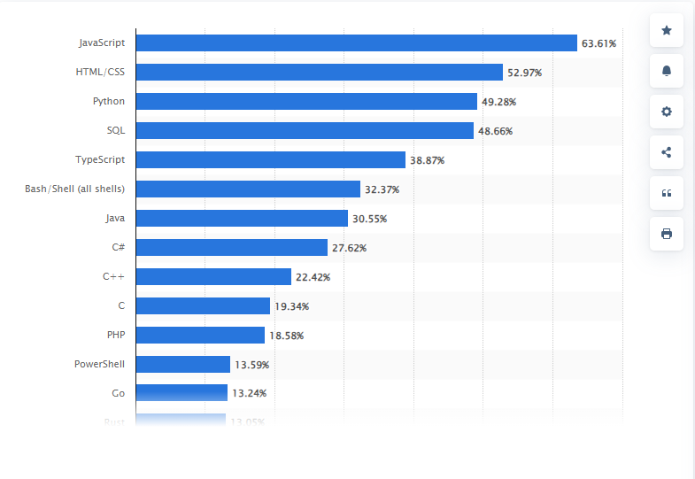

Figure : Most used programming languages among developers worldwide as of 2023 (source: https://www.statista.com/statistics/793628/worldwide-developer-survey-most-used-languages/)