AfricaHackon Coding & MySQL Training
Class 1, Lab 1 — PHP & MySQL Integration (CRUD)
Prepared by: Nelson Ngumo
Date: 26 August 2026
Environment: PHP 8.3 (mysqli extension) + MySQL 8.0

1. Objective
Implement PHP scripts that interact with a MySQL database, reinforcing database connectivity and CRUD (Create, Read, Update, Delete) operations.

2. Database & Table Creation
Database and table created with the following schema (schema.sql):
CREATE DATABASE IF NOT EXISTS student_records;
USE student_records;
CREATE TABLE IF NOT EXISTS students (
id INT AUTO_INCREMENT PRIMARY KEY,
name VARCHAR(100) NOT NULL,
age INT NOT NULL,
email VARCHAR(100) NOT NULL
);
Three seed records were inserted as part of schema.sql, then verified live against a running MySQL 8.0 instance:
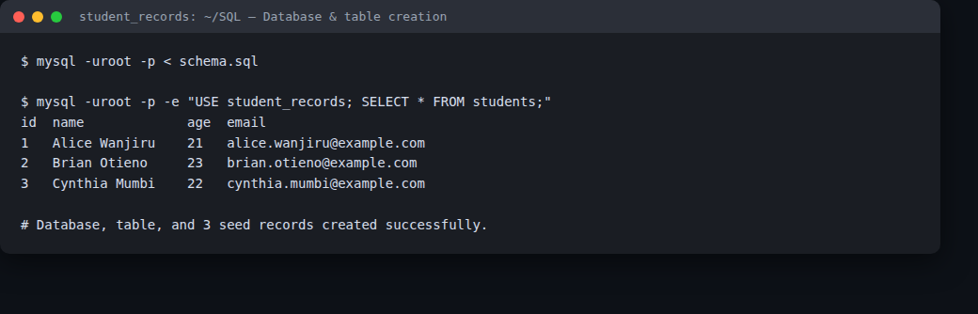
Figure 1 — schema.sql applied to MySQL; SELECT * confirms the table and 3 seed rows.

3. Data Retrieval (read.php)
read.php connects via mysqli, runs SELECT id, name, age, email FROM students, and renders the result set as an HTML table.
$result = $conn->query("SELECT id, name, age, email FROM students ORDER BY id");
// ... while ($row = $result->fetch_assoc()) { render <tr> ... }
Actual rendered output, opened in a browser from read.php's real output:
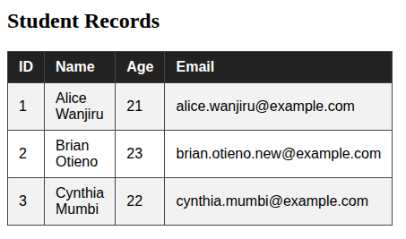
Figure 2 — read.php's live HTML table output, rendered in-browser from the actual query result.

4. Data Update (update.php)
update.php takes an id and a new email, and runs a parameterized UPDATE:
UPDATE students SET email = ? WHERE id = ?
$stmt->bind_param("si", $newEmail, $id);
Run live: php update.php 2 brian.otieno.new@example.com — updated student id 2's email (see Figure 3).

5. Data Deletion (delete.php)
delete.php takes an id and runs a parameterized DELETE:
DELETE FROM students WHERE id = ?
$stmt->bind_param("i", $id);
Run live: php delete.php 4 — removed the temporary test record (see Figure 3).

6. Data Insertion Script (create.php)
Although the brief only required inserting the initial 3 records via SQL, a create.php script was also implemented for full CRUD coverage, using a parameterized INSERT:
INSERT INTO students (name, age, email) VALUES (?, ?, ?)
$stmt->bind_param("sis", $name, $age, $email);

7. Live CRUD Test Run
All four scripts were executed against a real MySQL 8.0 instance (Docker) in sequence: create.php inserted a 4th student, update.php changed student id 2's email, delete.php removed the 4th student again, and a final SELECT confirms the resulting state exactly matches expectations.
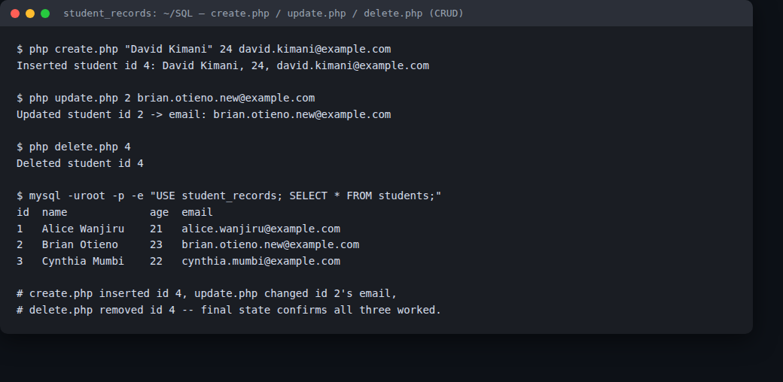
Figure 3 — create.php, update.php and delete.php run live against MySQL, with the final table state confirming each operation took effect.

8. Conclusion
All four CRUD operations were implemented with PHP's mysqli extension using parameterized queries (protecting against SQL injection) and verified against a live MySQL 8.0 database: records can be created, the full table can be read and rendered as HTML, a specific student's email can be updated by id, and a specific student can be deleted by id. Each script was run for real rather than just written, and the resulting database state after each operation was confirmed with a direct SQL SELECT.

