Python Scripting Assignment
Custom Automation Script — subfinder + httpx Recon Pipeline
Squad Number: 5
Group Members: Daniel Muthomi, Eileenhope Achieng, Elijah Amani Maluki, Festus Gakure, Nelson Ngumo, Winrose Kanini Kimuli, Brian Mwangi, Kennedy Luguta Vusaka
Submitted by (individual submission): Nelson Ngumo
Course: AfricaHackon Academy — Cohort 6
Date: 27 August 2026
Target used for testing: vulnweb.com (Acunetix's public, intentionally-vulnerable practice domain — a standard, permitted target for security-tooling exercises).

What the Script Does
recon_automation.py takes a target domain via a required -d/--domain CLI argument and runs a two-stage recon pipeline. First, it shells out to subfinder to passively enumerate subdomains and writes the raw list to <domain>.txt. Then, provided that list isn't empty (a conditional check that skips the probing step entirely for a domain with zero results), it feeds that file into httpx to actually probe each subdomain over HTTP/HTTPS and writes only the ones that respond live to <domain>_live.txt. Every stage prints a "[recon_automation] ..." progress message, subprocess calls are wrapped in try/except with explicit timeouts so a hung tool can't hang the script forever, and every fatal condition (bad output directory, missing binary, non-zero exit code from a tool) prints a clear ERROR line and exits with status 1. As a bonus feature, an optional --discord-webhook argument posts a short completion summary (subdomains found / live hosts) to a Discord webhook once the run finishes; a failed notification is deliberately non-fatal, since by that point the actual recon results are already safely written to disk.
One real, non-obvious problem the script has to solve: on this machine (plain Ubuntu, not Kali, so subfinder and httpx had to be built with 'go install' rather than 'apt install' as the brief suggested), there is already a program called httpx on PATH — the Python HTTP client library's CLI, installed via pip, which is a completely different tool from ProjectDiscovery's subdomain prober. Calling "httpx" naively via subprocess would silently run the wrong program. resolve_tool() handles this by checking $(go env GOPATH)/bin first, and — for either tool — verifying whatever binary it's about to trust actually behaves like the real thing (by checking its -h output for a flag string, e.g. -silent, that only ProjectDiscovery's tool has) before using it, rather than trusting the first thing found on PATH with a matching name.

How It Was Tested (Evidence)

1. A full real run against vulnweb.com
subfinder was pointed at vulnweb.com and found 18 subdomains in this run (passive-source results vary slightly run to run); those were fed into httpx, which confirmed 3 of them were actually live over HTTP. Both output files were inspected directly to confirm the content matched what the tools reported.
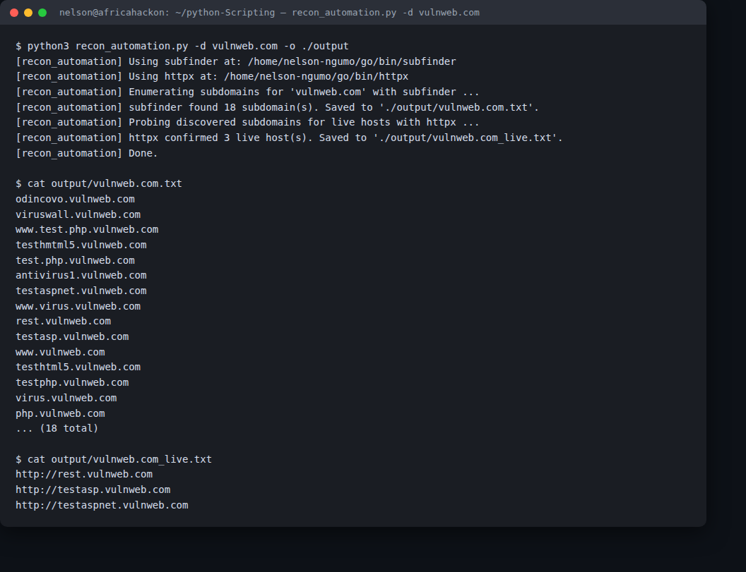
Figure 1 — full run against vulnweb.com: subfinder finds 18 subdomains, httpx confirms 3 are live, both files inspected directly.

2. Fatal-error path and the httpx name-collision guard
To confirm the error handling isn't just theoretical, the script was run with PATH stripped down to nothing but python3 and sh (no subfinder, no Go, no httpx at all) — it correctly printed a clear ERROR and exited 1. It was then run again with only the wrong (Python HTTP-client) httpx reachable on PATH: the script detected that binary didn't behave like ProjectDiscovery's httpx, skipped it, and failed with a clear error rather than silently trying to use the wrong tool.
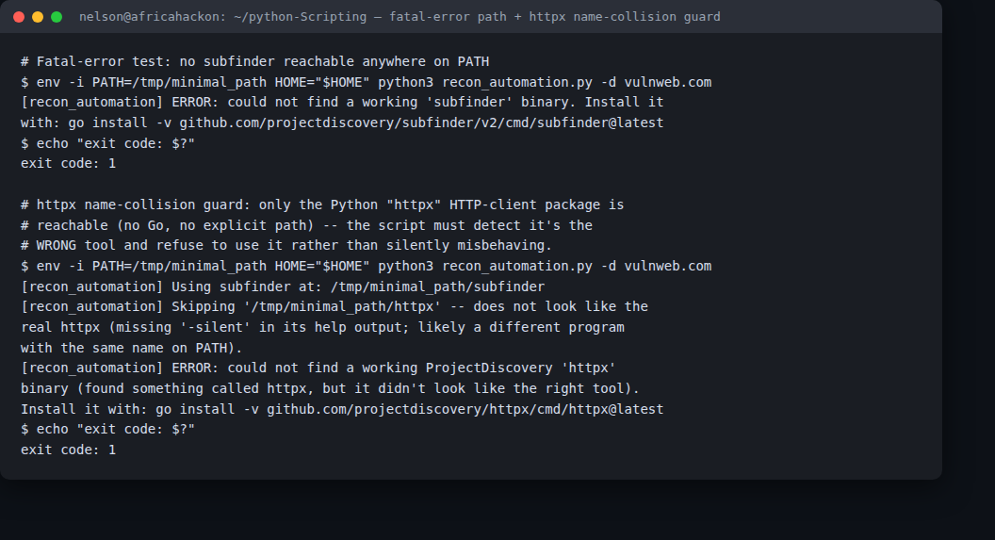
Figure 2 — genuinely no subfinder anywhere on PATH (exit code 1), and the httpx name-collision guard correctly rejecting the Python HTTP-client package's CLI.

3. Empty-result conditional and the bonus Discord notification
A domain that (almost certainly) has zero subdomains was run through the pipeline to confirm the conditional correctly skips the httpx step rather than calling it on an empty list, while still producing an empty <domain>_live.txt so downstream tooling can rely on the file existing. Separately, the bonus --discord-webhook flag was exercised with a deliberately invalid webhook URL to confirm a failed notification doesn't crash the run or lose the already-saved recon results — it just logs a non-fatal warning and exits 0.
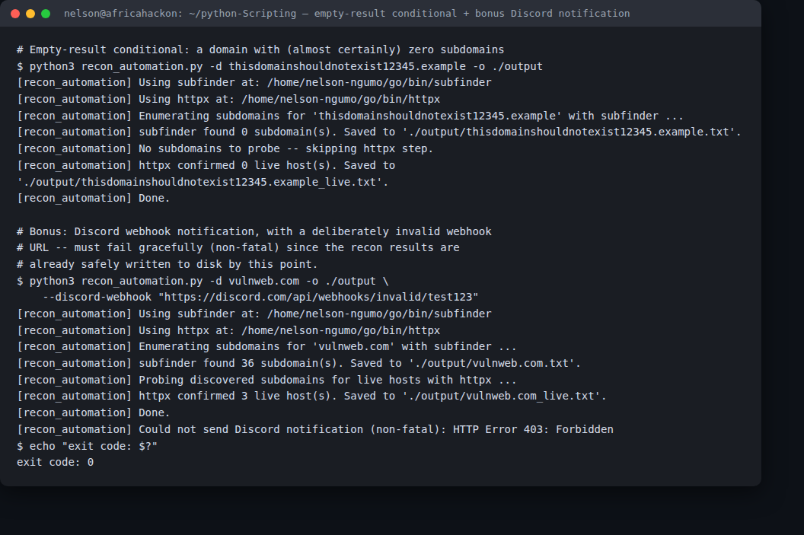
Figure 3 — the httpx step correctly skipped for zero subdomains, and the bonus Discord notification failing gracefully (non-fatal) with an invalid webhook.

Challenges Faced & How They Were Solved
The single biggest challenge was the tool-installation mismatch: the assignment brief assumes a Kali environment where 'sudo apt install subfinder' just works, but on this plain Ubuntu box that package doesn't exist in the repos at all, and neither does ProjectDiscovery's httpx. Both were built from source instead with 'go install github.com/projectdiscovery/.../cmd/<tool>@latest', which lands them in $(go env GOPATH)/bin rather than a standard system path. That surfaced the second, more interesting problem: this machine already had a completely different program called httpx on PATH (from 'pip install httpx', a popular Python HTTP client library that also ships a CLI with the same name). A naive subprocess.run(["httpx", ...]) would have silently invoked the wrong tool and either errored confusingly or done nothing useful — worse, it could have failed quietly rather than loudly. The fix was to write resolve_tool() to actively verify a candidate binary's identity (checking its help output for a flag unique to the real tool) rather than trusting anything found by name alone, and to prefer the Go-installed binaries as the first candidate. This was verified for real, not just assumed to work, by stripping PATH down and confirming the script correctly rejects the wrong httpx and fails with a clear, actionable error message (Figure 2) instead of misbehaving silently.

