AfricaHackon Cybersecurity Lab
Network Forensics: Keylogger Incident Investigation
Prepared by: Nelson Ngumo
Date: 26 August 2026
Environment: Wireshark / tshark analysis of Noobs Keylogger.pcap

1. Objective
Investigate a suspected keylogger infection within a monitored network using Wireshark. The goal is to identify the infected host, trace its communication to the attacker's server, determine the frequency and content of the exfiltrated data, identify the attacker, and recover any files transmitted.

2. Tools & Environment
- Wireshark / tshark (packet dissection engine is identical; tshark used for scripted, reproducible extraction alongside the Wireshark GUI)
- Capture source: github.com/nipunjaswal/networkforensics — Ch1/Noobs Keylogger/Noobs Keylogger.pcap
- Assumed scenario: analyst connected to a network mirror port; this PCAP is used to simulate that captured traffic
- Live-capture equivalent (mirror/SPAN port, no ready-made PCAP available): from the analyst host connected to the mirror port, run sudo dumpcap -i <iface> -w capture.pcapng (or sudo tcpdump -i <iface> -w capture.pcap) to passively sniff all traffic, then open the resulting file in Wireshark/tshark and apply the same filters and steps used below.

3. Methodology
- Statistics > Endpoints and Statistics > Conversations to identify the busiest internal host
- Filter traffic to/from the suspect host and inspect protocols in use
- Statistics > IO Graph / timestamp analysis to determine the transmission interval (beaconing pattern)
- Follow TCP Stream to inspect FTP control-channel payload content and credentials
- File > Export Objects (FTP-DATA) to recover any transferred files

4. Findings Summary
Item | Value / Status
Capture file | Noobs Keylogger.pcap
Infected host (internal IP) | 192.168.76.131 — appears in nearly every conversation (2,163 packets / 945 kB total across 25+ external peers)
Gateway / broadcast (noise, excluded) | 192.168.76.1 (gateway), 192.168.76.2, 192.168.76.255 (broadcast), 224.0.0.251 (mDNS), 239.255.255.250 (SSDP)
C2 / exfil server | 140.82.59.185:21 (FTP, vsFTPd 3.0.3) — confirmed via Follow TCP Stream on the port-21 control channel
Beacon frequency | ~63 seconds between FTP delivery cycles (uploads observed at t=0.07s and t=63.40s)
Additional exfiltrated data | Active window/application titles, timestamps, logged-in Windows username ("nipun"), and visited URLs — not just raw keystrokes
Attacker indicators | FTP creds test_user / Nipun@123, drop directory "Test", server banner vsFTPd 3.0.3, tool signature string "Ardamax_FTP_Delivery" (Ardamax Keylogger)
Recovered files | Keys_2018-11-28_16-04-42.html (579 B) and Web_2018-11-29_11-28-13.html (621 B) — recovered via ftp-data export, see extracted_files/

5. Infected System Identification
The Ethernet-level Endpoints view was checked first, but MAC addresses alone do not identify hosts across a routed network, so analysis moved to the IPv4 layer.
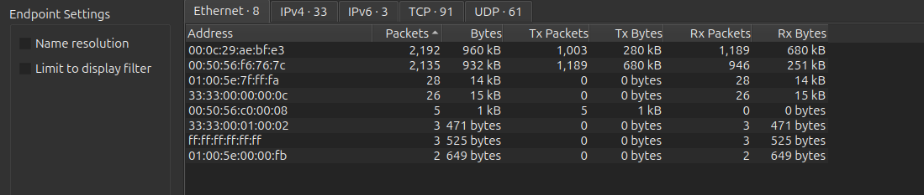
Figure 1 — Initial Ethernet Endpoints view (MAC-level; multicast/broadcast addresses present but not diagnostic on their own).
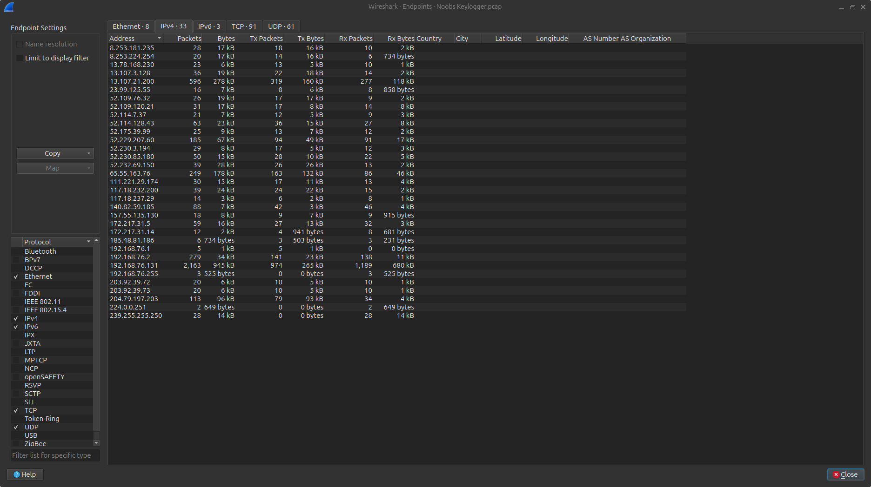
Figure 2 — IPv4 Endpoints view. 192.168.76.131 stands out with 2,163 packets and 945 kB across the largest number of distinct peers.
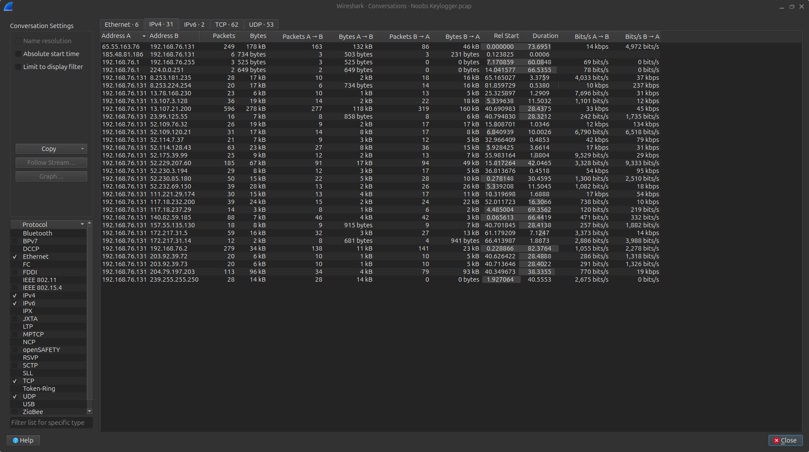
Figure 3 — IPv4 Conversations view. 192.168.76.131 appears as Address A in nearly every row, confirming it as the single internal host generating the bulk of outbound traffic.
Conclusion: 192.168.76.131 is identified as the infected system. Filter applied to isolate its traffic for further analysis:
ip.addr == 192.168.76.131
Addresses excluded as normal network noise: 192.168.76.1 (gateway), 192.168.76.2, 192.168.76.255 (broadcast), 224.0.0.251 (mDNS), 239.255.255.250 (SSDP). Several external IPs (13.107.x.x, 52.x.x.x Azure ranges, 204.79.197.203, 111.221.29.174, 157.55.135.130) correspond to legitimate Microsoft/Office telemetry and were provisionally deprioritized as C2 candidates.

6. Tracing Data to the C2 Server
Filtering ip.src == 192.168.76.131 && !(tcp.port == 80 || tcp.port == 443) isolates two short-lived TCP sessions to 140.82.59.185 on port 21 (FTP control) — conversations 51648↔140.82.59.185:21 and 51700↔140.82.59.185:21 — each immediately followed by a PASV data-channel session (ports 18439 and 5142) opened to the same host.
ip.src == 192.168.76.131 && !(tcp.port == 80 || tcp.port == 443)
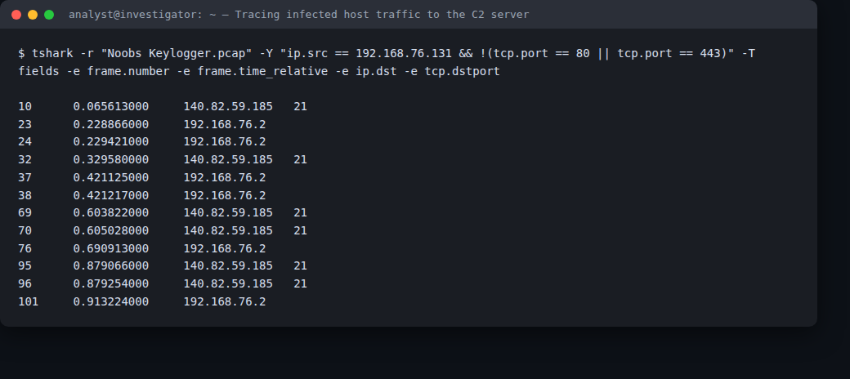
Figure 4 — Isolating the infected host's non-web traffic: every non-HTTP(S) session it opens goes to 140.82.59.185.
Following the FTP control stream (right-click a port-21 packet → Follow > TCP Stream in the GUI) shows a full authenticated FTP session:
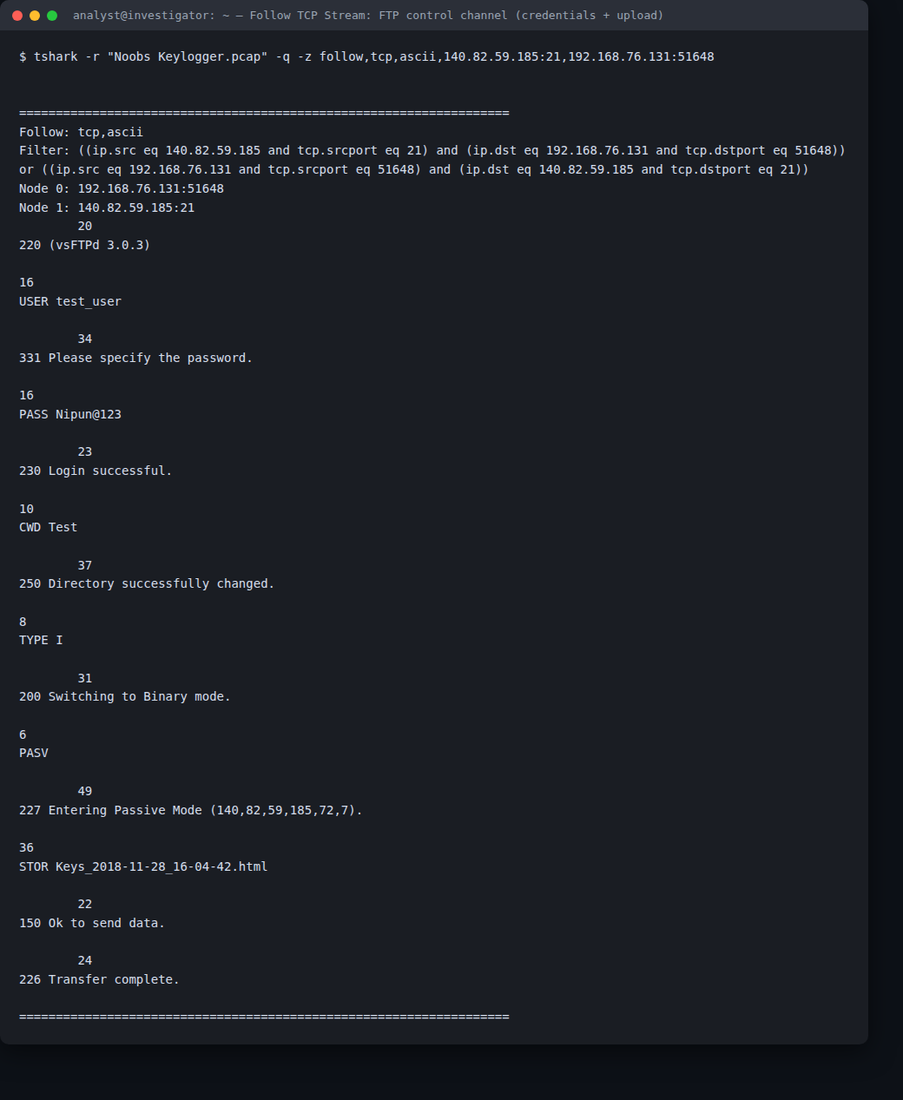
Figure 6 — Follow TCP Stream on the FTP control channel: full login sequence and file upload command, captured in cleartext.
Conclusion: the infected host exfiltrates data via plaintext FTP to 140.82.59.185:21 — the confirmed C2/exfiltration server. No DNS query for this IP appears anywhere in the capture, meaning the address is hard-coded into the keylogger rather than resolved by hostname (reduces its forensic/DNS footprint).

7. Frequency of Data Transmission
Two complete FTP upload cycles are visible in this ~85-second capture: the control-channel SYN to 140.82.59.185 occurs at t=0.07s (frame 10) and again at t=63.40s (frame 1783) — almost exactly 63 seconds apart. Each cycle uploads one report file and then closes the connection.
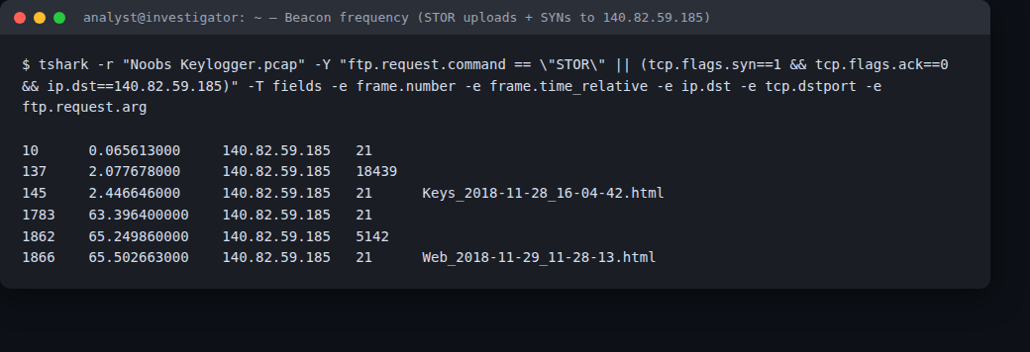
Figure 5 — SYN and STOR timestamps for both FTP delivery cycles, ~63 seconds apart — the IO-Graph-equivalent view of the beaconing pattern.
This matches Ardamax Keylogger's configurable “send logs every N seconds/minutes” delivery option, set here to roughly a 1-minute interval. Filtering ip.addr == 192.168.76.131 && ip.addr == 140.82.59.185 in Statistics > IO Graph would show two isolated ~1-second bursts of activity separated by ~62 seconds of silence — a clear beaconing pattern rather than continuous traffic.

8. Additional Data Exfiltrated (beyond keystrokes)
The two delivered files are not raw keystroke text — they are Ardamax-style HTML activity reports (full recovery method in Section 10).
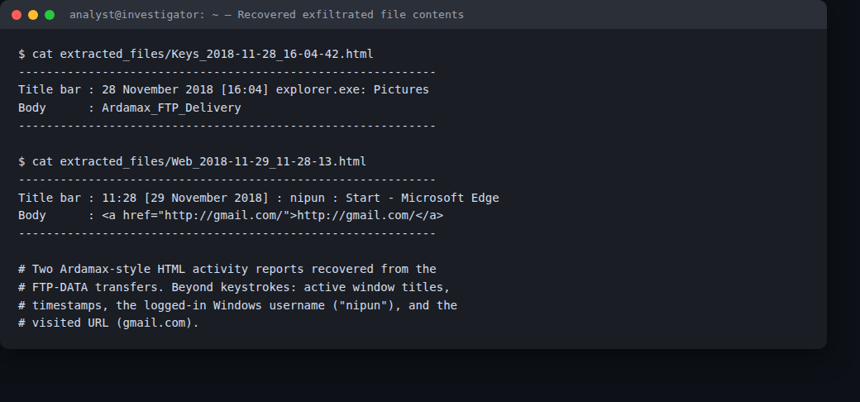
Figure 8 — Contents of both recovered files: window-title/keystroke log and browsed-URL log.
Keys_2018-11-28_16-04-42.html logs a timestamped active-window entry (‘28 November 2018 [16:04] explorer.exe: Pictures’) alongside the keystroke/window content, and contains the tool-identifying string “Ardamax_FTP_Delivery”. Web_2018-11-29_11-28-13.html logs browser activity: a timestamped active-window entry identifying the logged-in user (‘11:28 [29 November 2018] : nipun : Start - Microsoft Edge’) and the visited URL (http://gmail.com/). So beyond raw keystrokes, the malware also exfiltrates active window/application titles, timestamps, the logged-on Windows username (“nipun”), and visited website URLs — i.e. full user-activity monitoring, not just a keystroke stream.

9. Attacker Identification
The attacker's drop server is 140.82.59.185, running vsFTPd 3.0.3 on port 21. The malware authenticates with hard-coded credentials captured in cleartext from the FTP control stream — username test_user, password Nipun@123 — uploading into a folder named Test (visible in Figure 6 above). The string “Ardamax_FTP_Delivery” embedded in the first log file identifies the specific tool as Ardamax Keylogger configured in FTP-delivery mode. No SMTP/e-mail traffic appears in this capture (no port 25), so no attacker e-mail address is recoverable — the FTP credentials and drop-server IP are the direct attacker-infrastructure indicators available here. The infected host's Ethernet source MAC (00:0c:29:ae:bf:e3) carries a VMware OUI, confirming the victim host itself is a VM, consistent with this being a lab capture.

10. Extraction & Reconstruction of Exfiltrated Files
File > Export Objects > FTP-DATA lists two objects, both recovered intact:
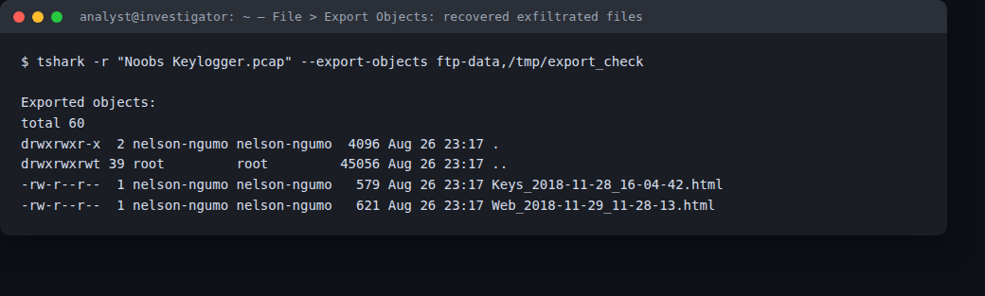
Figure 7 — File > Export Objects (FTP-DATA): both exfiltrated files listed and exported intact.
- Keys_2018-11-28_16-04-42.html — 579 bytes — keystroke/active-window log
- Web_2018-11-29_11-28-13.html — 621 bytes — browsed-URL/active-window log
Both were reconstructed with the CLI equivalent of File > Export Objects — tshark -r "Noobs Keylogger.pcap" --export-objects "ftp-data,extracted_files" — and saved to extracted_files/ alongside this report. Opening them confirms both are well-formed Ardamax-style HTML reports (content shown in Figure 8, Section 8).

11. Conclusion
Host 192.168.76.131 (a VMware VM) is infected with Ardamax Keylogger configured for FTP-based delivery. Approximately every 63 seconds the malware opens a plaintext FTP session to 140.82.59.185:21 (vsFTPd 3.0.3), authenticates as test_user/Nipun@123, and uploads an HTML activity report into a /Test directory on the server — alternating between a keystroke/active-window log (Keys_*.html) and a browsed-URL log (Web_*.html) — together revealing not just keystrokes but the logged-in username (“nipun”), application usage, and browsing activity. Both exfiltrated files were fully recovered from the capture (see extracted_files/). Because credentials and the drop path travel in cleartext FTP, and the C2 IP is hard-coded with no DNS lookup, the same artifacts (IP 140.82.59.185, port 21, credentials test_user/Nipun@123) can be used directly as network IOCs. Recommended remediation: remove the keylogger from the host, block 140.82.59.185 at the perimeter, force a credential reset for the affected user, and deploy egress filtering/DLP to flag outbound FTP or ~1-minute-interval beaconing to non-corporate IPs.

