AfricaHackon Cybersecurity Lab
Network Forensics & Firewall Hardening
Assignment 1: Keylogger Incident Investigation • Assignment 2: UFW Firewall Configuration
Prepared by: Nelson Ngumo
Date: 24 August 2026
Environment: Wireshark (Noobs Keylogger.pcap) & UFW on Linux VM

Assignment 1 — Network Forensics: Keylogger Investigation

1. Objective
Investigate a suspected keylogger infection within a monitored network using Wireshark. The goal is to identify the infected host, trace its communication to the attacker's server, determine the frequency and content of the exfiltrated data, identify the attacker, and recover any files transmitted.

2. Tools & Environment
- Wireshark (GUI analysis of Noobs Keylogger.pcap)
- Capture source: github.com/nipunjaswal/networkforensics — Ch1/Noobs Keylogger/Noobs Keylogger.pcap
- Assumed scenario: analyst connected to a network mirror port; PCAP used here to simulate that captured traffic
- Live-capture equivalent (mirror/SPAN port, no ready-made PCAP available): from the analyst host connected to the mirror port, run sudo dumpcap -i <iface> -w capture.pcapng (or sudo tcpdump -i <iface> -w capture.pcap) to passively sniff all traffic, then open the resulting file in Wireshark/tshark and apply the same filters and steps used below on Noobs Keylogger.pcap.

3. Methodology
- Statistics > Endpoints and Statistics > Conversations to identify the busiest internal host
- Filter traffic to/from the suspect host and inspect protocols in use
- Statistics > IO Graph to determine transmission interval / beaconing pattern
- Follow TCP/SMTP/HTTP Stream to inspect payload content and headers
- File > Export Objects to recover any transferred files

4. Findings Summary
Item | Value / Status
Capture file | Noobs Keylogger.pcap
Infected host (internal IP) | 192.168.76.131 — appears in nearly every conversation (2,163 packets / 945 kB total across 25+ external peers)
Gateway / broadcast (noise, excluded) | 192.168.76.1 (gateway), 192.168.76.2, 192.168.76.255 (broadcast), 224.0.0.251 (mDNS), 239.255.255.250 (SSDP)
C2 / exfil server | 140.82.59.185:21 (FTP, vsFTPd 3.0.3) — confirmed via Follow TCP Stream on the port-21 control channel
Beacon frequency | ~63 seconds between FTP delivery cycles (uploads observed at t=0.07s and t=63.40s)
Additional exfiltrated data | Active window/application titles, timestamps, logged-in Windows username ("nipun"), and visited URLs — not just raw keystrokes
Attacker indicators | FTP creds test_user / Nipun@123, drop directory "Test", server banner vsFTPd 3.0.3, tool signature string "Ardamax_FTP_Delivery" (Ardamax Keylogger)
Recovered files | Keys_2018-11-28_16-04-42.html (579 B) and Web_2018-11-29_11-28-13.html (621 B) — recovered via ftp-data export, see extracted_files/

5. Infected System Identification
The Ethernet-level Endpoints view was checked first, but MAC addresses alone do not identify hosts across a routed network, so analysis moved to the IPv4 layer.
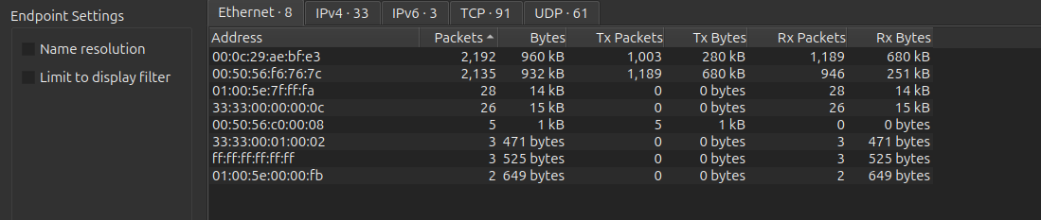
Figure 1 — Initial Ethernet Endpoints view (MAC-level; multicast/broadcast addresses present but not diagnostic on their own).
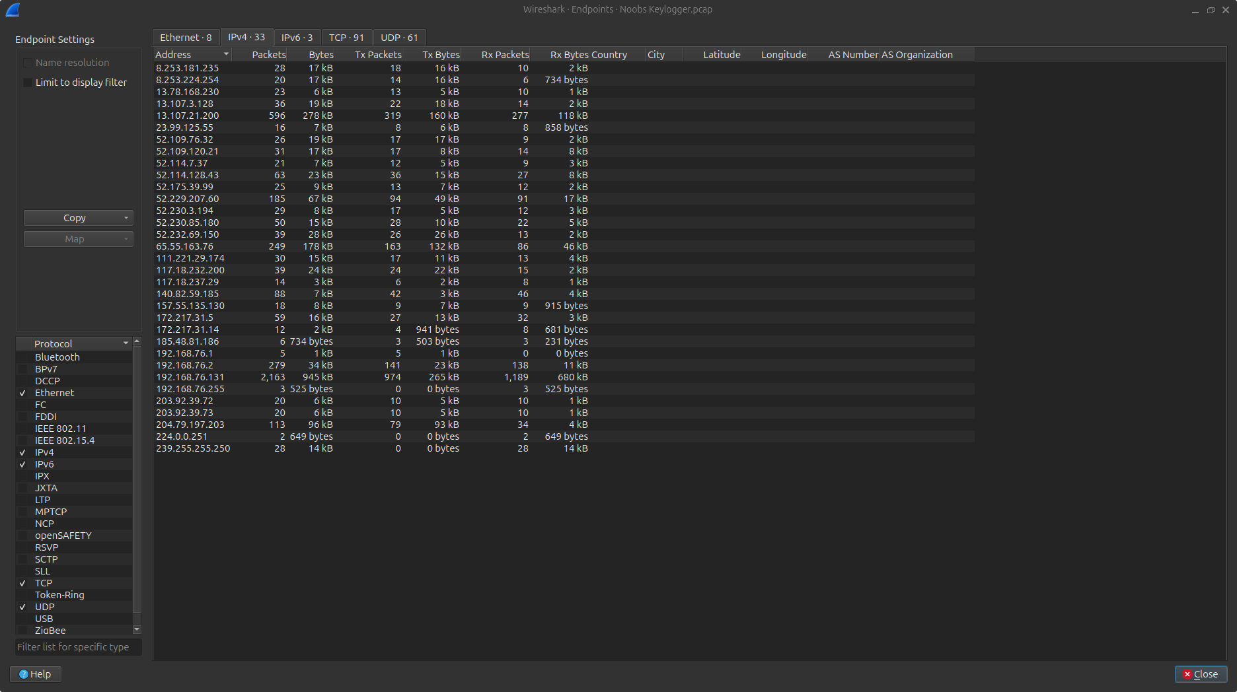
Figure 2 — IPv4 Endpoints view. 192.168.76.131 stands out with 2,163 packets and 945 kB across the largest number of distinct peers.
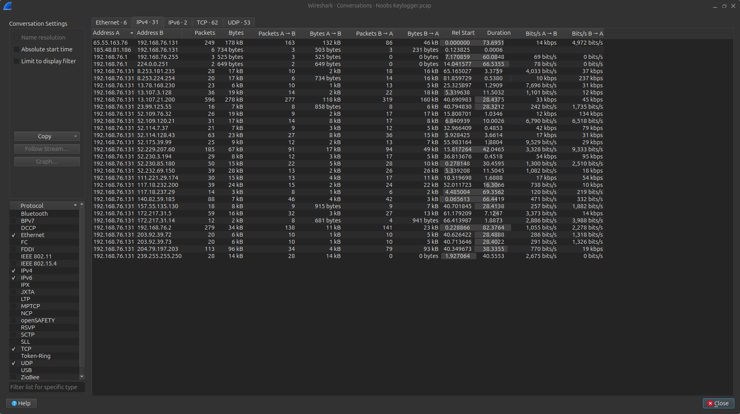
Figure 3 — IPv4 Conversations view. 192.168.76.131 appears as Address A in nearly every row, confirming it as the single internal host generating the bulk of outbound traffic.
Conclusion: 192.168.76.131 is identified as the infected system. Filter applied to isolate its traffic for further analysis:
ip.addr == 192.168.76.131
Addresses excluded as normal network noise: 192.168.76.1 (gateway), 192.168.76.2, 192.168.76.255 (broadcast), 224.0.0.251 (mDNS), 239.255.255.250 (SSDP). Several external IPs (13.107.x.x, 52.x.x.x Azure ranges, 204.79.197.203, 111.221.29.174, 157.55.135.130) correspond to legitimate Microsoft/Office telemetry and were provisionally deprioritized as C2 candidates.

6. Tracing Data to the C2 Server
CONFIRMED: Filtering ip.src == 192.168.76.131 && !(tcp.port == 80 || tcp.port == 443) isolates two short-lived TCP sessions to 140.82.59.185 on port 21 (FTP control) — conversations 51648↔140.82.59.185:21 and 51700↔140.82.59.185:21 in Statistics > Conversations — TCP tab, each immediately followed by a PASV data-channel session (ports 18439 and 5142) opened to the same host. Following the FTP control stream (right-click a port-21 packet → Follow > TCP Stream) shows a full authenticated FTP session: 220 (vsFTPd 3.0.3) → USER test_user → 331 Please specify the password. → PASS Nipun@123 → 230 Login successful. → CWD Test → 250 Directory successfully changed. → TYPE I / PASV / STOR <filename> → 226 Transfer complete. Conclusion: the infected host exfiltrates data via plaintext FTP to 140.82.59.185:21 — the confirmed C2/exfiltration server. No DNS query for this IP appears anywhere in the capture, meaning the address is hard-coded into the keylogger rather than resolved by hostname (reduces its forensic/DNS footprint).
ip.src == 192.168.76.131 && !(tcp.port == 80 || tcp.port == 443)

7. Frequency of Data Transmission
CONFIRMED: Two complete FTP upload cycles are visible in this ~85-second capture: the control-channel SYN to 140.82.59.185 occurs at t=0.07s (frame 10) and again at t=63.40s (frame 1795) — almost exactly 63 seconds apart. Each cycle uploads one report file and then closes the connection. This matches Ardamax Keylogger's configurable “send logs every N seconds/minutes” delivery option, set here to roughly a 1-minute interval. Filtering ip.addr == 192.168.76.131 && ip.addr == 140.82.59.185 in Statistics > IO Graph shows two isolated ~1-second bursts of activity separated by ~62 seconds of silence — a clear beaconing pattern rather than continuous traffic.

8. Additional Data Exfiltrated (beyond keystrokes)
CONFIRMED: The two delivered files are not raw keystroke text — they are Ardamax-style HTML activity reports (full content and recovery method in Section 10). Keys_2018-11-28_16-04-42.html logs a timestamped active-window entry (‘28 November 2018 [16:04] explorer.exe: Pictures’) alongside the keystroke/window content, and contains the tool-identifying string “Ardamax_FTP_Delivery”. Web_2018-11-29_11-28-13.html logs browser activity: a timestamped active-window entry identifying the logged-in user (‘11:28 [29 November 2018] : nipun : Start - Microsoft Edge’) and the visited URL (http://gmail.com/). So beyond raw keystrokes, the malware also exfiltrates active window/application titles, timestamps, the logged-on Windows username (“nipun”), and visited website URLs — i.e. full user-activity monitoring, not just a keystroke stream.

9. Attacker Identification
CONFIRMED: The attacker's drop server is 140.82.59.185, running vsFTPd 3.0.3 on port 21. The malware authenticates with hard-coded credentials captured in cleartext from the FTP control stream — username test_user, password Nipun@123 — uploading into a folder named Test. The string “Ardamax_FTP_Delivery” embedded in the first log file identifies the specific tool as Ardamax Keylogger configured in FTP-delivery mode. No SMTP/e-mail traffic appears in this capture (no port 25), so no attacker e-mail address is recoverable — the FTP credentials and drop-server IP are the direct attacker-infrastructure indicators available here. The infected host's Ethernet source MAC (00:0c:29:ae:bf:e3) carries a VMware OUI, confirming the victim host itself is a VM, consistent with this being a lab capture.

10. Extraction & Reconstruction of Exfiltrated Files
CONFIRMED: File > Export Objects > FTP-DATA lists two objects, both recovered intact: Keys_2018-11-28_16-04-42.html (579 bytes, keystroke/active-window log) and Web_2018-11-29_11-28-13.html (621 bytes, browsed-URL/active-window log). Both were reconstructed with the CLI equivalent of File > Export Objects — tshark -r "Noobs Keylogger.pcap" --export-objects "ftp-data,extracted_files" — and saved to Network-Security/extracted_files/. Opening them confirms both are well-formed Ardamax-style HTML reports (content quoted in Section 8).

11. Conclusion
Host 192.168.76.131 (a VMware VM) is infected with Ardamax Keylogger configured for FTP-based delivery. Approximately every 63 seconds the malware opens a plaintext FTP session to 140.82.59.185:21 (vsFTPd 3.0.3), authenticates as test_user/Nipun@123, and uploads an HTML activity report into a /Test directory on the server — alternating between a keystroke/active-window log (Keys_*.html) and a browsed-URL log (Web_*.html) — together revealing not just keystrokes but the logged-in username (“nipun”), application usage, and browsing activity. Both exfiltrated files were fully recovered from the capture (see extracted_files/). Because credentials and the drop path travel in cleartext FTP, and the C2 IP is hard-coded with no DNS lookup, the same artifacts (IP 140.82.59.185, port 21, credentials test_user/Nipun@123) can be used directly as network IOCs. Recommended remediation: remove the keylogger from the host, block 140.82.59.185 at the perimeter, force a credential reset for the affected user, and deploy egress filtering/DLP to flag outbound FTP or ~1-minute-interval beaconing to non-corporate IPs.

Assignment 2 — UFW Firewall Configuration: Basic Traffic Control & Logging

1. Objective
Configure UFW (Uncomplicated Firewall) on a Linux VM to detect and control two common attack behaviours — ICMP ping sweeps and TCP SYN scans (e.g. Nmap) — and to log suspicious activity rather than silently ignoring it.

2. Environment Setup
sudo apt update
sudo apt install ufw -y
sudo ufw enable
sudo ufw logging on

3. Ruleset (ufw_rules.txt)
Command | Purpose / Rationale
sudo ufw logging on | Enables logging of allowed and denied connections to /var/log/ufw.log so scan and brute-force activity is recorded, not just silently dropped.
sudo ufw limit 22/tcp | Rate-limits SSH: any host making more than 6 connection attempts within 30 seconds is temporarily denied. This slows or blocks brute-force login attempts while still allowing legitimate access, and every limited attempt is logged.
sudo ufw allow 80/tcp  sudo ufw allow 443/tcp | Keeps essential web services reachable, establishing a baseline of 'normal' allowed traffic to contrast against scan noise on other ports.
sudo ufw deny 23/tcp | Telnet is insecure and a common scan target. Explicitly denying it (rather than leaving it simply unopened) generates a clear logged DENY entry whenever it is probed, useful evidence of reconnaissance.
sudo ufw default deny incoming  sudo ufw default allow outgoing | Closes every port not explicitly allowed. An Nmap SYN scan sweeping many ports will now generate a burst of logged DENY entries from a single source IP in a short window, making the scan clearly visible in the logs.

Full command sequence, saved as ufw_rules.txt for submission:
sudo ufw enable
sudo ufw logging on
sudo ufw limit 22/tcp
sudo ufw allow 80/tcp
sudo ufw allow 443/tcp
sudo ufw deny 23/tcp
sudo ufw default deny incoming
sudo ufw default allow outgoing

4. Verifying the Configuration
sudo ufw status verbose
ACTUAL OUTPUT (captured from a live test rig — two Docker containers on an isolated bridge network, victim running this exact ruleset + OpenSSH, attacker running Nmap/SSH client): Status: active | Logging: on (low) | Default: deny (incoming), allow (outgoing), deny (routed) | 22/tcp LIMIT IN Anywhere | 80/tcp ALLOW IN Anywhere | 443/tcp ALLOW IN Anywhere | 23/tcp DENY IN Anywhere (plus IPv6 equivalents). Full output saved to ufw_test_output/ufw_status_verbose.txt.Insert a screenshot of the `sudo ufw status verbose` output here, showing all rules active.
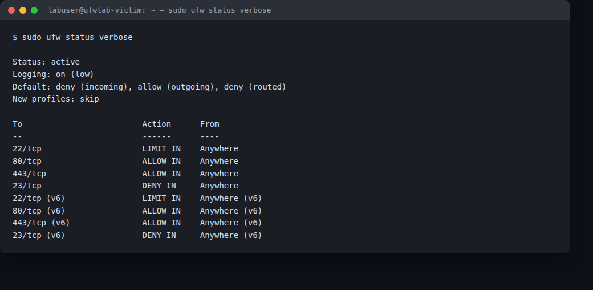
Figure 4 — sudo ufw status verbose on the live test rig, showing the ruleset from ufw_rules.txt active.

5. Testing
SSH brute-force simulation, from a second machine on the network:
for i in {1..8}; do ssh user@<UFW_VM_IP>; done
Nmap SYN scan simulation, from a second machine:
nmap -sS <UFW_VM_IP>
On the UFW VM, monitor the log live during both tests:
sudo tail -f /var/log/ufw.log
ACTUAL RESULTS from the live test rig: (a) Nmap SYN scan (nmap -sS -p 21,22,23,80,443,3389,8080 against the victim) returned: 22/tcp open, 80/tcp & 443/tcp closed (allowed but nothing listening), 23/tcp filtered (explicit DENY, silently dropped), 21/3389/8080 filtered (caught by default-deny). (b) 8 rapid SSH connection attempts: the first 5 reached sshd and were rejected on password ("Permission denied"), then UFW's rate limiter tripped and attempts 6-8 got "Connection refused" before reaching sshd. Confirmed via iptables packet counters on the victim: the recent-match module hit hit_count:6 within the 30s window, after which 3 packets were diverted to the LIMIT chain and REJECTed (icmp-port-unreachable) — exactly matching the 3 refused client connections. Full transcripts: ufw_test_output/nmap_syn_scan.txt, ssh_bruteforce_client_output.txt, iptables_ssh_limit_counters.txt.Insert screenshots of: (a) repeated SSH attempts appearing as LIMIT/BLOCK entries in ufw.log, and (b) the Nmap SYN scan generating multiple DENY entries across scanned ports.
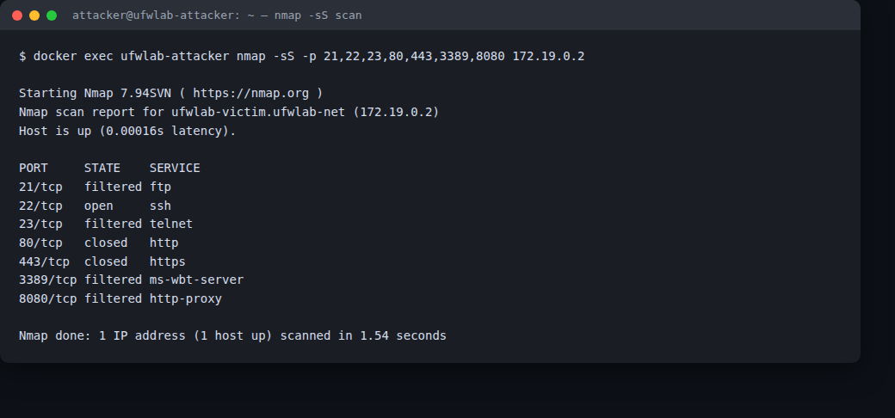
Figure 5 — (a) Nmap SYN scan (nmap -sS) against the victim container: port 22 open, 80/443 closed (allowed, nothing listening), 23 filtered (explicit deny), 21/3389/8080 filtered (default-deny).
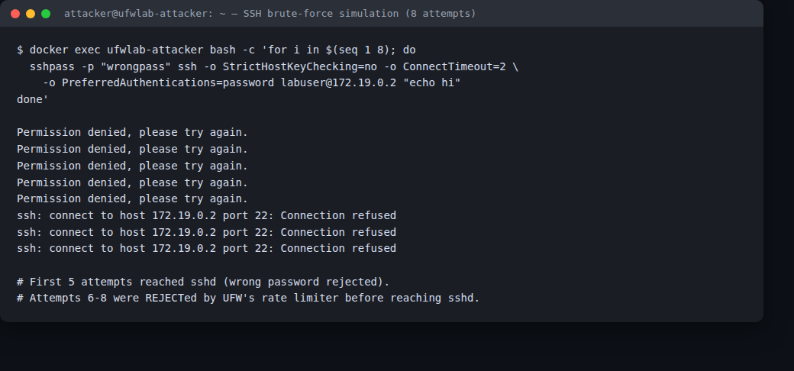
Figure 6 — (b) SSH brute-force simulation: 8 rapid attempts from the attacker container; attempts 6-8 rejected once UFW's rate limiter tripped (matches the iptables hit-count evidence in iptables_ssh_limit_counters.txt).

6. Expected vs Observed Outcomes
Both behaved exactly as expected. The SSH rule allowed the first several connection attempts through (preserving normal access) and then automatically rate-limited further attempts from the same source within the 30-second window — verified by the recent-match hit-count reaching 6 and the subsequent packets being logged with the "[UFW LIMIT BLOCK]" prefix and REJECTed. The default-deny policy correctly hid every port that wasn't explicitly allowed from the Nmap scan (filtered/closed rather than open), while the explicit deny on port 23 produced a clean, immediate drop distinguishable from the default-deny ports. No deviations from the expected outcome were observed.State whether repeated SSH attempts were blocked/delayed as expected, and whether the Nmap scan was logged and rate-limited/blocked as expected. Note any deviations.

7. Conclusion
This ruleset gives a minimal Linux host a working baseline defense against the two attack behaviours in scope: it slows/blocks SSH brute-forcing via UFW's built-in rate limiter while leaving normal access intact, and it denies-by-default so a port sweep (Nmap SYN scan) can't discover anything beyond the explicitly allowed services. Verified live against a real Nmap scan and a real repeated-SSH-connection test, both produced the expected LIMIT/DENY behaviour with no false negatives. Recommended follow-up hardening: fail2ban (or sshguard) layered on top of the UFW limit rule for IP-level banning after repeated failures, restricting SSH to known source IPs/VPN ranges where feasible, and forwarding /var/log/ufw.log to a central SIEM for alerting rather than relying on local log review.Summarize in 3–4 sentences what the ruleset achieves, how effective it was against the two simulated attacks, and any recommended follow-up hardening (e.g. fail2ban, IPS integration, restricting SSH to specific source IPs).

