1

2

3

4

5

6

7

8

9

10

11

12

13

14

15

16

17

18

19

20

21

22

23

24

25

26

27

28

29

30

31

32

33

34

35

36

37

38

39

40

Contents

1 SAY IT BETTER IN ENGLISH 3

1.1 SAY IT BETTER IN ENGLISH - Page8 - Week 1 - Day 1 - Keep going 3

1.2 SAY IT BETTER IN ENGLISH - Page9 - Week 1 - Day 2 - Mr. Lee 4

1.3 SAY IT BETTER IN ENGLISH - Page10 - Week 1 - Day 3 - Drop by 5

1.4 SAY IT BETTER IN ENGLISH – Page11 - Week 1 - Day 4 - Can I put you on hold? 6

1.5 SAY IT BETTER IN ENGLISH – Page12 - Week 1 - Day 5 - In charge of 7

1.6 SAY IT BETTER IN ENGLISH – Page13 - Week 1 – Day 6 - Running short of time 8

1.7 SAY IT BETTER IN ENGLISH – Page14 - Week 1 – Day 7 - Puzzle #1 9

1.8 SAY IT BETTER IN ENGLISH – Page15 - Week 2 – Day 1 - Get a move on 10

1.9 SAY IT BETTER IN ENGLISH – Page16 - Week 2 – Day 2 - That’s K for Korea 11

1.10 SAY IT BETTER IN ENGLISH – Page17- Week 2 – Day 3 - How can I help you? 12

1.11 SAY IT BETTER IN ENGLISH –Page18- Week 2 – Day 4 - it’s for you 13

1.12 SAY IT BETTER IN ENGLISH –Page19- Week 2 – Day 5 - in an hour = one hour after now 14

1.13 SAY IT BETTER IN ENGLISH – Page20 - Week 2 – Day 6 - Ahead of / on / behind schedule 15

1.14 SAY IT BETTER IN ENGLISH – Page21 - Week 2 – Day 7 - Puzzle #2 16

1.15 SAY IT BETTER IN ENGLISH – Page22 - Week 3 – Day 1 - Tied up 17

1.16 SAY IT BETTER IN ENGLISH – Page23 - Week 3 – Day 2 - When is a good time? 18

2 PHRASAL VERBS IN USE 20

2.1 PHRASAL VERBS IN WORK 20

# SAY IT BETTER IN ENGLISH

## SAY IT BETTER IN ENGLISH - Page8 - Week 1 - Day 1 - Keep going

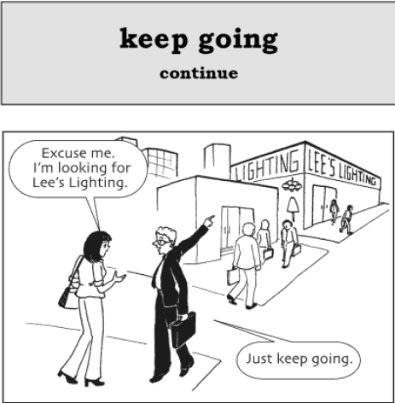

A: “Should we **stop working** at 5 o’clock?”

B: “No, let’s **keep going** until 8 o’clock.”

A: “Can I **stop running**?”

B: “No, keep going. You need the exercise.”

**Keep going** **=** **continue** (v) **=** **go on**

**Stop + V_ing**: to indicate that an action or event is no longer continuing.

It’s **stopped raining**. (It was raining, but not anymore.)

I **have stopped cycling** to work.

**Stop + to-infinitive**: to indicate that someone stops/interrupt doing something in order to do something else.

On the way to Edinburgh, we **stopped to look** at an old castle. (We were travelling, then we stopped our journey in order to look at the castle.). **Look + at**: xem, xem xét. **Be + looking + at**: đối mặt với.

I **stopped to take** a break, but I’ll start again soon.

S + V + **in order to + infinitive** = S + V + **so as to + infinitive** = S + V + **to + infinitive**: để, để mà.

I study hard **in order to / so as to / to pass** the exam.

S + V + **in order + NOT + to** + infinitive = S + V + **so as + NOT + to** + infinitive. Note: **~~NOT to infinitive~~**

I study hard. I **~~want to~~** pass the exam. => I study hard in order to pass the exam. Note: **~~want, like, hope,…~~**

S + V + **in order to for O + infinitive** = S + V + **so as to for O + infinitive** = S + V + **to for O + infinitive**

She works hard **in order for her kids to have** a better life.

## SAY IT BETTER IN ENGLISH - Page9 - Week 1 - Day 2 - Mr. Lee

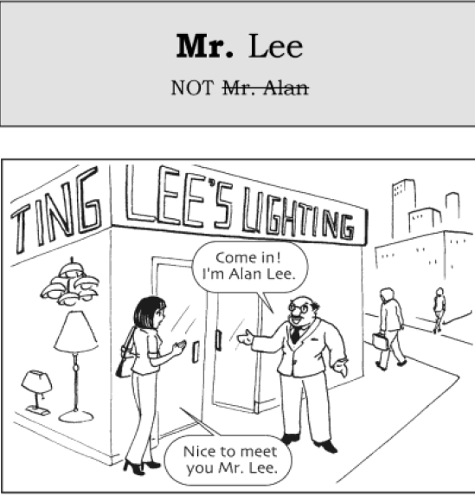  
A: “I’m Bill Jones.”

B: “Nice to meet you, **Mr.** Jones.”

A: “You can call me by my first name.”

B: “Alright. Hello Bill.”

Ex: Name: Bill Clinton; Nguyễn Thị Trang; Bùi Thị Hải Yến

Tên = **Given name = First name = Forename**: Bill, Trang, Thị Trang

Tên lót = **Middle name**: Thị

Họ = **Last name = Family name = Surname**: Clinton, Nguyễn, Nguyễn Thị

**VISA, Vé máy bay,…: Surname/Given name** = BUI / THI HAI YEN

## SAY IT BETTER IN ENGLISH - Page10 - Week 1 - Day 3 - Drop by

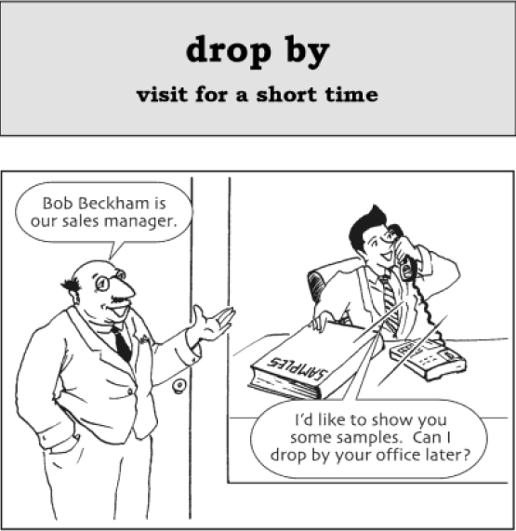

“You **left** your book in my car. I’ll **drop by** your house and give it to you.”

“I **dropped by** the camera store to **pick up** our photos.”

**Drop by = visit for a short time**

**Pick up** something **= pick** something **up = collect** something

Note: **pick** it **up**, NOT **~~pick up~~** ~~it~~

**Leave - Left**

**Leave** something (preposition) somewhere **= let** something **stay** somewhere **= forget** s.thing s.where

## SAY IT BETTER IN ENGLISH – Page11 - Week 1 - Day 4 - Can I put you on hold?

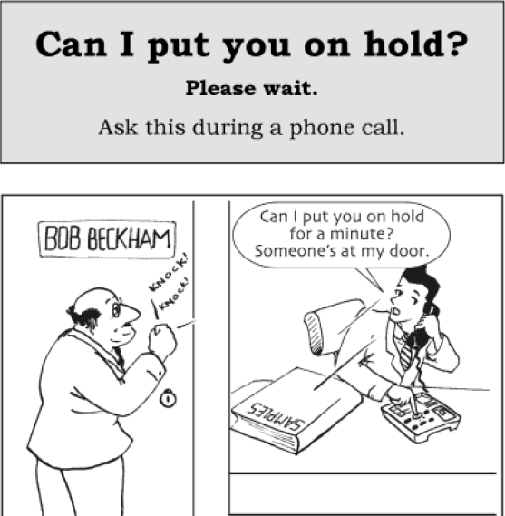

A: “Can I speak to the manager?”

B: “**Can I put you on hold** for a minute? I’ll see if he’s here.”

A: “Hello, ABC Market? Do you have any fresh raspberries?”

B: “**Can I put you on hold** while I go and see if we have any **left**?”

**Can I put you on hold = please wait**

**There is/are** something **left =** something **is/are remaining**

## SAY IT BETTER IN ENGLISH – Page12 - Week 1 - Day 5 - In charge of

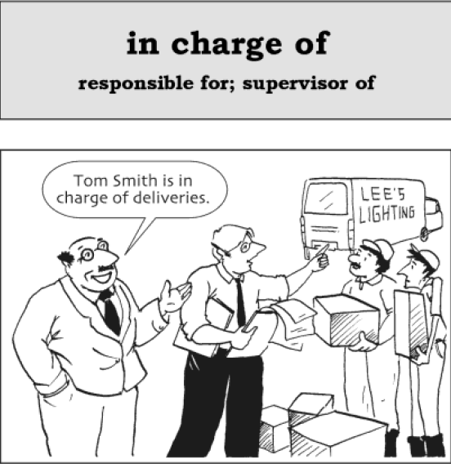

“I’d like to speak to the person **in charge of** customer service.”

“He’s **in charge of** train**ing** new staff.”

**In charge of = responsible for = supervisor of**

**In charge of + n; in charge of + V_ing**

## SAY IT BETTER IN ENGLISH – Page13 - Week 1 – Day 6 - Running short of time

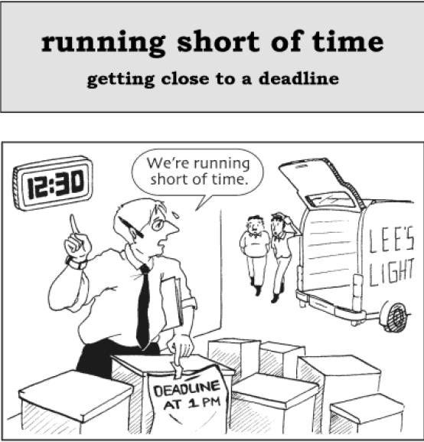

“I **have to** work late tonight. I **need to** finish a project, and I’m **running short of time**.”

“I**’d like to** finish this meeting soon. Let’s **move on** to the next point because we’re **running short of time**.”

**Running short of time = getting close to a deadline**

**Have to**

**Need to**

**Would like to**

**Move on** = **begin a new topic** (use this in meetings)

## SAY IT BETTER IN ENGLISH – Page14 - Week 1 – Day 7 - Puzzle #1

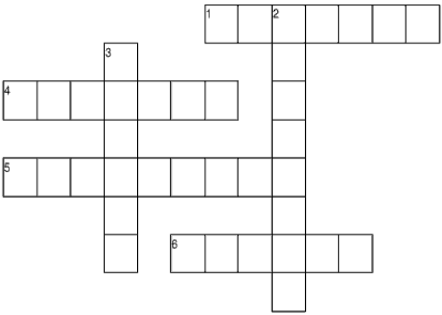

**ACROSS:**

1) “This is Stephen Jackson.” “Nice to meet you, Mr. _.”

4) “Your test is tomorrow. You haven’t studied yet! You’re running _ _ time!”

5) “Let’s stop driving and have dinner.” “No, let’s _ _. We will be there soon.”

6) (On the phone). “What time is the meeting?” “Can I put you _ _? I’ll ask my boss.”

**DOWN:**

2) “I’m a teacher. I’m in _ _ 50 students.”

3) “If you _ _ my house tonight, I’ll give you the money.”

## SAY IT BETTER IN ENGLISH – Page15 - Week 2 – Day 1 - Get a move on

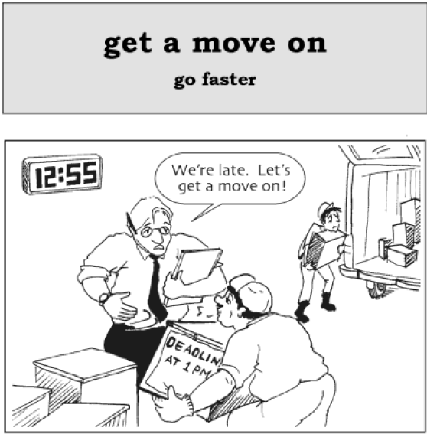

**“**The movie is going to start soon. Let’s **get a move on** or we’ll be late**.”**

**“**We have to **get a move on** if we want to finish by Wednesday**.”**

**Get a move on = go faster**

## SAY IT BETTER IN ENGLISH – Page16 - Week 2 – Day 2 - That’s K for Korea

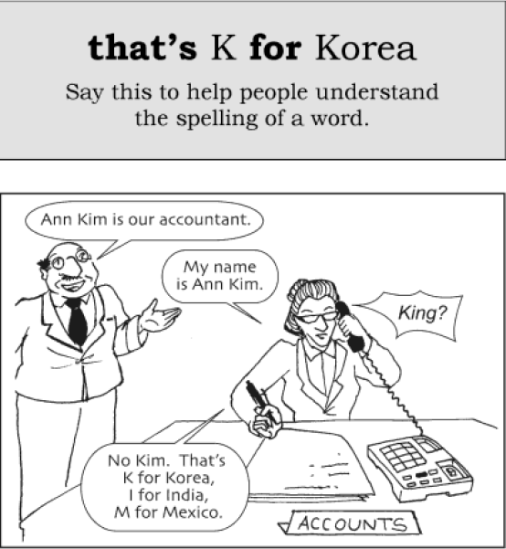

## SAY IT BETTER IN ENGLISH – Page17- Week 2 – Day 3 - How can I help you?

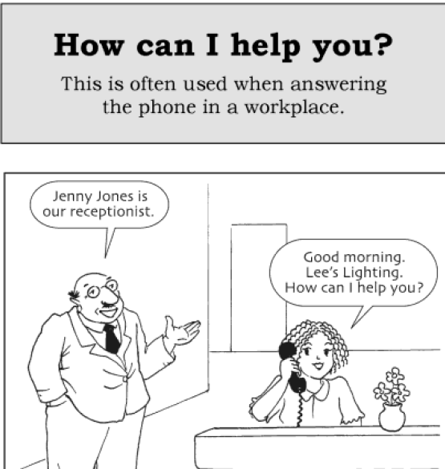

## SAY IT BETTER IN ENGLISH –Page18- Week 2 – Day 4 - it’s for you

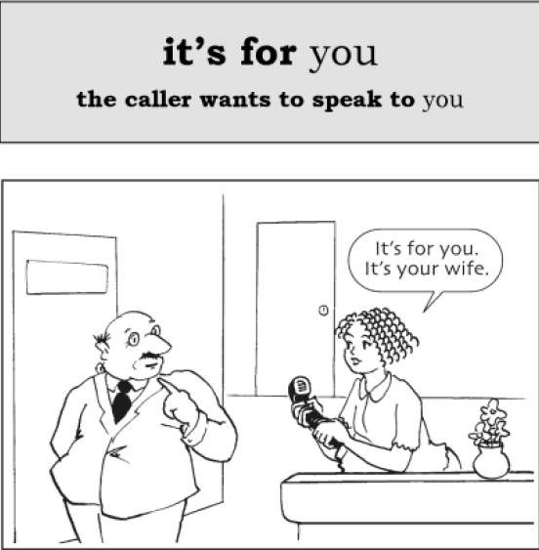

**it’s for** you **= the caller wants to speak to** you

want to

speak to

“Could you ask Chris to come to the phone?” “**It’s for** him. It’s his mother.”

“The phone is ringing.” “I’ll get it. I think **it’s for** me.”

**Get it** = **answer the phone**

“The phone is ringing.” “I’ll **get it**. I think it’s for me.”

## SAY IT BETTER IN ENGLISH –Page19- Week 2 – Day 5 - in an hour = one hour after now

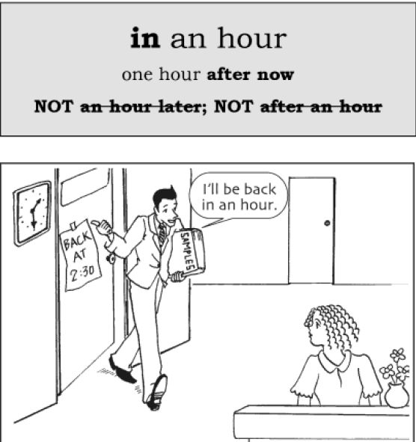

**in** an hour = one hour **after now**

**NOT: ~~an hour later~~; ~~after an hour~~**

“She hasn’t arrived yet. She’ll be here **in** 10 minutes.”

“He is almost finished with high school. He will graduate **in** a few months.”

Note: Different meaning of **in**: Do something **in** five days = **it takes** five days **to complete** something

## SAY IT BETTER IN ENGLISH – Page20 - Week 2 – Day 6 - Ahead of / on / behind schedule

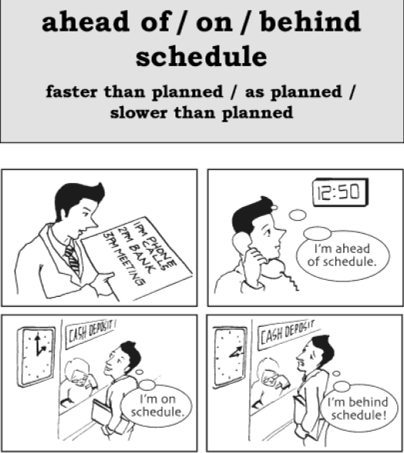

**Ahead of / on / behind schedule = faster than planned / as planned / slower than planned**

“Please drive faster. We are **behind schedule**.”

“How’s the project coming along?” “Fine. Everything is **on schedule**.”

**How’s** something **coming along? = tell me about the progress** of something that is not finished

“**How’s** the report **coming along**?” “We are half-way through.”

## SAY IT BETTER IN ENGLISH – Page21 - Week 2 – Day 7 - Puzzle #2

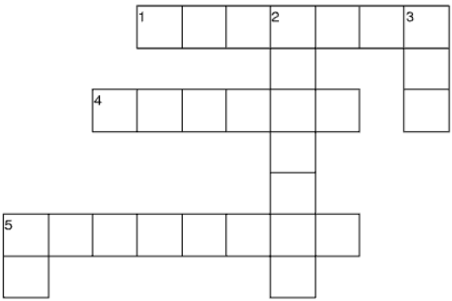

**ACROSS**

1) “Don’t forget to finish the report tomorrow.”

“I’ve already finished. I’m ___ ___schedule.”

4) (on the phone) “Can I speak to Jane?” “One moment, please…Jane! ___ ___ you.”

5) (on the phone) “Good afternoon. This is the Hinton Hotel. How can ___ ___ ___?”

**DOWN**

2) “Hurry up! We have to get ___ ___ ___.”

“Okay. I’ll get my coat quickly.”

3) “My name is Sam. That’s S ___ Sweden, A, M.”

5) “I am driving to work now. I will arrive at work ___ 15 minutes.”

## SAY IT BETTER IN ENGLISH – Page22 - Week 3 – Day 1 - Tied up

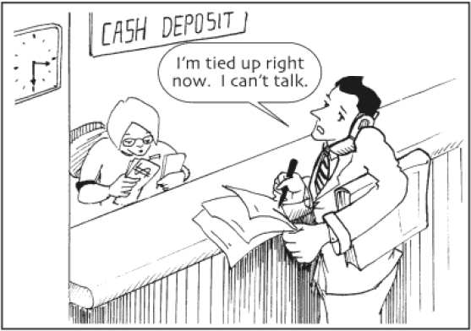

**Tied up** = busy doing something that you can’t stop

“Can we meet today?” “Sorry, I’ll be **tied up** all day. How about tomorrow?”

“I’m **tied up** now, but I’ll be free **in an hour**.”

**in** an hour = one hour **after now**

“She hasn’t arrived yet. She’ll be here **in** 10 minutes.”

## SAY IT BETTER IN ENGLISH – Page23 - Week 3 – Day 2 - When is a good time?

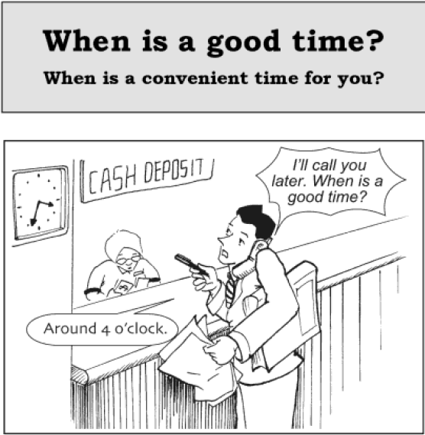

**When is a good time? = When is a convenient time for you?**

“I have some papers for you to sign. **When is a good time** to **drop by** your office?”

“Can we meet next week?” “Sure. **When is a good time** for you?” “How about Friday at 10 a.m?”

**Drop by = visit for a short time**

**Pick up** something **= pick** something **up = collect** something

Note: **pick** it **up**, NOT **~~pick up~~** ~~it~~

**Leave - Left**

**Leave** something (preposition) somewhere **= let** something **stay** somewhere **= forget** s.thing s.where

“You **left** your book in my car. I’ll **drop by** your house and give it to you.”

“I **dropped by** the camera store to **pick up** our photos.”

# PHRASAL VERBS IN USE

## PHRASAL VERBS IN WORK

**Point of view**: quan điểm

**From** + n + **point of view**: từ quan điểm + n

**step-by-step:** từng bước

**From** programming **point of view**, an algorithm is a **step-by-step** procedure to resolve any problem.

**Figure + out**: Tìm ra

**Stand + for**: là viết tắt của

**Stand + for = represent**: đại diện cho