

**ONLINE CARS SELLING SYSTEM**

**Software Design Specification**

– Hanoi, February 2023 –

Record of changeS

|  |  |  |  |
| --- | --- | --- | --- |
| Date | A* M, D | In charge | Change Description |
| 01/02/2023 | A | HungNB | Add database design, class diagram and sequence diagram for login |
| 05/02/2023 | A | NamVT | Add code package |
| 9/2/2022 | M | HungHM | Modified code package |
| 13/2/2022 | M | DatNA | Modified SQL Database |
|  |  |  |  |
|  |  |  |  |
|  |  |  |  |
|  |  |  |  |
|  |  |  |  |
|  |  |  |  |
|  |  |  |  |
|  |  |  |  |
|  |  |  |  |

*A - Added M - Modified D - Deleted

I. Overview 5

1. Code Packages 5

2. Database Design 6

a. Database Schema 6

b. Table Description 6

II. Code Designs 7

1. Register 7

a. Class Diagram 7

b. Class Specifications 7

c. Sequence Diagram(s) 9

d. Database Queries 9

2. Login 10

a. Class Diagram 10

b. Class Specifications 10

c. Sequence Diagram(s) 11

d. Database Queries 11

3. Home Page 12

4. Forgot Password 12

5. Change Password 12

6. Create Car 14

a. Class Diagram 14

b. Class Specifications 14

c. Sequence Diagram(s) 16

d. Database Queries 16

7. View List Car 17

a. Class Diagram 17

b. Class Specifications 17

c. Sequence Diagram(s) 18

d. Database Queries 18

8. Search Car 19

a. Class Diagram 19

b. Class Specifications 19

c. Sequence Diagram(s) 20

d. Database Queries 21

9. View Detail Car 21

a. Class Diagram 21

b. Class Specifications 21

c. Sequence Diagram(s) 22

d. Database Queries 22

10. Update Car 22

a. Class Diagram 22

b. Class Specifications 23

c. Sequence Diagram(s) 24

d. Database Queries 25

11. Create Car 25

a. Class Diagram 25

b. Class Specifications 25

c. Sequence Diagram(s) 27

d. Database Queries 27

12. View Detail Car 27

13. Update Car 27

14. Delete Car 27

15. Search Car 27

16. User Detail 27

a. Class Diagram 27

b. Sequence Diagram(s) 28

17. Update Profile 30

a. Class Diagram 30

b. Sequence Diagram(s) 31

# I. Overview

## 1. Code Packages

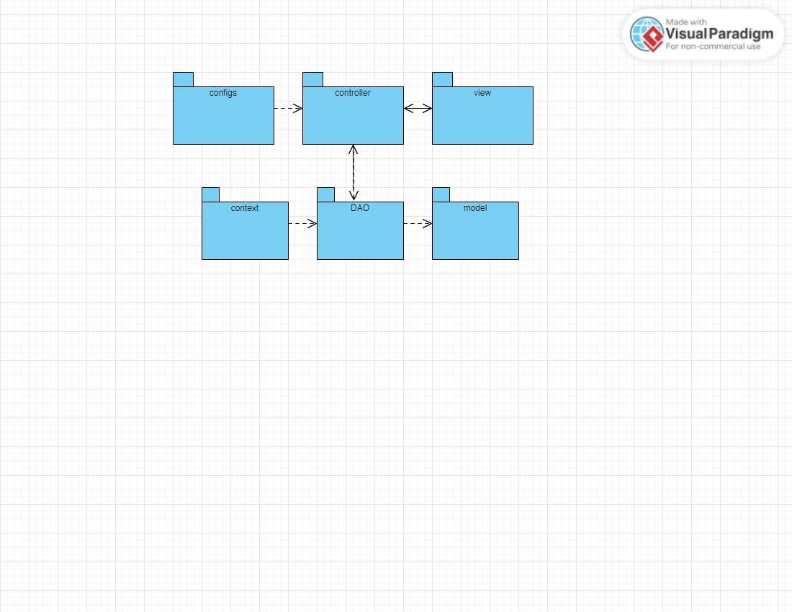

***Package descriptions***

|  |  |  |
| --- | --- | --- |
| **No** | **Package** | **Description** |
| *01* | *controller* | *Acts as a go-between for the service layer and the view, passing on different input requests* |
| *02* | *DAO* | *This component is used to get data directly FROM the database* |
| *03* | *configs* | *This component helps define configuration* |
| *04* | *context* | *This component helps connect database* |
| *05* | *model* | *This component includes interfaces used to receive data retrieved FROM the database and classes used to receive data* |
| *06* | *view* | *This component display view.* |

## 2. Database Design

### a. Database Schema

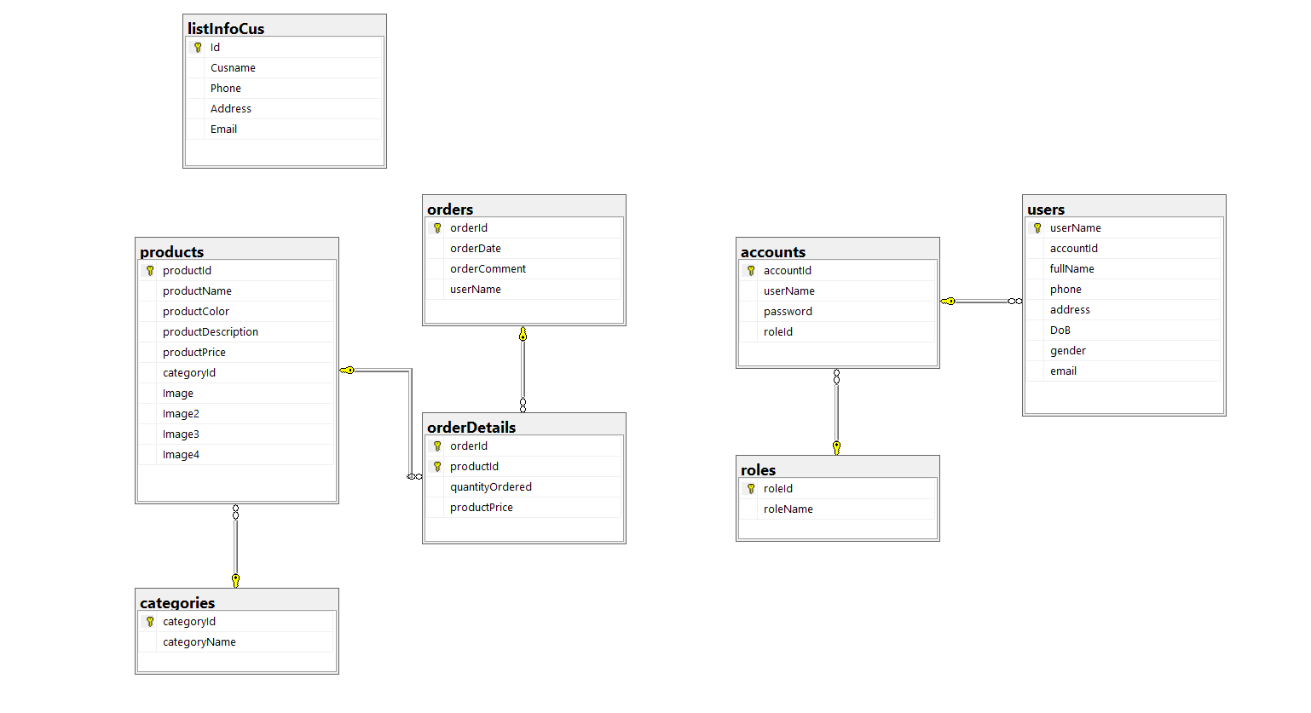

### b. Table Description

|  |  |  |
| --- | --- | --- |
| **No** | **Table** | **Description** |
| *01* | *user* | *User of the system* |
| *02* | *Accounts* | *The management system of users of admin and manager* |
| *03* | *Roles* | *Account functions* |
| *04* | *Orders* | *Where contains product information: name, date, time, product code* |
| 05 | orderDetails | Contains price, quantity, product code |
| 06 | Products | Products are presented to users in this table |
| 07 | Categories | Where to classify vehicles and choose |
| 08 | listInfoCus | Manage contact information to care and consult with customers |

# II. Code Designs

## Register

### a. Class Diagram

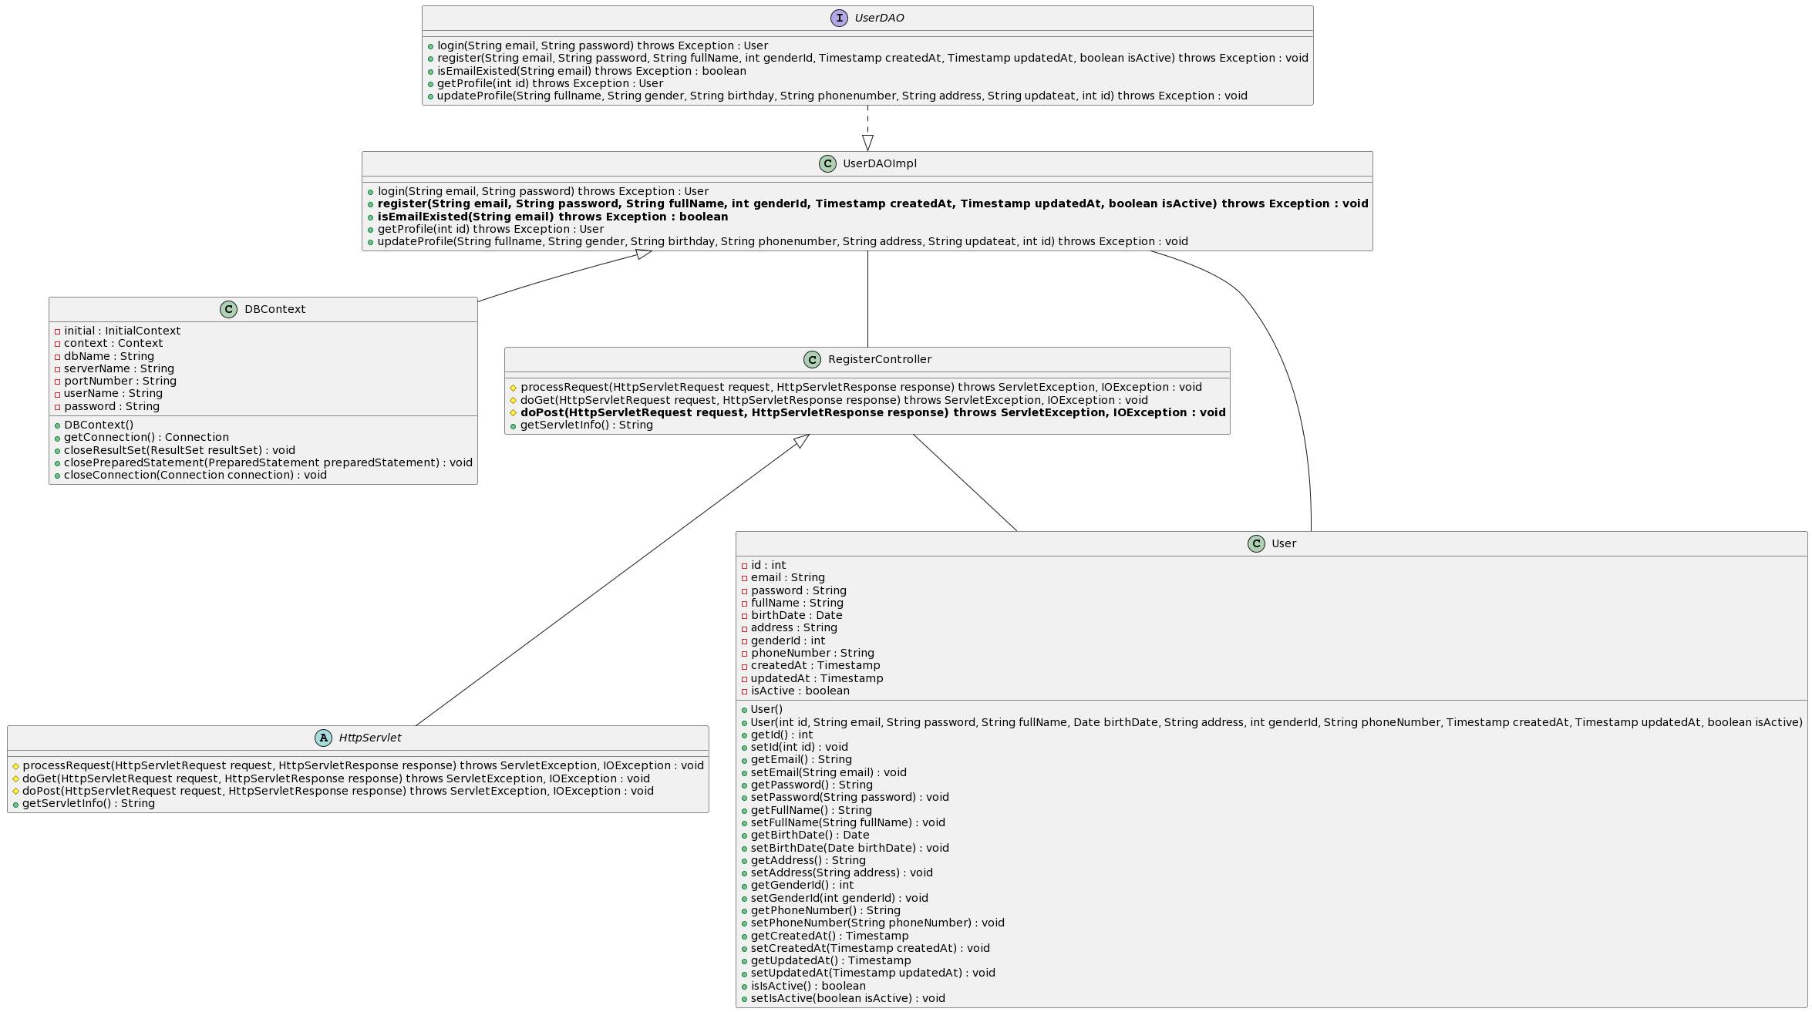

### b. Class Specifications

#### RegisterController

***Class Methods***

|  |  |  |
| --- | --- | --- |
| **No** | **Method** | **Description** |
| *01* | *doPost(HttpServletRequest request, HttpServletResponse response)* | *Get email, password and fullname from register form, check it and add to the database* |

#### DBContext

***Class Methods***

|  |  |  |
| --- | --- | --- |
| **No** | **Method** | **Description** |
| *01* | *getConnection()* | *To connect with database* |
| *02* | *closeResultSet(ResultSet resultSet)* | *To close result set* |
| *03* | *closePreparedStatement(PreparedStatement preparedStatement)* | *To close prepared statement* |
| *04* | *closeConnection(Connection connection)* | *To close connection* |

#### UserDAO

***Class Methods***

|  |  |  |
| --- | --- | --- |
| **No** | **Method** | **Description** |
| *01* | *register(String email, String password, String fullName, int genderId, Timestamp createdAt, Timestamp updatedAt, boolean isActive)* | *Interface abstract method register with email, password, and fullName* |
| *02* | *isEmailExisted(String email)* | *Interface abstract method check email is existed in the system or not* |

#### UserDAOImpl

***Class Methods***

|  |  |  |
| --- | --- | --- |
| **No** | **Method** | **Description** |
| *01* | *register(String email, String password, String fullName, int genderId, Timestamp createdAt, Timestamp updatedAt, boolean isActive)* | *Register account of the system with email, password and fullName* |
| *02* | *isEmailExisted(String email)* | *Check email is existed in the system or not* |

#### User

***Class Methods***

|  |  |  |
| --- | --- | --- |
| **No** | **Method** | **Description** |
| *01* | *Constructors* | *Entity initialization* |
| *02* | *Getter* | *Get value of each attributes* |
| *03* | *Setter* | *Set value for each attributes* |

### c. Sequence Diagram(s)

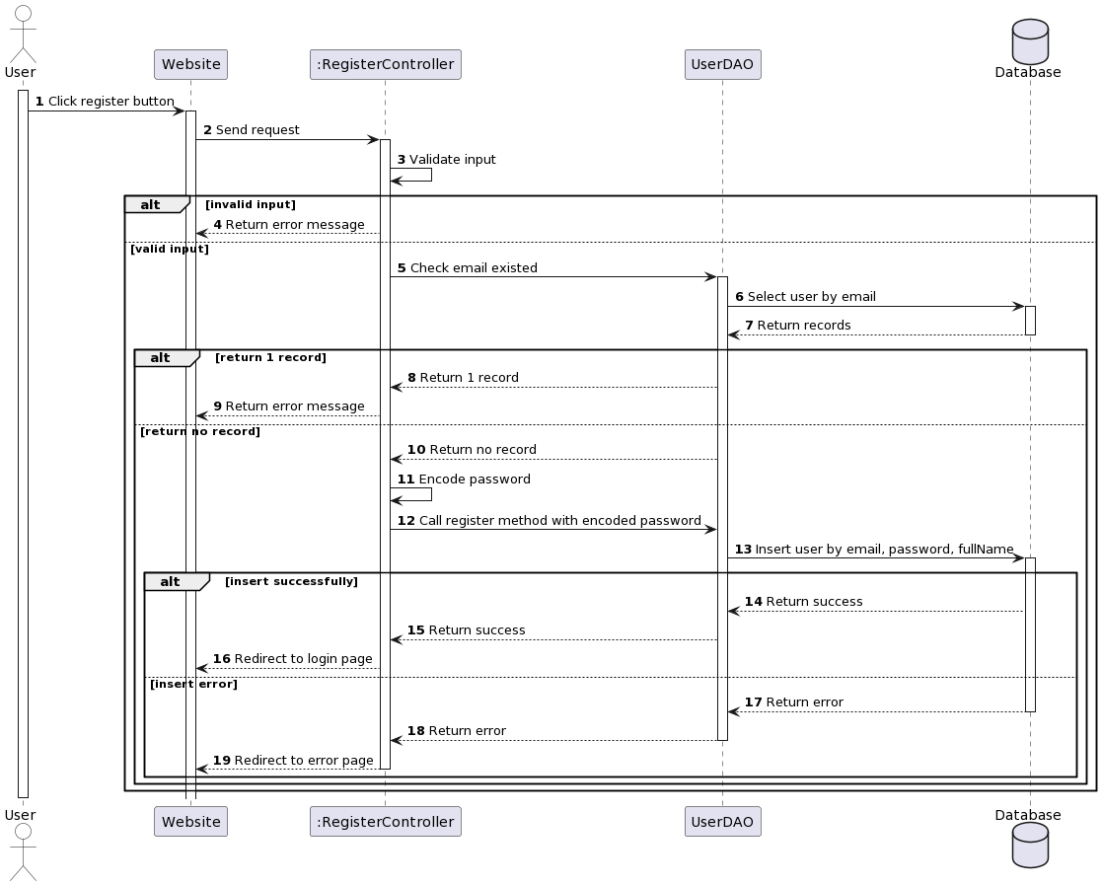

### d. Database Queries

**- SELECT * FROM [user] WHERE [email] = ?**

**- insert into [user] (email, password, full_name, gender_id, created_at, updated_at, is_active) values (?, ?, ?, ?, ?, ?, ?)**

## Login

### a. Class Diagram

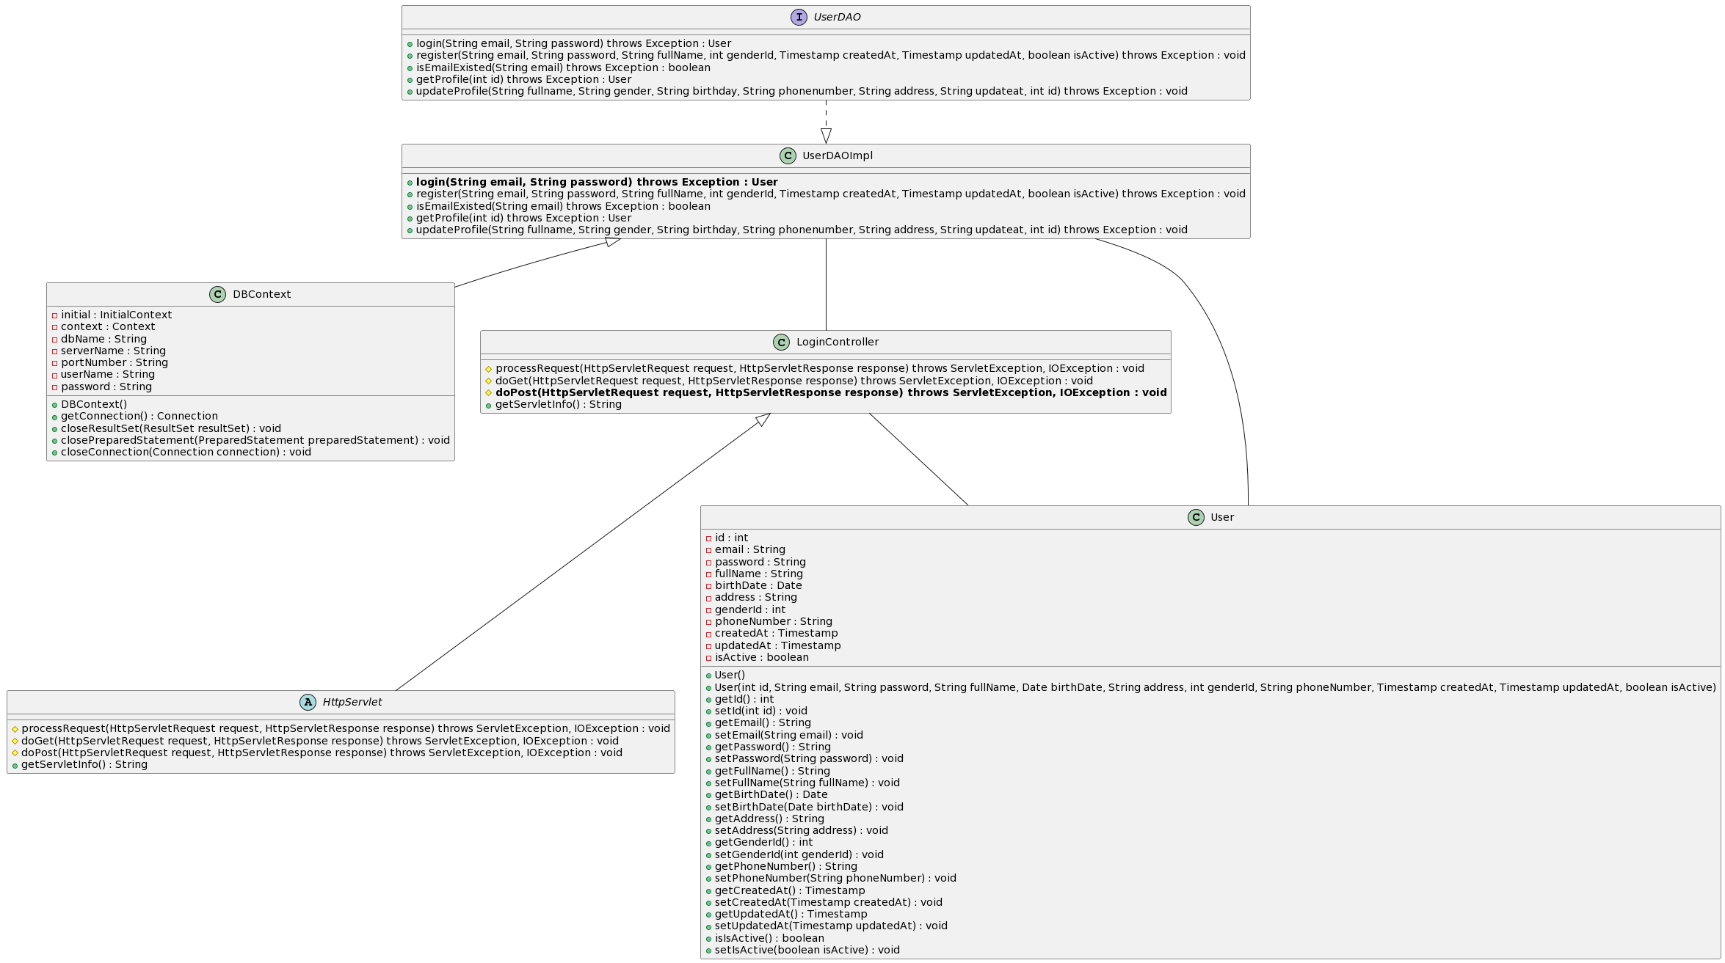

### b. Class Specifications

#### LoginController

***Class Methods***

|  |  |  |
| --- | --- | --- |
| **No** | **Method** | **Description** |
| *01* | *doPost(HttpServletRequest request, HttpServletResponse response)* | *Get email and password from Login Form and compare data in database. If user exist in database with correct password, user will login successfully* |

#### DBContext

***Class Methods***

|  |  |  |
| --- | --- | --- |
| **No** | **Method** | **Description** |
| *01* | *getConnection()* | *To connect with database* |
| *02* | *closeResultSet(ResultSet resultSet)* | *To close result set* |
| *03* | *closePreparedStatement(PreparedStatement preparedStatement)* | *To close prepared statement* |
| *04* | *closeConnection(Connection connection)* | *To close connection* |

#### UserDAO

***Class Methods***

|  |  |  |
| --- | --- | --- |
| **No** | **Method** | **Description** |
| *01* | *login(String email, String password)* | *Interface abstract method login with email and password* |

#### UserDAOImpl

***Class Methods***

|  |  |  |
| --- | --- | --- |
| **No** | **Method** | **Description** |
| *01* | *login(String email, String password)* | *Login to the system with email and password* |

#### User

***Class Methods***

|  |  |  |
| --- | --- | --- |
| **No** | **Method** | **Description** |
| *01* | *Constructors* | *Entity initialization* |
| *02* | *Getter* | *Get value of each attributes* |
| *03* | *Setter* | *Set value for each attributes* |

### c. Sequence Diagram(s)

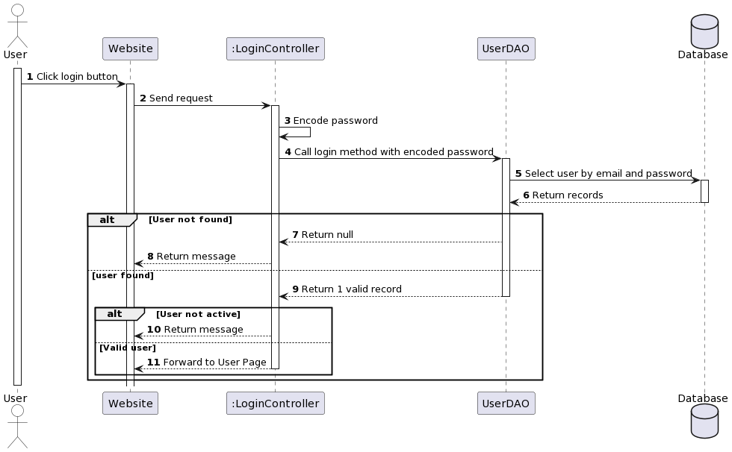

### d. Database Queries

**SELECT * FROM [user] WHERE [email] = ? and [password] = ?**

## Home Page

## Forgot Password

## Change Password

***a. Class Diagram***

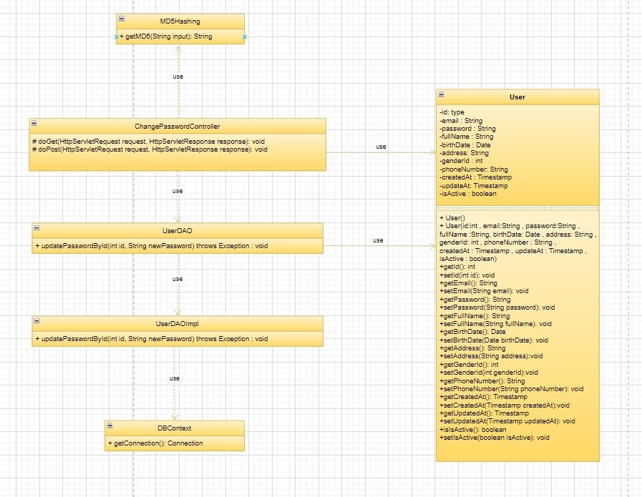

***b. Class Specifications***

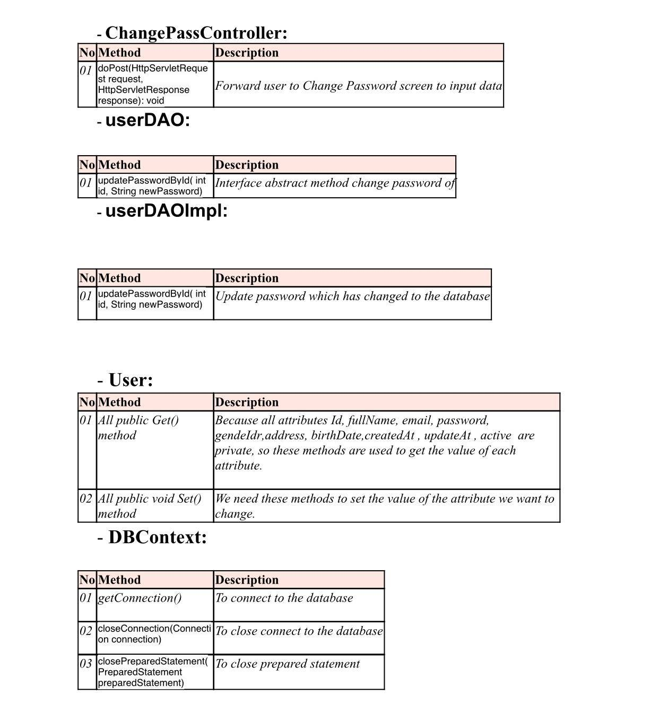

***c. Sequence Diagram(s)***

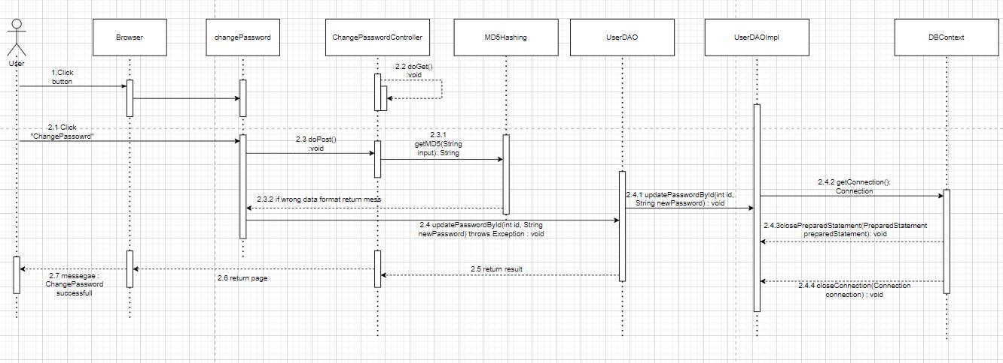

***d. Database Queries***

***SELECT * FROM WHERE userId = ?;***

## Create Car

### a. Class Diagram

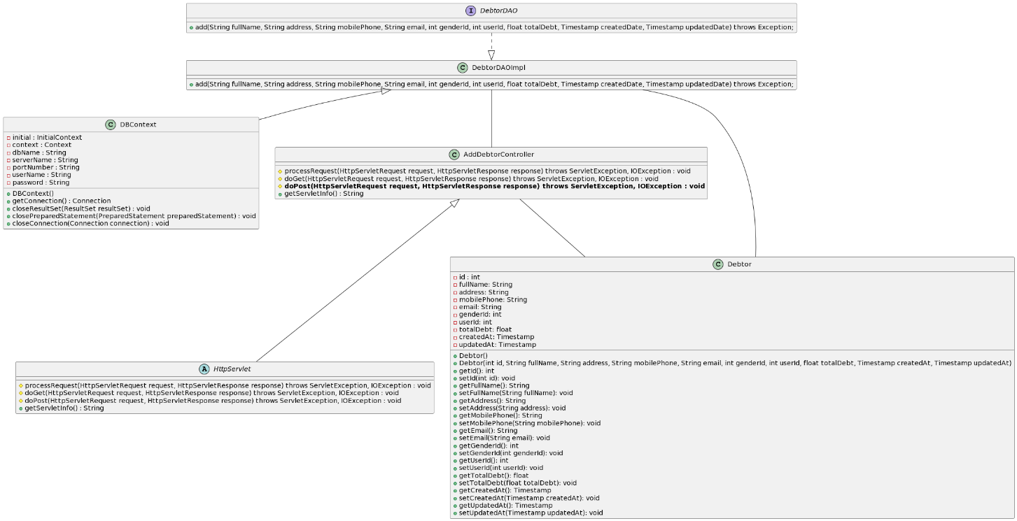

### b. Class Specifications

#### AddCarController

***Class Methods***

|  |  |  |
| --- | --- | --- |
| **No** | **Method** | **Description** |
| *01* | *doPost(HttpServletRequest request, HttpServletResponse response)* | *Get id, name, address, email, gender, user id, total debt, created at, updatedAt from created debtor form and create a debtor from it. Then save new debtor to database.* |

#### DBContext

***Class Methods***

|  |  |  |
| --- | --- | --- |
| **No** | **Method** | **Description** |
| *01* | *getConnection()* | *To connect with database* |
| *02* | *closeResultSet(ResultSet resultSet)* | *To close result set* |
| *03* | *closePreparedStatement(PreparedStatement preparedStatement)* | *To close prepared statement* |
| *04* | *closeConnection(Connection connection)* | *To close connection* |

#### CarDAO

***Class Methods***

|  |  |  |
| --- | --- | --- |
| **No** | **Method** | **Description** |
| *01* | *add(String fullName, String address, String email, int genderId, int userId, Timestamp createdAt, Timestamp updatedAt )* | *Interface abstract method add debtor with id, name, address, email, gender, user id, total debt, created at, updated at.* |

#### DebtorDAOImpl

***Class Methods***

|  |  |  |
| --- | --- | --- |
| **No** | **Method** | **Description** |
| *01* | *add(String fullName, String address, String email, int genderId, int userId, Timestamp createdAt, Timestamp updatedAt )* | *Add debtor with id, fullName, address, email, genderId, userId, createdAt, updatedAt to database.* |

Car

***Class Methods***

|  |  |  |
| --- | --- | --- |
| **No** | **Method** | **Description** |
| *01* | *Constructors* | *Entity initialization* |
| *02* | *Getter* | *Get value of each attributes* |
| *03* | *Setter* | *Set value for each attributes* |

### c. Sequence Diagram(s)

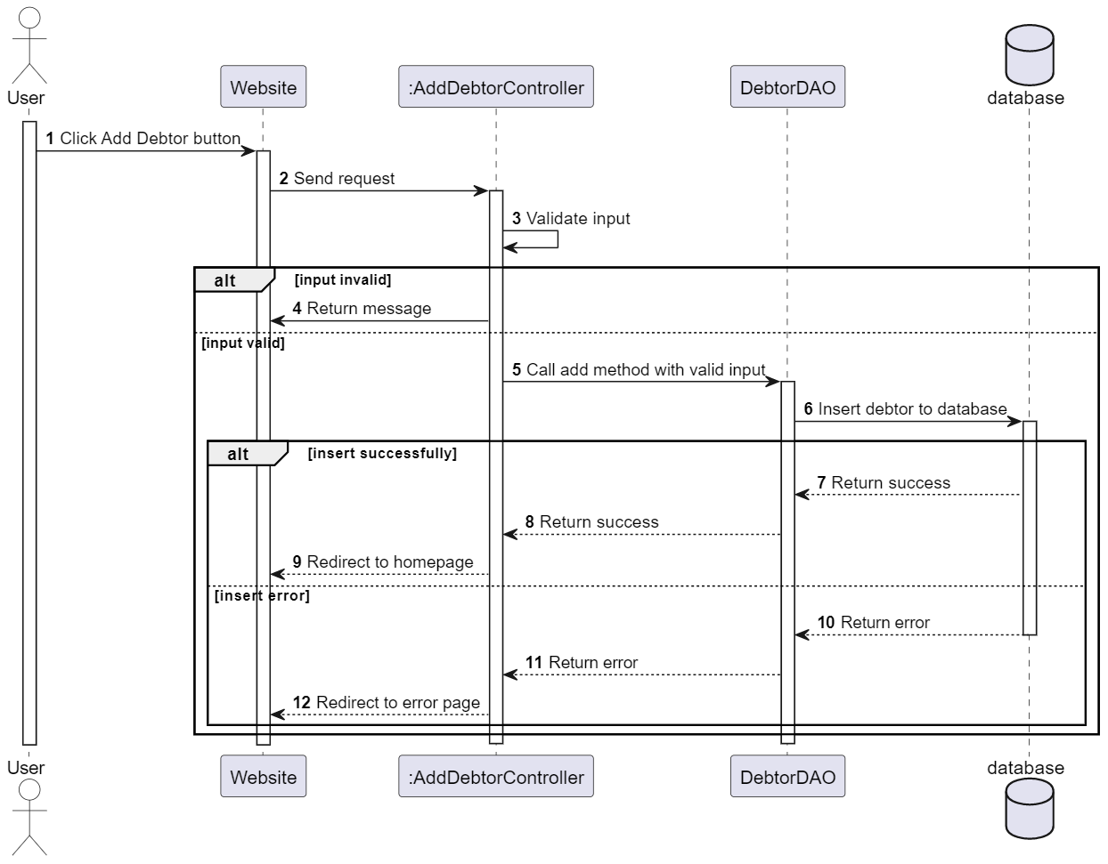

### d. Database Queries

**INSERT INTO [debtor] ([full_name], [address] ,[mobile_phone] ,[email] ,[gender_id] ,[total_debt] ,[created_at] ,[updated_at] ,[user_id]) VALUES (?, ?, ? ,? ,? ,? ,? ,?, ?)**

## View List Car

### a. Class Diagram

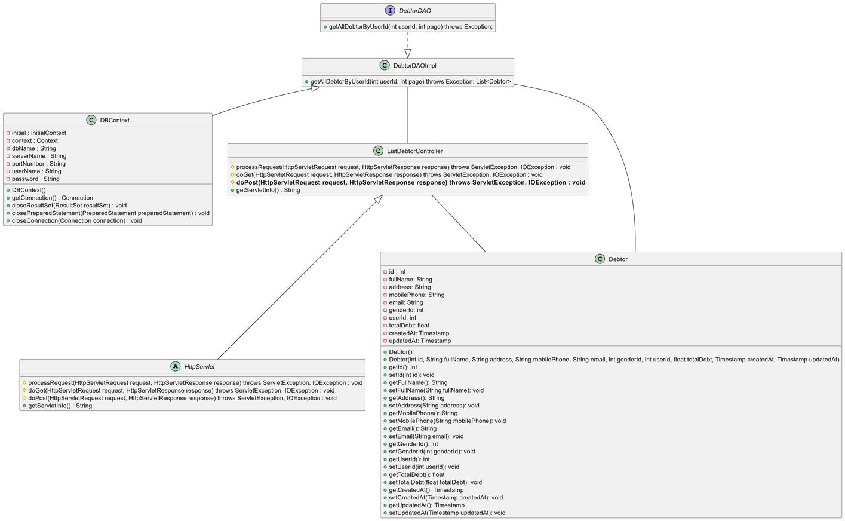

### b. Class Specifications

#### ListCarController

***Class Methods***

|  |  |  |
| --- | --- | --- |
| **No** | **Method** | **Description** |
| *01* | *doPost(HttpServletRequest request, HttpServletResponse response)* | *Get user id from session and return list debtor of user who logged in.* |

#### DBContext

***Class Methods***

|  |  |  |
| --- | --- | --- |
| **No** | **Method** | **Description** |
| *01* | *getConnection()* | *To connect with database* |
| *02* | *closeResultSet(ResultSet resultSet)* | *To close result set* |
| *03* | *closePreparedStatement(PreparedStatement preparedStatement)* | *To close prepared statement* |
| *04* | *closeConnection(Connection connection)* | *To close connection* |

#### CarDAO

***Class Methods***

|  |  |  |
| --- | --- | --- |
| **No** | **Method** | **Description** |
| *01* | *getAllDebtorByUserId(int userId)* | *Interface abstract method getAllDebtorByUserId with user id.* |

#### CarDAOImpl

***Class Methods***

|  |  |  |
| --- | --- | --- |
| **No** | **Method** | **Description** |
| *01* | *getAllDebtorByUserId(int userId)* | *Return List debtor are created by user with id is user id.* |

***Car***

***Class Methods***

|  |  |  |
| --- | --- | --- |
| **No** | **Method** | **Description** |
| *01* | *Constructors* | *Entity initialization* |
| *02* | *Getter* | *Get value of each attributes* |
| *03* | *Setter* | *Set value for each attributes* |

### c. Sequence Diagram(s)

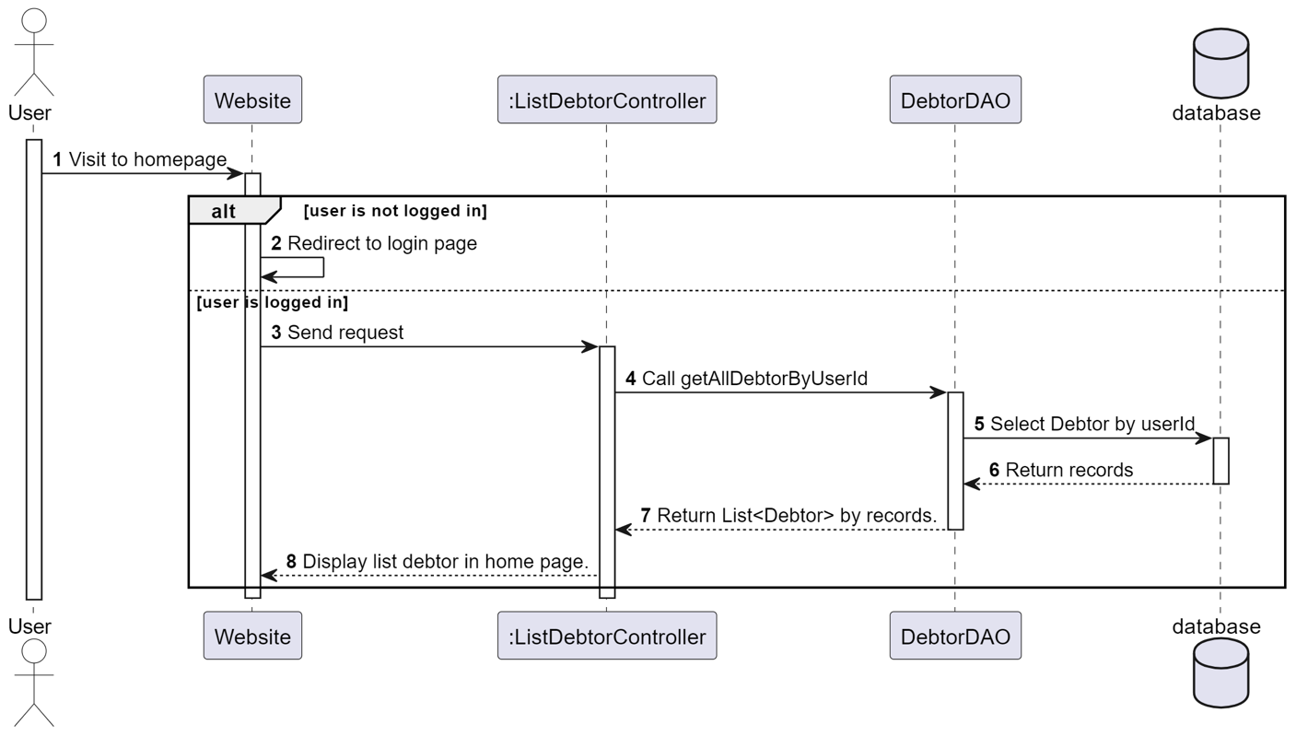

### d. Database Queries

**SELECT * FROM [Car] WHERE userId = ?;**

## Search Car

### a. Class Diagram

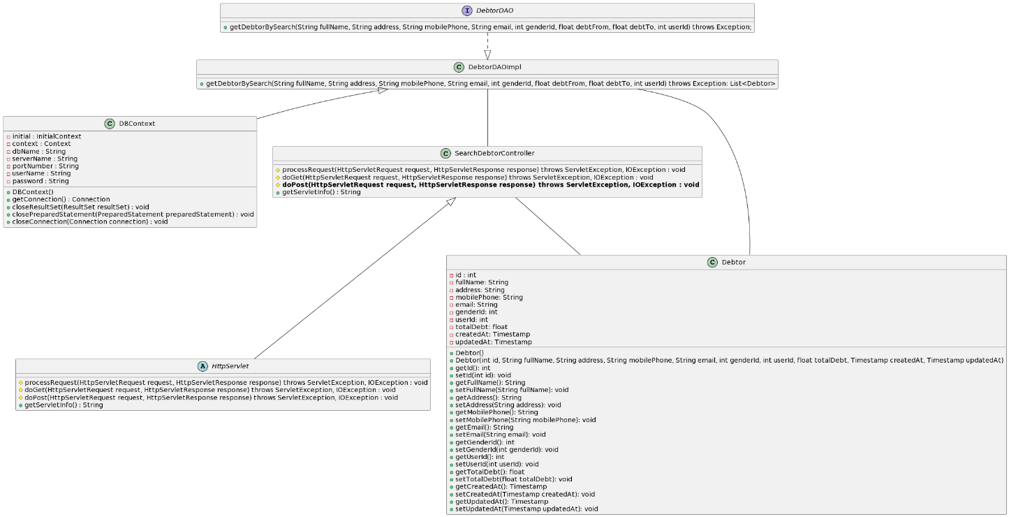

### b. Class Specifications

#### SearchCarController

***Class Methods***

|  |  |  |
| --- | --- | --- |
| **No** | **Method** | **Description** |
| *01* | *doPost(HttpServletRequest request, HttpServletResponse response)* | *Get name, address, email, gender, total debt from Search Form. Return all debtors satisfy the condition.* |

#### DBContext

***Class Methods***

|  |  |  |
| --- | --- | --- |
| **No** | **Method** | **Description** |
| *01* | *getConnection()* | *To connect with database* |
| *02* | *closeResultSet(ResultSet resultSet)* | *To close result set* |
| *03* | *closePreparedStatement(PreparedStatement preparedStatement)* | *To close prepared statement* |
| *04* | *closeConnection(Connection connection)* | *To close connection* |

#### CarDAO

***Class Methods***

|  |  |  |
| --- | --- | --- |
| **No** | **Method** | **Description** |
| *01* | *getDebtorBySearch(int id, String fullName, String address, String email, int genderId, int userId, float totalDebt )* | *Interface abstract method search debtor with id, name, address, email, gender, user id, total debt.* |

#### CarDAOImpl

***Class Methods***

|  |  |  |
| --- | --- | --- |
| **No** | **Method** | **Description** |
| *01* | *get*Car*BySearch (int id, String fullName, String address, String email, int genderId, int userId, Timestamp createdAt, Timestamp updatedAt )* | *Find* Car *with id, fullName, address, email, genderId, userId, createdAt, updatedAt in database.* |

Car

***Class Methods***

|  |  |  |
| --- | --- | --- |
| **No** | **Method** | **Description** |
| *01* | *Constructors* | *Entity initialization* |
| *02* | *Getter* | *Get value of each attributes* |
| *03* | *Setter* | *Set value for each attributes* |

### c. Sequence Diagram(s)

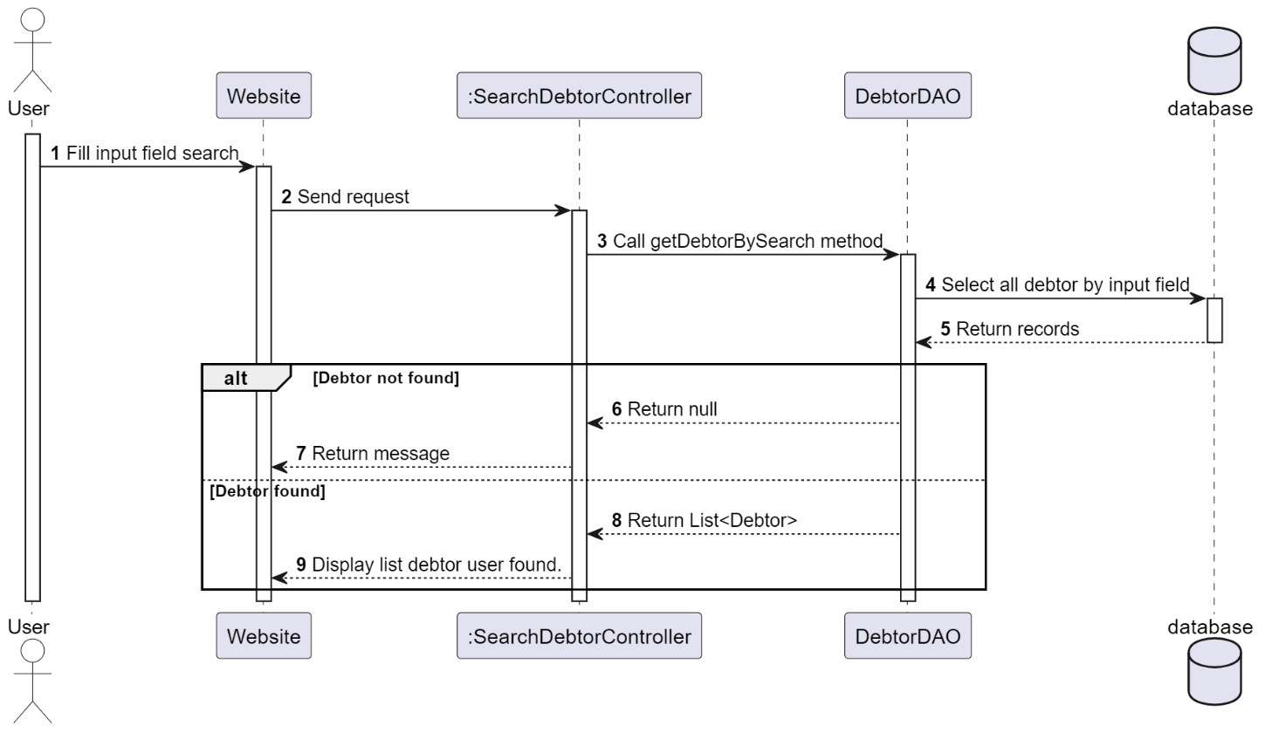

### d. Database Queries

SELECT * FROM [debtor] WHERE user_id = ? AND full_name like ? AND address like ? AND mobile_phone like ? AND email like ? AND total_debt between ? and ?

## View Detail Car

### a. Class Diagram

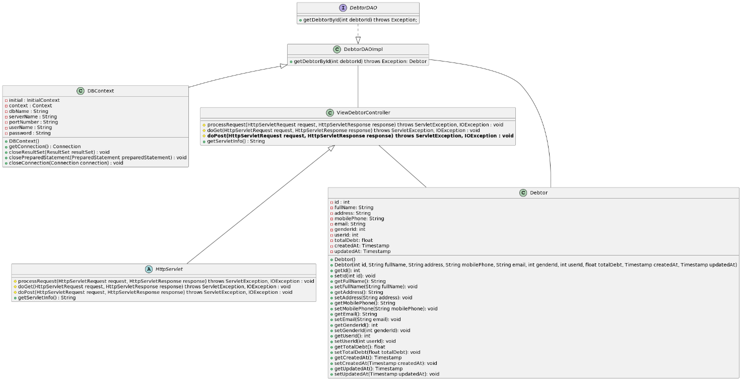

### b. Class Specifications

#### ViewCarController

***Class Methods***

|  |  |  |
| --- | --- | --- |
| **No** | **Method** | **Description** |
| *01* | *doPost(HttpServletRequest request, HttpServletResponse response)* | *Get id from debtor button and return debtor with that id.* |

#### DBContext

***Class Methods***

|  |  |  |
| --- | --- | --- |
| **No** | **Method** | **Description** |
| *01* | *getConnection()* | *To connect with database* |
| *02* | *closeResultSet(ResultSet resultSet)* | *To close result set* |
| *03* | *closePreparedStatement(PreparedStatement preparedStatement)* | *To close prepared statement* |
| *04* | *closeConnection(Connection connection)* | *To close connection* |

#### CarDAO

***Class Methods***

|  |  |  |
| --- | --- | --- |
| **No** | **Method** | **Description** |
| *01* | *getDebtorById(int id)* | *Interface abstract method view debtor with debtor id.* |

#### CarDAOImpl

***Class Methods***

|  |  |  |
| --- | --- | --- |
| **No** | **Method** | **Description** |
| *01* | *getDebtorById(int id)* | *Find debtor by debtor id.* |

#### Car

***Class Methods***

|  |  |  |
| --- | --- | --- |
| **No** | **Method** | **Description** |
| *01* | *Constructors* | *Entity initialization* |
| *02* | *Getter* | *Get value of each attributes* |
| *03* | *Setter* | *Set value for each attributes* |

### c. Sequence Diagram(s)

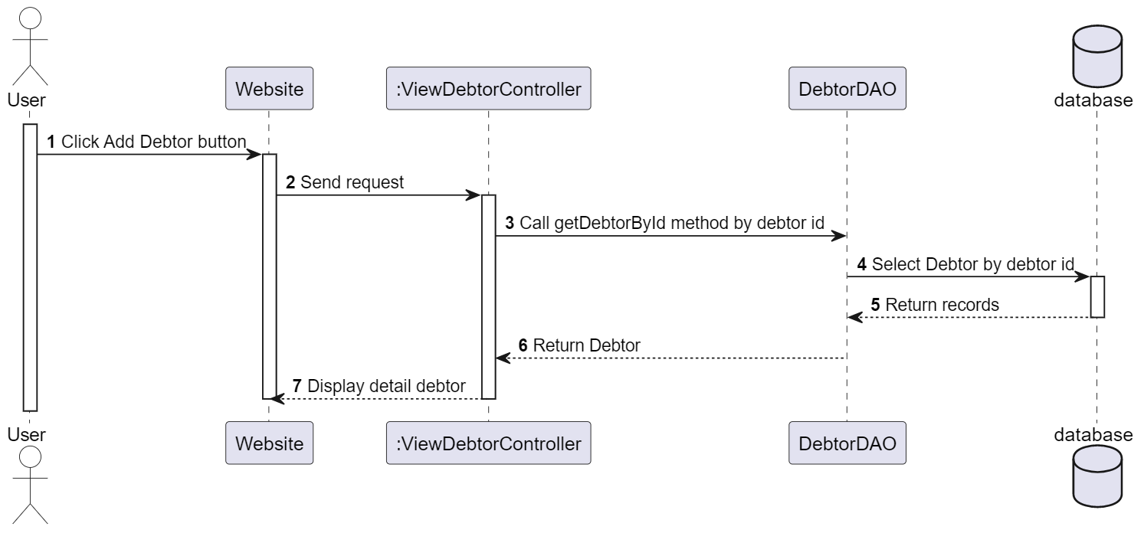

### d. Database Queries

**SELECT * FROM [car] where [product_id] = ?**

## Update Car

### a. Class Diagram

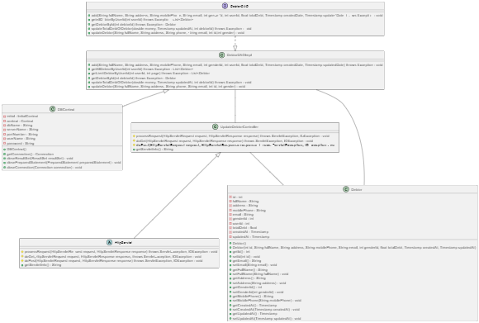

### b. Class Specifications

*UpdateCarController*

*Class Methods*

|  |  |  |
| --- | --- | --- |
| **No** | **Method** | **Description** |
| *01* | *doPost(HttpServletRequest request, HttpServletResponse response)* | *Get data from Update Debt Form and add it into database* |

#### DBContext

***Class Methods***

|  |  |  |
| --- | --- | --- |
| **No** | **Method** | **Description** |
| *01* | *getConnection()* | *To connect with database* |
| *02* | *closeResultSet(ResultSet resultSet)* | *To close result set* |
| *03* | *closePreparedStatement(PreparedStatement preparedStatement)* | *To close prepared statement* |
| *04* | *closeConnection(Connection connection)* | *To close connection* |

***CarDAO***

***Class Methods***

|  |  |  |
| --- | --- | --- |
| **No** | **Method** | **Description** |
| *01* | *add(String fullName, String address, String mobilePhone, String email, int genderId, int userId, float totalDebt, Timestamp createdDate, Timestamp updatedDate)* | *Interface abstract method add debtor with name, address, mobile phone, email, gender and total debt* |
| *02* | *getAllDebtorByUserId(int userId)* | *Interface abstract method get debtor by user ID* |
| *03* | *getLimitDebtorByUserId(int userId, int page)* | *Interface abstract method get limit debtor by user ID* |
| *04* | *getDebtorById(int debtorId)* | *Interface abstract method get debtor by ID* |
| *05* | *updateTotalDebtOfDebtor(double money, Timestamp updatedAt, int debtorId)* | *Interface abstract method update total debt of debtor* |
| *06* | *updateDebtor(String fullName, String address, String phone, String email, int id,int gender)* | *Interface abstract method update debtor* |

#### CarDAOImpl

***Class Methods***

|  |  |  |
| --- | --- | --- |
| **No** | **Method** | **Description** |
| *01* | *add(String fullName, String address, String mobilePhone,*  *String email, int genderId, int userId, float totalDebt, Timestamp createdDate, Timestamp updatedDate)* | *Add debtor with name, address, mobile phone, email, gender and total debt* |
| *02* | *getAllDebtorByUserId(int userId)* | *Get debtor by user ID* |
| *03* | *getLimitDebtorByUserId(int userId, int page)* | *Get limit debtor by user ID* |
| *04* | *getDebtorById(int debtorId)* | *Get debtor by ID* |
| *05* | *updateTotalDebtOfDebtor(double money, Timestamp updatedAt, int debtorId)* | *Update total debt of debtor* |
| *06* | *updateDebtor(String fullName, String address, String phone, String email, int id,int gender)* | *Update debtor* |

#### Car

***Class Methods***

|  |  |  |
| --- | --- | --- |
| **No** | **Method** | **Description** |
| *01* | *Constructors* | *Entity initialization* |
| *02* | *Getter* | *Get value of each attributes* |
| *03* | *Setter* | *Set value for each attributes* |

### c. Sequence Diagram(s)

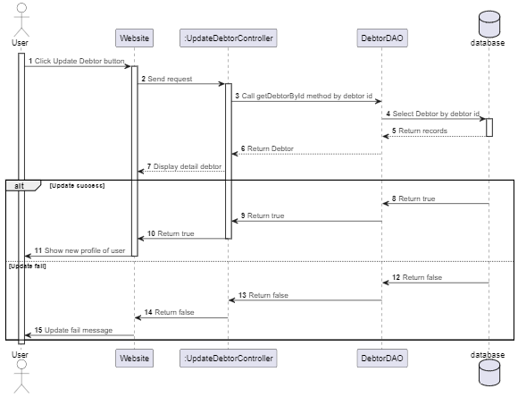

### d. Database Queries

"update debtor set full_name = ?, address = ?, mobile_phone = ?, email = ? gender_id =? where id = ?"

## Create Debt

### a. Class Diagram

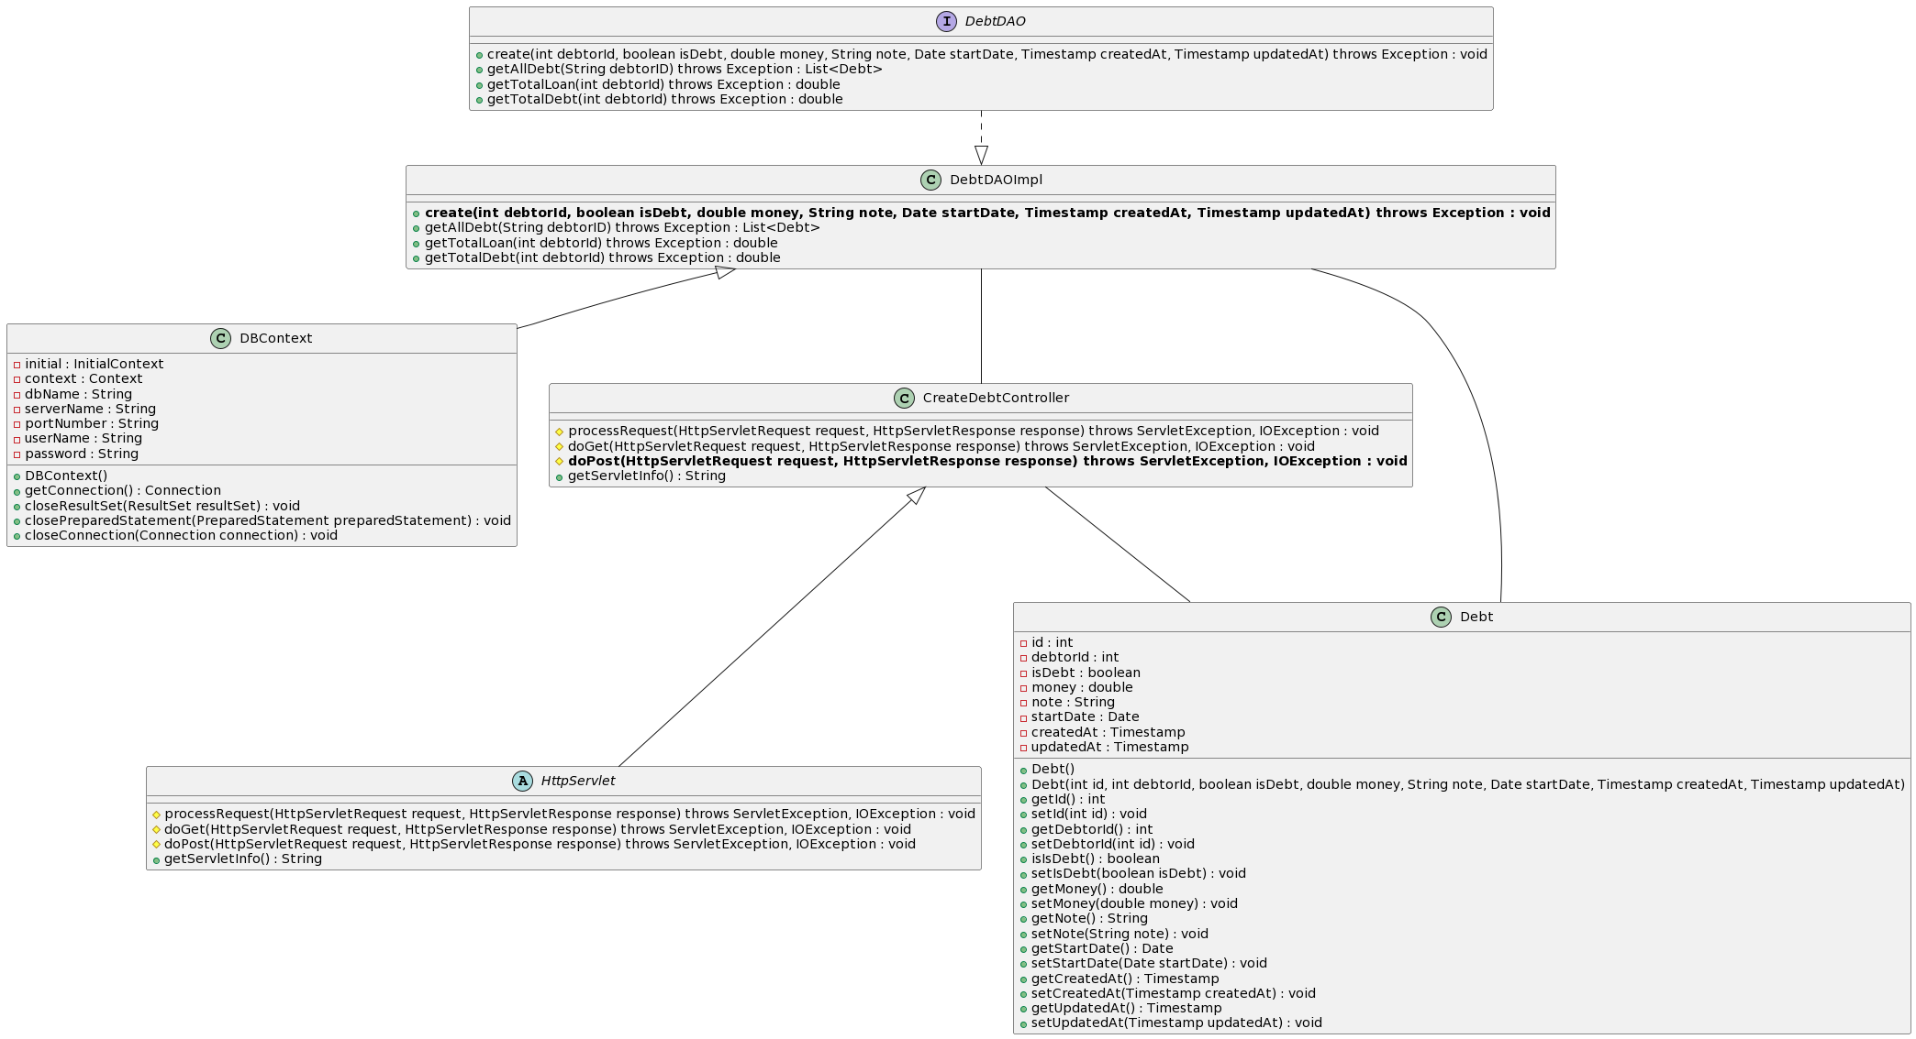

### b. Class Specifications

#### CarController

***Class Methods***

|  |  |  |
| --- | --- | --- |
| **No** | **Method** | **Description** |
| *01* | *doPost(HttpServletRequest request, HttpServletResponse response)* | *Get data from Create Debt Form and add it into database* |

#### DBContext

***Class Methods***

|  |  |  |
| --- | --- | --- |
| **No** | **Method** | **Description** |
| *01* | *getConnection()* | *To connect with database* |
| *02* | *closeResultSet(ResultSet resultSet)* | *To close result set* |
| *03* | *closePreparedStatement(PreparedStatement preparedStatement)* | *To close prepared statement* |
| *04* | *closeConnection(Connection connection)* | *To close connection* |

#### CarDAO

***Class Methods***

|  |  |  |
| --- | --- | --- |
| **No** | **Method** | **Description** |
| *01* | *create(int debtorId, boolean isDebt, double money, String note, Date startDate, Timestamp createdAt, Timestamp updatedAt)* | *Interface abstract method create debt with debtorId, money, note, startDate and type of debt* |

#### CarDAOImpl

***Class Methods***

|  |  |  |
| --- | --- | --- |
| **No** | **Method** | **Description** |
| *01* | *create(int debtorId, boolean isDebt, double money, String note, Date startDate, Timestamp createdAt, Timestamp updatedAt)* | *Create debt for a debtor with debtorId, type of debt, number of money, note, startdate* |

#### Debt

***Class Methods***

|  |  |  |
| --- | --- | --- |
| **No** | **Method** | **Description** |
| *01* | *Constructors* | *Entity initialization* |
| *02* | *Getter* | *Get value of each attributes* |
| *03* | *Setter* | *Set value for each attributes* |

### c. Sequence Diagram(s)

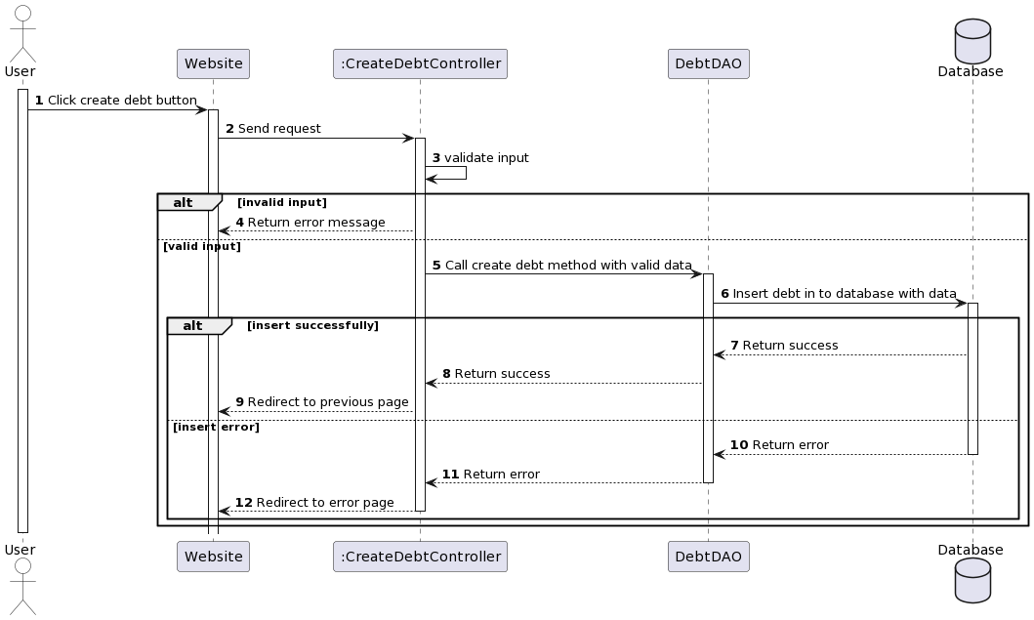

### d. Database Queries

**- insert into [debt] (debtor_id, is_debt, money, note, start_date, created_at, updated_at) values (?, ?, ?, ?, ?, ?, ?)**

## View Detail Debt

## Update Debt

## Delete Debt

## Search Debt

## User Detail

### a. Class Diagram

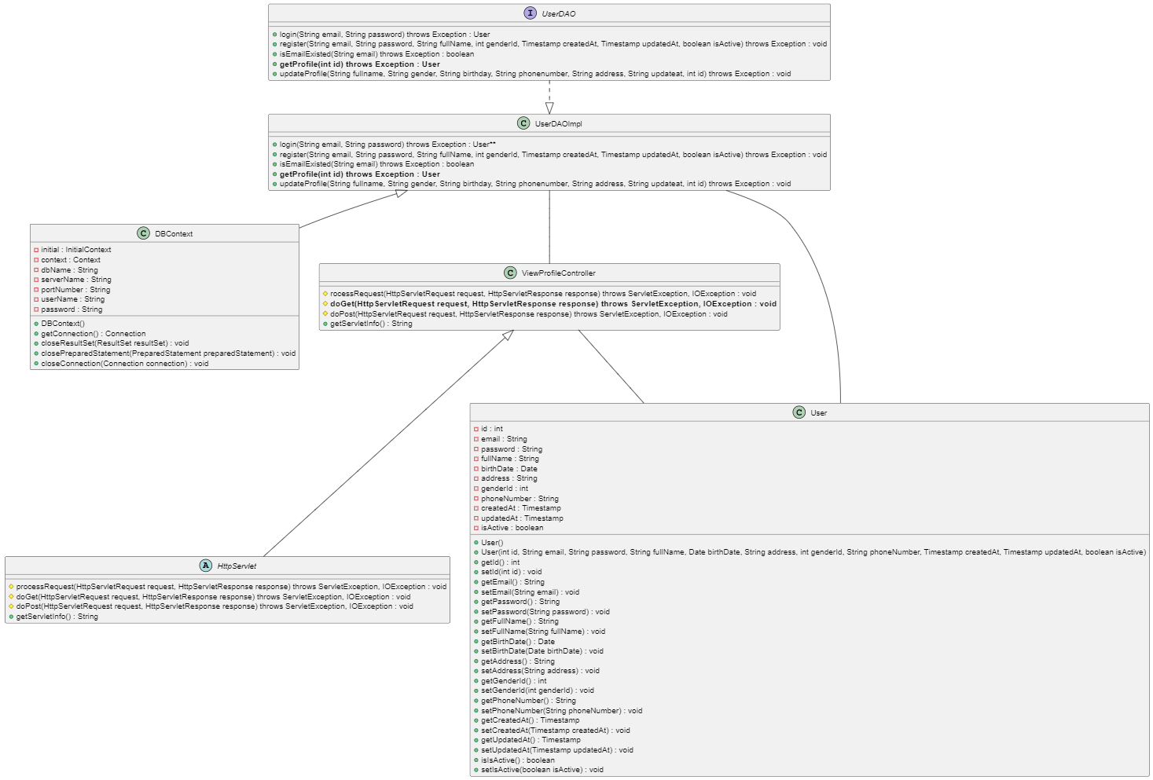

### b. Sequence Diagram(s)

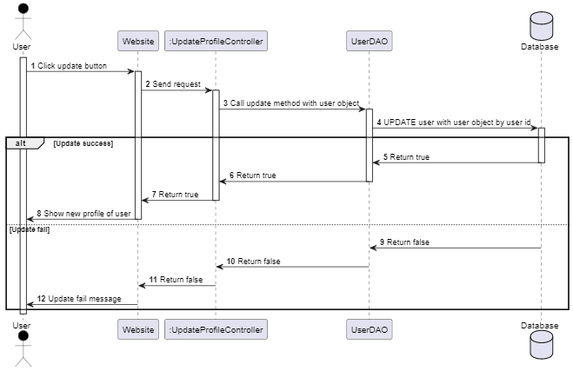

## Update Profile

### a. Class Diagram

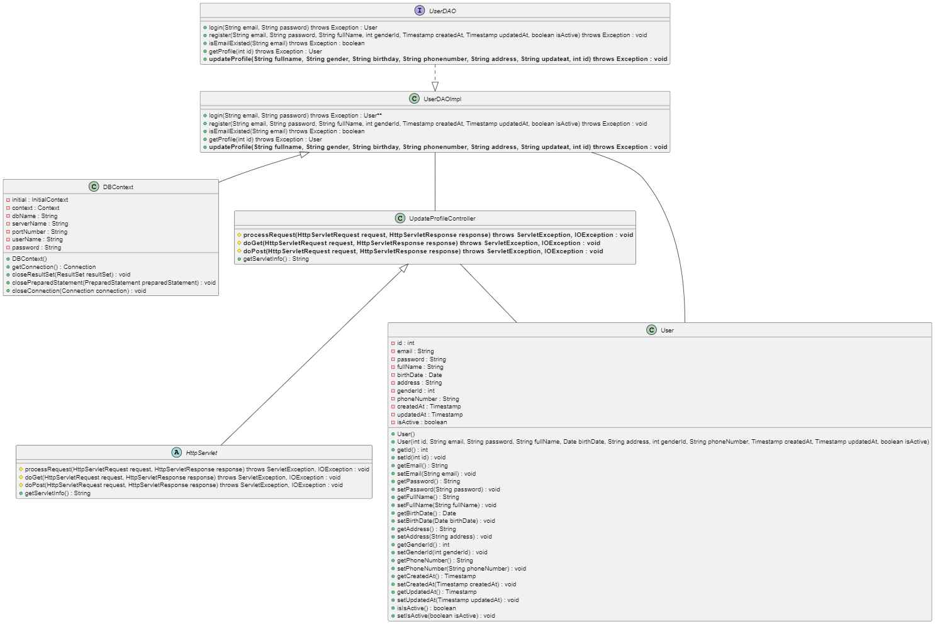

### b. Sequence Diagram(s)



## View List Debt of a Debtor

### a. Class Diagram

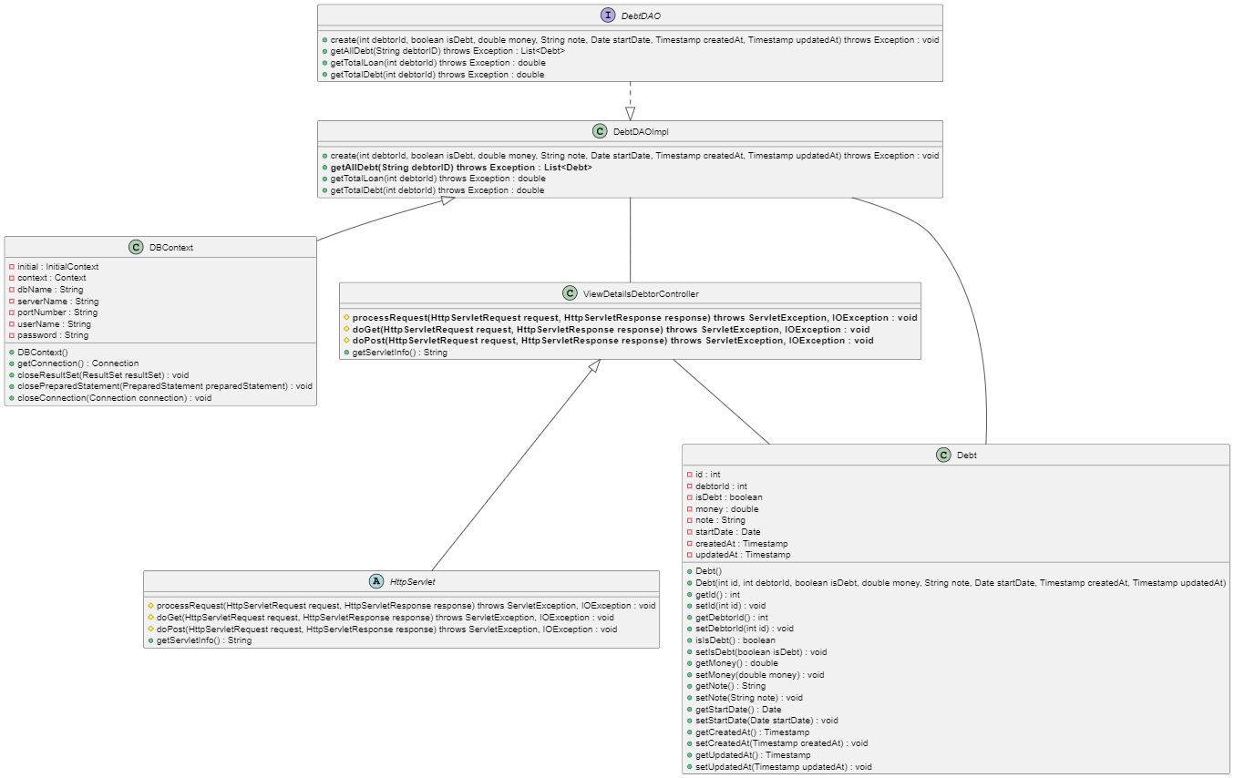

### b. Sequence Diagram(s)

