

**<<Online Shop>>**

**Software Requirement Specification**

– Hanoi, February 2023 –

Record of changeS

|  |  |  |  |
| --- | --- | --- | --- |
| Date | A* M, D | In charge | Change Description |
| 13/Apr | A | KienNT | Thêm mô tả chức năng Setting Details (II.1.a) |
|  |  |  |  |
|  |  |  |  |
|  |  |  |  |
|  |  |  |  |
|  |  |  |  |
|  |  |  |  |
|  |  |  |  |
|  |  |  |  |
|  |  |  |  |
|  |  |  |  |
|  |  |  |  |

*A - Added M - Modified D - Deleted

**Table of Contents**

I. Overview 4

1. Introduction 4

2. System Functions 5

3. Entity Relationship Diagram 6

II. Functional Requirements 7

1. <<Feature Name 1>> 7

a. <<Function Name 1>> 7

b. <<Function Name 2>> 7

2. <<Feature Name 2>> 7

# I. Overview

## 1. Introduction

*[Content part 1: presents a high-level overview of the product and the environment in which it will be used, the users, and known constraints, assumptions, and dependencies]*

*[Content part 2: describes the product's context in the form of a context diagram in which you present the boundary and connections between the system you’re developing and everything else in the universe. This identifies external entities (or terminators – software, hardware, human components, and other systems) outside the system that interface to it in some way, as well as data, control, and material flows between the terminators and the system]*

A car sales website is an online platform that allows auto dealers and individuals to buy and sell cars. The site is expected to grow over several releases, eventually providing an easy and convenient way for consumers to browse and compare a variety of vehicles and make informed purchasing decisions. Car sales sites also offer additional resources and tools, such as auto reviews, financing options, and commercial valuations, to help users make informed decisions. In addition, there will be a number of authorized services for customers to refer to (for example, customers who buy installments through banks).

>>

## 2. System Functions

#### a. Screen Flow

*[This part shows the system screens and the relationship among screens. You can draw the Screens Flow for the system in the form of diagram as below]*

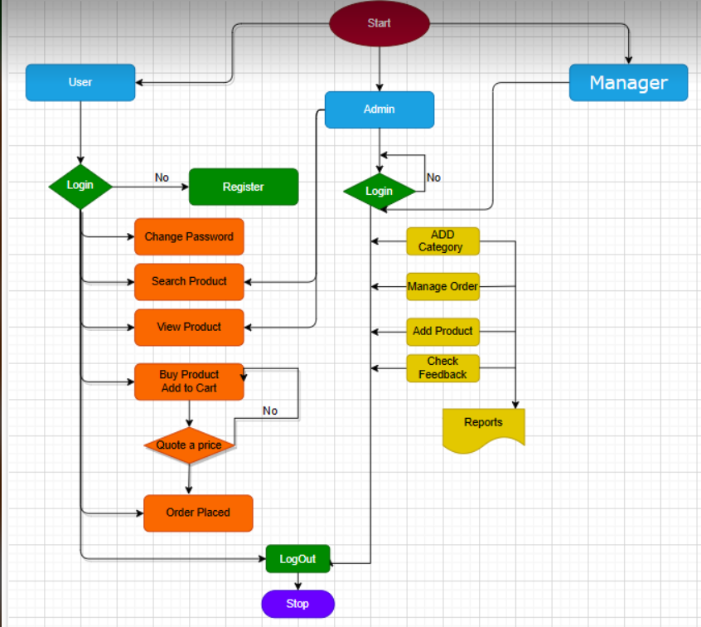

#### b. Screen Details

*[Provide the descriptions for the screens in the Screens Flow above]*

|  |  |  |  |
| --- | --- | --- | --- |
| **#** | **Feature** | **Screen** | **Description** |
| 1 | Home | Home | Information of Web |
| 2 | Login | Login system | Accept to system |
| 3 | Register | Register account | Create new user |
| 4 | Add | Add product | Add new product |
| 5 | Change pass | Change pass user | Change password of user |
| 6 | Show | List Product | All product in system |
| 7 | Update | Update product | Update all information off product |
| 8 | Details | Details product | Show details |
| 9 | ViewCart | Shoping Cart | Show oder of customer |
| 10 | Delete | Delete product | Delete 1 product |

#### c. User Authorization

*[Provide the system roles authorization to the system features (down to screens, and event to the screen activities if applicable) in the table form as below – replace Role1, Role2,… with the specific system user role names]*

|  |  |  |  |
| --- | --- | --- | --- |
| **Screen** | **Admin** | **Manager** | **User** |
| <<Home>> | X | X | X |
| <<Login>> | X | X | X |
| <<Profile>> |  | X | X |
| Change Password | X | X | X |
| Register |  |  | X |
| Add Account | X | X |  |
| Update Account | X | X | X |
| Delete Account | X | X | X |
| Add Product | X |  |  |
| Update Product | X |  |  |
| Delete Product | X |  |  |
| Logout | X | X | X |

In which:

* Role1: <<Admin>>
* Role2: <<Manager>>
* Role3:<<User>>

#### d. Non-Screen Functions

*[Provide the descriptions for the non-screen system functions, i.e batch/cron job, service, API, etc.]*

|  |  |  |  |
| --- | --- | --- | --- |
| **#** | **Feature** | **System Function** | **Description** |
| 1 | <<Feature Name>> | <<Function Name1>> | <<Function Name1 Description>> |
| 2 | … |  |  |

## 3. Entity Relationship Diagram

*[Provide the entity relationship diagram and the entity descriptions in the table format as below]*



**Entities Description**

|  |  |  |
| --- | --- | --- |
| **#** | **Entity** | **Description** |
| 1 | User |  |
| 2 | Meal |  |
| 3 | Meal Subscription |  |
| 4 | … |  |

# II. Functional Requirements

## 1. <<Feature Name 1>>

### a. <<Function Name 1>>

*[A function can be a screen or a non-screen function (listed in the part I.2.d above). In this part, you need to provide the details on the related function, focus on mentioning below information*

* *Function trigger: how this function is triggered (navigation path, a timing frequency, etc.)*
* *Function description: actors/roles, purpose, interface, data processing, etc.*
* *Screen layout: mockup prototype of the screen, sample below is for Manage Products screen*

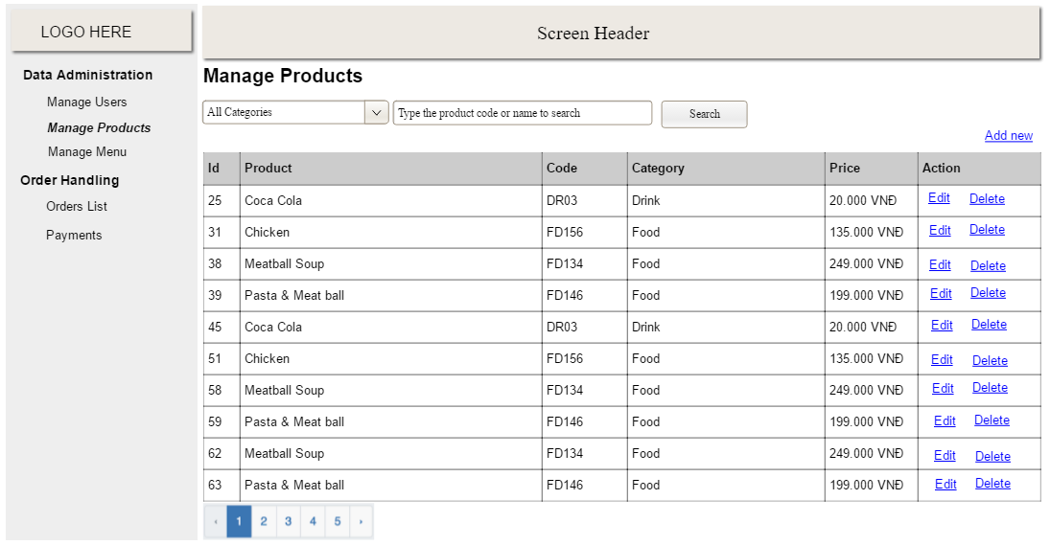

* *Function Details: provide explanation for the data, validation, business logics, functionalities (for both normal cases and abnormal cases), etc. of the function so that the reader can image how it work.*

*]*

### b. <<Function Name 2>>

…

## 2. <<Feature Name 2>>

…