<<Online Shop>>
Software Requirement Specification

– Hanoi, February 2023 –

Record of changeS
Date | A*  M, D | In charge | Change Description
13/Apr | A | KienNT | Thêm mô tả chức năng Setting Details (II.1.a)
*A - Added M - Modified D - Deleted

Table of Contents
I. Overview
1. Introduction
2. System Functions
3. Entity Relationship Diagram
II. Functional Requirements
1. <<Home>>

a. <<Login>>
b. <<Change Password>>
c. <<Search>>
d. <<List Product>>
e. <<Favorite Product>>

2. << List Favourite >

a. <<Quantity >>

b. <<Receive Information>>

c. <<Continue Add List >>
3.<<List Product>>
a. Search car
b. View cart
c. Sort product

I. Overview

1. Introduction
[Content part 1: presents a high-level overview of the product and the environment in which it will be used, the users, and known constraints, assumptions, and dependencies]
[Content part 2: describes the product's context in the form of a context diagram in which you present the boundary and connections between the system you’re developing and everything else in the universe. This identifies external entities (or terminators – software, hardware, human components, and other systems) outside the system that interface to it in some way, as well as data, control, and material flows between the terminators and the system]
A car sales website is an online platform that allows auto dealers and individuals to buy and sell cars. The site is expected to grow over several releases, eventually providing an easy and convenient way for consumers to browse and compare a variety of vehicles and make informed purchasing decisions. Car sales sites also offer additional resources and tools, such as auto reviews, financing options, and commercial valuations, to help users make informed decisions. In addition, there will be a number of authorized services for customers to refer to (for example, customers who buy installments through banks).
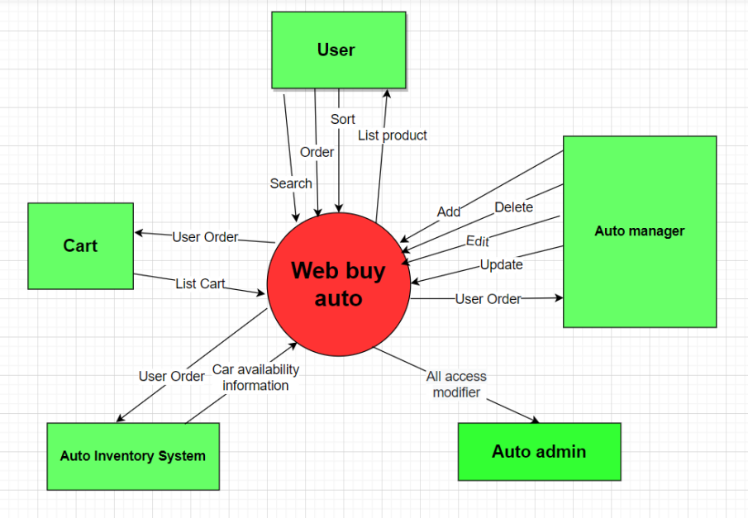

2. System Functions

a. Screen Flow
[This part shows the system screens and the relationship among screens. You can draw the Screens Flow for the system in the form of diagram as below]
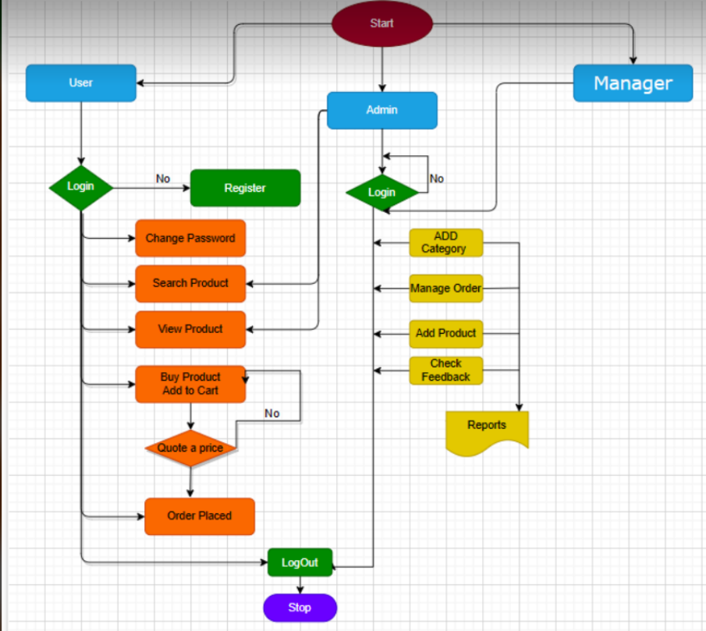

b. Screen Details
[Provide the descriptions for the screens in the Screens Flow above]
# | Feature | Screen | Description
1 | Home | Home | Information of Web
2 | Login | Login system | Accept to system
3 | Register | Register account | Create new user
4 | Add | Add product | Add new product
5 | Change pass | Change pass user | Change password of user
6 | Show | List Product | All product in system
7 | Update | Update product | Update all information off product
8 | Details | Details product | Show details
9 | ViewCart | Shoping Cart | Show oder of customer
10 | Delete | Delete product | Delete 1 product

c. User Authorization
[Provide the system roles authorization to the system features (down to screens, and event to the screen activities if applicable) in the table form as below – replace Role1, Role2,… with the specific system user role names]
Screen | Admin | Manager | User
<<Home>> | X | X | X
<<Login>> | X | X | X
<<Profile>> |  | X | X
Change Password | X | X | X
Register |  |  | X
Add Account | X | X
Update Account | X | X | X
Delete Account | X | X | X
Add Product | X
Update Product | X
Delete Product | X
Logout | X | X | X
In which:
· Role1: <<Admin>>
· Role2: <<Manager>>
· Role3:<<User>>

d. Non-Screen Functions
[Provide the descriptions for the non-screen system functions, i.e batch/cron job, service, API, etc.]
# | Feature | System Function | Description
1 | <<Feature Name>> | <<Function Name1>> | <<Function Name1 Description>>
2 | …

3. Entity Relationship Diagram
[Provide the entity relationship diagram and the entity descriptions in the table format as below]
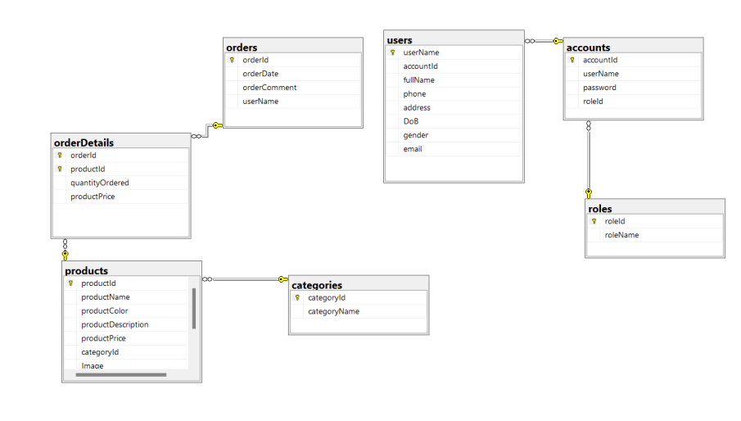
Entities Description
# | Entity | Description
1 | Users | Information of user
2 | Accounts | Contains the information of the accounts in the system
3 | Roles | Split role by account word
4 | Oders | Contains the date of purchase and the name of the customer
5 | OderDertails | Contains information of the ordered product
6 | products | Contains information of products
7 | categories | classification of product samples

II. Functional Requirements

1. <<Home>>
The home page displays the functions of login, logout, change password, search, view product list, view favorite product list. Attached are some pictures of the best-selling models, as well as the newly launched models on the market.

· Screen layout: mock up prototype of the screen, sample below is for Manage Products screen
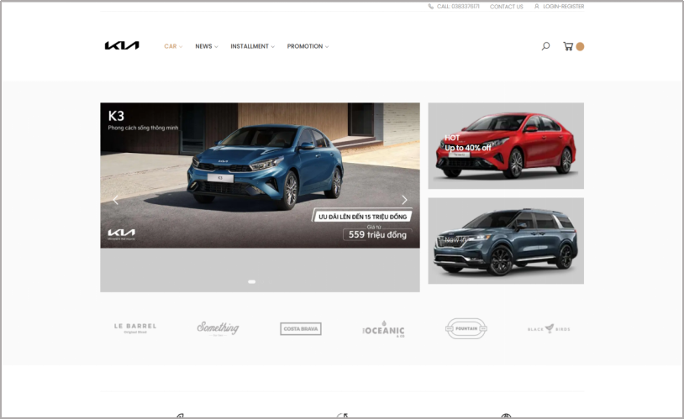

a. <<Login>>
· Login: Users can visit the website to view and request to purchase products.
b. <<Change Password>>
· Change Password: Help users keep their information confidential with other customers.
c. <<Search>>
· Search: Can find products quickly
d. <<List Product>>
· List Product: View all products the company has on the market
e. <<Favorite Product>>
· view favorite product list: Contains information about the car model you intend to buy

2. << List Favourite >
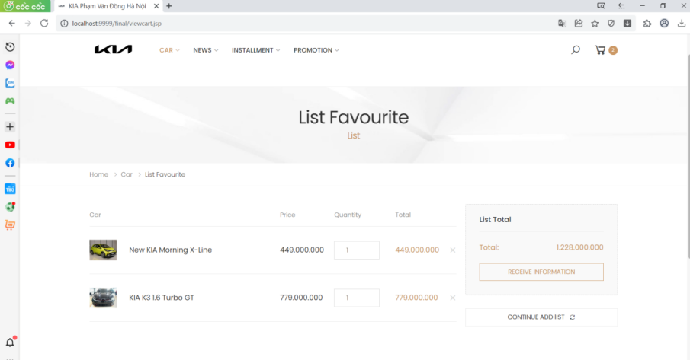
· The favorite list function is used to describe the products that customers are most interested in in the product list. Here, Customers can see the car's name, vehicle price, quantity, and total product price

a. <<Quantity >>
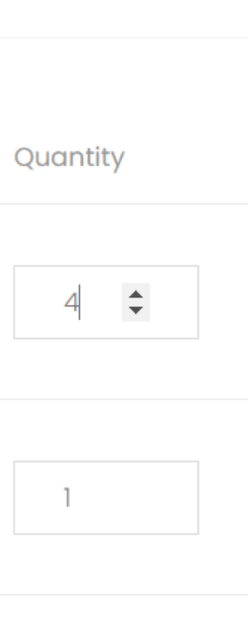
· Provide detailed quantity of each product

b. <<Receive Information>>
· After adding a favorite product, the receive information function so that the staff can receive more advice about the product
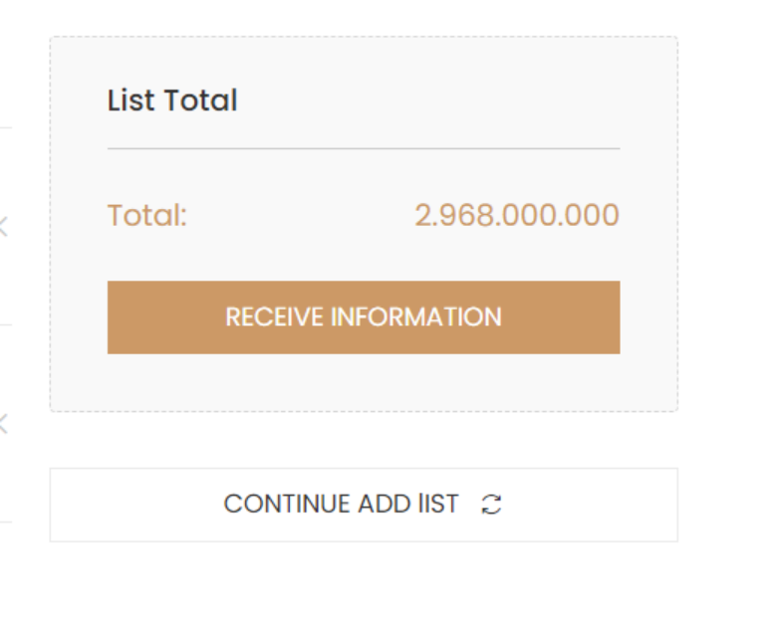

c. <<Continue Add List >>
· Continue Add List is a function for customers to return to the product list to add the next favorite products
3. <<List Product>>
a. Search car

· It helps you find the right car: Searching for products on an auto sales website allows you to narrow down your search to the specific make, model, year, and other features you are looking for. This can help you find the right car that fits your needs and preferences.
· It provides you with information: As you search for products on an auto sales website, you can learn more about the cars you are interested in. You can read about their features, see photos and videos, compare prices, and read reviews from other customers.
· It saves you time: Instead of going from dealership to dealership, searching for the right car, you can search for products on an auto sales website from the comfort of your own home. This can save you time and hassle.

Overall, searching for products on an auto sales website can be a useful tool for car buyers looking to find the right car that fits their needs and preferences.

b. View cart
· It may remind you of other items you need: If you have not yet completed your purchase, viewing your cart may remind you of other items you may need, such as car insurance or accessories.
· It can provide you with payment and shipping options: When you view your cart on an auto sales website, you may be prompted to select a payment method and shipping option. This can help you complete your purchase quickly and easily.
· It can lead to targeted advertising: As you view your cart on an auto sales website, the website may use cookies to track your activity and show you targeted advertising related to cars or related products and services.
· It helps you review your choices: Viewing your cart on an auto sales website allows you to see all the cars you have selected and review your choices. You can see the price of each car, any discounts or promotions, and the total cost.
c. Sort product

· Improved user experience: Sorting products on an auto sales website makes it easier for users to find what they are looking for. By sorting products by relevant criteria, such as price, model year, or mileage, users can quickly filter out irrelevant vehicles and find the ones that best match their needs.
· Increased engagement: When users can easily find what they are looking for, they are more likely to engage with the website and spend more time browsing. This increased engagement can lead to more opportunities for sales and conversions.
· Increased sales: By sorting products in a way that aligns with customer preferences, such as by price or features, auto sales websites can increase the likelihood of a sale. Users who are able to easily find the vehicles they are interested in are more likely to make a purchase.
Overall, sorting products on an auto sales website can improve the user experience, increase engagement, drive sales, and improve SEO.

