**Group exam on ontology development**

**Ontology for European Amusement Park**  
<http://www.amusementpark.com>

Aurore NGUYEN – [aurore.nguyen@etu.univ-tours.fr](mailto:aurore.nguyen@etu.univ-tours.fr)  
  
Daphné PAGNARD – [daphne.pagnard@etu.univ-tours.fr](mailto:daphne.pagnard@etu.univ-tours.fr)

* **Presentation**

This ontology is developed for modelling data for Amusement Park in Europe. From Disneyland Paris to Europa-park in Germany, to Port Aventura World in Spain, there is no shortage of amusement parks in Europe. Each one has its own characteristics (size, place, number of attractions, etc.) and its own history (date of creation, owners, etc.). This ontology was created to combine these many characteristics. We used many online resources to compose the dataset including the Wikipedia page of the parks, the officially webpage of the parks and the database of Theme Parks and attractions around the world (<https://www.theparkdb.com/>).

This ontology is available for downloading on <https://github.com/Nguyen-Au/OWL_EXAM.git>

* **Taxonomy**

The following link present the taxonomy thank to a UML:

<http://owlgred.lumii.lv/online_visualization/0th9>

* **Class and relation**

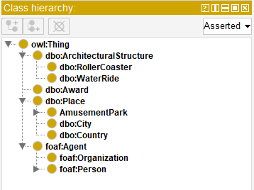

***(Class hierarchy on Protege)***

|  |  |  |
| --- | --- | --- |
| Prefix | Class | Meaning |
| owl | ArchitecturalStructure | An architectural structure is a human-made, free-standing, immobile outdoor construction (from DBpedia). |
| dbo | RollerCoaster | An exciting entertainment in an amusement park, like a fast train that goes up and down very steep slopes and around very sudden bends (from Cambridge Dictionary). |
| dbo | WaterRide | Water rides are amusement rides that are set over water (from Wikipedia). |
| dbo | Award | A prize or a sum of money that a person or organization is given for an achievement (from Cambridge Dictionary). |
| dbo | Place | Immobile things or locations (from DPpedia). |
| * | AmusementPark | A place where people can go to enjoy games, rides, and other activities (from Cambridge Dictionary). |
| dbo | City | A relatively large and permanent settlement, particularly a large urban settlement (from DBpedia). |
| dbo | Country | An area of land that has its own government, army, etc. (from Cambridge Dictionary). |
| foaf | Agent | Things that do stuff (from FOAF's specification). |
| foaf | Organization | A kind of Agent corresponding to social institutions such as companies, societies, etc. (from FOAF's specification). |
| foaf | Person | The Person class represents people. Something is a Person if it is a person. We don't nitpic about whether they're alive, dead, real, or imaginary. The Person class is a sub-class of the Agent class, since all people are considered 'agents' in FOAF (from FOAF's specification) |
|  |  |  |

*(* : our own namespace).*

* **Screenshot from Protege**

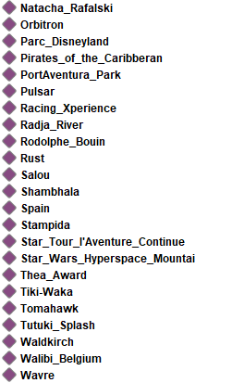**Individuals**

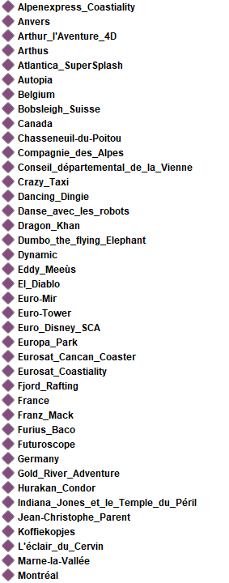

**Annotation properties**

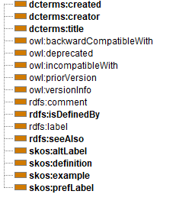

**Object properties**

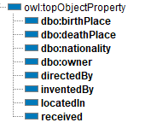

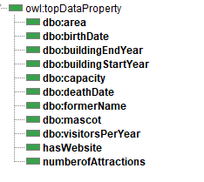**Data properties**

* **Example (RDF Turtle notation)**

**:Parc_Disneyland**

**rdf:type dbo:AmusementPark;**

**rdf:type dbo:ThemePark;**

**skos:prefLabel "Parc Disneyland";**

**dbo:directedBy :Natacha_Rafalski;**

**:received :Thea_Award;**

**dbo:owner :Euro_Disney_SCA;**

**:locatedIn :Marne-la-Vallée;**

**:hasWebsite "www.disneylandparis.com";**

**dbo:buildingEndYear "1992"^gYear;**

**dbo:area "55000";**

**:numberofAttractions "34"^^;**

**dbo:formerName "Euro Disneyland";**

**dbo:visitorsPerYear "9.843".**

**:Natacha_Rafalski**

**rdf:type :CEO;**

**skos:prefLabel "Natasha Rafalski";**

**dbo:birthPlace :Montréal;**

**dbo:nationality :Canada;**

**dbo:birthDate "1968"^^gYear.**

**:Montréal**

**rdf:type dbo:City.**

**SPARQL** request:

