Lab 11 – Handling XML Data using JavaScript

**(10 Marks)**

# Aims

* Practise how to retrieve the content of an XML document
* Practise how to display retrieved XML data in an HTML web page
* Get used to reading comments and Javascript code

# Task 1: Handling Local XML Files using JavaScript

## Description

You are required to develop JavaScript code that takes the URL of an XML document, retrieve XML data and display the data in a table in an HTML web page. The XML file contains data about teams from the National Basketball Association (NBA). For an image of the example result, please refer to Figure 2 on page 3.

**Design**

The design process starts with discussion and paper drawings. Ensure this process is completed before implementation.

### Step 1: Form Creation and Presentation (HTML and CSS)

The design presented in Figure 1 will be used.

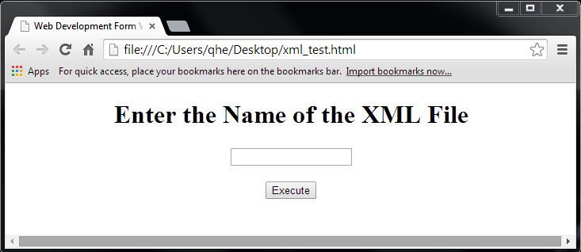

**Figure 1. Form Mock Up**

**IMPORTANT: In this lab, there is only one XML file, named nba.xml. Thus, the only valid input for this form is** "**nba.xml**"**.**

## Implementation

Implementation requires the creation of HTML, CSS and JavaScript files. In this lab, we will use the files available in lab11_files.zip which is available on Canvas.

### Step 2: Directory Set Up

* 1. Create a new folder ‘lab11’ under the unit folder on the mercury server ~/COS10005/www/htdocs. This is the directory where all files will be uploaded.

### Step 3: HTML Creation

* 1. Using NotePad++ (or SubLime Text for Mac users), open file xml.html.
  2. Add missing HTML code as required.  
     For your convenience, the basic code and additional code is shown below:

<!DOCTYPE html>

<html lang="en">

<head>

<meta charset="utf-8" />

<meta name="description" content="Web development" />

<meta name="keywords" content="Registration Form" />

<meta name="author" content="put your name here" />

**(1)****link to CSS file**

**(2)link to jQuery file**

**(3)****link to JavaScript file**

<title>Web Development Registration Form</title>

</head>

<body>

<form id="xmlForm" method="post" action="#">

<h1>Enter the Name of the XML File</h1>

<p>

<input type="text" id="tbFile" />

</p>

<p>

<input type="button" value="Execute" id="btnExecute" />

</p>

</form>

</body>

</html>

### Step 4: CSS Creation

* 1. Open files style.css. Review the CSS code, no changes need to be made.

### Step 5: Form Data Validation

* 1. Based on the comments provided in script.js, complete the following functions. The rules to apply to form validation are:

1. The text box must not be empty.
2. It must be a valid XML filename.

//function execute() will execute function parseXML() only when the form validation succeeded

**function** execute() {

**if** (validate()) {

parseXML();

}

}

/* function validate() will validate form data */

**function** validate() {

……

**Note: Please read the comments in the provided JavaScript file to understand how it works and how to complete those functions.**

}

//link functions to elements' events

**function** init() {

……

}

//the initialise function

$(document).ready(init);

### Step 6: Handling the XML Document

* 1. Based on the comments provided in script.js for function parseXML(), complete function parseXML() which will parse the XML document and display the data in a table.

**function** parseXML() {

……

}

**Note: Refer to the lecture slides and the comments in script.js about how function parseXML() works and how to complete it.**

**The final solution will display a page as presented in Figure 2.**

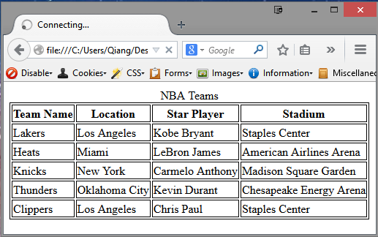

**Figure 2. Example Result of Task 1**

## Testing and Quality Assurance

Test your code for errors.

**Note: For simplicity, please save your HTML, CSS, JavaScript and XML files in a same folder.**

### Step 7: Test and view web pages.

* 1. Using WinSCP, upload **all** your files onto Mercury.
  2. To view the pages through http, use any Web browser and type in the following address,

http://mercury.swin.edu.au/<your unit code>/***s****<your Swinburne ID>*/<folder>/<filename>

Please refer to the following examples to identify the URLs of your web pages.

|  |  |
| --- | --- |
| **Folder on Mercury Web Server** | **URL** |
| ~/cos10005/www/htdocs/index.html | <http://mercury.swin.edu.au/cos10005/s1234567>/index.html |
| ~/cos60002/www/htdocs/lab11/xml_test.html | <http://mercury.swin.edu.au/cos60002/s1234567>/lab11/xml_test.html |

### Step 8. HTML and CSS Validation

* 1. To validate the HTML file, use the validator at <http://validator.w3.org>.
  2. To validate the CSS file, use the <http://jigsaw.w3.org/css-validator>.