CHƯƠNG 6:
Sao lưu và phục hồi dữ liệu

Tham khảo: Chapter 9: Disaster Prevention and Recovery

Mục tiêu chương 6:

Học viên phải biết, hiểu và thực hiện được các nội dung sau:
- Phòng tránh rủi ro hư hỏng dữ liệu
- Sao lưu dữ liệu
- Phục hồi dữ liệu

Các kiểu phục hồi của Database (Recovery Models)
SQL Server có 3 kiểu phục hồi CSDL:
- Simple
- Full
- Bulk-Logged
Tuy nhiên chỉ có 2 kiểu thường dùng: Simple và Full
Kiểu Bulk-Logged được thiết kế dùng với kiểu Full
Mỗi kiểu có ưu khuyết điểm riêng
Full Recovery Model:
- tất cả hoạt động được lưu lại thông tin (fully logged)
- các giao tác có thể phục hồi đầy đủ nếu có sự cố
- nhược điểm: file log tăng dung lượng rất nhanh
- khi backup thì sẽ xoá thông tin trong file log
Bulk-Logged Recovery Model: hạn chế tối thiểu lưu vào log file các thông tin của
- Index creation
- Index rebuild
- Bulk copy operations
- BULK INSERT
- SELECT INTO
- BLOB operations
Simple Recovery Model:
- log sẽ được xóa khi tới 1 checkpoint
- kích cỡ log hầu như không tăng
- các giao tác có sự cố không phục hồi được

Sao lưu CSDL SQL Server 2008
Backup Devices: ổ đĩa băng từ hay đường dẫn file lưu bachup
Đọc thêm : Các bước thực hiện khi backup:
- Logs the BACKUP statement in the transaction log.
- Issues a checkpoint causing all outstanding dirty buffer pages to be written to the disk.
- Writes all data pages specified by the FULL, DIFFERENTIAL, FILE, or FILEGROUP backup options to the backup media.
- Writes all data modifications recorded in the transaction log that occurred during the backup to the backup media.
- Logs the completion of the backup in the transaction log.

Các kiểu backup
- Full Backup
- Differential Backup
- File/Filegroup Backup
- File/Filegroup with Differential
- Transaction Log Backup
- Partial Backup
- Copy Only Backup

Các lựa chọn khi thực hiện backup (Backup Options)
Backup Stripe: chia nhỏ và lưu các phần đồng thời lên các ổ đĩa vật lý khác nhau
BACKUP DATABASE SmallWorks
TO DISK='C:\StripedBackupsA\SmallWorksStripe1.bak'
, DISK='C:\StripedBackupsB\SmallWorksStripe2.bak'
, DISK='C:\StripedBackupsC\SmallWorksStripe3.bak'
WITH DESCRIPTION = 'Striped Backup';
Tạo nhiều bảng copy khác nhau (Mirrored Backup): phải chạy lệnh, không có visual tool, là chức năng mới trong SQL Server 2008
BACKUP DATABASE SmallWorks
TO DISK='C:\MirroredBackupsA\SmallWorksMirror1.bak'
MIRROR TO DISK='C:\MirroredBackupsB\SmallWorksMirror2.bak'
WITH FORMAT, DESCRIPTION = 'Mirrored Backup';
Đọc thêm:
Dùng các option sau từ khoá WITH:
Option | Description
BLOCKSIZE = integer | Specifies a specific block size. If not specified, SQL Server will attempt to choose a block size that is optimum for the tape or disk destination.
CHECKSUM | NO_CHECKSUM | The CHECKSUM option specifies that SQL Server will validate any page checksum or torn page information when reading the page. SQL Server will also generate page checksum that can be used to validate backups with the RESTORE command. The CHECKSUM option will decrease the speed and performance of the backup. The NO_CHECKSUM setting is the default setting, and configures SQL Server to not generate or validate page checksum data during the backup.
STOP_ON_ERROR | CONTINUE_AFTER_ERROR | The default setting of STOP_ON_ERROR aborts the backup if a bad page checksum or torn page is detected during the backup. The CONTINUE_AFTER_ERROR setting overrides this behavior, allowing the database to be backed up even if there are errors in the database.
DESCRIPTION = string | A description of the database backup is often useful to identify the backup media. The description property supports a description length of 255 characters.
DIFFERENTIAL | Specifies that a Differential backup is to be performed on the associated database or data file/filegroup.
EXPIREDATE = datetime | A date specification used to identify when the backup is no longer required and may be overwritten.
RETAINDAYS = integer | Specifies the number of days the backup is required. This option or the EXPIREDATE option are used to control this behavior.
PASSWORD = string | A password can be assigned to a backup so that the password is required in order to use the backup during a restore operation. The password protection is very weak and should not be relied upon to guarantee the security of a backup. The PASSWORD option is deprecated and will be removed in a future release.
FORMAT | NOFORMAT | The FORMAT option is used to create a new backup media set. It will overwrite any existing media set at the destination. NOFORMAT is the default setting, which would prevent an inadvertent overwriting of a backup file that was participating in a backup stripe set.
INIT | NOINIT | The default setting of NOINIT specifies that any backups sent to the destination will be appended to the backup file. INIT specifies that subsequent backups will overwrite the existing backup file contents.
NOSKIP | SKIP | The NOSKIP default setting configures SQL Server to check the backup media’s expiration date to prevent inadvertent overwriting of previous backups. The SKIP setting ignores the expiration date information.
MEDIADESCRIPTION = string | A maximum-length string of 255 characters used to describe the backup media.
MEDIANAME = string | The backup media’s logical name with a maximum of 128 characters.
MEDIAPASSWORD = string | Like the PASSWORD option that defines a password for an individual backup, the MEDIAPASSWORD sets a password on the backup media set. The MEDIAPASSWORD is also very weak and should not be relied upon for media set security. This option is deprecated.
NAME = string | A maximum length of 128 characters to identify the name of the backup set.
NOREWIND | REWIND | This option is only used when the backup destination is specified as TAPE. The default REWIND option configures SQL Server to rewind the tape when the backup is com pleted, or the end of the tape is reached during a backup.
NOUNLOAD | UNLOAD | This option is only used with tape backups. The default setting is UNLOAD, which configures SQL Server to rewind and eject the tape when the backup is complete. NOUNLOAD overrides this default behavior, and leaves the tape open and mounted.
RESTART | This option does absolutely nothing. It does not generate an error when used and is included to prevent old scripts from previous releases from failing.
STATS = percentage as integer | Configures SQL Server to return progress information every time the specified percentage is reached. The default is 10.
COPY_ONLY | COPY_ONLY backups do not affect the transaction log sequence. These backups cannot be used for a Differential or Transaction Log backup base.

Các chiến lược (Backup Strategies):
Full Backup Only
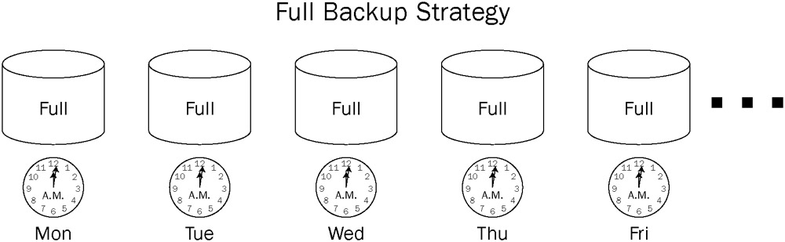
Full Backup with Differential
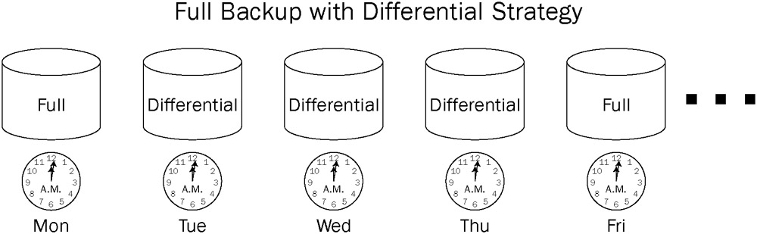
Full Backup with Transaction Log
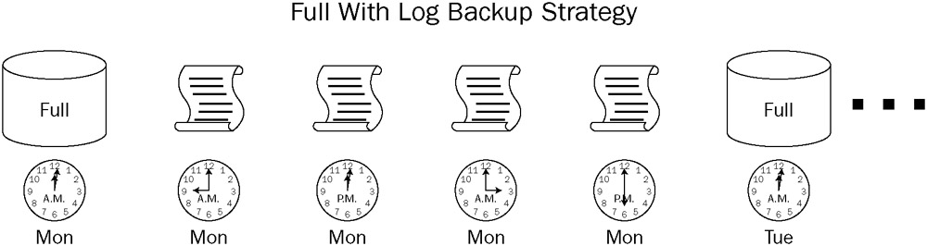

Full and Differential Backup with Transaction Log
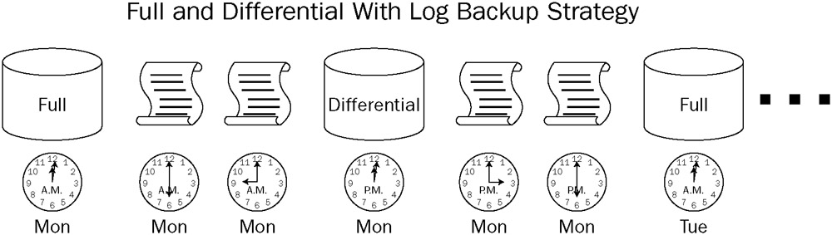

File and Filegroup Backup

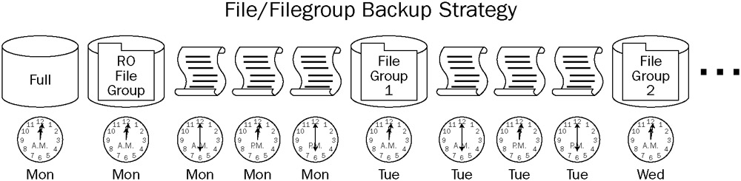

Partial Backup

Phục hồi CSDL (Restoring Databases):

3 bước của tiến trình phục hồi:
- Data Copy phase: copy dữ liệu từ thiết bị lưu trữ vào các data file
- Redo phase: làm lại các thao tác trong các giao tác cho phù hợp với các hàng dữ liệu vừa phục hồi
- Undo phase: làm ngược lại các thao tác trong các giao tác đã rollback (theo thông tin từ log file)
Khi bị hư dữ liệu backup: Không thể phục hồi đền thời điểm phía sau phần bị hư.
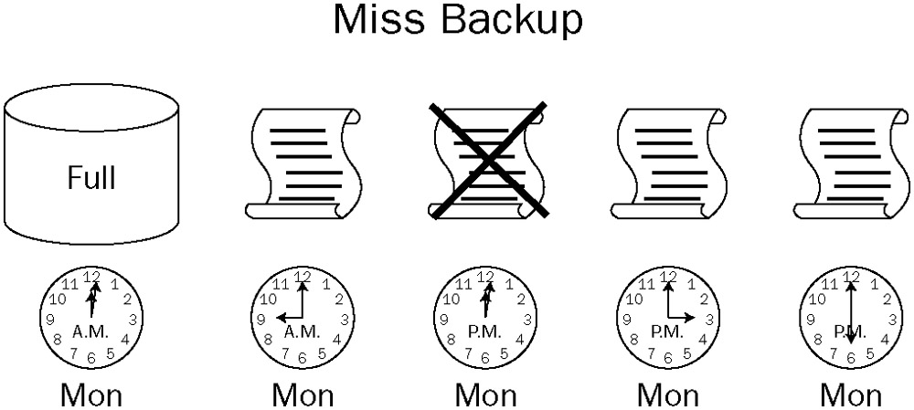
Phục hồi bằng cách viết lệnh:
Mẫu câu lệnh:
RESTORE DATABASE | LOG database_name
[File | FileGroup]
[FROM <backup_media> [ ,…n ] ]
[WITH
[CHECKSUM | NO_CHECKSUM]
[[,] FILE = file_number]
[[,] MOVE 'logical_file_name' TO 'operating_system_file_name'] [,…n]
[[,] RECOVERY | NORECOVERY | STANDBY = standby_file_name]
[[,] REPLACE]
[[,] STOPAT = date_time
]
Phục hồi CSDL:
- Phục hồi FILE:
RESTORE DATABASE SmallWorks
FILE = 'SmallWorks_Data2'
FROM DISK = 'C:\SQLBackups\SmallWorksFull.BAK';
- Phục hồi FILEGROUP:
RESTORE DATABASE SmallWorks
FILEGROUP = 'SWUserData2'
FROM DISK = 'C:\SQLBackups\SmallWorksFull.BAK';
- Phục hồi READ_WRITE_FILEGROUPS:
RESTORE DATABASE SmallWorks
READ_WRITE_FILEGROUPS
FROM DISK = 'C:\SQLBackups\SmallWorksFull.BAK';
- Phục hồi PAGE:
RESTORE DATABASE SmallWorks PAGE = '1:14'
FROM = 'C:\SQLBackups\SmallWorksFull.BAK';
- Phục hồi RESTORE LOG:
RESTORE LOG SmallWorks
FROM DISK = 'C:\SQLBackups\SmallWorksLog.BAK';
Phục hồi CSDL với từ khoá “FROM”:
- FROM DISK:
RESTORE DATABASE SmallWorks
FROM DISK = 'C:\SQLBackUps\SmallWorksFull.BAK';

RESTORE DATABASE SmallWorks
FROM DISK = '\\AughtFive\SQLBackUps\SmallWorksFull.BAK';
- FROM TAPE:
RESTORE DATABASE Master
FROM TAPE = '\\.\tape1';
- FROM DATABASE_SNAPSHOT
Phục hồi CSDL với mệnh đề “WITH”:
- RECOVERY | NORECOVERY: chỉ dùng RECOVERY đối với bản backup mới nhất nếu ta phục hồi từ nhiều bản backup
RESTORE DATABASE SmallWorks
FROM DISK = 'C:\SQLBackups\SmallWorksFull.BAK'
WITH NORECOVERY;

RESTORE LOG SmallWorks
FROM DISK = 'C:\SQLBackups\SmallWorksTailLog.BAK'
WITH RECOVERY;
- STANDBY: nếu dùng NORECOVERY thì CSDL sẽ tạm thời không truy xuất được, còn dùng STANDBY thì ta có thể truy xuất CSDL nhưng chỉ được truy xuất read-only.
RESTORE DATABASE SmallWorks
FROM DISK = 'C:\SQLBackups\SmallWorksFull.BAK'
WITH STANDBY = 'C:\SQLBackups\SmallWorksUndoRollback.BAK';
- CHECKSUM | NO_CHECKSUM: nếu khi backup có dùng checksum thì khi phục hồi mới có thể dùng checksum
BACKUP DATABASE SmallWorks
TO DISK = 'C:\SQLBackups\SmallWorksCheckSumFull.BAK'
WITH CHECKSUM;

--Capture the tail of the log prior to restore operation
BACKUP LOG SmallWorks
TO DISK = 'C:\SQLBackups\SmallWorksTailLog.BAK'
WITH NO_TRUNCATE;

RESTORE DATABASE SmallWorks
FROM DISK = 'C:\SQLBackups\SmallWorkCheckSumsFull.BAK'
WITH CHECKSUM;
- CONTINUE_AFTER_ERROR | STOP_ON_ERROR: mặc định là STOP_ON_ERROR
- FILE: chú ý:
FILE = option trong mệnh đề RESTORE chỉ ra file cần phục hồi
FILE = option trong mệnh đề WITH có kèm theo số chỉ ra các file đã backup cùng phục hồi cho file trên
--Initialize the backup file and backup the SmallWorks database to the file

BACKUP DATABASE SmallWorks
TO DISK = 'C:\SQLBackups\SmallWorksBackups.BAK'
WITH INIT, DESCRIPTION = 'Full Backup of SmallWorks';

--Send an Additional backup to the file

BACKUP DATABASE SmallWorks
TO DISK = 'C:\SQLBackups\SmallWorksBackups.BAK'
WITH DIFFERENTIAL, DESCRIPTION = 'Differential Backup of SmallWorks';

--Capture the tail of the log prior to restore operation

BACKUP LOG SmallWorks
TO DISK = 'C:\SQLBackups\SmallWorksBackups.BAK'
WITH NO_TRUNCATE, DESCRIPTION = 'Tail Log Backup of SmallWorks';

--Restore the Full Backup with NORECOVERY

RESTORE DATABASE SmallWorks
FROM DISK = 'C:\SQLBackups\SmallWorksBackups.BAK'
WITH FILE = 1, NORECOVERY;

--Restore the Differential Backup with NORECOVERY

RESTORE DATABASE SmallWorks
FROM DISK = 'C:\SQLBackups\SmallWorksBackups.BAK'
WITH FILE = 2, NORECOVERY;

--Restore the Tail Log Backup with RECOVERY

RESTORE LOG SmallWorks
FROM DISK = 'C:\SQLBackups\SmallWorksBackups.BAK'
WITH File = 3, RECOVERY;
- MOVE…TO… dùng khi đã thay đổi đường dẫn file cần phục hồi
RESTORE DATABASE SmallWorks
FROM DISK = 'C:\SQLBackups\SmallWorksFull.BAK'
WITH MOVE 'SmallWorksPrimary' TO 'S:\SQLData\SmallWorks.mdf'
, MOVE 'SmallWorks_log' TO 'T:\SQLLogs\SmallWorks_log.ldf'
, MOVE 'SmallWorksData1' TO 'S:\SQLData\SmallWorksData1.ndf'
, MOVE 'SmallWorksData2' TO 'S:\SQLData\SmallWorksData2.ndf'
- PARTIAL: chỉ ra rằng Primary filegroup và các user-defined filegroups nào cần phải phục hồi.
- REPLACE: chỉ ra các file sao lưu sẽ thay thế các file cần phục hồi
Chuẩn bị cho việc phục hồi dữ liệu:
Thường có 3 bước:
- Dùng SINGLE_USER mode.
- Sao lưu phần sau của transaction log (tail log) nếu dùng Full hay Bulk-Logged recovery mode. Mục đích để lưu các hoạt động mới nhất.
- Tập hợp các bản backup cần thiết để phục hồi tới thời điểm mới nhất.
Phục hồi các User Databases:

Full Restore
12:02 a.m. backup
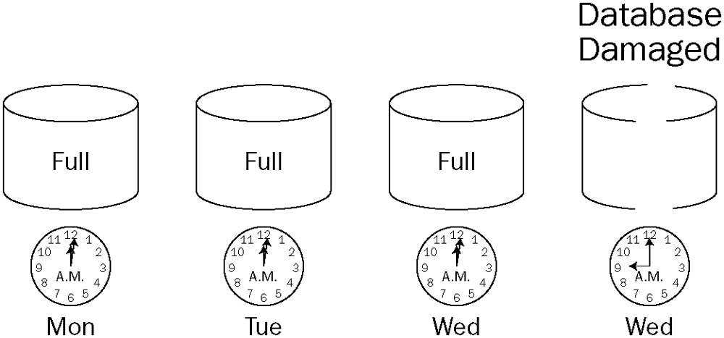

RESTORE DATABASE SmallWorks
FROM DISK = 'C:\SQLBackups\SmallWorksWed0002.BAK'
WITH RECOVERY;

Full with Differential Restore
Monday Full backup → Wednesday Differential backup
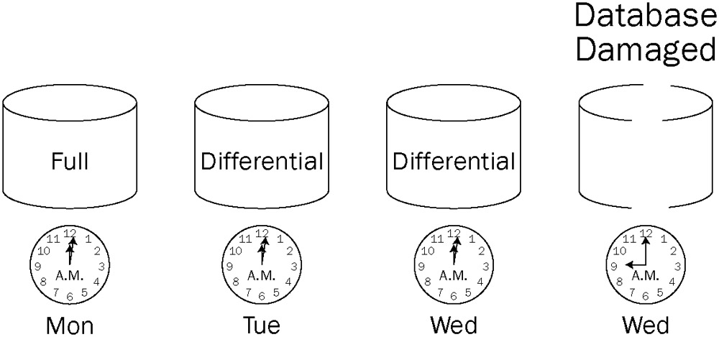

RESTORE DATABASE SmallWorks
FROM DISK = 'C:\SQLBackups\SmallWorksFullMon0002.BAK'
WITH NORECOVERY;

RESTORE DATABASE SmallWorks
FROM DISK = 'C:\SQLBackups\SmallWorksDiffWed0002.BAK'
WITH RECOVERY;

Full with Transaction Log Restore
Monday Full backup → Transaction Log backups.
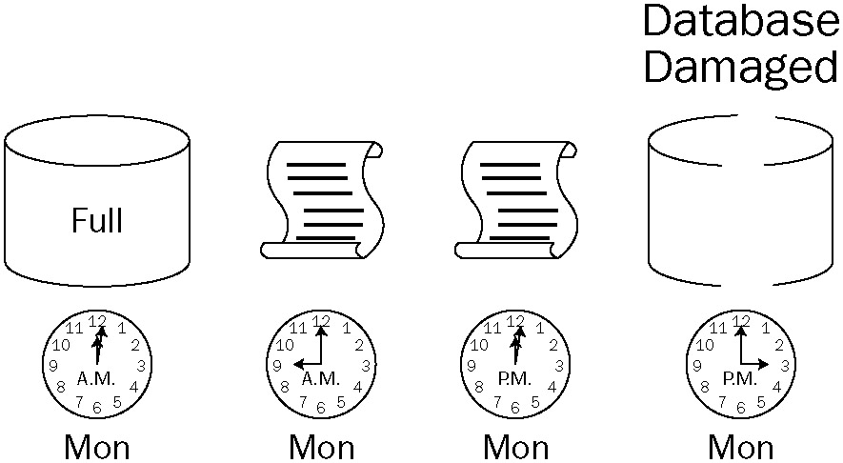

BACKUP LOG SmallWorks
TO DISK = 'C:\SQLBackups\SmallWorksTailLogMon1510.BAK'
WITH NO_TRUNCATE;

RESTORE DATABASE SmallWorks
FROM DISK = 'C:\SQLBackups\SmallWorksFullMon0002.BAK'
WITH NORECOVERY;

RESTORE LOG SmallWorks
FROM DISK = 'C:\SQLBackups\SmallWorksLogMon0900.BAK'
WITH NORECOVERY;

RESTORE LOG SmallWorks
FROM DISK = 'C:\SQLBackups\SmallWorksLogMon1202.BAK'
WITH NORECOVERY;

RESTORE LOG SmallWorks
FROM DISK = 'C:\SQLBackups\SmallWorksTailLogMon1510.BAK'
WITH RECOVERY;

Full and Differential with Transaction Log Restore
Full, Differential, regular Transaction Log, and Tail Log backups.
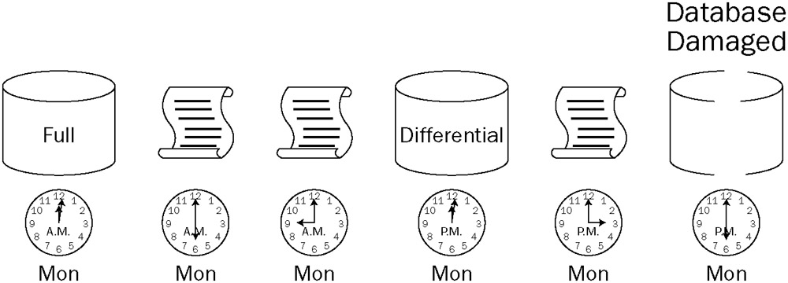

BACKUP LOG SmallWorks
TO DISK = 'C:\SQLBackups\SmallWorksTailLogMon1810.BAK'
WITH NO_TRUNCATE;

RESTORE DATABASE SmallWorks
FROM DISK = 'C:\SQLBackups\SmallWorksFullMon0002.BAK'
WITH NORECOVERY;

RESTORE DATABASE SmallWorks
FROM DISK = 'C:\SQLBackups\SmallWorksDiffMon1202.BAK'
WITH NORECOVERY;

RESTORE LOG SmallWorks
FROM DISK = 'C:\SQLBackups\SmallWorksLogMon1500.BAK'
WITH NORECOVERY;

RESTORE LOG SmallWorks
FROM DISK = 'C:\SQLBackups\SmallWorksTailLogMon1810.BAK'
WITH RECOVERY;

File and Filegroup Restore (xem tài liệu)

Partial Restore (xem tài liệu)

Point-in-Time Restore:

RESTORE DATABASE SmallWorks
FROM DISK = 'C:\SQLBackups\SmallWorksFull1600.BAK'
WITH STOPAT = '06/05/2006 14:59:00'
,NORECOVERY;

RESTORE LOG SmallWorks
FROM DISK = 'C:\SQLBackups\SmallWorksLog1700.BAK'
WITH STOPAT = '06/05/2006 14:59:00'
,RECOVERY;

Đọc thêm:

Recovering System Databases

Recovering the Master Database
Start in single-user mode:

sqlservr.exe –m
Login command to an instance of SQL Server called AughtFive (-S) using Windows Security (-E):
C:\>SQLCMD –S AughtFive –E
Master database can be completed through the normal RESTORE syntax:

1>RESTORE DATABASE MASTER FROM DISK = 'C:\SQLBackups\MasterFull.BAK'
2>GO

Database Snapshots:
“A snapshot is a point-in-time, static, read-only view of a database”
CREATE DATABASE AdventureWorksSnapShot ON
( NAME = 'AdventureWorks_Data'
, FILENAME = 'C:\SQLSnapShotData\AdventureWorksSnapShot.mdf')
AS SNAPSHOT OF AdventureWorks;
Database snapshots can’t really be used for disaster recovery in the case of a complete database loss. However, they can be very useful in reversing the effects of database modifications.

