Assignment 1:

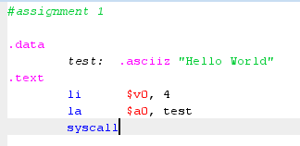



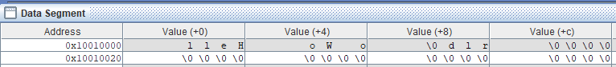

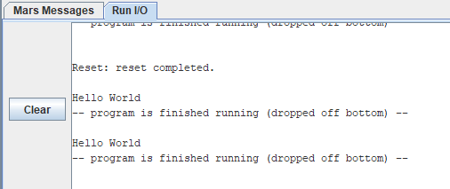

Assignment 2:

.data

test: .asciiz "The sum of "

test1: .asciiz " and "

test2: .asciiz " is "

.text

# Gan s0,s1

li $s0, 8

li $s1, 7

# In "The sum of"

li $v0, 4

la $a0, test

syscall

#In s0

li $v0, 1

la $a0, 0($s0)

syscall

#In "and"

li $v0, 4

la $a0, test1

syscall

#In s1

li $v0, 1

la $a0, 0($s1)

syscall

# In "is"

li $v0, 4

la $a0, test2

syscall

#In tong

add $s3, $s0, $s1

li $v0, 1

la $a0, 0($s3)

syscall

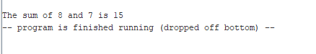

Assignment 3:

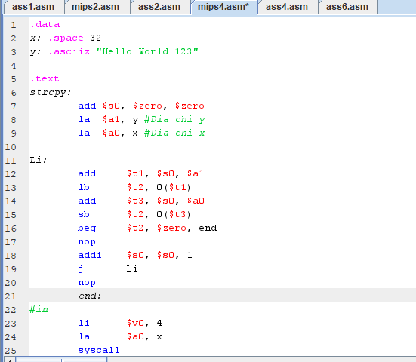

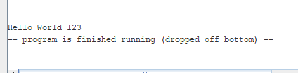

Assignment 4:

.data

string: .space 50

Mess1: .asciiz "Nhap xau: "

Mess2: .asciiz "Do dai xau la: "

.text

main:

get_string: #todo

#Nhap xau

li $v0, 54

la $a0,Mess1

la $a1, string

la $a2, 50

syscall

get_length:

la $a0,string # $a0=address(string[0])

add $t0, $zero,$zero # $t0=i=0

check_char: add $t1, $a0, $t0 # $t1=$a0+$t0

lb $t2, 0($t1) # $t2=string[i]

beq $t2, $zero,end_of_str # is null char?

addi $t0, $t0, 1 # $t0=$t0+1->i=i+1

j check_char

end_of_str:

end_of_get_length:

print_length:

#In chieu dai

addi $t0, $t0, -1

li $v0, 56

la $a0, Mess2

la $a1, 0($t0)

syscall

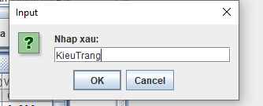

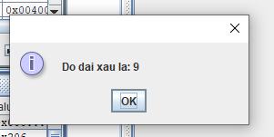

Assignment 5:

.data  
string: .space 50  
enter: .asciiz "\n"  
Message1: .asciiz "Nhap vao xau: "  
str: .space 20  
.text  
main:  
#in thong bao nhap vao xau  
    li $v0, 4  
     la $a0, Message1  
     la $s2,enter  
     syscall  
  
    add $s0,$zero,$zero         #$s0=i=0  
    la $a3,string #a0 = address of var string  
    li $s1,19     #max_string = 20, bat dau = 0.  
loop:  
    li $v0, 12  
     syscall  
     add $t3,$s0,$a3  
     bge $s0,$s1,end_loop #length>20 thi endloop  
     beq $v0,'\n',end_loop # is enter char?  
     sb $v0,0($t3) # save entered char into string a0  
    nop  
        addi $s0,$s0,1 #index=length +=1  
     j loop  
end_loop:

start:                 
beq  $s0,$zero,end2  
addi $s0,$s0,-1  
add  $t4,$a3,$s0    
lbu $a0,0($t4)  
li $v0, 11  
syscall  
j start  
end2:

