

**Music Streaming**

**Software Requirement Specification**

– Hanoi, August 2019 –

**Table of Contents**

I. Overview 3

1. Introduction 3

2. System Functions 4

3. Database…………………………………………………………………………………………………………………………………….6

# I. Overview

## 1. Introduction

Music Streaming System is a software that allow user can listening to music, system also allow user can post their music. Create playlist and add track to playlist.

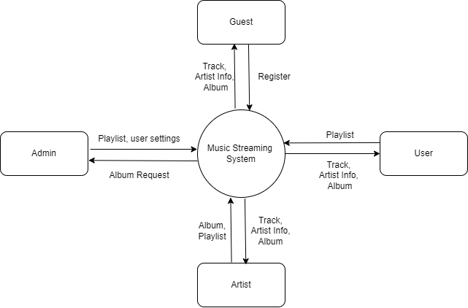

## 2. System Functions

#### a. Screen Flow

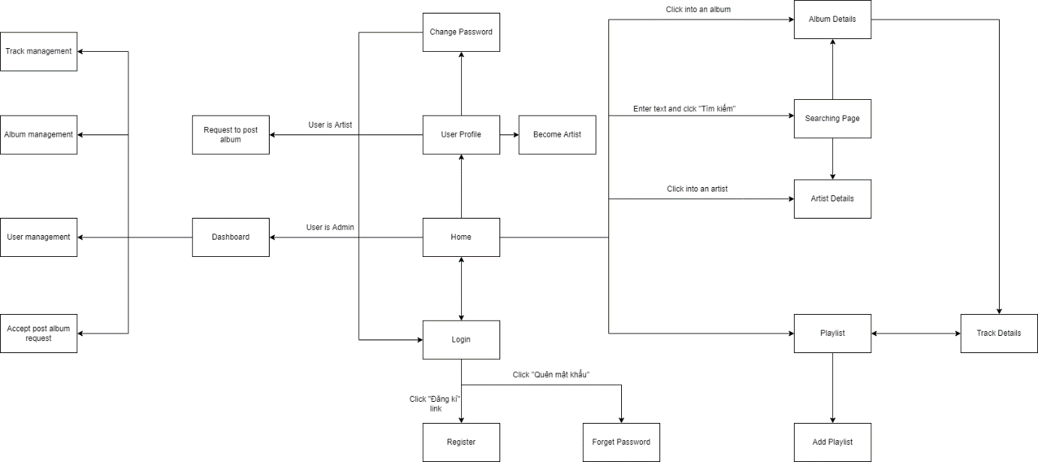

#### b. Screen Details

|  |  |  |  |
| --- | --- | --- | --- |
| **#** | **Feature** | **Screen** | **Description** |
| 1 | Common | Login | authenticate the user to give him/her to access authorized features later on |
| 2 | Common | Register | Allow user can create account so they can login into web application |
| 3 | Common | Home | Allow user can view some basic information include popular track, album, artist,… |
| 4 | Common | Search | Allow user can search base on keywords include genre, album, track, artist, … |
| 5 | Common | Artist Detail | View details of artist |
| 6 | Common | Album Details | View details of album |
| 7 | Common | Track Details | View details of track can add tracks in playlist, like track or comment in tracks |
| 8 | User Feature | User Details | Allow user can see their information |
| 9 | User Feature | Forget Password | If user can’t remember their password, reset their password |
| 10 | User Feature | Playlist | User can create playlist, delete track in playlist |
| 11 | User Feature | Become Artist | Screen has form for user to register as an artist |
| 12 | User Feature | Change Password | User can change his/her password |
| 13 | Artist Feature | Request to post an album | Artist can create a request then admin can accept this request then album will be public |
| 14 | Admin Feature | User management | Manage user (add, create, edit, delete) and accept artist request |
| 15 | Admin Feature | Accept post album request | Accept a post album request to make it public |
| 16 | Artist, Admin Feature | Album Manage | Artist can manage their album while admin can manage all artist’s album |
| 17 | Artist, Admin Feature | Track Manage | Artist can manage their track while admin can manage all artist’s track |

c. User Authorization

|  |  |  |  |  |
| --- | --- | --- | --- | --- |
| **Screen** | **Guest** | **User** | **Artist** | **Admin** |
| Home | X | X | X | X |
| Listen tracks | X | X | X | X |
| View Album Details | X | X | X | X |
| View Artist Info | X | X | X | X |
| Listen a playlist | X | X | X | X |
| Like tracks |  | X | X | X |
| Add to playlist |  | X | X | X |
| Become artist |  | X |  |  |
| Register | X |  |  |  |
| Login |  | X | X | X |
| Forgot password |  | X | X | X |
| Change password |  | X | X | X |
| User profile |  | X | X | X |
| Comment |  | X | X | X |
| Follow artists |  | X | X | X |
| Create an album post request |  |  | X |  |
| Accept album request |  |  |  | X |
| User manage |  |  |  | X |
| Track manage |  |  | X | X |
| Album manager |  |  | X | X |
| New playlist |  | X | X | X |
| Comment management |  |  |  | X |

In which:

* **Guest**: Who don’t have account
* **User:** Who already had account and logged in.
* **Artist:** Who already had account, have accepted by admin
* **Admin:** Administrator of web application

## 3. Database

a. ERD

