
TRƯỜNG CÔNG NGHỆ VÀ TRUYỀN THÔNG
ĐẠI HỌC CẦN THƠ
CT005_D03_Nền Tảng Kỹ Thuật Số_HK1
(Thạc Sĩ Lê Huỳnh Quốc Bảo)
Khóa: 52


CHỦ ĐỀ:
TIN HỌC VĂN PHÒNG
LAB 02-03-04-05

HỌ và TÊN : Nguyễn Lê Minh Tiến
MSSV: B2605310
Niên Khóa: 2026-2027

Mục lục
LAB02 Microsoft Word và Google Docs 5
LAB02_EX1 Trộn thư dữ liệu từ Excel 5
LAB02_EX.1.1 Data.xlsx 5
LAB02_EX.1.2 Template.docx 5
LAB02_EX.1.3 FinaL 6
LAB02_EX2 Tạo mục lục 9
LAB02_EX.2.1 FINAL 9
9
LAB02_EX3 Google Docs 11
LAB02_EX.3.1 FINAL 11
LAB03 Microsoft Excel và Google Sheets 11
LAB03_EX1 TẠO SHEET TỔNG HỢP ĐIỂM 11
LAB03_EX.1.1 FINAL 11
LAB3_EX1.1_ẢNH1 LỆNH ĐIỂM TH1 11
LAB3_EX1.1_ẢNH2 LỆNH ĐIỂM TH2 12
LAB3_EX1.1_ẢNH3 LỆNH ĐIỂM TH2 12
LAB3_EX1.1_ẢNH4 LỆNH ĐIỂM TH3 12
LAB3_EX1.1_ẢNH5 LỆNH ĐIỂM BT LỚN 12
12
LAB3_EX1.1_ẢNH6 LỆNH ĐIỂM LT 13
LAB3_EX1.1_ẢNH7 LỆNH ĐIỂM TỔNG 13
LAB3_EX1.1_ẢNH8 LỆNH ĐIỂM THEO THANG ĐIỂM 10 13
LAB3_EX1.1_ẢNH9 LỆNH ĐIỂM CHỮ 14
LAB03_EX.1.2 BẢNG ĐIỂM THỰC HÀNH 14
LAB03_EX.1.3 BẢNG ĐIỂM BÀI TẬP LỚN 14
LAB03_EX.1.4 BẢNG ĐIỂM LÝ THUYẾT 15
LAB03_EX.1.5 BẢNG THỐNG KÊ 15
LAB03_EX2 Google Spreadsheet 15
LAB03_EX.2.1 BẢNG TỔNG HỢP 15
LAB03_EX.2.2 BẢNG SV NGÀNH CNTT 16
LAB03_EX.2.3 BẢNG NT_CNTT 16
LAB03_EX.2.4 BẢNG ĐIỂM D-F 17
LAB03_EX.2.5 BẢNG SV ĐĂNG KÍ HƠN 1 MÔN 17
LAB04 Microsoft Powerpoint 18
LAB04_EX1 Định dạng cho Slide Master 1 18
LAB04_EX.1.1 SLIDE MASTER 18
LAB4_EX1.1_ẢNH1 Office Theme Slide master 18
LAB4_EX1.1_ẢNH2 Title Slide Layout 19
LAB4_EX1.1_ẢNH3 Title and Content Layout 19
LAB4_EX1.1_ẢNH4 Title Only Layout 19
LAB04_EX.1.2 TẠO CÁC SLIDE 20
LAB04_EX2 Định dạng cho Slide Master 1 21
LAB04_EX.2.1 Office Theme Slide master 21
LAB04_EX.2.2 TẠO CÁC SLIDE 21

Microsoft Word và Google Docs

Trộn thư dữ liệu từ Excel

Data.xlsx
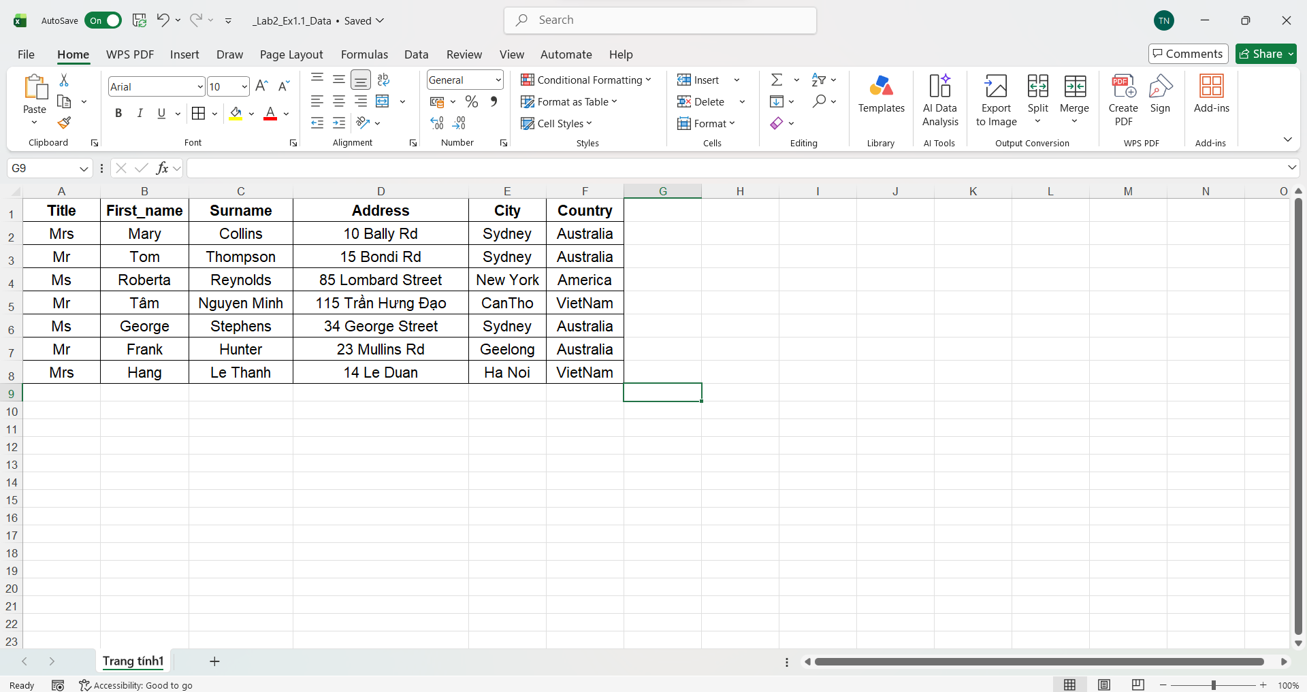

Template.docx
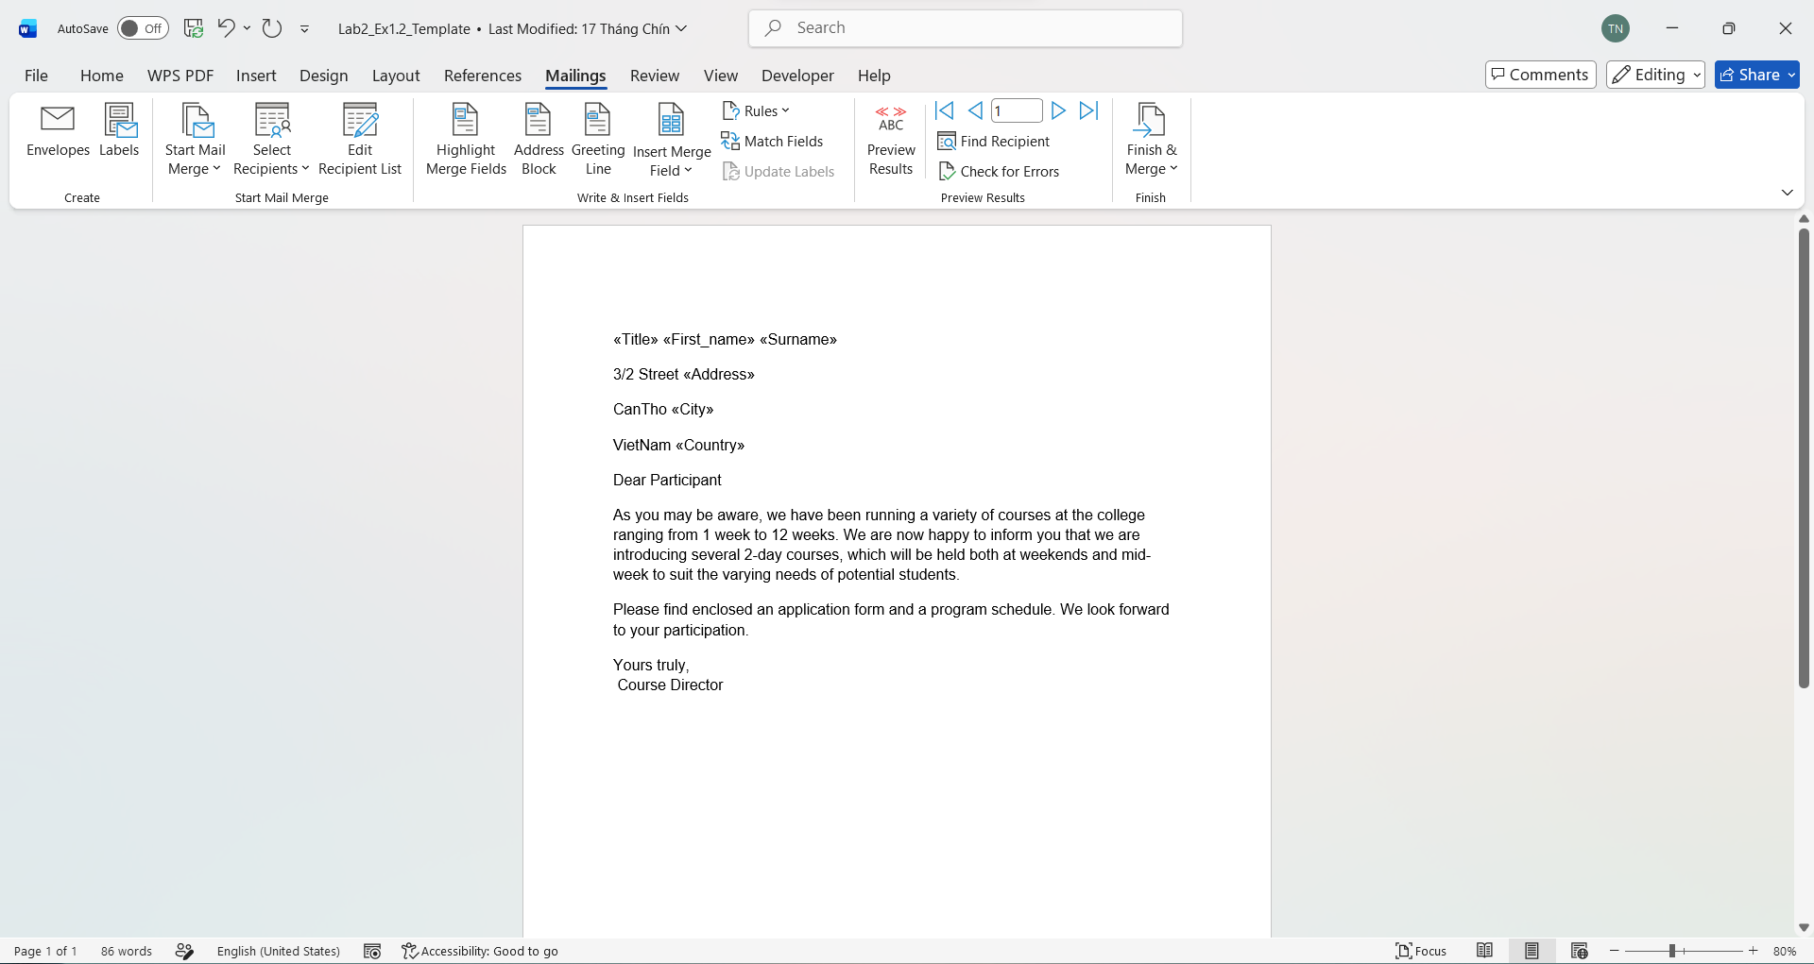

FinaL
Mrs Mary Collins
3/2 Street 10 Bally Rd
CanTho Sydney
VietNam Australia
Dear Participant
As you may be aware, we have been running a variety of courses at the college ranging from 1 week to 12 weeks. We are now happy to inform you that we are introducing several 2-day courses, which will be held both at weekends and mid-week to suit the varying needs of potential students.
Please find enclosed an application form and a program schedule. We look forward to your participation.
Yours truly,
Course Director
Mr Tom Thompson
3/2 Street 15 Bondi Rd
CanTho Sydney
VietNam Australia
Dear Participant
As you may be aware, we have been running a variety of courses at the college ranging from 1 week to 12 weeks. We are now happy to inform you that we are introducing several 2-day courses, which will be held both at weekends and mid-week to suit the varying needs of potential students.
Please find enclosed an application form and a program schedule. We look forward to your participation.
Yours truly,
Course Director

Ms Roberta Reynolds
3/2 Street 85 Lombard Street
CanTho New York
VietNam America
Dear Participant
As you may be aware, we have been running a variety of courses at the college ranging from 1 week to 12 weeks. We are now happy to inform you that we are introducing several 2-day courses, which will be held both at weekends and mid-week to suit the varying needs of potential students.
Please find enclosed an application form and a program schedule. We look forward to your participation.
Yours truly,
Course Director
Mr Tâm Nguyen Minh
3/2 Street 115 Trần Hưng Đạo
CanTho CanTho
VietNam VietNam
Dear Participant
As you may be aware, we have been running a variety of courses at the college ranging from 1 week to 12 weeks. We are now happy to inform you that we are introducing several 2-day courses, which will be held both at weekends and mid-week to suit the varying needs of potential students.
Please find enclosed an application form and a program schedule. We look forward to your participation.
Yours truly,
Course Director
Ms George Stephens
3/2 Street 34 George Street
CanTho Sydney
VietNam Australia
Dear Participant
As you may be aware, we have been running a variety of courses at the college ranging from 1 week to 12 weeks. We are now happy to inform you that we are introducing several 2-day courses, which will be held both at weekends and mid-week to suit the varying needs of potential students.
Please find enclosed an application form and a program schedule. We look forward to your participation.
Yours truly,
Course Director
Mr Frank Hunter
3/2 Street 23 Mullins Rd
CanTho Geelong
VietNam Australia
Dear Participant
As you may be aware, we have been running a variety of courses at the college ranging from 1 week to 12 weeks. We are now happy to inform you that we are introducing several 2-day courses, which will be held both at weekends and mid-week to suit the varying needs of potential students.
Please find enclosed an application form and a program schedule. We look forward to your participation.
Yours truly,
Course Director
Mrs Hang Le Thanh
3/2 Street 14 Le Duan
CanTho Ha Noi
VietNam VietNam
Dear Participant
As you may be aware, we have been running a variety of courses at the college ranging from 1 week to 12 weeks. We are now happy to inform you that we are introducing several 2-day courses, which will be held both at weekends and mid-week to suit the varying needs of potential students.
Please find enclosed an application form and a program schedule. We look forward to your participation.
Yours truly,
Course Director

Tạo mục lục

FINAL

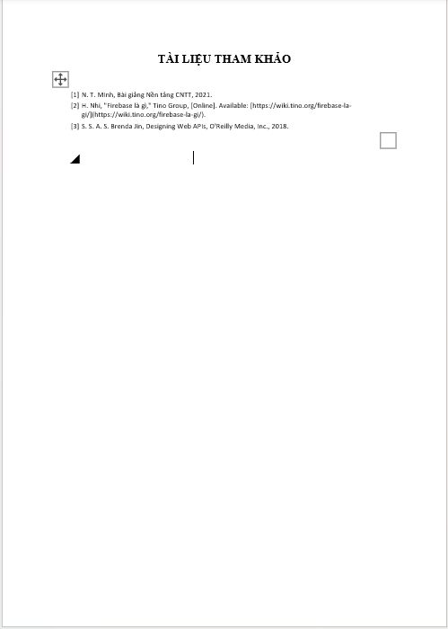
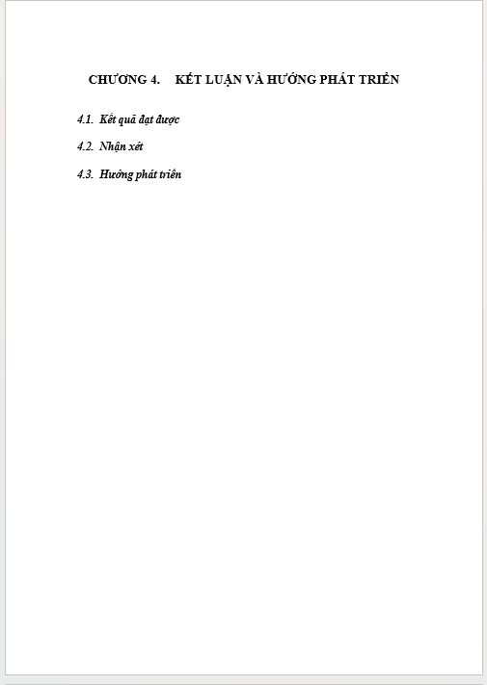
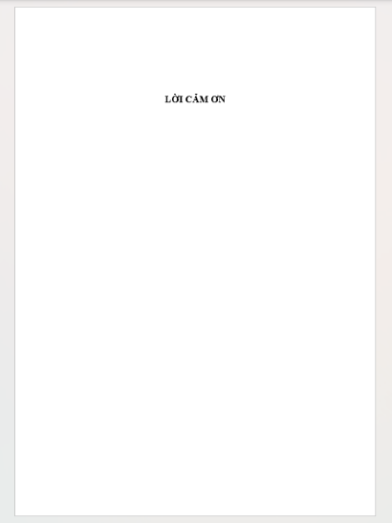
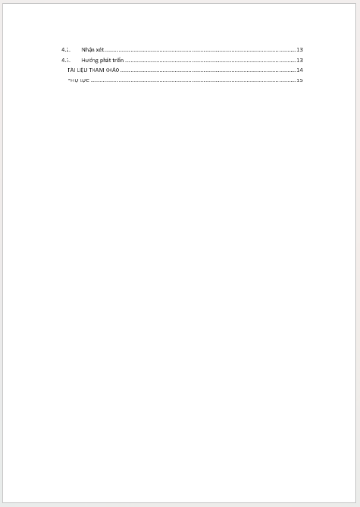
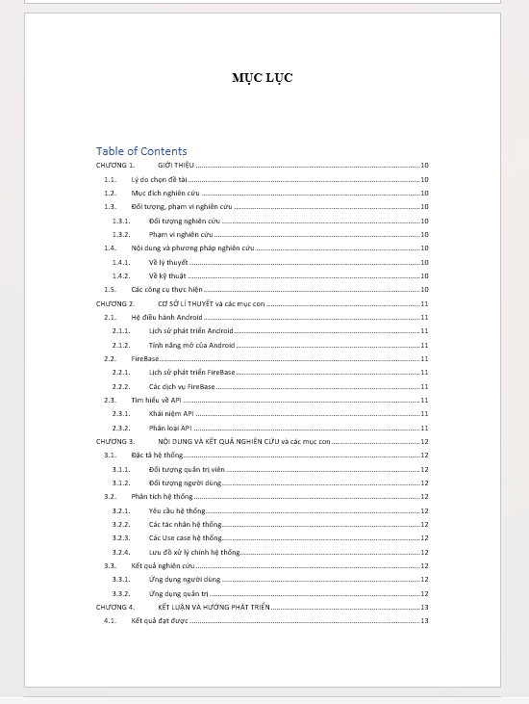

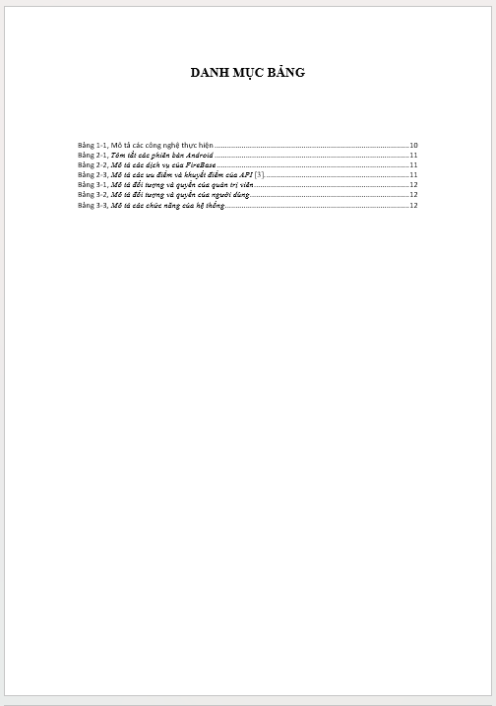
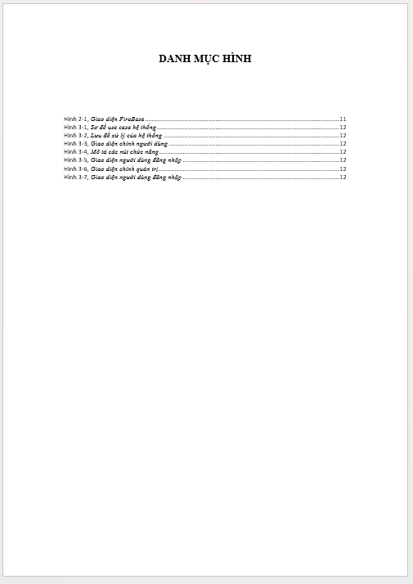


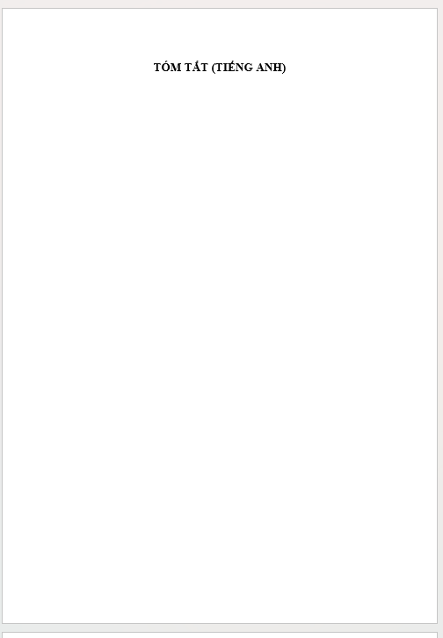
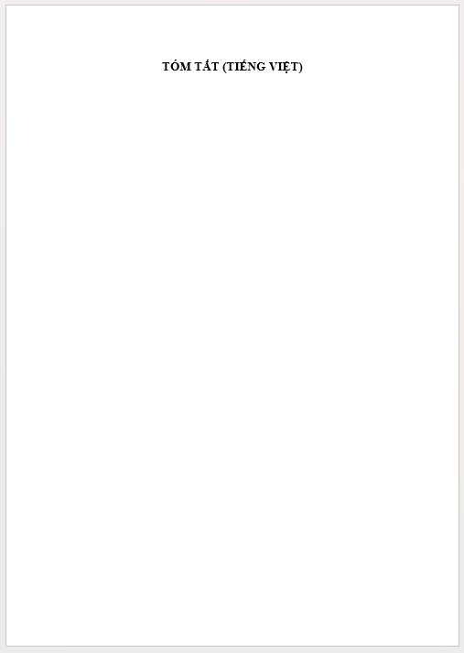
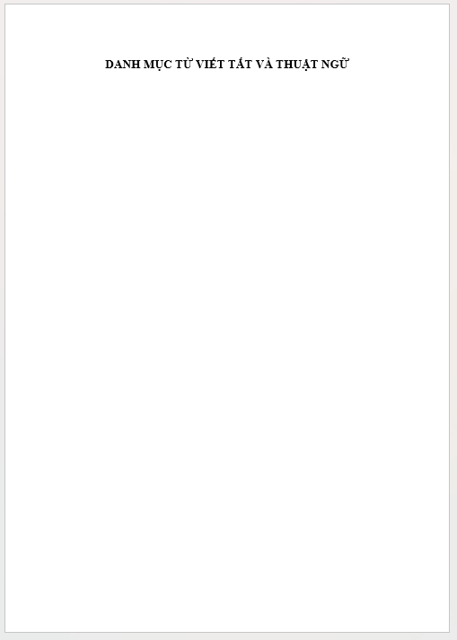

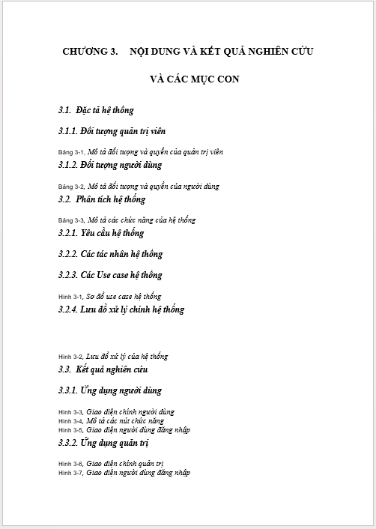
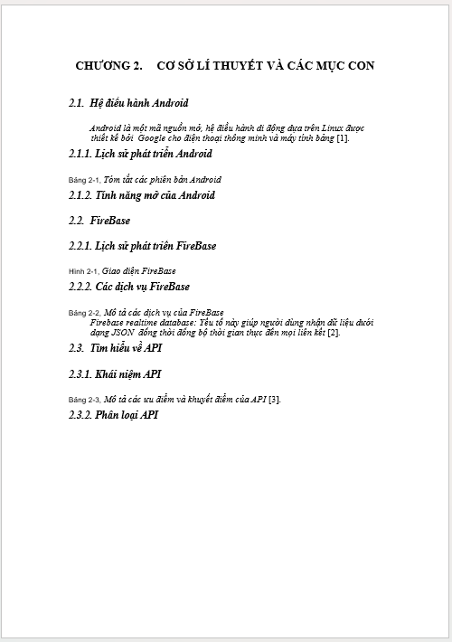
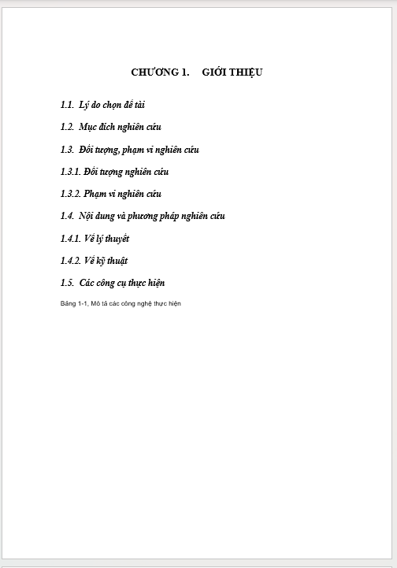


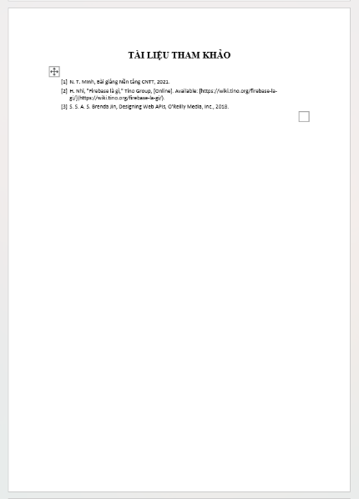
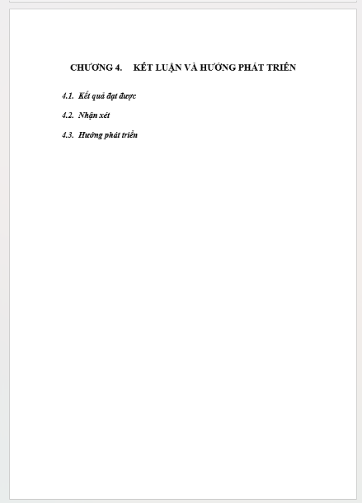

Google Docs

FINAL
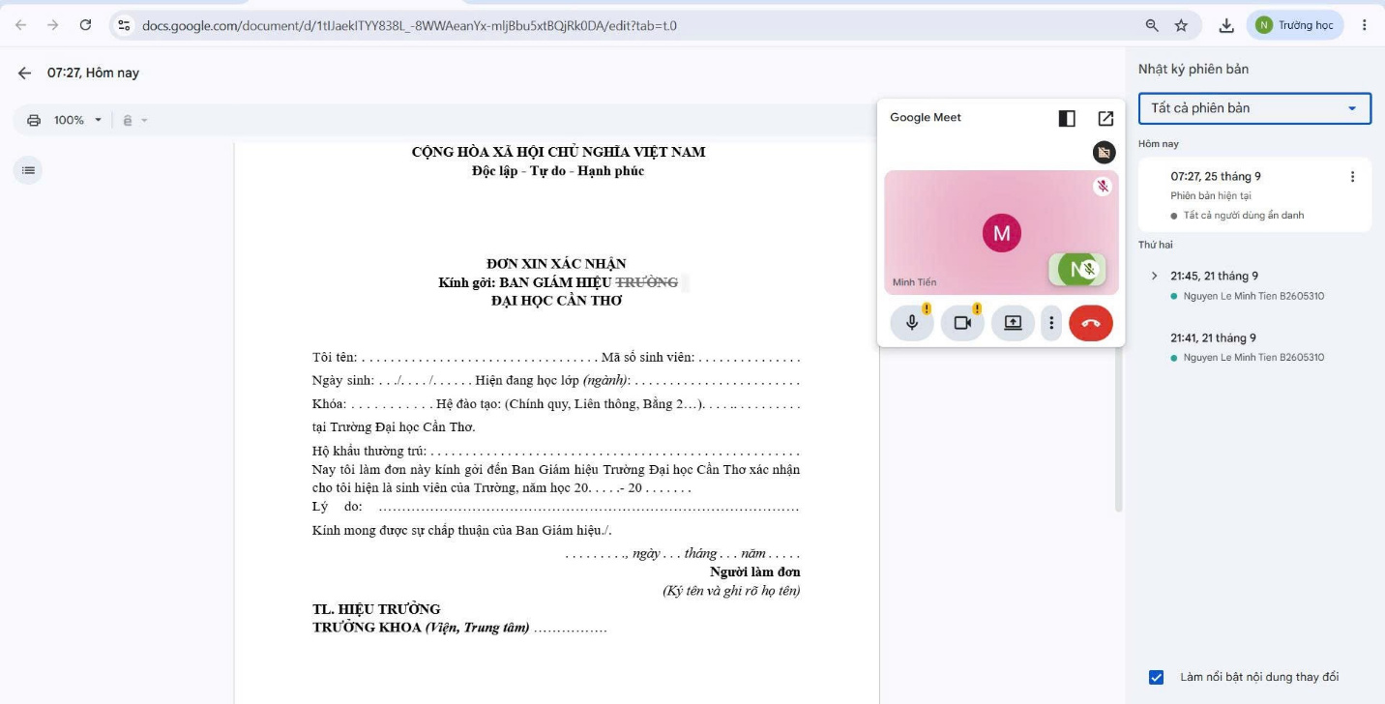

Microsoft Excel và Google Sheets

TẠO SHEET TỔNG HỢP ĐIỂM

FINAL

LỆNH ĐIỂM TH1
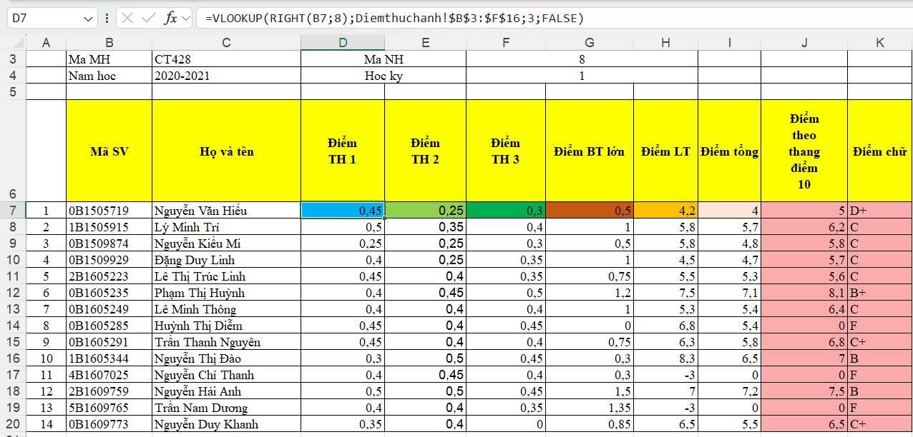

LỆNH ĐIỂM TH2

LỆNH ĐIỂM TH2
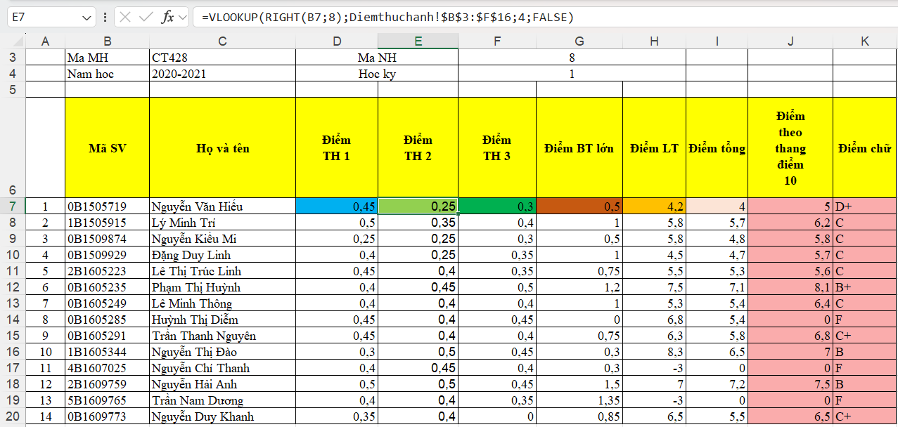

LỆNH ĐIỂM TH3
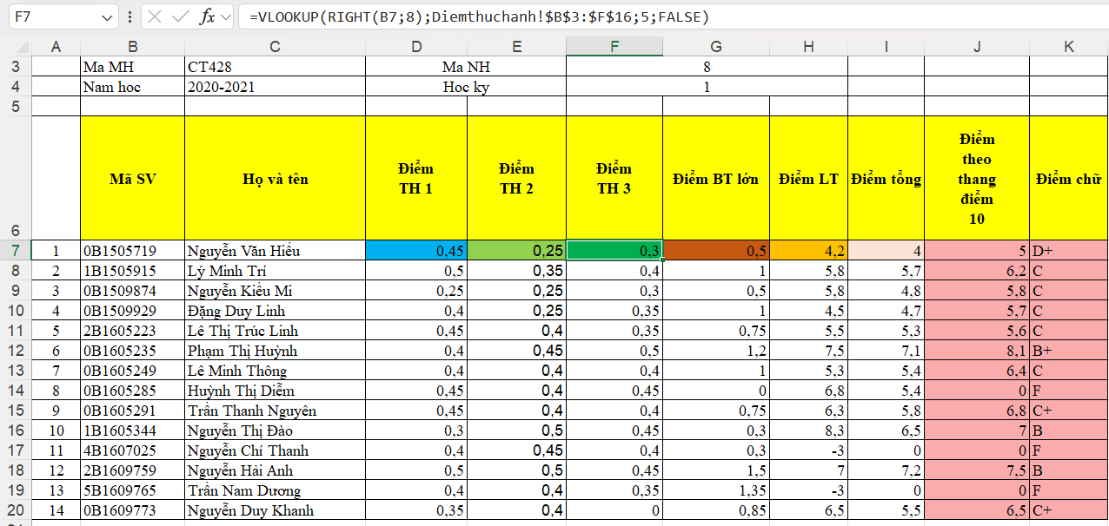

LỆNH ĐIỂM BT LỚN
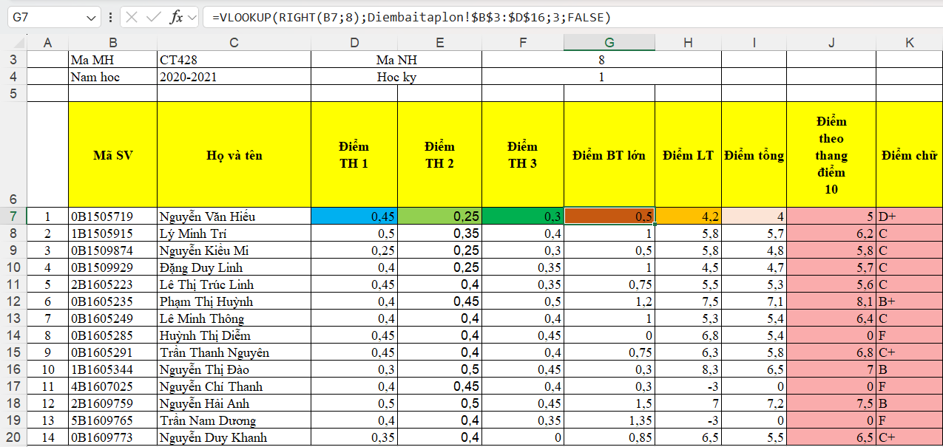

LỆNH ĐIỂM LT
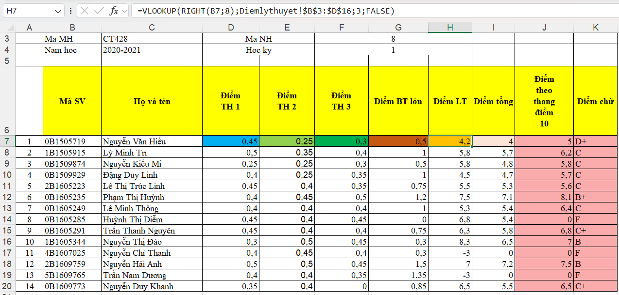

LỆNH ĐIỂM TỔNG
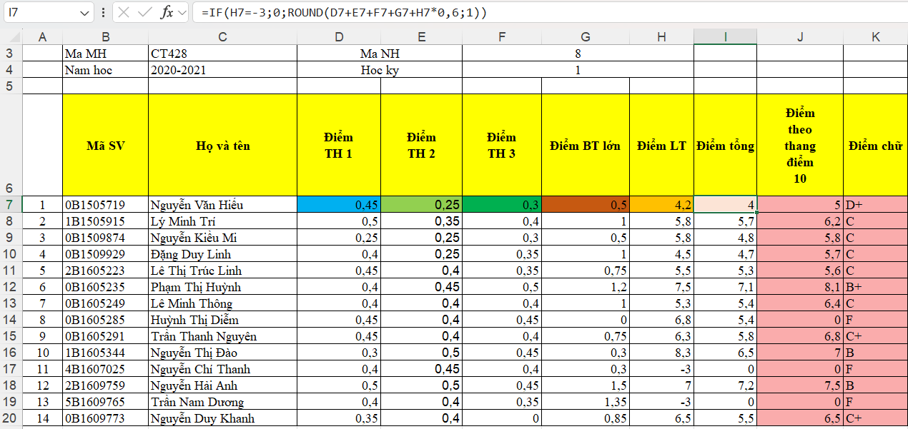

LỆNH ĐIỂM THEO THANG ĐIỂM 10
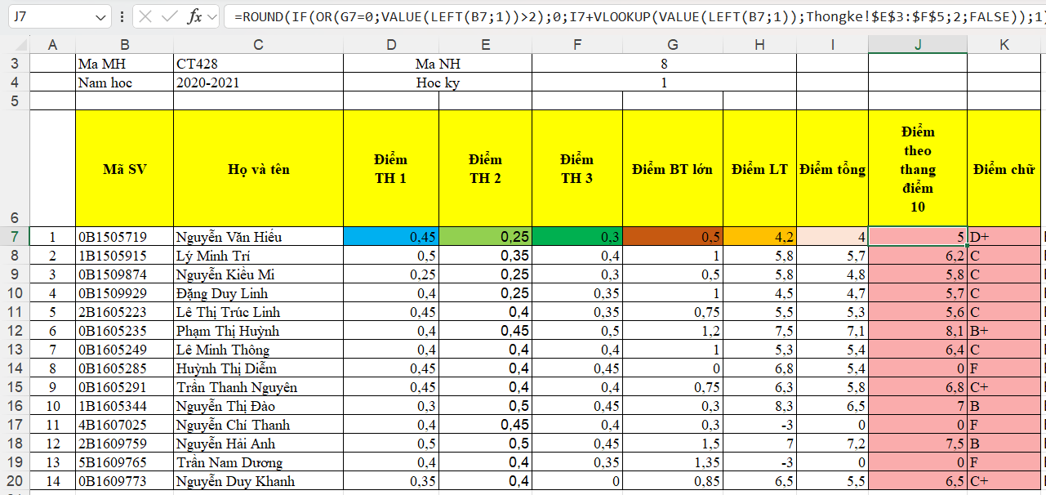

LỆNH ĐIỂM CHỮ
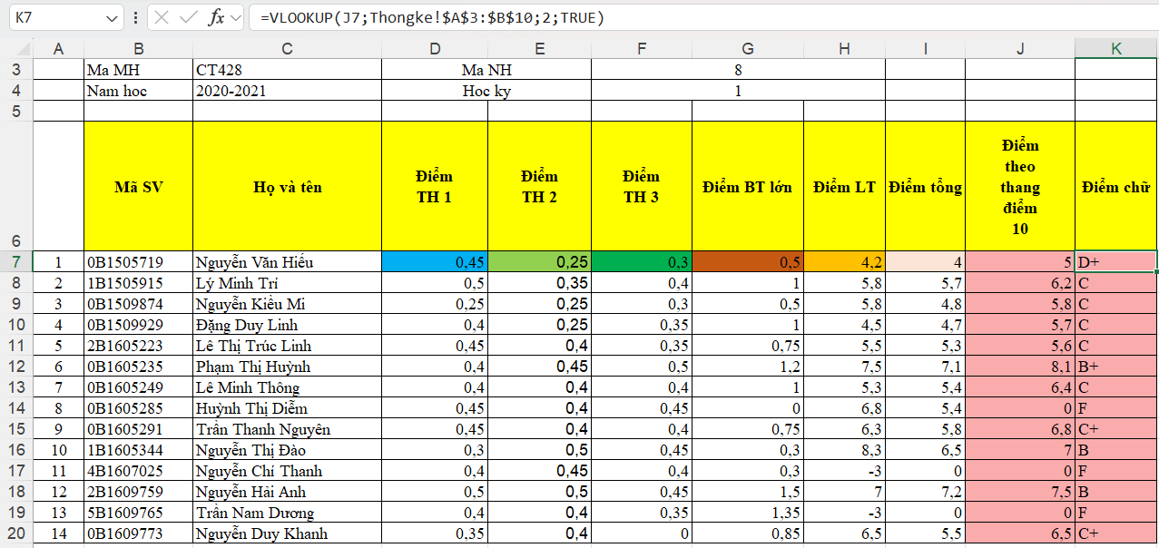

BẢNG ĐIỂM THỰC HÀNH
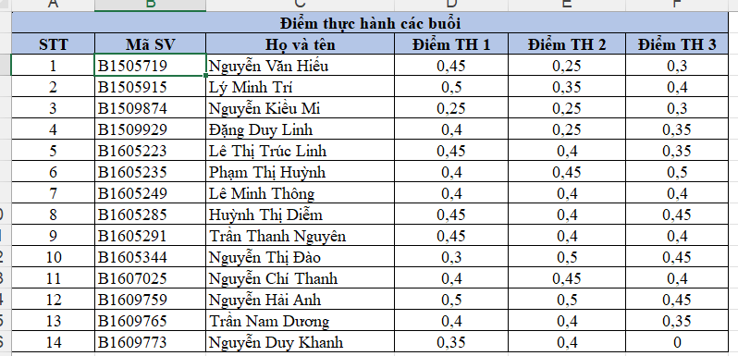

BẢNG ĐIỂM BÀI TẬP LỚN
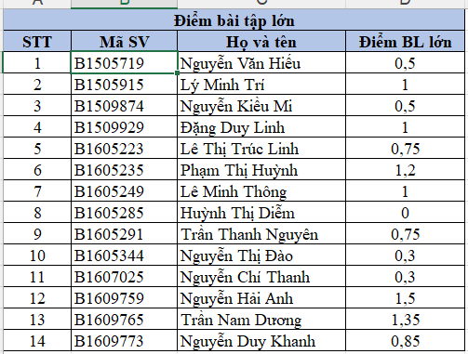

BẢNG ĐIỂM LÝ THUYẾT
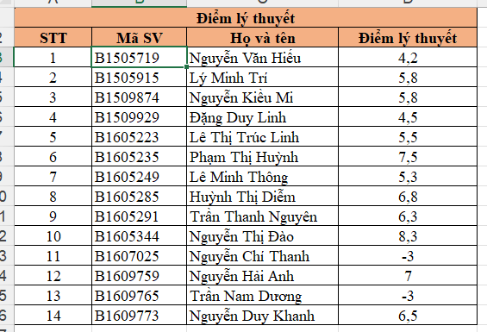

BẢNG THỐNG KÊ
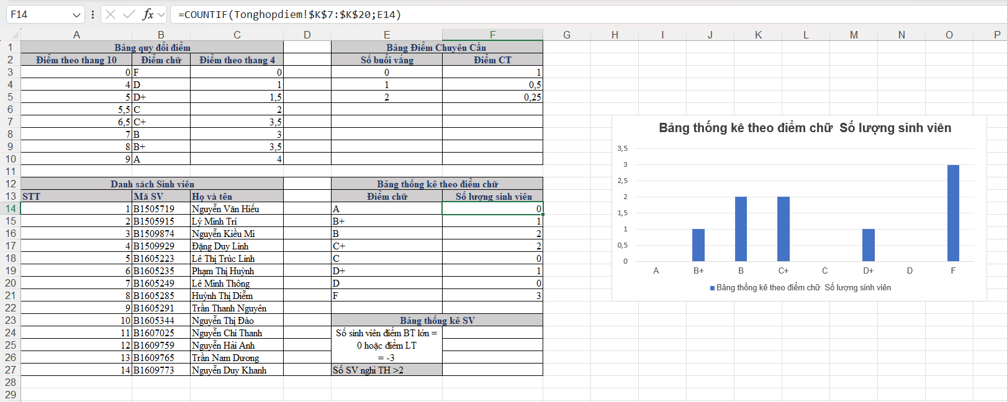

Google Spreadsheet

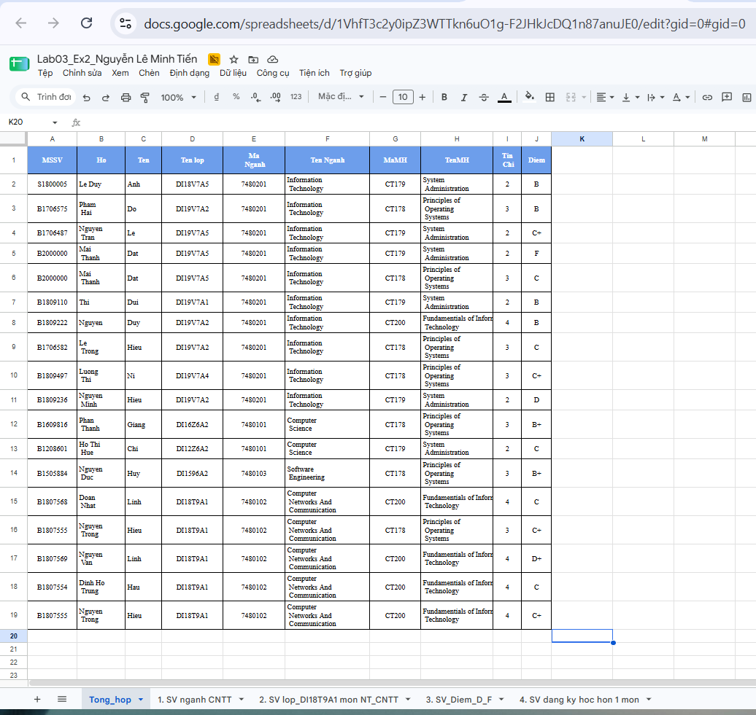
BẢNG TỔNG HỢP

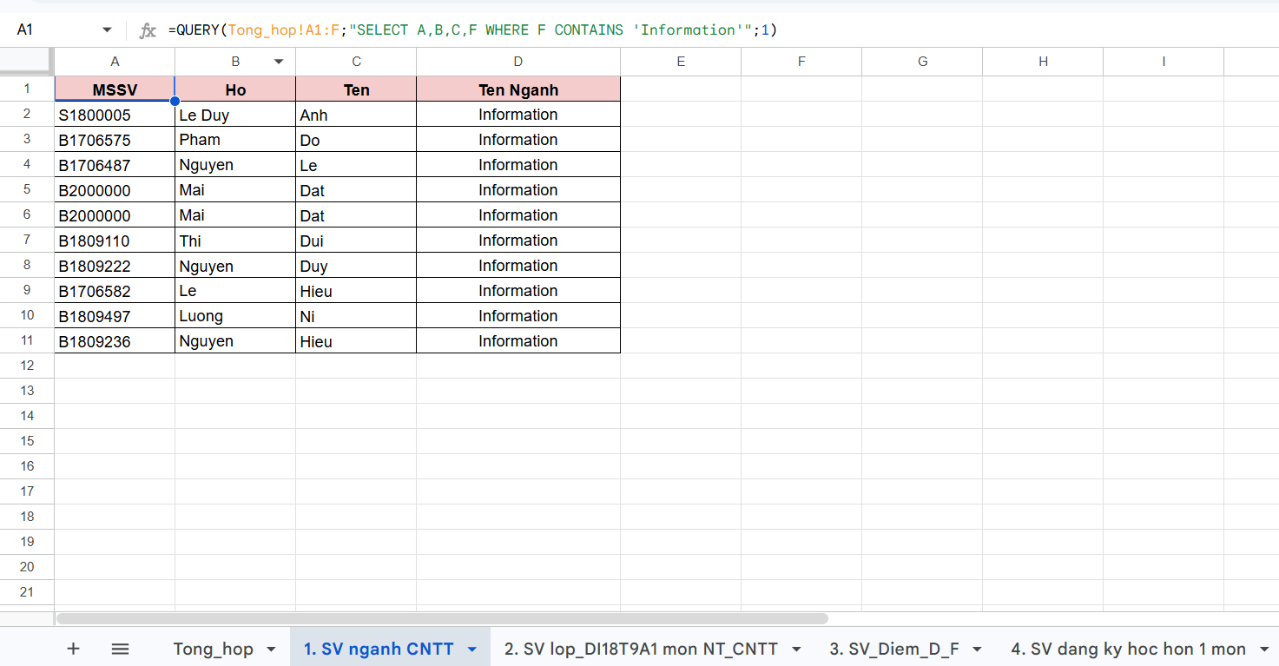
BẢNG SV NGÀNH CNTT

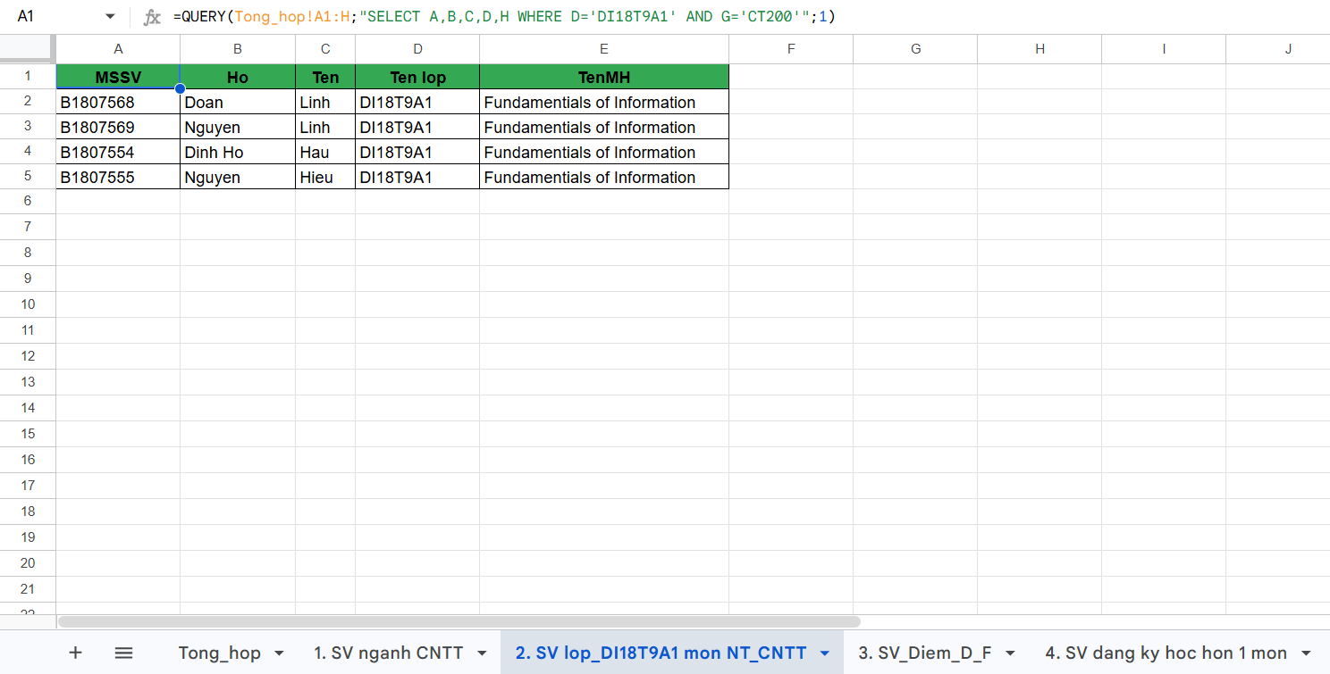
BẢNG NT_CNTT

BẢNG ĐIỂM D-F
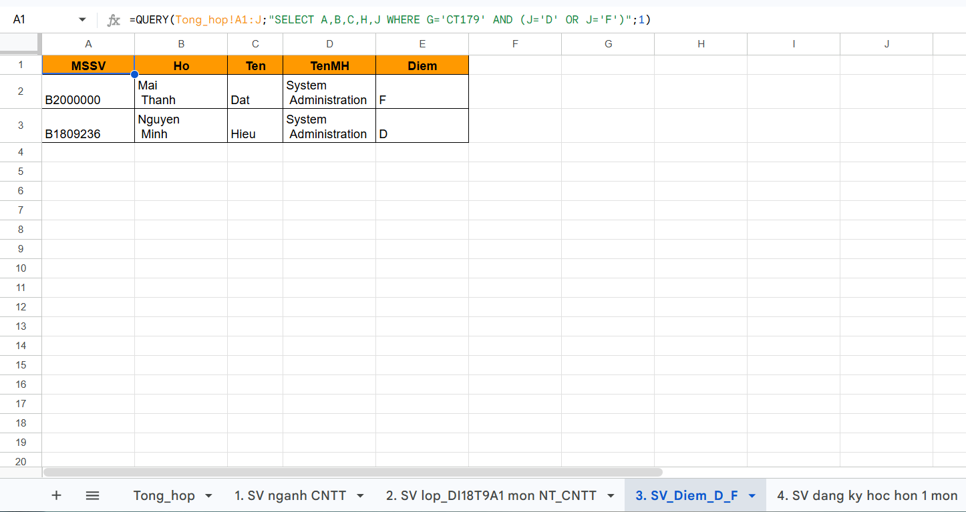

BẢNG SV ĐĂNG KÍ HƠN 1 MÔN
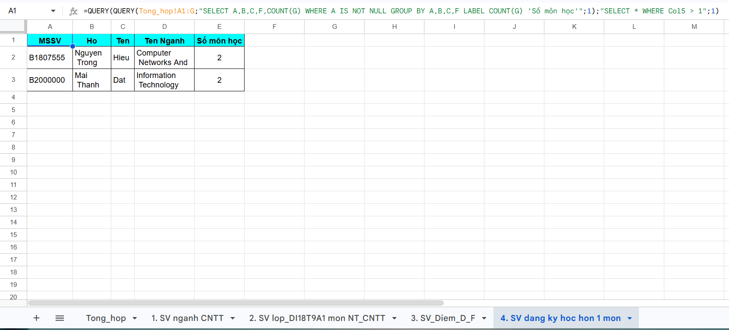

Microsoft Powerpoint

Định dạng cho Slide Master 1

SLIDE MASTER

Office Theme Slide master

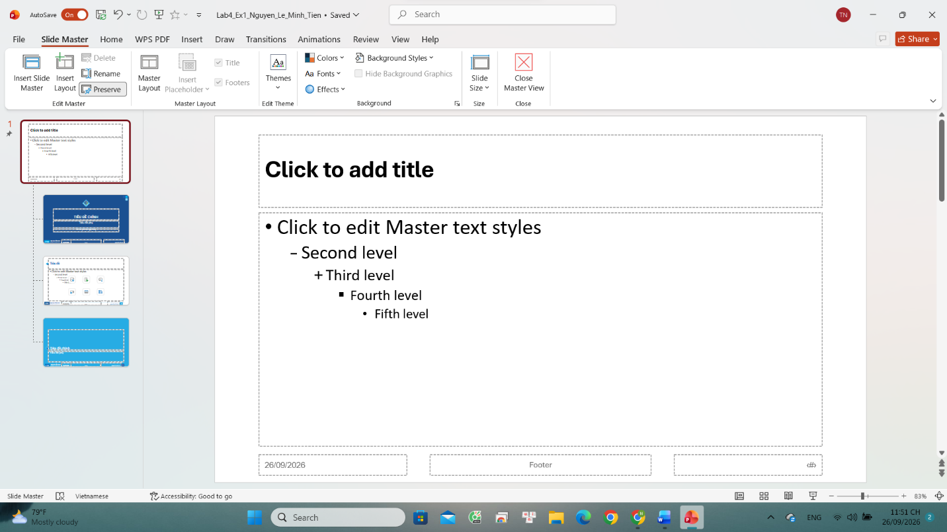

Title Slide Layout
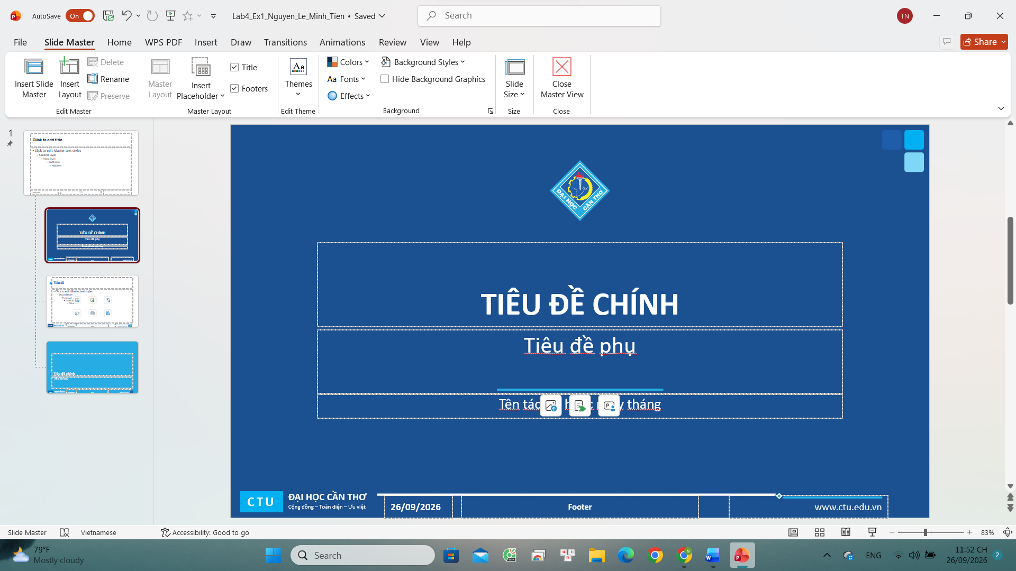

Title and Content Layout
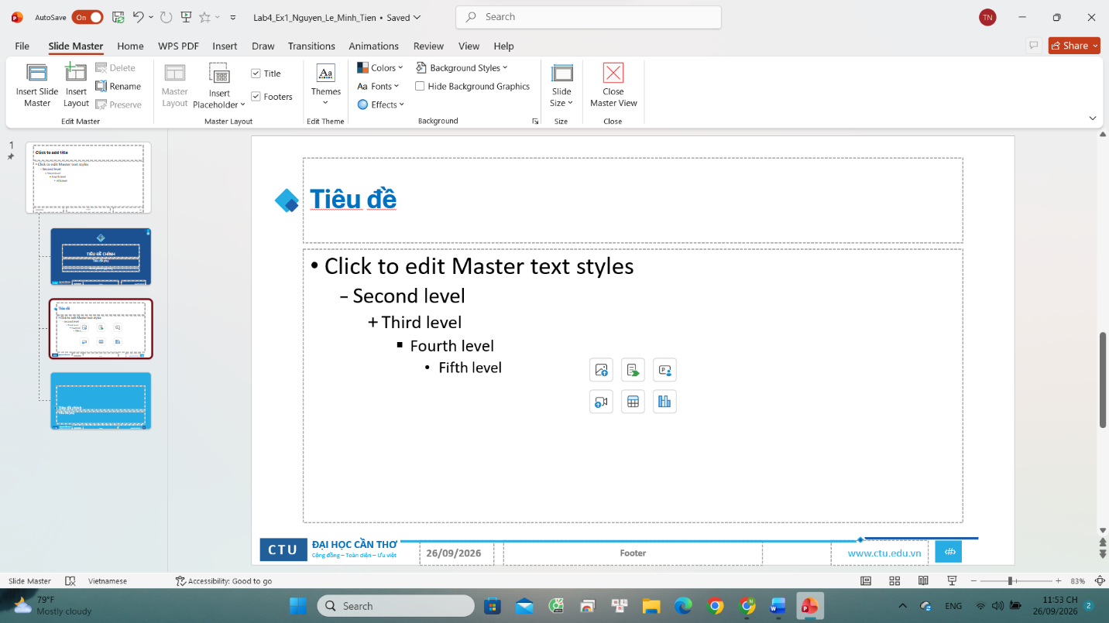

Title Only Layout
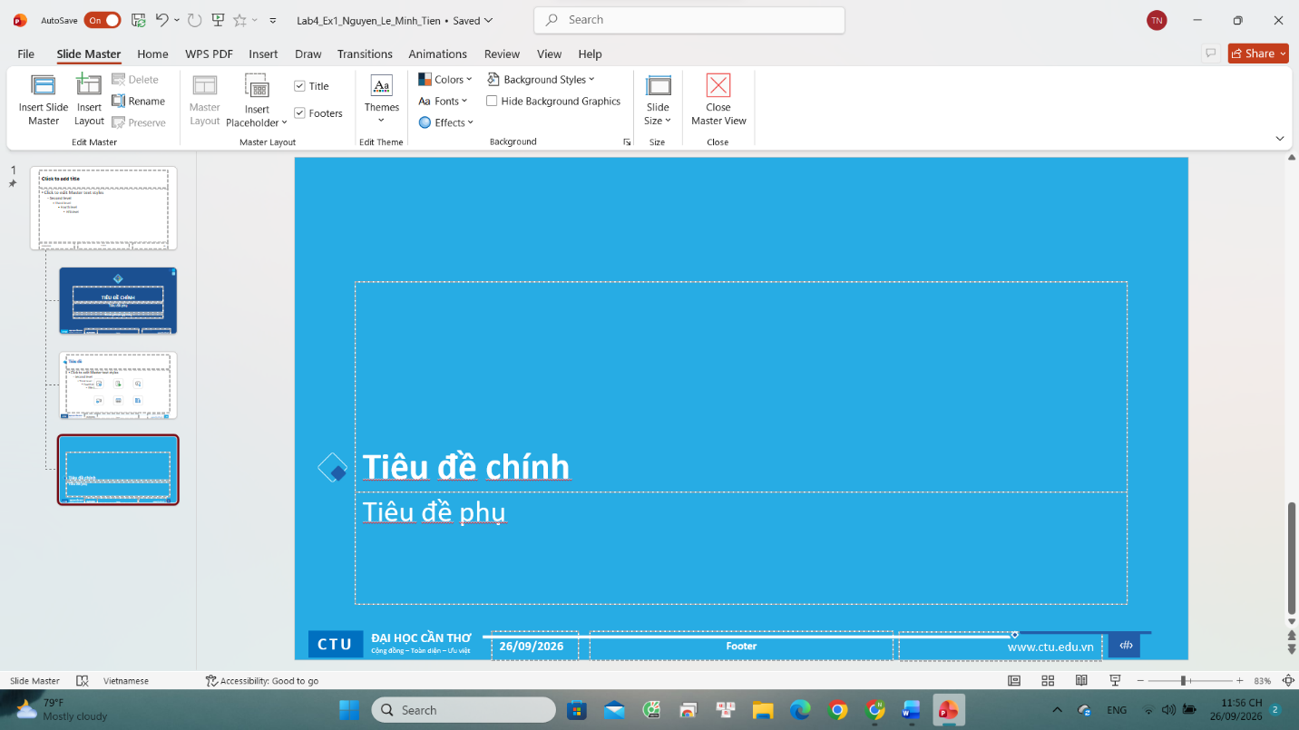

TẠO CÁC SLIDE
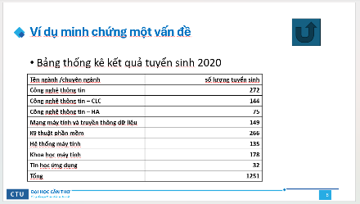
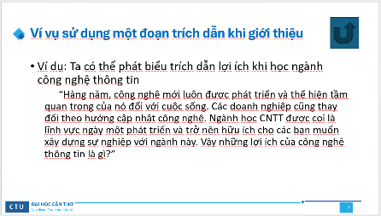
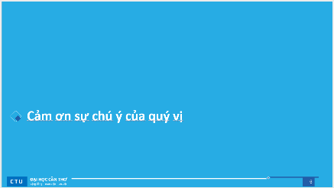
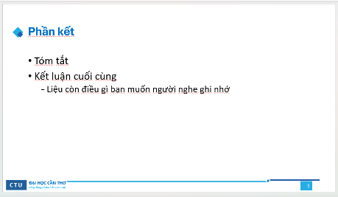
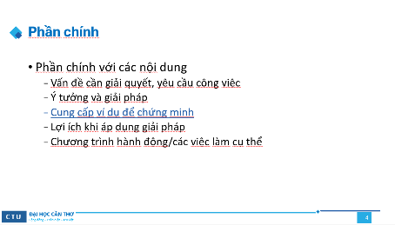
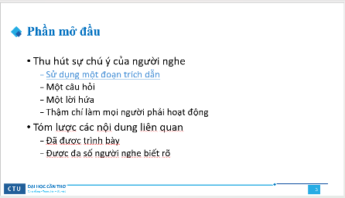
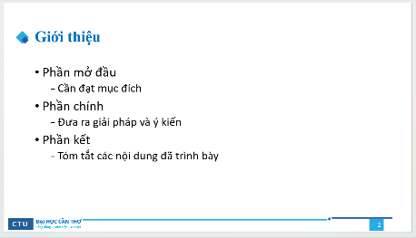
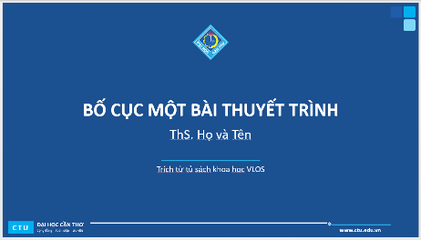

Định dạng cho Slide Master 1

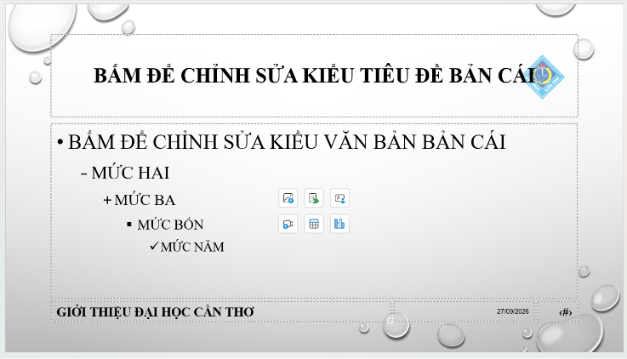
Office Theme Slide master


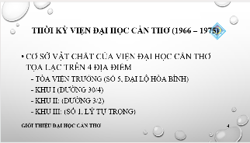

TẠO CÁC SLIDE
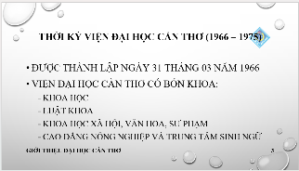
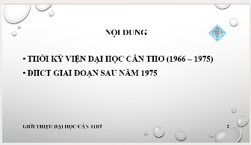

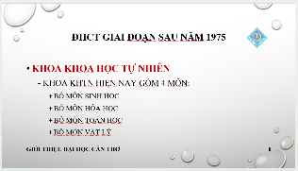
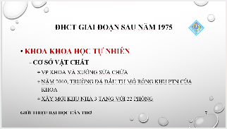
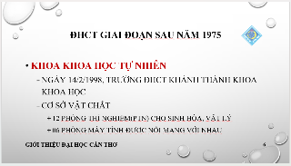
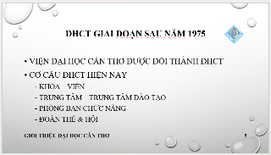

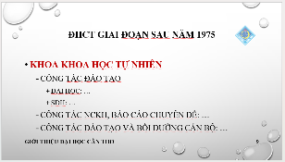
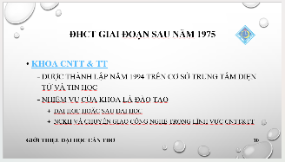
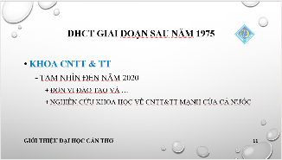
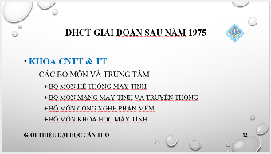
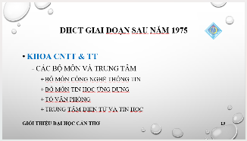
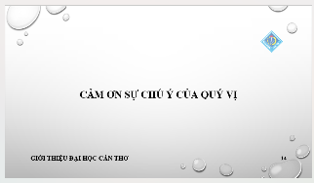

TẠO QUẢN LÝ VÀ CHIA SẺ NỘI DUNG SỐ

HỢP TÁC NHÓM TRÊN GOOGLE DOCS
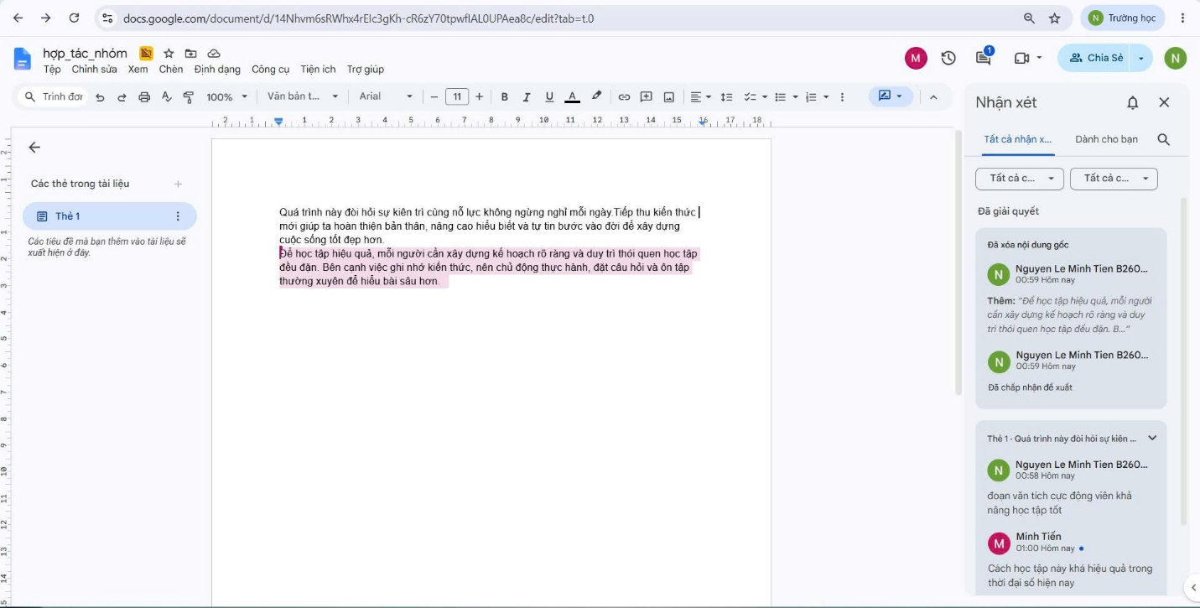

QUẢN LÝ MÃ NGUỒN GITHUB
LINK: CT005_B2605310_Lab05

