|  |  |
| --- | --- |
|  | **FPT ACADEMY INTERNATIONAL**  **FPT – APTECH COMPUTER EDUCATION** |

**Centre Name: ACE-THUDUC-1-FPT.**

**Address: 590 Cach Mang Thang 8, District 3, Ho Chi Minh City, Viet Nam.**

**Eyeonic**

|  |  |  |
| --- | --- | --- |
| **Supervisor.** | Mr. Nguyen Phat Tai | |
| **Batch.** | T1.2306.M0 | |
| **Group.** | Group 3 | |
| **Serial No.** | **Enrollment Number** | **Student Name** |
| 1. | Student1477170 | Mai Duy Anh |
| 2. | Student1477475 | Dương Phú Khoa |
| 3. | Student1470283 | Trần Cao Nguyên |
| 4. | Student1477228 | Phan Phước Vũ |

September-2023

**This is to certify that**

**Mr./Ms.:**

Mai Duy Anh

Tran Cao Nguyen

Duong Phu Khoa

Phan Phuoc Vu

**has successfully designed & developed**

eProject: Eyeoic

**Submitted by: Mai Duy Anh**

**Date of issue: 16-Oct-2023**

**Authorized Signature: Anh**

**TABLE OF CONTENTS**

FPT – APTECH COMPUTER EDUCATION 1

ACKNOWLEGMENT 3

SYNOSIS 3

PROBLEM DEFINITION 3

CUSTOMER'S REQUIREMENTS SPECIFICATIONS (CRS) 4

**Business/Project Objective: 4**

**Hardware/ Software Requirements: 5**

SCOPE OF THE WORK (IN BRIEF) 6

Architecture and design of the system 7

Diagram of the website 8

TASK SHEET REVIEW 1 9

***MOCK OF WEBSITE…………………………………………………………………………………………………………………….……………9***

***1.HOMEPAGE………………………………………………………………………………………………………….…………….……..………...11***

***2.CATEGORIES……………………………………………………………………………………………………………………..………………....12***

***3.BRANDS…………………………………………………………………………………………………………………………………………..……13***

***4.GALLERY………………………………………………………………………………………………………………………………………..……..14***

***5.FEEDBACK………………………………………………………………………………………………...............................................15***

***6.CONTACTUS……………………………………………………………………………………………………………………………….…………15***

***7.ABOUTUS………………………………………………………………………………………………………………………………………….....16***

**TASK SHEET REVIEW 2** 17

**1.** **HOMEPAGE** 18

2**.** **BRAND** 19

3**.** **GALLEYRIES** 20

**5. CONTACT** **21**

**6. PRODUCT DETAIL** **22**

**T****ASK SHEET REVIEW 3** 23

**Problem Statement**

Eyeonic is selling various types of Lenses and Frames. Company has a large collection of Frames and lenses. The company advertises by distributing the pamphlets, advertising on television and so on. Due to rapid development in internet field, the company decides to launch a website where people will get all the information about the various products available with them easily.

You are supposed to create a website for them with the below mentioned requirement specifications.

The website is to be developed for the Windows Platform using HTML5, JavaScript and Geolocation. The site should work well in all leading browsers including Chrome, IE, Firefox etc.

**Requirement Specification:**

The Web site is to be created based on the following requirements.

1. Home Page should contain logo of the site with proper sections and details of Frames and Lenses with suitable images.
2. The site should display a menu which will contain the options for brief introduction about the various frames and lenses available, location of the shop and any other information if required.
3. The information should be categorized according to the brand names of the products like if a User wants to see only “Ray-Ban” products or any other companies products then he/she can click on a Link/button/menu etc and can see only that Brand products.
4. Another category option for “Contact Lenses”, “SunGlasses” etc. should be created and accordingly the products should be listed.
5. When a user selects any particular brand, a list of products for that brand will be displayed
6. A brief summary of features of individual products should be displayed on the Web Page along with the product but detailed Features should be stored in Individual Word documents which can be downloaded or viewed by the User who wishes to see the same.
7. The user should also be able to compare the various products of different as well as similar brands.
8. There should be a “Contact Us” page which will have the Address of the Company which is as follows and the mail address which when clicked will invoke the local mail client from where they can send an email. Address of the Company should be displayed using GeoLocation API (eg. GoogleMaps).

# 

# CUSTOMER'S REQUIREMENTS SPECIFICATIONS (CRS)

**Client: Eyeonic**

### Business/Project Objective:

* The menu options should change color on hover and also after clicking.
* Fade in and fade out options can be used for the menus

**Input to the system:**

* + - * Browsing products based on brands, type of glasses products.

**Output from the system:**

* A menu that will categorize all the functions of the site.
* Display the list of available albums category wisely.
* Perform the search based on a particular: brands, type of glasses products.
* Site should be able to provide brief introduction/history about the company under About Us page.
* The location of the company under Contact-Us page.
* Besides the above requirements, the site should have look and feel as per the industry standards.

**Expected delivery date:** 16-Oct-2023.

**List of deliverables:**

* + - * Document Word.
      * User Guide.
      * Source code.
      * Video clip.

### Hardware/ Software Requirements:

* **For developer**

**Hardware**

* Intel Core i3/i5 Processor or higher
* 8 GB RAM or above
* Color SVGA
* 500 GB Hard Disk space
* Mouse
* Keyboard

**Software**

Technologies to be used:

* Frontend: HTML5, CSS3, Bootstrap, JavaScript, jQuery, React JS, JSON
* Data Store: JSON files or TXT files .

Other Requirements:

* Operating Portal: Windows
* Browsers: Edge, Chrome, Mozilla Firefox, Safari

# SCOPE OF THE WORK (IN BRIEF)

After a long and detailed discussion, our group has decided to create a website contain the following webpages:

1. ***Homepage***: Display information about newest-selling products, an introduction about insurance products.
2. ***Brands***: Display all models of brands based on category (Ray-ban, Okley, Porsche Design, Burberry, etc.).
3. ***Type of galasses Products***: Sunglasses, Frames, Lenses,..
4. ***About Us***: Display the information of the company and about us.
5. ***Contact***: Display the address of the company, allow customers to request any information
6. ***Compare***: Providing a clear view to the customer for brief comparison of 2 products among those on sale

# Architecture and design of the system

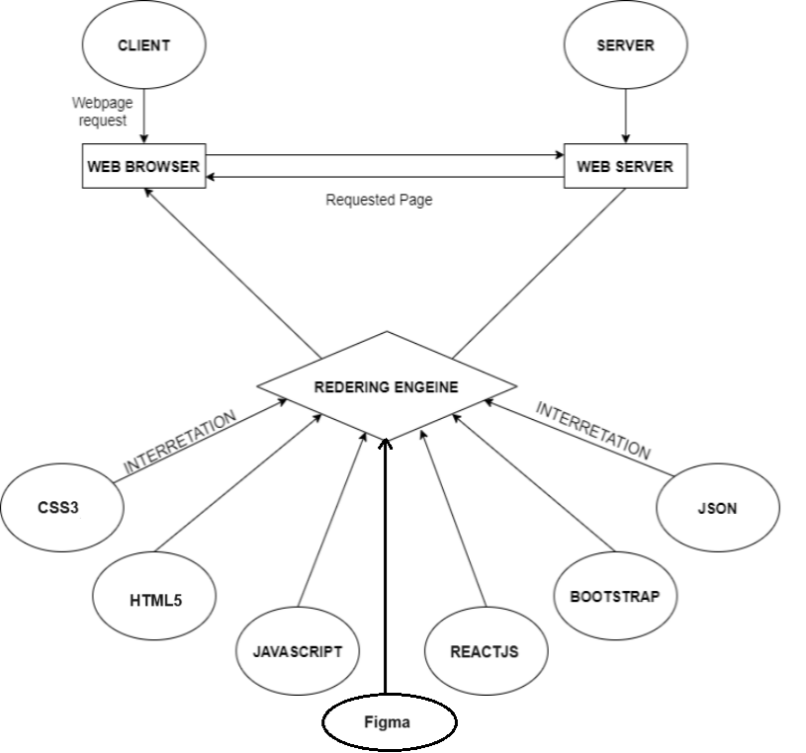

# Diagram of the website

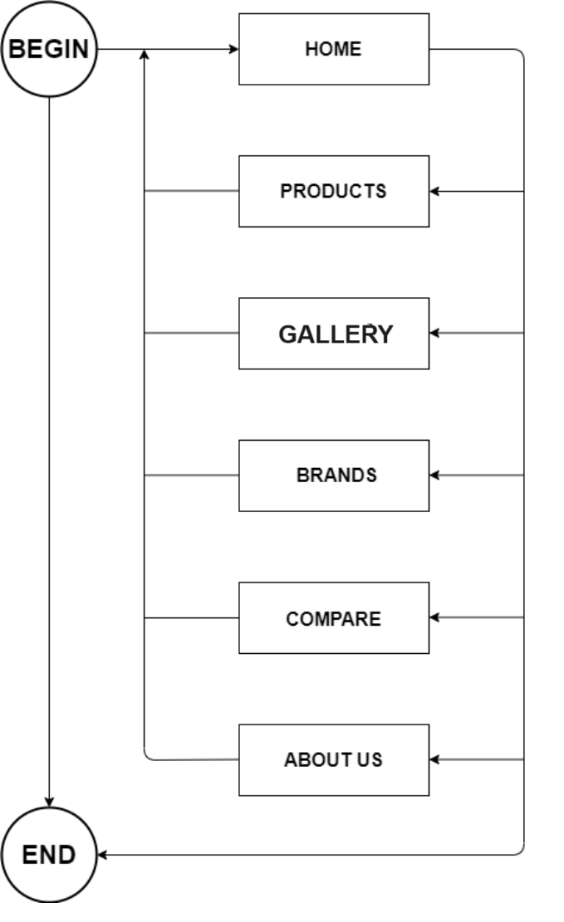

# TASK SHEET REVIEW 1

|  |  |  |  |  |  |  |  |
| --- | --- | --- | --- | --- | --- | --- | --- |
| **Project Ref. No.:**  **eP/Advertisement Portal Management**  **System/01** | | **Project Title:** | **Activity Plan Prepared By:** | **Date of Preparation of Activity Plan:** | | | |
| **Sr.**  **No.** | **Task** | **Actual**  **Start Date** | **Actual Days** | **Team**  **Mate Names** | **Status** |
| 1 | Problem Statement | Eyeonic | Anh | 15-Sep-2023 | 1 | Anh | Completed |
| 2 | Analysis of Glasses requirements about the website | 15-Sep-2023 | 1 | Anh | Completed |
| 3 | The scope of the work (in brief) | 15-Sep-2023 | 1 | Nguyen | Completed |
| 4 | Architecture and design of the system | 15-Sep-2023 | 1 | Nguyen | Completed |
| 5 | Diagram of the website | 15-Sep-2023 | 1 | Nguyen | Completed |
| 6 | Task Sheet | 15-Sep-2023 | 1 | Khoa | Completed |
| 7 | Mock of The Website |  |  | 15-Sep-2023 | 1 | Khoa | Completed |

|  |  |
| --- | --- |
| **Date: 22-Sep-2023** | |
| Signature of Instructor:  **Mr. Nguyen Phat Tai** | Signature of Team Leader:  **Mr. Mai Duy Anh** |

**SITE MAP**

**MOCK OF THE WEBSITE**

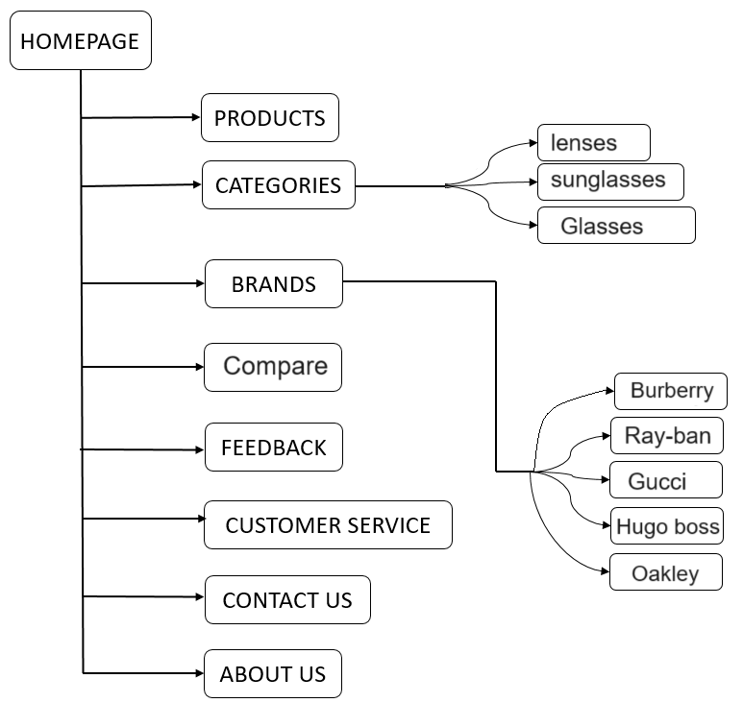

1. **HOMEPAGE**

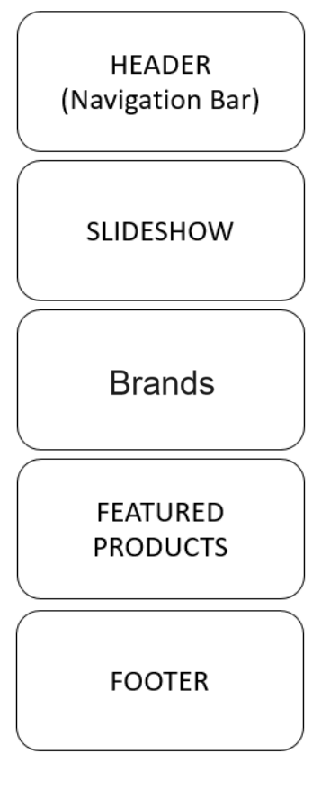

**2.CATEGORIES**

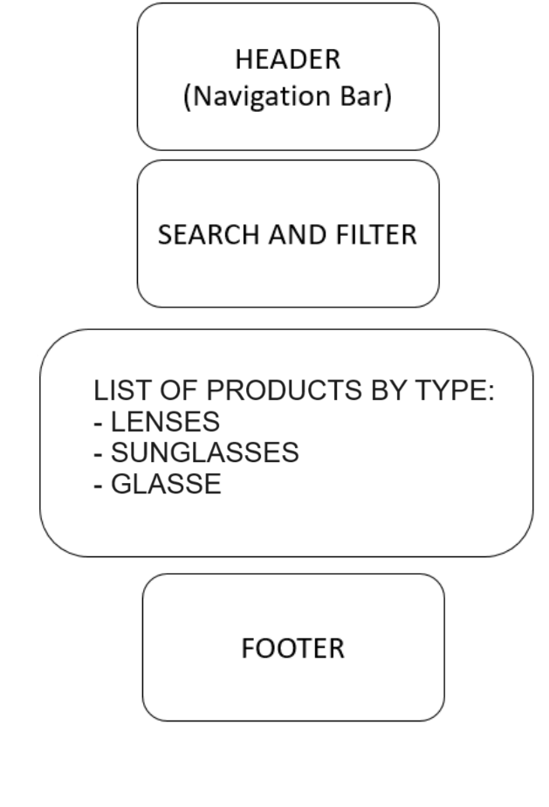

**3.BRANDS**

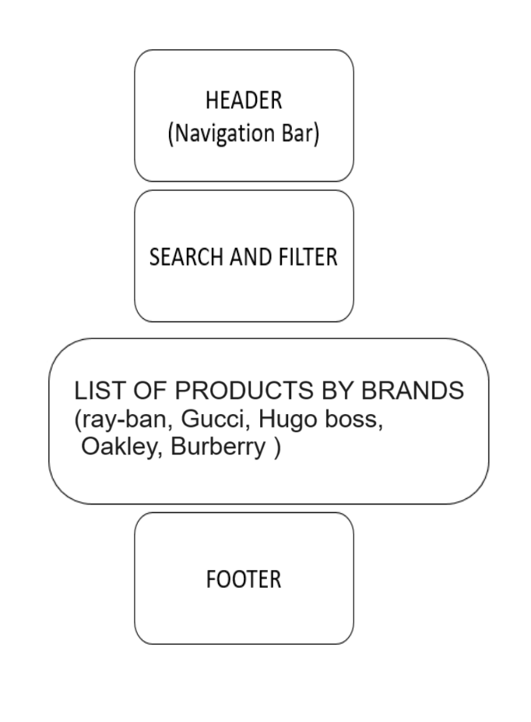

**4.GALLERY**

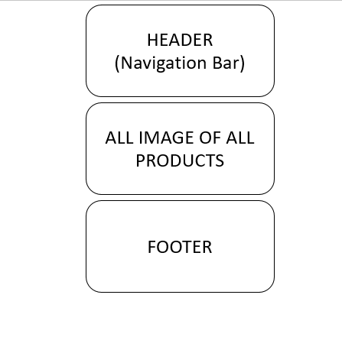

**5.FEEDBACK**

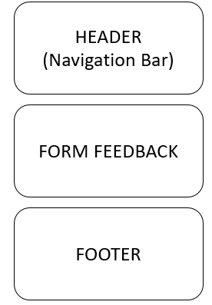

**6.CONTACT US**

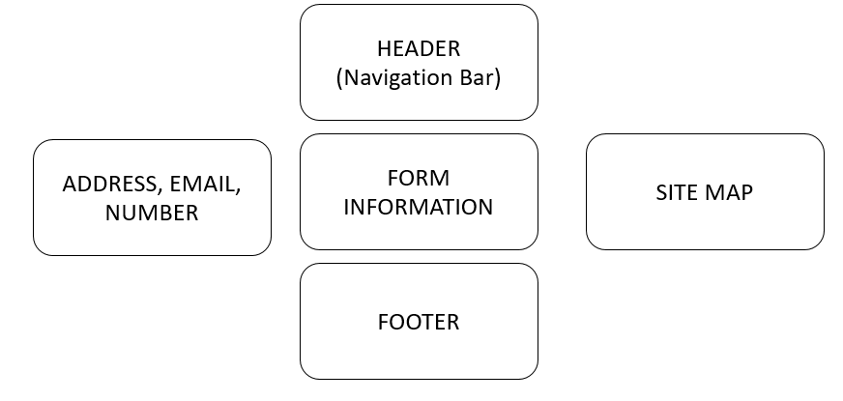

**7.ABOUT US**

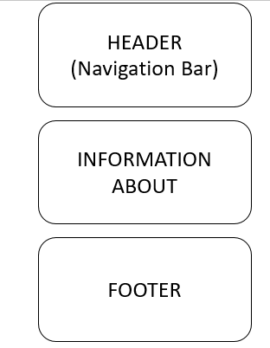

# TASK SHEET REVIEW 2

|  |  |  |  |  |  |  |  |
| --- | --- | --- | --- | --- | --- | --- | --- |
| **Project Ref. No.:**  **eP/Advertisement**  **Portal Management System/01** | | **Project Title:** | **Activity Plan Prepared By:** | **Date of Preparation of Activity Plan:** | | | |
| **Sr.**  **No.** | **Task** | **Actual**  **Start Date** | **Actual Days** | **Team**  **Mate Names** | **Status** |
| 1 | Site map | **Eyeonic** | DuyAnh | 29-Sep-2023 | 1 | DuyAnh | Completed |
| 2 | Mock of the website | 29-Sep-2023 | 1 | Nguyên | Completed |
| 3 | Task Sheet | 29-Sep-2023 | 1 | Khoa | Completed |

|  |  |
| --- | --- |
| **Date: 29/09/2023** | |
| Signature of Instructor:  **Mr. Nguyen Phat Tai** | Signature of Team Leader:  **Ms. Mai Duy Anh** |

# WEBSITE DESCRIPTION

1. **Homepage**

The homepage contains the following information:

* + - * The name and navigation menu of the website.
      * The search bar.

The slideshows of the website gallery

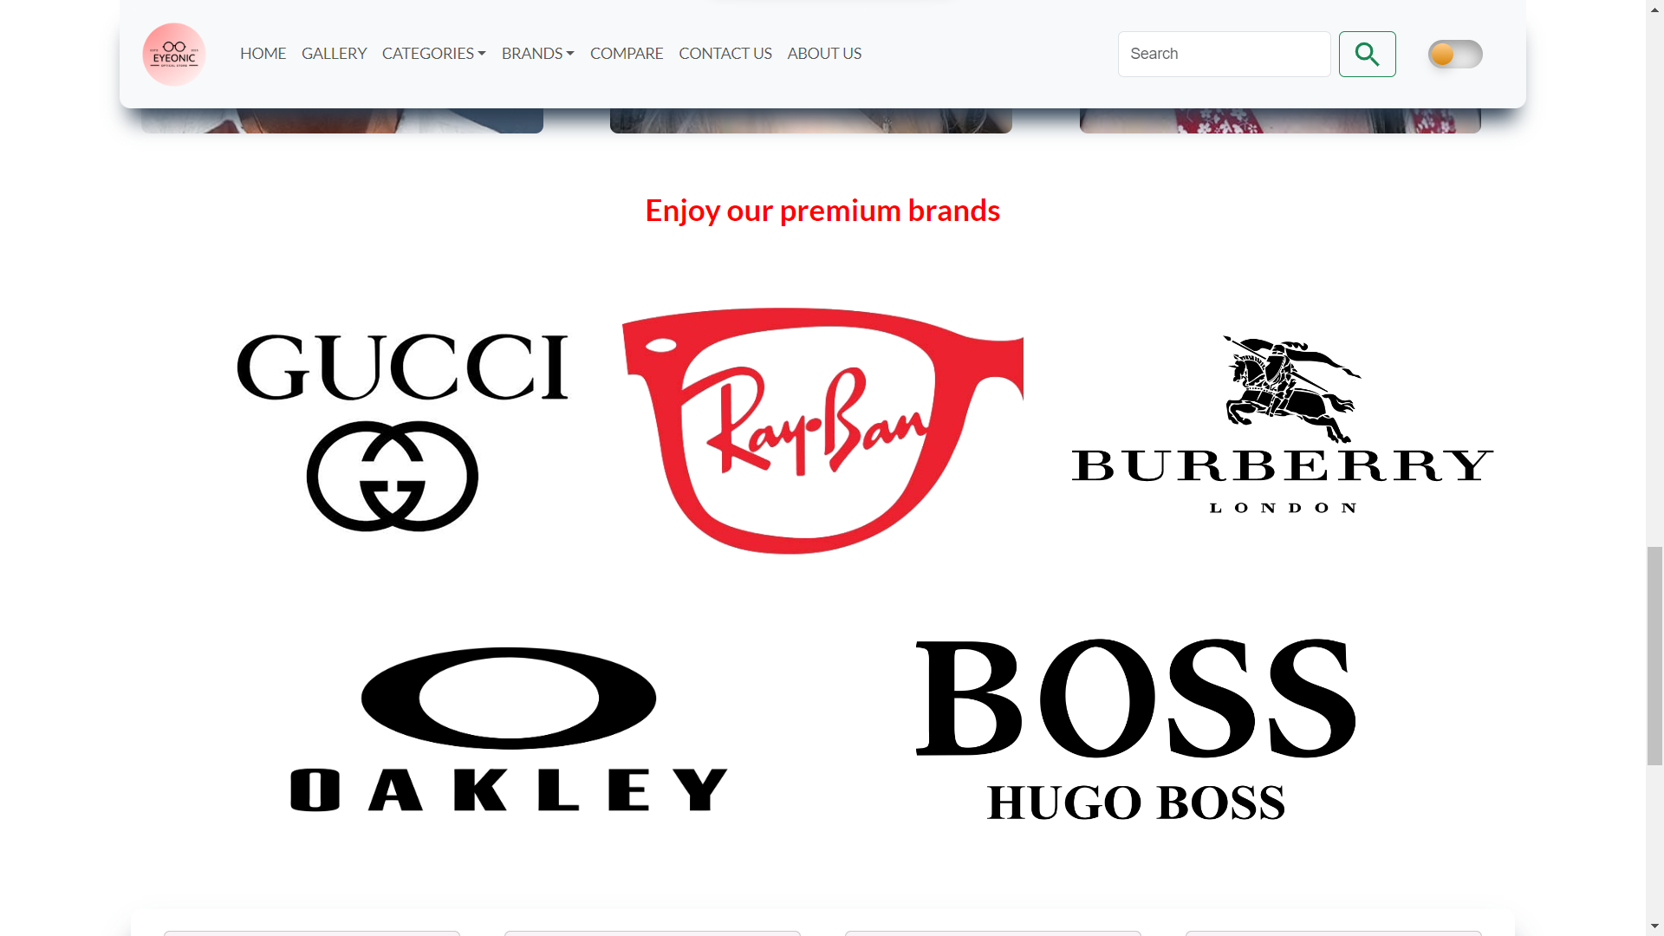

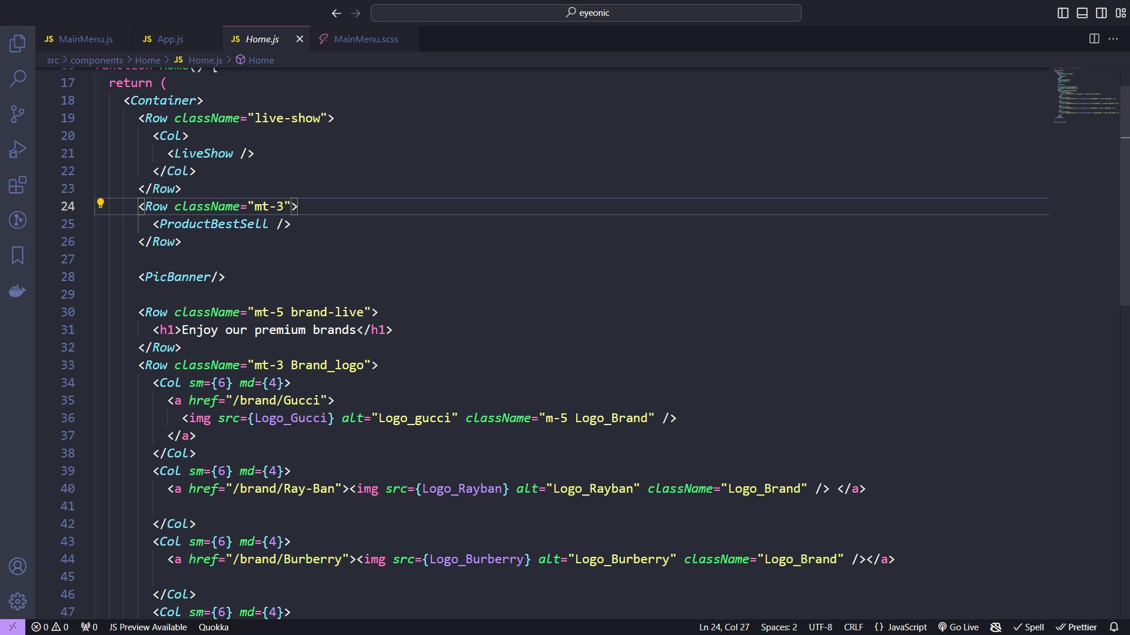

1. **Brand**

A place for customers to easily choose their favorite brands.Compare prices between products

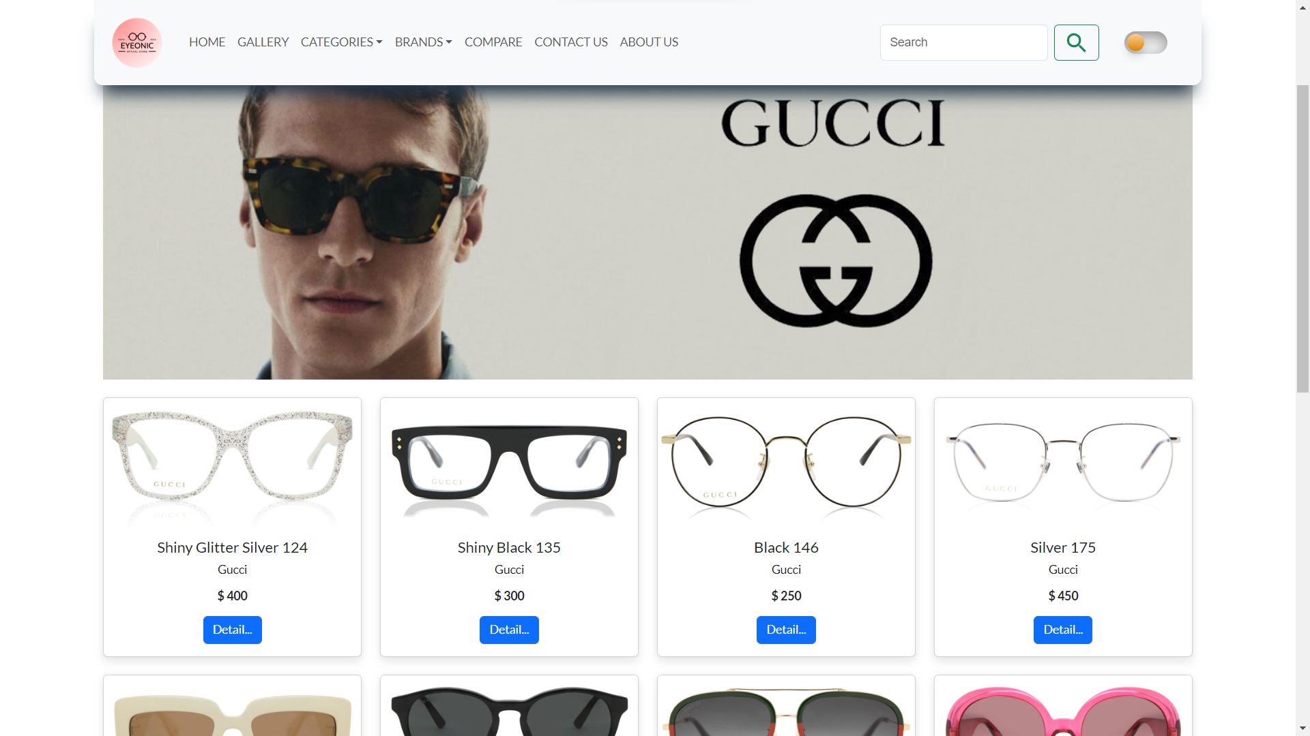

Brand code  
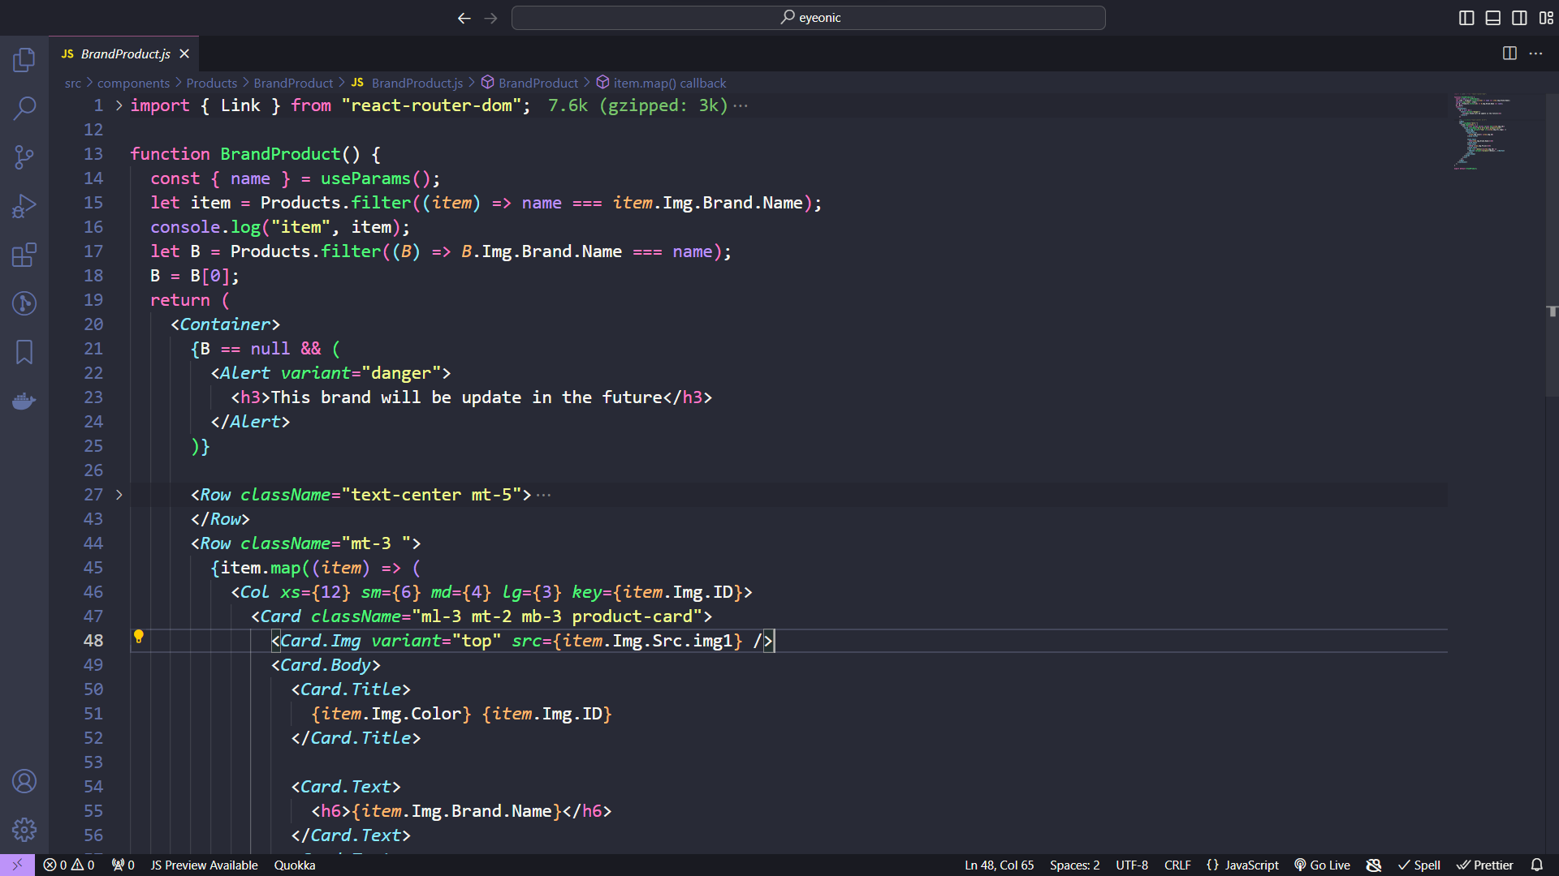

1. **Galleries**

A glasses store's "Galleries" typically refer to dedicated sections or areas within the store where they showcase different styles and brands of eyeglasses or sunglasses. These Galleries are designed to help customers easily browse and select their preferred eyewear. Each Gallery may focus on a specific category, such as designer frames, prescription lenses, or trendy sunglasses, offering a diverse range of options to cater to various customer preferences and needs.

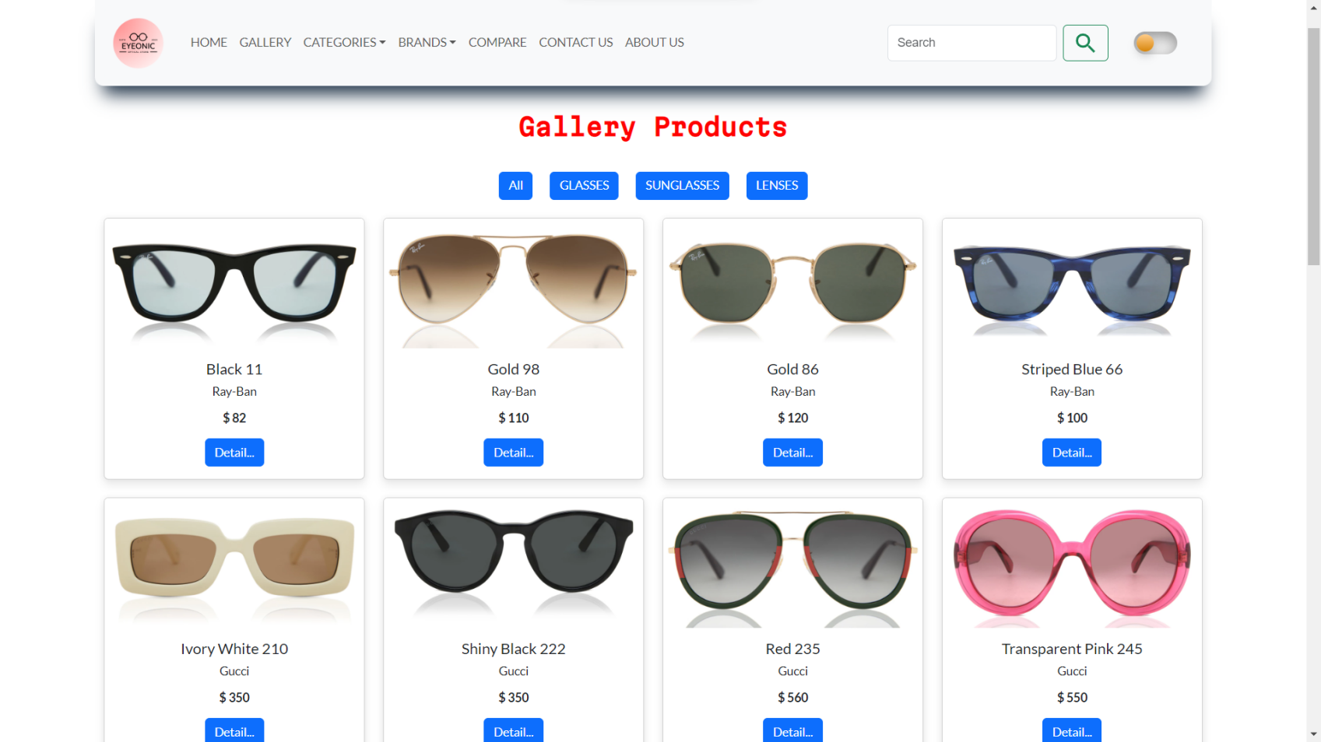

1. **Contact**

The contact us shows the information to contact to the owner of the website. Furthermore, the visitors can also directly contact the admin by submitting the form through the website.

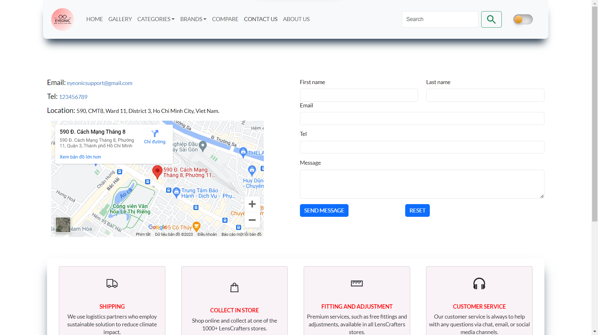Code contact

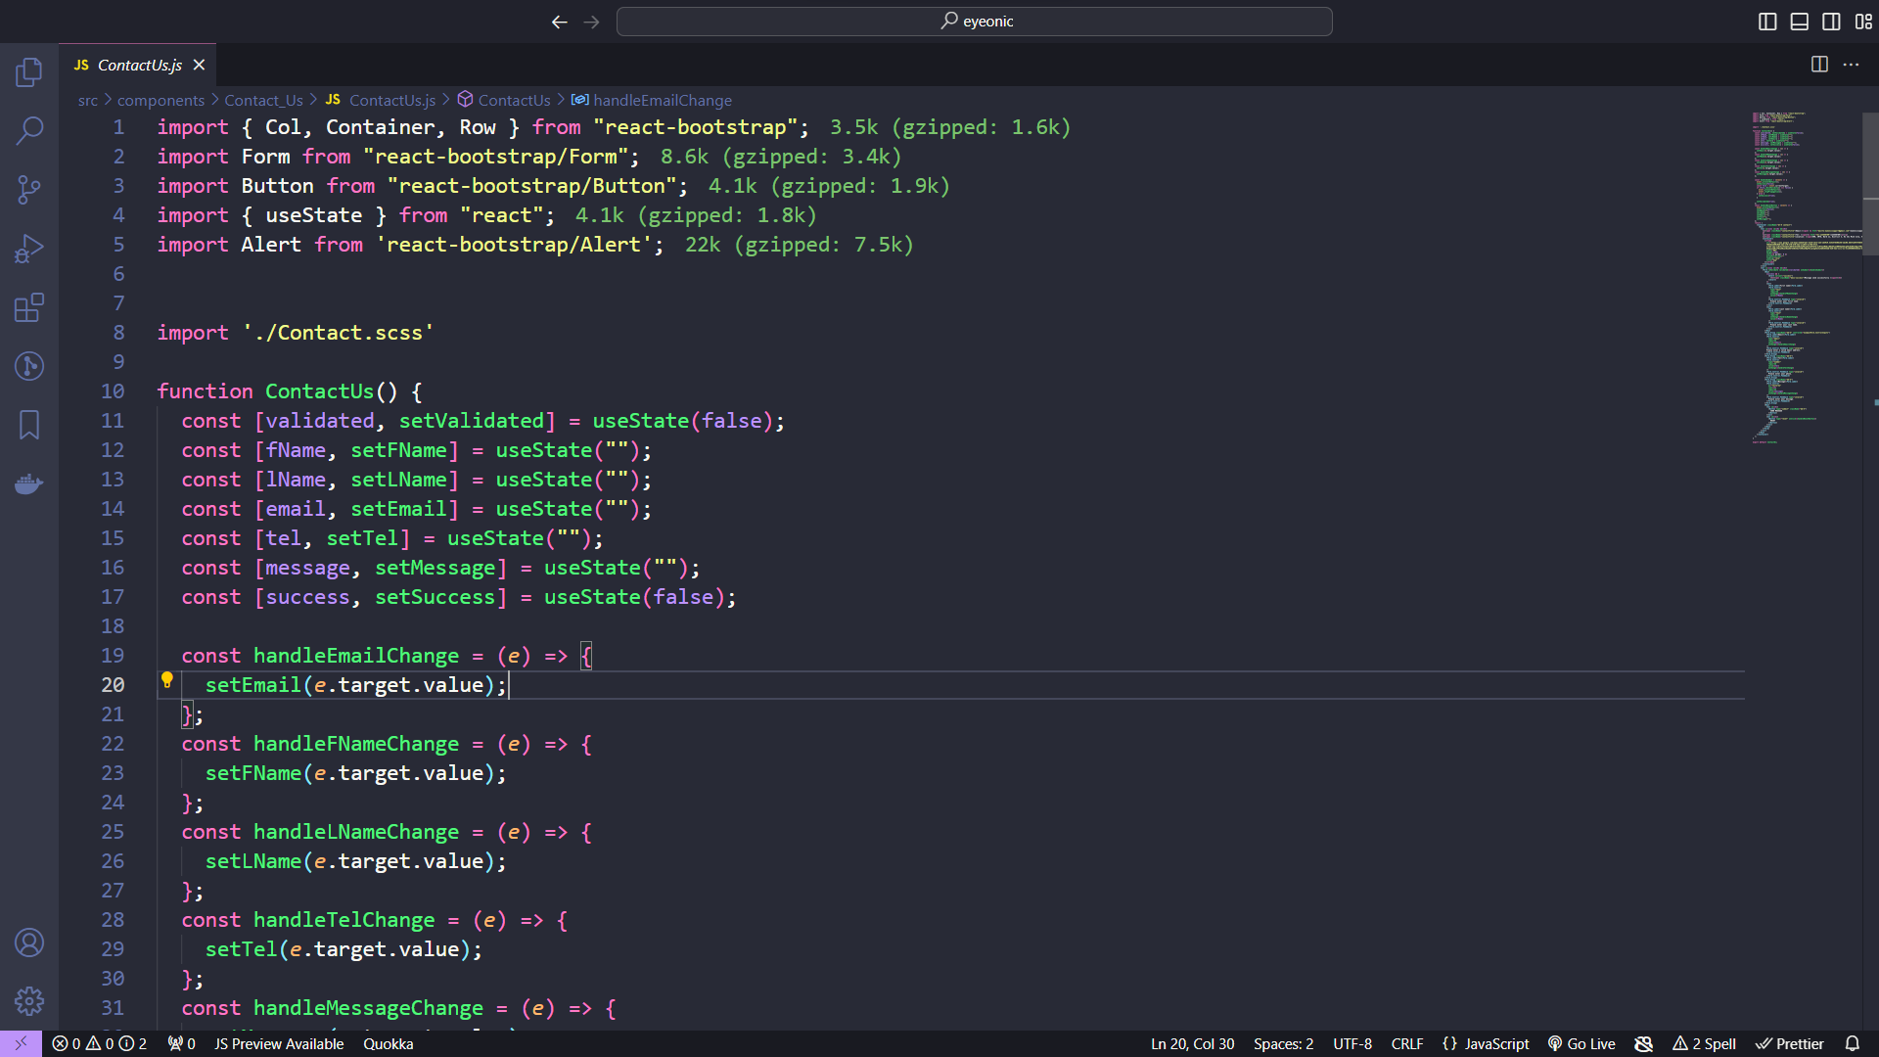

1. **Product detatail**

Product details at an eyeglass store typically provide comprehensive information about each eyewear item, helping customers make informed choices.

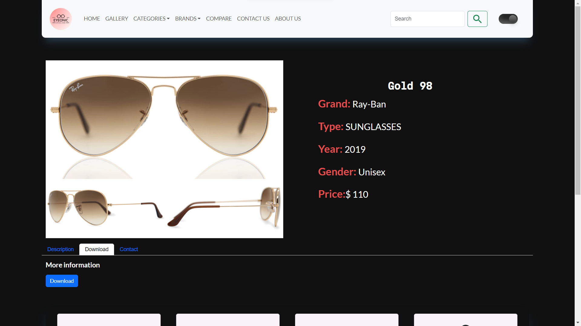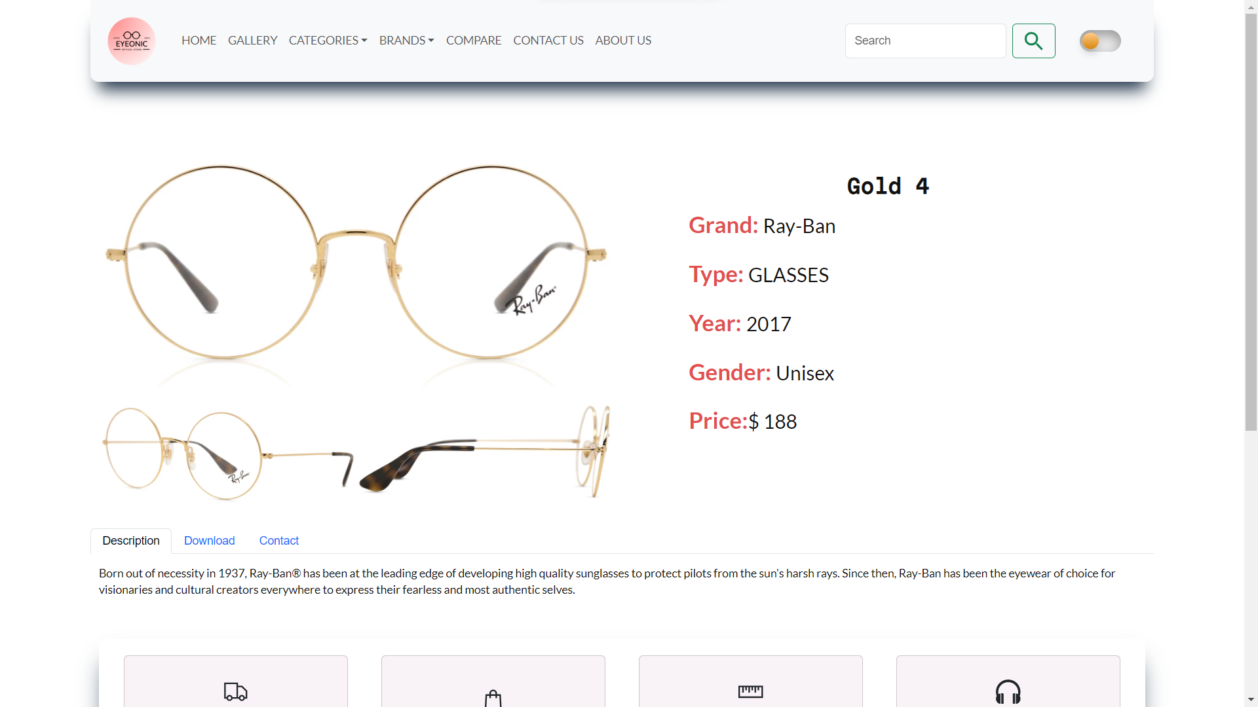

# TASK SHEET REVIEW 3

|  |  |  |  |  |  |  |  |
| --- | --- | --- | --- | --- | --- | --- | --- |
| **Project Ref. No.:**  **eP/Advertisement**  **Portal Management System/01** | | **Project Title:** | **Activity Plan Prepared By:** | **Date of Preparation of Activity Plan:** | | | |
| **Sr.**  **No.** | **Task** | **Actual**  **Start Date** | **Actual Days** | **Team**  **Mate Names** | **Status** |
| 1 | Home page | eyeonic | DuyAnh | 05-Oct-2023 | 1 | Anh,Nguyen,Khoa | Completed |
| 2 | Categories | 05-Oct-2023 | 1 | Nguyen | Completed |
| 3 | Galleries | 05-Oct-2023 | 1 | Nguyen | Completed |
| 4 | ProductsPage | 05-Oct-2023 | 1 | Anh | Completed |
| 5 | Contact us | 05-Oct-2023 | 1 | Nguyen | Completed |
| 6 | About us | 05-Oct-2023 | 1 | Khoa | Completed |
| 7 | json | 05-Oct-2023 | 1 | Nguyen | Completed |
| 8 | Task sheet | 05-Oct-2023 | 1 | Anh | Completed |

|  |  |
| --- | --- |
| Date: **05/10/2023** | |
| Signature of Instructor:  **Mr. Nguyen Phat Tai** | Signature of Team Leader:  **Mr. MaiDuyAnh** |