Yêu cầu 1:

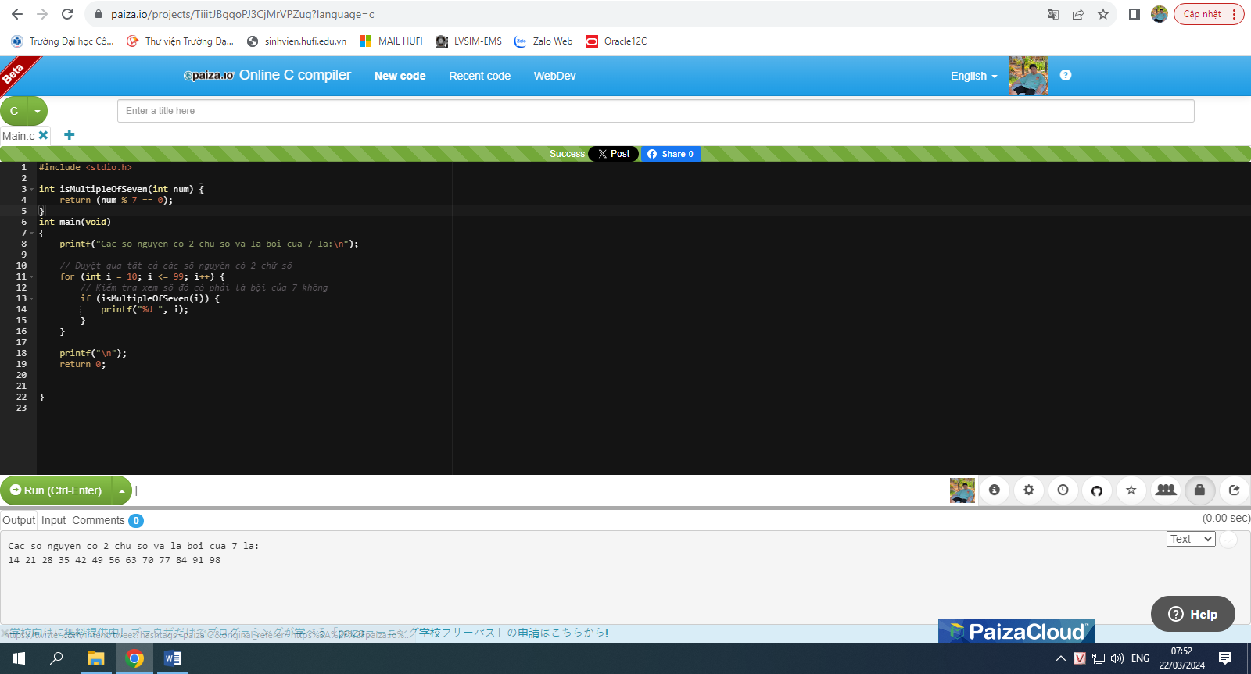

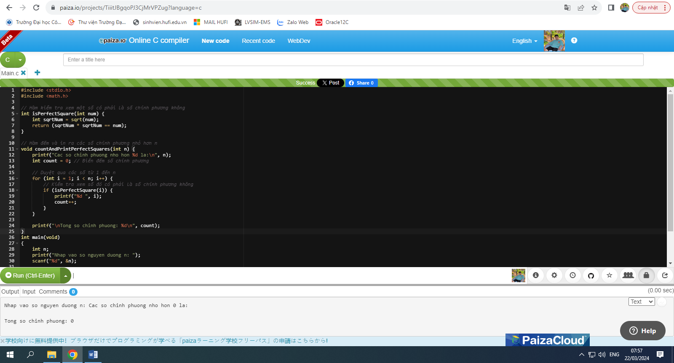

Yêu cầu 2:

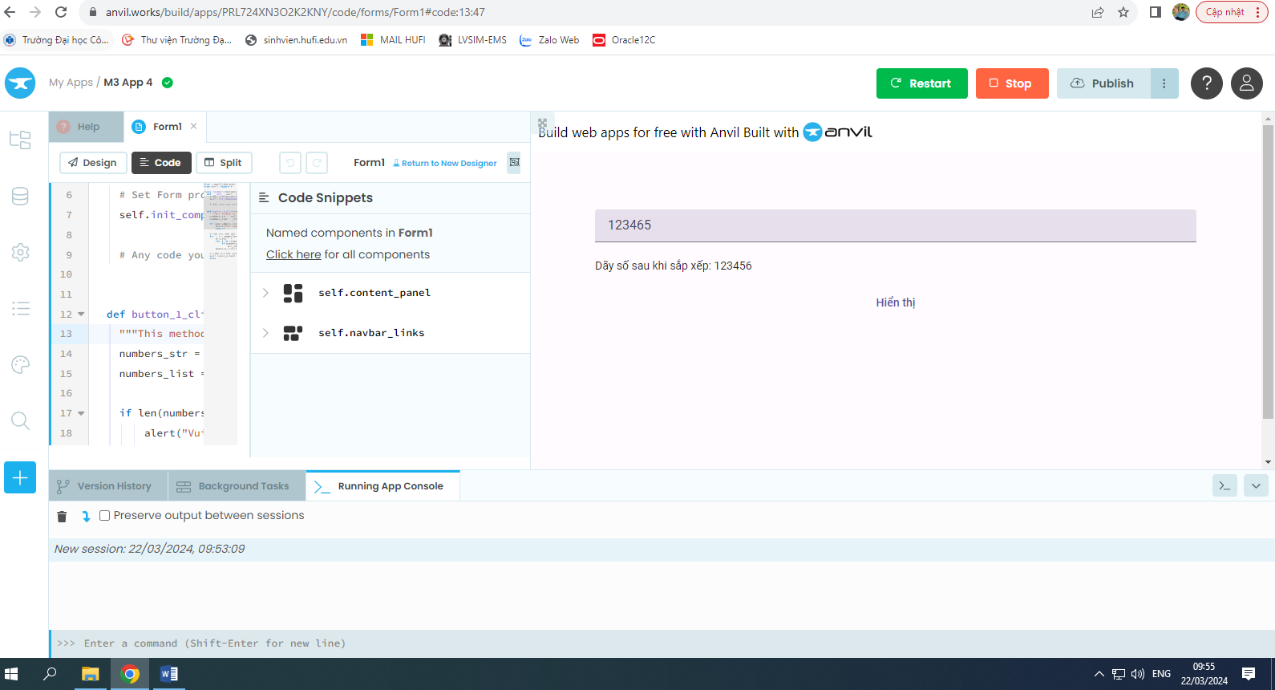

Link: <https://nguyenanhthai.anvil.app>

Yêu cầu 3:

Link: <https://github.com/NguyenAnhThai35789/2001200103_NguyenAnhThai>