- Do all requires that based on the variable as below
var people = [
{name: 'Jack', age: 50},
{name: 'Michael', age: 9},
{name: 'John', age: 40},
{name: 'Ann', age: 19},
{name: 'Elisabeth', age: 16}
]
Find the first person off the people array is teenager (age >=10 and age <=20)
Find the all person of the people array is teenager (age >=10 and age <=20)
Check if every person of the people array is teenager (age >=10 and age <=20), which should return true or false
Checks if any person of the people array is teenager (age >=10 and age <=20), which should return true or false.
- Do all requires that based on the variable as below
var array = [1, 2, 3, 4]
Applies a function passed as the first parameter against an accumulator and each element in the array (from left to right), thus reducing it to a single value. The initial value of the accumulator should be provided as the second parameter of the reduce function.
Implementation of very simple functions (like the aforementioned sum or product) requires writing a lot of boilerplate. Is there any remedy for that? just try arrow functions!
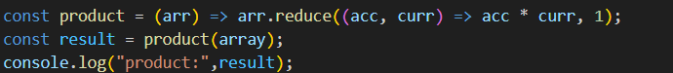
- Do all requires that based on three variables as below
const companies = [
{ name: "Company One", category: "Finance", start: 1981, end: 2004 },
{ name: "Company Two", category: "Retail", start: 1992, end: 2008 },
{ name: "Company Three", category: "Auto", start: 1999, end: 2007 },
{ name: "Company Four", category: "Retail", start: 1989, end: 2010 },
{ name: "Company Five", category: "Technology", start: 2009, end: 2014 },
{ name: "Company Six", category: "Finance", start: 1987, end: 2010 },
{ name: "Company Seven", category: "Auto", start: 1986, end: 1996 },
{ name: "Company Eight", category: "Technology", start: 2011, end: 2016 },
{ name: "Company Nine", category: "Retail", start: 1981, end: 1989 }
];

const ages = [33, 12, 20, 16, 5, 54, 21, 44, 61, 13, 15, 45, 25, 64, 32];

const person = {
name: "Costas",
address: {
street: "Lalaland 12"
}
};
Print the name of each company using forEach
Print the name of each company that started after 1987
Get only the companies that have category Retail, increment their start by 1 and append in the DOM a div that has the name, the category, the start and the end in paragraphs elements
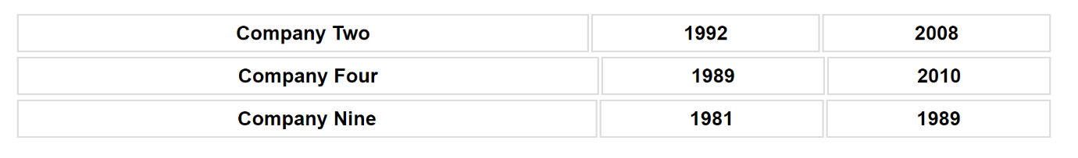
Sort the companies based on their end date in ascending order
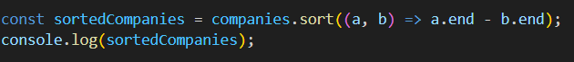
Sort the ages array in descending order
Print the sum if you add all the ages using reduce
Make a new object that has the properties of name and category same as the companies [0] and a method print that prints out the name, use object restructuring and ES6 JS
Create a function that takes an unknown number of arguments that are numbers and return their sum;
Make a function that takes an unknown number of arguments of any type and adds them in an array and returns the array, if the argument is an array, it should add its values to the array that will be returned by the function
Destructuring the property street in a variable named street from the object person
Write a function that every time you call it, it returns a number that increments starting from 0
Create a function that destructors the query parameters of a URL and adds them in an object as key value pairs and then returns the object
- Create classes as image below
