Exercise 16: Demo about Event Handling
Objectives and Outcomes
This exercise is a demo that showcases event handling in React
Exercises
Create a functional component called EventHandlingDemo. Inside the component, we use the useState hook to initialize and manage a count state variable.
Define a function called handleButtonClick that increments the count state when the button is clicked. This function is called in the onClick event handler of the button.
import React, { useState } from 'react';

const EventHandlingDemo = () => {
const [count, setCount] = useState(0);

const handleButtonClick = () => {
setCount(count + 1);
};

return (
<div>
<h1>Event Handling Demo</h1>
<p>Count: {count}</p>
<button onClick={handleButtonClick}>Increase Count</button>
</div>
);
};

export default EventHandlingDemo;
The return statement renders a simple UI that displays the current count and a button. When the button is clicked, the handleButtonClick function is called, updating the count and triggering a re-render of the component.
import React from 'react';
import EventHandlingDemo from './EventHandlingDemo';

const App = () => {
return (
<div>
<EventHandlingDemo />
</div>
);
};

export default App;
Conclusion
This demo showcases a simple event handling scenario in React. You can extend and modify it to handle different events and perform various actions based on user interaction.
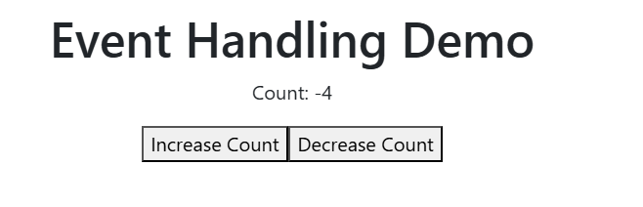
Exercise 17: Demo about Render and Commit
Objectives and Outcomes
In this exercise, through a simple demo that illustrates the concepts of rendering and committing in React.
Exercises
Create a new React component called RenderAndCommitDemo. This component will have a button that, when clicked, changes the state and triggers a re-rendering.
import React, {useState} from 'react';

const RenderAndCommitDemo = () => {
const [count, setCount] = useState(0);

const handleClick = () => {
setCount(count + 1);
};

return (
<div>
<h1>Render and Commit Demo</h1>
<p>Count: {count}</p>
<button onClick={handleClick}>Increment</button>
</div>
);
};
export default RenderAndCommitDemo;

Render the RenderAndCommitDemo component in the root of our application.
import React from 'react';
import './Component/RenderAndCommitDemo'
import RenderAndCommitDemo from './Component/RenderAndCommitDemo';
function App() {
return (
<React.StrictMode>
<RenderAndCommitDemo />
</React.StrictMode>

);
}

export default App;
Conclusion
In this demo, when the button is clicked and the state is updated, React triggers the reconciliation process. It compares the previous virtual DOM with the updated virtual DOM and determines that the count value has changed. React then applies the necessary changes to the actual DOM, updating the displayed count value on the screen.
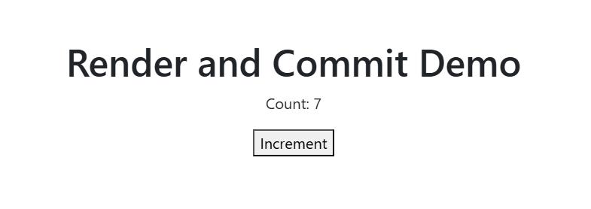Exercise 18: Demo about State as a Snapshot
Objectives and Outcomes
In this example, we'll create a simple counter component that allows you to take a snapshot of the current count value and restore it later.
Exercises
Create a new React component called SnapshotDemo
import React, {useState} from 'react';

const SnapshotDemo = () => {
const [count, setCount] = useState(0);
const [snapshot, setSnapshot] = useState(null);

const handleIncrement = () => {
setCount(count + 1);
};

const handleSnapshot = () => {
setSnapshot(count);
};

const handleRestore = () => {
if (snapshot !== null) {
setCount(snapshot);
}
};

return (
<div>
<h1>State as a Snapshot Demo</h1>
<p>Count: {count}</p>
<button onClick={handleIncrement}>Increment</button>
<button onClick={handleSnapshot}>Take Snapshot</button>
<button onClick={handleRestore}>Restore Snapshot</button>
</div>
);
};

export default SnapshotDemo;
In this component, we use the useState hook to create two state variables: count and snapshot. The count state represents the current count value, while the snapshot state holds the snapshot of the count value.
We have three event handlers:
handleIncrement: Increases the count value by 1 when the "Increment" button is clicked.
handleSnapshot: Takes a snapshot of the current count value and stores it in the snapshot state when the "Take Snapshot" button is clicked.
handleRestore: Restores the count value from the snapshot state when the "Restore Snapshot" button is clicked, but only if a snapshot is available.
The rendered JSX displays the count value, along with three buttons to increment the count, take a snapshot, and restore the snapshot.
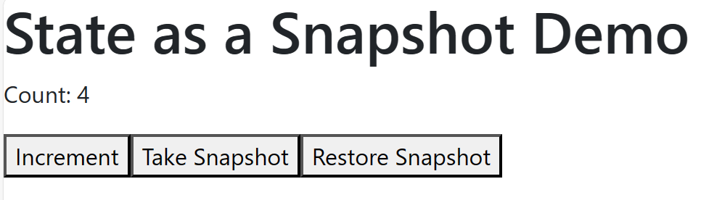
To use the SnapshotDemo component, render it in the root of your application:
import './App.css';
import React from 'react';
import './Component/SnapshotDemo';

function App() {
return (
<React.StrictMode>
<SnapshotDemo />
</React.StrictMode>
);
}

Conclusion
Using state as a snapshot allows you to save and restore specific states of your component. In this demo, we save the count value as a snapshot and restore it if a snapshot is available. This concept can be useful when you want to implement features like undo/redo functionality or save and restore user input in forms.
