| Software design |
| --- |
| Library system |
| Version 2.0 |
| Prepared by class SE1825, Group 2  Nguyễn Bá Khánh HE170920  Nguyễn Minh Hoàng HE181094  Nguyễn Xuân Tùng HE176893  Phan Bảo Hoàng HE170958  July 10, 2021 |

**Contents**

Revision history 4

1. Document description 5

2. SRS overview 5

2.1. List of system users 5

2.2. List of use cases 5

2.3. Use case diagram 5

2.3.1. Preliminary use case diagram 5

2.3.2. Use case detail diagrams 6

2.4. Activity diagrams of use case scenarios 7

2.4.1. Activity diagram for use case “Borrow Book” 7

2.4.2. Activity diagram for use case “Return Book” 8

2.4.1. Activity diagram for use case “Reserve Book” 8

3. Data model 9

3.1. Entity Relationship Diagram 9

3.2. Table details/Chi tiết các bảng 9

3.2.1. Table name: Borrower 9

3.2.2. Table name: Book 9

3.2.3. Table name: Copy 10

3.2.4. Table name: CirculatedCopy 10

3.2.5. Table name: Reservation 10

4. Class diagram (p.61 – p70) 11

4.1. List of classes in the Layers 11

4.2. Modeling the Class Behaviors - sequence diagrams ( p. 66, 77) 11

4.2.1. Sequence diagram for use case “Borrow Book” 11

4.2.2. Sequence diagram for use case “Return Book” 12

4.2.3. Sequence diagram for use case “Reserve Book” 13

5. User Interface Model Design (p. 70 – p.74) 13

5.1. User interface model design 13

5.2. Interface Flow Diagrams (p. 51) 13

# **Revision history**

| **Date** | **Authors** | **Modifications** | **Version** |
| --- | --- | --- | --- |
|  |  |  |  |
|  |  |  |  |
|  |  |  |  |
|  |  |  |  |
|  |  |  |  |

# **Document description**

This document describes OO solution version 1.0 for Library system. It is divided into the following sections:

* In the section 2 an overview of the Library system’s requirements will be provided, including list of system users, use cases, use case diagram, and activity diagrams that describes the most important use case scenarios.
* In the section 3 an E-R diagram and all tables of the Library system in detail will be presented.
* In the section 4 all classes organized in the layers and their behaviors (sequence diagrams) for the most important use cases will be presented.
* In the section 5 the most screen prototypes will be presented.

# **SRS overview**

## **2.1. List of system users**

1. Admin: The person is working in the Library room

2. Borrower: The person uses services of the Library system

## **2.2. List of use cases**

1. Login

2. Logout

3. View books

4. Request book

5. Return book

6. View record

7. Manage book

8. Manage category

9. Manage user

10. Search book

## **2.3. Use case diagram**

## 

## **2.4. Activity diagrams of use case scenarios**

### **2.4.1. Activity diagram for use case “Login”**

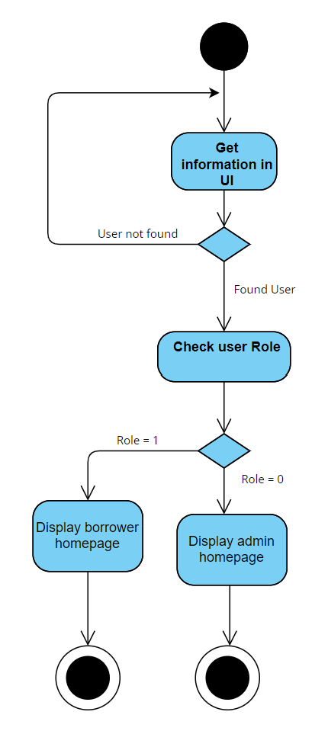

### **2.4.2. Activity diagram for use case “View Book”**

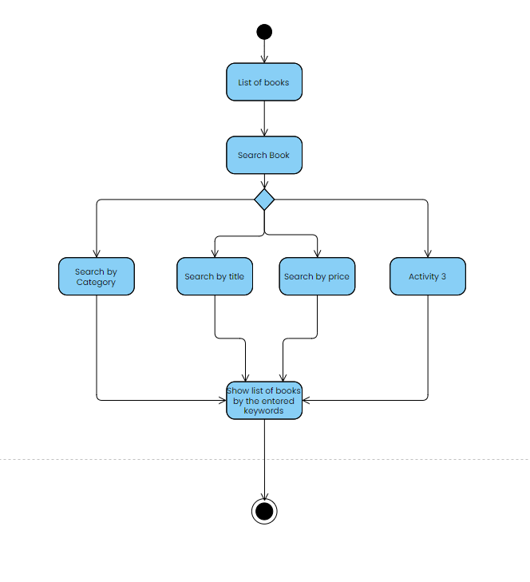

### **2.4.3. Activity diagram for use case “Request Book”**

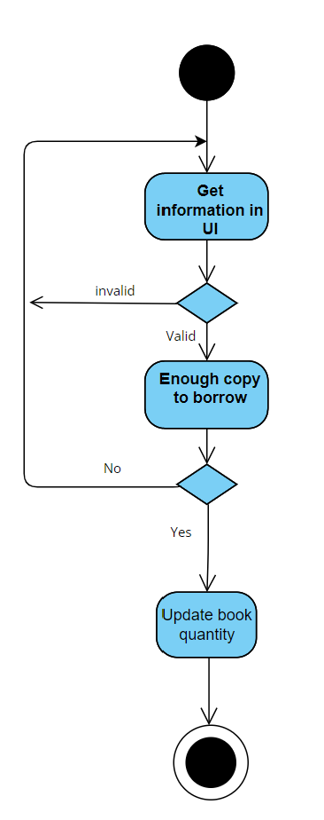

### **2.4.4. Activity diagram for use case “Return Book”**

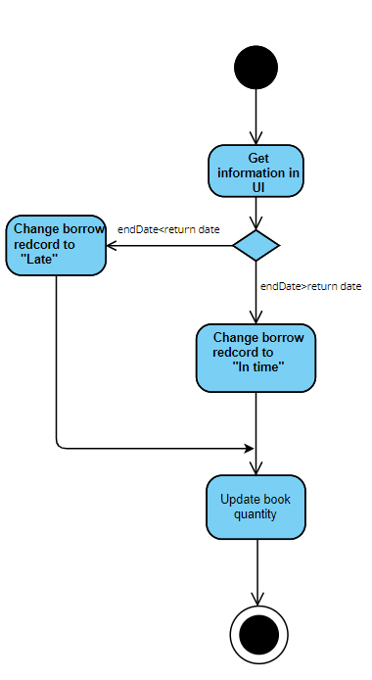

### **2.4.5. Activity diagram for use case “Manage Book”**

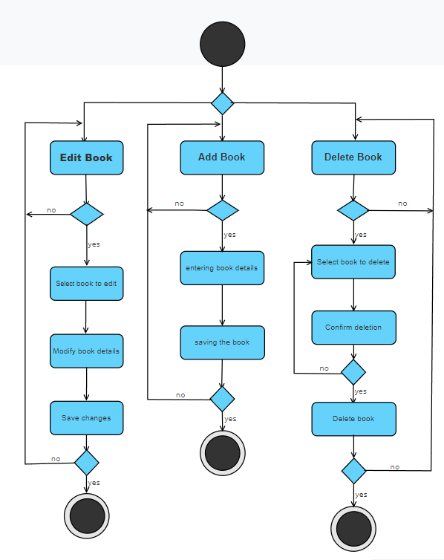

### **2.4.6. Activity diagram for use case “Manage category”**

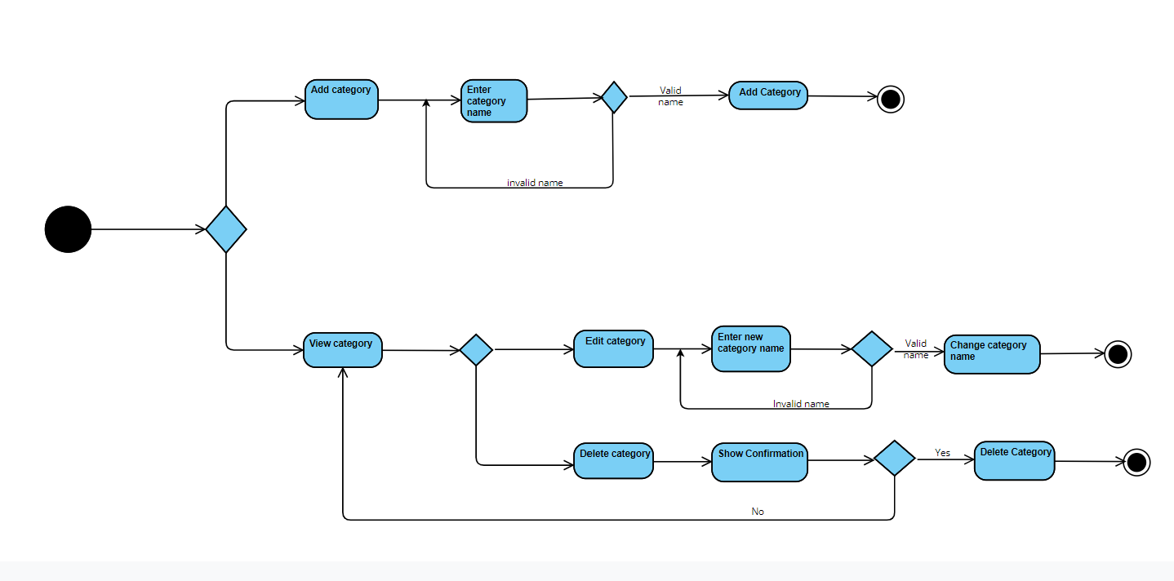

**2.4.7. Activity diagram for use case “Manage user”**

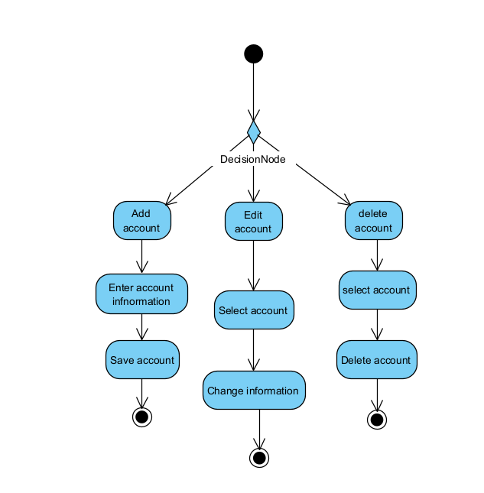

# **Data model**

## **Entity Relationship Diagram**

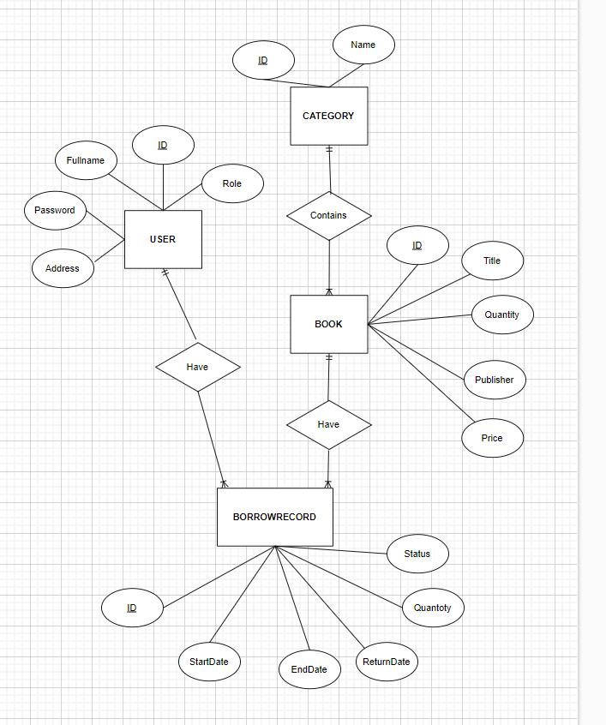

## **Database Diagram**

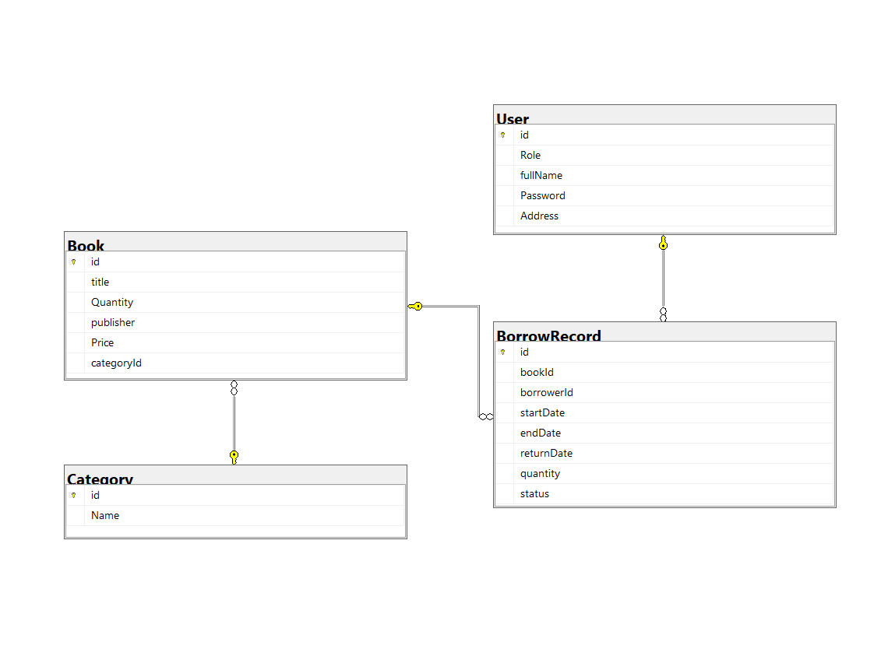

## 

## **Table details/Chi tiết các bảng**

Note: Attribute with underline is Primary key

### **Table name: User**

| **Field name** | **Type** | **Size** | **Note** |
| --- | --- | --- | --- |
| ID | Integer | 10 | Primary key |
| Role | Integer | 10 | Not null |
| Address | String | 40 | Allows null |
| Fullname | String | 40 | Not null |
| Password | String | 40 | Not null |

### **Table name: Book**

| **Field name** | **Type** | **Size** | **Note** |
| --- | --- | --- | --- |
| ID | Integer | 10 | Primary key |
| Title | String | 40 | Not null |
| Publisher | String | 40 | Allows null |
| Quantity | Integer | 10 | Not null |
| Price | Integer | 10 | Not null |
| CategoryId | Integer | 10 | Not null |

### **Table name: BorrowRecord**

| **Field name** | **Type** | **Size** | **Note** |
| --- | --- | --- | --- |
| BookId | Integer | 10 | Foreign key, refers to Book table |
| CopyNumber | Integer | 10 | Primary key |
| BorrowerId | Integer | 10 | Foreign key, refers to User table |
| StartDate | Datetime | 7 | Not Null |
| EndDate | Datetime | 7 | Not Null |
| ReturnDate | Datetime | 7 | Allow Null |
| Quantity | Integer | 10 | Not Null |
| Status | String | 40 | Allow Null |

### **Table name: Category**

| **Field name** | **Type** | **Size** | **Note** |
| --- | --- | --- | --- |
| ID | Integer | 10 | Primary key |
| Name | String | 40 | Allow null |

# **Class diagram (p.61 – p70)**

## **List of classes in the Layers**

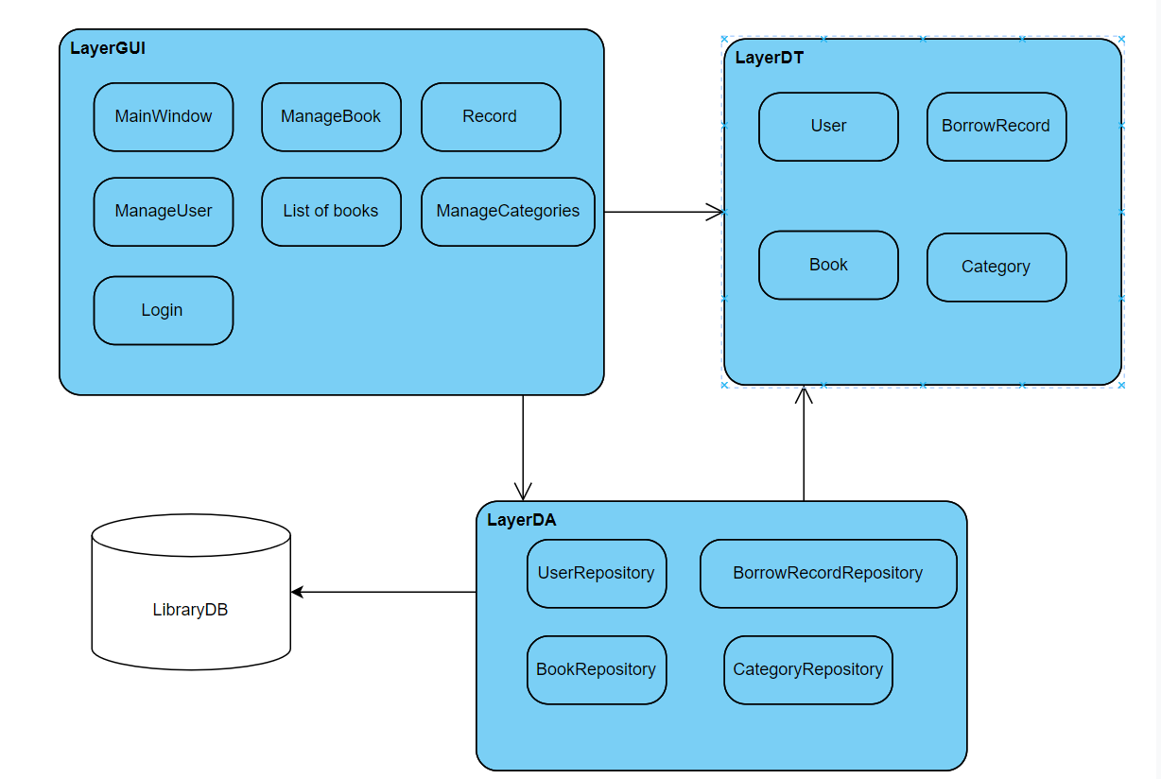

## **Modelling the Class Behaviours - sequence diagrams ( p. 66, 77)**

### **Sequence diagram for use case “Login”**

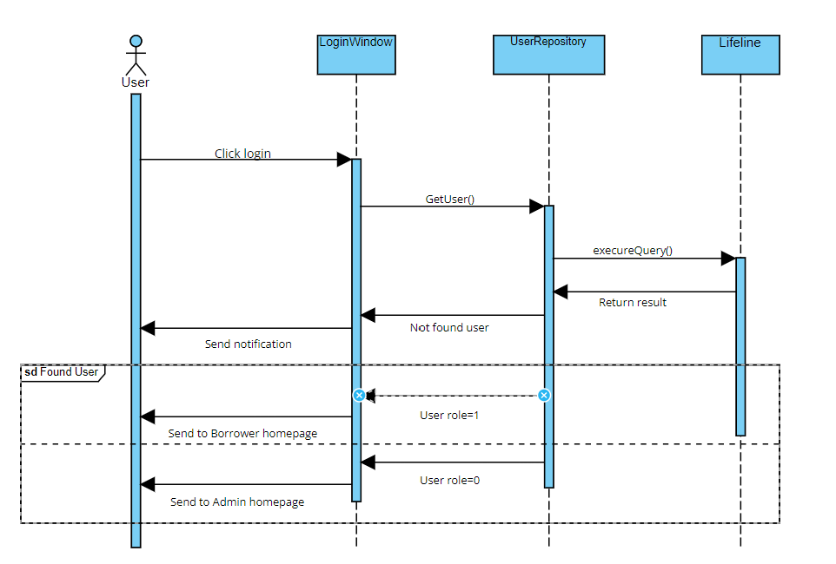

### **Sequence diagram for use case “Return Book”**

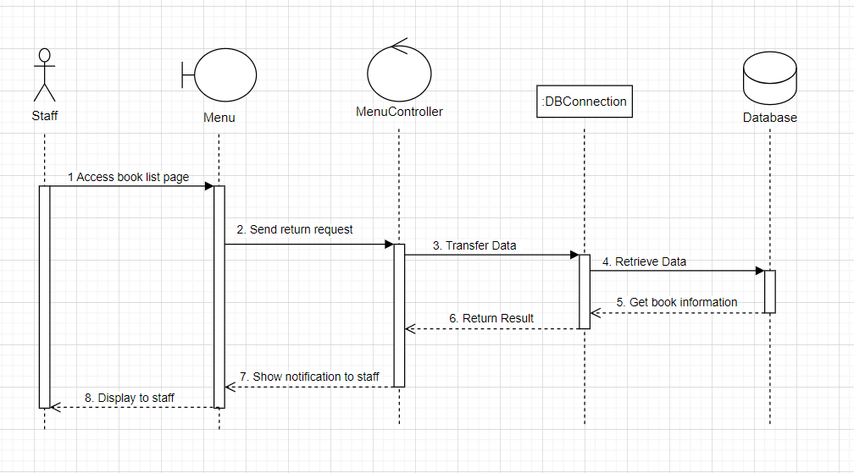

### **Sequence diagram for use case “Manage Book”**

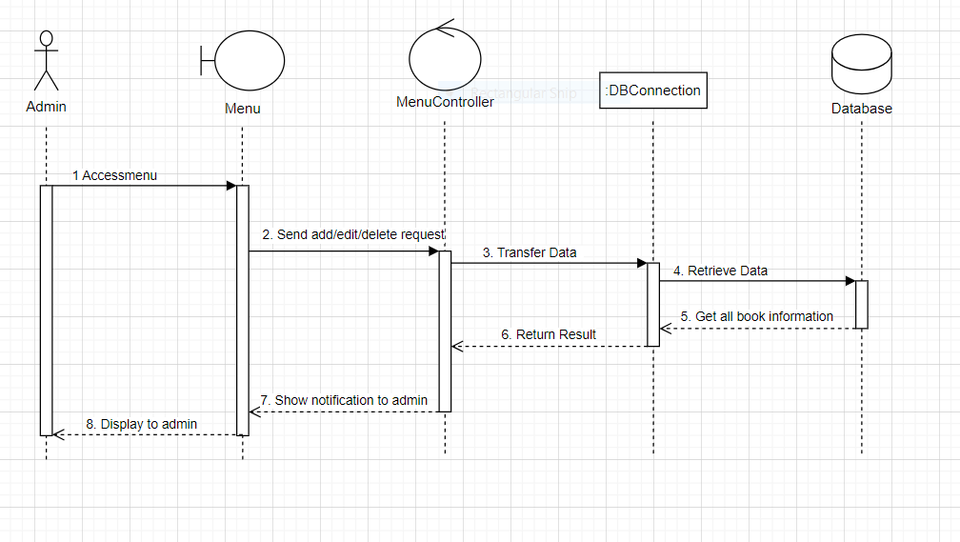

### **Sequence diagram for use case “ManageUser”**

### 

### 

# **User Interface Model Design (p. 70 – p.74)**

## **User interface model design**

### **51.1. Screen “View Book”**

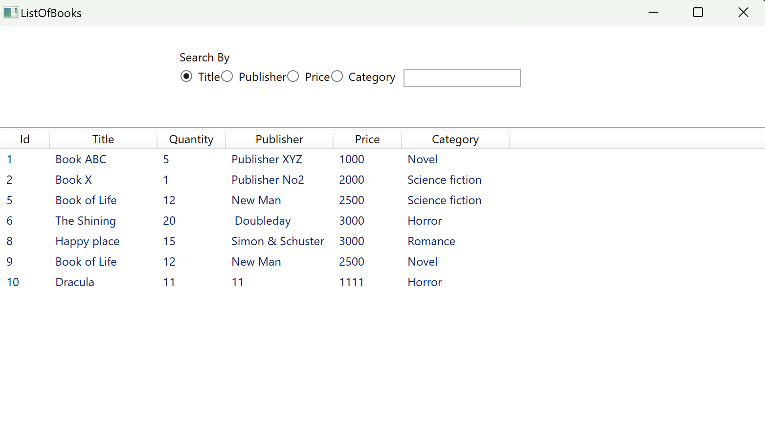

### **51.2. Screen “Manage books”**

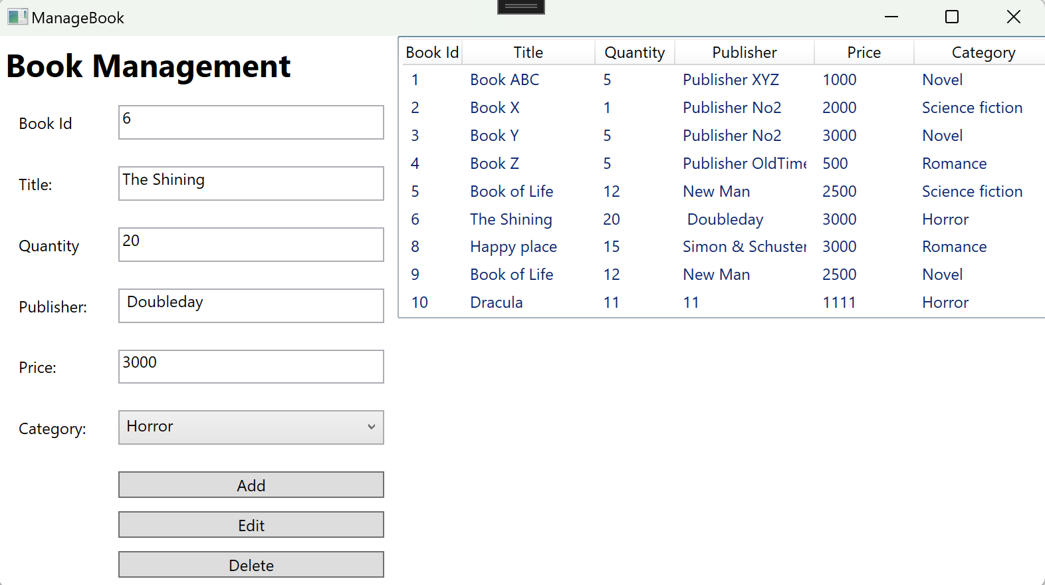

### **5.1.3. Screen “Manage user”**

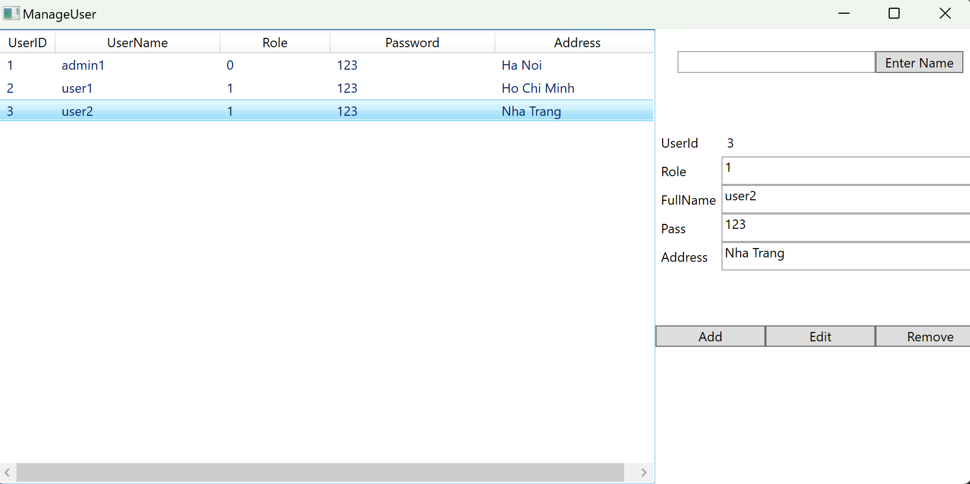

### **5.1.4. Screen “Request/Return books”**

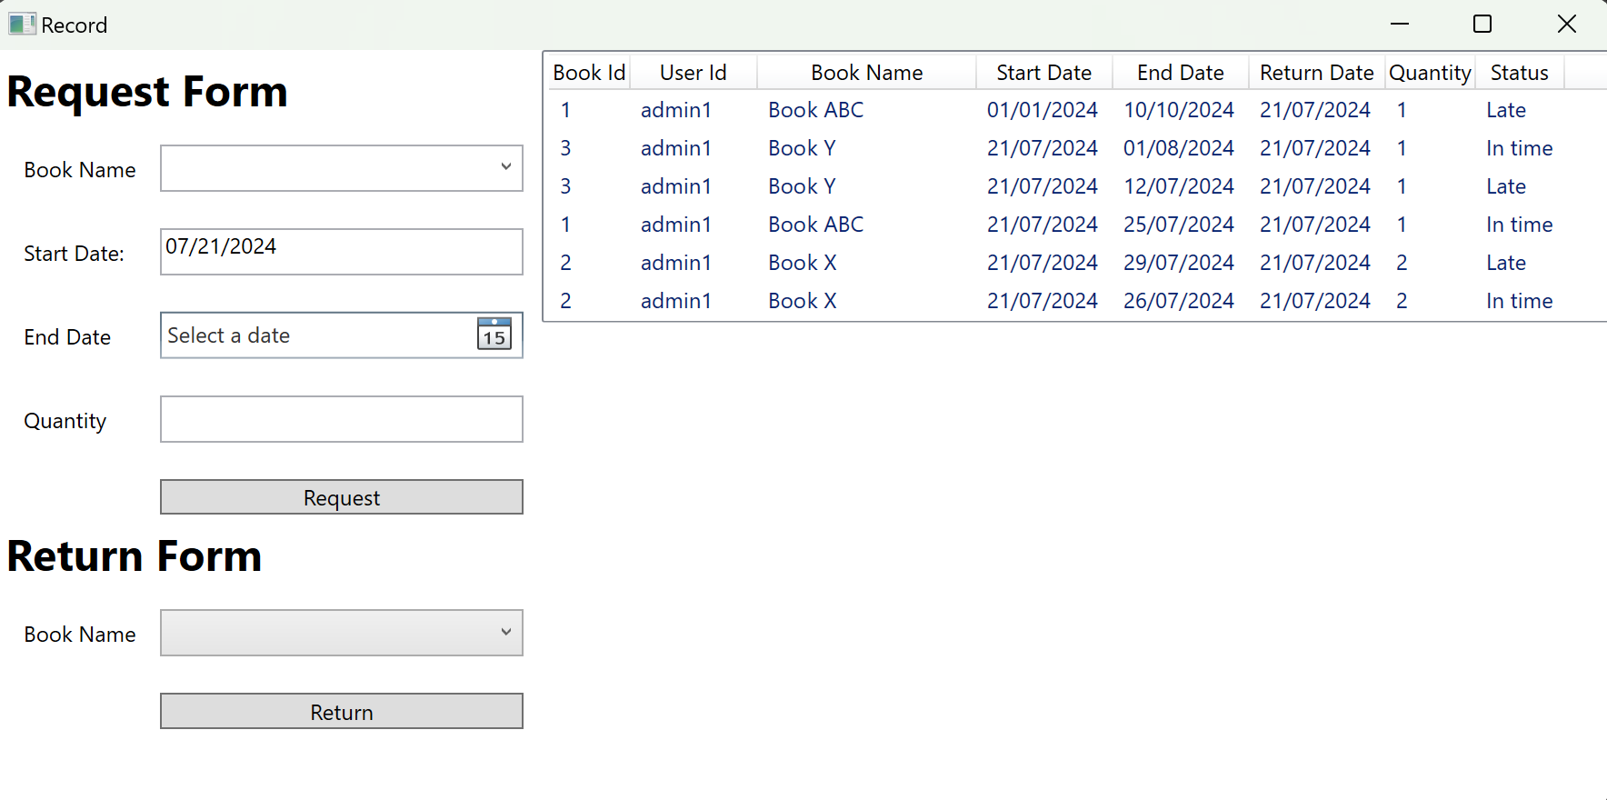

### **51.5. Screen “Manage categories”**

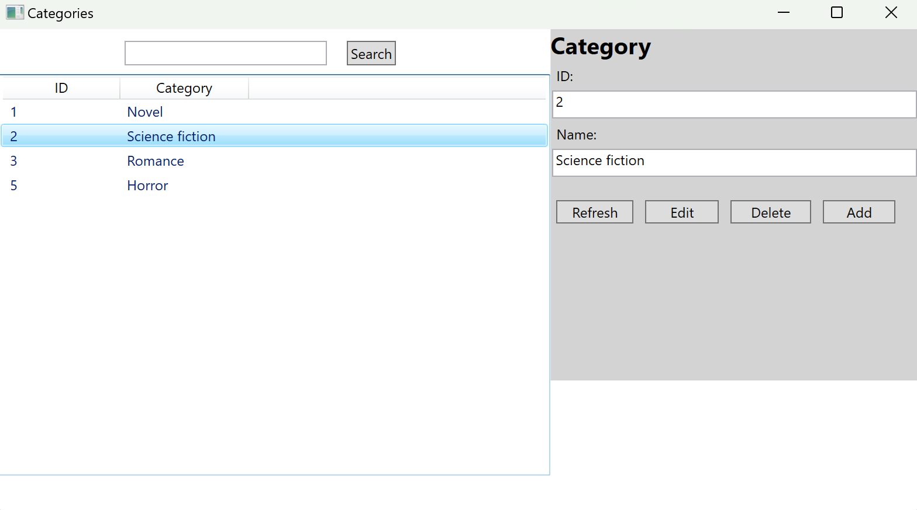

## **Interface Flow Diagrams (p. 51)**

