1. Designing

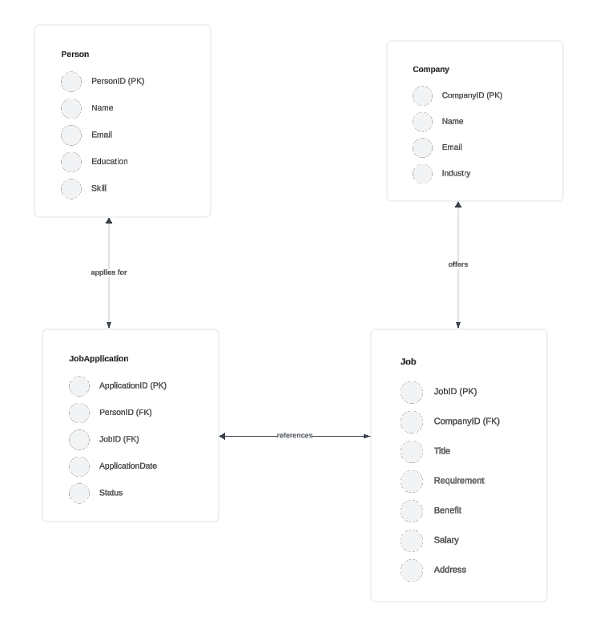

1. Project process

a) In a software development project, a Technical Manager typically oversees the use of 5 key branches in GIT to manage code effectively. The primary branches and their purposes are as follows:

**1. Main/Master Branch**

* **Purpose**: This is the primary branch where the source code of HEAD always reflects a production-ready state. All code in this branch should be thoroughly tested and stable.
* **Usage**:
  + Production releases
  + Hotfixes

**2. Develop Branch**

* **Purpose**: This branch is used as an integration branch for features. It contains the latest development changes and serves as a precursor to the main branch.
* **Usage**:
  + Integrate all completed and tested features
  + Continuous integration

**3. Feature Branches**

* **Purpose**: These branches are created from the develop branch to work on new features or enhancements. Each feature branch is dedicated to a single feature or task.
* **Naming Convention**: feature/<feature-name>
* **Usage**:
  + Develop specific features
  + Isolate feature development to avoid conflicts

**4. Release Branches**

* **Purpose**: These branches support preparation for a new production release. They allow for minor bug fixes, preparing meta-data for a release, and performing final tests.
* **Naming Convention**: release/<version-number>
* **Usage**:
  + Prepare for a new release
  + Perform final testing
  + Fix minor bugs before release

**5. Hotfix Branches**

* **Purpose**: These branches are created from the main branch to quickly address critical issues found in production. After fixes are applied, they are merged back into both the main and develop branches.
* **Naming Convention**: hotfix/<issue-number>
* **Usage**:
  + Immediate fixes to production issues
  + Quick patches without waiting for the next release cycle

b)

Here are 8 steps I prepare to develop a new module, from starting development to releasing it:

1. **Planning:**
   * **Define Requirements:** Clearly understand the functionalities and goals of the new module. This involves gathering requirements from stakeholders, analyzing user needs, and defining acceptance criteria.
   * **Module Design:** Plan the architecture and design of the module. This includes outlining components, interfaces, data flow, and how it integrates with existing systems.
2. **Development:**
   * **Coding:** Implement the functionalities of the module based on the design plan. This involves writing clean, well-documented code that adheres to coding standards.
3. **Testing:**
   * **Unit Testing:** Write unit tests to ensure individual components of the module (functions, classes) function correctly in isolation.
   * **Integration Testing:** Test how the new module interacts with other parts of the system on a testing environment. This ensures proper data exchange and functionality across modules.
4. **Code Review:**
   * Have another developer with expertise in the codebase review your code for quality, efficiency, adherence to best practices, and potential issues. This helps identify bugs, improve maintainability, and catch potential security vulnerabilities.
5. **Merge and Deployment:**
   * **Merge:** Once testing and review are complete, merge the feature branch containing the new module's code back into the development branch (usually called "develop").
   * **Deployment:** Deploy the updated code containing the new module to a testing environment. This allows for further testing in a simulated production environment.
6. **Release Testing:**
   * Perform thorough testing on the testing environment with the newly deployed module. This may involve user acceptance testing (UAT) where potential users interact with the new functionality to ensure it meets their needs.
7. **Production Release:**
   * Once all testing is successful and any critical bugs are fixed, deploy the code with the new module to the production environment. This makes the module available to actual users.
8. **Monitoring and Maintenance:**
   * After release, monitor the performance and functionality of the new module in production. Be prepared to address any issues that arise and provide ongoing maintenance and bug fixes as needed.
9. Testing

a) Here are the main types of testing strategies:

1. Unit Testing:
2. Integration Testing
3. System Testing
4. Acceptance Testing
5. Regression Testing
6. Non-Functional Testing

b) Here are some key benefits of unit testing:

* **Early Bug Detection:** Unit testing allows you to catch bugs early in the development process, before they become more complex and expensive to fix later.
* **Improved Code Quality:** By writing unit tests, developers are forced to think about the logic and behavior of their code more carefully. This leads to cleaner, more maintainable code.
* **Refactoring Confidence:** Unit tests provide a safety net when refactoring code. You can make changes to the codebase and be confident that the existing functionality hasn't been broken.
* **Documentation:** Well-written unit tests can serve as a form of documentation, explaining how different parts of the code are supposed to work.

c) Here's a breakdown of what integration testing is used for:

* **Identifying Interface Issues:** It helps identify problems with how modules communicate with each other, such as mismatched data formats, incorrect function calls, or unexpected behavior when interacting.
* **Verifying Data Flow:** Integration testing ensures data is passed correctly between modules and that data transformations or manipulations occur as intended.
* **Testing Interdependencies:** It helps verify how modules that rely on each other function together. This is particularly important for complex systems where components interact heavily.
* **Early System-Level Checks:** While not a full-fledged system test, integration testing provides an early glimpse into how the overall system might function. It helps catch major integration issues before reaching the system testing stage.
* **Building Confidence in Modular Development:** By ensuring individual modules work well together, integration testing builds confidence in the modular design approach and simplifies future maintenance efforts.

d) When a tester receives a new module, here's a typical process they should follow to ensure its quality before release:

1. Review Requirements and Design Documents
2. Understand Test Coverage
3. Test Case Design
4. Test Data Preparation
5. Unit Testing Collaboration (Optional
6. Module Functionality Testing
7. Defect Logging and Reporting
8. Regression Testing (Optional
9. Communication and Collaboration
10. Test Completion and Sign-off