EXAM  
**1. Designing**

- You has responsibility to create a website for Person who finding a new job and Companies that searching employees for their job positions.

- Person who use this website must fill their informations of Educations, Skills.

- Companies that use this website must fill types of jobs that they are finding candidates. Each job has title, requirement, benefit, salary and address of working.

- Please design Entity Relationship Diagram of this project in details.

**2. Project process**

- In software development project, how many branches in GIT does the Technical manager should use? What are the branches used for?

- If you have a new module to develop, which steps do you should prepare to develop from

starting the module to releasing the module?

**3. Testing**

- What are types of testing strategies?

- What is Unit Testing used for?

- What is Integration Testing used for?

- If a tester has a new module to test, which steps does he/she should test from starting the module to releasing the module?

# SOLVING

**1. Designing**

**Entity Relationship Diagram (ERD) Design:**

Entities:

1. **Person**
   * Attributes: PersonID (PK), FirstName, LastName, Email, Password
   * Relationships: Has many Educations, Has many Skills, Applies to many Jobs
2. **Education**
   * Attributes: EducationID (PK), SchoolName, Degree, FieldOfStudy, StartDate, EndDate, PersonID (FK)
   * Relationships: Belongs to one Person
3. **Skill**
   * Attributes: SkillID (PK), SkillName, ProficiencyLevel, PersonID (FK)
   * Relationships: Belongs to one Person
4. **Company**
   * Attributes: CompanyID (PK), CompanyName, Industry, Email, Password
   * Relationships: Posts many Jobs
5. **Job**
   * Attributes: JobID (PK), Title, Requirement, Benefit, Salary, Address, CompanyID (FK)
   * Relationships: Posted by one Company, Applied by many Persons
6. **Application**
   * Attributes: ApplicationID (PK), PersonID (FK), JobID (FK), ApplicationDate
   * Relationships: Many to Many between Person and Job

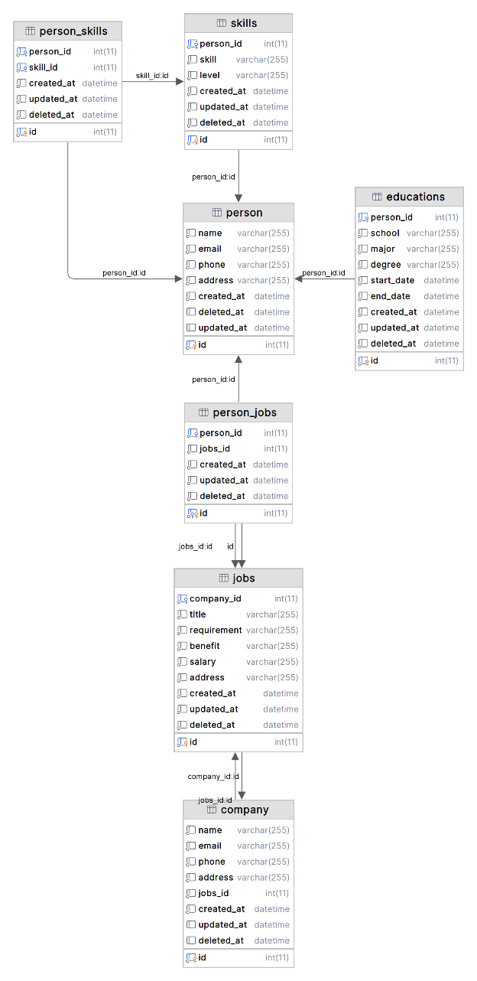

This ERD represents the basic structure for a job finding website, capturing the relationships between persons, their educations, skills, companies, and job postings.

**2. Project Process**

**GIT Branch Strategy:**

A technical manager should use at least four branches in GIT:

1. **Main/Master**: Stable version of the project, reflects production-ready state.
2. **Development**: Integration branch for features, bug fixes, and other development work.
3. **Feature**: Branches created from development for new features or enhancements.
4. **Hotfix**: Branches created from main/master for urgent fixes.

**Development Steps for a New Module:**

1. **Planning**: Define the module's requirements and specifications.
2. **Design**: Architect the module, considering the system's overall design.
3. **Feature Branch Creation**: Create a new branch from development for the module.
4. **Development**: Start coding, adhering to coding standards and practices.
5. **Code Review**: Submit the code for review by peers or a senior developer.
6. **Testing**: Perform unit and integration testing.
7. **Merge to Development**: Once the module passes tests, merge it into the development branch.
8. **Staging Deployment**: Deploy the development branch to a staging environment for further testing.
9. **Production Deployment**: After final approval, merge the development branch into the main/master branch and deploy to production.

**3. Testing**

**Types of Testing Strategies:**

1. **Unit Testing**: Tests individual components or functions of the software.
2. **Integration Testing**: Tests the integration or interfaces between components.
3. **System Testing**: Tests the complete and integrated software.
4. **Acceptance Testing**: Validates the end-to-end business flow.

**Unit Testing:**

Used for testing individual units/components of the software to ensure they work as expected.

**Integration Testing:**

Used for testing the integration points between different units/components to ensure they work together as expected.

**Testing Steps for a New Module:**

1. **Requirement Analysis**: Understand what the module is supposed to do.
2. **Test Planning**: Plan the tests to cover all aspects of the module.
3. **Test Case Development**: Write test cases that cover all functionalities.
4. **Environment Setup**: Prepare the testing environment with necessary data and tools.
5. **Test Execution**: Execute the test cases.
6. **Bug Reporting**: Report any bugs or issues found during testing.
7. **Regression Testing**: Re-test after bugs are fixed.
8. **Sign Off**: Once all tests pass and the module meets the requirements, sign off for release.