Intellij UML code screenshot

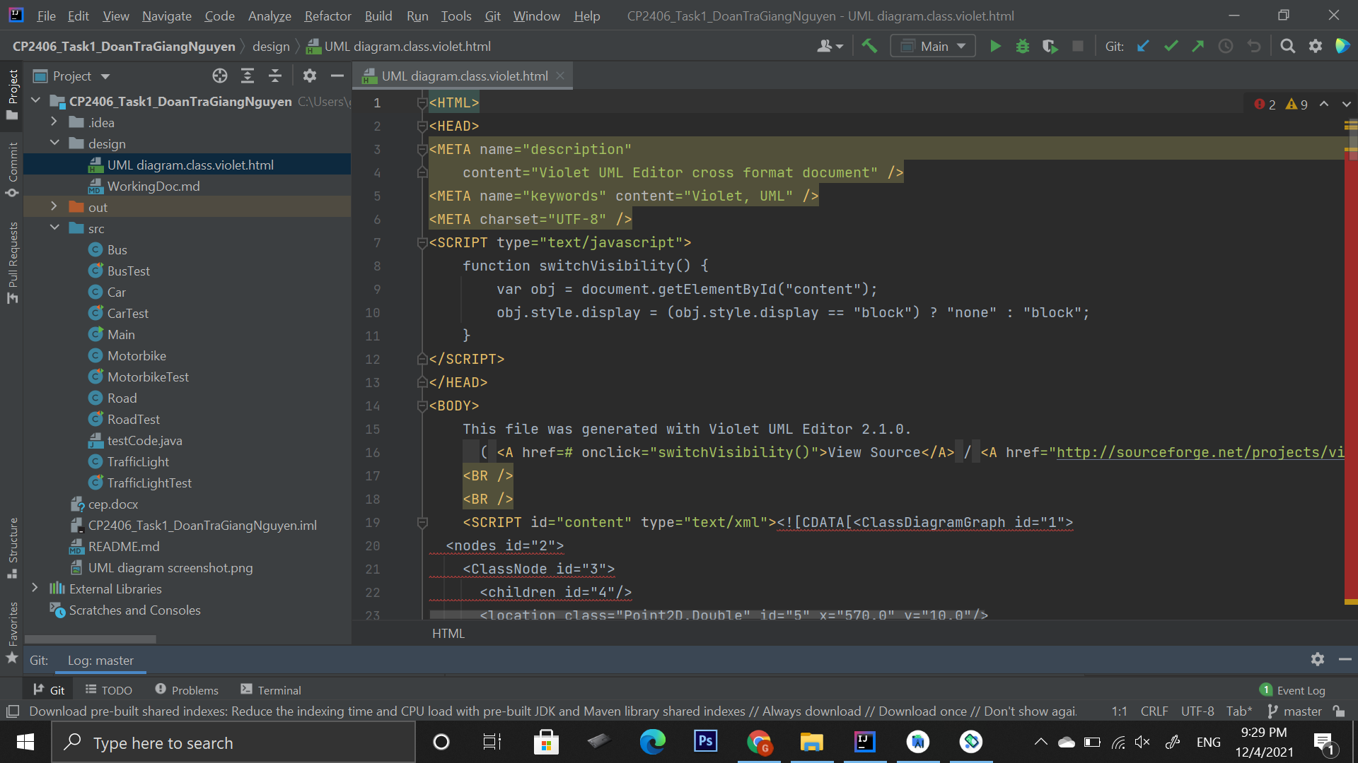

UML diagram screenshot

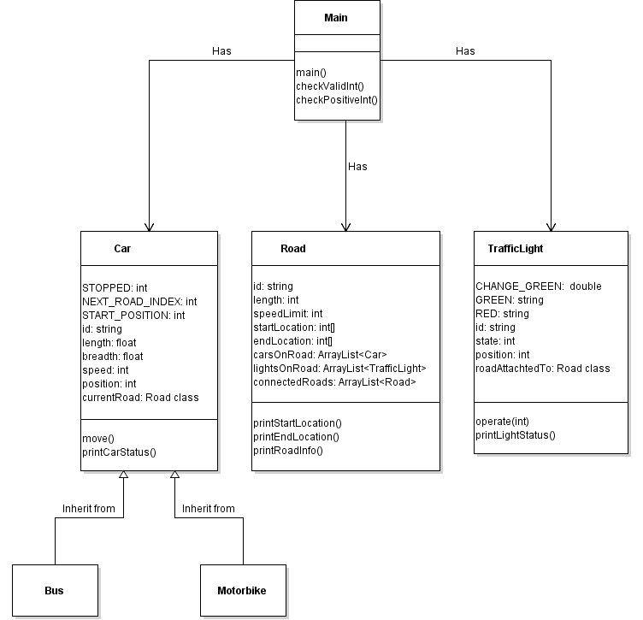

GitHub screenshot (https://github.com/NguyenDoanTraGiang/CP2406_Task1_DoanTraGiangNguyen)

