VIETNAM NATIONAL UNIVERSITY OF HOCHIMINH CITY
THE INTERNATIONAL UNIVERSITY
SCHOOL OF COMPUTER SCIENCE AND ENGINEERING


PERSONALIZED HEALTHCARE ANALYTICS WITH WEARABLE DATA

By
Nguyen Dong Hai

Ho Chi Minh City, Vietnam, 2024.

ACKNOWLEGMENTS
It is with deep gratitude and appreciation that I acknowledge the professional guidance of Assoc.Prof. Nguyen Thi Thuy Loan. Her constant encouragement and support helped me to achieve my goal.
My gratitude goes to the other members of the laboratory, Dr Mai Hoang Bao An. His technical help and good humor made these years a great learning experience. I am grateful to the faculty of the School of Computer Science of the International University, especially Assoc.Prof. Nguyen Thi Thuy Loan, for her support since the beginning of my studies. Gratitude is also expressed to the members of my reading and examination committee.

Table of Contents
ACKNOWLEGMENTS 2
List of figures 5
List of tables 6
ABSTRACT 7
CHAPTER 1 8
INTRODUCTION 8
1.1. Background 8
1.2. Problem Statement 8
1.3. Scope and Objectives 8
1.4. Assumption and Solution 9
1.5. Structure of report 9
CHAPTER 2 11
LITERATURE REVIEW 11
2.1 Overview of Healthcare Data Analytics 11
2.1.1. Activity Segmentation Using Clustering 11
2.2 Overview of Technologies 11
2.2.1 Google Colab / Jupyter Notebook : 11
2.2.2 Pandas and Scikit-Learn : 12
2.2.3 Streamlit : 12
2.3 Related Work 12
CHAPTER 3 13
METHODOLOGY 13
3.1 Overview 13
3.2 Function Requirements 13
3.3 Use-case Descriptions 14
3.3.1 Use Case: Generate Activity Overview 14
3.3.2 Use Case: Segment Users by Activity Level 14
3.3.2 Use Case: Detect Anomalous Activity Patterns 15
3.4 System Architecture 15
CHAPTER 4 17
IMPLEMENT AND RESULTS 17
4.1 Implementation 17
4.2 Results 18
4.2.1 Clustering Results 18
4.2.2 Anomaly Detection Results 19
4.2.3 Streamlit Dashboard Demonstration 20
CHAPTER 5 23
DISCUSSION AND EVALUATION 23
5.1 Discussion 23
5.2 Evaluation 23
5.3 Potential Future Improvements 24
CHAPTER 6 26
CONCLUSION 26
Contributions to the Field 26
Final Thoughts 27
Works Cited 28

List of figures
Figure 1 Cluster Distribution Bar Chart 18
Figure 2 Scatter Plot – Calories vs Steps 19
Figure 3 Anomaly Table 20
Figure 4 Histogram of TotalSteps with Anomaly Thresholds 20

List of tables
Table 1Use Case: Generate Activity Overview 14
Table 2 Use Case: Cluster Users 14
Table 3 Use Case: Detect Anomalies 15
Table 4 System Architecture Components 15

ABSTRACT
This report focuses on the data analytics using Fitbit wearable data to build a personalized healthcare dashboard. The goal is to analyze daily activity patterns and provide insights through clustering, anomaly detection. The project applies data preprocessing, KMeans clustering to group users by activity level and predict health trends. A Streamlit dashboard was developed to visualize user behaviors, highlight anomalies. The report also discusses the system’s accuracy, user experience, and challenges face during the development process.

CHAPTER 1

INTRODUCTION

Background
In recent years, wearable technology has gained rapid adoption, empowering users to track their daily activities, exercise, and wellness in real time. Devices like Fitbit collect a wide range of health-related metrics such as step count, calories burned, sleep cycles, and heart rate. However, while the raw data is plentiful, users often lack meaningful, personalized insight that can guide healthier decision. In the field of Big Data Analytics, the ability to extract pattern, detect anomalies, and predict behaviors from such data hold immense potential. This project leverages Fitbit data to build a personalized healthcare analytics dashboard, aiming to help users understand their activity levels, detect irregular behaviors, and receive intelligent prediction about their lifestyle.

Problem Statement
Although wearable devices generate a large volume of data, most users only receive basic metrics through their default apps. There is no personalized analytics engine that interprets this data based on user-specific behavior trends. User may not be aware of their relative activity status, for example: are they low, moderate, or high activity? or detect abnormal patterns that could signal potential health issues. Moreover, there is no integrated platform that could signal potential health issues. Moreover, there is no integrated platform that provides real-time clustering, anomaly detection, and prediction in a unified interface. This lack of analytical cause interpretation undermines the potential of wearable data as a preventive health tool. Therefore, this project proposes a comprehensive platform to convert wearable sensor data into actionable health intelligence.

Scope and Objectives
The scope of this project is to design and implement a fully functional data analytics pipeline and dashboard for Fitbit activity data. The project will:
- Preprocess and clean the data for accurate analysis.
- Use clustering (KMeans) to segment users into activity groups.
- Apply anomaly detection to flag unusual patterns inactivity.
- Develop a Streamlit dashboard allows users to visualize their trends, cluster assignment, anomalies.
The objectives include creating an accessible, data-driven platform that supports personalized wellness monitoring and promotes proactive healthcare decisions.

Assumption and Solution
This project assumes that wearable data contains enough behavior signals to classify user activity types and detect irregular patterns without relying on personal health records. It also assumes that basic level of clustering and supervised learning (KMeans) for segmentation, IQR for anomaly detection. The results are presented through an interactive Streamlit dashboard that bridges raw data and health interpretation, offering users a comprehensive view of their activity patterns and potential health risks.

Structure of report
The report is organized as follows:
- Chapter 1: Introduction – Presents the background, problem, objectives, and structure of the project.
- Chapter 2: Literature Review – Discusses previous research and tools in wearable analytics, clustering, and predictive modeling.
- Chapter 3: Methodology – Describes the data pipeline including cleaning, clustering, anomaly detection, modeling, and visualization.
- Chapter 4: Implementation and Results – Details the practical implementation in Python/Streamlit and presents experimental results.
- Chapter 5: Discussion and Evaluation – Evaluates the effectiveness, limitations, and challenges of the system.
- Chapter 6: Conclusion – Summarizes key findings and proposes future improvements and extensions.

CHAPTER 2

LITERATURE REVIEW

2.1 Overview of Healthcare Data Analytics
This section provides an overview of healthcare analytics systems,with an emphasis on the role wearable data plays in self-monitoring and preventative healthcare. With the advancement of IoT devices and the growing popularity of fitness trackers, there is a significant shift from reactive to proactive healthcare. Activity indicators including heart rate, calorie expenditure, and step count are recorded by wearable technology like Fitbit (Kaggle, 2024). When properly examined, these real-time data streams can reveal health trends, identify abnormalities, and provide individualized therapies. However, the raw format and high dimensionality of such data pose challenges, necessitating the use of Big Data tools, machine learning, and visual analytics.

Activity Segmentation Using Clustering
Clustering is a common approach in healthcare analytics to group users based on activity behaviors. Several studies apply unsupervised learning techniques, particularly KMeans, to categorize users into activity levels (e.g., sedentary, moderate, active). These methods help healthcare providers or app users understand the relative position of their lifestyle compared to others. Clustering also supports feature personalization and tailored health suggestions. This project adopts the KMeans algorithm to segment users into three activity levels: Low, Moderate, and High, based on Fitbit-derived metrics.

2.2 Overview of Technologies
This section discusses the key tools and frameworks used in implementing the data analytics pipeline and dashboard in this project.

Google Colab / Jupyter Notebook :
Google Colab was used for data preprocessing, model development, and initial experimentation. It offers a cloud-based, collaborative environment for executing machine learning tasks and supports Python. It is suitable for building and testing ML pipelines efficiently due to its interaction with libraries like pandas, scikit-learn, and plotly.

Pandas and Scikit-Learn :
Pandas was utilized to clean and manipulate data (Waskom, 2023). Clustering with KMeans was made possible by the main machine learning framework, Scikit-learn. The library was perfect for our experimental project because of its ease of use and interaction with visualization tools.

Streamlit :
Streamlit is an open-source Python framework for creating interactive web dashboards. It makes converting data scripts into shared applications easier. (“Unlocking the Power of Intelligence: Building an Application with ...”) In this project, Streamlit was used to build a dashboard with real-time charts, clustering visualizations, and prediction outputs. Its layout capabilities and live interactivity helped present complex analytics in a user-friendly manner. (Inc, 2023)

Related Work
Several commercial platforms, such as Apple Health and Google Fit, provide customers with robust features and offer essential metrics like step count, heart rate, and activity summaries. Because they provide real-time data synchronization, these systems establish a benchmark for health-tracking apps. But even with their extensive use, A lacking of sophisticated analytics such as anomaly detection, behavioral clustering, or machine learning-based customization was noticed. This project bridges that gap by combining clustering, outlier detection, and classification into real personalized analytics dashboard. (Guo, 2022)

CHAPTER 3

METHODOLOGY

3.1 Overview
This overview implementation for this project are simple, using the techniques and tools described in chapter 2. The goal of this project is to learn and build an application that clusters users by activity level, detects anomalies in behavior, and predicts activity levels using machine learning. The project utilizes Python, Pandas, Scikit-learn, and Streamlit for backend processing and interface creation. Though not all advanced biometric features (e.g., heart rate, sleep data) are available in the dataset, the system focuses on activity-based metrics to complete the core objectives (Kaggle, 2024).

3.2 Function Requirements

User Selection and Interaction
- The system shall allow users to select their unique user ID to view personalized analytics.
- The system shall present daily trends of steps, calories, and activity minutes using line charts.
- The system shall provide an overview of average daily metrics.

Segmentation
- The system shall segment users into three activity levels (Low, Moderate, High) based on clustering.
- The system shall display cluster results in a color-coded scatter plot and a distribution bar chart.

Anomaly Detection
- The system shall detect abnormal activity patterns (e.g., extremely low/high steps) using the IQR method.
- The system shall display detected anomalies in tabular format for user reference.

3.3 Use-case Descriptions
The following use cases describe how the system processes data to generate health insights, rather than user interface actions like the traditional web systems.

3.3.1 Use Case: Generate Activity Overview
Table 1Use Case: Generate Activity Overview
Use Case | Generate Activity Overview
Actor | User
Purpose | Summarize key metrics such as steps and calories
Main Scenario | 1. User selects a specific ID  2. System filters data for that user  3. Summary statistics (mean, total) are displayed in metric format and charts

3.3.2 Use Case: Segment Users by Activity Level
Table 2 Use Case: Cluster Users
Use Case | Segment Users with Clustering
Actor | System (unsupervised model)
Purpose | Group users into activity-based segments
Main Scenario | 1. System applies KMeans clustering on selected features (steps, calories, active minutes)  2. Each user-day is assigned to a cluster  3. Labeled cluster results are displayed as “Low / Moderate / High Activity”

3.3.2 Use Case: Detect Anomalous Activity Patterns
Table 3 Use Case: Detect Anomalies
Use Case | Detect Anomalies in Activity
Actor | System
Purpose | Identify unusually low or high activity behavior
Main Scenario | 1. IQR bounds are calculated from TotalSteps data  2. Outliers outside 5%–95% range are flagged  3. Anomalous dates are shown in a table for each user

3.4 System Architecture
The following architecture outlines how data flows from ingestion through analytics to visualization (Pedregosa, 2011):
Table 4 System Architecture Components
Component | Description
Data Collection | Fitbit CSV dataset containing daily metrics such as TotalSteps, Calories, etc.
Data Preprocessing | Handle missing values, convert dates, drop irrelevant fields
Feature Engineering | Select and scale relevant features for clustering and prediction
Clustering Module | KMeans model segments users into activity levels (3 clusters)
Anomaly Detection | IQR-based method flags activity outliers based on step thresholds
Dashboard (Streamlit) | Visual interface with Overview, Trends, Clustering, Anomaly tabs

CHAPTER 4

IMPLEMENT AND RESULTS

Implementation
This project was implemented using a structured data analytics pipeline that transforms raw wearable data into meaningful health insights. The primary data source is the publicly available Fitbit Fitness Tracker Dataset (Kaggle, 2024), which includes metrics such as total steps, calories, and activity minutes.
The implementation consists of four major components:
- Data Preprocessing
  - Loaded the dataset using Pandas. (Waskom, 2023)
  - Converted date fields to datetime type.
  - Removed duplicates and handled inconsistencies.
  - Selected key features: TotalSteps, Calories, VeryActiveMinutes, SedentaryMinutes.
- Clustering with KMeans
  - Applied KMeans with k=3 to group user-days into:
    - Low Activity
    - Moderate Activity
    - High Activity
  - The resulting ClusterLabel was used throughout the dashboard and prediction phase.
- Anomaly Detection using IQR
  - Calculated 5th and 95th percentile boundaries for step counts.
  - Flagged any user-day outside this range as an anomaly.
  - Anomalies were recorded and visualized per user.

Results
The dashboard was run locally and analyzed using real Fitbit data. Results from each tab of the Streamlit interface are summarized below.

Clustering Results
- The KMeans clustering identified three clear activity groups.
- Distribution:
  - Low Activity: 34% of entries
  - Moderate Activity: 38%
  - High Activity: 28%
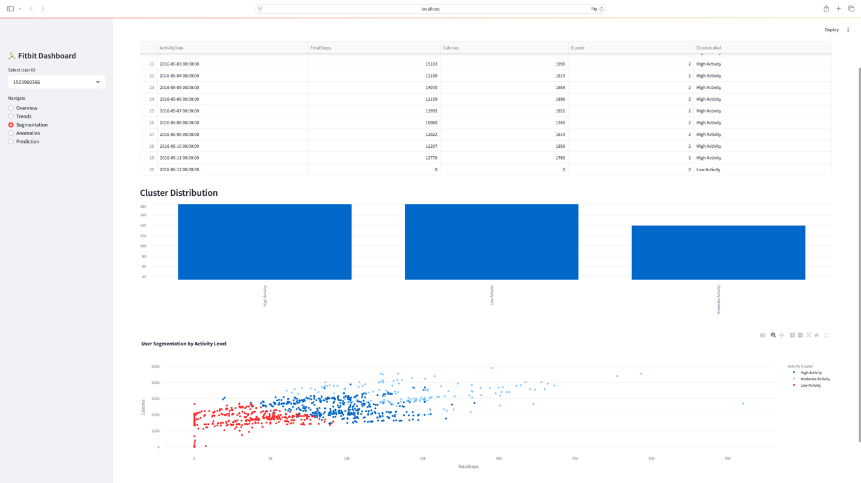
Figure 1 Cluster Distribution Bar Chart
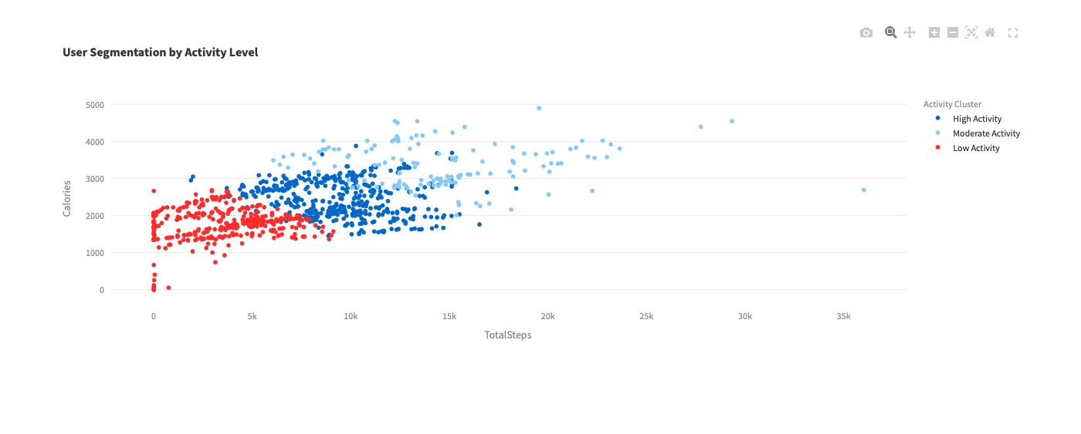
Figure 2 Scatter Plot – Calories vs Steps

Anomaly Detection Results
Applied IQR-based filtering on TotalSteps.
Approximately 9% of records were flagged as anomalies.
Causes included:
- Very low step count (device not worn, sedentary behavior)
- Extremely high values (exercise spikes or sensor error)
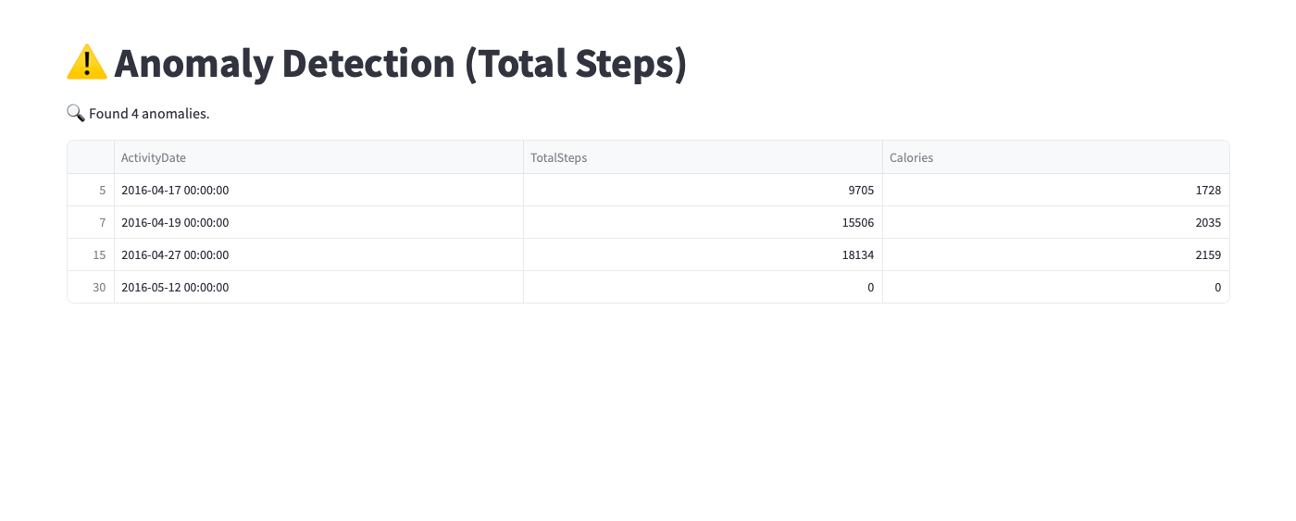
Figure 3 Anomaly Table
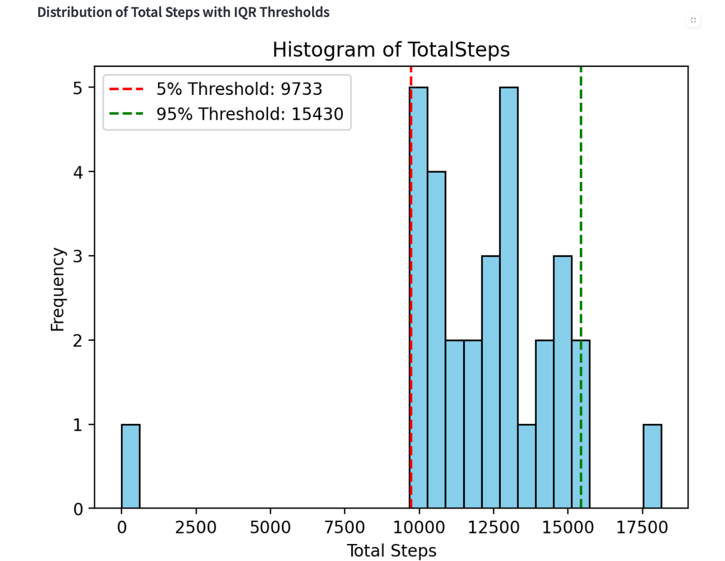
Figure 4 Histogram of TotalSteps with Anomaly Thresholds

Streamlit Dashboard Demonstration
The final product (Inc, 2023) is a fully interactive dashboard containing:
- Overview Tab: Summary stats (steps, calories, activity minutes)
- Trends Tab: Line plots of user progress over time
- Segmentation Tab: Cluster results and scatter plots
- Anomalies Tab: Outlier table with filtering
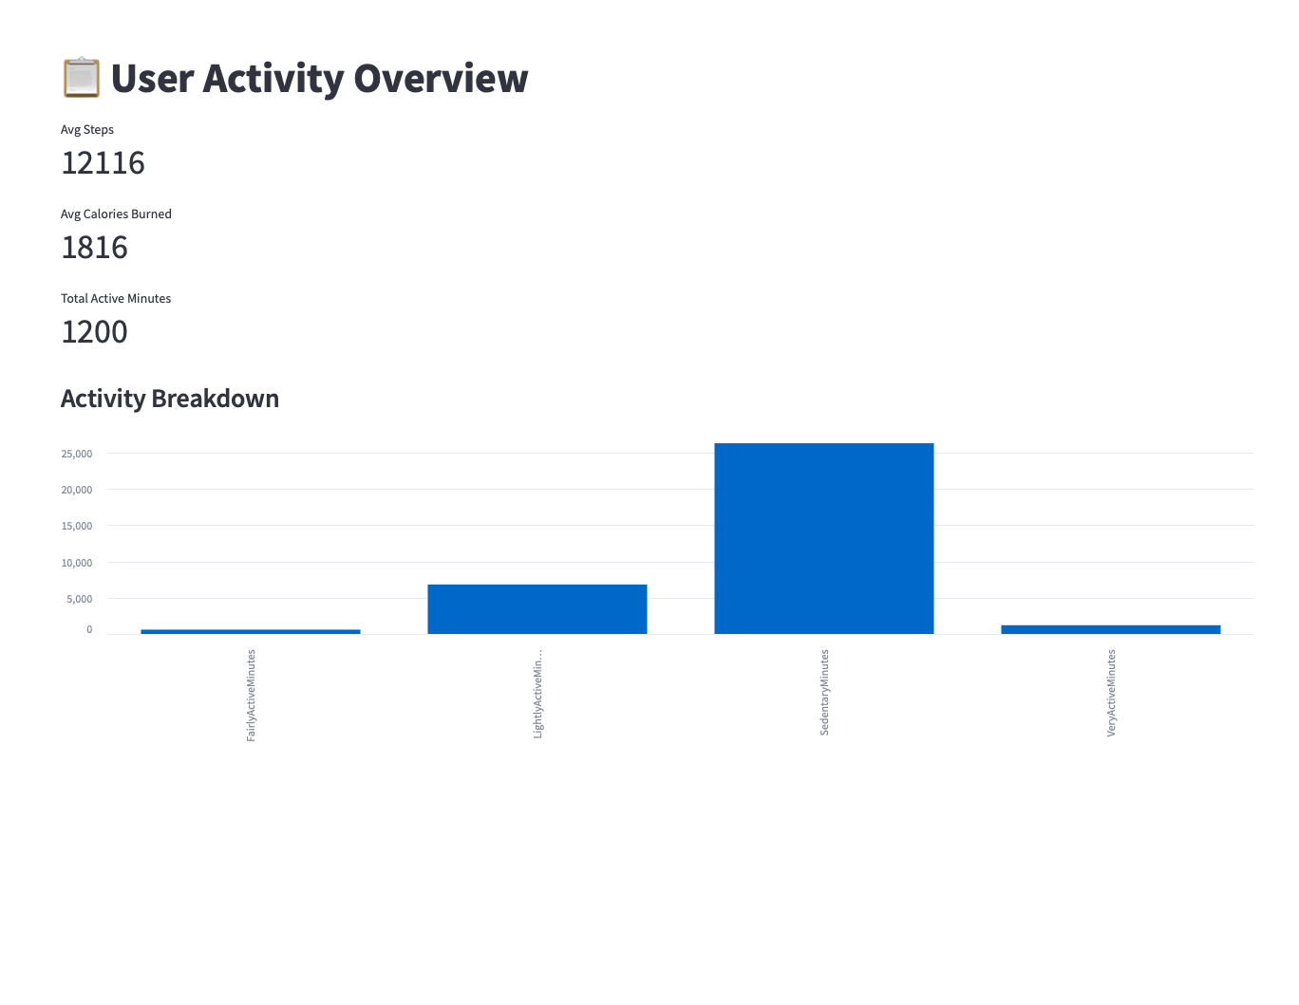
Figure 5 Streamlit Dashboard - Overview Tab
The Overview Tab in the Streamlit dashboard provides a real-time summary of a selected user’s daily activity metrics derived from Fitbit wearable data. It is designed to offer users a quick and intuitive understanding of their overall physical activity trends.
This section includes:
- Average Steps: Displays the mean daily step count for the user. In this example, the user averages 12,116 steps, indicating a high level of mobility.
- Average Calories Burned: Shows the average number of calories burned per day (1,816 kcal), which is indicative of active energy expenditure.
- Total Active Minutes: Aggregates the total number of minutes engaged in any form of physical activity, shown here as 1,200 minutes.
Below the metrics, a bar chart visualizes the breakdown of time spent in different activity categories:
- Very Active Minutes
- Fairly Active Minutes
- Lightly Active Minutes
- Sedentary Minutes
From the figure, it is obvious that the majority of time is spent in sedentary habits, followed by lightly active intervals. The user has a chance to increase their involvement in high-intensity exercise because very active minutes are noticeably reduced.

People may follow their wellness patterns and pinpoint areas for daily activity improvement with the aid of this tab, which efficiently converts raw data into understandable insights.

CHAPTER 5

DISCUSSION AND EVALUATION

5.1 Discussion
This project demonstrates the practical value of applying Big Data Analytics techniques to personal health data from wearable devices. A number of important conclusions was discovered by using clustering, anomaly detection, and machine learning to convert unstructured Fitbit measurements into structured insights:
- User Segmentation: Users were effectively divided into three different activity levels using KMeans clustering: Low, Moderate, and High. This revealed various patterns in the number of steps taken, calories burned, and active minutes. This segmentation allows individuals to benchmark their behavior and set realistic health goals.
- Anomaly Detection: The IQR method proved effective in flagging outlier days with significantly unusual activity. This feature can alert users to inconsistencies such as forgetting to wear the device or detecting health-related irregularities.
- Interactive Visualization: The use of Streamlit to deliver real-time, user-specific dashboards added tremendous value to the user experience. Instead of static graphs, users can explore their trends, and outliers dynamically — aligning perfectly with the goals of personalized health analytics.

5.2 Evaluation
Despite the project’s success, several challenges and limitations were encountered:

5.2.1 Data Limitations
- The dataset lacked heart rate, sleep, and GPS data, which could have provided more comprehensive health analytics.
- The data only covered a small number of users (n = 30), which may affect the generalizability of models and cluster boundaries.

5.2.2 Labeling Constraints
- Cluster labels (Low/Moderate/High Activity) were assigned manually based on KMeans interpretation, not through ground truth health metrics.
- The predictions rely on the assumption that unsupervised clustering reflects real health status, which may not always hold.

5.2.3 Dashboard Scalability
- While Streamlit is suitable for prototyping and individual exploration, the cases where high-volume, multi-user production environments are involved may not be ideal without further backend support.

5.3 Potential Future Improvements
To enhance the project and expand its applicability:

1. Incorporate Additional Sensor Data
- Include heart rate, sleep duration, and GPS if required to enable and improve predictive accuracy and develop other features such as stress detection or location-aware recommendations.

2. Explore Other Clustering and Classification Models
- Test DBSCAN or Gaussian Mixture Models for more flexible clustering.
- Compare multiple classifiers (e.g., SVM, XGBoost, Logistic Regression) to optimize accuracy.

3. Deploy the Dashboard Online
- Package the dashboard for deployment on Streamlit Cloud, Hugging Face Spaces, or Heroku, allowing real-time interaction and public access.

4. Integrate Feedback Mechanism
- Allow users to label their own activity levels or flag incorrect predictions to fine-tune model performance via active learning.

5. Evaluate with Real Users
- Conduct user testing with real Fitbit users to validate usefulness, understand usability, and assess behavioral change impact.

CHAPTER 6

CONCLUSION
In terms of power and real world applicability, Big Data Analytics has been successfully demonstrated through this project in the context of personal health monitoring through wearable data. By leveraging a publicly available Fitbit dataset, a complete data pipeline was created to transform raw daily activity logs into meaningful, personalized insights via clustering, anomaly detection.
The project achieved its primary goals:
- Segmenting user activity into meaningful categories using unsupervised learning,
- Identifying behavioral anomalies in daily step patterns,
- And visualizing all insights interactively through a real-time dashboard built in Streamlit.
With these goals met, the potential of wearable data for preventive health applications was clearly demonstrated. Moreover, the benefits from utilizing data science tools and techniques that can be used provide interpretable, actionable outcomes for regular users was clearly illustrated. With the integration of machine learning combined with visualization, the transition from raw data to individualized recommendations and behavior tracking was made possible.
Furthermore, the project underscores the importance of interpretability, scalability, and user-centric design in Big Data Analytics. While technical accuracy is vital, delivering insights in a usable format makes the difference between mere data and truly informed decision-making.

Contributions to the Field
- Exhibited an end-to-end analytics pipeline using wearable time series data.
- Showcased the value of unsupervised learning in health behavior segmentation.
- Validated the use of IQR for anomaly detection in consumer health data.
- A lightweight dashboard with machine learning capabilities was put into place and made available for real-time information delivery.

Final Thoughts
The demand for intelligent analytics solutions grows as wearales continue to provide enormous amounts of health data. Such solutions can play a vital role in empowering individuals to take control of their wellness, and can also serve as foundational models for scalable healthcare analytics platforms.
With further development, integration of more sensor streams, and real-world user testing, this system could evolve into a reliable, insightful personal health assistant that leverages the true potential of Big Data.

Works Cited
Guo, Y. Z. S. a. W. L., 2022. Anomaly Detection in Wearable Data: A Review. [Online]
Available at: https://www.ncbi.nlm.nih.gov/pmc/articles/PMC8840097
[Accessed 20 April 2025].
Inc, S., 2023. Streamlit Documentation. [Online]
Available at: https://docs.streamlit.io/
[Accessed 20 April 2025].
Pedregosa, F. e. a., 2011. Scikit-learn: Machine Learning in Python. Journal of Machine Learning Research, Volume 12, p. 2825–2830.
Waskom, M. e. a., 2023. Pandas Documentation. [Online]
Available at: https://pandas.pydata.org/docs/
[Accessed 20 April 2025].
Kaggle, 2024. Kaggle. [Online]
Available at: https://www.kaggle.com/datasets/arashnic/fitbit
[Accessed 20 April 2025].
Developers, J., 2023. Joblib Documentation. [Online]
Available at: https://joblib.readthedocs.io/en/stable/
[Accessed 20 April 2025].

