

**FPT UNIVERSITY**

**FPT POLYTECHNIC COLLEGE**

**Topic 1:**

Food

**INSTRUCTOR:**

**Nguyen Thi Thu My**

**Class:** EN 12307

**Member:** Nguyen Duc Thanh Tam – Luong Hanh Phuong Uyen

**Student Code :** PS05854 – PS06495



**COMMENTS**

***Lecturer 1:***

....................................................................................................................

....................................................................................................................

....................................................................................................................

....................................................................................................................

....................................................................................................................

.................................................................................................................... ....................................................................................................................

***Lecturer 2:***

....................................................................................................................

....................................................................................................................

....................................................................................................................

....................................................................................................................

....................................................................................................................

.................................................................................................................... ....................................................................................................................

**Outline:**

* Introduction.
* My healthy eating plan:

+ First, make a plan, a detailed plan. Ask yourself the following question:

* What changes can I make to the way I eat?
* How can I maintain these changes?
* How can I not be influenced by my surroundings?

+ Second, getting started.

* Set small but practical goals.
* Start small and cook food that is healthy but you will enjoy.
* There will be some challenges when following a healthy eating plan. So, be strong and overcome these. Look for some tips on how to maintain a healthy diet.

+Third, reflect.

* Look at all the changes you have made. These may be small but helpful, aren’t they?
* Reflect on what you have done, NOT what you have not.
* Reward yourself whenever you have achieved a goal. Instead of eating what you like as a reward, just do something you like, it will motivate you a lot.
* Set yourself a new healthy plan.
* One of the most important things when on a diet: DO NOT give up your favorite comfort food to maintain a healthy weight. If you do this, you will feel a lot of pressure and this will discourage you. You had better eat what you like in a better way as I have mentioned above.
* Conclusion.

# INTRODUCTION

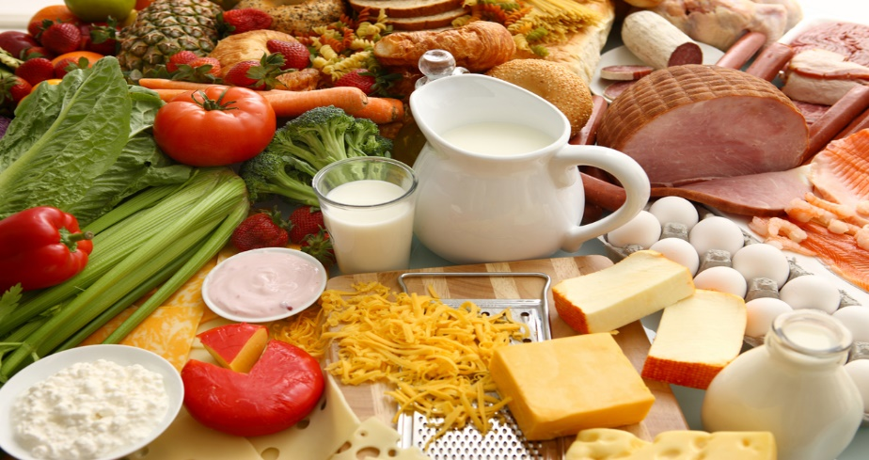

Nowadays, people are getting busier, so we have a tendency to eat more fast food than before. In addition to this, many kinds of transportation have increased in use, making us less active. This has bad effects on our body such as: getting fat, increased disease, and so on. Because of this threat, we have to change our way of eating, and make a healthy eating plan to improve our health immediately.

# BODY

* Now, ask yourself: “**What is a healthy eating plan**?” - A healthy eating plan is a plan which is set to reach goals in the way you eat healthy food. So, **how do you think about a healthy eating plan**? - A healthy eating plan gives your body the nutrients it needs every day and maintains or improves overall health.
* **My healthy eating plan:**

+ Firstly, **make a plan**, a detailed plan. Ask yourself the following question:

* 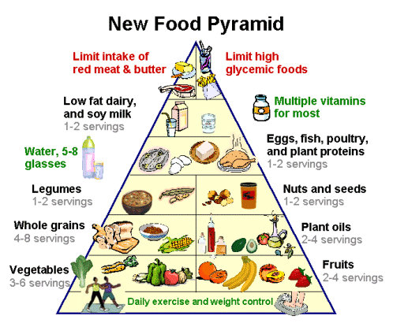**What changes can I make to the way I eat?** For example: I’m very busy so I eat fast food almost every day. The solution is you should cook your food the previous night and store it in the fridge.
* 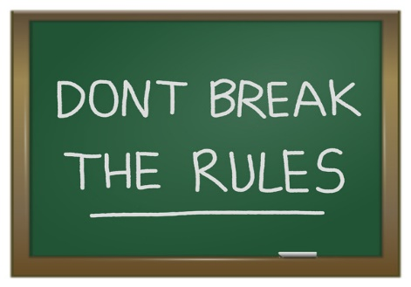**How can I maintain these changes?** Set an alarm and make a promise to yourself. Find yourself a motivation and DO NOT break the rules you’ve made.
* 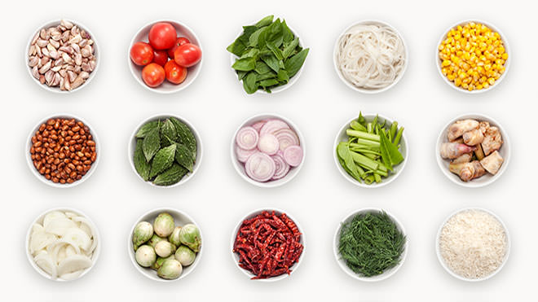**How can I not be influenced by my surroundings?** DO NOT let others weaken you. Just don’t let yourself desire for those full of calories and unhealthy food. Be tough and be wide.

+ Secondly, **getting started.**

* 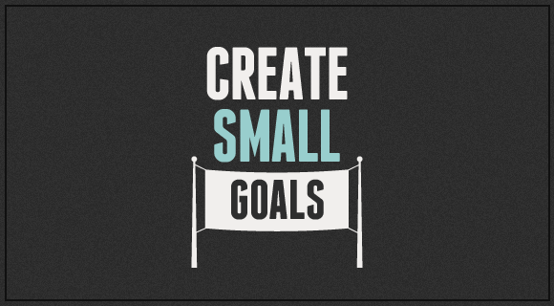**Set small but practical goals** which are easy to stick to them. You should reduce the amount of calories your body consumes by eating more salad and less carbohydrates. Despite of small goals, they help you a lot.
* 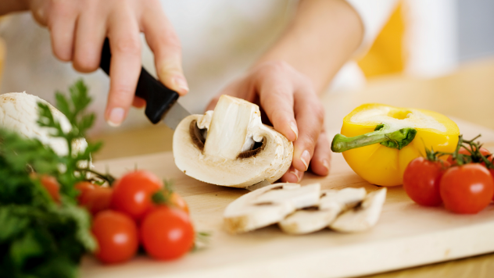**Start small step** such as cook food which is healthy but you will enjoy. It won’t take much time. For instance: you cook your favorite soup with sea food and a fillet of fish. It’s easy to cook but very healthy and less calories.
* 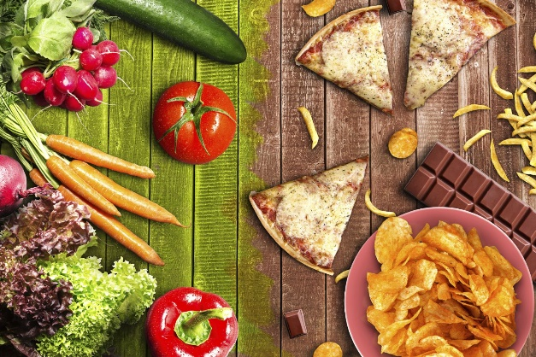**There will be some challenges** when following a healthy eating plan. So, be strong and overcome these. Look for some tips on how to maintain a healthy diet. I will give you a tip: cut down on fat and sugar such as: butter, cream, sausages.

+Thirdly, **reflect.**



* **Look at all the changes you have made.** These may be small but helpful? It needs time, not just a couple of days, be patient.
* **Reflect on what you have done**, NOT what you have not. When follow a plan, you need a lot of motivation so don’t reflect on things that will discourage you. Don’t reflect on how hard you have tried, just think about all the wonderful things after you lose weight like: you have hot body that others will admire, for instance.

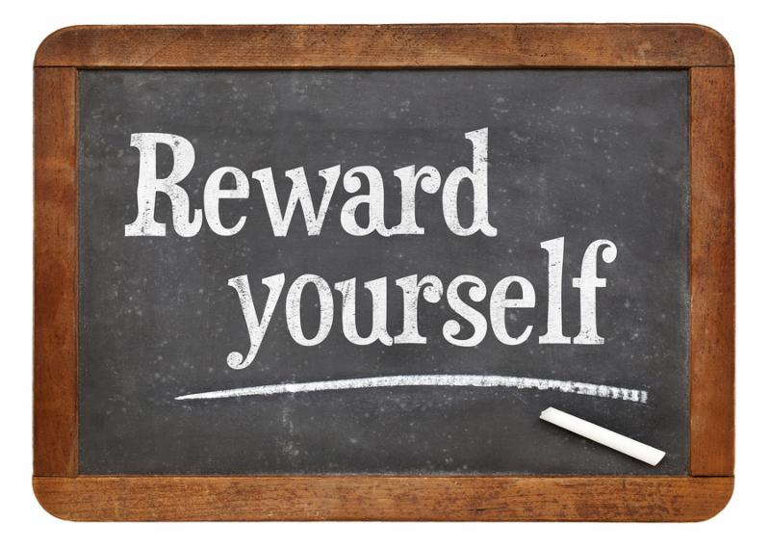

* **Reward yourself** whenever you have achieved a goal. Instead of eating what you like as a reward, just do something you like, it will motivate you a lot.
* Last but not least, **set yourself a new healthy plan**. Like Winston Churchill quotes: “To improve is to change; to be perfect is to change often."
* One of the most important things when on a diet: **DO NOT give up your favorite comfort food** to maintain a healthy weight. If you do this, you will feel a lot of pressure and this will discourage you. You had better eat what you like in a better way as I have mentioned above.

**CONCLUSION:**



To have a healthy lifestyle, we must first change our eating habits. A healthy eating plan will help us a lot in our lives, such as: decreasing diseases, maintaining good health, having a longer human life span and so on. It may not be easy but it is helpful. As long as we can maintain our healthy diet, our body will change significantly. In conclusion, food is only good for us when we eat it in the right way. Keep eating good food; good health will come to us.

The end.

Thanks for reading !!!