Step 1  – Create new Android project.

Provide Activity name as **SQLiteApp**as shown below

**[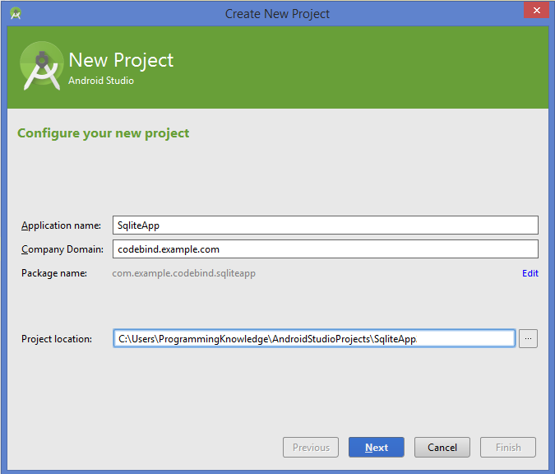](http://www.codebind.com/wp-content/uploads/2016/08/Android-SQLite-Database-Tutorial-1.png)**Android SQLite Database Tutorial . Create Project

Step 2 – Add components in the main activity as shown in the picture below.

**[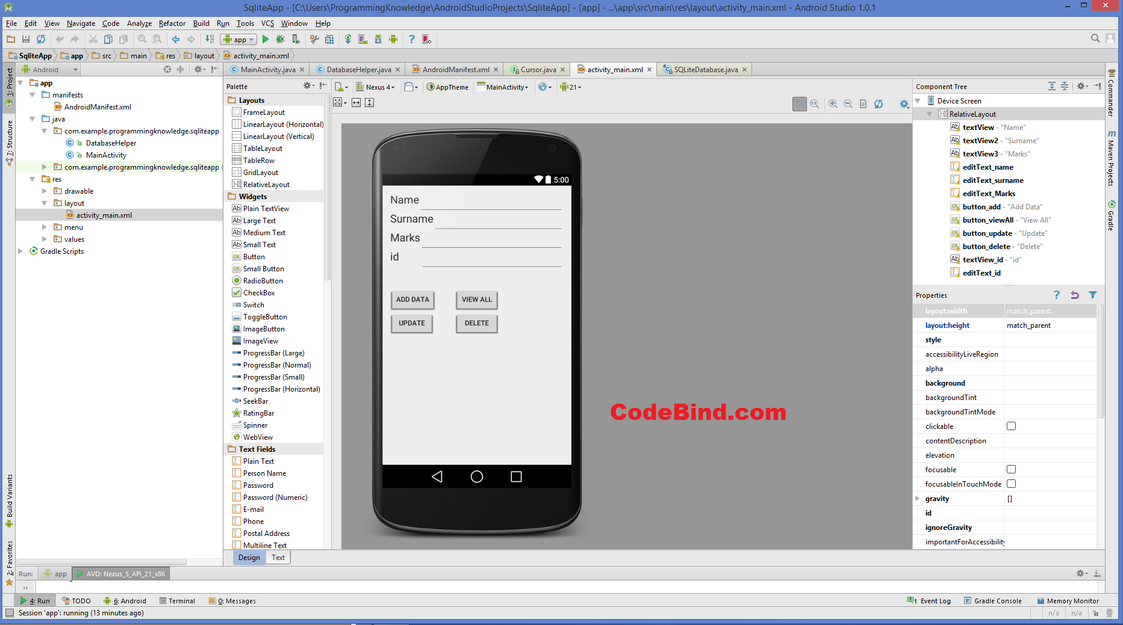](http://www.codebind.com/wp-content/uploads/2016/08/Android-SQLite-Database-Tutorial.-Design-Activity.png)**Android SQLite Database Tutorial. Design Activity

**\AndroidStudioProjects\SqliteApp\app\src\main\res\layout\activity_main.xml**



|  |  |
| --- | --- |
| 1  2  3  4  5  6  7  8  9  10  11  12  13  14  15  16  17  18  19  20  21  22  23  24  25  26  27  28  29  30  31  32  33  34  35  36  37  38  39  40  41  42  43  44  45  46  47  48  49  50  51  52  53  54  55  56  57  58  59  60  61  62  63  64  65  66  67  68  69  70  71  72  73  74  75  76  77  78  79  80  81  82  83  84  85  86  87  88  89  90  91  92  93  94  95  96  97  98  99  100  101  102  103  104  105  106  107  108  109  110  111  112  113  114  115  116  117  118 | <RelativeLayout xmlns:android="http://schemas.android.com/apk/res/android"      xmlns:tools="http://schemas.android.com/tools" android:layout_width="match_parent"      android:layout_height="match_parent" android:paddingLeft="@dimen/activity_horizontal_margin"      android:paddingRight="@dimen/activity_horizontal_margin"      android:paddingTop="@dimen/activity_vertical_margin"      android:paddingBottom="@dimen/activity_vertical_margin" tools:context=".MainActivity">        <TextView          android:layout_width="wrap_content"          android:layout_height="wrap_content"          android:textAppearance="?android:attr/textAppearanceLarge"          android:text="Name"          android:id="@+id/textView"          android:layout_alignParentTop="true"          android:layout_alignParentLeft="true"          android:layout_alignParentStart="true" />        <TextView          android:layout_width="wrap_content"          android:layout_height="wrap_content"          android:textAppearance="?android:attr/textAppearanceLarge"          android:text="Surname"          android:id="@+id/textView2"          android:layout_below="@+id/editText_name"          android:layout_alignParentLeft="true"          android:layout_alignParentStart="true" />        <TextView          android:layout_width="wrap_content"          android:layout_height="wrap_content"          android:textAppearance="?android:attr/textAppearanceLarge"          android:text="Marks"          android:id="@+id/textView3"          android:layout_below="@+id/editText_surname"          android:layout_alignParentLeft="true"          android:layout_alignParentStart="true" />        <EditText          android:layout_width="match_parent"          android:layout_height="wrap_content"          android:id="@+id/editText_name"          android:layout_alignTop="@+id/textView"          android:layout_toRightOf="@+id/textView"          android:layout_toEndOf="@+id/textView" />        <EditText          android:layout_width="match_parent"          android:layout_height="wrap_content"          android:id="@+id/editText_surname"          android:layout_alignTop="@+id/textView2"          android:layout_toRightOf="@+id/textView2"          android:layout_toEndOf="@+id/textView2" />        <EditText          android:layout_width="match_parent"          android:layout_height="wrap_content"          android:id="@+id/editText_Marks"          android:layout_below="@+id/editText_surname"          android:layout_toRightOf="@+id/textView3"          android:layout_toEndOf="@+id/textView3" />        <Button          android:layout_width="wrap_content"          android:layout_height="wrap_content"          android:text="Add Data"          android:id="@+id/button_add"          android:layout_below="@+id/editText_Marks"          android:layout_alignParentLeft="true"          android:layout_alignParentStart="true"          android:layout_marginTop="76dp" />        <Button          android:layout_width="wrap_content"          android:layout_height="wrap_content"          android:text="View All"          android:id="@+id/button_viewAll"          android:layout_above="@+id/button_update"          android:layout_centerHorizontal="true" />        <Button          android:layout_width="wrap_content"          android:layout_height="wrap_content"          android:text="Update"          android:id="@+id/button_update"          android:layout_below="@+id/button_add"          android:layout_alignParentLeft="true"          android:layout_alignParentStart="true" />          <Button          android:layout_width="wrap_content"          android:layout_height="wrap_content"          android:text="Delete"          android:id="@+id/button_delete"          android:layout_centerVertical="true"          android:layout_below="@+id/button_viewAll"          android:layout_alignLeft="@+id/button_viewAll"          android:layout_alignStart="@+id/button_viewAll" />        <TextView          android:layout_width="wrap_content"          android:layout_height="wrap_content"          android:textAppearance="?android:attr/textAppearanceLarge"          android:text="id"          android:id="@+id/textView_id"          android:layout_below="@+id/editText_Marks"          android:layout_alignParentLeft="true"          android:layout_alignParentStart="true" />        <EditText          android:layout_width="match_parent"          android:layout_height="wrap_content"          android:id="@+id/editText_id"          android:layout_alignTop="@+id/textView_id"          android:layout_toRightOf="@+id/textView3"          android:layout_toEndOf="@+id/textView3" />    </RelativeLayout> |

Step 3 – Now create a new Java class called **DatabaseHelper.java**.

**[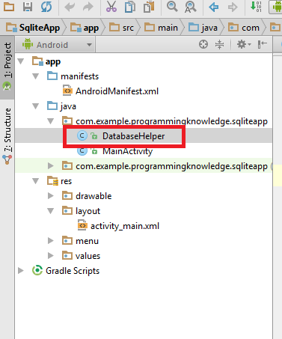](http://www.codebind.com/wp-content/uploads/2016/08/Android-SQLite-Database-Tutorial.-DatabaseHelper.png)**Android SQLite Database Tutorial. DatabaseHelper

Add the following code in this class to **DatabaseHelper.java**



|  |  |
| --- | --- |
| 1  2  3  4  5  6  7  8  9  10  11  12  13  14  15  16  17  18  19  20  21  22  23  24  25  26  27  28  29  30  31  32  33  34  35  36  37  38  39  40  41  42  43  44  45  46  47  48  49  50  51  52  53  54  55  56  57  58  59  60  61  62  63  64  65  66  67  68  69 | package com.example.programmingknowledge.sqliteapp;    import android.content.ContentValues;  import android.content.Context;  import android.database.Cursor;  import android.database.sqlite.SQLiteDatabase;  import android.database.sqlite.SQLiteOpenHelper;    /**  * Created by ProgrammingKnowledge on 4/3/2015.  */  public class DatabaseHelper extends SQLiteOpenHelper {      public static final String DATABASE_NAME = "Student.db";      public static final String TABLE_NAME = "student_table";      public static final String COL_1 = "ID";      public static final String COL_2 = "NAME";      public static final String COL_3 = "SURNAME";      public static final String COL_4 = "MARKS";        public DatabaseHelper(Context context) {          super(context, DATABASE_NAME, null, 1);      }    *@Override*      public void onCreate(SQLiteDatabase db) {          db.execSQL("create table " + TABLE_NAME +" (ID INTEGER PRIMARY KEY AUTOINCREMENT,NAME TEXT,SURNAME TEXT,MARKS INTEGER)");      }    *@Override*      public void onUpgrade(SQLiteDatabase db, int oldVersion, int newVersion) {          db.execSQL("DROP TABLE IF EXISTS "+TABLE_NAME);          onCreate(db);      }        public boolean insertData(String name,String surname,String marks) {          SQLiteDatabase db = this.getWritableDatabase();          ContentValues contentValues = new ContentValues();          contentValues.put(COL_2,name);          contentValues.put(COL_3,surname);          contentValues.put(COL_4,marks);          long result = db.insert(TABLE_NAME,null ,contentValues);          if(result == -1)              return false;          else              return true;      }        public Cursor getAllData() {          SQLiteDatabase db = this.getWritableDatabase();          Cursor res = db.rawQuery("select * from "+TABLE_NAME,null);          return res;      }        public boolean updateData(String id,String name,String surname,String marks) {          SQLiteDatabase db = this.getWritableDatabase();          ContentValues contentValues = new ContentValues();          contentValues.put(COL_1,id);          contentValues.put(COL_2,name);          contentValues.put(COL_3,surname);          contentValues.put(COL_4,marks);          db.update(TABLE_NAME, contentValues, "ID = ?",new String[] { id });          return true;      }        public Integer deleteData (String id) {          SQLiteDatabase db = this.getWritableDatabase();          return db.delete(TABLE_NAME, "ID = ?",new String[] {id});      }  } |

**MainActivity.java**



|  |  |
| --- | --- |
| 1  2  3  4  5  6  7  8  9  10  11  12  13  14  15  16  17  18  19  20  21  22  23  24  25  26  27  28  29  30  31  32  33  34  35  36  37  38  39  40  41  42  43  44  45  46  47  48  49  50  51  52  53  54  55  56  57  58  59  60  61  62  63  64  65  66  67  68  69  70  71  72  73  74  75  76  77  78  79  80  81  82  83  84  85  86  87  88  89  90  91  92  93  94  95  96  97  98  99  100  101  102  103  104  105  106  107  108  109  110  111  112  113  114  115  116  117  118  119  120  121  122  123  124  125  126  127  128  129  130  131  132  133  134  135  136  137  138  139  140  141  142  143  144  145  146 | package com.example.programmingknowledge.sqliteapp;    import android.app.AlertDialog;  import android.database.Cursor;  import android.support.v7.app.ActionBarActivity;  import android.os.Bundle;  import android.view.Menu;  import android.view.MenuItem;  import android.view.View;  import android.widget.Button;  import android.widget.EditText;  import android.widget.Toast;      public class MainActivity extends ActionBarActivity {      DatabaseHelper myDb;      EditText editName,editSurname,editMarks ,editTextId;      Button btnAddData;      Button btnviewAll;      Button btnDelete;        Button btnviewUpdate;  *@Override*      protected void onCreate(Bundle savedInstanceState) {          super.onCreate(savedInstanceState);          setContentView(R.layout.activity_main);          myDb = new DatabaseHelper(this);            editName = (EditText)findViewById(R.id.editText_name);          editSurname = (EditText)findViewById(R.id.editText_surname);          editMarks = (EditText)findViewById(R.id.editText_Marks);          editTextId = (EditText)findViewById(R.id.editText_id);          btnAddData = (Button)findViewById(R.id.button_add);          btnviewAll = (Button)findViewById(R.id.button_viewAll);          btnviewUpdate= (Button)findViewById(R.id.button_update);          btnDelete= (Button)findViewById(R.id.button_delete);          AddData();          viewAll();          UpdateData();          DeleteData();      }      public void DeleteData() {          btnDelete.setOnClickListener(                  new View.OnClickListener() {  *@Override*                      public void onClick(View v) {                          Integer deletedRows = myDb.deleteData(editTextId.getText().toString());                          if(deletedRows > 0)                              Toast.makeText(MainActivity.this,"Data Deleted",Toast.LENGTH_LONG).show();                          else                              Toast.makeText(MainActivity.this,"Data not Deleted",Toast.LENGTH_LONG).show();                      }                  }          );      }      public void UpdateData() {          btnviewUpdate.setOnClickListener(                  new View.OnClickListener() {  *@Override*                      public void onClick(View v) {                          boolean isUpdate = myDb.updateData(editTextId.getText().toString(),                                  editName.getText().toString(),                                  editSurname.getText().toString(),editMarks.getText().toString());                          if(isUpdate == true)                              Toast.makeText(MainActivity.this,"Data Update",Toast.LENGTH_LONG).show();                          else                              Toast.makeText(MainActivity.this,"Data not Updated",Toast.LENGTH_LONG).show();                      }                  }          );      }      public  void AddData() {          btnAddData.setOnClickListener(                  new View.OnClickListener() {  *@Override*                      public void onClick(View v) {                         boolean isInserted = myDb.insertData(editName.getText().toString(),                                  editSurname.getText().toString(),                                  editMarks.getText().toString() );                          if(isInserted == true)                              Toast.makeText(MainActivity.this,"Data Inserted",Toast.LENGTH_LONG).show();                          else                              Toast.makeText(MainActivity.this,"Data not Inserted",Toast.LENGTH_LONG).show();                      }                  }          );      }        public void viewAll() {          btnviewAll.setOnClickListener(                  new View.OnClickListener() {  *@Override*                      public void onClick(View v) {                         Cursor res = myDb.getAllData();                          if(res.getCount() == 0) {                              // show message                              showMessage("Error","Nothing found");                              return;                          }                            StringBuffer buffer = new StringBuffer();                          while (res.moveToNext()) {                              buffer.append("Id :"+ res.getString(0)+"\n");                              buffer.append("Name :"+ res.getString(1)+"\n");                              buffer.append("Surname :"+ res.getString(2)+"\n");                              buffer.append("Marks :"+ res.getString(3)+"\n\n");                          }                            // Show all data                          showMessage("Data",buffer.toString());                      }                  }          );      }        public void showMessage(String title,String Message){          AlertDialog.Builder builder = new AlertDialog.Builder(this);          builder.setCancelable(true);          builder.setTitle(title);          builder.setMessage(Message);          builder.show();      }      *@Override*      public boolean onCreateOptionsMenu(Menu menu) {          // Inflate the menu; this adds items to the action bar if it is present.          getMenuInflater().inflate(R.menu.menu_main, menu);          return true;      }    *@Override*      public boolean onOptionsItemSelected(MenuItem item) {          // Handle action bar item clicks here. The action bar will          // automatically handle clicks on the Home/Up button, so long          // as you specify a parent activity in AndroidManifest.xml.          int id = item.getItemId();            //noinspection SimplifiableIfStatement          if (id == R.id.action_settings) {              return true;          }            return super.onOptionsItemSelected(item);      }  } |

OUTPUT

**[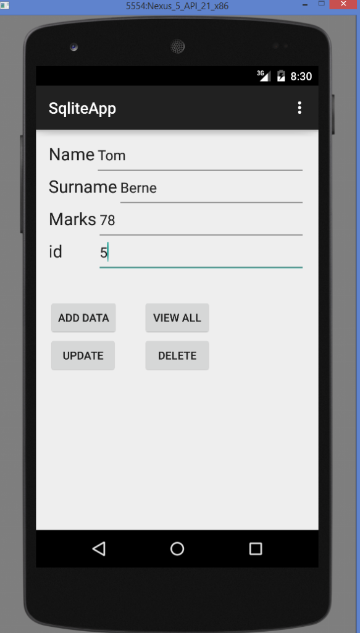](http://www.codebind.com/wp-content/uploads/2016/08/Android-SQLite-Database-Tutorial.-Add-Data.png)**Android SQLite Database Tutorial. Add Data**[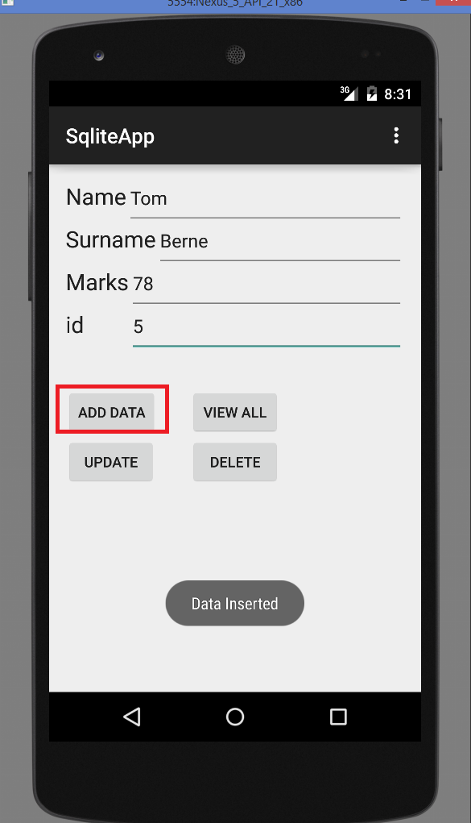](http://www.codebind.com/wp-content/uploads/2016/08/Android-SQLite-Database-Tutorial.-Data-Successfully-added-to-sqlite-database.png)**Android SQLite Database Tutorial. Data Successfully added to sqlite database

**[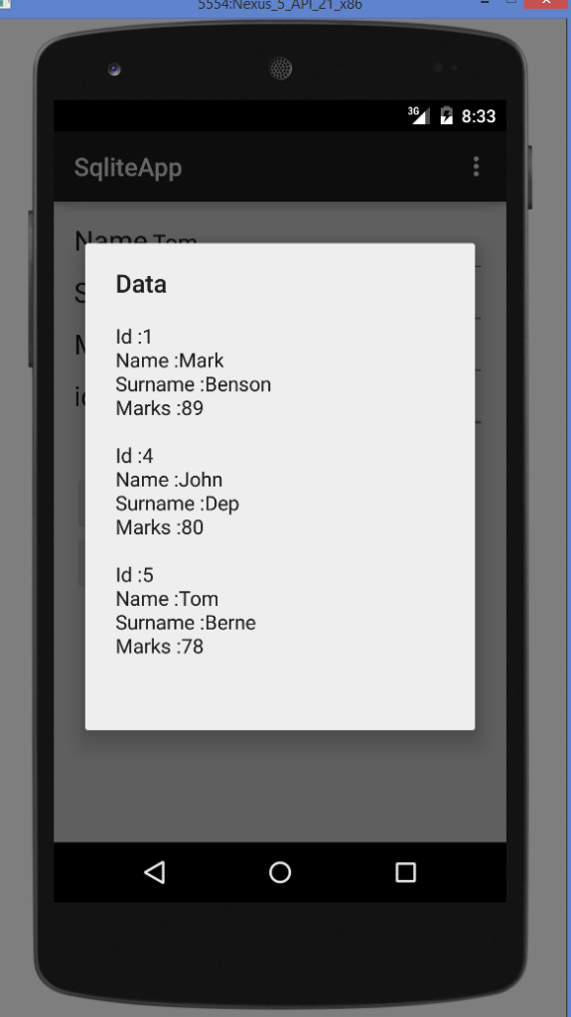](http://www.codebind.com/wp-content/uploads/2016/08/Android-SQLite-Database-Tutorial.-View-Data.png)**