Software Requirements Specification

for

Online phone shopping system

Version 1.0 approved

Prepared by NGUYEN DUC THIEN

SE1209

21/02/2019

Table of Contents

Table of Contents ii

Revision History ii

1. Introduction 2

1.1 Purpose 2

1.2 Document Conventions 2

1.3 Project Scope 2

1.4 References 2

2. Overall Description 2

2.1 Product Perspective 2

2.2 User Classes and Characteristics 2

2.3 Operating Environment 2

2.4 Design and Implementation Constraints 2

2.5 Assumptions and Dependencies 2

3. System Features 2

3.1 System Feature 1 2

3.2 System Feature 2 (and so on) 2

4. External Interface Requirements 2

5.1 User Interfaces 2

5.2 Software Interfaces 2

5.3 Hardware Interfaces 2

5.4 Communications Interfaces 2

5. Quality Attributes 2

6.1 Usability 2

6.2 Performance 2

6.3 Security 2

6.4 Safety 2

6.5 [Others as relevant] 2

6. Internationalization and Localization Requirements 2

# Introduction

## Purpose

The purpose of this document is to present a detailed description of the Online phone shopping system. It will explain the purpose and features of the system, the interfaces of the system, what the system will do, the constraints under which it must operate and how the system will react to external stimuli.

## Document Conventions

|  |  |
| --- | --- |
| **Acronym** | **Meaning** |
| OPS | Online Phone Store |
| HTTPS | Hypertext Transfer Protocol Secure |

## Project Scope

This software system will be an OPS for everybody and this system will be designed to maximize the sale’s productivity.

More specifically, this system is designed to allow a seller to manage, upload their products and communicate with customer to help them choose a product, Adequate searching mechanisms for easy and quick access to particular products and services, Creating a Shopping cart so that customers can shop ‘n’ no. of items and checkout finally with the entire shopping carts. Customers can add or delete items in the cart, Shop employees are responsible for internal affairs like processing orders, assure home delivery, getting customer's delivery-time feedback, updating order's status and answering client's queries online, Feedback mechanism, so that customers can give feedback for the product or service which they have purchased. Also facility rating of individual products by relevant customers, Adequate payment mechanism and gateway for all popular credit cards and other relevant payment options, as available from time to time, Dynamic price model by which prices can be changed based on demand and supply. The software will facilitate communication between Sales and customer via E-Mail. The system also contains a relational database containing a list of Products, Users, manufacturers,...etc.

## References

This document is completed based on the Software Requirements Specification Template on the FPT University CMS website of SWR302

# Overall Description

## Product Perspective

OPS is aimed common people who want to buy a new phone or phone accessories. This project envisages bridging the gap between the seller, manufacturer and the customer. OPS should be user-friendly. It will run on any web platform.

## User Classes and Characteristics

# Customers

# The user should be familiar with using tablets, laptops and other devices.

* The user should be familiar with the Shopping Mall related terminology like Shopping cart/Checking out/Transaction etc.
* The user should be familiar with the Internet.

# Administrator

# Administrator should be familiar with using tablets, laptops and other devices.

* Administratorshould be familiar with the Shopping Mall related terminology like Shopping cart/Checking out/Transaction etc.
* Administratorcan use admin page manage order , user,…etc.

# Manager

# Manager should be familiar with using tablets, laptops and other devices.

* Managershould be familiar with the Shopping Mall related terminology like Shopping cart/Checking out/Transaction etc.
* Managercan use Managerpage to upload, update,…etc. about product.

## Operating Environment

The OPS is a website that shall operate in all famous browsers like Google Chrome, Coc Coc, Internet Explorer, Safari, Opera, for a model we are taking Google Chrome.

* Main programming language: C# with ASP.NET.
* Display: HTML, CSS.
* IDE:
  + Microsoft visual studio 2015
  + .NET framework 3.5
  + Sublime Text version 3.1.1
  + Visual studio code version 1.23
* Database: query use Microsoft SQL Server Management Studio version 17.
* Project workspace, source code: GitHub.

## Design and Implementation Constraints

* Language requirements: the website must be multilingual, including the following languages: English, Vietnamese.
* The website can use on any device: mobile, laptop, tablet.

## Assumptions and Dependencies

N/A

# System Features

|  |  |  |
| --- | --- | --- |
| **ID** | **Actor** | **Name** |
| UC-1 | Guest | Register new account |
| UC-2 | Guest, Admin, Manager | Login |
| UC-3 | Guest | Sign in with Google account |
| UC-4 | Guest | Sign in with Facebook account |
| UC-5 | Guest | Forgot password |
| UC-6 | Guest, User | Search Products by keywords |
| UC-7 | Guest, User | Add to cart |
| UC-8 | Guest, User | View shopping cart |
| UC-9 | Guest, User | Edit quantity of each product in shopping cart |
| UC-10 | Guest, User | Delete item in shopping cart |
| UC-11 | Guest, User | Add shipping information |
| UC-12 | Guest, User | Add payment information |
| UC-13 | Guest, User | Payment |
| UC-14 | Guest, User | Tracking order |
| UC-15 | User, Admin, Manager | Sign out |
| UC-16 | Manager | Upload Product |
| UC-17 | Manager | Update Product |
| UC-18 | User | View profile |
| UC-19 | User, Manager | Change password |
| UC-20 | User | Update basic information |
| UC-21 | User | Update bank account information |
| UC-22 | User | Change status of design |
| UC-23 | User, Manager | View User’s orders |
| UC-24 | User, Manager | View order's detail |
| UC-25 | Admin | Manage all user |
| UC-26 | Admin | Ban user |
| UC-27 | Admin | View user's detail information |
| UC-28 | Admin, Manager | Manage order's detail |
| UC-29 | System | Send email that has password recover information's link |

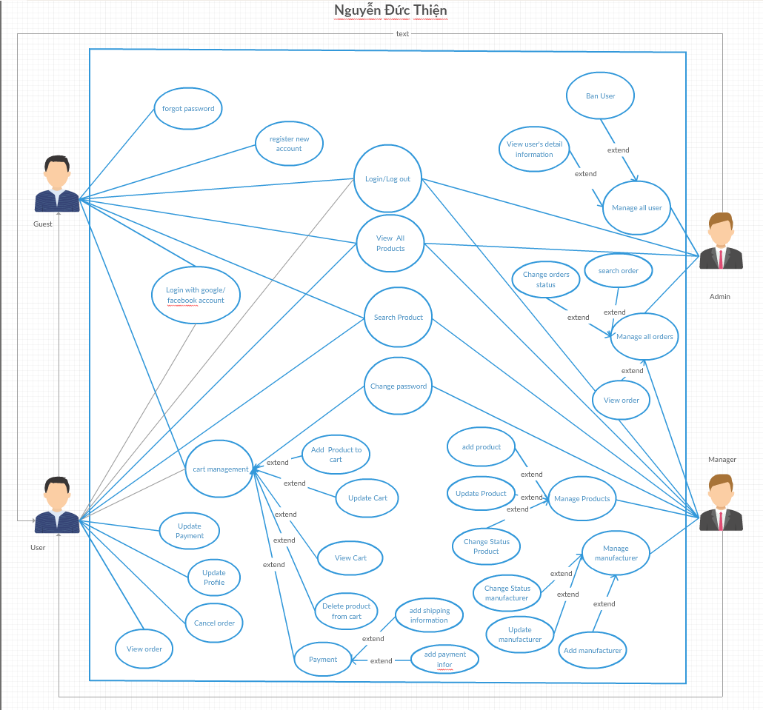

|  |  |  |  |  |
| --- | --- | --- | --- | --- |
| **Function** | **Guest** | **User** | **Manager** | **Admin** |
| Login | **v** | **v** | **v** | v |
| Login with google/Facebook | v | **v** |  |  |
| Register | v |  |  |  |
| Logout |  | **v** | **v** | **v** |
| Forgot password | v | v |  |  |
| View profile |  | v |  |  |
| Update profile |  | v |  |  |
| Change password |  | v | v | v |
| Search products | v | v | v |  |
| Update Users information |  | v |  |  |
| Add product to cart | v | v |  |  |
| Delete products in shopping cart | v | v |  |  |
| View cart | v | v |  |  |
| Edit number of each product in cart | v | v |  |  |
| Update Payment |  | v |  |  |
| Add payment info | v | v |  |  |
| Add shipping info | v | v |  |  |
| Tracking order | v | v |  |  |
| Upload product |  |  | v |  |
| Update product |  |  | v |  |
| Change status product |  |  | v |  |
| Upload manufacturer |  |  | v |  |
| Update manufacturer |  |  | v |  |
| Change status manufacturer |  |  | v |  |
| View user’s order |  | v | v |  |
| Change status order |  |  | v |  |

## Register new account

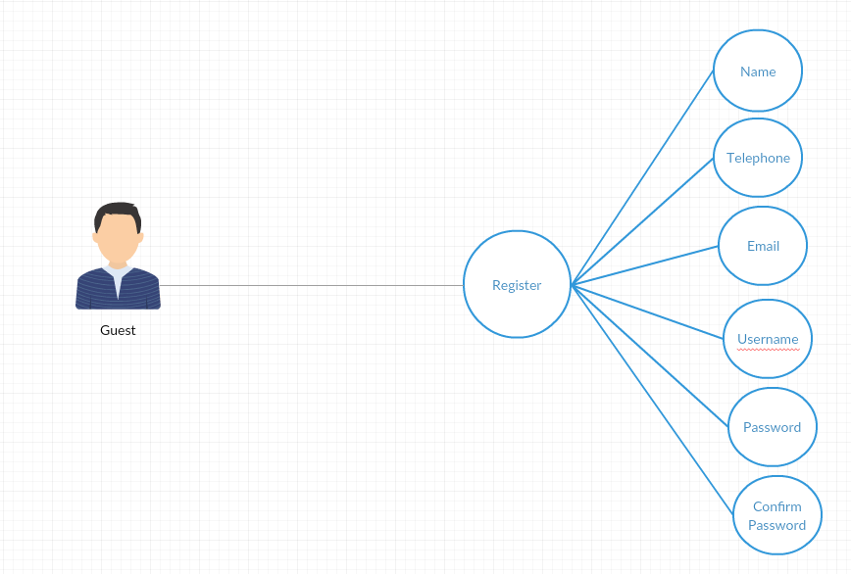

### Screen Design

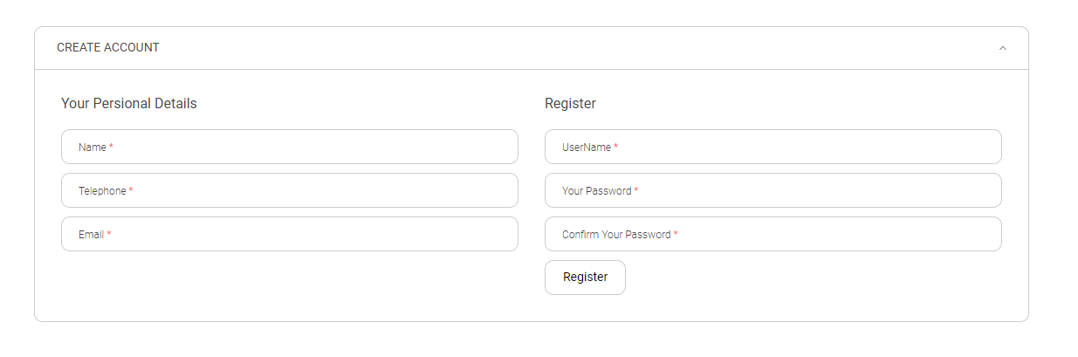

### Screen Definition

|  |  |  |  |  |  |
| --- | --- | --- | --- | --- | --- |
| **STT** | **Field Name** | **Type** | **Mandatory** | **Max Length** | **Description** |
| 1 | User Name | Text | Yes | 20 |  |
| 2 | Password | Password | Yes | 20 | Display "*" instead of clear character |
| 3 | Confirm Password | Password | Yes | 20 | Display "*" instead of clear character |
| 4 | Name | Text | Yes | 30 |  |
| 5 | Email | Email | Yes | 30 |  |
| 6 | Phone | Text | yes | 20 |  |
| 7 | submit | Button |  |  | submit data to server |

### Use case Specification

|  |  |  |  |
| --- | --- | --- | --- |
| UC ID and Name: | UC01_Register new account | | |
| Created By: | Thienndse05883 | Date Created: | 21/01/2019 |
| Primary Actor: | Guest | Secondary Actors: | User |
| Trigger: | Guest click on submit button | | |
| Description: | From Login pages, Guest click on register button and input all textbox to create account | | |
| Preconditions: | 1. Guest go to Home Page 2. Click on Register button 3. Fill info into all textbox 4. Click on submit button | | |
| Post conditions: | Validate data  Display register success or fail  Forward to home page | | |
| Normal Flow: | |  |  |  | | --- | --- | --- | | Step | Actor | Action | | 1 | Guest | Click on register button from home page | | 2 | System | Show Register Form | | 3 | Guest | Fill info into all textbox and click on submit button | | 4 | System | Validate data if ok show register success and Forward to home page else show wrong info | | | |
| Alternative Flows: | At step 3 if have any textbox is empty, the system will display “you must fill info into all textbox ” | | |
| Exceptions: | 1. Can’t connect with server | | |
| Priority: | Medium | | |
| Frequency of Use: | When guest want to have an account. | | |
| Business Rules: | N/A | | |
| Other Information: | N/A | | |
| Assumptions: | N/A | | |

## Login

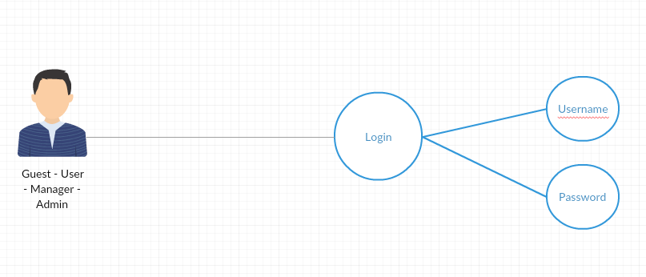

### Screen Design

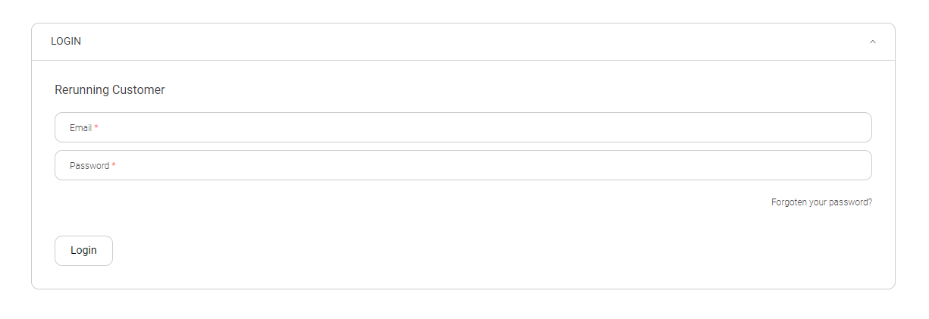

### Screen Denfinition

|  |  |  |  |  |  |
| --- | --- | --- | --- | --- | --- |
| **STT** | **Field Name** | **Type** | **Mandatory** | **Max Length** | **Description** |
| 1 | User Name | Text | Yes | 20 |  |
| 2 | Password | Text | Yes | 20 | Display "*" instead of clear character |
| 3 | Login | Button |  |  | Go to home page |

### Use case Specification

|  |  |  |  |
| --- | --- | --- | --- |
| UC ID and Name: | UC02_Login | | |
| Created By: | Thienndse05883 | Date Created: | 21/01/2019 |
| Primary Actor: | Guest | Secondary Actors: | User |
| Trigger: | Guest click on submit button | | |
| Description: | From Login pages, Guest click on Login button | | |
| Preconditions: | 1. Guest go to Home Page 2. Click on Login button 3. Fill info into all textbox 4. Click on submit button | | |
| Post conditions: | Validate data  Display Login success or fail  Forward to home page | | |
| Normal Flow: | |  |  |  | | --- | --- | --- | | Step | Actor | Action | | 1 | Guest | Click on Login button from home page | | 2 | System | Show Login Form | | 3 | Guest | Fill info into all textbox and click on Login button | | 4 | System | Validate data if ok show Login success and Forward to home page else show wrong info | | | |
| Alternative Flows: | At step 3 if have any textbox is empty, the system will display “you must fill info into all textbox ” | | |
| Exceptions: | 1. Can’t connect with server | | |
| Priority: | Medium | | |
| Frequency of Use: | When guest want to Login page | | |
| Business Rules: | N/A | | |
| Other Information: | N/A | | |
| Assumptions: | N/A | | |

## Login with google account

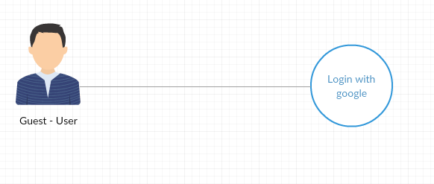

### Screen Design

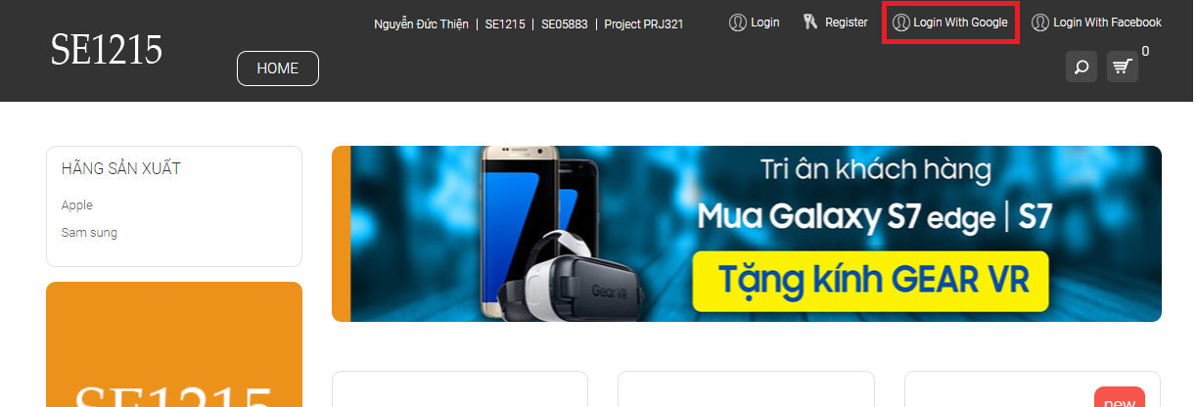

### Screen Denfinition

|  |  |  |  |  |  |
| --- | --- | --- | --- | --- | --- |
| **STT** | **Field Name** | **Type** | **Mandatory** | **Max Length** | **Description** |
| 1 | Login | Button |  |  | Go to Google and get info form Google |

### Use case Specification

|  |  |  |  |
| --- | --- | --- | --- |
| UC ID and Name: | UC03_Login With Google Account | | |
| Created By: | Thienndse05883 | Date Created: | 21/01/2019 |
| Primary Actor: | Guest | Secondary Actors: | User |
| Trigger: | Guest click on Login with google button | | |
| Description: | From Login pages, Guest click on Login with google button | | |
| Preconditions: | 1. Guest go to Home Page   2 Click on Login with google button | | |
| Post conditions: | 1. Get data and access rights google 2. Display Login success or fail 3. Forward to home page | | |
| Normal Flow: | |  |  |  | | --- | --- | --- | | Step | Actor | Action | | 1 | Guest | Click on Login button from home page | | 2 | System | Show Login Form | | 3 | Guest | Click on login with google button | | 4 | System | Using google login API | | 5 | Guest | Click on accept button | | 6 | System | Get info of user and Forward to home page | | | |
| Alternative Flows: | At step 5 if guest does not accept, the system will display “Login failed because we cant login your google account” | | |
| Exceptions: | 1. Can’t connect with server 2. Guest does not accept | | |
| Priority: | Medium | | |
| Frequency of Use: | When guest want to Login page | | |
| Business Rules: | N/A | | |
| Other Information: | N/A | | |
| Assumptions: | N/A | | |

## Login with facebook account

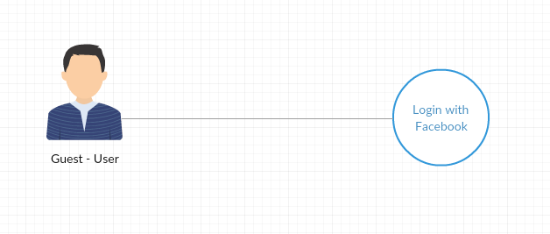

### Screen Design

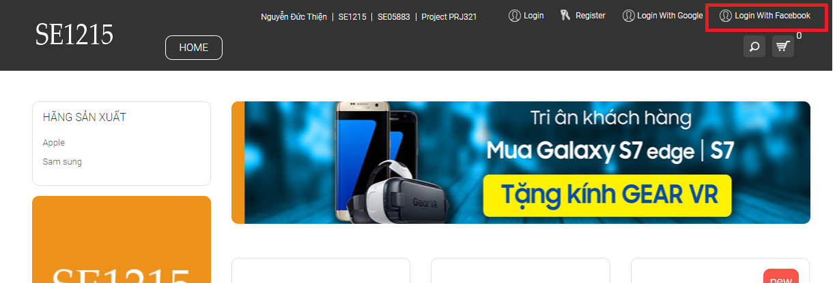

### Screen Definition

|  |  |  |  |  |  |
| --- | --- | --- | --- | --- | --- |
| **STT** | **Field Name** | **Type** | **Mandatory** | **Max Length** | **Description** |
| 1 | Login | Button |  |  | Go to Facebook and get info form Facebook |

### Use case Specification

|  |  |  |  |
| --- | --- | --- | --- |
| UC ID and Name: | UC04_Login With facebook Account | | |
| Created By: | Thienndse05883 | Date Created: | 21/01/2019 |
| Primary Actor: | Guest | Secondary Actors: | User |
| Trigger: | Guest click on Login with Facebook button | | |
| Description: | From Login pages, Guest click on Login with Facebook button | | |
| Preconditions: | 1. Guest go to Home Page   2 Click Login with Facebook button | | |
| Post conditions: | 1. Get data and access rights Facebook 2. Display Login success or fail 3. Forward to home page | | |
| Normal Flow: | |  |  |  | | --- | --- | --- | | Step | Actor | Action | | 1 | Guest | Click on Login button from home page | | 2 | System | Show Login Form | | 3 | Guest | Click on login with Facebook button | | 4 | System | Using Facebook login API | | 5 | Guest | Click on accept button | | 6 | System | Get info of user and Forward to home page | | | |
| Alternative Flows: | At step 5 if guest does not accept, the system will display “Login failed because we cant login your google account” | | |
| Exceptions: | 1. Can’t connect with server 2. Guest does not accept | | |
| Priority: | Medium | | |
| Frequency of Use: | When guest want to Login page | | |
| Business Rules: | N/A | | |
| Other Information: | N/A | | |
| Assumptions: | N/A | | |

## Forgot password

### Screen Design

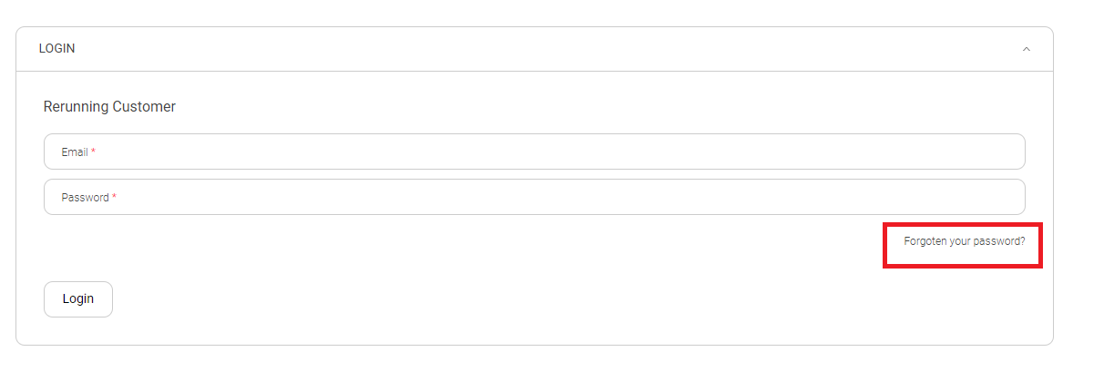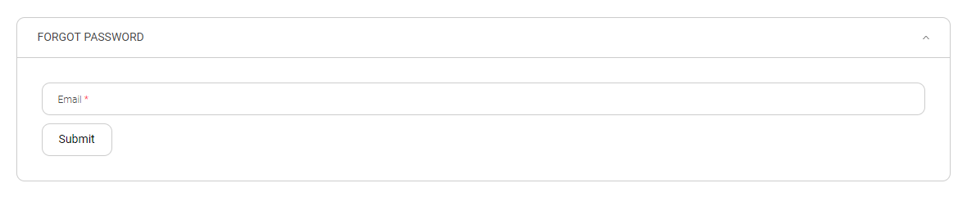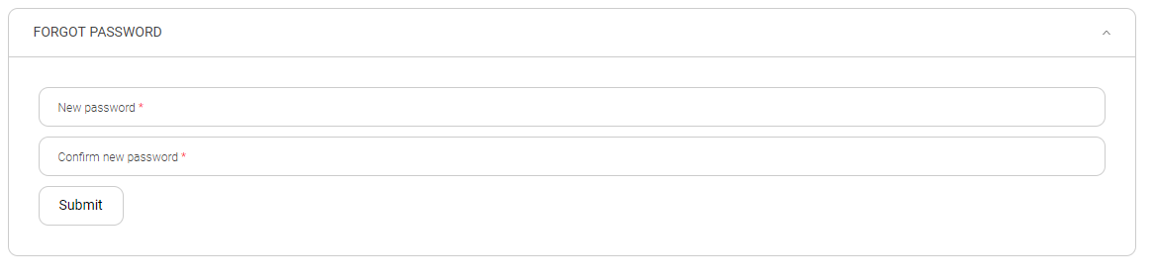

### Screen Denfinition

|  |  |  |  |  |  |
| --- | --- | --- | --- | --- | --- |
| **STT** | **Field Name** | **Type** | **Mandatory** | **Max Length** | **Description** |
| 1 | User Name | Text | Yes | 20 |  |
| 2 | New Password | Password | Yes | 20 | Display "*" instead of clear character |
| 3 | Confirm new Password | Password | Yes | 20 | Display "*" instead of clear character |
| 4 | Name | Text | Yes | 30 |  |
| 5 | Email | Email | Yes | 30 |  |
| 6 | submit | Button |  |  | submit data to server |

### Use case Specification

|  |  |  |  |
| --- | --- | --- | --- |
| UC ID and Name: | UC05_Forgot Password | | |
| Created By: | Thienndse05883 | Date Created: | 21/01/2019 |
| Primary Actor: | Guest | Secondary Actors: | User |
| Trigger: | Guest click on submit button | | |
| Description: | From Login pages, Guest click on forgot password button | | |
| Preconditions: | 1. Guest go to Login Page 2. Click on forgot password button 3. Enter nickname or email 4. Click submit 5. Go to email and click on the link in user’s email 6. Enter new password and confirm new password textbox 7. Click submit | | |
| Post conditions: | 1. validate token email 2. validate data password 3. display change password success or fail 4. forward to homepage | | |
| Normal Flow: | |  |  |  | | --- | --- | --- | | Step | Actor | Action | | 1 | Guest | Click on forgot password button from Login page | | 2 | System | Show forgot password Form | | 3 | Guest | Fill username or email and then Click on submit button | | 4 | System | Send link change password to user’s email | | 5 | User | Click on the link and enter new password and confirm new password after that click submit button | | 6 | System | Validate data if right change password for user else display wrong info | | | |
| Alternative Flows: | At step 5 if guest does not input anything to textbox, the system will display “don’t be Empty” | | |
| Exceptions: | 1. Can’t connect with server | | |
| Priority: | Medium | | |
| Frequency of Use: | When user want to reset password | | |
| Business Rules: | N/A | | |
| Other Information: | N/A | | |
| Assumptions: | N/A | | |

## Search Product

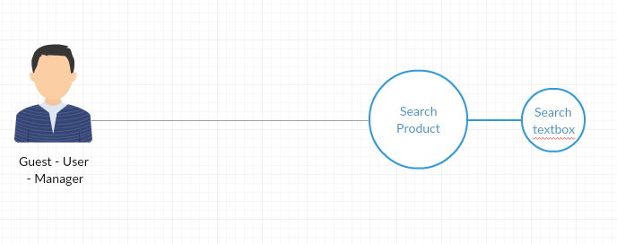

### Screen Design

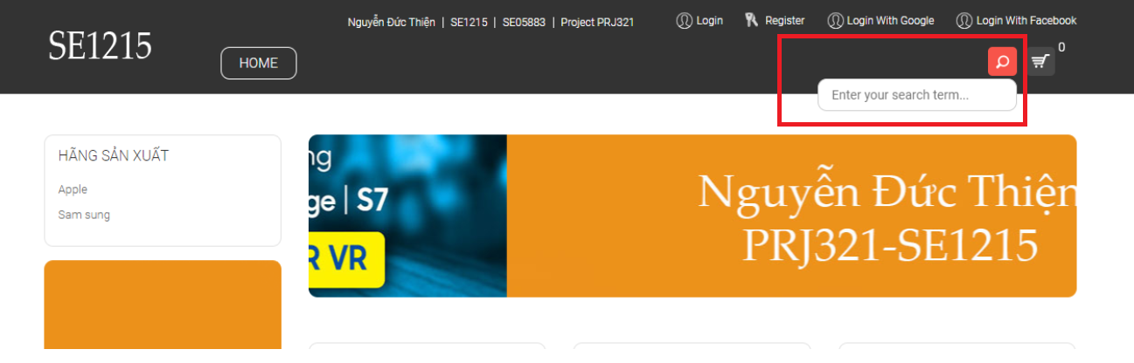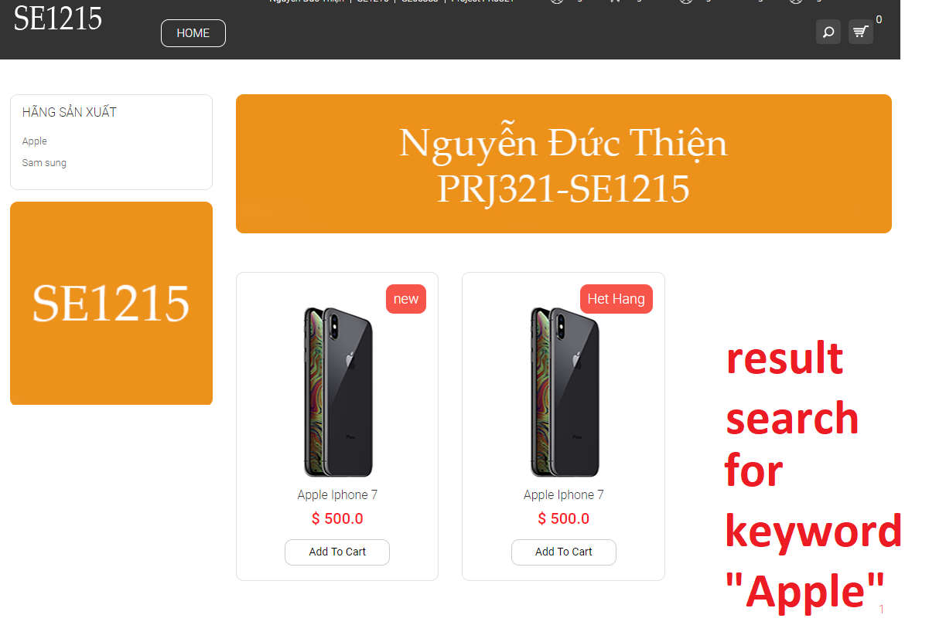

### Screen Definition

|  |  |  |  |  |  |
| --- | --- | --- | --- | --- | --- |
| **STT** | **Field Name** | **Type** | **Mandatory** | **Max Length** | **Description** |
| 1 | Name | Text | Yes | 50 |  |
| 2 | submit | Button |  |  | submit data to server |

### Use case Specification

|  |  |  |  |
| --- | --- | --- | --- |
| UC ID and Name: | UC06_Search Product | | |
| Created By: | Thienndse05883 | Date Created: | 21/01/2019 |
| Primary Actor: | Guest, User, Manager | Secondary Actors: | Guest, User, Manager |
| Trigger: | Guest, User, Manager click on search button | | |
| Description: | From home pages, Guest, User, Manager click on search textbox and input name of product want to find, and then click on search button | | |
| Preconditions: | 1 Guest, User, Manager go to Home Page  2 Enter name product in search textbox  3 Click on search button | | |
| Post conditions: | N/a | | |
| Normal Flow: | |  |  |  | | --- | --- | --- | | Step | Actor | Action | | 1 | Guest, User, Manager | Enter name product in search textbox and click on search button | | 2 | System | Show result | | | |
| Alternative Flows: | At step 2 if cant find any product, the system will display “Not found” | | |
| Exceptions: | Can’t connect with server | | |
| Priority: | Medium | | |
| Frequency of Use: | When user want to find a product | | |
| Business Rules: | N/A | | |
| Other Information: | N/A | | |
| Assumptions: | N/A | | |

## Add to cart

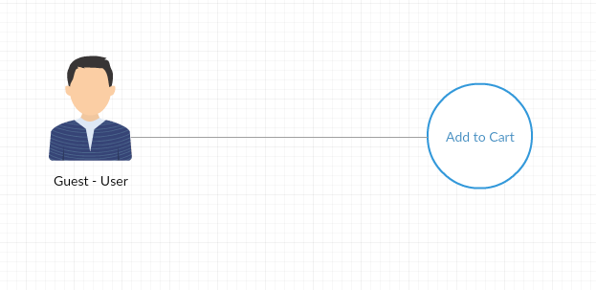

### Screen Design

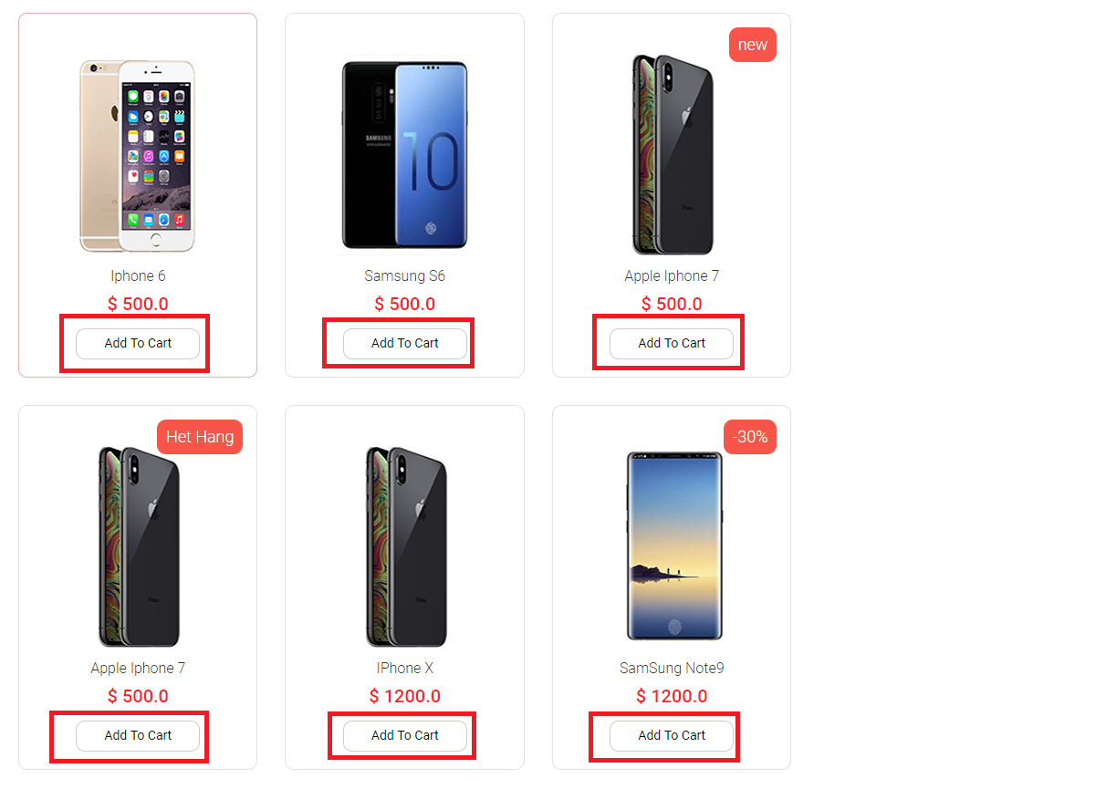

### Screen Definition

|  |  |  |  |  |  |
| --- | --- | --- | --- | --- | --- |
| **STT** | **Field Name** | **Type** | **Mandatory** | **Max Length** | **Description** |
| 1 | Add to cart | Button |  |  | Add product to cart |

### Use case Specification

|  |  |  |  |
| --- | --- | --- | --- |
| UC ID and Name: | UC07_Add to cart | | |
| Created By: | Thienndse05883 | Date Created: | 21/01/2019 |
| Primary Actor: | Guest, User | Secondary Actors: | Guest, User |
| Trigger: | Guest, User click on Add to cart button | | |
| Description: | From home pages, Guest, User click on add to cart button in each product to buy it | | |
| Preconditions: | 1 Guest, User go to Home Page  2 Choice a product want to buy and click add to cart button | | |
| Post conditions: | N/a | | |
| Normal Flow: | |  |  |  | | --- | --- | --- | | Step | Actor | Action | | 1 | Guest, User | Choice a product and click add button | | 2 | System | Add id product into session | | | |
| Alternative Flows: | At step 2 the system will display “add success” | | |
| Exceptions: | Can’t connect with server | | |
| Priority: | High | | |
| Frequency of Use: | When user want to buy a product | | |
| Business Rules: | N/A | | |
| Other Information: | N/A | | |
| Assumptions: | N/A | | |

## View shopping cart

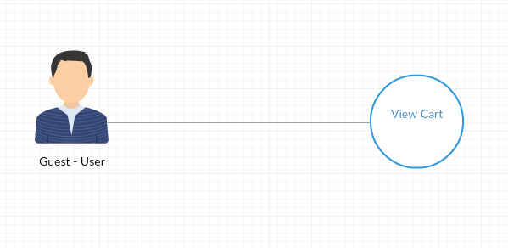

### Screen Design

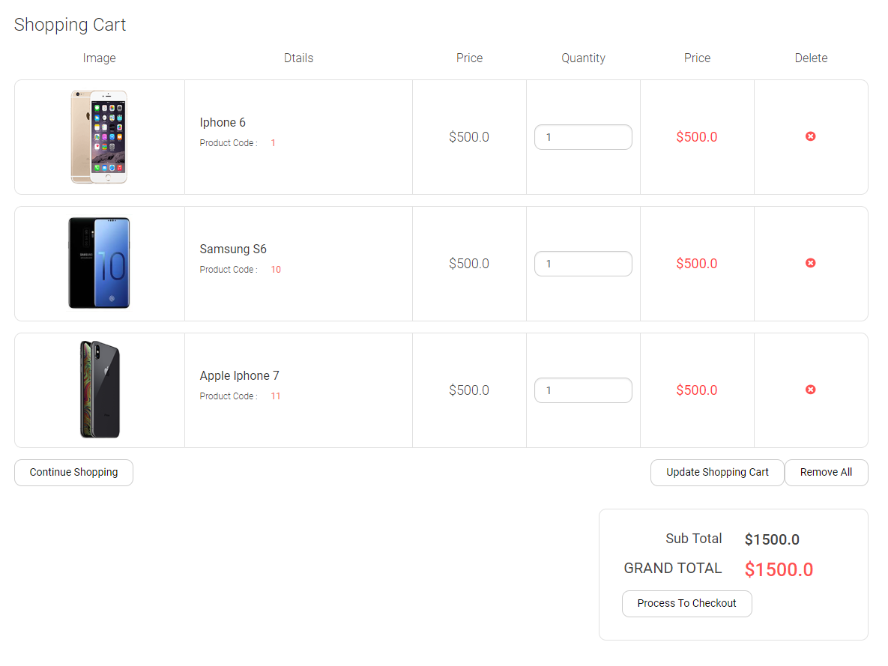

### Screen Denfinition

|  |  |  |  |  |  |
| --- | --- | --- | --- | --- | --- |
| **STT** | **Field Name** | **Type** | **Mandatory** | **Max Length** | **Description** |
| 1 | View Cart | Button |  |  | Add product to cart |

### Use case Specification

|  |  |  |  |
| --- | --- | --- | --- |
| UC ID and Name: | UC08_View Cart | | |
| Created By: | Thienndse05883 | Date Created: | 21/01/2019 |
| Primary Actor: | Guest, User | Secondary Actors: | Guest, User |
| Trigger: | Guest, User click on payment | | |
| Description: | From home pages, Guest, User click on view cart, all product in cart will display and show total price of order | | |
| Preconditions: | 1 Guest, User go to Home Page  2 click view cart button | | |
| Post conditions: | N/a | | |
| Normal Flow: | |  |  |  | | --- | --- | --- | | Step | Actor | Action | | 1 | Guest, User | Click view cart | | 2 | System | Show cart form | | | |
| Alternative Flows: | At step 2 if cart empty, the system will display “empty” | | |
| Exceptions: | Can’t connect with server | | |
| Priority: | High | | |
| Frequency of Use: | When user want to see order | | |
| Business Rules: | N/A | | |
| Other Information: | N/A | | |
| Assumptions: | N/A | | |

## Edit quantity of each product in shopping cart

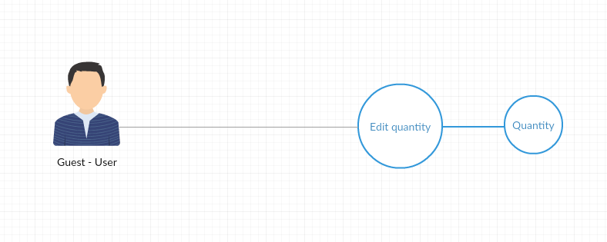

### Screen Design

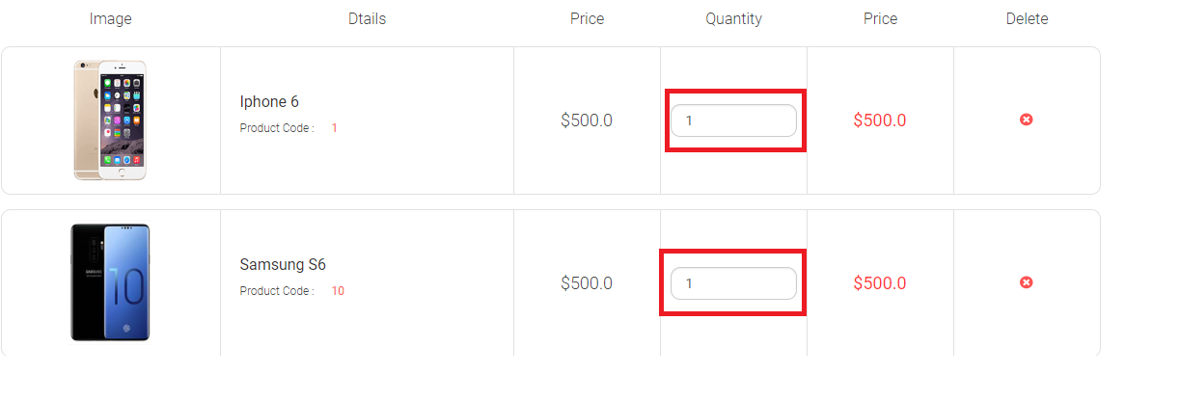

### Screen Denfinition

|  |  |  |  |  |  |
| --- | --- | --- | --- | --- | --- |
| **STT** | **Field Name** | **Type** | **Mandatory** | **Max Length** | **Description** |
| 1 | Update | Button |  |  | Update number of each product in cart |
| 2 | quantity | number |  |  | Min = 1 max = 10 |

### Use case Specification

|  |  |  |  |
| --- | --- | --- | --- |
| UC ID and Name: | UC09_Update quantity of each product | | |
| Created By: | Thienndse05883 | Date Created: | 21/01/2019 |
| Primary Actor: | Guest, User | Secondary Actors: | Guest, User |
| Trigger: | Guest, User click on Update cart button | | |
| Description: | From home pages, Guest, User click on view cart, all product in cart will display and user, guest can update quantity of each product | | |
| Preconditions: | 1 Guest, User go to Home Page  2 click on view cart button  3 change quantity  4 click on update button | | |
| Post conditions: | Validate data and check quantity of product in database | | |
| Normal Flow: | |  |  |  | | --- | --- | --- | | Step | Actor | Action | | 1 | Guest, User | Click view cart | | 2 | System | Show cart form | | 3 | Guest, User | Change quantity and click on update cart button | | 4 | System | System will check quantity in database before update | | | |
| Alternative Flows: | At step 3 if quantity greater than quantity in database, the system will display “quantity must be less than x”(x is quantity in database) | | |
| Exceptions: | Can’t connect with server | | |
| Priority: | High | | |
| Frequency of Use: | When user want to update quantity of each product | | |
| Business Rules: | N/A | | |
| Other Information: | N/A | | |
| Assumptions: | N/A | | |

## Delete item in shopping cart

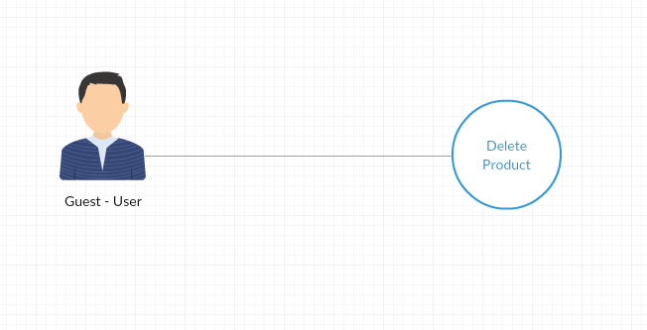

### Screen Design

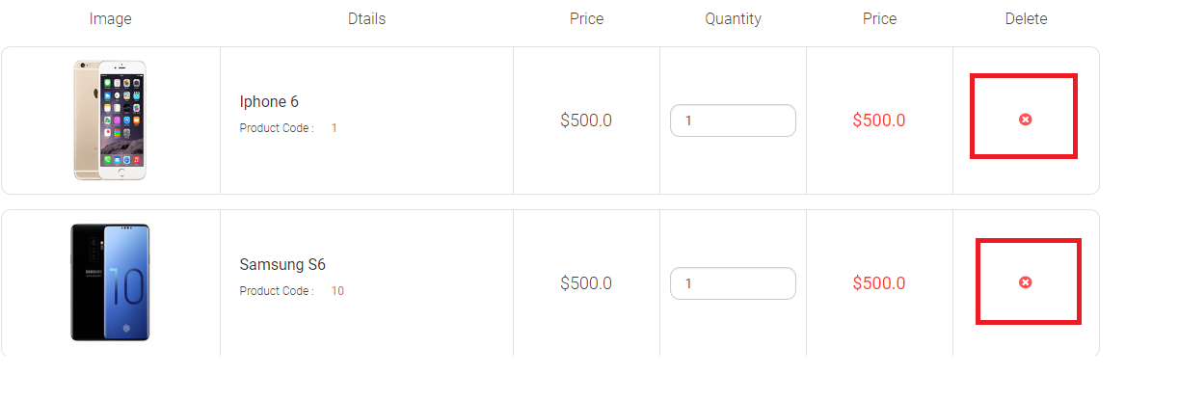

### Screen Definition

|  |  |  |  |  |  |
| --- | --- | --- | --- | --- | --- |
| **STT** | **Field Name** | **Type** | **Mandatory** | **Max Length** | **Description** |
| 1 | delete | Button |  |  | Delete an item in cart |
| 2 | Delete all item | Button |  |  | Delete all items in cart |

### Use case Specification

|  |  |  |  |
| --- | --- | --- | --- |
| UC ID and Name: | UC10_delete item in cart | | |
| Created By: | Thienndse05883 | Date Created: | 21/01/2019 |
| Primary Actor: | Guest, User | Secondary Actors: | Guest, User |
| Trigger: | na | | |
| Description: | From home pages, Guest, User click on view cart, all product in cart will display and user, guest can delete product in cart | | |
| Preconditions: | 1 Guest, User go to Home Page  2 click on view cart button  3 click on delete button | | |
| Post conditions: | na | | |
| Normal Flow: | |  |  |  | | --- | --- | --- | | Step | Actor | Action | | 1 | Guest, User | Click view cart | | 2 | System | Show cart form | | 3 | Guest, User | Delete product in cart | | 4 | System | System will delete id product in session | | | |
| Alternative Flows: | At step 4 the system will display “successful” | | |
| Exceptions: | Can’t connect with server | | |
| Priority: | High | | |
| Frequency of Use: | When user want to delete product | | |
| Business Rules: | N/A | | |
| Other Information: | N/A | | |
| Assumptions: | N/A | | |

# External Interface Requirements

<This section provides information to ensure that the system will communicate properly with users and with external hardware or software elements.>

## User Interfaces

The OPS user interface has been specifically designed with their customers in

mind, giving them convenience while they buy a mobile on the website.

The home screen offers a menu with a list of functions that the device performs. The

user can select one of the options on the menu, and is taken to the respective screen. Every

screen displays the menu on the bottom. The user can click on any one of the options and is

taken to the screen of their choice. In addition, clicking on the power button displays the home

screen with the menu options.

The device offers easy scroll options to navigate the screens efficiently. To scroll

down any screen, simply touch the scroll bar on the screen, and roll down. If the user does not

know how to use any functionality or has any queries, the help option can be used. The help

screen contains a text field to enter search terms. A list of search results pertaining to the query is

displayed

## Software Interfaces

The OPS runs on Website. The OPS uses synchronization Bootstrap that is compatible with Windows, Linux & Mac, Android, Ios, etc

Operating systems. The device contains an in-built language database containing image, text and

audio files.

## Hardware Interfaces

Since the application must run over the internet, all the hardware shall require to connect internet.

## Communications Interfaces

* The system shall use the HTTP protocol for communication over the internet.
* Web browser: Chrome – Firefox – Internet Explore – Coc Coc – Safari

# Quality Attributes

## Usability

The UI will be clear, simple, easy to use.

## Performance

* The loading time of a page will be less than 10 seconds. It still largely depends on the Internet connection strength and the computer’s speed.
* The time it takes for the search engine to display results will be less than 10 seconds.

## Security

OPS using HTTPS

## Safety

None

# Internationalization and Localization Requirements

Currency : USD $

Language : English – Vietnamese

Time zones: +7

# Check list

|  |  |  |
| --- | --- | --- |
|  | Completeness | Pass |
| 1 | Do the requirements address all known customer or system needs? | v |
| 2 | Have algorithms intrinsic to the functional requirements been defined? |  |
| 3 | Have algorithms intrinsic to the functional requirements been defined? |  |
| 4 | Are all external hardware, software, and communication interfaces defined? | v |
| 5 | Is the expected behaviour documented for all anticipated error conditions? |  |
| 6 | Do the requirements provide an adequate basis for design and test? | v |
| 7 | Is the implementation priority of each requirement included? | v |
|  | Correctness | |
| 8 |  | v |
| 9 | ls each requirement written in clear, concise, unambiguous, grammatically correct language? | v |
| 10 | Is each requirement verifiable by testing, demonstration, review, or analysis? | v |
| 11 | Are any specified error messages clear and meaningful? | v |
| 12 | Are all requirements actually requirements, not solutions or constraints? | v |
|  |  | |
| 13 | Are the requirements technically feasible and implementable within known constraints? | v |
| 14 | Are all usability, performance, security, and safety objectives properly specified? |  |
| 15 | Are other quality attributes documented and quantified, with the acceptable trade-offs specified? |  |
| 16 | Are the time-critical functions identified and timing criteria specified for them? | v |
| 17 | Have internationalization and localization issues been adequately addressed? | v |
| 18 | Are all of the quality requirements measurable? |  |
|  |  | |
| 19 | Are the requirements organized in a logical and accessible way? | v |
| 20 | Are all cross-references to other requirements and documents correct? |  |
| 21 | Are all requirements written at a consistent and appropriate level of detail? | v |
| 22 | ls each requirement uniquely and correctly labelled? | v |
| 23 | Is each functional requirement traced back to its origin (e.g., system requirement, business rule)? | v |
|  | Other Issues | |
| 24 | Are any use cases or process flows missing? |  |
| 25 | Are any alternative flows, exceptions, or other information missing from use cases? | v |
| 26 | Are all of the business rules identif‌ied? |  |
| 27 | Are there any missing visual models that would provide clarity or completeness? | v |
| 28 | Are all necessary report specifications present and complete? |  |