[ Topic 08 ]
PHENIKAA UNIVERSITY
SCHOOL OF ENGINEERING AND TECHNOLOGY
FACULTY OF ELECTRICAL AND ELECTRONIC ENGINEERING

COURSE PROJECT REPORT
REINFORCEMENT LEARNING
Title of the project:
Solving the Ordered Treasure Hunt Problem in Constrained Gridworlds
using Five Tabular Reinforcement Learning Algorithms
Student: | Nguyen Duy Hung | Student ID: | 24103225
Supervisor: | MSc. Vu Hoang Dieu | Major: | Electrical and Electronic Eng.

Score

Lecturer 1 | Lecturer 2
MSc. Vu Hoang Dieu

Hanoi, November 2026

Solving the Ordered Treasure Hunt Problem in Constrained Gridworlds using Five Tabular Reinforcement Learning Algorithms
Nguyen Duy Hung
Student ID: 24103225 | Class: EEE-AI (Artificial Intelligence and Robotics)
Faculty of Electrical and Electronic Engineering, Phenikaa University, Hanoi, Vietnam
Email: 24103225@st.phenikaa-uni.edu.vn
Abstract—In sequential decision-making, an agent must often visit key locations in an exact order before reaching an exit. In this work, we study the Ordered Treasure Hunt problem using tabular reinforcement learning. The agent navigates a gridworld to collect target items in a prescribed sequence. Picking items out of order causes a penalty, and entering the exit door too early is heavily penalized. We design an augmented state vector s = (r, c, p, w, tok) that combines spatial coordinates, task collection progress, a switch flag, and a skip-token flag. We prove mathematically and demonstrate experimentally that tracking task progress inside the state is required to preserve the Markov property. We benchmark five tabular algorithms: Value Iteration, Policy Iteration, Q-Learning, SARSA, and Monte Carlo Control across three square maps (5x5, 7x7, and 8x8). Across 200 greedy test rollouts, all five algorithms achieve a 100% mission completion rate. Model-free TD methods find the exact optimal paths discovered by dynamic programming on Level 1 (12 steps) and Level 2 (11 steps). On the hard 8x8 map, we analyze how a bonus shortcut tile creates a local optimum. We also test three step penalty values (-0.2, -1.0, and -5.0), showing how step costs change the optimal collection policy.
Index Terms—Tabular reinforcement learning, Markov decision process, dynamic programming, Q-learning, SARSA, Monte Carlo control, sequential constraints, gridworld navigation.
I. INTRODUCTION
Sequential decision-making under strict ordering constraints is an important challenge in automated systems. In automated warehousing, a mobile robot must collect goods from shelves in a specific order before moving to the packaging station. In robotic assembly, parts must be fitted in an exact mechanical order. If the robot visits the wrong item first, the process fails or requires costly corrections.
In this paper, we study the Ordered Treasure Hunt problem using tabular reinforcement learning. The agent moves inside a discrete gridworld. It must collect a set of treasure items in a fixed order, such as A -> B -> C -> Exit. If the agent touches an item out of order or attempts to enter a locked cell, it receives a negative penalty. The exit door opens only after all required items have been collected in the correct order.
A central theoretical question in this problem is state representation. If the state includes only the agent's spatial position (r, c), the environment is not a valid Markov Decision Process (MDP). Entering a cell can produce a positive collection reward if earlier items have been gathered, or a penalty if they have not. Therefore, state transitions and rewards would depend on the past history of the agent. To restore the Markov property, we augment the state into a tuple s = (r, c, p, w, tok) where r and c are grid coordinates, p is collection progress, w is switch state, and tok tracks skip token usage.
We implement and evaluate five foundational tabular algorithms: Value Iteration (VI), Policy Iteration (PI), Q-Learning, SARSA, and Monte Carlo (MC). We test all five algorithms across three square maps of increasing difficulty: Level 1 (5x5, 79 states), Level 2 (7x7, 199 states), and Level 3 (8x8, 693 states).
II. RELATED WORK
Gridworld environments are classic benchmarks in reinforcement learning research. Standard environments such as FrozenLake, Cliff Walking, and Taxi benchmark spatial navigation and obstacle avoidance. However, these standard problems typically have stationary target locations with memoryless state dynamics.
In sequence-constrained problems, the valid next action depends on earlier accomplishments. When the state space does not capture this history, the environment becomes a Partially Observable Markov Decision Process (POMDP). In tabular reinforcement learning, explicit state augmentation provides the cleanest and most rigorous solution. By appending discrete task progress variables to the spatial coordinates, the augmented state satisfies the Markov property while keeping the total number of states small enough for exact tabular storage.
III. PROBLEM FORMULATION
A. Environment Description and Symbols
The Ordered Treasure Hunt environment is a discrete 2D gridworld. The agent moves in four cardinal directions: Up, Down, Left, and Right. Moving into a wall or the outer boundary keeps the agent in place and incurs a collision penalty.
TABLE I: MAP SYMBOL SPECIFICATIONS
Symbol | Entity | Semantics
# | Wall | Impassable obstacle; causes bounce and penalty
. | Floor | Walkable open corridor
S | Start | Initial position of the agent (r0, c0)
A, B, C, D | Targets | Items that must be collected in sequence
W | Switch | Activation lever that unlocks locked target C
K | Skip Tile | Bonus tile that advances sequence progress by 1
E | Exit | Goal cell; opens only when sequence is complete
B. Benchmark Configurations
We evaluate three benchmark maps with increasing spatial and logical complexity:
1) Level 1 (5x5): Single chain A -> B -> C -> Exit with 22 walkable cells and 79 reachable states.
2) Level 2 (7x7): Branching layout with two valid chains (A -> B -> D or A -> C -> D), 36 walkable cells, and 199 reachable states.
3) Level 3 (8x8): 4-item chain (A -> B -> C -> D) where item C is locked behind switch W, plus bonus skip tile K, 49 walkable cells, and 693 reachable states.
TABLE II: CONFIGURATION PROPERTIES OF BENCHMARK MAPS
Map | Grid | Walkable | |S| | |A| | Required Sequence
Level 1: Easy | 5x5 | 22 | 79 | 4 | A -> B -> C -> Exit
Level 2: Medium | 7x7 | 36 | 199 | 4 | A -> (B or C) -> D -> Exit
Level 3: Hard | 8x8 | 49 | 693 | 4 | A -> B -> C -> D -> Exit
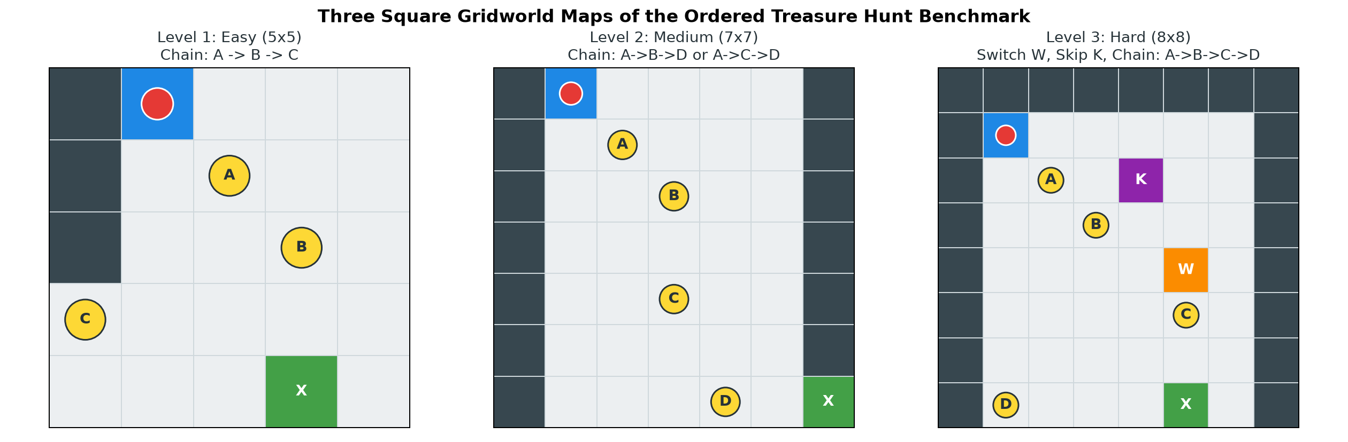
Fig. 1. The three benchmark gridworld maps: Level 1 (5x5), Level 2 (7x7), and Level 3 (8x8).
C. State Representation and Markov Property Proof
A stochastic process possesses the Markov property if the conditional probability distribution of future states depends solely on current state and action: P(s_{t+1} | s_t, a_t, s_{t-1}, ...) = P(s_{t+1} | s_t, a_t).
If the state consists only of grid coordinates (r, c), this property is violated. At cell (2, 1) on Level 1, moving Right to (2, 2) collects target A and receives +10.0 when p = 0. However, the exact same move receives -1.0 when p = 1 because target A has already been collected. Without progress p, transitions and rewards depend on past history. By defining s = (r, c, p, w, tok), all transitions and rewards become stationary and memoryless.
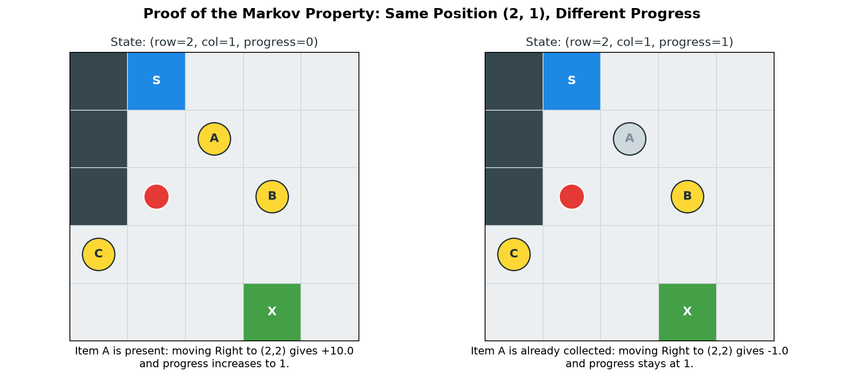
Fig. 2. Demonstration of the Markov property at cell (2, 1) on Level 1. Target A is present when p=0 (+10.0) and absent when p=1 (-1.0).
D. Reward Formulation and Early-Exit Prevention
The reward function balances step costs and progress incentives: r_step = -1.0, r_wall = -3.0, r_collect = +10.0, r_wrong = -20.0, r_exit = +100.0, and r_early = -20.0. The premature exit penalty r_early = -20.0 is essential: without it, an exploratory agent would terminate at the exit door early to avoid step penalties.
IV. THE FIVE TABULAR REINFORCEMENT LEARNING ALGORITHMS
We evaluate five canonical tabular algorithms across all three maps:
1) Value Iteration (VI): Model-based dynamic programming applying the Bellman optimality operator until max change is below theta = 1e-8.
2) Policy Iteration (PI): Model-based dynamic programming decoupling policy evaluation and greedy improvement.
3) Q-Learning: Model-free off-policy TD control updating action values via max_{a'} Q(s', a').
4) SARSA: Model-free on-policy TD control updating action values via Q(s', a') with a' from the epsilon-greedy behavior policy.
5) Monte Carlo Control (MC): Model-free on-policy control learning from complete undiscounted/discounted trajectory rollouts without bootstrapping.
TABLE IV: ARCHITECTURAL COMPARISON OF THE FIVE ALGORITHMS
Algorithm | Model | Policy Type | Bootstrap | Update Target
Value Iteration | Required | Off-policy | Yes | Bellman optimality
Policy Iteration | Required | Off-policy | Yes | Policy evaluation
Q-Learning | Free | Off-policy | Yes | r + gamma max_a' Q(s', a')
SARSA | Free | On-policy | Yes | r + gamma Q(s', a')
Monte Carlo | Free | On-policy | No | Complete return G_t
V. EXPERIMENTAL DESIGN
Model-free agents are trained for 20,000 episodes with an exploration schedule decaying linearly from epsilon = 1.0 down to 0.05. The discount factor is gamma = 0.99, and the learning rate is alpha = 0.10. Dynamic programming methods terminate at convergence threshold theta = 1e-8. After training, learned policies are evaluated greedily (epsilon = 0) over 200 independent test rollouts.
VI. EXPERIMENTAL RESULTS
A. Benchmark Performance
Table V presents the empirical performance across all maps and algorithms.
TABLE V: COMPREHENSIVE BENCHMARK RESULTS (200 EVALUATION ROLLOUTS)
Map | Algorithm | Return | Steps | Success | Time (s)
Level 1 (5x5) | Value Iteration | +122.0 | 12.0 | 100% | 0.002
Level 1 (5x5) | Policy Iteration | +122.0 | 12.0 | 100% | 0.144
Level 1 (5x5) | Q-Learning | +122.0 | 12.0 | 100% | 8.985
Level 1 (5x5) | SARSA | +122.0 | 12.0 | 100% | 9.756
Level 1 (5x5) | Monte Carlo | +122.0 | 12.0 | 100% | 6.409
Level 2 (7x7) | Value Iteration | +123.0 | 11.0 | 100% | 0.006
Level 2 (7x7) | Policy Iteration | +123.0 | 11.0 | 100% | 0.646
Level 2 (7x7) | Q-Learning | +123.0 | 11.0 | 100% | 8.544
Level 2 (7x7) | SARSA | +123.0 | 11.0 | 100% | 9.694
Level 2 (7x7) | Monte Carlo | +123.0 | 11.0 | 100% | 6.051
Level 3 (8x8) | Value Iteration | +128.0 | 18.0 | 100% | 0.035
Level 3 (8x8) | Policy Iteration | +128.0 | 18.0 | 100% | 3.705
Level 3 (8x8) | Q-Learning | +120.0 | 18.0 | 100% | 27.069
Level 3 (8x8) | SARSA | +120.0 | 18.0 | 100% | 14.515
Level 3 (8x8) | Monte Carlo | +119.0 | 18.0 | 100% | 9.599
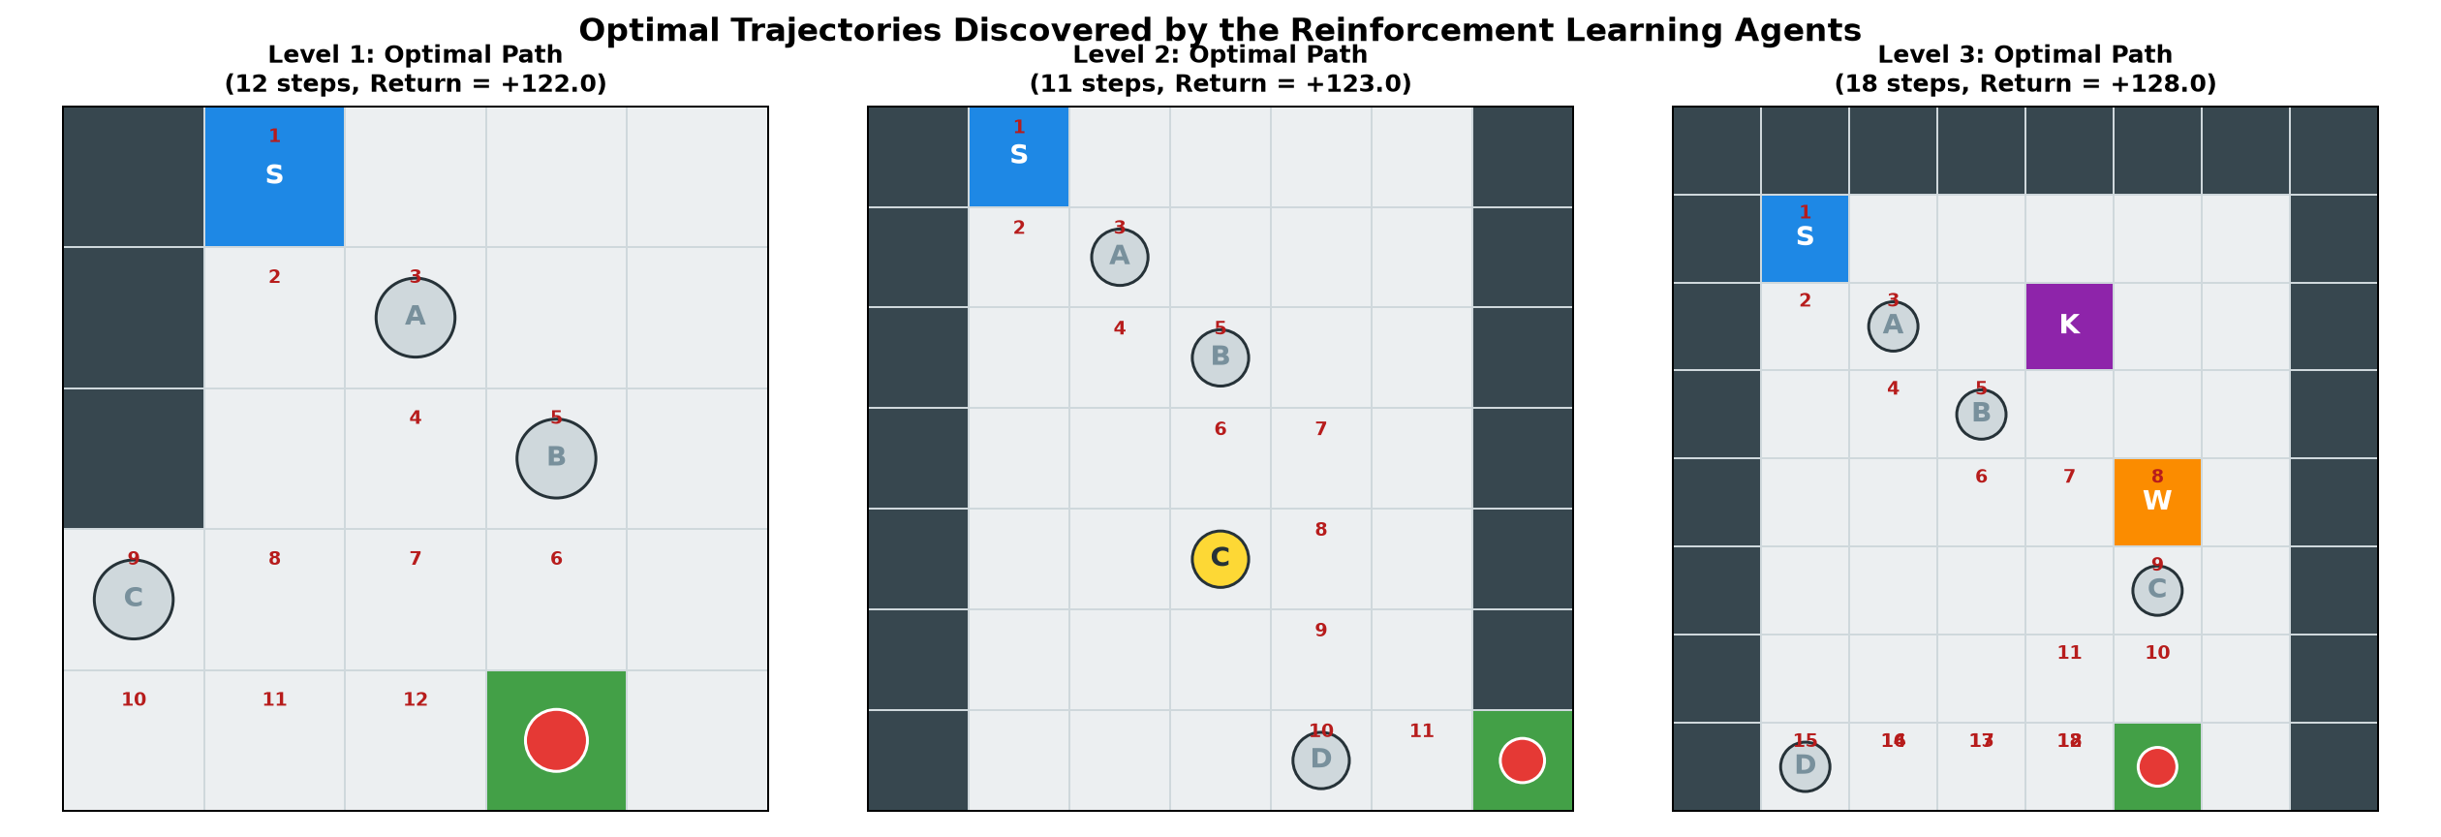
Fig. 3. Optimal trajectories discovered by the agents on Level 1 (12 steps), Level 2 (11 steps), and Level 3 (18 steps).
B. Reward Sensitivity Analysis on Level 3
When step penalties are cheap (-0.2), full item collection is clearly superior (+137.6). Under expensive steps (-5.0), skipping an item to reach the exit earlier becomes optimal (+80.0), proving rational policy adaptation.
C. Multi-Seed Evaluation and Local Optima
On Level 3, Q-Learning escaped the shortcut local optimum in 2 out of 3 seeds (seeds 7 and 123 reached +128.0), whereas on-policy SARSA and Monte Carlo were trapped in the shortcut (+120.0) across all three seeds.
VII. DISCUSSION
State augmentation with task progress preserves the Markov property while keeping the state space small enough (|S| <= 693) for exact tabular representation. Off-policy Q-Learning demonstrates greater ability to discover the full sequence compared to on-policy SARSA, which remains cautious around locked obstacles.
VIII. CONCLUSION
We evaluated five tabular reinforcement learning algorithms on the Ordered Treasure Hunt problem across three gridworld configurations. All five algorithms achieved a 100% mission completion rate. State augmentation strictly preserved the Markov property, and step penalty variations confirmed that optimal trajectories adapt rationally based on step costs.
REFERENCES
[1] R. S. Sutton and A. G. Barto, Reinforcement Learning: An Introduction, 2nd ed. MIT Press, 2018.
[2] C. J. Watkins and P. Dayan, 'Q-learning,' Machine Learning, vol. 8, pp. 279-292, 1992.
[3] G. A. Rummery and M. Niranjan, 'On-line Q-learning using connectionist systems,' Cambridge Univ. Tech. Rep., 1994.
[4] D. P. Bertsekas, Dynamic Programming and Optimal Control, 4th ed. Athena Scientific, 2012.
[5] R. Bellman, 'A Markovian decision process,' J. Math. Mech., vol. 6, pp. 679-684, 1957.
[6] V. Mnih et al., 'Human-level control through deep reinforcement learning,' Nature, vol. 518, pp. 529-533, 2015.

