docker –version
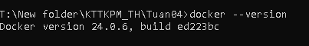
docker run hello-world
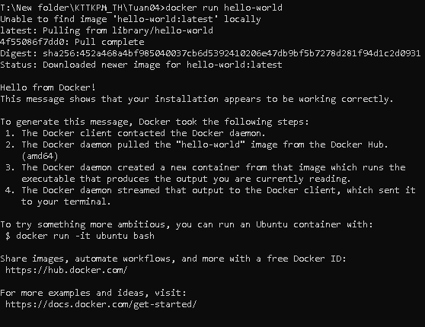
docker pull nginx
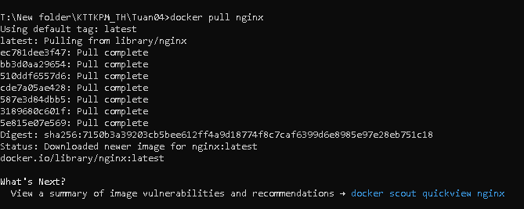
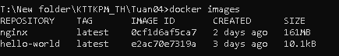
docker run -d nginx
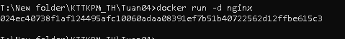
docker ps
docker ps –a
docker logs <container_id>
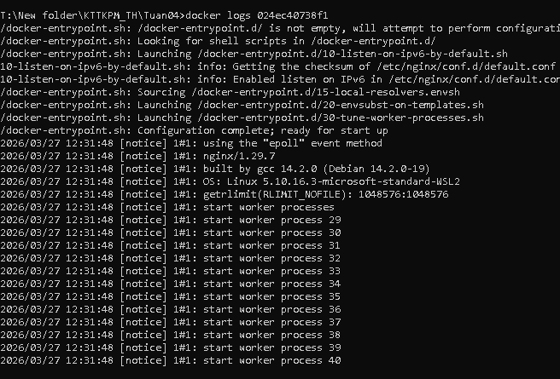
docker exec -it <container_id> /bin/sh
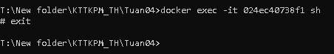
docker stop <container_id>
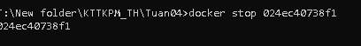
docker restart <container_id>
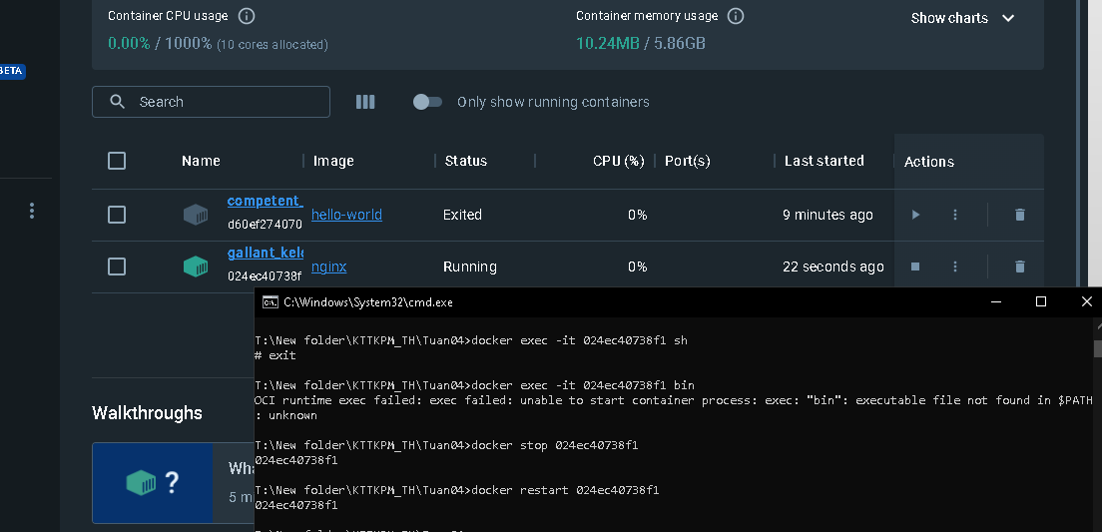
docker rm <container_id>
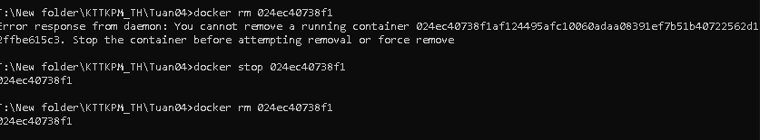
docker container prune
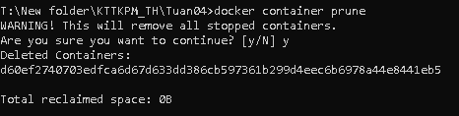

docker rmi <image_id>
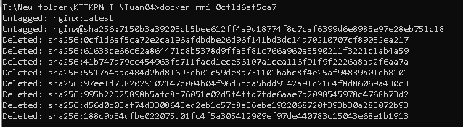

docker image prune –a
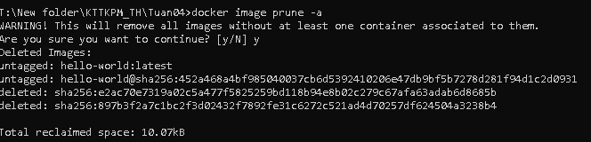
docker run -d -p 8080:80 nginx
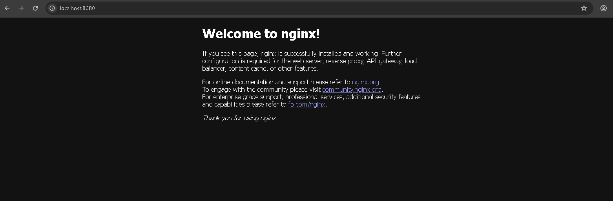
docker inspect <container_id>
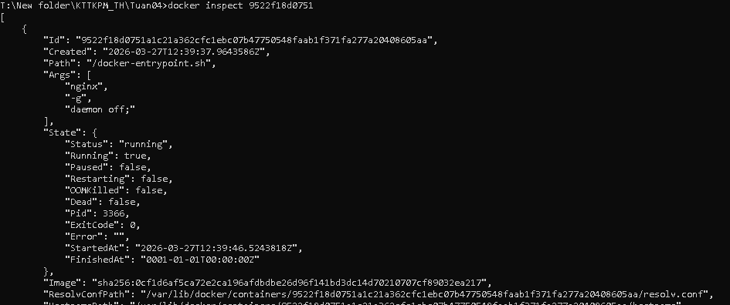
docker run -d -v mydata:/data nginx
docker volume ls
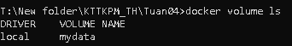
docker volume prune
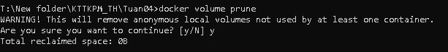
docker run -d --name my_nginx nginx
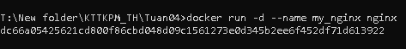
docker stats
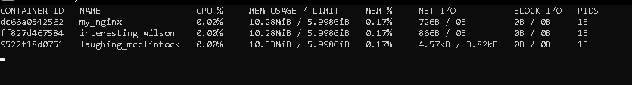
docker network ls
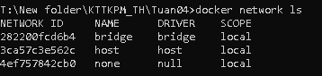
docker network create my_network
docker run -d --network my_network --name my_container nginx
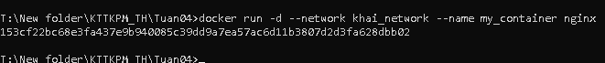
docker network connect my_network my_nginx
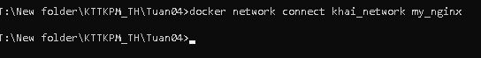
docker run -d -e MY_ENV=hello_world nginx
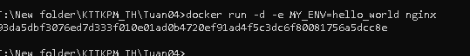
docker logs -f my_nginx
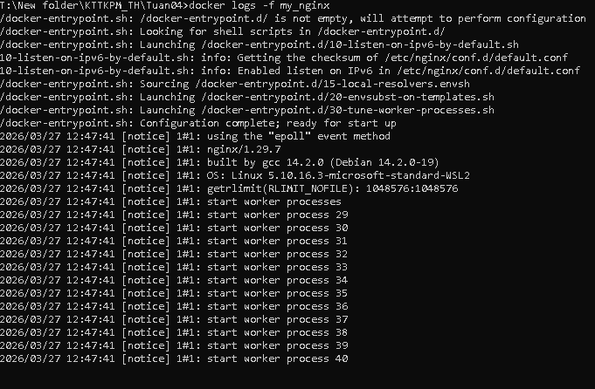

FROM nginx
COPY index.html /usr/share/nginx/html/index.html

docker build -t my_nginx_image .
docker run -d -p 8080:80 my_nginx_image

