**PEARLAND, TX DISCOVERY TO OPEN THE NEW VIETNAMESE RESTAURANT**

**INTRODUCTION**

Pearland, TX is one of the improving and newest cities in Texas. There are various culture people or immigration who is living in Pearland, TX; and Vietnamese people is one of the most populations in Pearland. But there is not many Vietnamese restaurants in here and this project will help the Vietnamese people who want to open the new Vietnamese restaurant. This project can provide more information about the current Vietnamese restaurants in Pearland; also analyze Median Household Income and Diversity in 2017. Then, they can decide if they still want to open the new restaurant and prepare more finance and plan for that opening.

**DATA SECTION**

* Data Requirements:
  + Number of Vietnamese restaurants currently in Pearland, TX
  + The points or rates, tips, location nearby the Pearland Shopping Center
  + The median household income in 2017
  + The diversity rate of non-English spoken language in 2017
* Data Sources:
  + Number of Vietnamese restaurants: <https://developer.foursquare.com/>
  + The other information of Vietnamese restaurants are provided by uses in Foursquare who used to try there: <https://developer.foursquare.com/>
  + The median household income: <https://datausa.io/profile/geo/pearland-tx/#economy>
  + The diversity: <https://datausa.io/profile/geo/pearland-tx/#demographics>

**METHODOLOGY**

The purpose of this project is to discover Pearland, TX neighborhoods based on specific requirements about number of Vietnamese restaurants in the neighborhoods and more information about income and diversity. Therefore, this project is using K-means clustering algorithm, the Folium library, and Foursquare API, and Matplotlib library.

* The Foursquare API is to explore all Vietnamese restaurants in Pearland, TX. It can give more information about the rating, tip, and command.
* K-mean clustering algorithm is used to form the clusters of same Vietnamese restaurants in Pearland, TX. These clusters are analyzed deeper to derive the conclusion.
* The Folium library is used to point out the locations on the map clearly and can view all the current restaurant in Pearland, TX.
* The Matplotlib library is used to draw the bar charts and pie chart with all information to help easier analyze.

**DISCUSSION AND RESULT SECTIONS**

There are around 14 Vietnamese restaurants and food churches in round 16,000km from Pearland Shopping Center with HEB supermarket’s address. But there is only 7 restaurants where we can find the authentic Vietnamese food and nearby HEB location. After analyzed, there is only one restaurant, Thanh Phuong Chinese and Vietnamese Restaurant, has enough information about the rating (7.2/10) , no tip, and closest to Pearland Shopping Center. This can be the good point to open the new Vietnamese restaurant because there are not many competitors for them.

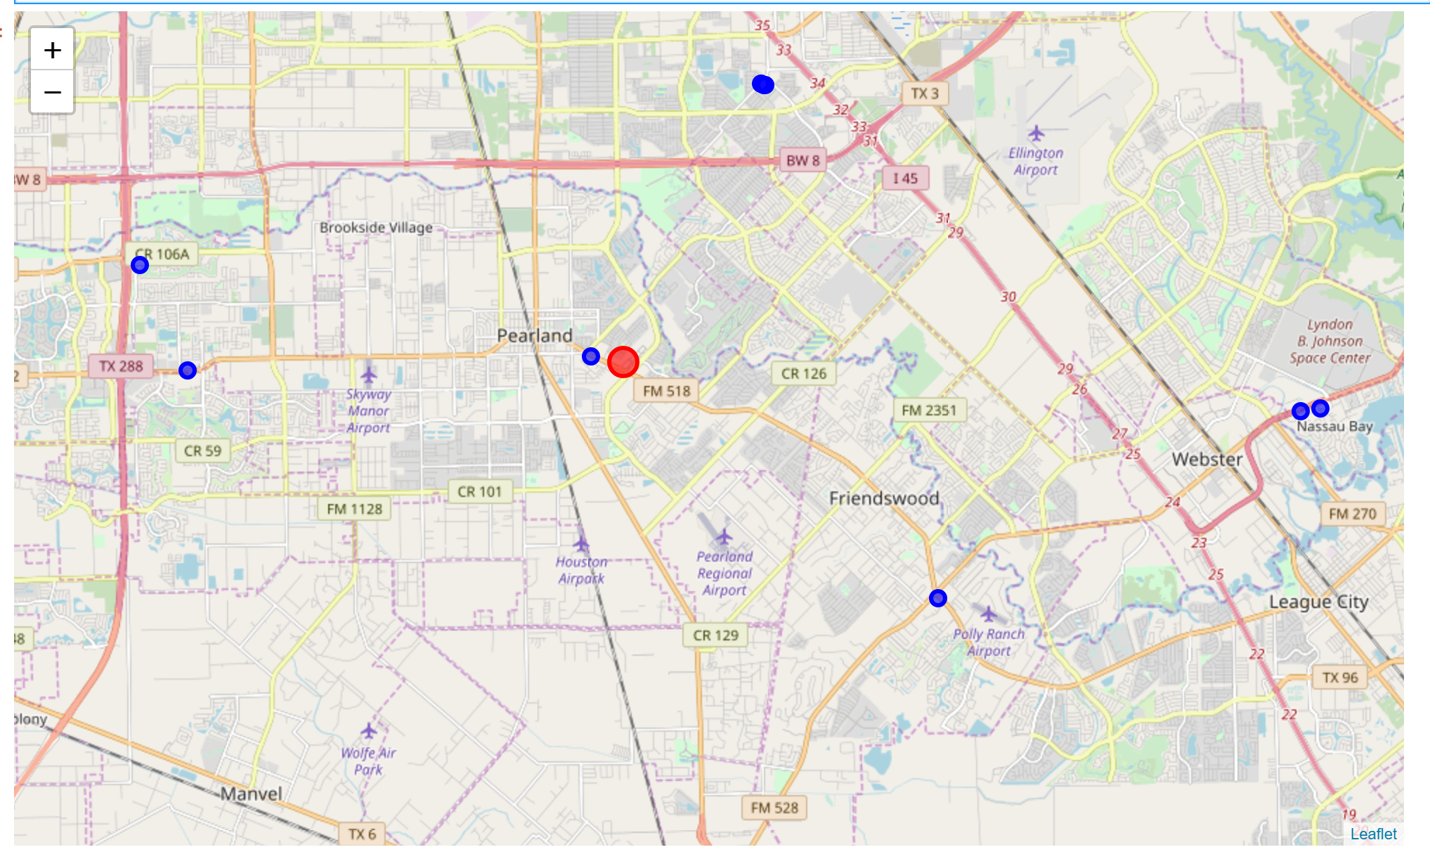

We don’t know why there are not many Vietnamese restaurants in the Pearland Shopping Center. Therefore, we need more information about the household medium income and diversity in Pearland to know if Pearland is the good city to open the new Vietnamese restaurant or not.

In 2007, the median household income of the 38.8k households in Pearland, TX grew to $102,124 from the previous year’s value of $96,954. The following chart displays the households in Pearland, TX distributed between a series of income buckets compared to the national averages for each bucket. The largest shares of households have an income in the $75k - $100k range. And Pearland, TX income is the highest income in Houston’s neighborhood. Therefore, opening the new restaurant in here also the good idea because they will have the generous customers who are too busy to cook at home but have generous income to support eat outside.

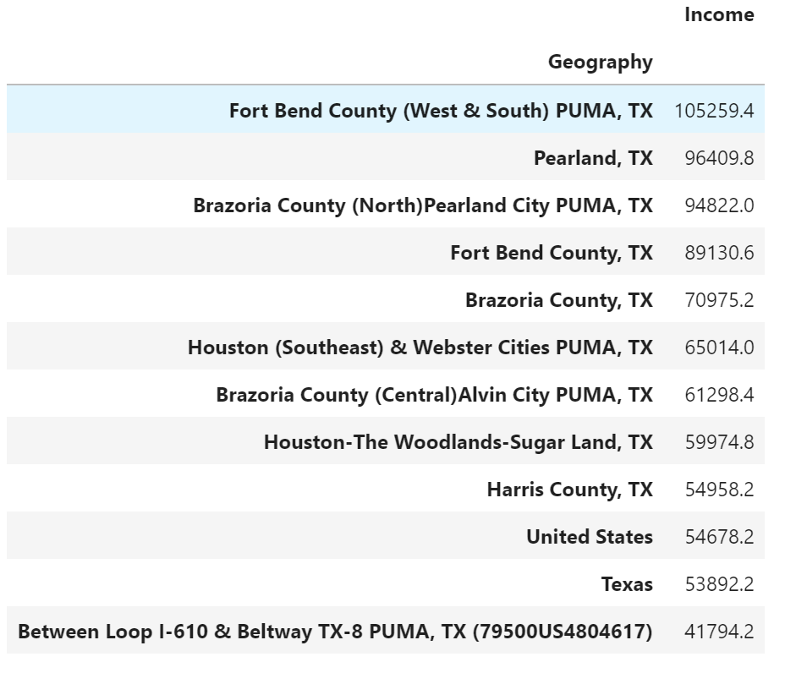

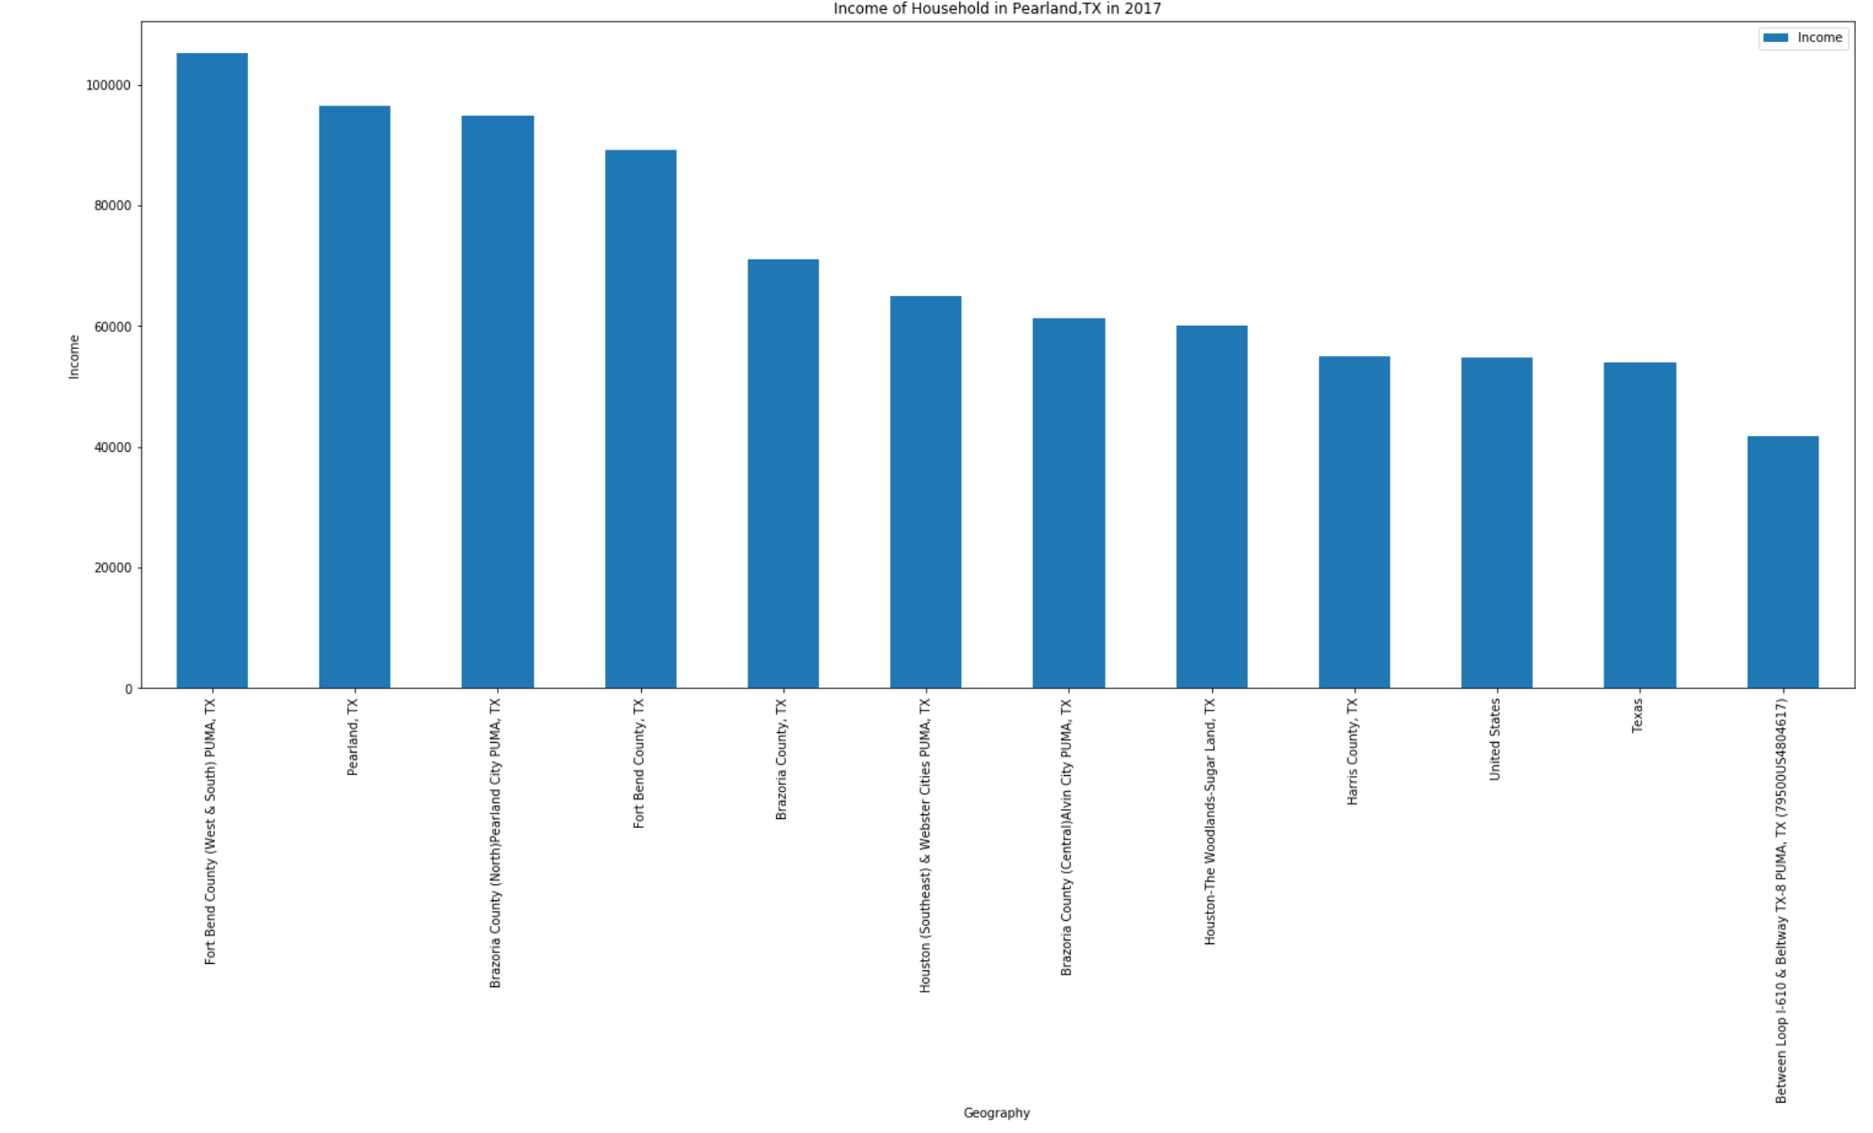

Pearland, TX is home to a population of 114k people, from which 94.7% are citizens. As of 2017, 15.9% of Pearland, TX residents were born outside of the country. 28.6% of Pearland, TX citizens are speakers of a non-English language, which is higher than the national average of 21.5%. In 2017, the most common non-English language spoken in Pearland, TX was Spanish or Spanish Creole. 13.9% of the overall population of Pearland, TX is native Spanish or Spanish Creole speakers. 4.17% speak Vietnamese and 2.66% speak Spanish or Spanish Creole, the next two common languages. Therefore, with the second highest population non-English language spoken, Vietnamese, Vietnamese restaurant will have the regular clients who miss the Vietnamese food and their food culture in Pearland, TX.

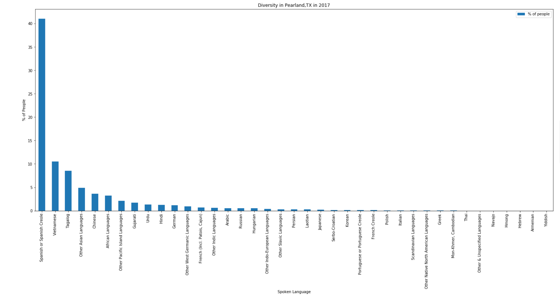

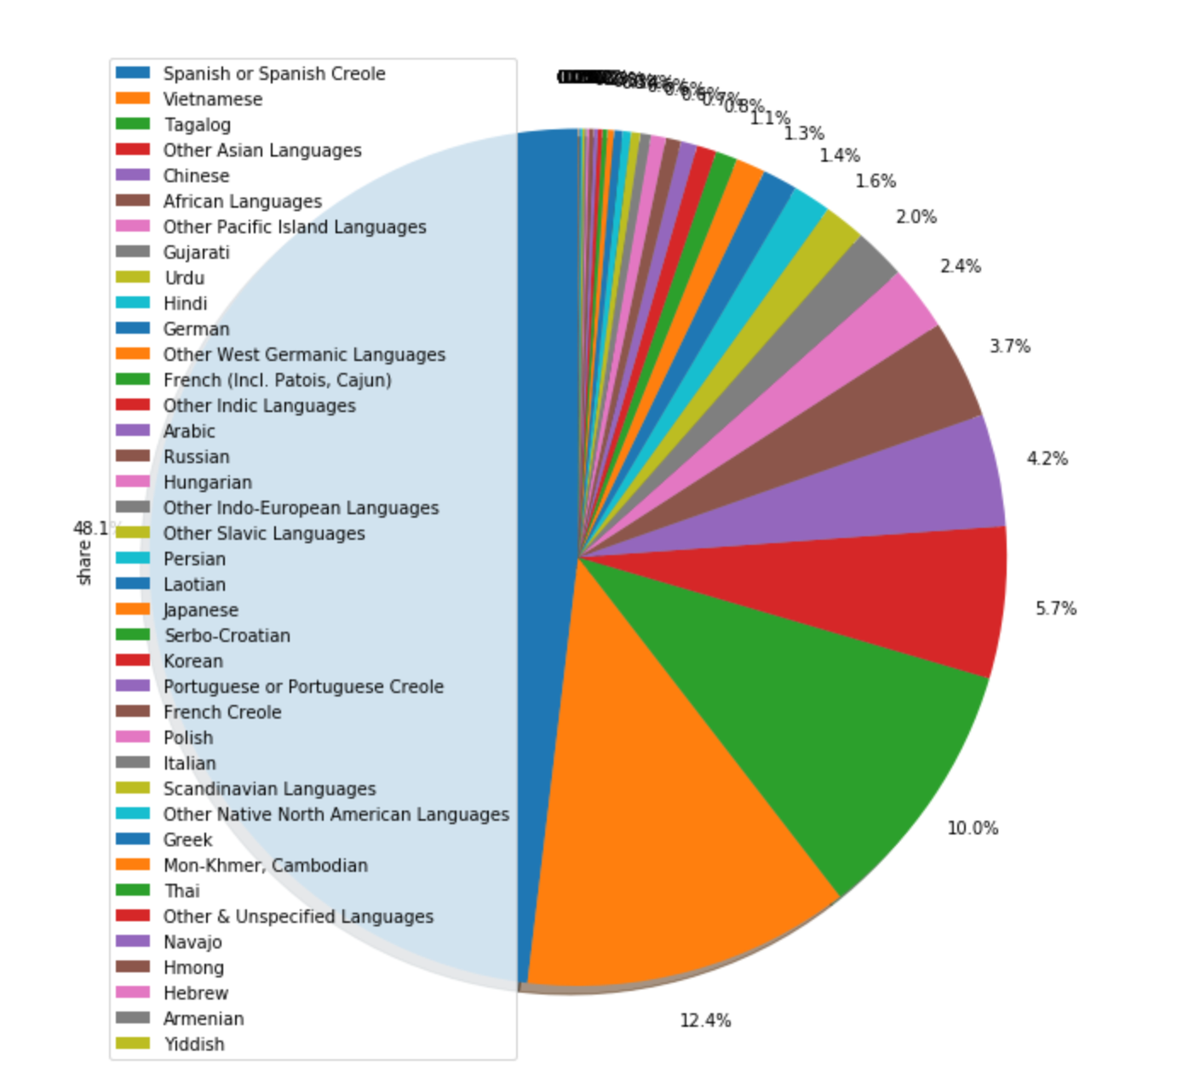

**CONCLUSION**

Based on the information that we analyze, open the new Vietnamese restaurant in Pearland, TX is the good idea because there are 3 reasons. First, there are not many competitors with us. Second, the residents in Pearland have good income and they easily to eat outside without considering about the price. Last, there are many Vietnamese people living in Pearland, TX and love Vietnamese food.