**Higher Nationals – Assignment Front Sheet**

|  |  |  |  |
| --- | --- | --- | --- |
| **Student Name/ID** | Nguyen Hoai Phong / GCC210165 | | |
| **Unit Title** | Unit 30: Application Development | | |
| **Assignment Number** | Assignment 1 | **Assessor** | Nguyen Trung Viet |
| **Submission Date** | February 20, 2024 | **Date Received 1st submission** |  |
| **Re-submission Date** |  | **Date Received 2nd submission** |  |
| **Grading grid**   |  |  |  |  |  |  | | --- | --- | --- | --- | --- | --- | | **P1** | **P2** | **P3** | **M1** | **M2** | **D1** | |  |  |  |  |  |  | | | | |
| **Assessor Feedback:**  *Please note that constructive and useful feedback should allow students to understand:   1. Strengths of performance 2. Limitations of performance 3. Any improvements needed in future assessments   Feedback should be against the learning outcomes and assessment criteria to help students understand how these inform the process of judging the overall grade.  Feedback should give full guidance to the students on how they have met the learning outcomes and assessment criteria. | | | |
| **Grade:** | **Assessor Signature:** | | **Date:** |
| **Resubmission Feedback:**  *Please note resubmission feedback is focussed only on the resubmitted work | | | |
| **Grade:** | **Assessor Signature:** | | **Date:** |
| **Internal Verifier’s Comments:** | | | |
| **Signature & Date:** | | | |

* Please note that grade decisions are provisional. They are only confirmed once internal and external moderation has taken place and grades decisions have been agreed at the assessment.

Unit 30: Application Development

Assignment 1 Brief

|  |  |
| --- | --- |
| Student Name/ID Number | Nguyen Hoai Phong / GCC210165 |
| Unit Number and Title | Unit 30: Application Development |
| Academic Year | 2023 - 2024 |
| Unit Tutor | Vinh Hoang |
| Assignment Title | Assignment 1: Analysis and Design solution for a given problem |
| Issue Date | 08 Jan 2024 |
| Submission Date | 08 Jan 2024 |
| Submission Format | |
| *Format: The submission is in the form of one document containing:*  An individual SRS document  An individual evaluation document  *Submission*  Students are compulsory to submit the assignment on the due date and in a way requested by the Tutor.  The form of submission will be a soft copy posted on <http://cms.greenwich.edu.vn/>.  Remember to convert the word file into a PDF file before the submission on CMS.  *Note:*  The individual Assignment *must* be your work, and not copied by or from another student.   If you use ideas, quotes, or data (such as diagrams) from books, journals, or other sources, you must reference your sources, using the Harvard style.  Make sure that you understand and follow the guidelines to avoid plagiarism. Failure to comply with this requirement will result in a failed assignment. | |
| Unit Learning Outcomes | |
| LO1 Produce a Software Design Document by analyzing a business-related problem and deduce an appropriate solution including a set of initial requirements  LO2 Use design and development methodologies with tools and techniques associated with the creation of a business application | |
| Transferable skills and competencies developed | |
| Documentation:   * Skill in producing clear and comprehensive Software Design Documents (SDD) that outline the problem, solution, and initial requirements.   UML (Unified Modeling Language):   * Knowledge of UML for creating diagrams such as use case diagrams, class diagrams, and sequence diagrams.   Prototyping:   * Ability to create prototypes or mockups to visualize and validate proposed solutions.   Software Development Life Cycle (SDLC):   * Understanding of SDLC phases, including requirements gathering, design, implementation, testing, deployment, and maintenance.   Agile/Scrum Methodologies:   * Familiarity with Agile or Scrum methodologies for iterative development and rapid adaptation to changing requirements.   Version Control:   * Proficiency in using version control systems (e.g., Git) to manage code changes and collaborate with a team.   Programming Languages:   * Knowledge of programming languages relevant to business application development (e.g., Java, Python, C#).   Database Design:   * Ability to design and model databases to store and retrieve business data efficiently.   Testing Strategies:   * Knowledge of testing methodologies, including unit testing, integration testing, and system testing.   Development Tools:   * Proficiency in using development tools and Integrated Development Environments (IDEs) for coding and debugging.   Project Management:   * Familiarity with project management tools and techniques to plan, monitor, and control project activities. | |
| **Vocational scenario** | |
| Introducing **FPTJobMatch**, an innovative web-based platform designed to revolutionize the job posting and hiring process. This state-of-the-art software aims to streamline and enhance the recruitment experience for both employers and job seekers. By providing a user-friendly interface, **FPTJobMatch** aims to simplify the complexities of job posting, application management, and candidate selection.  Stay tuned for a detailed document that delves into the comprehensive features and functionalities of **FPTJobMatch**, offering a transformative solution to meet the evolving needs of the employment landscape. Get ready to experience a new era in job matching and recruitment efficiency with **FPTJobMatch**! | |
| Assignment activity and guidance | |
| You and your teammates (3 members/team maximum) need to prepare a design document with the following sections to prepare for the **FPTJobMatch!** Project development. Read the ***Unit 30 - Assignment 1 Brief - 2023 2024.docx*** for more details   * A requirement specification that explores the problem by a set of user and system requirements, as well as determines any risks related to the successful completion of your application. You are advised to use an SRS template or modify one to complete this task. * An evaluation section in which you research the use of software development tools and techniques and identify any that have been selected for the development of this application. You should compare them and justify your choices. * A design section in which you use chosen tools from the previous step to produce design diagrams for your solution based on the requirement specification. | |
| **Recommended Resources**  **Please note that the resources listed are examples for you to use as a starting point in your research – the list is not definitive.** | |

**Learning Outcomes and Assessment Criteria**

|  |  |  |
| --- | --- | --- |
| Pass | Merit | Distinction |
| **LO1** Produce a Software Design Document by analyzing a business-related problem and deduce an appropriate solution including a set of initial requirements | | **D1** Justify the tools and techniques chosen to realise a custom built website. Justify your preferred selection of tools and techniques in deducing an appropriate solution to a business related problem. |
| **P1** Explore a business-related problem and produce a well-defined Problem Definition Statement supported by a set of user and system requirements.    **P2** Determine any areas of risk related to the successful completion of your application. | **M1** Analyse a business-related problem using appropriate methods and produce a well-structured Software Design Document that defines a proposed solution and includes relevant details on requirements, system analysis, system design, coding, testing and implementation. |
| **LO2** Use design and development methodologies with tools and techniques associated with the creation of a business application | |
| **P3** Research the use of software development tools and techniques and identify any that have been selected for the development of this application. | **M2** Compare the differences between the various software development tools and techniques researched and justify your preferred selection as well as your preferred software development methodology. |

**Table of Contents**

**1. Introduction 9**

**1.1. Document Purpose 9**

**1.2. Product Scope 9**

**1.3. Intended Audience and Document Overview 9**

**1.4. Definitions, Acronyms and Abbreviations 10**

**1.5. References and Acknowledgements 10**

**2. Overall Description 10**

**2.1. Product Overview 10**

**2.2. Product Functionality 11**

**3. Specific Requirements 12**

**3.1. Functional Requirements 12**

**3.2. Use case Diagram 18**

**3.3. Site Map 44**

**4. Technical Design 46**

**4.1. Entity Relationship Diagram 46**

**4.2. Class Diagram 48**

**4.3. Activity Diagram 50**

**4.4. Gantt Chart 55**

**5. Risk Assessment 57**

**6. Design Tools 59**

**6.1. Tools to design UML 59**

**6.2. Tools to design User Interface 61**

**6.3. Conclude which tools will be used for the design of the application 63**

**7. Front End technology 64**

**7.1. Front End Programming Language 64**

**7.2. HTML/CSS 66**

**7.3. JavaScript Library / Framework 68**

**7.4. CSS Framework 70**

**7.5. Conclude which Front End technologies will be used for the development 73**

**8. Back End technology 73**

**8.1. Back End programming languages 73**

**8.2. Operating system 75**

**8.3. Web server 77**

**8.4. Database 79**

**8.5. Hosting 81**

**8.6. Framework 83**

**8.7. Conclude which Back End technologies will be used for the development 86**

**9. Tools for source control management 86**

**9.1. Git 86**

**9.2. GitHub 87**

**9.3. Conclude which tools for source control management will be used for development 88**

**10. Software Development Models 89**

**10.1. Introduce several SDLC models: Scrum, Waterfall, V-model, etc. 89**

**10.2. Conclude which SDLC model will be used for development 92**

**11. Illustrate all your findings on how to use these by drawing the overview 93**

Figure 1: System diagram 14

Figure 2: Login wireflow 16

Figure 3: Homepage wireflow 17

Figure 4: Category wireflow 18

Figure 5: Job wireflow 19

Figure 6: Profile wireflow 20

Figure 7: Admin wireflow 21

Figure 8: Account wireflow 21

Figure 9: Usecase of FPTJobMatch 22

Figure 10: Sitemap of FPTJobMatch 49

Figure 11: Entity relationship diagram for FPTJobMatch 51

Figure 12: Class diagram of FPTJobMatch 53

Figure 13: Activity diagram for "Create Category" 55

Figure 14: Activity diagram for “Create Job” 56

Figure 15: Activity diagram for "Update Job" 57

Figure 16: Activity diagram for "Delete Job" 58

Figure 17: Gantt chart 59

Figure 18: Initiation phase 60

Figure 19: Planning phase 60

Figure 20: Executing phase 60

Figure 21: Closing phase 61

Figure 22: System Diagram Overview 97

Table 1: Table specification for “Manage Job” 25

Table 2: Table specification for “Create Job” 26

Table 3: Table specification of “Update Job” 27

Table 4: Table specification of “Delete Job” 28

Table 5: Table specification of “Search for job” 29

Table 6: Table specification for “View detailed job” 30

Table 7: Table specification for “Create job category” 31

Table 8: Table specification of “View profile of Job Seeker” 32

Table 9: Table specification for “Log out” 33

Table 10: Table specification for “Manage Profile” 34

Table 11: Table specification for “Create Profile” 35

Table 12: Table specification for “Update Profile” 36

Table 13: Table specification for “Delete Profile” 37

Table 14: Table specification for “View profile of job seekers” 38

Table 15: Table specification for “Search for job” 39

Table 16: Table specification for “View detailed job” 40

Table 17: Table specification for “Log out” 40

Table 18: Table specification for “Manage Account” 41

Table 19: Table specification for “Create Account” 42

Table 20: Table specification for “Suspend Account” 43

Table 21: Table specification for “Delete Account” 44

Table 22: Table specification for “Reset password” 45

Table 23: Table specification for “Manage Category” 46

Table 24: Table specification for “Approve” 47

Table 25: Table specification for “Reject” 48

Table 26: Table specification for “Log out” 49

Table 27: Risk Assessment 63

**Software Requirements Specification**

# Introduction

FPTJobMatch is an innovative web platform to change the way of job posting and recruitment. This software was developed to optimize the recruitment process for both employers and job seekers. FPTJobMatch is designed with a focus on simplicity and efficiency, providing a user-friendly interface to streamline job posting, application processing and candidate selection, ultimately enhancing the recruitment experience overall.

## Document Purpose

The Software Requirements Specification (SRS) document provides a comprehensive overview and detailed representation of a web-based software system. Its main purpose is to clarify the project's objectives, functionalities, and scope, catering to a wide range of audiences including employers, job seekers, and end users of FPTJobMatch. Additionally, other intended audiences include development teams such as requirements gathering and synthesis teams, requirements analysts, design teams, programmers, and various members within the development organization.

## Product Scope

The FPTJobMatch project is developed to assist employers in conveniently posting job vacancies and providing job seekers with an easy-to-use platform for searching and submitting applications on the website. Key functions for employers include managing job listings such as creating, updating, deleting jobs, or creating new job categories. For job seekers, primary functionalities are related to managing personal profiles, including creating, updating, and deleting personal information. The main objective of the FPTJobMatch project is to optimize the job posting process for recruiters and offer an optimal experience for job seekers in searching and submitting job applications.

## Intended Audience and Document Overview

Documentation for the FPTJobMatch project is designed to serve a wide range of audiences, including project stakeholders, development teams, employers, job seekers, and end users. This document covers many different aspects of the project, including product scope, system architecture, user guides, development documentation, support, and maintenance. This document is intended to be an important source of information, helping stakeholders understand how the FPTJobMatch system works and how to use it effectively.

## Definitions, Acronyms and Abbreviations

Below are definitions, acronyms, and abbreviations provided within the FPTJobMatch project documentation to help the reader comprehend the information:

|  |  |  |
| --- | --- | --- |
| **No.** | **Acronym & Abbreviation** | **Explanation** |
| 1 | ASP. Net | Active Server Pages Network |
| 2 | MVC | Model -View-Controller |
| 3 | UI | User Interface |
| 4 | UX | User Experience |
| 5 | SQL | Structured Query Language |
| 6 | UML | Unified Modelling Language |

## References and Acknowledgements

balsamiq, n.d. *Wireframing User Flow with Wireflows.* [Online]   
Available at: https://balsamiq.com/learn/articles/wireflows/#:~:text=A%20wireflow%20is%20a%20hybrid,take%20while%20using%20your%20product.

geeksforgeeks, n.d. Use Case Diagrams | Unified Modeling Language (UML). [Online]   
Available at: https://www.geeksforgeeks.org/use-case-diagram/

Pavlik, V., 2023. What Is a Sitemap? Website Sitemaps Explained. [Online]   
Available at: <https://www.semrush.com/blog/website-sitemap/>

visual-paradigm, n.d. What is Entity Relationship Diagram (ERD)?. [Online]   
Available at: https://www.visual-paradigm.com/guide/data-modeling/what-is-entity-relationship-diagram/

visual-paradigm, n.d. What is Class Diagram?. [Online]   
Available at: https://www.visual-paradigm.com/guide/uml-unified-modeling-language/what-is-class-diagram/

geeksforgeeks, n.d. Activity Diagrams | Unified Modeling Language (UML). [Online]   
Available at: https://www.geeksforgeeks.org/unified-modeling-language-uml-activity-diagrams/

projectmanager, n.d. Gantt Chart: Definition and Examples. [Online]   
Available at: https://www.projectmanager.com/guides/gantt-chart

# Overall Description

## Product Overview

FPTJobMatch is an advanced recruitment platform that helps connect job seekers and employers easily and effectively. With a friendly interface and advanced features, FPTJobMatch provides a smooth experience for both job seekers and employers. Job seekers can easily search and apply for positions that match their skills and career goals, while employers can effectively post jobs and manage candidates. FPTJobMatch represents innovation and efficiency in the field of job search and recruitment, helping both job seekers and employers find the best solution for their needs.

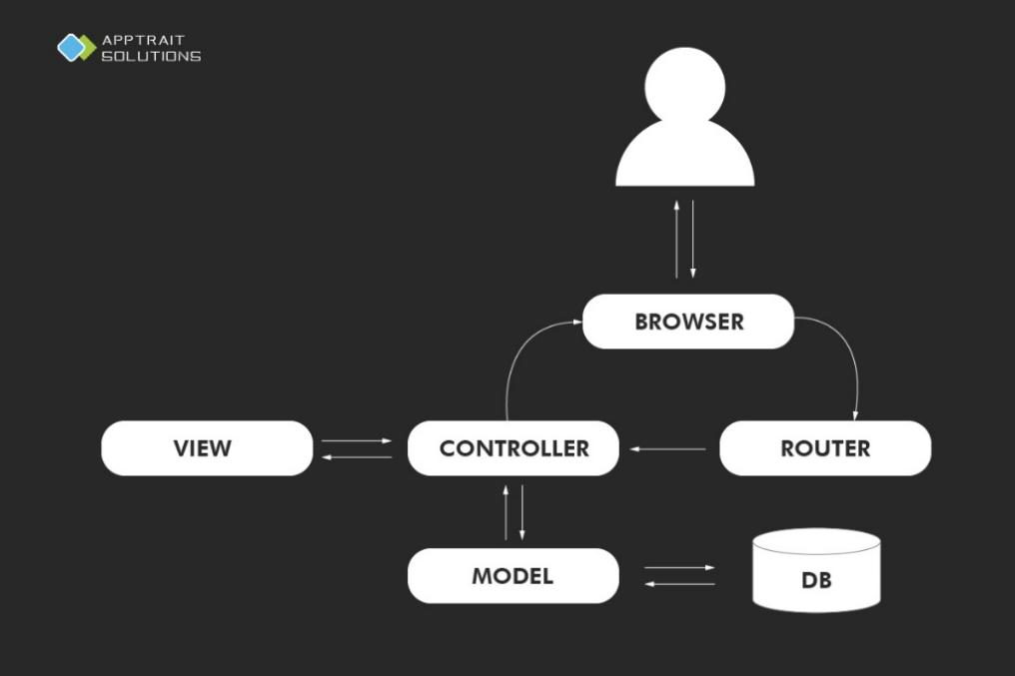

Figure 1: System diagram

## Product Functionality

* The system's functions will be designed to meet the needs of each subject. Below is a summary of the main functions of each object in the system:
* The main function of the **Employer** will be designed to support posting recruitment information and managing job listings such as creating, updating, deleting jobs, searching, and viewing job details. In addition, employers can also create a new job category.
* The main functionality of **Job Seeker** will be designed to facilitate job searching and applying to job listings including searching for jobs, viewing job details, and managing profiles such as creating, updating, deleting profiles and viewing profiles.
* The main function of the **Administrator** will be to manage user accounts such as creating, updating, deleting accounts, and resetting passwords, as well as managing job categories such as responding to requests submitted by Employer by approving or rejecting.

# Specific Requirements

## Functional Requirements

|  |  |  |  |
| --- | --- | --- | --- |
| **ID** | **AS A**  **<TYPE OF USER>** | **I WANT TO**  **<PERFORM SOME TASK>** | **SO THAT I CAN**  **<ACHIEVE SOME GOAL>** |
| 1 | Employer | Create a new job category | Send the request to the administrator for approval |
| Manage job | Create, update, and delete job from the website |
| Search for job | Search quickly and view job details |
| View profile of job seekers | Check the job seeker's information and qualifications |
| 2 | Job Seeker | Manage profiles | Create, update, delete and view profile from the website |
| Search for job | Easily search for jobs and apply |
| View detailed job | Consider jobs that match abilities. |
| 3 | Admin | Manage accounts | Control employers and job seekers accounts |
| Reset passwords for users (employers and job seekers) | Assist users in resetting their passwords |
| Send approval or rejection notifications to employers for new category requests | Manage decisions regarding category additions. |

## Wireflow

A wireflow is a hybrid design document that combines wireframing with flow diagramming. They are essentially wireframes showing user and system flow (balsamiq, n.d.).

Wireflow of the FPTJobMatch:

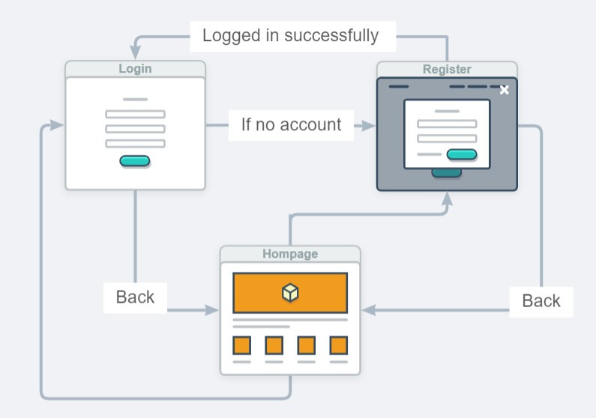

Figure 2: Login wireflow

On the homepage, the user can navigate to the login or registration page. If the user navigates to the login page without an account, the user will need to register an account. If the registration is successful, the user will be redirected. return to the login page. Same if the user navigates to the registration page.

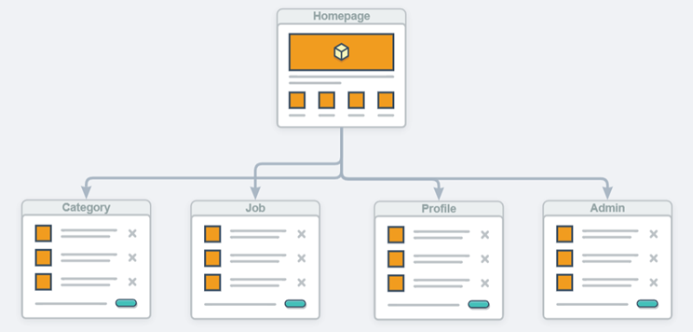

Figure 3: Homepage wireflow

Users can access tasks relevant to their roles from the homepage. Employers can navigate to categories, and jobs, while job seekers can access profiles and apply for jobs.

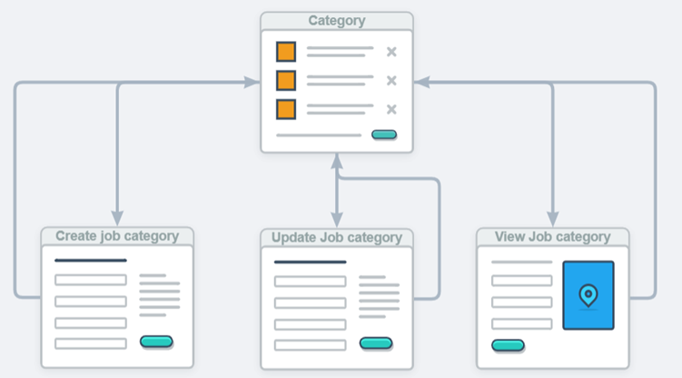

Figure 4: Category wireflow

The Category page features links to three other pages. To add a category, select "Create new" to navigate to the Job Category creation page. Clicking "Update" directs to the Update Category page, and selecting "Detail" allows the employer to view the details of a Category.

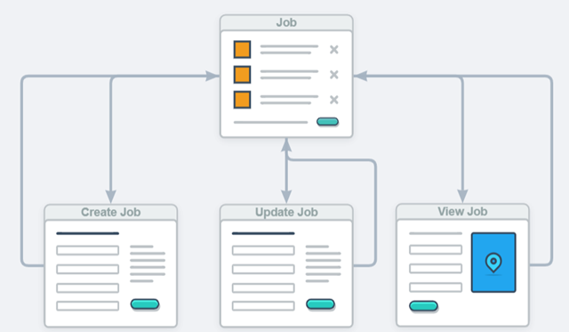

Figure 5: Job wireflow

The Job page features links to three other pages. To add a job, select "Create new" to navigate to the Job creation page. Clicking "Update" directs to the Update Job page and selecting "Detail" allows the employer to view the details of a Job.

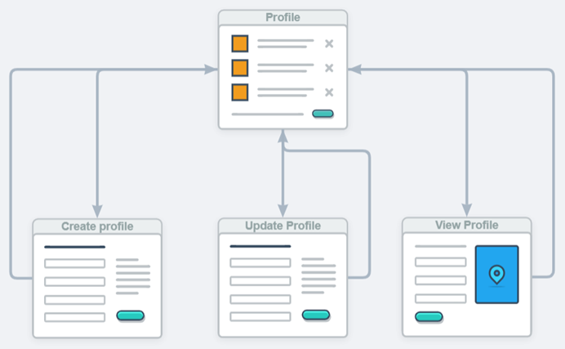

Figure 6: Profile wireflow

The Profile page features links to three other pages. To add a profile, select "Create new" to navigate to the Profile creation page. Clicking "Update" directs to the Update Profile page and selecting "Detail" allows the job seeker to view the details of a Profile.

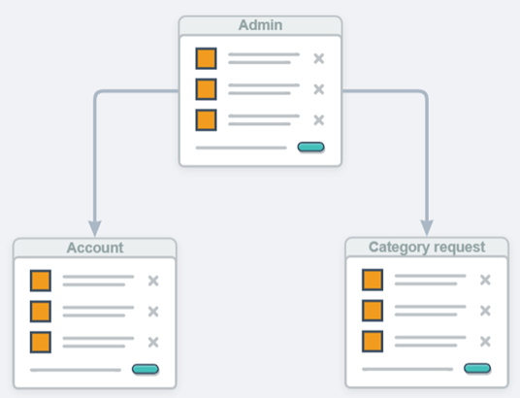

Figure 7: Admin wireflow

The Admin page serves as a privileged area for administrators, granting them the ability to manage accounts and handle category requests from employers.

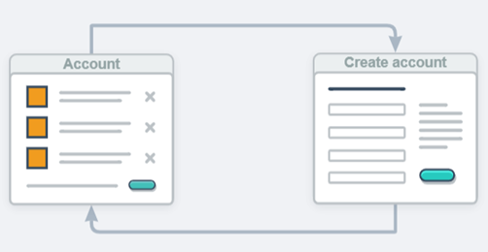

Figure 8: Account wireflow

On the Account page, admins can view a list of user accounts or provide accounts for users by clicking the "Create new" button.

## Use case Diagram

* **Definition**

A Use Case Diagram is a type of Unified Modeling Language (UML) diagram that represents the interaction between actors (users or external systems) and a system under consideration to accomplish specific goals. It provides a high-level view of the system’s functionality by illustrating the various ways users can interact with it (geeksforgeeks, n.d.).

* **This is usecase diagram of the FPTJobMatch system:**

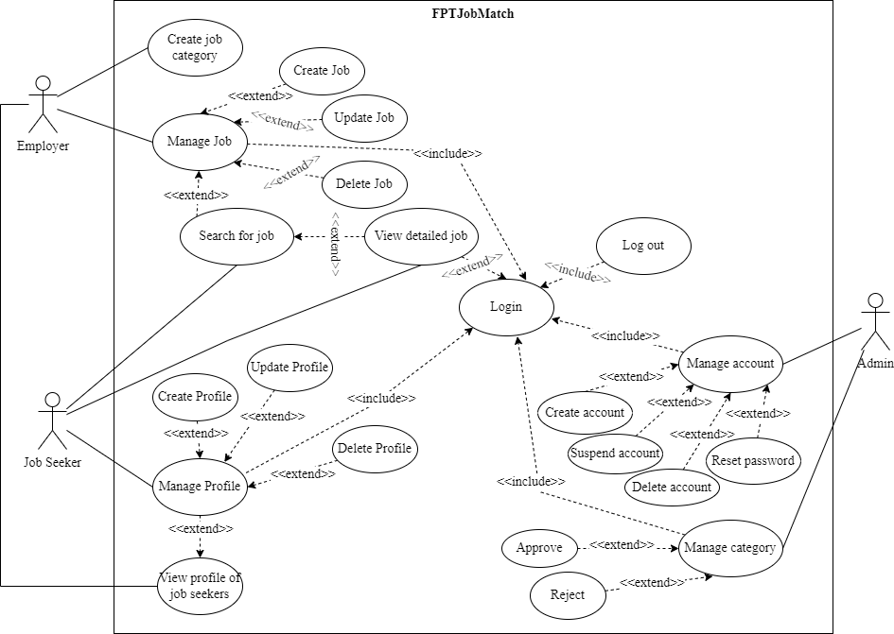

Figure 9: Usecase of FPTJobMatch

According to the use case diagram, the FPTJobMatch system involves three primary actors: Employers, Job Seekers, and Administrators.

For Employers, they can manage jobs by creating, updating, and deleting jobs. Additionally, they can search for jobs and view job details. Moreover, Employers can request to create a new job category by sending a request to the Administrator for approval. They also can view profiles of Job Seekers.

For Job Seekers, they can manage their profiles by creating, updating, deleting profiles, and viewing profile information. Furthermore, Job Seekers can search for jobs and view job details.

Lastly, Administrators can manage user accounts by creating, suspending, deleting, and resetting passwords. Additionally, they have the authority to manage job categories by approving or rejecting requests from Employers to create new categories.

* **Tables for usecase specification for FPTJobMatch system**
* **Employer**

Table 1: Table specification for “Manage Job”

|  |  |
| --- | --- |
| **Usecase specification** | |
| **Usecase name** | Manage Job |
| **Actor(s)** | Employer |
| **Summary description** | Employer manages job on the website. |
| **Priority** | Must have |
| **Entry condition** | The website is open |
| **Basic path** | 1. Employer accesses the website and logs in using their account.  2. Employer navigates to the "Manage Job" section.  3. Employer uses functions in the “Manage Job” section such as creating, updating, and deleting job listings on the website. |
| **Exit condition** | The employer successfully manages the job listings on the website, which involves functions such as creating, updating, and deleting jobs as needed. |
| **Alternative path** | If the employer doesn’t make any changes, they can exit the “Manage Job” section. |

Table 2: Table specification for “Create Job”

|  |  |
| --- | --- |
| **Usecase specification** | |
| **Usecase name** | Create Job |
| **Actor(s)** | Employer |
| **Summary description** | Employer creates a new job to the website. |
| **Priority** | Must have |
| **Entry condition** | The website is open |
| **Basic path** | 1. Employer accesses the website and logs in using their account.  2. Employer navigates to the "Create Job" section.  3. Employer fills in all information to create a new job, including title, description, requirement, deadline, location, and industry |
| **Exit condition** | Employer successfully creates a new job on the website. |
| **Alternative path** | 1. If the employer leaves any information blank, a message will be displayed asking to enter full information.  2. If the employer decides not to create a job after starting the process, the employer can cancel the job creation action and return to the job management interface or select other job management functions. |

Table 3: Table specification of “Update Job”

|  |  |
| --- | --- |
| **Usecase specification** | |
| **Usecase name** | Update Job |
| **Actor(s)** | Employer |
| **Summary description** | Employer updates the information of an existing job on the website. |
| **Priority** | Must have |
| **Entry condition** | The website is open |
| **Basic path** | 1. Employer accesses the website and logs in using their account.  2. Employer navigates to the "Update Job" section.  3. Employer selects the specific job they want to update.  4. Employer edits the job's information as needed, such as updating title, description, requirement, deadline, location, and industry. |
| **Exit condition** | Employer successfully updates the information of the selected job on the website. |
| **Alternative path** | 1. If the employer leaves any information blank, a message will be displayed asking to enter full information.  2. If the employer decides not to update the job after starting the process, the employer can cancel the job update action and return to the job management interface or choose other job management functions. |

Table 4: Table specification of “Delete Job”

|  |  |
| --- | --- |
| **Usecase specification** | |
| **Usecase name** | Delete Job |
| **Actor(s)** | Employer |
| **Summary description** | Employer deletes the information of an existing job on the website. |
| **Priority** | Must have |
| **Entry condition** | The website is open |
| **Basic path** | 1. Employer accesses the website and logs in using their account.  2. Employer navigates to the "Delete Job" section.  3. Employer selects the specific job they want to remove.  4. The message “Do you want to delete?” will be displayed.  5. Employer clicks “Yes”. |
| **Exit condition** | Employer successfully deletes the information of the selected job on the website. |
| **Alternative path** | If the employer decides not to delete the job after starting the process, the employer can cancel the job delete action and return to the job management interface or choose other job management functions. |

Table 5: Table specification of “Search for job”

|  |  |
| --- | --- |
| **Usecase specification** | |
| **Usecase name** | Search for job |
| **Actor(s)** | Employer |
| **Summary description** | Employer searches the information about an existing job on the website. |
| **Priority** | Must have |
| **Entry condition** | The website is open |
| **Basic path** | 1. Employer accesses the website and logs in using their account.  2. Employer enters keywords about any job that the employer wants to find into the search bar.  3. Employer presses the “Search” or “Enter” button. |
| **Exit condition** | Successfully display the job the employer wants to search for. |
| **Alternative path** | If no results are found, the system will display the message "Not Found" and the employer can re-enter to search for another job. |

Table 6: Table specification for “View detailed job”

|  |  |
| --- | --- |
| **Usecase specification** | |
| **Usecase name** | View detailed job |
| **Actor(s)** | Employer |
| **Summary description** | Employer views detailed job information |
| **Priority** | Must have |
| **Entry condition** | The website is open |
| **Basic path** | 1. Employer accesses the website and logs in using their account.  2. Employers choose a specific job they want to see.  3. Job information will be displayed including title, description, requirements, deadline, location and industry. |
| **Exit condition** | Employer successfully viewed detailed information about a selected job. |
| **Alternative path** | If the employer wants to see detailed information of another job, they can press the “Back” button to select another one. |

Table 7: Table specification for “Create job category”

|  |  |
| --- | --- |
| **Usecase specification** | |
| **Usecase name** | Create job category |
| **Actor(s)** | Employer |
| **Summary description** | Employer creates a new job category |
| **Priority** | Must have |
| **Entry condition** | The website is open |
| **Basic path** | 1. Employer accesses the website and logs in using their account.  2. Employer navigates to the “Category” section.  3. Employer presses the “Create new” button.  4. Employer fills in all information to create a new job category, including name and status. |
| **Exit condition** | Employer successfully creates a new job category. |
| **Alternative path** | 1. If the employer leaves any information blank, a message will be displayed asking to enter full information.  2. If the employer decides not to create new a job category after starting the process, the employer can cancel the job category creation action and return to the category management interface or select other category management functions. |

Table 8: Table specification of “View profile of Job Seeker”

|  |  |
| --- | --- |
| **Usecase specification** | |
| **Usecase name** | View profile of job seekers |
| **Actor(s)** | Employer |
| **Summary description** | Employer views profile information of Job Seeker on the website. |
| **Priority** | Must have |
| **Entry condition** | The website is open |
| **Basic path** | 1. Employer accesses the website and logs in using their account.  2. Employer chooses to view profile information for a job seeker who has applied for a job.  3. The candidate's profile information will be displayed including introduction and file CV. |
| **Exit condition** | Successfully displayed candidate profile information. |
| **Alternative path** | If the employer wants to see another candidate's profile information, they can press the "Back" button to select another candidate. |

Table 9: Table specification for “Log out”

|  |  |
| --- | --- |
| **Usecase specification** | |
| **Usecase name** | Log out |
| **Actor(s)** | Employer |
| **Summary description** | Employer logs out of the website |
| **Priority** | Must have |
| **Entry condition** | The website is open |
| **Basic path** | 1. Employer accesses the website and logs in using their account.  2. Employer navigates the “Log out” button.  3. The system will display the message “Do you want to log out?”.  4. Employer clicks “Yes”.  5. Employer will log out of the website. |
| **Exit condition** | The employer successfully logged out of their account from the website. |
| **Alternative path** | If the Employer clicks "No", the log out process is canceled, and the Employer remains logged in. |

* **Job Seeker**

Table 10: Table specification for “Manage Profile”

|  |  |
| --- | --- |
| **Usecase specification** | |
| **Usecase name** | Manage Profile |
| **Actor(s)** | Job Seeker |
| **Summary description** | Job Seeker manages profile on the website |
| **Priority** | Must have |
| **Entry condition** | The website is open |
| **Basic path** | 1. Job Seeker accesses the website and logs in using their account.  2. Job Seeker navigates to the "Manage Profile" section.  3. Job Seeker uses functions in the “Manage Profile” section such as creating, updating, deleting profile, and viewing profile on the website. |
| **Exit condition** | The job seeker successfully manages their profile on the website, which involves functions such as creating, updating, deleting profile, and viewing profile as needed. |
| **Alternative path** | If the job seeker doesn’t make any changes, they can exit the “Manage Profile” section. |

Table 11: Table specification for “Create Profile”

|  |  |
| --- | --- |
| **Usecase specification** | |
| **Usecase name** | Create Profile |
| **Actor(s)** | Job Seeker |
| **Summary description** | Job Seeker creates a new profile on the website. |
| **Priority** | Must have |
| **Entry condition** | The website is open |
| **Basic path** | 1. Job Seeker accesses the website and logs in using their account.  2. Job Seeker navigates to the "Create Profile" section.  3. Job Seeker fills in all information to create a new profile, including introduction and file CV. |
| **Exit condition** | Job Seeker successfully creates a new profile on the website. |
| **Alternative path** | 1. If the job seeker leaves any information blank, a message will be displayed asking to enter full information.  2. If the job seeker decides not to create a profile after starting the process, the job seeker can cancel the profile creation action and return to the profile management interface or select other profile management functions. |

Table 12: Table specification for “Update Profile”

|  |  |
| --- | --- |
| **Usecase specification** | |
| **Usecase name** | Update Profile |
| **Actor(s)** | Job Seeker |
| **Summary description** | Job Seeker updates their profile information on the website. |
| **Priority** | Must have |
| **Entry condition** | The website is open |
| **Basic path** | 1. Job Seeker accesses the website and logs in using their account.  2. Job Seeker navigates to the "Update Profile" section.  3. Job Seeker edits the profile's information as needed, such as updating introduction and file CV. |
| **Exit condition** | Job Seeker successfully updates their profile information on the website. |
| **Alternative path** | 1. If the job seeker leaves any information blank, a message will be displayed asking to enter full information.  2. If the job seeker decides not to update the profile after starting the process, the job seeker can cancel the profile update action and return to the profile management interface or choose other profile management functions. |

Table 13: Table specification for “Delete Profile”

|  |  |
| --- | --- |
| **Usecase specification** | |
| **Usecase name** | Delete Profile |
| **Actor(s)** | Job Seeker |
| **Summary description** | Job Seeker deletes their profile information on the website. |
| **Priority** | Must have |
| **Entry condition** | The website is open |
| **Basic path** | 1. Job Seeker accesses the website and logs in using their account.  2. Job Seeker navigates to the "Delete Profile" section.  3. Job Seeker clicks the “Delete” button.  4. The message “Do you want to delete?” will be displayed.  5. Job Seeker clicks “Yes”. |
| **Exit condition** | Job Seeker successfully deletes their profile information on the website. |
| **Alternative path** | If the job seeker decides not to delete the profile after starting the process, the job seeker can cancel the profile delete action and return to the profile management interface or choose other profile management functions. |

Table 14: Table specification for “View profile of job seekers”

|  |  |
| --- | --- |
| **Usecase specification** | |
| **Usecase name** | View profile of job seekers |
| **Actor(s)** | Job Seeker |
| **Summary description** | Job Seeker views profile information on the website. |
| **Priority** | Must have |
| **Entry condition** | The website is open |
| **Basic path** | 1. Job Seeker accesses the website and logs in using their account.  2. Job Seeker clicks on their avatar to navigate to their profile information page.  3. The job seeker’s profile information will be displayed including introduction and file CV. |
| **Exit condition** | Successfully displayed job seeker profile information. |
| **Alternative path** | If job seeker wants to return to the homepage they can press the “Back” button. |

Table 15: Table specification for “Search for job”

|  |  |
| --- | --- |
| **Usecase specification** | |
| **Usecase name** | Search for job |
| **Actor(s)** | Job Seeker |
| **Summary description** | Job Seeker searches the information about an existing job on the website. |
| **Priority** | Must have |
| **Entry condition** | The website is open |
| **Basic path** | 1. Job Seeker accesses the website and logs in using their account.  2. Job Seeker enters keywords about any job that the employer wants to find into the search bar.  3. Job Seeker presses the “Search” or “Enter” button. |
| **Exit condition** | Successfully display the job the job seeker wants to search for. |
| **Alternative path** | If no results are found, the system will display the message "Not Found" and the job seeker can re-enter to search for another job. |

Table 16: Table specification for “View detailed job”

|  |  |
| --- | --- |
| **Usecase specification** | |
| **Usecase name** | View detailed job |
| **Actor(s)** | Job Seeker |
| **Summary description** | Job Seeker view detailed job information |
| **Priority** | Must have |
| **Entry condition** | The website is open |
| **Basic path** | 1. Job Seeker accesses the website and logs in using their account.  2. Job Seeker chooses a specific job they want to see.  3. Job information will be displayed including title, description, requirements, deadline, location and industry. |
| **Exit condition** | Job Seeker successfully viewed detailed information about a selected job. |
| **Alternative path** | If job seeker wants to see detailed information of another job, they can press the “Back” button to select another one. |

Table 17: Table specification for “Log out”

|  |  |
| --- | --- |
| **Usecase specification** | |
| **Usecase name** | Log out |
| **Actor(s)** | Job Seeker |
| **Summary description** | Job Seeker logs out of the website |
| **Priority** | Must have |
| **Entry condition** | The website is open |
| **Basic path** | 1. Job Seeker accesses the website and logs in using their account.  2. Job Seeker navigates the “Log out” button.  3. The system will display the message “Do you want to log out?”.  4. Job Seeker clicks “Yes”.  5. Job Seeker will log out of the website. |
| **Exit condition** | Job Seeker successfully logged out of their account from the website. |
| **Alternative path** | If the Job Seeker clicks "No", the log out process is canceled, and the Job Seeker remains logged in. |

* **Admin**

Table 18: Table specification for “Manage Account”

|  |  |
| --- | --- |
| **Usecase specification** | |
| **Usecase name** | Manage Account |
| **Actor(s)** | Admin |
| **Summary description** | Admin manages accounts on the website. |
| **Priority** | Must have |
| **Entry condition** | The website is open |
| **Basic path** | 1. Admin accesses the website and logs in using their account.  2. Admin navigates to the "Manage Account" section.  3. Admin uses functions in the “Manage Account” section such as creating, updating, deleting account, and resetting password on the website. |
| **Exit condition** | The admin successfully manages the accounts on the website, which involves functions such as creating, updating, deleting account, and resetting password as needed. |
| **Alternative path** | If the admin doesn’t make any changes, they can exit the “Manage Account” section. |

Table 19: Table specification for “Create Account”

|  |  |
| --- | --- |
| **Usecase specification** | |
| **Usecase name** | Create Account |
| **Actor(s)** | Admin |
| **Summary description** | Admin creates accounts for users |
| **Priority** | Must have |
| **Entry condition** | The website is open |
| **Basic path** | 1. Admin accesses the website and logs in using their account.  2. Admin navigates to the "Create Account" section.  3. Admin fills in all information to create a new account, including Name, Date of Birth, Address and Phone number. |
| **Exit condition** | Admin successfully creates a new account on the website. |
| **Alternative path** | 1. If the admin leaves any information blank, a message will be displayed asking to enter full information.  2. If the admin decides not to create an account after starting the process, the admin can cancel the account creation action and return to the account management interface or select other account management functions. |

Table 20: Table specification for “Suspend Account”

|  |  |
| --- | --- |
| **Usecase specification** | |
| **Usecase name** | Suspend Account |
| **Actor(s)** | Admin |
| **Summary description** | Admin suspends user account |
| **Priority** | Must have |
| **Entry condition** | The website is open |
| **Basic path** | 1. Admin accesses the website and logs in using their account.  2. Admin navigates to the "Suspend Account" section.  3. Admin selects an account to suspend. |
| **Exit condition** | Admin successfully suspends an account on the website. |
| **Alternative path** | If the admin decides not to suspend an account after starting the process, the admin can cancel the account suspension action and return to the account management interface or select other account management functions. |

Table 21: Table specification for “Delete Account”

|  |  |
| --- | --- |
| **Usecase specification** | |
| **Usecase name** | Delete Account |
| **Actor(s)** | Admin |
| **Summary description** | Admin deletes the user account |
| **Priority** | Must have |
| **Entry condition** | The website is open |
| **Basic path** | 1. Admin accesses the website and logs in using their account.  2. Admin navigates to the "Delete Account" section.  3. Admin selects the specific account they want to remove.  4. The message “Do you want to delete?” will be displayed.  5. Admin clicks “Yes”. |
| **Exit condition** | Admin successfully deletes the user account on the website. |
| **Alternative path** | If the admin decides not to delete the account after starting the process, the admin can cancel the account delete action and return to the account management interface or choose other account management functions. |

Table 22: Table specification for “Reset password”

|  |  |
| --- | --- |
| **Usecase specification** | |
| **Usecase name** | Reset password |
| **Actor(s)** | Admin |
| **Summary description** | Admin can reset the user account password |
| **Priority** | Must have |
| **Entry condition** | The website is open |
| **Basic path** | 1. Admin accesses the website and logs in using their account.  2. Admin selects the specific account they want to reset password.  4. The message “Do you want to reset password?” will be displayed.  5. Admin clicks “Yes”.  6. Admin reset new password.  7. Admin clicks the “Save” button. |
| **Exit condition** | Admin successfully reset the user account password on the website. |
| **Alternative path** | If the admin decides not to reset the user account password after starting the process, the admin can cancel the reset password action and return to the account management interface or choose other account management functions. |

Table 23: Table specification for “Manage Category”

|  |  |
| --- | --- |
| **Usecase specification** | |
| **Usecase name** | Manage Category |
| **Actor(s)** | Admin |
| **Summary description** | Admin manages category on the website. |
| **Priority** | Must have |
| **Entry condition** | The website is open |
| **Basic path** | 1. Admin accesses the website and logs in using their account.  2. Admin navigates to the "Manage Category" section.  3. Admin uses functions in the “Manage Category” section such as approval and rejection on the website. |
| **Exit condition** | The admin successfully manages the categories on the website, which involves functions such as approval and rejection as needed. |
| **Alternative path** | If the admin doesn’t make any changes, they can exit the “Manage Category” section. |

Table 24: Table specification for “Approve”

|  |  |
| --- | --- |
| **Usecase specification** | |
| **Usecase name** | Approve |
| **Actor(s)** | Admin |
| **Summary description** | Admin approves the request to create a new job category |
| **Priority** | Must have |
| **Entry condition** | The website is open |
| **Basic path** | 1. Admin accesses the website and logs in using their account.  2. Admin navigates to the "Manage Category" section.  3. Admin selects a request to create a new job category.  4. Admin clicks the “Approve” button. |
| **Exit condition** | Admin successfully approved to create a new job category. |
| **Alternative path** | If the admin decides not to approve after starting the process, the admin can cancel the approve action and return to the category management interface or choose other category management functions. |

Table 25: Table specification for “Reject”

|  |  |
| --- | --- |
| **Usecase specification** | |
| **Usecase name** | Reject |
| **Actor(s)** | Admin |
| **Summary description** | Admin rejects the request to create a new job category |
| **Priority** | Must have |
| **Entry condition** | The website is open |
| **Basic path** | 1. Admin accesses the website and logs in using their account.  2. Admin navigates to the "Manage Category" section.  3. Admin selects a request to create a new job category.  4. Admin clicks the “Reject” button. |
| **Exit condition** | Admin successfully rejects the creation of a new job category. |
| **Alternative path** | If the admin decides not to reject after starting the process, the admin can cancel the reject action and return to the category management interface or choose other category management functions. |

Table 26: Table specification for “Log out”

|  |  |
| --- | --- |
| **Usecase specification** | |
| **Usecase name** | Log out |
| **Actor(s)** | Admin |
| **Summary description** | Admin logs out of the website |
| **Priority** | Must have |
| **Entry condition** | The website is open |
| **Basic path** | 1. Admin accesses the website and logs in using their account.  2. Admin navigates the “Log out” button.  3. The system will display the message “Do you want to log out?”.  4. Admin clicks “Yes”.  5. Admin will log out of the website. |
| **Exit condition** | Admin successfully logged out of their account from the website. |
| **Alternative path** | If the admin clicks "No", the log out process is canceled, and the admin remains logged in. |

## Site Map

A sitemap is a file that shows the structure of a website, including its pages and content and the relationships between them. Search engines use sitemaps to crawl websites more efficiently (Pavlik, 2023).

Site map of the FPTJobMatch:

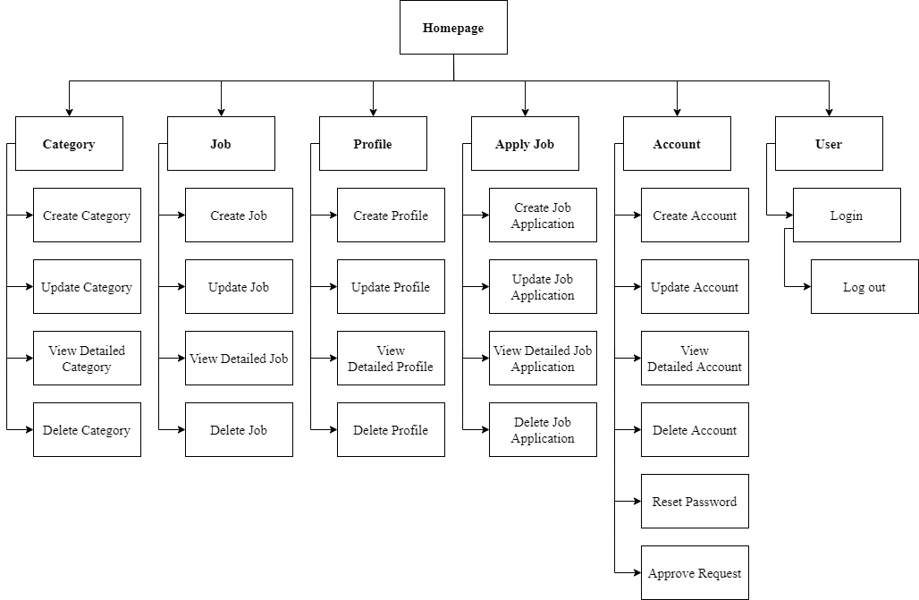

Figure 10: Sitemap of FPTJobMatch

FPTJobMatch's site map starts from the home page and branches out into six main sections: Category, Job, Profile, Apply Job, Account and User.

* For Category section: Employer can create, update, view details, or delete categories.
* For Job section: Allow employer to create job postings, update them, or view details about them. Employer can also delete job postings if needed.
* For Profile section: Job seeker can the option to create a profile or update an existing profile. They can view profile details or delete their profile.
* For Apply Job section: Allow job seeker to apply and update their applications. They can view application details or delete their application.
* For Account section: Users can create an account or update their existing account. They can also view account details or delete the account if needed. There is a password reset option and a request approval function (if it is an admin account).
* For User section: Contains login and logout options.

# Technical Design

## Entity Relationship Diagram

Entity Relationship Diagram, also known as ERD, is a type of structural diagram for use in database design. An ERD contains different symbols and connectors that visualize two important information: The major entities within the system scope, and the inter-relationships among these entities (visual-paradigm, n.d.).

Entity Relationship Diagram of the FPTJobMatch:

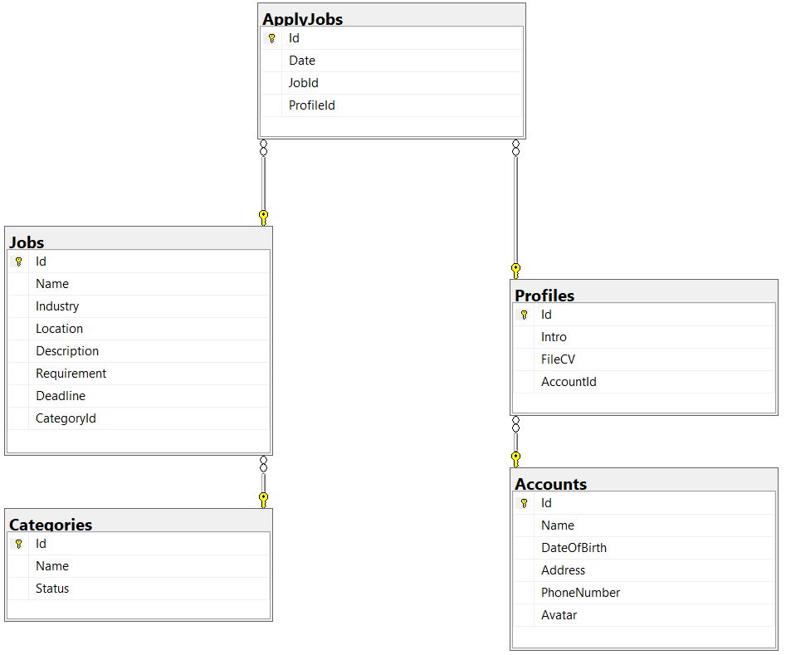

Figure 11: Entity relationship diagram for FPTJobMatch

This is an entity relationship diagram representing the structure of FPTJobMatch's database system. It includes 5 entities: Categories, Jobs, Profiles, ApplyJobs and Accounts. Each entity contains attributes represented by fields within them.

* Category is an entity with attributes such as Id, Name and Status.
* Jobs is an entity with attributes such as Id, Name, Industry, Location, Description, Requirement, Deadline and CategoryId.
* Profiles is an entity with attributes such as Id, Intro, FileCV and AccountId.
* ApplyJobs is an entity with attributes such as Id, Date, JobId and ProfileId. It plays a role in indicating which profile has applied for which job.
* Accounts is an entity with attributes such as Id, Name, DateOfBirth, Address, PhoneNumber and Avatar.

## Class Diagram

A class diagram in the Unified Modeling Language (UML) is a type of static structure diagram that describes the structure of a system by showing the system's classes, their attributes, operations (or methods), and the relationships among objects (visual-paradigm, n.d.).

Class diagram of the FPTJobMatch:

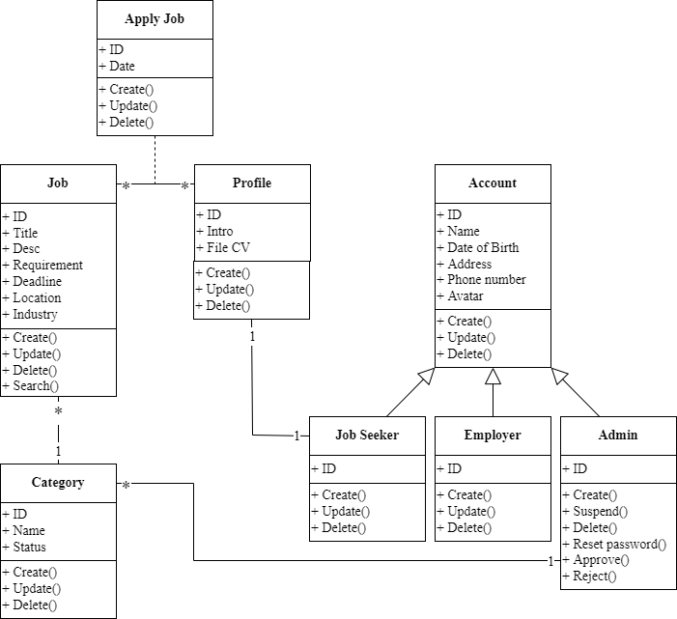

Figure 12: Class diagram of FPTJobMatch

This is the class diagram of FPTJobMatch, it includes classes such as Category, Job, Profile, Apply Job, Account, Job Seeker, Employer and Admin. Each class has properties and methods associated with it.

* Category class has properties such as ID, Name, Status and methods including Create(), Update(), Delete().
* Job class has properties such as ID, Title, Desc, Requirement, Deadline, Location, Industry and methods including Create(), Update(), Delete(), Search().
* Profile class has properties such as ID, Intro, File CV and methods including Create(), Update(), Delete().
* Apply Job class has properties such as ID, Date and methods including Create(), Update(), Delete().
* Account class has properties such as ID, Name, Date of Birth, Address, Phone number, Avatar and methods including Create(), Update(), Delete().
* Job Seeker, Employer and Admin are classes that are inherited from the Account class.
  + Job Seeker class has properties such as ID and methods including Create(), Update(), Delete().
  + Employer class has properties such as ID and methods including Create(), Update(), Delete().
  + Admin class has properties such as ID and methods including Create(), Suspend(), Delete(), Reset password(), Approve(), Reject().

## Activity Diagram

* **Definition**

Activity Diagrams are used to illustrate the flow of control in a system and refer to the steps involved in the execution of a use case. Programmer can depict both sequential processing and concurrent processing of activities using an activity diagram, i.e. an activity diagram focuses on the condition of flow and the sequence in which it happens (geeksforgeeks, n.d.).

* **Activity diagram for “Create Category”**

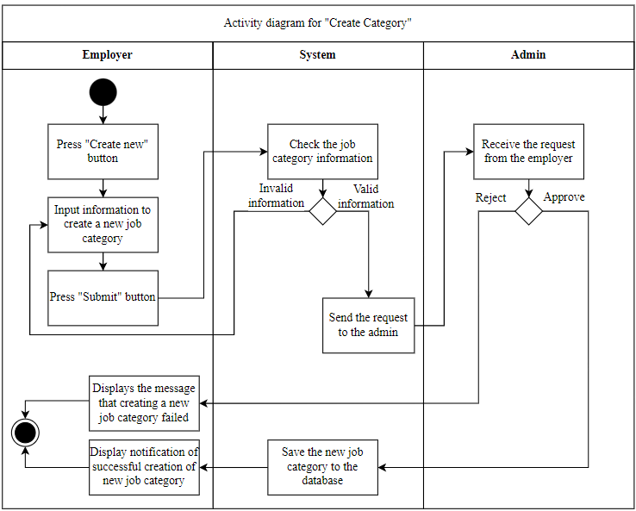

Figure 13: Activity diagram for "Create Category"

The “Create Category” activity diagram describes the process of creating a new job category in a system involving three entities: Employer, System, and Admin. Employer starts the process by pressing the “Create new” button and entering information to create a new job category before submitting it. The System will then check the information that has been sent, if valid, it sends a request to Admin, if not valid, the Employer will have to re-enter and resubmit the request. Admin receives the request and has the option to accept or reject it. If accepted a new job category will be created and a successfully created message will be displayed, if rejected, the job category will not be created and a creation failed message will be displayed and the process will end.

* **Activity diagram for “Create Job”**

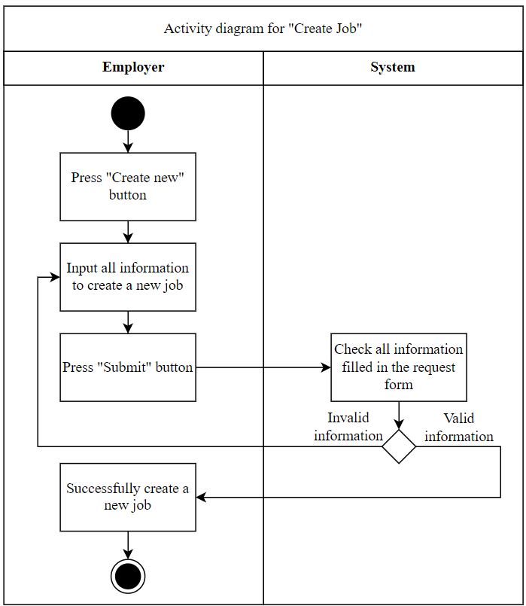

Figure 14: Activity diagram for “Create Job”

The “Create Job” activity diagram describes the process of creating a new job in a system involving two entities: Employer and System. Employer starts the process by pressing the “Create new” button and entering information to create a new job before submitting it. After that, the System will check the submitted information. If it is invalid, the Employer will have to re-enter and resubmit the request. If valid, a message will be displayed to successfully create a new job and end the process.

**Note*:** Similar to the activity diagrams “Create Profile”, “Create Apply Job”.

* **Activity diagram for “Update Job”**

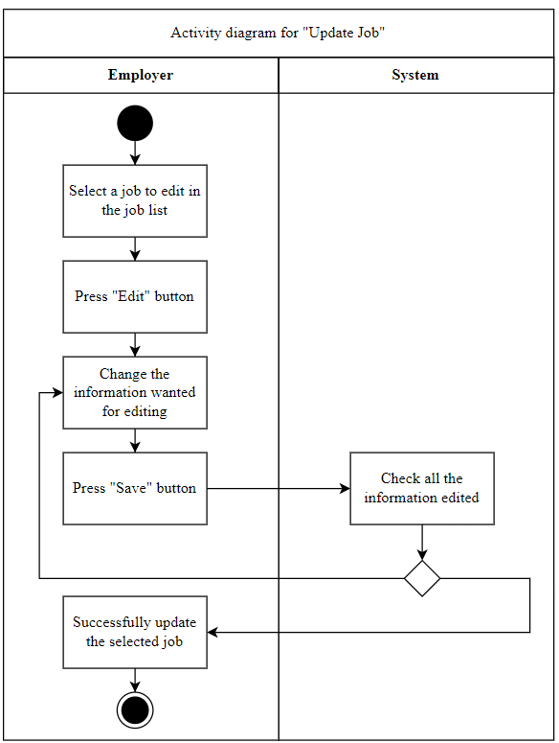

Figure 15: Activity diagram for "Update Job"

The activity diagram of “Update Job” describes the process of updating a job in a system involving two entities: Employer and System. Employer starts the process by selecting a job they want to edit and pressing the “Edit” button and changing the new editable information before saving it. After that, the System will check the edited information. If it is invalid, the Employer will have to edit it again. If valid, a message about successfully updating the job and ending the process will be displayed.

**Note*:** Similar to the activity diagrams “Update Profile”, “Update Apply Job”.

* **Activity diagram for “Delete Job”**

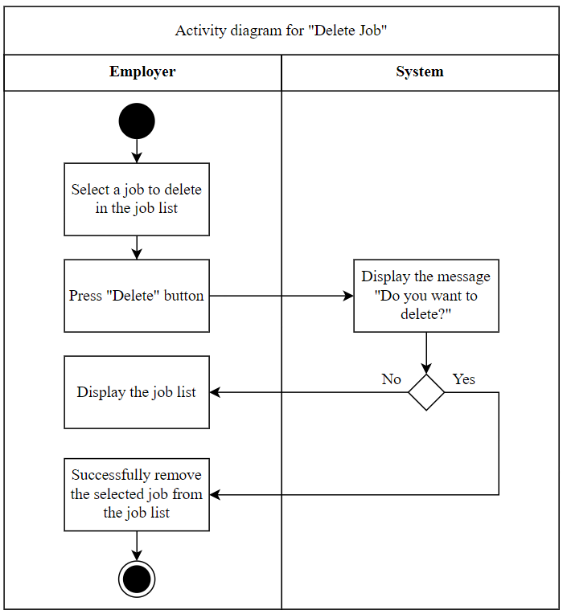

Figure 16: Activity diagram for "Delete Job"

The activity diagram of “Delete Job” describes the process of deleting a job in a system involving two entities: Employer and System. Employers start the process by selecting a job they want to delete and pressing the “Delete” button. After that, the System will display the message "Do you want to delete?", if the Employer presses "No", the job will not be deleted and displays the job list. If the Employer clicks "Yes", a message will be displayed to successfully remove the job from the list and end the process.

**Note*:** Similar to the activity diagrams “Delete Profile”, “Delete Apply Job”.

## Gantt Chart

* **Definition**

A Gantt chart is a project management tool that shows the duration of tasks on a visual project schedule. It has two main parts, a task list on the left side and a project timeline on the right (projectmanager, n.d.).

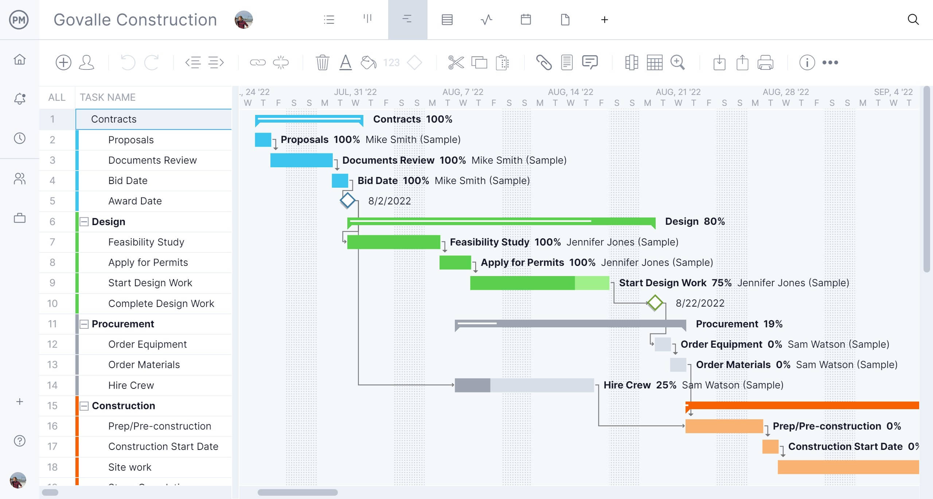

Figure 17: Gantt chart

* **Gannt chart of the project**
* **Initiation phase**

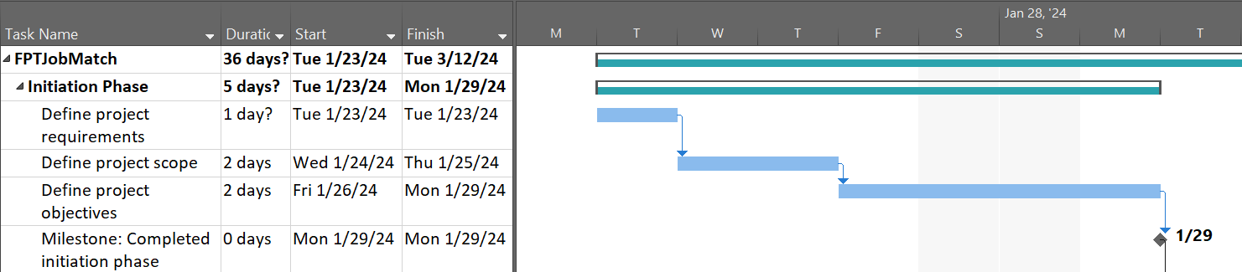

Figure 18: Initiation phase

* **Planning phase**

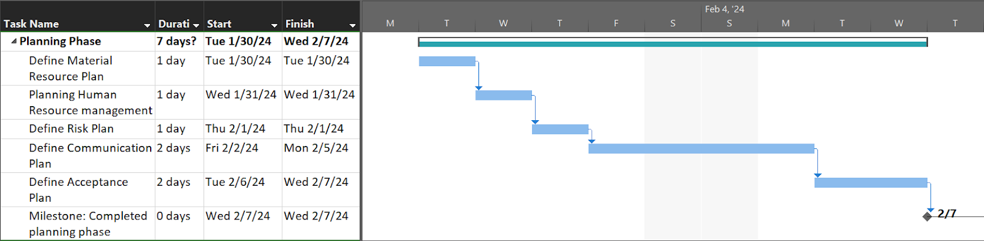

Figure 19: Planning phase

* **Executing phase**

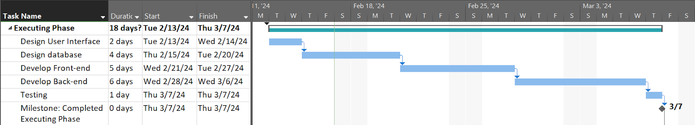

Figure 20: Executing phase

* **Closing phase**

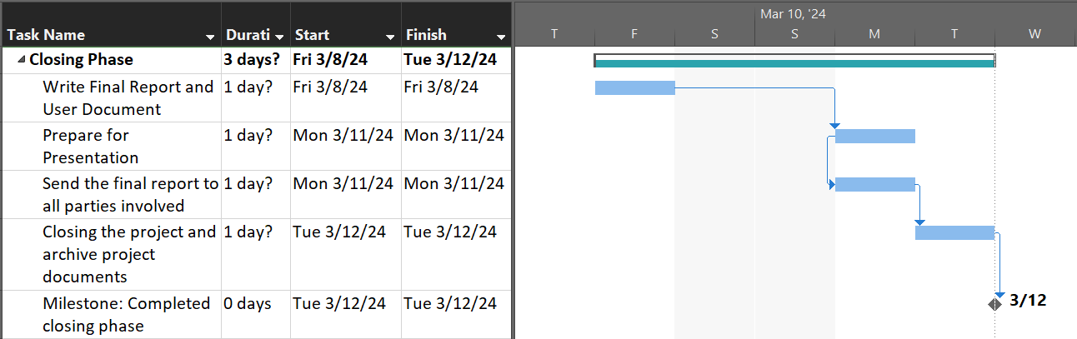

Figure 21: Closing phase

# Risk Assessment

Table 27: Risk Assessment

|  |  |  |  |  |  |  |  |  |  |  |
| --- | --- | --- | --- | --- | --- | --- | --- | --- | --- | --- |
| **REF/**  **ID** | **P R E - M I T I G A T I O N** | | | | **DEPARTMENT/**  **LOCATION** | **MITIGATIONS / WARNINGS / REMEDIES** | **P O S T – M I T I G A T I O N** | | | |
| **RISK** | **RISK SEVERITY** | **RISK LIKELIHOOD** | **RISK LEVEL** | **RISK SEVERITY** | **RISK LIKELIHOOD** | **RISK LEVEL** | **ACCEPTABLE**  **TO PROCEED?** |
| 1 | Technology | UNDESIRABLE | IMPROBABLE | HIGH | IT Rooms | Allocate a projected budget to account for unexpected equipment damages. | ACCEPTABLE | IMPROBABLE | HIGH | YES |
| 2 | Cost | ACCEPTABLE | IMPROBABLE | MEDIUM | Meeting Rooms | Calculate expenditures in accordance with the purpose and requirements of the project. | ACCEPTABLE | POSSIBLE | HIGH | YES |
| 3 | Time | ACCEPTABLE | IMPROBABLE | HIGH | Meeting Rooms | Make detailed and specific plans, arrange time and goals in accordance with members' abilities. Make a contingency plan if a risk occurs. | ACCEPTABLE | IMPROBABLE | MEDIUM | YES |
| **4** | Cost | ACCEPTABLE | IMPROBABLE | MEDIUM | Meeting Rooms | Determine expenses aligned with the project's objectives. | ACCEPTABLE | POSSIBLE | HIGH | YES |
| **5** | Time | ACCEPTABLE | IMPROBABLE | HIGH | Meeting Rooms | Create detailed and specific plans, schedule tasks and objectives based on team members' capabilities, and devise contingency strategies for potential risks. | ACCEPTABLE | IMPROBABLE | MEDIUM | YES |

**Evaluation Report**

# Design Tools

## Tools to design UML

* **Draw.io**

Draw.io is a freely available open-source platform designed for creating UML diagrams, wireframes, and business charts. Its intuitive interface, along with lots of predefined templates, is mainly used for professional diagrams. Available as standalone software and an online tool, Draw.io supports a variety of file formats including PNG, JPEG, SVG, and PDF. It delivers a seamless experience across popular browsers such as Chrome, Microsoft Edge, and Mozilla Firefox, and is compatible with operating systems such as Windows, Linux, and macOS (geeksforgeeks, n.d.).

* **Advantages**
* One notable advantage is its cost-effectiveness, being entirely free.
* Its intuitive interface makes it user-friendly, especially for beginners.
* Collaborative groups can access a variety of shapes for their diagrams.
* As a web-based application, users don't need to download or install it on their devices.
* **Disadvantages**
* It still lacks advanced features and is not up to the mark when compared to other online tools.
* The browser-based nature of the tool can result in occasional sluggishness and delays.
* Users may find fewer shortcuts available to enhance workflow efficiency.
* **Visual Paradigm**

Visual Paradigm is a diagramming tool used by business organizations for planning and modeling. Visual Paradigm is available both as an online tool and software. It requires a single sign-up for using an online tool. It contains predefined layouts. It is a paid platform and provides a free trial of 30 days. The purpose of the Visual paradigm is not only limited to drawing UML diagrams but also for many purposes such as creating Business Cards, Brochures, Book covers, Gift Cards, etc. It can also be used as an image editing tool (geeksforgeeks, n.d.).

* **Advantages**
* **Professional diagram tool:** Visual Paradigm gears towards complex diagrams, so all its features are aimed to make flowcharts most efficiently. It generally outweighs a software design tool that has diagram features.
* **Convenience:** The ability to edit existing samples based on personal preference instead of building a diagram from scratch helps users save time and effort significantly.
* **User-friendly interface:** Visual Paradigm online platform boasts an extremely simple, straightforward user interface, which is quite easy to get used to for those with a diagram experience.
* **Stable, solid performance:** As one of the best diagram tools, it is reliable, lag-free, and generates great flowcharts.
* **Versatile tool:** Users can rely on Paradigm for study or project development, project management, or business strategy.
* **Perfect tool for teams:** After saving the flow chart on the diagram maker, it is possible to make use of real-time collaboration features to involve teammates or friends for diagramming.
* **Great pricing:** The cost of each plan is relatively low compared with other diagramming software on the market.
* **Disadvantages**
* **Learning curve:** This web-based flowchart maker, though user-friendly, can still be confusing if users have never worked on diagrams before.
* **No available templates to choose from:** While there are samples to refer to, they are quite similar. No customizable templates are available to use with little space for creativity.
* **Not very eye-catching flowcharts:** As a result of limited design capabilities, flowcharts created with this online tool may seem a little dull, not very beautiful or fun to look at.
* **Issues with shortcuts:** Some tools on this platform have shortcuts, but they are hard to find or do not work. It can be irritating, so users may want to skip using shortcuts altogether.
* **Limited access for free users:** Similar to other diagram software, Visual Paradigm gives free users limited features and resources. To unlock the diagram tool to its full potential, users must pay a certain amount monthly or yearly (zenflowchart, 2022)

## Tools to design User Interface

* **Sketch**

Sketch is a vector graphics editor that serves various purposes such as drawing, wireframing, prototyping, and facilitating design handoff, offering a comprehensive suite to materialize design concepts. Renowned for its robustness and adaptability, Sketch stands out as a leading UX and UI design solution tailored for collaborative endeavors. It caters to designers of all proficiency levels, cementing its status as an industry staple. It's important to note that Sketch exclusively operates on macOS systems (Stevens, 2023)s

* **Advantages**
* The tool is specifically designed for digital design, offering vector and pixel-perfect tools.
* A vast library containing plugins and components expedites project initiation.
* Smart layouts automatically adjust elements within the design for seamless resizing.
* Design and collaboration seamlessly integrate within a unified workspace.
* Export code and presets with ease.
* It supports the creation of a wide range of projects, from gifs to wireframes, prototypes, mockups, and complete designs.
* **Disadvantages**
* Sketch is resource-intensive and exclusively runs on desktop Mac computers.
* There’s no repeat grid.
* Additional plugins are required to access more responsive design tools (designshack, 2019).
* **Adobe XD**

Adobe XD stands as a comprehensive vector-based UI tool equipped with an array of features tailored for collaborative design and prototyping purposes. Widely recognized as the primary design tool of choice, it boasts speed, power, and versatility, enabling users to accomplish virtually any design task. Whether at the initial ideation stage with low-fidelity designs or delving into intricate animations and lifelike prototypes, Adobe XD provides a seamless journey throughout the entire UX and UI design process (Stevens, 2023).

* **Advantages**
* Developed explicitly for design purposes and supported by a robust infrastructure.
* Users can employ reusable elements, responsively resize groups and objects, and establish universal assets, styles, or a repeat grid, all of which are editable.
* Precise vector editing capabilities enhance design functionality.
* Interactive prototypes can be created with features such as flows, animation, voice prototyping, gaming support, and mobile previews.
* Ability to collaborate with files or share in a view-only mode.
* Ability to save in the cloud with linked assets.
* Extensive plugin and app integration support.
* A mobile app version is available for cross-device work.
* **Disadvantages**
* Access to the full suite of features requires a monthly subscription cost if users don't already have a Creative Cloud plan, with Adobe XD priced at $9.99 per month separately.
* While basic shapes can be drawn, there's a lack of options for customized shapes.
* Exporting designs is possible, but obtaining CSS requires the use of a plugin (designshack, 2019).

## Conclude which tools will be used for the design of the application

After analyzing the advantages and disadvantages, Draw.io will be chosen as the tool for UML design and Adobe XD will be chosen as the tool for user interface design in this project.

# Front End technology

## Front End Programming Language

* **JavaScript**

JavaScript is a lightweight, cross-platform, single-threaded, and interpreted compiled programming language. It is also known as the scripting language for web pages. It is well-known for the development of web pages, and many non-browser environments also use it.

JavaScript is a weakly typed language (dynamically typed). JavaScript can be used for Client-side developments as well as Server-side developments. JavaScript is both an imperative and declarative type of language. JavaScript contains a standard library of objects, such as Array, Date, and Math, and a core set of language elements such as operators, control structures, and statements (geeksforgeeks, n.d.).

* **Advantages**
* **Enhanced Speed:** JavaScript offers rapid execution for client-side operations. Its interactive features contribute to augmenting processing speed.
* **Ease of Learning:** JavaScript is user-friendly and straightforward to grasp. Individuals familiar with languages such as C or Java find it particularly accessible due to its additional functionalities.
* **Wide Adoption:** JavaScript enjoys widespread usage across the web development spectrum.
* **Rich Interfaces:** JavaScript provides numerous interfaces to make the webpage more interactive.
* **Disadvantages**
* **Browser Compatibility Challenges:** JavaScript interpretation varies among different browsers, resulting in inconsistent display of content.
* **Security Vulnerabilities:** As a client-side language, JavaScript is susceptible to exploitation for malicious intents.
* **Performance Limitations with Bitwise Operations:** JavaScript's utilization of 32-bit bitwise operands alongside 64-bit floating-point numbers necessitates conversions during operations, leading to reduced script execution speed (data-flair, n.d.).
* **TypeScript**

TypeScript, an open-source programming language developed and overseen by Microsoft, debuted in 2012 with a reputation for robust typing. Serving as an extension of JavaScript, TypeScript enriches the language with advanced functionalities while maintaining compatibility with conventional JavaScript syntax. It proves valuable for extensive projects due to its capacity for better upkeep and seamless integration into pre-existing JavaScript endeavors through code conversion from TypeScript to JavaScript (geeksforgeeks, n.d.).

* **Advantages**
* **IDE Support:** TypeScript's IDE (Integrated Development Environment) provides helpful features such as autocomplete and code navigation because it includes type information. This is really useful for managing large codebases and spotting mistakes easily in the editor.
* **Cross Platform Compatibility:** If a platform or device works well with JavaScript, it will also work with TypeScript since TypeScript is an alternative to JavaScript. However, the JavaScript code needs to be converted into Vanilla JS. Additionally, TypeScript allows to conversion of a part, or the entire code as needed. This conversion is done using a compiler called TypeScript compiler (TSC).
* **Troubleshooting Errors:** Most common bugs are detected at the compile stage of the development, unlike JavaScript where they're caught during runtime. This means programmers can find bugs before the program is even compiled. Since the usual bugs are already caught, the quality assurance team can focus on fixing other logic errors, reducing their overall workload.
* **Disadvantages**
* **Technical Expertise:** Since JavaScript is more popular than TypeScript, developers show less interest in TypeScript. Thus, finding experienced TypeScript developers is not an easy process. Moreover, it takes more time to learn TypeScript.
* **Initial Setup:** Since TypeScript relies on JavaScript, setting it up initially can be difficult. If the necessary modules aren't installed, the code won't work properly (Roomi, 2022).

## HTML/CSS

* **HTML**

HTML (Hypertext Markup Language) is the standard markup language for crafting web pages. It enables the organization and presentation of content through HTML elements, which include tags and attributes, defining sections, paragraphs, and links within a webpage structure.

* **Advantages**
* **Easy for Beginners:** HTML offers a straightforward and consistent markup system, making it easy for newcomers to grasp.
* **Supportive Community:** With widespread usage and ample resources, HTML benefits from a large and supportive user community.
* **Accessibility:** Being open-source and free, HTML is universally available and compatible with all web browsers.
* **Versatility:** HTML seamlessly integrates with various backend languages such as PHP and Node.js, offering flexibility in web development.
* **Disadvantages**
* **Limited Dynamism:** HTML primarily caters to static websites, necessitating additional languages such as JavaScript or a back-end language such as PHP for dynamic functionality.
* **Separate HTML page:** Users must create individual web pages for HTML, even if the elements are the same.
* **Browser Compatibility:** Some browsers lag in adopting new HTML features, leading to inconsistencies in rendering, particularly in older browsers (hostinger, 2023).
* **CSS**

CSS (Cascading Style Sheets) is used to design elements within a markup language such as HTML. It delineates the presentation of content from its structural markup, thereby ensuring a clear distinction between content and visual appearance on a website. The relationship between HTML and CSS is closely intertwined, with HTML serving as the structural backbone of a site while CSS dictates its overall aesthetics (hostinger, 2023).

* **Advantages**
* **Enhanced Website Speed:** In today's fast-paced digital environment, website speed plays a crucial role in user satisfaction. CSS contributes significantly to faster load times, ensuring a smoother browsing experience for visitors.
* **Simplified Maintenance:** CSS requires less maintenance effort as a single line of code modification can impact the entire webpage. Making improvements or adjustments to the webpage design is also less labor-intensive.
* **Consistent Design:** One thing common to all these websites is consistency in design. CSS enables developers to ensure the style elements are applied consistently across several web pages.
* **Disadvantages**
* **Complexity of CSS Levels:** Novice learners may find it daunting to navigate through the various levels of CSS, such as CSS2 and CSS3, which can lead to confusion during the learning process.
* **Cross-Browser Issues:** Different browsers work differently. So, developers have to check that changes implemented on the website via CSS codes are reflected properly among all browsers (Vatsal, 2024).

## JavaScript Library / Framework

* **Angular**

Angular, an open-source JavaScript framework built with TypeScript, is overseen by Google, and designed primarily for crafting single-page applications. With Angular, developers benefit from a structured framework that facilitates the development of large-scale applications in a manageable fashion (Deshpande, 2023).

* **Advantages**
* **Implementation of MVC architecture:** Angular adopts the Model-View-Controller architecture, which not only adds value to building client-side applications but also lays the groundwork for features such as data binding and scopes. With MVC architecture, developers can segregate the application logic from the UI layer, promoting the separation of concerns. Requests for the application are handled by the controller, which collaborates with the model to prepare the necessary data for the view. The view then utilizes the data provided by the controller to render a final presentation.
* **Enhanced design architecture:** Many large web applications comprise numerous components. Angular streamlines the management of these components, even if new developers join the project midway through development. The architecture is designed to facilitate easy code location and development for programmers.
* **Disadvantages**
* **Limited SEO options:** A major drawback of using Angular is the limited SEO options and poor accessibility for search engine crawlers.
* **Steep learning curve:** For developers new to JavaScript transitioning to Angular, the learning curve can be steep. The extensive array of topics and aspects to cover can pose challenges for beginners to the framework (Sidana, 2023).
* **ReactJs**

ReactJs is an open-source JavaScript library, crafted with precision by Facebook, that aims to simplify the intricate process of building interactive user interfaces (Herbert, 2023).

* **Advantages**
* **Ease of learning and utilization:** ReactJs stands out for its simplicity in learning and application. It offers ample documentation, tutorials, and training materials. Any developer with a JavaScript background can swiftly grasp React and commence building web applications within a few days.
* **Simplified creation of dynamic web applications:** Developing dynamic web applications, particularly with HTML strings, used to be complex due to intricate coding requirements. ReactJs resolves this issue by streamlining the process, requiring less code while offering enhanced functionality. Through JSX (JavaScript Extension), React enables the use of HTML quotes and tag syntax to render specific subcomponents, facilitating the creation of machine-readable code.
* **SEO friendliness:** Traditional JavaScript frameworks often struggle with SEO, as search engines face difficulty in parsing JavaScript-heavy applications. ReactJs addresses this concern by enabling server-side rendering of applications. Consequently, ReactJs applications can be easily indexed by various search engines, enhancing navigability.
* **Disadvantages**
* **Rapid development pace:** The rapid pace of development presents both advantages and disadvantages. While it promotes innovation, some developers may find it challenging to adapt to frequent changes. Staying updated with evolving skills and learning new methodologies becomes essential, which can be demanding for certain individuals.
* **Inadequate documentation:** ReactJs rapid evolution sometimes results in insufficient documentation. Developers often resort to creating their own instructions to keep pace with new releases and tools, especially in ongoing projects.
* **Limited scope:** ReactJs primarily focuses on the UI layer of applications and does not encompass other aspects. Consequently, developers may need to integrate additional technologies to achieve a comprehensive toolset for project development (javatpoint, n.d.).

## CSS Framework

* **Bootstrap**

Bootstrap is a free and open-source tool collection for creating responsive websites and web applications. It stands as the leading framework for HTML, CSS, and JavaScript, prioritizing the development of responsive, mobile-friendly websites. Nowadays, websites built using Bootstrap are optimized for all major browsers (including IE, Firefox, and Chrome) and adapt seamlessly to screens of varying sizes, encompassing desktops, tablets, phablets, and phones (geeksforgeeks, n.d.).

* **Advantages**
* **Responsiveness:** In today's technological landscape, easy access to the internet is paramount. With the prevalence of mobile devices and tablets, it's crucial for websites to be accessible across all platforms. Bootstrap serves as a responsive framework, ensuring that websites function seamlessly on various devices.
* **Automatic Resizing:** Bootstrap simplifies the process of website development by automatically adjusting elements such as images to fit different screen sizes. This eliminates the need for manual size adjustments, ultimately saving developers time and effort.
* **User-Friendly for Web Developers:** Bootstrap offers a user-friendly experience for web developers. Even individuals aiming to create business websites can leverage this framework to develop responsive sites with ease, thanks to its straightforward setup options.
* **Disadvantages**
* **Coding Knowledge Required:** Bootstrap necessitates coding proficiency, which can be a barrier for individuals without programming backgrounds. Without coding skills, users may find it challenging to fully utilize the framework for website development.
* **Naming Scheme:** The naming scheme within Bootstrap can be intricate, leading to confusion for developers. Users may need to maintain numerous document files to navigate through the complexities associated with the framework.
* **Lack of Streamlining:** Bootstrap's design incorporates various complexities, making it less streamlined for building simple websites. Users may encounter difficulties when attempting to create straightforward websites within this framework, as scaling up is often required (learntube, 2023).
* **Foundation**

Foundation is an open-source front-end framework developed by ZURB in September 2011, designed to facilitate the creation of responsive websites, applications, and emails that function seamlessly across all devices. Notable companies such as Facebook, eBay, Mozilla, Adobe, and Disney utilize Foundation for their projects. Unlike Bootstrap, Foundation is more intricate, adaptable, and configurable. It shares similarities with SaaS and includes a command-line interface, which enhances its compatibility with module bundlers and simplifies its usage (geeksforgeeks, n.d.).

* **Advantages**
* **Highly customizable:** Foundation provides a modular structure that makes it easy to customize and extend. Developers can choose which components to include in their project and modify the styles to fit their specific needs.
* **Lightweight:** Foundation's modular structure makes it more lightweight than some other CSS frameworks.
* **Accessibility:** Foundation includes built-in accessibility features, making it easier to create websites that are accessible to users with disabilities.
* **Disadvantages**
* **Steep learning curve:** Foundation's flexible structure can make it more difficult for beginners to get started.
* **Smaller community:** While Foundation has a dedicated community of users and developers, it is not as large as Bootstrap’s (T., 2023).

## Conclude which Front End technologies will be used for the development

The technologies used to build a user-friendly interface on the front end after analyzing the advantages and disadvantages are JavaScript, HTML, CSS, and Bootstrap in this project.

# Back End technology

## Back End programming languages

* **Java**

Java is a general-purpose, class-based, object-oriented programming language designed to have lesser implementation dependencies. Serving as a robust computing platform for application development, Java is renowned for its speed, security, and reliability. Consequently, it finds widespread usage across various domains, including laptops, data centers, game consoles, scientific supercomputers, and mobile phones (Hartman, 2023).

* **Advantages**
* **General-purpose nature:** Java serves as a versatile programming language, allowing developers to write code once and run it on various platforms, promoting the creation of reusable code.
* **Simplicity of programming:** Java boasts a straightforward syntax, making it easy to write, debug, and understand. Unlike other languages such as C/C++, Java's high-level nature avoids complexities such as operator overloading and pointers, enhancing its learnability.
* **Client-side security:** Java enhances client-side security by minimizing explicit pointer usage, reducing the risks associated with unwanted memory access.
* **Disadvantages**
* **Performance limitations:** Java's interpretation to machine-level code and reliance on the Java Virtual Machine result in slower performance compared to languages such as C/C++. Additionally, the garbage collector consumes additional CPU time and memory space.
* **Lack of backup facility:** Java excels in storing code and data but lacks built-in backup mechanisms, potentially leading to code loss and discouraging long-term adoption.
* **Bland GUI appearance:** While Java offers frameworks such as Swing and JavaFX for graphical user interfaces (GUIs), they may not provide the richness and complexity desired for intricate interfaces. Consequently, programming in Java may feel monotonous and less appealing compared to languages with more visually striking interfaces (Thakur, 2023).
* **CSharp**

CSharp (C#) is a programming language developed by Microsoft, blending the computational strength of C++ with the user-friendly aspects of Visual Basic, Microsoft's event-driven programming language and environment. Rooted in C++, C# shares similarities with Java and finds applications across diverse domains in software development. There’s a high demand for C# developers in the job market. Developers can use C# in many areas of software development including game and app development (Jalli, 2022).

* **Advantages**
* **Object-oriented programming (OOP):** C# is rooted in object-oriented programming principles, enabling developers to define data types and structures and apply standard functions to them. OOP organizes data into objects, facilitating the division of applications into manageable components that are quicker to develop, manage, and integrate. This approach allows for easier testing and reading of applications, facilitates issue response, and promotes a more streamlined code-writing process.
* **High-Level language with memory access capabilities:** C# is categorized as a high-level language due to its syntax resembling human language. This abstraction from machine code necessitates compilation for hardware comprehension.
* **Designed as part of the .NET platform:** Initially perceived as Windows desktop-focused, C# gains flexibility through integration with the extensive capabilities of the .NET platform, enabling cross-platform utilization.
* **Disadvantages**
* **Dependence on .NET platform:** C# relies heavily on .NET resources for execution across various operating systems or platforms.
* **Hard learning curve:** Learning C# can be challenging, especially when incorporating .NET libraries, which add complexity. The constantly evolving nature of .NET libraries necessitates thorough learning and understanding for developers seeking employment in C# programming (altexsoft, 2021).

## Operating system

* **Linux**

Linux-based operating systems make use of what is known as the Linux kernel to manage device hardware resources and the software packages that power the remainder of the operating system (Corbo, 2022).

* **Advantages**
* **Cost:** Linux operating systems are licensed under the General Public License (GPL) and do not require any additional licensing fees such as Windows. The OS and many software packages for Linux are free to use, making it highly cost-effective.
* **Security:** By default, Linux is designed with security in mind and is less susceptible to viruses compared to Windows. Linux users often do not need to install antivirus software, and the low market share of Linux makes it less attractive to hackers. Even if targeted, Linux systems are more difficult to compromise due to built-in security measures.
* **Disadvantages**
* **Adaptation:** Linux can be challenging for users with limited computer expertise due to its use of terminals and command-line interfaces for tasks. The level of difficulty may vary depending on the Linux distribution used. For distributions such as Arch, learning to use Linux becomes even more difficult.
* **Software compatibility:** Many popular applications designed for Windows and Mac platforms are not available for Linux. Developers often prioritize these larger markets, resulting in fewer software options for Linux users. Some notable examples include MS Office, iTunes, and Photoshop, for which Linux alternatives may not fully match the original software's capabilities (Roomi, 2022).
* **Windows**

The Windows operating system, developed by Microsoft, is a graphical interface that enables users to perform various tasks such as reading and storing files, running applications, playing games, watching videos, and accessing the internet. It is designed for both personal and professional purposes (javatpoint, n.d.).

* **Advantages**
* **User-friendly interface:** The Windows operating system offers a Graphical User Interface (GUI) that simplifies its functions, making it more accessible compared to other operating systems. Even individuals with basic computer knowledge can navigate and utilize Windows with ease.
* **Software compatibility:** Windows enjoys widespread success due to its extensive compatibility with a vast range of software available on the internet. Users can expect most software to be compatible with Windows OS.
* **Hardware compatibility:** Hardware manufacturers typically provide support for Windows whenever they introduce new devices. The widespread popularity of Windows makes it essential for hardware manufacturers to ensure compatibility with the OS.
* **Disadvantages**
* **Cost:** Unlike Linux OS, Windows requires users to purchase a license to use it legally. Acquiring a license can be costly, adding to the expense of using Windows.
* **Security vulnerabilities:** Windows operating systems are susceptible to security threats, including attacks from hackers. The OS's high popularity makes it a frequent target for cybercriminals. Consequently, Windows is often criticized for its security weaknesses, with a significant number of viruses specifically designed to exploit its vulnerabilities (Roomi, 2022).

## Web server

* **Apache**

Apache is a freely available and open-source software that enables users to host their websites on the internet. Developed and maintained by the Apache Software Foundation, it is one of the most enduring and dependable web server software, having been initially released in 1995.

* **Advantages** **Open-source and freely available, including for commercial usage.**
* Open-source and freely available, including for commercial usage.
* Known for its reliability and stability.
* Regularly updated with security patches.
* Flexible structure based on modules.
* Simple configuration, suitable for beginners.
* Cross-platform compatibility, functioning on Unix and Windows servers.
* Efficient delivery of static files and compatibility with various programming languages (such as PHP, Python, etc.).
* **Disadvantages**
* Performance issues may arise on heavily trafficked websites.
* Extensive configuration options can potentially result in security vulnerabilities (G., 2024).
* **IIS**

An IIS server, whether in hardware or software form, manages client requests for the World Wide Web by utilizing protocols such as HTTP, HTTPS, or other associated protocols (atatus, 2021).

* **Advantages**

One of the primary benefits of utilizing IIS is its cost-effectiveness, as it is provided free of charge. Additionally, it is straightforward to install and operate. Furthermore, IIS seamlessly integrates with various Microsoft products such as Active Directory, Exchange Server, and SharePoint. Users also have the option to manage IIS remotely through tools such as Remote Administration Tools (RAT) or the Microsoft Management Console (MMC).

* **Disadvantages**

Despite being a feature-rich web server, IIS does have its limitations. For example, it lacks the extensive support enjoyed by other servers such as Apache, making it more challenging to access help and documentation. It’s also not as flexible as some of the other web servers. It can be challenging to configure certain types of deployments. Moreover, users can only use it with Windows OS (Morris, 2022).

## Database

* **SQL Server**

Microsoft SQL Server is a relational database management system (RDBMS) designed to store and retrieve data as requested by different applications. It is utilized in corporate IT environments to support a variety of transaction processing, business intelligence, and analytics applications (techmonitor, 2023).

* **Advantages**
* **Swift and efficient query processing:** SQL demonstrates notable speed in processing queries, significantly improving data retrieval and other operations such as data modification and storage. Its relational design ensures organized data storage and accelerates tasks compared to unstructured databases such as MongoDB. SQL performs tasks such as querying and analytical calculations swiftly, often completing them within seconds.
* **No coding skills required:** SQL simplifies data extraction without necessitating extensive coding skills. Unlike other programming languages, SQL's approach doesn't require complex coding, making database maintenance more straightforward. Its English-like statements facilitate easy comprehension and usage during data extraction. Basic keywords such as SELECT, INSERT INTO, DELETE, and UPDATE enable efficient operations. SQL's uncomplicated syntactical rules enhance its user-friendliness, appealing to learners and professionals alike.
* **Disadvantages**
* **Resource-intensive scaling:** Scaling SQL databases often requires investing in more powerful hardware through vertical scaling, which can be costly and time-consuming. Horizontal scaling, achieved through partitioning, is an alternative but introduces additional complexities, demanding more time and resources. Dealing with large databases typically involves coding and skilled developers, further increasing costs. Scaling SQL databases in response to growing data can become challenging and costly.
* **Cost inefficiency:** Certain SQL versions, such as SQL Server Standard, come with significant costs, making them inaccessible to some programmers. For example, SQL Server Standard carries an annual price tag of around $1,418 (skillvertex, 2024).
* **MySQL**

MySQL is an open-source Relational Database Management System (RDBMS) that allows users to efficiently store, manage, and retrieve structured data. It is widely used for various applications, from small-scale projects to large-scale websites and enterprise-level solutions (G., 2024).

* **Advantages**
* **Cost:** Despite being owned by Oracle, MySQL remains open-source, making it cost-effective due to its easily editable source code. While there are some associated expenses, they are significantly lower compared to alternative database options, making MySQL a preferred choice for many startup companies and developers.
* **Security:** Major technologies such as Facebook, Twitter, and WordPress opt for MySQL as their database management system because of its robust security measures. Encrypted passwords and layered security protocols protect critical data, making it challenging for intruders and hackers to gain unauthorized access. Such high protection is especially beneficial for e-commerce sites that deal with card and bank payments.
* **Disadvantages**
* **Performance:** Although MySQL is capable of handling large volumes of data, its performance lags behind in scenarios involving heavy read/write operations. This can lead to performance issues, especially under high data processing loads.
* **Scalability:** While MySQL may suffice for startup projects, challenges arise as applications expand in size. Scaling up becomes difficult and requires substantial effort, posing limitations to the system's scalability capabilities (Roomi, 2022).

## Hosting

* **Azure**

Azure is a public cloud computing platform, offering a range of solutions such as Infrastructure as a Service (IaaS), Platform as a Service (PaaS), and Software as a Service (SaaS). It provides services including analytics, virtual computing, storage, networking, among others. Azure can serve as a replacement or addition to on-premise servers (BasuMallick, 2022).

* **Advantages**
* **Backup and disaster recovery:** Azure enables users to back up and restore their data at any time, with offsite replication across its data centers allowing storage of company data for up to 90 years. Users can schedule backups on a daily, weekly, or monthly basis to prevent downtime effectively.
* **Web and mobile app development:** Azure supports users in hosting, developing, and managing web and mobile applications. It accommodates all programming languages and frameworks, simplifying the coding process and enabling users to concentrate on enhancing their applications and customer experiences.
* **Disadvantages**
* **Limitations of Azure's web-based portal:** As a cloud computing platform, Azure's functionality relies on internet connectivity, which can pose challenges if the connection is unstable. Additionally, it consumes considerable bandwidth, leading to slower performance compared to locally installed programs.
* **Learning curve for beginners:** Azure encompasses four distinct cloud computing services – IaaS, PaaS, SaaS, and serverless functions – which can be daunting for newcomers to navigate. Moreover, hidden fees associated with data transfers can present significant challenges for companies (Angolluan, 2023).
* **Heroku**

Heroku is a cloud service platform that has gained increasing popularity in recent times. Its user-friendly interface makes it a preferred option for numerous development projects. With a particular emphasis on facilitating customer-centric applications, Heroku simplifies the process of application development and deployment. Since the Heroku platform manages hardware and servers, businesses that use Heroku can focus on perfecting their apps (Rusev, 2020).

* **Advantages**
* **It is easy to use and does not require any special skills:** Heroku is a very user-friendly platform and does not require specific coding skills or knowledge to use it. This makes it ideal for those who are not familiar with coding or web development.
* **It is quick and easy to deploy apps:** One of the main advantages of Heroku is the fact that it is very quick and easy to deploy apps. All users need to do is push a button, and their app will be live. This is extremely convenient for those who need to get their app up and running quickly.
* **It offers a variety of features:** Heroku provides users with a wide range of features, such as support for multiple languages, databases, and frameworks. This makes it a very versatile platform that can be used for a variety of different applications.
* **Disadvantages**
* **Limited control over the servers and environment:** Heroku does offer users some control over the servers and the environment, but it is limited compared to other platforms. This can be a problem for those who need more control over their app or who want to customize their server environment.
* **It can be difficult to use for complex apps:** Heroku can be a bit difficult to use for complex apps due to its limited control over the server environment. This can be a problem for those who need more control or who want to customize their app (digitaljournal, 2022).

## Framework

* **Laravel**

Laravel is a freely available PHP framework that offers developers a comprehensive set of tools and resources for constructing contemporary PHP web applications. With built-in functionalities such as the Artisan command-line interface (CLI), native authentication, and the model-view-controller (MVC) architecture, Laravel simplifies development processes and has garnered significant popularity as a result (Jalli, 2022).

* **Advantages**
* **Security:** Laravel employs multiple authentication and authorization techniques to prevent unauthorized access, ensuring the safety and security of data it handles. Additionally, Laravel encrypts passwords similar to WhatsApp, ensuring they are not stored directly in the database.
* **Documentation:** Every version of the Laravel framework is accompanied by extensive documentation covering coding methods, styles, and classes. This documentation enhances Laravel's appeal as a developer-friendly framework.
* **Disadvantages**
* **Learning curve:** Despite the comprehensive documentation provided with Laravel, beginners may find it overwhelming initially. The abundance of documentation can make the early stages of working with Laravel challenging, necessitating users to undergo various training courses to become proficient.
* **Technical expertise:** While Laravel includes many automated features that simplify framework usage, it also contains complex functionalities that not everyone can comprehend. As a result, there is a shortage of skilled Laravel developers in the market (Roomi, 2022).
* **.NET**

The .NET Framework is a software development framework developed by Microsoft that provides a runtime environment and a set of libraries and tools for building and running applications on Windows operating systems. The framework includes a variety of programming languages, such as C#, F#, and Visual Basic, and supports a range of application types, including desktop, web, mobile, and gaming applications.

* **Advantages**
* **Multi-language support:** The .NET Framework supports a variety of programming languages, including C#, F#, and Visual Basic, which allows developers to choose the language that best fits their needs and expertise.
* **Cross-platform compatibility:** The .NET Framework can run on multiple operating systems, including Windows, Linux, and macOS, which provides flexibility in developing and deploying applications.
* **Large community:** The .NET Framework has a large and active community of developers who have created a wide range of resources, including libraries, tools, and documentation.
* **Security:** The .NET Framework includes a variety of security features, such as code access security and digital signatures, which can help protect applications from malicious attacks.
* **Productivity:** The .NET Framework includes a large set of pre-built libraries and tools that can help developers save time and improve productivity.
* **Disadvantages**
* **Windows dependency:** Although the .NET Framework can run on multiple operating systems, it was originally designed for use on Windows operating systems, which means that it may not be the best choice for cross-platform applications.
* **Large footprint:** The .NET Framework has a large installation footprint, which can make it difficult to deploy applications on systems with limited storage or bandwidth.
* **Licensing:** Some versions of the .NET Framework require a license, which can add to the cost of developing and deploying applications.
* **Performance:** While the .NET Framework provides good performance for most applications, it may not be the best choice for high-performance applications that require low-level access to hardware or complex algorithms.
* **Learning curve:** Although the .NET Framework is designed to be easy to use, it still has a learning curve, especially for developers who are new to the platform or to object-oriented programming in general (geeksforgeeks, n.d.).

## Conclude which Back End technologies will be used for the development

To ensure a good website experience for users, backend technologies will be selected after analyzing the pros and cons including C#, Windows, IIS, SQL Server, Heroku, and .NET in this project.

# Tools for source control management

## Git

Git is a software tool predominantly utilized by computer programmers to facilitate collaboration. Its fundamental function involves monitoring changes made to files and enabling multiple users to synchronize updates to those files. While Git is commonly employed by developers for managing source code files, it can also be applied to oversee modifications to files across various formats (Fruhlinger, 2022)

* **Advantages**
* **Local operation:** Users work on copies of the main repository locally, allowing them to continue working offline without network connectivity to the main repository. They only need to connect when ready to push changes, which reduces network traffic to the main repository.
* **Reduces single point of failure:** By distributing the repository in local copies, there is less vulnerability in the event of a failure on the main repository. Restoration of the main repository can be achieved from one of the local copies.
* **Efficient handling of merging:** Contributors work independently on their copies of the main repository, and Git offers a robust system for reconciling and merging changes from multiple contributors. The staging process allows contributors to focus on specific features without impacting others.
* **Disadvantages**
* **Has a higher learning curve:** Collaborating on a project with Git involves making changes locally, staging them, and merging them back into the main branch. This process can be complex, particularly for non-technical users.
* **Limited access control:** While Git allows limits on a contributor's ability to create branches and merge changes on the main repository, it lacks granularity in access control. Users cannot restrict access to specific parts of the repository, as local repositories are clones of the entire codebase.
* **Ineffective handling of large binary files:** Git struggles to compress large binary files efficiently, leading to exponential growth in repository size with each change to such files (Stickman, 2023)

## GitHub

GitHub is a web-based platform that facilitates real-time collaboration, fostering teamwork in coding, web page creation, and content updates. It serves as a valuable tool during the development process for managing code, content, research, web pages, and similar tasks. GitHub enables developers to efficiently monitor changes and navigate through revisions (coursera, 2023).

* **Advantages**
* **Markdown simplifies formatting:** Markdown, a straightforward text formatting language, allows users to create formatted documents using basic text editors. GitHub, a widely used online repository service, integrates Markdown for various functions such as issue tracking, user comments, and wikis. This eliminates the need to learn additional systems when working on programming projects. Additionally, GitHub offers a variant known as "GitHub flavored Markdown," which enhances standard Markdown to better suit documentation needs.
* **Comprehensive guide and help section:** GitHub provides a comprehensive guide and help section covering a broad range of Git-related topics. Users can access information on generating SSH keys, learn about optimal Git workflows, explore samples for Gitignore files, and more. This means developers can rely on GitHub as a centralized resource for all their Git-related information needs, eliminating the need to search elsewhere for assistance.
* **Disadvantages**
* **Difficult to use for beginners:** GitHub's powerful features make it challenging for beginners to grasp. New users may find the array of options and methods confusing and overwhelming. In particular, navigating GitHub's numerous unintuitive commands and inconsistencies between commands and arguments can pose difficulties.
* **Security:** While GitHub offers both free and paid private repositories, there are apprehensions regarding the security of high-value intellectual property stored on the platform. Despite implementing security measures such as Dependabot for GitHub Enterprise, private repositories hosted on GitHub's cloud infrastructure remain accessible to anyone with login credentials. As a precaution, some clients and employers have policies restricting the storage of code on their own secure internal Git repositories (codeclouds, 2021)

## Conclude which tools for source control management will be used for development

After analysing the advantages and disadvantages of source code management tools, GitHub will be chosen for use in the project.

# Software Development Models

## Introduce several SDLC models: Scrum, Waterfall, V-model, etc.

* **Scrum**

Scrum serves as an agile development framework that enhances software development through iterative and incremental processes. It promotes adaptability, agility, and efficiency, ensuring continuous delivery of value to clients during project development.

In the fast-paced world of software development, Scrum acts as the orchestrator of an agile ensemble. Imagine a software project as a symphony, where multiple musicians collaborate to achieve a harmonious outcome. Scrum functions as the guiding principle that harmonizes team efforts, ensuring each member contributes efficiently and effectively.

Fundamentally, Scrum aims to meet customer needs through transparent communication, shared accountability, and a commitment to ongoing enhancement. Starting from a broad project concept, it refines this vision into a prioritized list of features, known as the product backlog, in alignment with the product owner’s objectives. This agile methodology has emerged as a cornerstone in software development, fostering innovation and enhancing customer satisfaction (S, 2024)

* **Advantages**
* **It's adaptable and flexible:** Scrum is suitable for a wide variety of environments and situations that don't initially have clearly identifiable requirements and require a flexible approach.
* **It encourages creative approaches:** With Scrum teams working together and analyzing ideas from all its members, creativity is encouraged, and new ideas are likely to appear.
* **It usually leads to better quality work:** Having everyone on the team take full responsibility and ownership of their work can create a productive environment that leads to high-quality end results.
* **Disadvantages**
* **It requires extensive training:** Although using the Scrum framework can potentially deliver quick and high-quality results, it requires a well-trained and skillful team to properly implement it. Before committing to Scrum, everyone within the team needs to understand the benefits and particularities of this approach for the project to be a successful one.
* **It can be difficult to scale:** Using the Scrum approach for large projects can be challenging, as implementing it on a bigger scale requires extensive training and precise coordination. Although ways to adapt Scrum to bigger projects have been developed, they're usually difficult to understand and implement.
* **It requires experienced personnel:** Adopting the Scrum methodology involves extended periods of intense work, and everyone involved needs to have experience and skills to quickly and successfully perform their own tasks. Everyone on the team needs to be able to execute and provide educated feedback on the results and overall process (indeed, 2023).
* **Waterfall**

The Waterfall Model is a linear approach to software development, dividing the process into distinct phases that must be completed sequentially, without any overlap between them. Each phase is dedicated to performing specific activities within the software development life cycle (SDLC) (Martin, 2023).

* **Advantages**
* Straightforward and user-friendly.
* Phases are executed and finalized sequentially.
* Effective for smaller projects with clearly understood requirements.
* Well-defined stages streamline the development process.
* Both the process and outcomes are thoroughly documented.
* **Disadvantages**
* Not a good model for complex projects.
* Unsuitable for projects with changing requirements.
* It takes a long time to bring the product to market.
* It is difficult to measure progress within stages (tutorialspoint, n.d.).
* **V-model**

The V-Model presents a systematic and visual depiction of the software development process as a software development life cycle (SDLC) model. It adopts the shape of a "V," with each leg representing the sequential steps in the software development process, starting from requirements gathering and analysis, progressing through design, implementation, testing, and finally maintenance of the software (geeksforgeeks, n.d.).

* **Advantages**
* Highly disciplined approach with sequential completion of phases.
* Suited for small projects with clear requirements.
* Simple and understandable.
* Focuses on early verification and validation activities, enhancing the likelihood of producing a high-quality, error-free product.
* Enables accurate progress tracking by project management.
* Offers a clear and structured development process, facilitating comprehension and adherence.
* Places significant emphasis on testing, ensuring software quality and reliability.
* Enhances traceability between requirements and the final product, simplifying change management.
* Improves communication between customers and development teams.
* **Disadvantages**
* The V-model is not suitable for complex or object-oriented projects.
* Inadequate for projects with unclear or frequently changing requirements.
* Lack of support for iterative phases.
* Inability to handle concurrent events effectively.
* Linear and sequential nature leads to inflexibility when adapting to changes or unexpected circumstances.
* Time-consuming due to extensive documentation and testing requirements.
* Overreliance on Documentation: The V-Model places a strong emphasis on documentation, which can lead to an overreliance on documentation at the expense of actual development work (geeksforgeeks, n.d.).

## Conclude which SDLC model will be used for development

After considering models such as scrum, waterfall and v-model, the waterfall model will be chosen for this project.

# Illustrate all your findings on how to use these by drawing the overview

FPTJobMatch

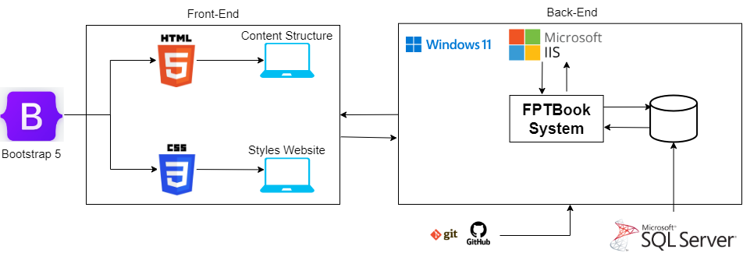

Figure 22: System Diagram Overview

**References**

altexsoft, 2021. *The Good and the Bad of C# Programming.* [Online]   
Available at: https://www.altexsoft.com/blog/c-sharp-pros-and-cons/

Angolluan, P., 2023. *What is Azure? Pros, Cons & Examples.* [Online]   
Available at: https://hackr.io/blog/what-is-azure

atatus, 2021. *IIS Server.* [Online]   
Available at: https://www.atatus.com/glossary/iis-server/#What-is-IIS-Server

balsamiq, n.d. *Wireframing User Flow with Wireflows.* [Online]   
Available at: https://balsamiq.com/learn/articles/wireflows/#:~:text=A%20wireflow%20is%20a%20hybrid,take%20while%20using%20your%20product.

BasuMallick, C., 2022. *What Is Azure? Fundamentals, Services, and Pricing in 2022.* [Online]   
Available at: https://www.spiceworks.com/tech/cloud/articles/what-is-azure/

codeclouds, 2021. *The Advantages and Disadvantages of Using GitHub.* [Online]   
Available at: https://www.codeclouds.com/blog/advantages-disadvantages-using-github/

Corbo, A., 2022. *What Is Linux?.* [Online]   
Available at: https://builtin.com/software-engineering-perspectives/linux

coursera, 2023. *What Is GitHub and Why Should You Use It?.* [Online]   
Available at: https://www.coursera.org/articles/what-is-git

data-flair, n.d. *JavaScript Tutorial – Best JavaScript Guide for Beginners!.* [Online]   
Available at: https://data-flair.training/blogs/javascript-tutorial/

Deshpande, C., 2023. *What is Angular?: Architecture, Features, and Advantages.* [Online]   
Available at: https://www.simplilearn.com/tutorials/angular-tutorial/what-is-angular#:~:text=Angular%20is%20an%20open%2Dsource,for%20developers%20to%20work%20with.

designshack, 2019. *Adobe XD vs. Sketch: Pros + Cons.* [Online]   
Available at: https://designshack.net/articles/software/adobe-xd-vs-sketch/

digitaljournal, 2022. *Advantages and Disadvantages of Heroku.* [Online]   
Available at: https://www.digitaljournal.com/pr/advantages-and-disadvantages-of-heroku

Fruhlinger, J., 2022. *What is Git? Version control for collaborative programming.* [Online]   
Available at: https://www.infoworld.com/article/3654955/what-is-git-version-control-for-collaborative-programming.html

G., D., 2024. *What Is Apache? An In-Depth Overview of Apache Web Server.* [Online]   
Available at: https://www.hostinger.com/tutorials/what-is-apache#What_Is_Apache

G., D., 2024. *What Is MySQL and How Does It Work.* [Online]   
Available at: https://www.hostinger.com/tutorials/what-is-mysql#What_is_MySQL

geeksforgeeks, n.d. *Activity Diagrams | Unified Modeling Language (UML).* [Online]   
Available at: https://www.geeksforgeeks.org/unified-modeling-language-uml-activity-diagrams/

geeksforgeeks, n.d. *Bootstrap Tutorial.* [Online]   
Available at: https://www.geeksforgeeks.org/bootstrap/

geeksforgeeks, n.d. *Foundation CSS Introduction.* [Online]   
Available at: https://www.geeksforgeeks.org/foundation-css-introduction/

geeksforgeeks, n.d. *Introduction to .NET Framework.* [Online]   
Available at: https://www.geeksforgeeks.org/introduction-to-net-framework/

geeksforgeeks, n.d. *Introduction to JavaScript.* [Online]   
Available at: https://www.geeksforgeeks.org/introduction-to-javascript/

geeksforgeeks, n.d. *Introduction to TypeScript.* [Online]   
Available at: https://www.geeksforgeeks.org/introduction-to-typescript/

geeksforgeeks, n.d. *SDLC V-Model – Software Engineering.* [Online]   
Available at: https://www.geeksforgeeks.org/software-engineering-sdlc-v-model/

geeksforgeeks, n.d. *SDLC V-Model – Software Engineering (Advantages and Disadvantages).* [Online]   
Available at: https://www.geeksforgeeks.org/software-engineering-sdlc-v-model/

geeksforgeeks, n.d. *Top 7 UML Diagram Tools That You Can Consider.* [Online]   
Available at: https://www.geeksforgeeks.org/top-7-uml-diagram-tools-that-you-can-consider/

geeksforgeeks, n.d. *Use Case Diagrams | Unified Modeling Language (UML).* [Online]   
Available at: https://www.geeksforgeeks.org/use-case-diagram/

Hartman, J., 2023. *What is Java? Definition, Meaning & Features of Java Platforms.* [Online]   
Available at: https://www.guru99.com/java-platform.html

Herbert, D., 2023. *What is React.js? Uses, Examples, & More.* [Online]   
Available at: https://blog.hubspot.com/website/react-js

hostinger, 2023. *What Is CSS and How Does It Work?.* [Online]   
Available at: https://www.hostinger.com/tutorials/what-is-css

hostinger, 2023. *What Is HTML? Hypertext Markup Language Basics Explained.* [Online]   
Available at: https://www.hostinger.com/tutorials/what-is-html#Pros_and_Cons_of_HTML

indeed, 2023. *List of Scrum Advantages and Disadvantages.* [Online]   
Available at: https://www.indeed.com/career-advice/career-development/disadvantages-of-scrum

Jalli, A., 2022. *What Is C#?.* [Online]   
Available at: https://builtin.com/software-engineering-perspectives/c-sharp

Jalli, A., 2022. *What Is Laravel?.* [Online]   
Available at: https://builtin.com/software-engineering-perspectives/laravel

javatpoint, n.d. *Pros and Cons of ReactJS.* [Online]   
Available at: https://www.javatpoint.com/pros-and-cons-of-react

javatpoint, n.d. *What is Windows?.* [Online]   
Available at: https://www.javatpoint.com/windows

Kumar, V., 2018. *Bootstrap or Foundation Pros and Cons.* [Online]   
Available at: https://www.oodlestechnologies.com/blogs/bootstrap-or-foundation-pros-and-cons/

learntube, 2023. *Advantages and Disadvantages of Bootstrap.* [Online]   
Available at: https://learntube.ai/blog/programming/bootstrap/advantages-and-disadvantages-of-bootstrap/

Martin, M., 2023. *What is Waterfall Model in SDLC?.* [Online]   
Available at: https://www.guru99.com/what-is-sdlc-or-waterfall-model.html

Morris, W., 2022. *What Is Microsoft IIS Web Server Software?.* [Online]   
Available at: https://www.elegantthemes.com/blog/wordpress/microsoft-iis#microsoft-iis-pros-vs-cons

Pavlik, V., 2023. *What Is a Sitemap? Website Sitemaps Explained.* [Online]   
Available at: https://www.semrush.com/blog/website-sitemap/

projectmanager, n.d. *Gantt Chart: Definition and Examples.* [Online]   
Available at: https://www.projectmanager.com/guides/gantt-chart

Roomi, M., 2022. *5 Advantages and Disadvantages of Laravel Framework | Drawbacks & Benefits of Laravel Framework.* [Online]   
Available at: https://www.hitechwhizz.com/2022/10/5-advantages-and-disadvantages-drawbacks-benefits-of-laravel-framework1.html

Roomi, M., 2022. *5 Advantages and Disadvantages of Linux Operating System | Drawbacks & Benefits of Linux Operating System.* [Online]   
Available at: https://www.hitechwhizz.com/2022/05/5-advantages-and-disadvantages-drawbacks-benefits-of-linux-operating-system.html

Roomi, M., 2022. *5 Advantages and Disadvantages of MySQL | Limitations & Benefits of MySQL.* [Online]   
Available at: https://www.hitechwhizz.com/2022/10/5-advantages-and-disadvantages-limitations-benefits-of-mysql1.html

Roomi, M., 2022. *5 Advantages and Disadvantages of TypeScript | Drawbacks & Benefits of TypeScript.* [Online]   
Available at: https://www.hitechwhizz.com/2022/11/5-advantages-and-disadvantages-drawbacks-benefits-of-typescript2.html

Roomi, M., 2022. *5 Advantages and Disadvantages of Windows Operating System | Limitations & Benefits of Windows Operating System.* [Online]   
Available at: https://www.hitechwhizz.com/2022/05/5-advantages-and-disadvantages-limitations-benefits-of-windows-operating-system.html

Rusev, K., 2020. *What is Heroku and What is it Used For?.* [Online]   
Available at: https://mentormate.com/blog/what-is-heroku-used-for-cloud-development/

S, B., 2024. *What Is Scrum Methodology? & Scrum Project Management.* [Online]   
Available at: https://www.nimblework.com/agile/scrum-methodology/#what-is-scrum

Sidana, U., 2023. *What are the Advantages and Disadvantages of Angular?.* [Online]   
Available at: https://www.edureka.co/blog/advantages-and-disadvantages-of-angular/

skillvertex, 2024. *Advantages And Disadvantages Of SQL?.* [Online]   
Available at: https://www.skillvertex.com/blog/advantages-and-disadvantages-of-sql/

Stevens, E., 2023. *The 10 best user interface (UI) design tools to try in 2023.* [Online]   
Available at: https://www.uxdesigninstitute.com/blog/user-interface-ui-design-tools/

Stickman, N., 2023. *SVN vs Git: Which Version Control System Should You Use?.* [Online]   
Available at: https://www.linode.com/docs/guides/svn-vs-git/

T., U., 2023. *CSS Framework Showdown: Bootstrap vs Foundation vs Tailwind CSS.* [Online]   
Available at: https://www.linkedin.com/pulse/css-framework-showdown-bootstrap-vs-foundation-tailwind-umair-tahir

techmonitor, 2023. *What is SQL Server?.* [Online]   
Available at: https://techmonitor.ai/what-is/what-is-sql-server

tutorialspoint, n.d. *SDLC - Waterfall Model (Advantages and Disadvantages).* [Online]   
Available at: https://www.tutorialspoint.com/sdlc/sdlc_waterfall_model.htm

Thakur, S., 2023. *Advantages And Disadvantages of Java Programming Language.* [Online]   
Available at: https://unstop.com/blog/advantages-and-disadvantages-of-java

Vatsal, S., 2024. *Advantages And Disadvantages of CSS: Know All About The Design Language.* [Online]   
Available at: https://unstop.com/blog/advantages-and-disadvantages-of-css

visual-paradigm, n.d. *What is Class Diagram?.* [Online]   
Available at: https://www.visual-paradigm.com/guide/uml-unified-modeling-language/what-is-class-diagram/

visual-paradigm, n.d. *What is Entity Relationship Diagram (ERD)?.* [Online]   
Available at: https://www.visual-paradigm.com/guide/data-modeling/what-is-entity-relationship-diagram/

zenflowchart, 2022. *Visual Paradigm Flowchart Maker - Product Review.* [Online]   
Available at: https://www.zenflowchart.com/blog/visual-paradigm-product-review