**Warehouse Management System Project**

Software Requirements Specification

Version <2.0>

Revision History

|  |  |  |  |
| --- | --- | --- | --- |
| **Date** | **Version** | **Description** | **Author** |
| <11/12/24> | <1.0> | SRS 1.0 | Group-9 |
| <11/23/24> | <2.0> | SRS 2.0 | Group-9 |
| <04/15/07> | <3.0> | SRS 3.0 | Group-1 |
| <04/16/07> | <4.0> | SRS 4.0 | Group-1 |

Table of Contents

1. Introduction 5

1.1 Purpose 5

1.2 Scope 5

1.3 Definitions, Acronyms, and Abbreviations 6

1.4 References 6

1.5 Overview 6

2. Overall Description 6

3. Specific Requirements 7

3.1 Functionality 7

3.1.1 Sell Configured to Ordered Products. 7

3.1.2 Provide comprehensive product details. 7

3.1.3 Detailed product Categorizations 7

3.1.4 Provide Search facility. 7

3.1.5 Maintain customer profile. 8

3.1.6 Provide personalized profile 8

3.1.7 Provide Customer Support. 8

3.1.8 Email confirmation. 9

3.1.9 Detailed invoice for customer. 9

3.1.10 Provide shopping cart facility. 9

3.1.11 Provide multiple shipping methods. 9

3.1.12 Online tracking of shipments 9

3.1.13 Provide online Tax Calculations 10

3.1.14 Allow multiple payment methods. 10

3.1.15 Allow online change or cancellation of order. 10

3.1.16 Allow Online Product reviews and ratings 10

3.1.17 Offer financing options. 10

3.1.18 Provide detailed sitemap. 10

3.1.19 Offer online promotions and rewards. 11

3.1.20 Online Purchase of products. 11

3.2 Usability 11

3.2.1 Graphical User Interface 11

3.2.2 Accessibility 11

3.3 Reliability & Availability 11

3.3.1 Back-end Internal Computers 11

3.3.2 Internet Service Provider 11

3.4 Performance 12

3.5 Security 12

3.5.1 Data Transfer 12

3.5.2 Data Storage 12

3.6 Supportability 13

3.6.1 Configuration Management Tool 13

3.7 Design Constraints 13

3.7.1 Standard Development Tools 13

3.7.2 Web Based Product 13

3.8 On-line User Documentation and Help System Requirements 13

3.9 Purchased Components 13

3.10 Interfaces 14

3.10.1 User Interfaces 14

3.10.2 Hardware Interfaces 14

3.10.3 Software Interfaces 14

3.10.4 Communications Interfaces 15

3.11 Licensing Requirements 15

3.12 Legal, Copyright, and Other Notices 15

3.13 Applicable Standards 15

4. Supporting Information 15

# Introduction

The introduction of the Software Requirements Specification (SRS) provides an overview of the entire SRS with purpose, scope, definitions, acronyms, abbreviations, references and overview of the SRS. The aim of this document is to gather and analyze and give an in-depth insight of the complete **Warehouse management system software system** by defining the problem statement in detail. Nevertheless, it also concentrates on the capabilities required by stakeholders and their needs while defining high-level product features. The detailed requirements of the Warehouse management are provided in this document.

## Purpose

The purpose of the document is to collect and analyze all assorted ideas that have come up to define the system, its requirements with respect to consumers. Also, we shall predict and sort out how we hope this product will be used in order to gain a better understanding of the project, outline concepts that may be developed later, and document ideas that are being considered, but may be discarded as the product develops.

In short, the purpose of this SRS document is to provide a detailed overview of our software product, its parameters and goals. This document describes the project's target audience and its user interface, hardware and software requirements. It defines how our client, team and audience see the product and its functionality. Nonetheless, it helps any designer and developer to assist in software delivery lifecycle (SDLC) processes.

## Scope

Primarily, the scope pertains to the E-Store product features for making Marvel Electronics and Home Entertainment project live. It focuses on the company, the stakeholders and applications, which allow for online sales, distribution and marketing of electronics.

This SRS is also aimed at specifying requirements of software to be developed but it can also be applied to assist in the selection of in-house and commercial software products. The standard can be used to create software requirements specifications directly or can be used as a model for defining a organization or project specific standard. It does not identify any specific method, nomenclature or tool for preparing an SRS.

## Definitions, Acronyms, and Abbreviations

|  |  |
| --- | --- |
| Configuration | It means a product which is available / Selected from a catalogue can be customized. |
| FAQ | Frequently Asked Questions |
| CRM | Customer Relationship Management |
| RAID 5 | Redundant Array of Inexpensive Disk/Drives |

## References

The references are:

* E-Store Structural Model
* E-Store Behavioral Model
* E-Store NFR Model
* Vision Draft 5

## Overview

The remaining sections of this document provide a general description, including characteristics of the users of this project, the product's hardware, and the functional and data requirements of the product.  General description of the project is discussed in section 2 of this document.  Section 3 gives the functional requirements, data requirements and constraints and assumptions made while designing the E-Store.  It also gives the user viewpoint of product.  Section 3 also gives the specific requirements of the product.  Section 3 also discusses the external interface requirements and gives detailed description of functional requirements. Section 4 is for supporting information.

# Overall Description

This document contains the problem statement that the current system is facing which is hampering the growth opportunities of the company. It further contains a list of the stakeholders and users of the proposed solution. It also illustrates the needs and wants of the stakeholders that were identified in the brainstorming exercise as part of the requirements workshop. It further lists and briefly describes the major features and a brief description of each of the proposed system.

The following SRS contains the detail product perspective from different stakeholders. It provides the detail product functions of E-Store with user characteristics permitted constraints, assumptions and dependencies and requirements subsets.

# Specific Requirements

The specific requirements are –

## Functionality

Introduction

A Warehouse Management System (WMS) is an information system designed to control and monitor all processes related to the storage, inbound and outbound flow of goods in a warehouse. The primary goal of the software is to optimize warehouse management processes, minimize errors, and maximize operational efficiency.

### Login

**Description**: user must input account and password to access the system

### Manager products

**Description** : user can insert , delete , update, find and show list products

**Information needs to be managed** : id name,categoryID,unitPrice, stockQuantity, description

### Manager Stock In

**Description** : user can insert , delete ,update ,find and show list stock in

**Information needs to be managed** : id , supplier , stockindate

### Manager Stock Out

**Description** : user can insert , delete ,update ,find and show list stock out

**Information needs to be managed** : id , supplier , stockoutdate, customname , notes

### Reporting

**Description:** Provides stock, stock in and stock out levels of all items in the warehouse with the ability to filter by specific time periods.

### Manager Report

**Description** : Supports management in analyzing and evaluating warehouse status.

### Manager Inventory

**Description**: management can updates and tracks the remaining quantity of products in the warehouse.

**Information needs to be managed** : id , supplier , products , quantity ,totalPrice , stockindate

## User case diagram Warehouse Management

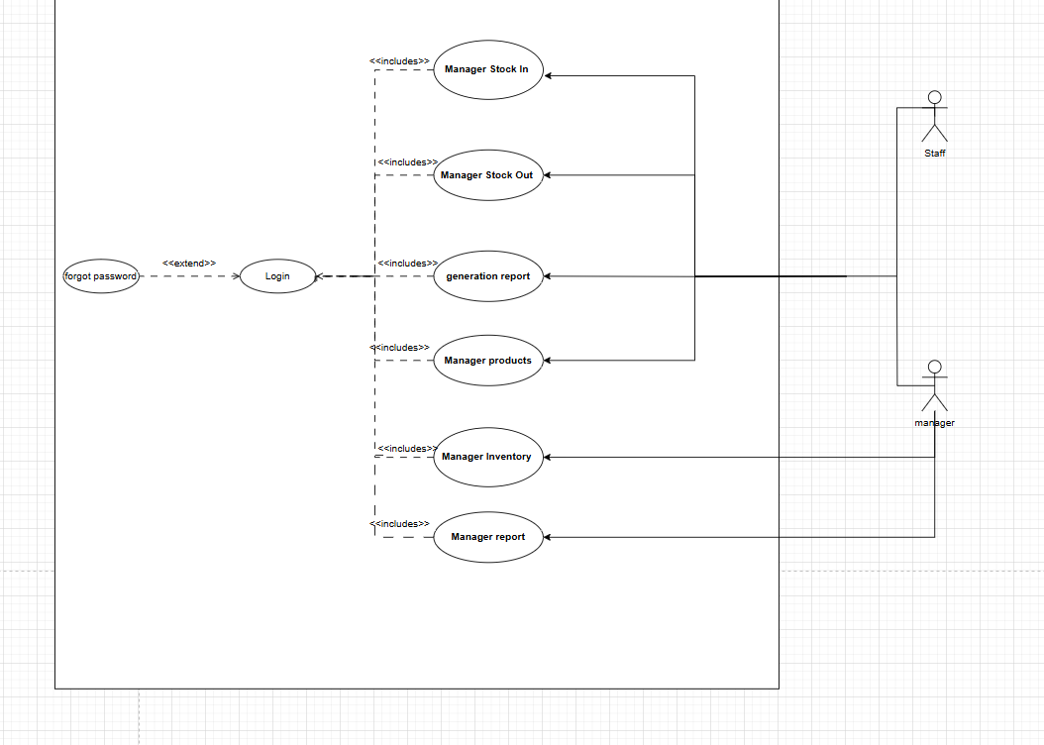

## Conceptual data diagram (CDM) Warehouse Management

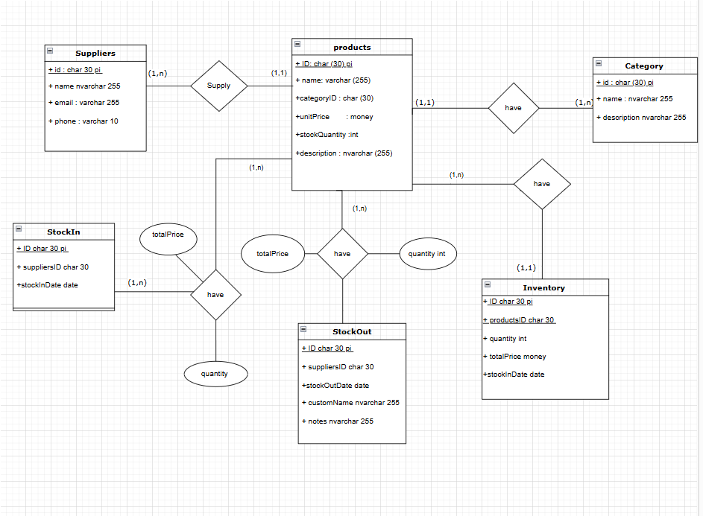

## Physical data model (PDM) Warehouse Management

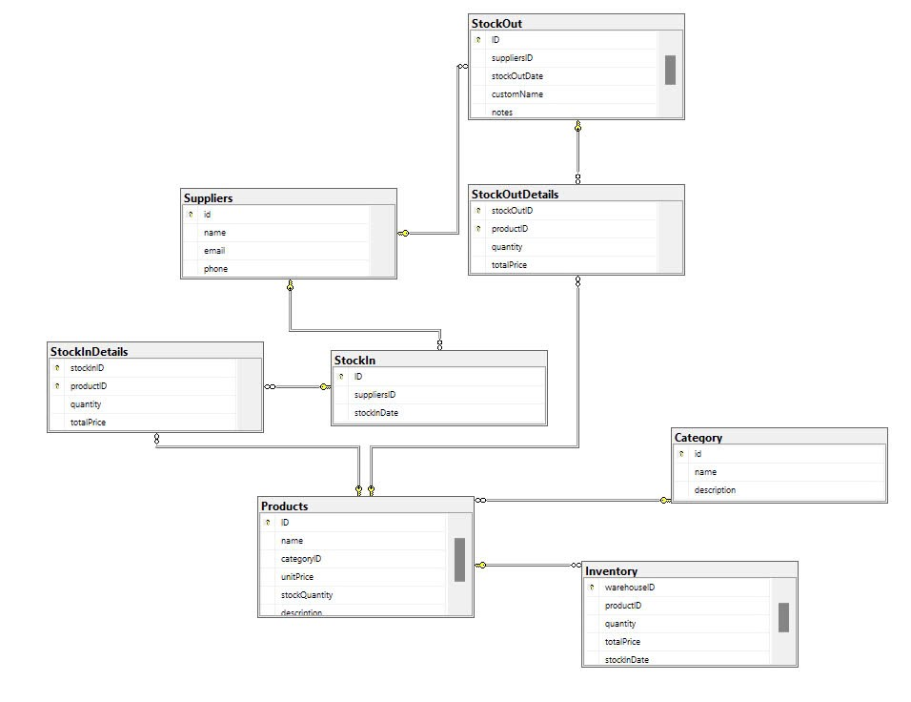

## Usability

### **Graphical User Interface**

The system shall provide a uniform look and feel between all the web pages.

The system shall provide a digital image for each product in the product catalog.

The system shall provide use of icons and toolbars.

### **Accessibility**

The system shall provide handicap access.

The system shall provide multi language support.

## Reliability & Availability

### **Back-end Internal Computers**

The system shall provide storage of all databases on redundant computers with automatic switchover.

The system shall provide for replication of databases to off-site storage locations.

The system shall provide RAID V Disk Stripping on all database storage disks.

### **Internet Service Provider**

The system shall provide a contractual agreement with an internet service provider for T3 access with 99.9999% availability.

The system shall provide a contractual agreement with an internet service provider who can provide 99.999% availability through their network facilities onto the internet.

## Performance

The product shall be based on web and has to be run from a web server.

The product shall take initial load time depending on internet connection strength which also depends on the media from which the product is run.

The performance shall depend upon hardware components of the client/customer.

## Security

### **Data Transfer**

The system shall use secure sockets in all transactions that include any confidential customer information.

The system shall automatically log out all customers after a period of inactivity.

The system shall confirm all transactions with the customer’s web browser.

The system shall not leave any cookies on the customer’s computer containing the user’s password.

The system shall not leave any cookies on the customer’s computer containing any of the user’s confidential information.

### **Data Storage**

The customer’s web browser shall never display a customer’s password. It shall always be echoed with special characters representing typed characters.

The customer’s web browser shall never display a customer’s credit card number after retrieving from the database. It shall always be shown with just the last 4 digits of the credit card number.

The system’s back-end servers shall never display a customer’s password. The customer’s password may be reset but never shown.

The system’s back-end servers shall only be accessible to authenticated administrators.

The system’s back-end databases shall be encrypted.

## Supportability

### **Configuration Management Tool**

The source code developed for this system shall be maintained in configuration management tool.

## Design Constraints

### **Standard Development Tools**

The system shall be built using a standard web page development tool that conforms to either IBM’s CUA standards or Microsoft’s GUI standards.

### **Web Based Product**

        There are no memory requirements

        The computers must be equipped with web browsers such as Internet explorer.

        The product must be stored in such a way that allows the client easy access to it.

        Response time for loading the product should take no longer than five minutes.

        A general knowledge of basic computer skills is required to use the product

## On-line User Documentation and Help System Requirements

As the product is E-store, On-line help system becomes a critical component of the system which shall provide –

It shall provide specific guidelines to a user for using the E-Store system and within the system.

To implement online user help, link and search fields shall be provided.

## Purchased Components

Not Applicable

## Interfaces

There are many types of interfaces as such supported by the E-Store software system namely; User Interface, Software Interface and Hardware Interface.

The protocol used shall be HTTP.

The Port number used will be 80.

There shall be logical address of the system in IPv4 format.

### **User Interfaces**

The user interface for the software shall be compatible to any browser such as Internet Explorer, Mozilla or Netscape Navigator by which user can access to the system.

The user interface shall be implemented using any tool or software package like Java Applet, MS Front Page, EJB etc.

### **Hardware Interfaces**

Since the application must run over the internet, all the hardware shall require to connect internet will be hardware interface for the system. As for e.g. Modem, WAN – LAN, Ethernet Cross-Cable.

### **Software Interfaces**

1. The e-store system shall communicate with the Configurator to identify all the available components to configure the product.
2. The e-store shall communicate with the content manager to get the product specifications, offerings and promotions.
3. The e-store system shall communicate with billPay system to identify available payment methods , validate the payments and process payment.
4. The e-store system shall communicate to credit management system for handling financing options.
5. The e-store system shall communicate with CRM system to provide support.
6. The e-store system shall communicate with Sales system for order management.
7. The e-store system shall communicate with shipping system for tracking orders and updating of shipping methods.
8. The e-store system shall communicate with external Tax system to calculate tax.
9. The e-store system shall communicate with export regulation system to validate export regulations.

10. The system shall be verisign like software which shall allow the users to complete secured transaction. This usually shall be the third party software system which is widely used for internet transaction.

### **Communications Interfaces**

The e-store system shall use the HTTP protocol for communication over the internet and for the intranet communication will be through TCP/IP protocol suite.

## Licensing Requirements

Not Applicable

## Legal, Copyright, and Other Notices

E-store should display the disclaimers, copyright, word mark, trademark and product warranties of the Marvel electronics and home entertainment.

## Applicable Standards

It shall be as per the industry standard.

# Supporting Information

Please refer the following document:

1. Vision document for E-store.
2. Use case analysis.
3. Structural models.
4. Behavioral models.
5. Non functional requirements model.
6. Traceability Matrix.
7. Project Plan